Supplementary Materials

Source apportionment and source-specific health risk of heavy metals in urban road dust of Jinan City, East China

Shengwei Zhang^{a,b}, Ge Maª, Shuzhen Dong^{a,c}, Xang-Zhou Meng^{d}, Lijun Wang^{a,*}
ªDepartment of Environmental Science and Engineering, School of Geography and Tourism, Shaanxi Normal University, Xi’an 710119, China
^{b}State Key Laboratory of Water Environment Simulation, School of Environment, Beijing Normal University, Beijing 100875, China
^{c}Shangluo City Meteorological Bureau, Shangluo 726000, China
^{d}State Key Laboratory of Pollution Control and Resources Reuse, College of Environmental Science and Engineering, Tongji University, Shanghai 200092, China

*Corresponding author E-mail: wanglijun@snnu.edu.cn (L. Wang)
Text 1. Sample digestion
The digestion of road dust samples was described in our previous work (Wang et al. 2018). In briefly, a total of 0.50 g road dust sample was weighted, placed into a 50-mL teflon crucible, and wetted using a small amount of ultra-pure water. After concentrated hydrogen nitrate (HNO_{3,} 5 mL), hydrofluoric acid (HF, 5 mL) and perchloric acid (HClO₄, 3 mL) were added, it was heated with an electric heating plate until near dryness. It was digested with HNO₃ (3 mL), HF (3 mL) and HClO₄ (1 mL) again. The residual was dissolved and transferred into a 25-mL volumetric flask and diluted to 25 mL with the solution of 25% HNO₃ (v : v). The prepared solution was stored at 4 °C before analysis.
Text 2. BCR sequential extraction
The modified BCR sequential extraction was described in our previous studies (Wang et al. 2015). The detailed processes were as follows:
Step 1 (Acid soluble state): A total of 0.80 g road dust sample was weighted and placed into a 100-mL erlenmeyer flask. After A 32 mL solution of 0.11 mol/L CH₃COOH was added, it was shaken for 16 h at room temperature. Next, it was transferred to a 50-mL glass centrifuge tube and centrifugated for 10 min at 7000 r/min. The supernatant was transferred into a 100-mL beaker and steamed to near dryness using a hot plate, then dissolved by adding 5 mL solution of 1.0 mol/L HNO_{3,} and finally transferred into a 25-mL volumetric flask. After 20 mL ultra-pure water was added into the solid residue, it was shaken for 15 min and centrifuged, then the supernatant was discarded.
Step 2 (Reducible state): A 32 mL solution of 0.5 mol/L HONH₂HCl was added into to the residue of Step 1 and the pH value of solution was adjusted to 2 with 2 mol/L HNO₃. It was shaken for 16 h at room temperature, then centrifuged with the method above. The treatment of the supernatant and residual was same to the description above.
Step 3 (Oxidizable state): A 10 mL solution of 30% H₂O₂ was added into the residue of Step 2 and the pH value of solution was adjusted to 2-3 with HNO₃. It was digested for 1 h at room temperature, occasionally shaken, then heated to 85 °C for 1 h in water bath. After a 50 mL solution of 1.0 mol/L CH₃COONH₄ (the pH of solution was adjusted to 2 with HNO₃) was added, it was shaken for 16 h at room temperature, then centrifuged with the method above. The process was repeated. The treatment of the supernatant and residual was same to the description above.
Step 4 (Residual state): The residue of Step 3 was treated by concentrated HF, HNO₃ and HClO₄. The treatment process was same to the sample digestion above.
Text 3. Instrument parameters
The concentration and speciation of heavy metals were measured by ICP-AES. High purity (99.9%) argon was used as carrier gas, the partial pressure was maintained at 0.7~1.0 MPa, and the optical chamber temperature was stable to 15 ± 0.1 ℃. The standard curve was constructed with the standard gradients 0, 0.1, 0.5, 1, 2, 4, 8, 10 and 20 mg/L (external standards dissolve into 5% HNO₃). Each sample is measured three times, the relative standard deviation (RSD) was less than 2%, and the regression coefficient R² was greater than 0.999. The spectral lines of heavy metals were Co (230.786), Cr (283.565), Cu (324.700), Cd (228.802), Mn (257.611), Ni (231.604), Pb (168.215), V (292.402), Zn (202.613) and Ba (455.404), with corresponding instrumental limits of detection (LLDs) 0.003, 0.004, 0.002, 0.001, 0.013, 0.003, 0.008, 0.001, 0.001, 0.001 mg/L, respectively.

Text 4. PMF receptor model
PMF receptor model is a good tool in apportioning the composition and contribution of heavy metal sources in urban road dust (Men et al. 2018). The PMF model can be described by equation 1 (Hopke 2003; Manousakas et al. 2017).
(1)
where, x_{ij} is the concentration of the ith species measured in the jth sample, f_{kj} is the contribution of the kth source to the jth sample, g_{ik} is the concentration of the ith species from the kth source, and e_{ij} is the error. In the PMF model, factor matrix is calculated under non-negative constraint condition, which means that all the results are positive. The composition and contribution of each source are derived from the PMF model by minimizing the sum of an ‘object function’ Q calculated by equation 2 (Norris and Henry, 2014; Kim and Hopke, 2007).
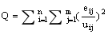 (2)
where, u_{ij} is the uncertainty; if the concentration is less than or equal to method detection limit (MDL), the uncertainty is equal to 5/6 MDL; otherwise, the uncertainty is calculated by equation 3.
(3)
The number of specific factors is not directly given, therefore, multiple debugging is required. Based on the ratios of signal-to-noise (S/N), the species is categorized as strong, weak or bad. If the scale of residuals for most of species is between -3 and +3, as well as Q_{true}, Q_{robust} and Q_{theoretical} are close, the base run may be regarded reasonable. The value of Q_{theoretical} is calculated by equation 4.
(4)
where, n is the number of species, m is the number of receptor sites, and p is the number of factors (Henry 2003; Norris and Henry, 2014).

Text 5. Health risk assessment model
The health risk assessment model of US EPA has been widely used to assess the carcinogenic and non-carcinogenic risks of human exposure to heavy metals (Khairy et al. 2011; US EPA, 2011). The average daily doses (ADDs) of human exposure to heavy metals in urban road dust through ingestion, inhalation and dermal adsorption are calculated by equation 5-7.
(5)
(6)
(7)
where, C is the concentration of heavy metals in road dust, being 95% upper confidence limit (95% UCL) and modified as the product of C and F_{bio} (bio-availability); IngR is the ingestion rate of road dust; EF is the exposure frequency; ED is the exposure duration; BW is the average body weight; AT is the average exposure time; InhR is the inhalation rate; PEF is the particle emission factor; SA is the surface area of skin exposure; and AF is the skin adherence factor. The specific values of parameters are shown in Table S3.
The non-carcinogenic risk of human exposure to heavy metals in urban road dust can be described by equation 8 and 9.
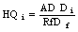 (8)
(9)
where, HQ_{i} is the hazard quotient of exposure pathway i for certain metal, RfD_{i} is the reference dose of corresponding exposure pathway for certain metal (Table S4), and HI is the hazard index of all exposure pathway for certain metal. HI > 1 indicates a significant non-carcinogenic risk, while HI ≤ 1 indicates that the non-carcinogenic risk is insignificant.
For carcinogenic effects, the lifetime average daily dose (LADD) is calculated by equation 10.
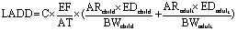 (10)
where, AR is absorption rate; AR = IngR for the ingestion, AR = InhR/PEF for the inhalation, and AR = SA×SL×ABS for dermal contact.
The carcinogenic risk of human exposure to heavy metals in urban road dust can be expressed by equation 11 and 12.
(11)
(12)
where, CR_{i} is the carcinogenic risk of exposure route i, SF_{i} is the carcinogenic slope factor of exposure route i (Table S4), and CR is the sum of cancer risk for all the exposure routes. The value of CR is between 1×10⁻⁶ and 1×10⁻⁴, suggesting that the carcinogenic risk is acceptable; the CR value is greater than 1 × 10⁻⁴, indicating a significant carcinogenic risk; and the CR is less than 1×10⁻⁶, implying that the carcinogenic risk is low or negligible (Shi et al. 2011; US EPA, 2019).
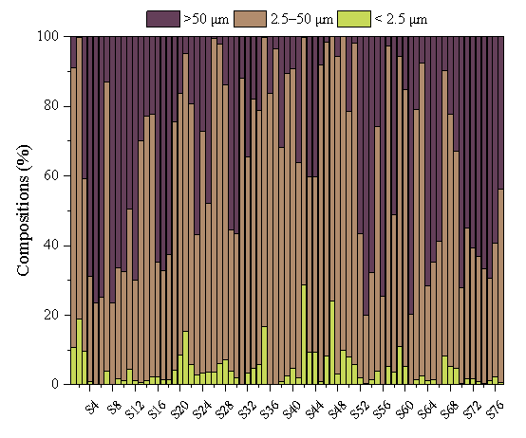

Fig. S1 Size fractions of road dust.

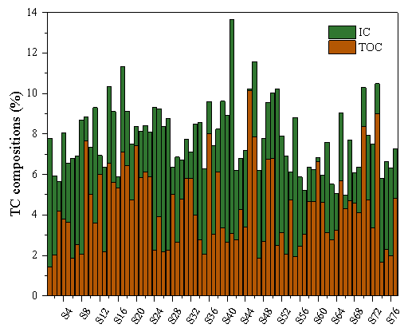

Fig. S2 Compositions of TOC (total organic carbon), IC (inorganic carbon) and TC (total carbon, TOC+IC), of road dust.

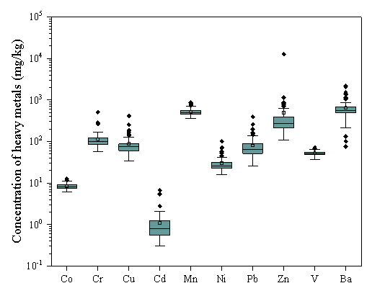

Fig. S3 Concentration of heavy metal in road dust of Jinan City.

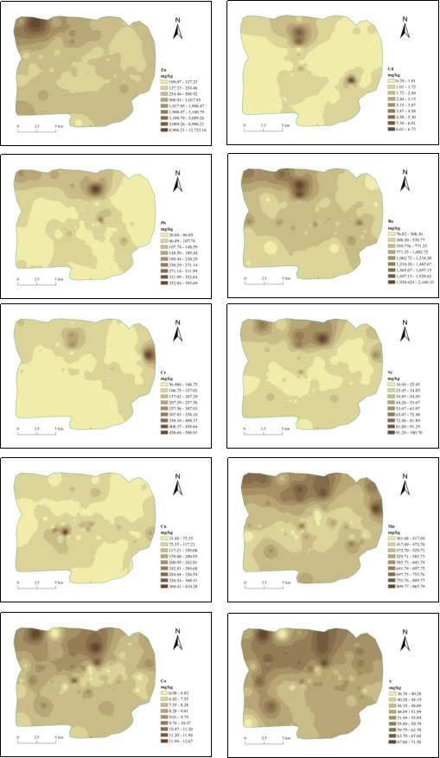
Fig. S4 Spatial distribution of heavy metals in the road dust of Jinan City

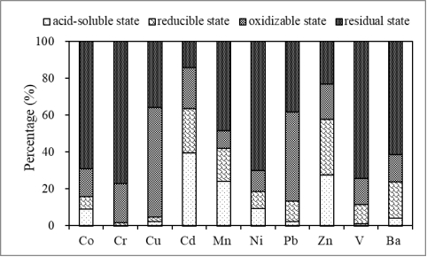

Fig. S5 Speciation characteristics of heavy metals in the road dust of Jinan City

Table S1
Physicochemical properties (pH, EC, LF, HF and FD) of road dust
Items | pH | EC | LF | HF | FD
Unit | Unitless | μS/cm | ×10⁸ m³/kg | ×10⁸ m³/kg | %
Min | 7.06 | 214 | 337 | 294 | 2.07
Max | 9.64 | 6.23×10³ | 1.69×10³ | 1.66×10³ | 12.8
Mean | 8.02 | 1.81×10³ | 608 | 561 | 8.40
Median | 8.04 | 1.48×10³ | 556 | 509 | 8.73
EC: Electrical conductivity; LF: Low frequency susceptibility; HF: High frequency susceptibility; FD: frequency susceptibility.

Table S2
Quality control of standard soils of GSS1 and GSD5
Elements | Co | Cr | Cu | Cd | Mn | Ni | Pb | Zn | V | Ba
GSS1 | 12.36 | 63.51 | 20.07 | 4.35 | 1669.27 | 19.32 | 104.40 | 570.27 | 75.18 | 530.48
Reference value | 14.2 | 62 | 21 | 4.3 | 1760 | 20.4 | 98 | 680 | 86 | 590
Absolute error | 1.84 | 1.51 | 0.93 | 0.05 | 90.73 | 1.08 | 6.40 | 109.73 | 10.82 | 59.52
Relative error | 12.94 | 2.44 | 4.43 | 1.26 | 5.16 | 5.30 | 6.54 | 16.14 | 12.59 | 10.09
GSD5 | 16.89 | 70.81 | 129.87 | 1.00 | 1099.69 | 33.28 | 118.63 | 208.08 | 98.44 | 394.96
Reference value | 18.9 | 70 | 137 | 0.82 | 1160 | 34 | 112 | 243 | 109 | 440
Absolute error | 2.01 | 0.81 | 7.13 | 0.18 | 60.31 | 0.72 | 6.63 | 34.92 | 10.56 | 45.04
Relative error | 10.64 | 1.15 | 5.20 | 21.88 | 5.20 | 2.12 | 5.92 | 14.37 | 9.69 | 10.24

Table S3
Parameter values of US EPA health risk assessment model
Parameters | Parameters | Unit | Children | Adults
 | C | mg/kg | 95%UCL | 95%UCL
Exposure behavior parameter | ED ª | a | 6 | 24
Exposure behavior parameter | BW ^{b} | kg | 15 | 58.6
Exposure behavior parameter | EF ^{c} | d/a | 180 | 180
Exposure behavior parameter | AT-NCR ^{a, c} | d | 365 × ED | 365 × ED
Exposure behavior parameter | AT-CR ^{a, c} | d | 365 ×70 | 365 ×70
Ingestion | lngR ª | mg/d | 200 | 100
Inhalation | lnhR ^{a, b} | m³/d | 7.6 | 12.8
Inhalation | PEF ª | m³/kg | 1.36 × 10⁹ | 1.36 × 10⁹
Adhesion | AF ª | mg/cm² | 0.2 | 0.07
Adhesion | ABS ª | unitless | 0.001 | 0.001
Adhesion | SA ^{b} | cm² | 1150 | 2145
ª: adopted from US EPA (2001, 2019); ^{b}: adopted from Li et al. (2011); ^{c}: adopted from Li et al. (2017)

Table S4
Reference dose (RfD) and slope factor (SF) of heavy metals
Elements | RfD (mg/kg/d) |  |  | SF (1/(mg/kg/d))
Elements | RfD_{ing} | RfD_{inh} | RfD_{dermal} | SF_{ing} | SF_{inh} | SF_{dermal}
Co | 2.00E-02 | 5.71E-06 | 1.60E-02 |  | 9.80E+00
Cr | 3.00E-03 | 2.86E-05 | 6.00E-05 |  | 4.20E+01
Cu | 4.00E-02 | 4.00E-02 | 1.20E-02
Cd | 1.00E-03 | 1.00E-03 | 1.00E-05 | 6.10E+00 | 1.80E-03 | 6.10E+00
Mn | 4.60E-02 | 1.43E-05 | 1.84E-03
Ni | 2.00E-02 | 2.06E-02 | 5.40E-03 |  | 8.40E-01
Pb | 3.50E-03 | 3.52E-03 | 5.25E-04
Zn | 3.00E-01 | 3.00E-01 | 6.00E-02
V | 7.00E-03 |  | 7.00E-05
Ba | 7.00E-02 | 1.43E-04 | 4.90E-03

Table S5
Mean concentrations of heavy metals in the study area and reference area (mg/kg)
City | Co | Cr | Cu | Cd | Mn | Ni | Pb | Zn | V | Ba | References
Jinan | 8.25 | 114.09 | 87.71 | 1.08 | 517.04 | 30.29 | 85.71 | 497.64 | 51.76 | 642.77 | This study
Beijing | - | 92.1 | 83.12 | 0.59 | 553.73 | 32.47 | 60.88 | 280.65 | - | - | Mehr et al. 2017
Guangzhou | - | - | 176 | 2.41 | - | - | 240 | 586 | - | - | Duzgoren-Aydin et al. 2006
Hangzhou | - | - | 116 | 1.6 | - | - | 202 | 321 | - | - | Zhang et al. 2009
Shanghai | - | - | 132.1 | 0.46 | - | - | 105.6 | 473.5 | - | - | Bi et al. 2018
Nanchang | 7.9 | - | 102 | 0.58 | - | - | 62 | 208 | 40 | - | Tang et al. 2017
Xi’an | 30.9 | 145 | 54.7 | - | - | 30.8 | 124.5 | 268.6 | 69.6 | - | Pan et al. 2017
Tianjing | 9.3 | 71.85 | 55.47 | 0.45 | - | - | 60.11 | - | - | - | Yu et al. 2018
Huai’an | 6.62 | 61.1 | 36.3 | 0.252 | - | - | 42.6 | - | - | - | Zhao et al. 2019
Delhi | 23 | - | 169 | - | - | - | 129 | 264 | - | - | Suryawanshi et al. 2016
Turin | - | - | 181 | 0.8 | - | - | 74 | 200 | - | - | Mohman et al. 2015
Thessaloniki | - | 104.9 | 662.3 | 1.76 | 336.4 | 89.43 | 209 | 452.8 | - | - | Doabi et al. 2018
Dhaka | - | 144.34 | 49.68 | 11.64 | 261.53 | 37.01 | 18.99 | 239.16 | - | - | Valottoet al. 2015
Kermanshah | - | 73.74 | 47.63 | - | - | 119.53 | - | 210.29 | - | - | Bourliva et al. 2017
Note: “-” no available data.
Table S6
Source-specific health risk of heavy metals in the road dust of Jinan City
Elements | Traffic emissions |  |  | Industrial discharges |  |  | Natural and coal combustion sources |  |  | Building material and manufacture sources
Elements | NCR |  | CR | NCR |  | CR | NCR |  | CR | NCR |  | CR
Elements | Children | Adults | CR | Children | Adults | CR | Children | Adults | CR | Children | Adults | CR
Co | 1.00E-04 | 1.56E-05 | 1.17E-10 | 2.06E-04 | 3.20E-05 | 2.40E-10 | 5.46E-04 | 8.46E-05 | 6.35E-10 | 6.99E-05 | 1.08E-05 | 8.13E-11
Cr | 1.21E-02 | 1.59E-03 | 9.42E-09 | 1.52E-02 | 1.99E-03 | 1.18E-08 | 2.37E-02 | 3.10E-03 | 1.84E-08 | 4.85E-03 | 6.35E-04 | 3.76E-09
Cu | 3.50E-04 | 4.48E-05 |  | 2.87E-03 | 3.68E-04 |  |  |  |  | 6.08E-03 | 7.79E-04
Cd | 3.84E-03 | 5.07E-04 | 2.72E-06 | 1.70E-03 | 2.24E-04 | 1.21E-06 |  |  |  | 7.55E-04 | 9.97E-05 | 5.36E-07
Mn | 6.05E-03 | 9.28E-04 |  | 9.30E-03 | 1.43E-03 |  | 2.40E-02 | 3.68E-03 |  | 2.85E-03 | 4.37E-04
Ni | 6.90E-04 | 8.84E-05 | 7.53E-11 | 2.90E-04 | 3.72E-05 | 3.17E-11 | 1.61E-03 | 2.06E-04 | 1.76E-10 | 2.37E-04 | 3.03E-05 | 2.58E-11
Pb | 2.27E-02 | 2.91E-03 |  | 3.49E-02 | 4.48E-03 |  | 8.44E-03 | 1.08E-03 |  | 1.34E-02 | 1.72E-03
Zn | 1.44E-03 | 1.85E-04 |  | 1.05E-03 | 1.35E-04 |  | 1.63E-03 | 2.09E-04 |  | 4.70E-04 | 6.02E-05
V | 1.10E-03 | 1.46E-04 |  | 3.43E-03 | 4.53E-04 |  | 8.35E-03 | 1.10E-03 |  | 9.75E-04 | 1.29E-04
Ba | 6.95E-03 | 9.22E-04 |  | 1.68E-02 | 2.23E-03 |  |  |  |  | 8.66E-06 | 1.15E-06
ΣHeavy metals | 5.53E-02 | 7.33E-03 | 2.73E-06 | 8.58E-02 | 1.14E-02 | 1.22E-06 | 6.82E-02 | 9.46E-03 | 1.92E-08 | 2.97E-02 | 3.90E-03 | 5.40E-07
NCR: Non-carcinogenic risk; CR: Lifetime carcinogenic risk.

References
Bi C, Zhou Y, Chen Z, Jia, JP, Bao XI (2018) Heavy metals and lead isotopes in soils, road dust and leafy vegetables and health risks via vegetable consumption in the industrial areas of Shanghai, China. Science of the Total Environment 619-620: 1349-1357.
Bourliva A, Christophoridis C, Papadopoulou L, Giouri K, Papadopoulos A, Mitsika E, Fytianos K (2017) Characterization, heavy metal content and health risk assessment of urban road dusts from the historic center of the city of Thessaloniki, Greece. Environmental Geochemistry Health 39: 611-634.
Doabi SA, Karami M, Afyuni M, Yeganeh M (2018) Pollution and health risk assessment of heavy metals in agricultural soil, atmospheric dust and major food crops in Kermanshah province, Iran. Ecotoxicology and Environmental Safety 163: 153-164.
Duzgoren-Aydin NS, Wong CSC, Aydin A, Song Z, You M, Li XD (2006) Heavy metal contamination and distribution in the urban environment of Guangzhou, SE China. Environmental Geochemistry and Health 28: 375-391.
Henry RC, Christensen ER (2010) Selecting an appropriate multivariate source apportionment model result. Environmental Science and Technology 44: 2474-2481.
Hopke PK (2003) Recent developments in receptor modeling. Journal of Chemistry 17, 255-265.
Khairy MA, Barakat AO, Mostafa AR, Wade TL (2011) Multielement determination by flame ,atomic absorption of road dust samples in Delta Region, Egypt. Microchemistry Journal 97: 234-242.
Kim E, Hopke PK (2007) Comparison between sample-species specific uncertainties and estimated uncertainties for the source apportionment of the speciation trends network data. Atmospheric Environment 41: 567-575.
Li HH, Chen LJ, Yu L, Guo Z, Shan C, Lin J, Gu Y, Yang Z, Yang Y, Shao J (2017) Pollution characteristics and risk assessment of human exposure to oral bioaccessibility of heavy metals via urban street dusts from different functional areas in Chengdu, China. Science of the Total Environment 586: 1076-1084.
Li RZ, Zhou AJ, Dong F, Wu Y, Zhang P, Yu J (2011) Distribution of metals in urban dusts of Hefei and health risk assessment. Environmental Science 32: 2261-2268. (In Chinese)
Manousakas M, Papaefthymiou H, Diapouli E, Migliori A, Karydas AG, Bogdanovic-Radovic I, Eleftheriadis K (2017) Assessment of PM_{2.5} sources and their corresponding level of uncertainty in a coastal urban area using EPA PMF 5.0 enhanced diagnostics. Science of the Total Environment 574: 155-164.
Mehr MR, Keshavarzi B, Moore F, Sharifi R, Lahijanzadeh A, Kermanic M (2017) Distribution, source identification and health risk assessment of soil heavy metals in urban areas of Isfahan province, Iran. Journal of African Earth Sciences 132: 16-26.
Men C, Liu RM, Xu F, Wang Q, Guo LJ, Shen ZY (2018) Pollution characteristics, risk assessment, and source apportionment of heavy metals in road dust in Beijing, China. Science of the Total Environment 612: 138-147.
Mohmand J, Eqani SAMAS, Fasola M, Alamdar A, Mustafa I, Ali N, Liu LP, Peng SY, Shen HQ (2015) Human exposure to toxic metals via contaminated dust: bio-accumulation trends and their potential risk estimation. Chemosphere 132: 142-151.
Norris G. Duvall R (2014) EPA Positive Matrix Factorization (PMF) 5.0 Fundamentals and User Guide (EPA/600/R-14/108). US EPA.
Pan H, Lu X, Lei K (2017) A comprehensive analysis of heavy metals in urban road dust of Xi'an, China: Contamination, source apportionment and spatial distribution. Science of the Total Environment 609: 1361-1369.
Shi G, Chen Z, Bi C, Wang L, Teng J, Li Y, Xu S (2011) A comparative study of health risk of potentially toxic metals in urban and suburban road dust in the most populated city of China. Atmospheric Environment 45: 764-771.
Suryawanshi PV, Rajaram BS, Bjanarkar AD, Rao CVC (2016) Determining heavy metal contamination of road dust in Delhi, India. Atmósfera 29: 221-234.
Tang Z, Chai M, Cheng J, Jin J, Yang Y, Nie Z, Huang Q, Li Y (2017) Contamination and health risks of heavy metals in street dust from a coalmining city in eastern China. Ecotoxicology and Environmental Safety 138: 83-91.
US EPA (United State Environmental Protection Agency), 2011. Exposure Factors Handbook. 2011 Edition. National Center for Environmental Assessment. Washington, DC. Office of Research and Development 20460. (EPA/600/R-09/052F)
US EPA (United States Environmental Protection Agency), 2001. Supplemental Guidance for Developing Soil Screening Level for Superfund Sites. OSWER 9355, 4-24. Office of Solid Waste and Emergency Response; U.S. Environmental Protection Agency, Washington, DC, USA.
US EPA (United States Environmental Protection Agency), 2019. Regional Screening Levels (RSLs), Generic Tables.
Valotto G, Rampazzo G, Visin F, Gonella F, Cattaruzza E, Glisenti A, Formenton G, Tieppo P (2015) Environmental and traffic-related parameters affecting road dust composition: A multi-technique approach applied to Venice area (Italy). Atmospheric Environment 122: 596-608.
Wang LJ, Lu XW, Li LY, Ren XH, Luo DC, Chen JH (2015) Content, speciation and pollution assessment of Cu, Pb and Zn in soil around the lead–zinc smelting plant of Baoji, NW China. Environmental Earth Sciences 73: 5281–5288.
Wang LJ, Tao WD, Smardon RC, Xu X, Lu XW (2018) Speciation, sources and risk assessment of heavy metals in suburban vegetable garden soil of Xianyang City, Northwest China. Frontiers of Earth Science 12: 397–407.
Yu B, Wang Y, Zhou Q (2014) Human health risk assessment based on toxicity characteristic leaching procedure and simple bioaccessibility extraction test of toxic metals in urban street dust of Tianjin, China. PLOS One 9: e92459.
Zhang M, Wang, H (2009) Concentrations and chemical forms of potentially toxic metals in road-deposited sediments from different zones of Hangzhou, China. Journal of Environmental Science 21: 625-631.
Zhao L, Hu G, Yan Y, Yu R, Cui J, Wang X, Yan Y (2019) Source apportionment of heavy metals in urban road dust in a continental city of eastern China: Using Pb and Sr isotopes combined with multivariate statistical analysis. Atmospheric Environment 201: 201-211.

