Supplementary material
Graphene oxide loading in hierarchical ZnO microflowers for room-temperature ethanol sensing and UVA photodetection
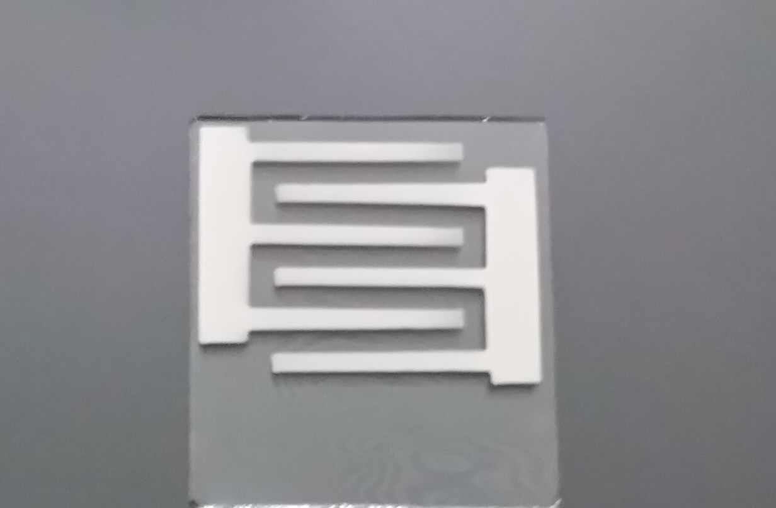
Fig. S1. Photograph of the interdigitated electrode used as the device substrate.
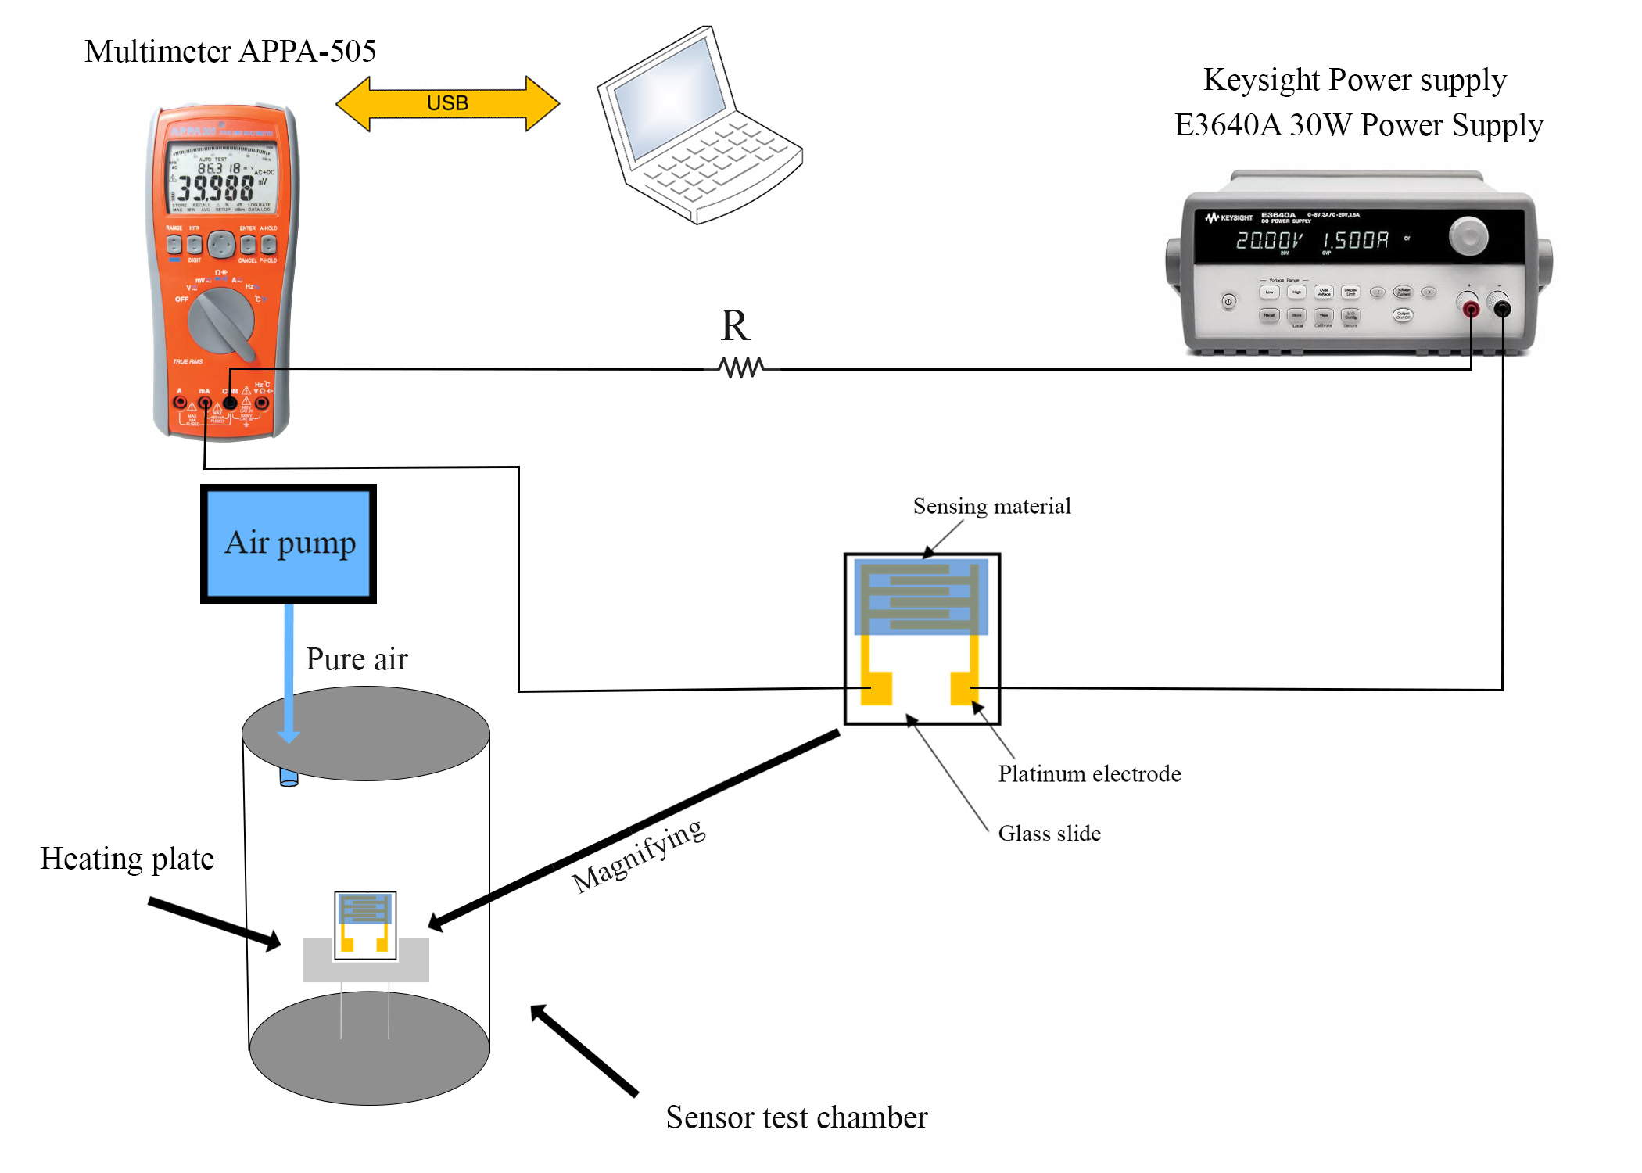
Fig. S2. Schematic of the ethanol sensing rig, with the Keysight E3640A DC supply, the series resistor R, the APPA-505 multimeter logged over USB, the air pump and the cylindrical test chamber with its heating plate, and the drop-cast film on interdigitated platinum electrodes carried on a glass slide.
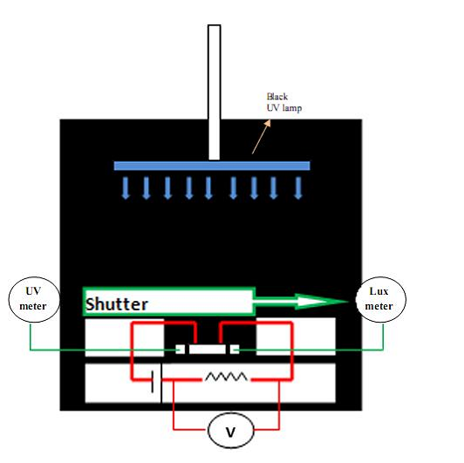
Fig. S3. Schematic of the ultraviolet dark box, with the black-light UVA lamp, shutter, UV meter, lux meter, interdigitated device, series resistor and 2 V bias.
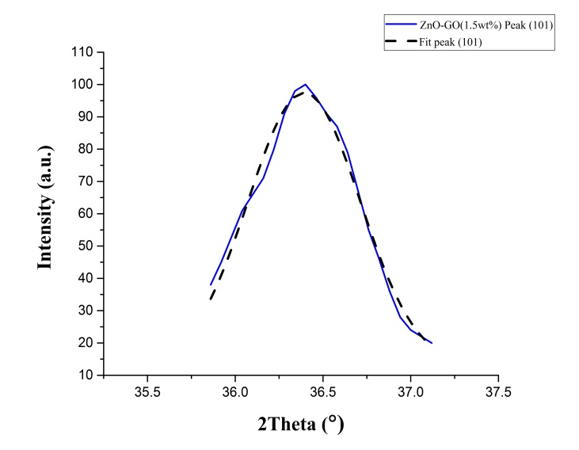
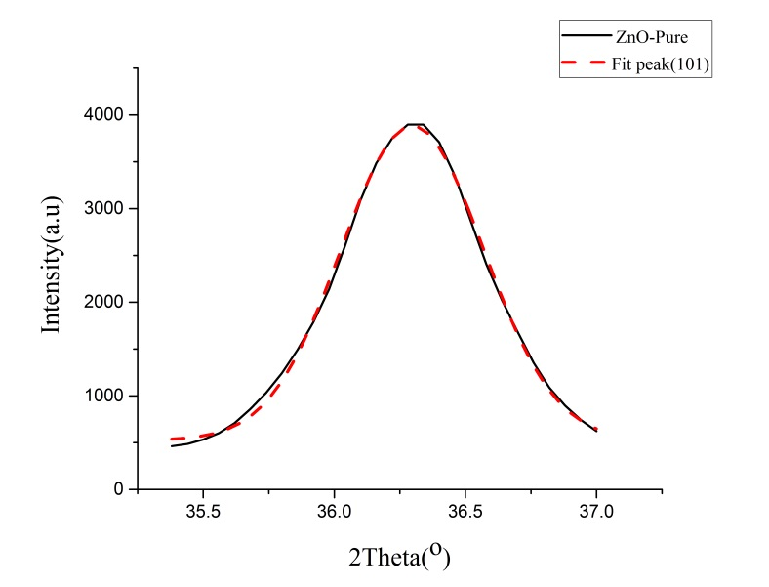
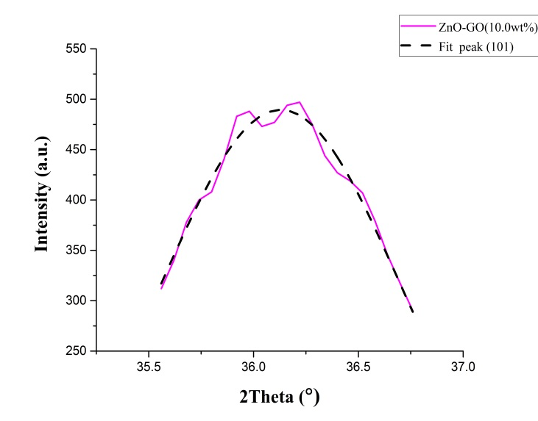
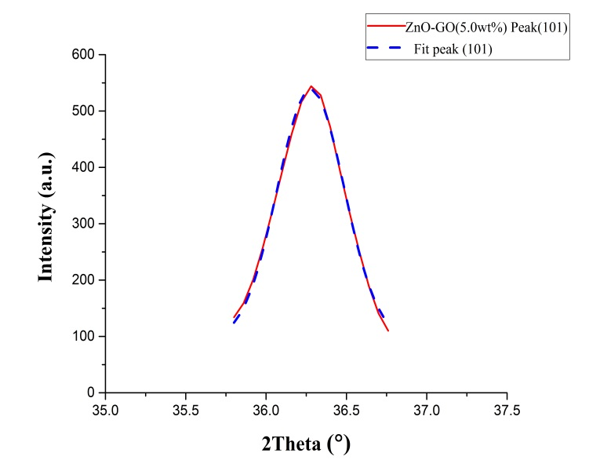
Fig. S4. The (101) reflection of (a) ZnO/1.5 wt% GO, (b) ZnO, (c) ZnO/10 wt% GO and (d) ZnO/5 wt% GO together with the fitted profiles.

