Supplementary files: This file included supplematary tables and figures.

Supplementary Tables
Table S1. Analytic counts and prespecified data-quality audit.
Domain | Finding | Interpretation
Unilateral; T1 | 97 patients; 97 eyes; 79 enucleations | Included in primary eye-level analysis
Unilateral; T2 | 166 patients; 166 eyes; 99 enucleations | Included in primary eye-level analysis
Bilateral; T1 | 72 patients; 144 eyes; 63 enucleations | Included in primary eye-level analysis
Bilateral; T2 | 156 patients; 312 eyes; 83 enucleations | Included in primary eye-level analysis
Primary adjusted GEE | 717 eyes; 489 clusters; maximum cluster size 2 | Accepted; robust covariance finite
All accepted GEE models | 20/20 passed cluster validation | Exchangeable working correlation retained
Missing age | 2/719 eyes (0.3%) | Excluded only from adjusted models requiring age
Missing/invalid globe time | 2/719 eyes (0.3%) | Excluded from globe-preservation analysis
Enucleation type | 1 enucleated eye had unknown type | Retained for any-enucleation analysis; not classified primary/secondary
T1 targeted-treatment crossover | 5 eye records from 4 bilateral patients | Addressed in sensitivity analysis
Bilateral eye-side metadata | 1 patient had 2 records both labeled OS | Outcomes retained as distinct source rows; patient clustering unaffected
ICRB source files | All 10 group-specific files matched master-file row counts | Used for validation only; not appended
Table 3 denominator audit | 10/10 laterality-by-ICRB rows reconciled | Initial management and final outcome balances passed
Table 4 landmark audit | 8/8 Kaplan-Meier strata passed | 7-year risk sets and event counts reconciled to full follow-up totals
Note: OS denotes left eye; GEE, generalized estimating equation. Raw-data discrepancies are reported transparently and were not silently overwritten.

Table S2. Detailed affected-eye characteristics by era and laterality.
Characteristic | Unilateral T1  (n=97 eyes) | Unilateral T2  (n=166 eyes) | Bilateral T1  (n=144 eyes) | Bilateral T2  (n=312 eyes)
Affected eye, right (OD) | 46/97 (47.4%) | 93/166 (56.0%) | Not applicable | Not applicable
Affected eye, left (OS) | 51/97 (52.6%) | 73/166 (44.0%) | Not applicable | Not applicable
ICRB group A | 1 (1.0%) | 1 (0.6%) | 9 (6.3%) | 18 (5.8%)
ICRB group B | 4 (4.1%) | 20 (12.0%) | 32 (22.2%) | 68 (21.8%)
ICRB group C | 8 (8.2%) | 11 (6.6%) | 24 (16.7%) | 47 (15.1%)
ICRB group D | 23 (23.7%) | 16 (9.6%) | 30 (20.8%) | 50 (16.0%)
ICRB group E | 61 (62.9%) | 118 (71.1%) | 49 (34.0%) | 129 (41.3%)
Advanced ICRB D/E | 84 (86.6%) | 134 (80.7%) | 79 (54.9%) | 179 (57.4%)
Any targeted chemotherapy | 0 (0.0%) | 50 (30.1%) | 5 (3.5%) | 93 (29.8%)
Targeted: intra-arterial only | 0 (0.0%) | 28 (16.9%) | 3 (2.1%) | 52 (16.7%)
Targeted: intra-arterial + intravitreal | 0 (0.0%) | 19 (11.4%) | 1 (0.7%) | 26 (8.3%)
Targeted: intravitreal only | 0 (0.0%) | 3 (1.8%) | 1 (0.7%) | 15 (4.8%)
Recurrence | 2 (2.1%) | 14 (8.4%) | 31/142 (21.8%) | 57/311 (18.3%)
Subretinal fluid | 34 (35.1%) | 45 (27.1%) | 24/142 (16.9%) | 69/311 (22.2%)
Vitreous seeding | 29 (29.9%) | 49 (29.5%) | 30/142 (21.1%) | 84/311 (27.0%)
Subretinal seeding | 22 (22.7%) | 44 (26.5%) | 19/142 (13.4%) | 74/312 (23.7%)
Unifocal | 60/84 (71.4%) | 59/121 (48.8%) | 53/131 (40.5%) | 78/273 (28.6%)
Multifocal | 24/84 (28.6%) | 62/121 (51.2%) | 78/131 (59.5%) | 195/273 (71.4%)
No enucleation | 18 (18.6%) | 67 (40.4%) | 81 (56.3%) | 229 (73.4%)
Primary enucleation | 74 (76.3%) | 83 (50.0%) | 50 (34.7%) | 65 (20.8%)
Secondary enucleation | 5 (5.2%) | 16 (9.6%) | 12 (8.3%) | 18 (5.8%)
Unknown enucleation type | 0 | 0 | 1 (0.7%) | 0
Note: Values are n (%) or n/N (%) when the nonmissing denominator differs from the stratum total. OD and OS are summarized only for unilateral disease because bilateral disease involves both eyes by definition. Overall among unilateral patients, 139 of 263 affected eyes (52.9%) were OD and 124 (47.1%) were OS. These are descriptive eye-level summaries; inferential comparisons account for patient clustering.

Table S3. ICRB-group-specific era effects on enucleation with false-discovery-rate control.
Laterality | ICRB | Eyes | Events | T2 vs T1 RR (95% CI) | P value | BH q value | Estimability
Bilateral | A | 27 | 0 | NE |  |  | Not estimable because one/both era groups have no events
Bilateral | B | 100 | 1 | NE |  |  | Not estimable because one/both era groups have no events
Bilateral | C | 71 | 5 | 2.22 (0.26-18.77) | 0.466 | 0.466 | Estimable
Bilateral | D | 80 | 24 | 0.25 (0.12-0.52) | <0.001 | <0.001 | Estimable
Bilateral | E | 178 | 116 | 0.62 (0.52-0.74) | <0.001 | <0.001 | Estimable
Unilateral | A | 2 | 0 | NE |  |  | Not estimable because one/both era groups have no events
Unilateral | B | 24 | 0 | NE |  |  | Not estimable because one/both era groups have no events
Unilateral | C | 19 | 1 | NE |  |  | Not estimable because one/both era groups have no events
Unilateral | D | 39 | 21 | 0.15 (0.04-0.56) | 0.005 | 0.006 | Estimable
Unilateral | E | 179 | 156 | 0.83 (0.75-0.91) | <0.001 | <0.001 | Estimable
Note: RRs are estimated with patient-clustered modified-Poisson GEE. BH denotes Benjamini-Hochberg; NE, not estimable because one or both era groups had no events.

Table S4. Targeted-chemotherapy adoption and targeted modality by era and laterality.
Laterality | Era | Patients with any targeted therapy | Eyes with targeted therapy | Intra-arterial only | Intra-arterial + intravitreal | Intravitreal only
Unilateral | T1 | 0/97 (0.0%) | 0/97 (0.0%) | 0/97 (0.0%) | 0/97 (0.0%) | 0/97 (0.0%)
Unilateral | T2 | 50/166 (30.1%) | 50/166 (30.1%) | 28/166 (16.9%) | 19/166 (11.4%) | 3/166 (1.8%)
Bilateral | T1 | 4/72 (5.6%) | 5/144 (3.5%) | 3/144 (2.1%) | 1/144 (0.7%) | 1/144 (0.7%)
Bilateral | T2 | 67/156 (42.9%) | 93/312 (29.8%) | 52/312 (16.7%) | 26/312 (8.3%) | 15/312 (4.8%)
Note: Patient-level receipt indicates targeted treatment in at least 1 affected eye. Eye-level modality categories are mutually exclusive and derived from the harmonized targeted-treatment field.

Table S5. Exploratory targeted-chemotherapy associations in the later treatment era.
Analysis population/outcome | Contrast | RR (95% CI) | P value | Interpretive limitation
Any enucleation among T2 advanced eyes | Targeted vs no targeted therapy | 0.55 (0.42-0.72) | <0.001 | Exploratory association; vulnerable to confounding by indication and structural treatment selection
Secondary enucleation among T2 eyes entering conservative management | Targeted vs no targeted therapy | 1.40 (0.73-2.68) | 0.313 | Exploratory association; treatment timing is not available, so immortal-time bias cannot be excluded
Note: Models use patient-clustered GEE and are associational. RR denotes risk ratio.

Table S6. Sensitivity analyses of treatment-era effects on enucleation.
Sensitivity population | Effect | RR/ratio of RRs | 95% CI | P value
Advanced eyes only (D/E) | T2 vs T1 within unilateral disease | 0.71 | 0.63-0.79 | <0.001
Advanced eyes only (D/E) | T2 vs T1 within bilateral disease | 0.53 | 0.44-0.64 | <0.001
Advanced eyes only (D/E) | Era-by-laterality interaction | 0.75 | 0.60-0.94 | 0.014
ICRB group D only | T2 vs T1 within unilateral disease | 0.15 | 0.04-0.57 | 0.005
ICRB group D only | T2 vs T1 within bilateral disease | 0.24 | 0.11-0.53 | <0.001
ICRB group D only | Era-by-laterality interaction | 1.56 | 0.34-7.18 | 0.566
ICRB group E only | T2 vs T1 within unilateral disease | 0.82 | 0.74-0.90 | <0.001
ICRB group E only | T2 vs T1 within bilateral disease | 0.62 | 0.53-0.74 | <0.001
ICRB group E only | Era-by-laterality interaction | 0.76 | 0.63-0.93 | 0.007
Exclude T1 targeted-therapy crossovers | T2 vs T1 within unilateral disease | 0.71 | 0.63-0.79 | <0.001
Exclude T1 targeted-therapy crossovers | T2 vs T1 within bilateral disease | 0.53 | 0.44-0.64 | <0.001
Exclude T1 targeted-therapy crossovers | Era-by-laterality interaction | 0.75 | 0.61-0.94 | 0.012
Secondary enucleation after excluding primary enucleations | T2 vs T1 within unilateral disease | 0.47 | 0.21-1.06 | 0.069
Secondary enucleation after excluding primary enucleations | T2 vs T1 within bilateral disease | 0.39 | 0.21-0.71 | 0.002
Secondary enucleation after excluding primary enucleations | Era-by-laterality interaction | 0.81 | 0.31-2.16 | 0.679
Note: All estimates use modified-Poisson GEE with patient clustering. Interaction rows are bilateral-to-unilateral ratios of era-specific RRs.

Table S7. Scaled Schoenfeld-residual tests for the globe-loss Cox model.
Cox model term | χ² | df | P value | Interpretation
era | 2.79 | 1 | 0.095 | No statistical evidence of nonproportionality
laterality | 0.52 | 1 | 0.472 | No statistical evidence of nonproportionality
stage_strata | 10.59 | 2 | 0.005 | Potential nonproportionality
splines::ns(age_months, knots = c(12, 31), Boundary.knots = c(1, 148)) | 5.28 | 3 | 0.152 | No statistical evidence of nonproportionality
sex_f | 1.17 | 1 | 0.280 | No statistical evidence of nonproportionality
era:laterality | 0.86 | 1 | 0.354 | No statistical evidence of nonproportionality
GLOBAL | 15.76 | 9 | 0.072 | Global test
Note: A small P value suggests departure from proportional hazards. The stage finding motivates cautious interpretation of Cox HRs as average summaries.

Table S8. Endpoint availability and harmonization decisions for supplementary clinical analyses.
Clinical domain | Availability in supplied master files | Decision for this analysis
Family history of retinoblastoma | No validated harmonized variable identified | Not analyzed; parent examination is not treated as family history
Metastasis | No metastasis variable identified | Not analyzed and never imputed from mortality
Secondary neoplasm | Variables identified only in the unilateral master file | Reported descriptively for available unilateral data; no laterality comparison
Trilateral retinoblastoma | Variable identified only in the unilateral master file | Reported separately from secondary neoplasm; no laterality comparison
Final globe preservation | Directly derivable from recorded enucleation status | Main clinical endpoint is anatomical retention without any enucleation; EBRT is reported separately
Strict reference-defined globe salvage | No single validated endpoint variable | Retained only as supplementary sensitivity analysis using the comparator definition
Affected eye side | OD/OS is recorded at eye level | Reported descriptively for unilateral disease;
Systemic chemotherapy | No harmonized bilateral/unilateral exposure variable; IVChem denotes intravitreal chemotherapy | Not compared quantitatively across era or laterality
Treatment timing | Exact treatment dates unavailable | Targeted-therapy analyses remain associational; immortal-time bias cannot be excluded
Calendar year 2012 boundary | Only supplied binary era code is available | Use supplied T1/T2 coding;
Note: Unavailable endpoints were not imputed from correlated variables.

Table S9. Patient-level mortality and availability of secondary safety outcomes.
Laterality | Era | Deaths, n/N (%) | Secondary neoplasm, n/N (%) | Trilateral retinoblastoma, n/N (%) | Availability note
Unilateral | T1 | 1/97 (1.0%) | 1/97 (1.0%) | 0/97 (0.0%) | Secondary-neoplasm and trilateral endpoints are separate, descriptive outcomes from available unilateral variables.
Unilateral | T2 | 2/166 (1.2%) | 0/166 (0.0%) | 0/166 (0.0%) | Secondary-neoplasm and trilateral endpoints are separate, descriptive outcomes from available unilateral variables.
Bilateral | T1 | 3/72 (4.2%) | Unavailable | Unavailable | Secondary-neoplasm and trilateral variables were unavailable in the bilateral master file; do not compare rates.
Bilateral | T2 | 5/156 (3.2%) | Unavailable | Unavailable | Secondary-neoplasm and trilateral variables were unavailable in the bilateral master file; do not compare rates.
Note: Secondary-neoplasm and trilateral-retinoblastoma variables were available only in the unilateral master file; no laterality comparison was made.

Table S10. Validated treatment-modality use by era and laterality.
Treatment modality | Laterality | Era | Treated eyes/known (%) | 95% CI
Targeted chemotherapy (any) | Unilateral | T1 | 0/97 (0.0%) | -
Targeted chemotherapy (any) | Unilateral | T2 | 50/166 (30.1%) | -
Targeted chemotherapy (any) | Bilateral | T1 | 5/144 (3.5%) | -
Targeted chemotherapy (any) | Bilateral | T2 | 93/312 (29.8%) | -
Cryotherapy | Unilateral | T1 | 7/97 (7.2%) | 3.5%-14.2%
Cryotherapy | Unilateral | T2 | 17/166 (10.2%) | 6.5%-15.8%
Cryotherapy | Bilateral | T1 | 41/142 (28.9%) | 22.1%-36.8%
Cryotherapy | Bilateral | T2 | 113/312 (36.2%) | 31.1%-41.7%
External-beam radiotherapy | Unilateral | T1 | 0/97 (0.0%) | 0.0%-3.8%
External-beam radiotherapy | Unilateral | T2 | 0/166 (0.0%) | 0.0%-2.3%
External-beam radiotherapy | Bilateral | T1 | 6/142 (4.2%) | 2.0%-8.9%
External-beam radiotherapy | Bilateral | T2 | 7/311 (2.3%) | 1.1%-4.6%
Focal therapy (any) | Unilateral | T1 | 19/97 (19.6%) | 12.9%-28.6%
Focal therapy (any) | Unilateral | T2 | 27/166 (16.3%) | 11.4%-22.6%
Focal therapy (any) | Bilateral | T1 | 73/142 (51.4%) | 43.3%-59.5%
Focal therapy (any) | Bilateral | T2 | 153/312 (49.0%) | 43.5%-54.6%
Intra-arterial chemotherapy | Unilateral | T1 | 0/97 (0.0%) | 0.0%-3.8%
Intra-arterial chemotherapy | Unilateral | T2 | 47/166 (28.3%) | 22.0%-35.6%
Intra-arterial chemotherapy | Bilateral | T1 | 4/144 (2.8%) | 1.1%-6.9%
Intra-arterial chemotherapy | Bilateral | T2 | 78/312 (25.0%) | 20.5%-30.1%
Intravitreal chemotherapy | Unilateral | T1 | 0/97 (0.0%) | 0.0%-3.8%
Intravitreal chemotherapy | Unilateral | T2 | 22/166 (13.3%) | 8.9%-19.3%
Intravitreal chemotherapy | Bilateral | T1 | 2/144 (1.4%) | 0.4%-4.9%
Intravitreal chemotherapy | Bilateral | T2 | 41/312 (13.1%) | 9.8%-17.3%
Perioperative chemotherapy | Unilateral | T1 | 0/97 (0.0%) | 0.0%-3.8%
Perioperative chemotherapy | Unilateral | T2 | 47/166 (28.3%) | 22.0%-35.6%
Perioperative chemotherapy | Bilateral | T1 | 4/144 (2.8%) | 1.1%-6.9%
Perioperative chemotherapy | Bilateral | T2 | 79/312 (25.3%) | 20.8%-30.4%
Plaque radiotherapy | Unilateral | T1 | 6/97 (6.2%) | 2.9%-12.8%
Plaque radiotherapy | Unilateral | T2 | 5/166 (3.0%) | 1.3%-6.9%
Plaque radiotherapy | Bilateral | T1 | 18/142 (12.7%) | 8.2%-19.1%
Plaque radiotherapy | Bilateral | T2 | 20/311 (6.4%) | 4.2%-9.7%
Thermotherapy | Unilateral | T1 | 9/97 (9.3%) | 5.0%-16.7%
Thermotherapy | Unilateral | T2 | 15/166 (9.0%) | 5.6%-14.4%
Thermotherapy | Bilateral | T1 | 47/142 (33.1%) | 25.9%-41.2%
Thermotherapy | Bilateral | T2 | 77/312 (24.7%) | 20.2%-29.8%
Note: Wilson 95% CIs are shown for source treatment-modality variables. IVChem denotes intravitreal chemotherapy. Perioperative chemotherapy is retained as its own validated source variable and is not used as a substitute for systemic chemotherapy. A comparable systemic-chemotherapy variable was not available in both master datasets; therefore, systemic chemotherapy use was not quantitatively compared across treatment eras or laterality groups.

Table S11. Sensitivity analysis using a strict literature-comparable globe-salvage definition.
Analysis | Contrast | Effect measure | Estimate (95% CI) | P value
Cross-sectional associations with strict salvage
Logistic GEE | Bilateral vs unilateral | OR | 1.55 (0.84-2.85) | 0.157
Logistic GEE | Advanced D/E vs A-C | OR | 0.11 (0.05-0.23) | <0.001
Era effects under the strict salvage definition
Modified-Poisson GEE | T2 vs T1 within unilateral disease | RR | 1.09 (0.87-1.36) | 0.448
Modified-Poisson GEE | T2 vs T1 within bilateral disease | RR | 1.14 (1.03-1.26) | 0.008
Modified-Poisson GEE | Era-by-laterality interaction | Ratio of RRs | 1.05 (0.82-1.33) | 0.702
Note: This supplementary definition is intentionally different from the main anatomical globe-preservation outcome. Primary enucleations are excluded. Among eyes initially managed conservatively, a retained eye must have at least 12 months of recorded follow-up; secondary enucleation or external-beam radiotherapy is classified as failure. OR denotes odds ratio; RR, risk ratio; GEE, generalized estimating equation.

Supplementary Figures
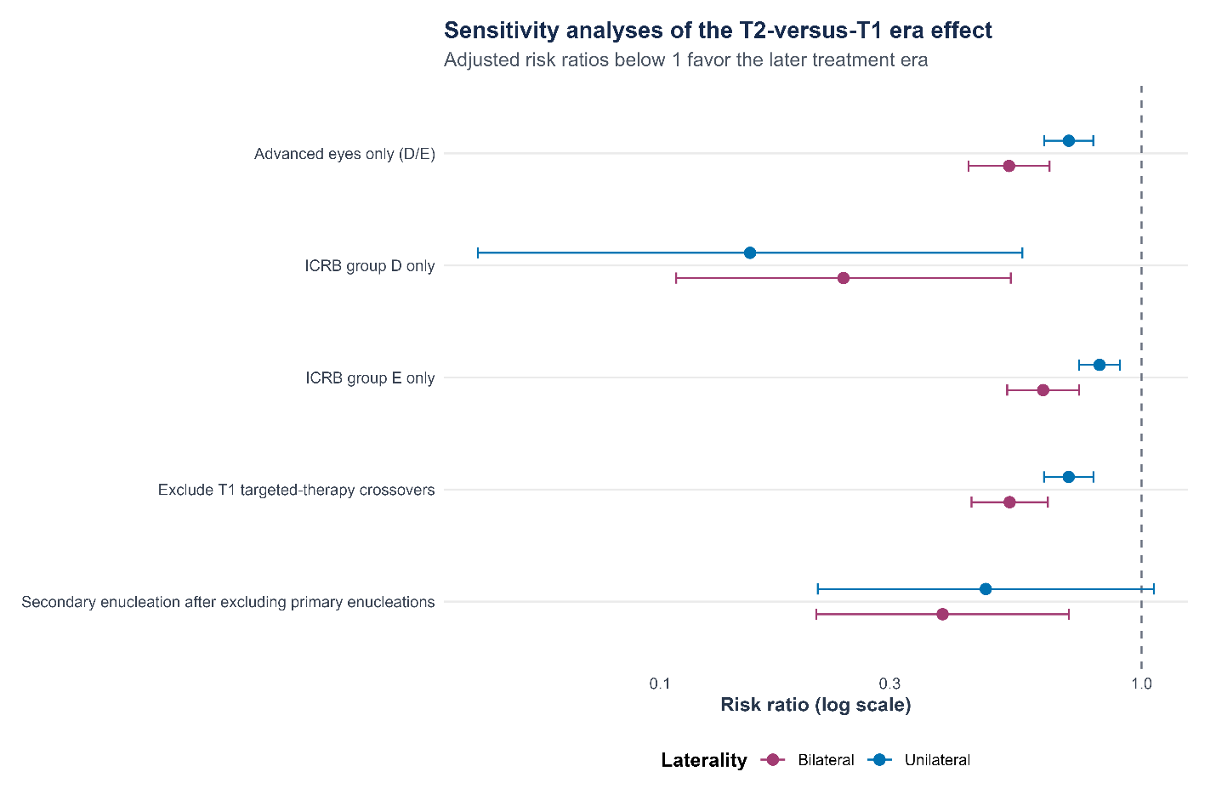
Figure S1. Sensitivity analyses of the T2-versus-T1 enucleation risk ratio. Points and 95% CIs are patient-clustered modified-Poisson GEE estimates; values below 1 favor T2.

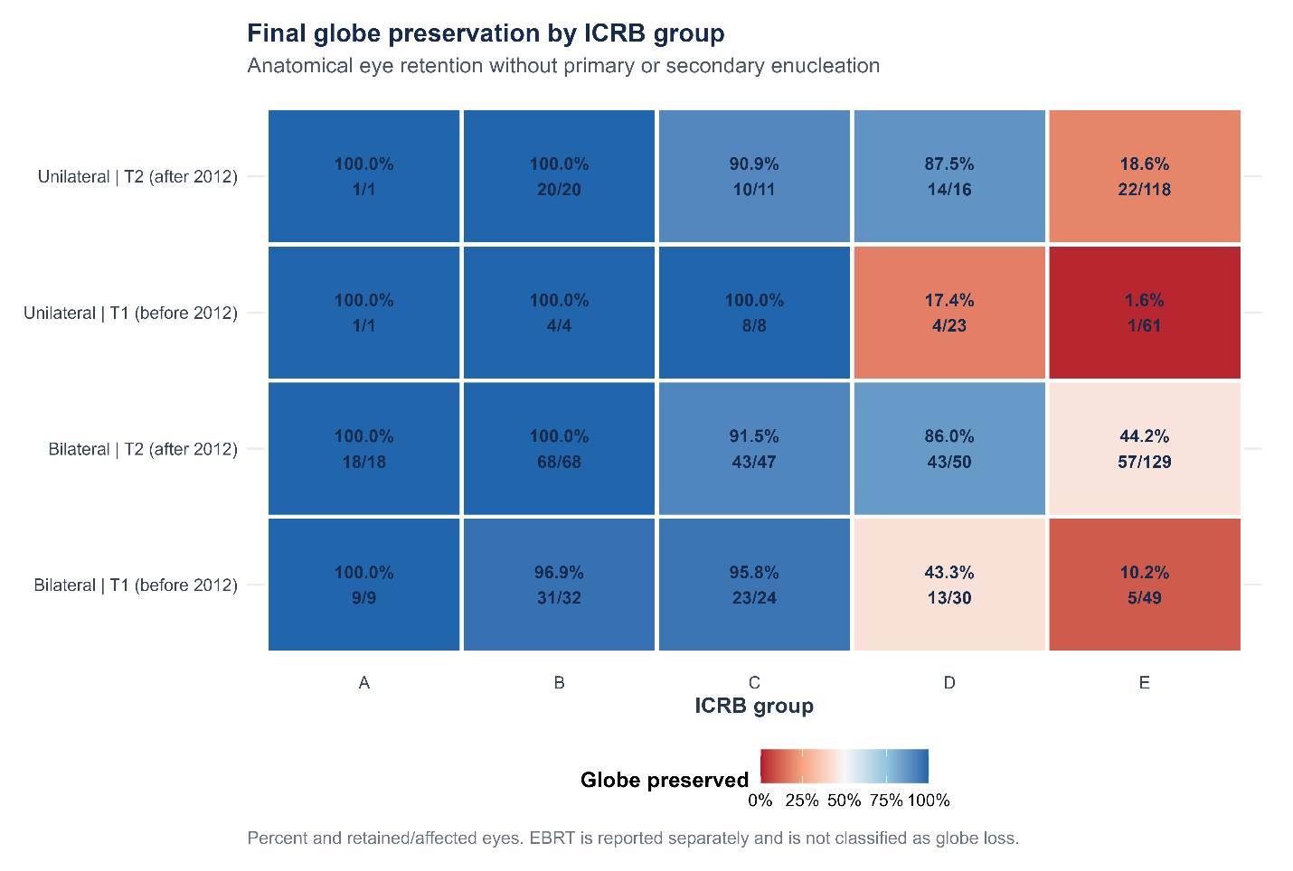
Figure S2. Final anatomical globe preservation by ICRB group, treatment era, and laterality. Final preservation means that the eye remained in situ without any recorded primary or secondary enucleation. External-beam radiotherapy is not classified as anatomical globe loss.

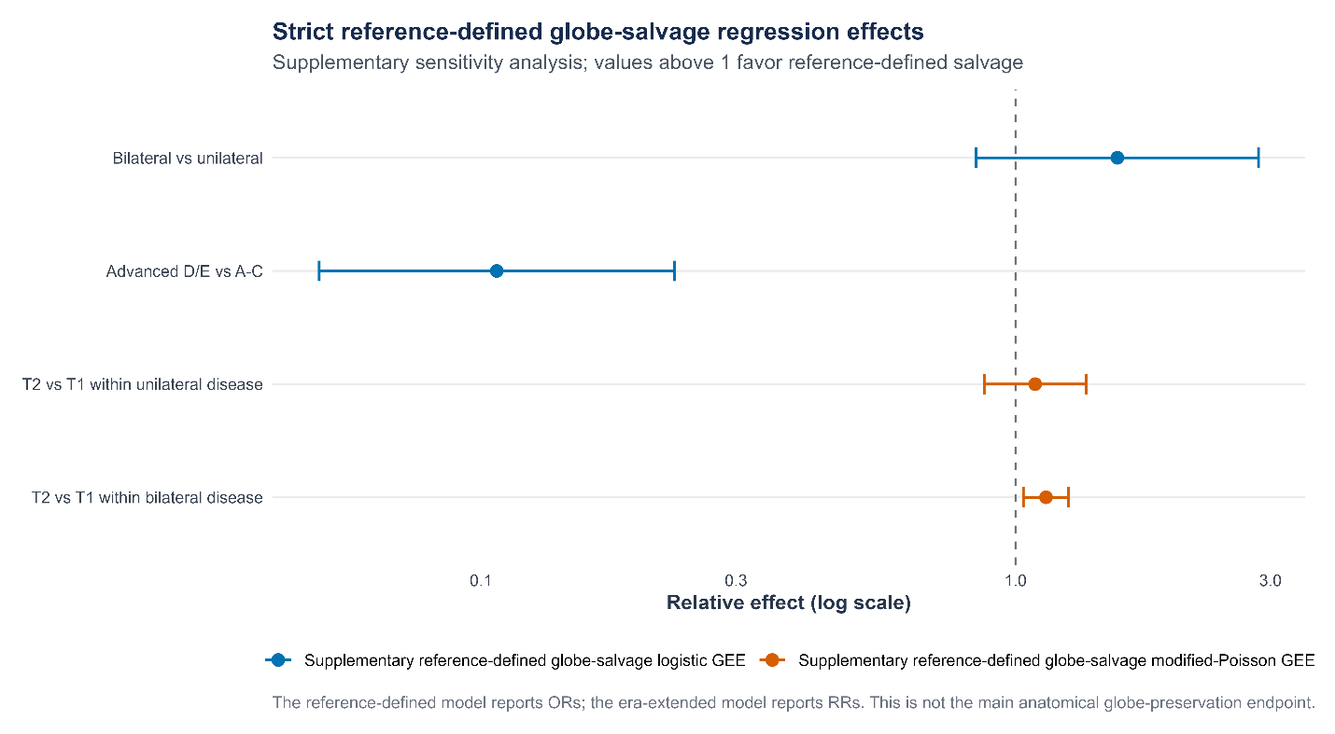
Figure S3. Strict literature-comparable globe-salvage models. Orange estimates are ORs from logistic GEE and blue estimates are RRs from modified-Poisson GEE. These estimates use the supplementary strict salvage definition rather than the main anatomical globe-preservation outcome.

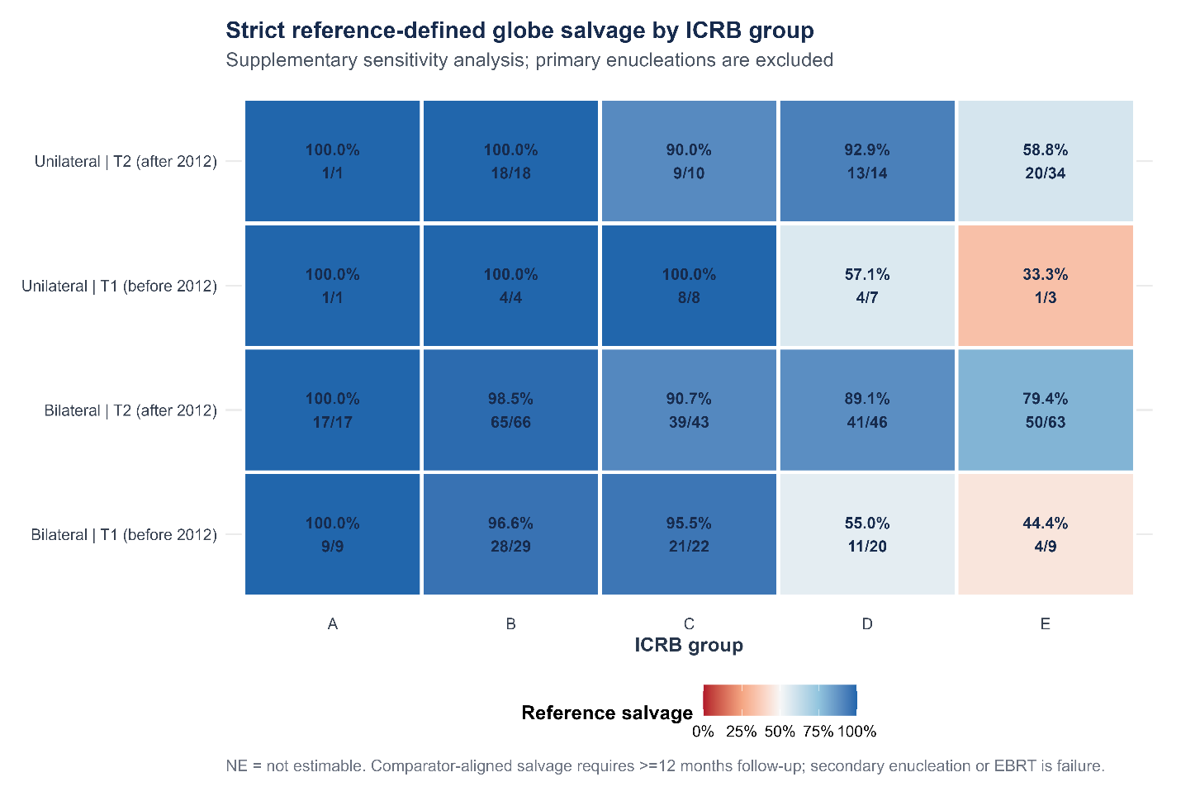
Figure S4. Strict literature-comparable globe salvage by ICRB group, treatment era, and laterality. Primary enucleations are excluded. A retained eye must have at least 12 months of recorded follow-up, and secondary enucleation or external-beam radiotherapy is classified as failure.

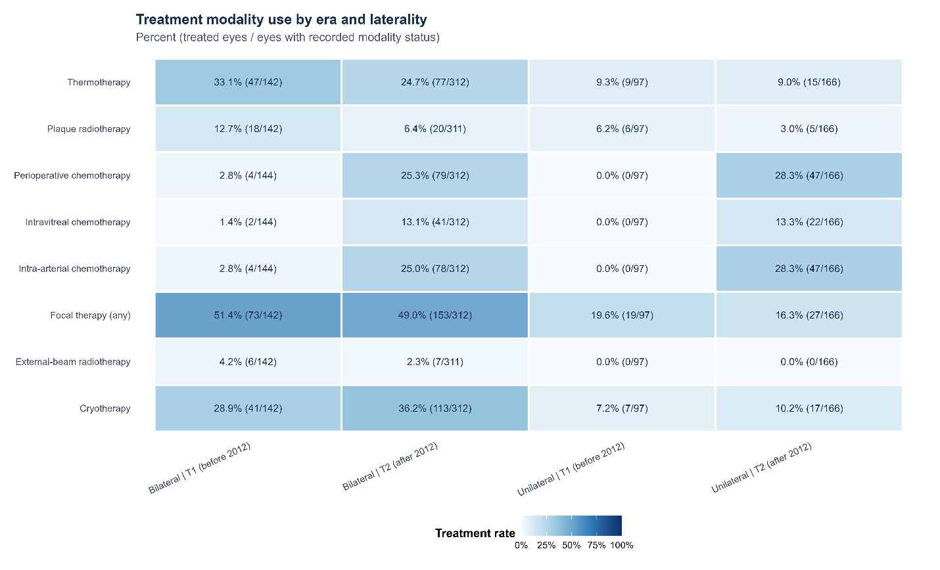
Figure S5. Validated treatment-modality use by treatment era and laterality. The heatmap summarizes source-validated treatment variables. IVChem denotes intravitreal chemotherapy. A systemic-chemotherapy row is not shown because a comparable variable was not available in both master datasets.

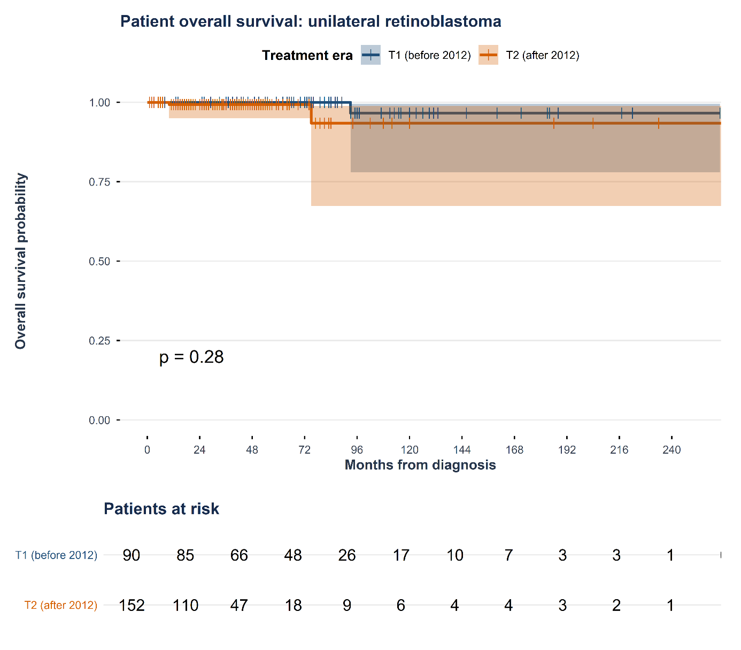
Figure S6A. Patient overall survival in unilateral retinoblastoma by treatment era. Shaded bands are 95% CIs; tick marks indicate censoring.

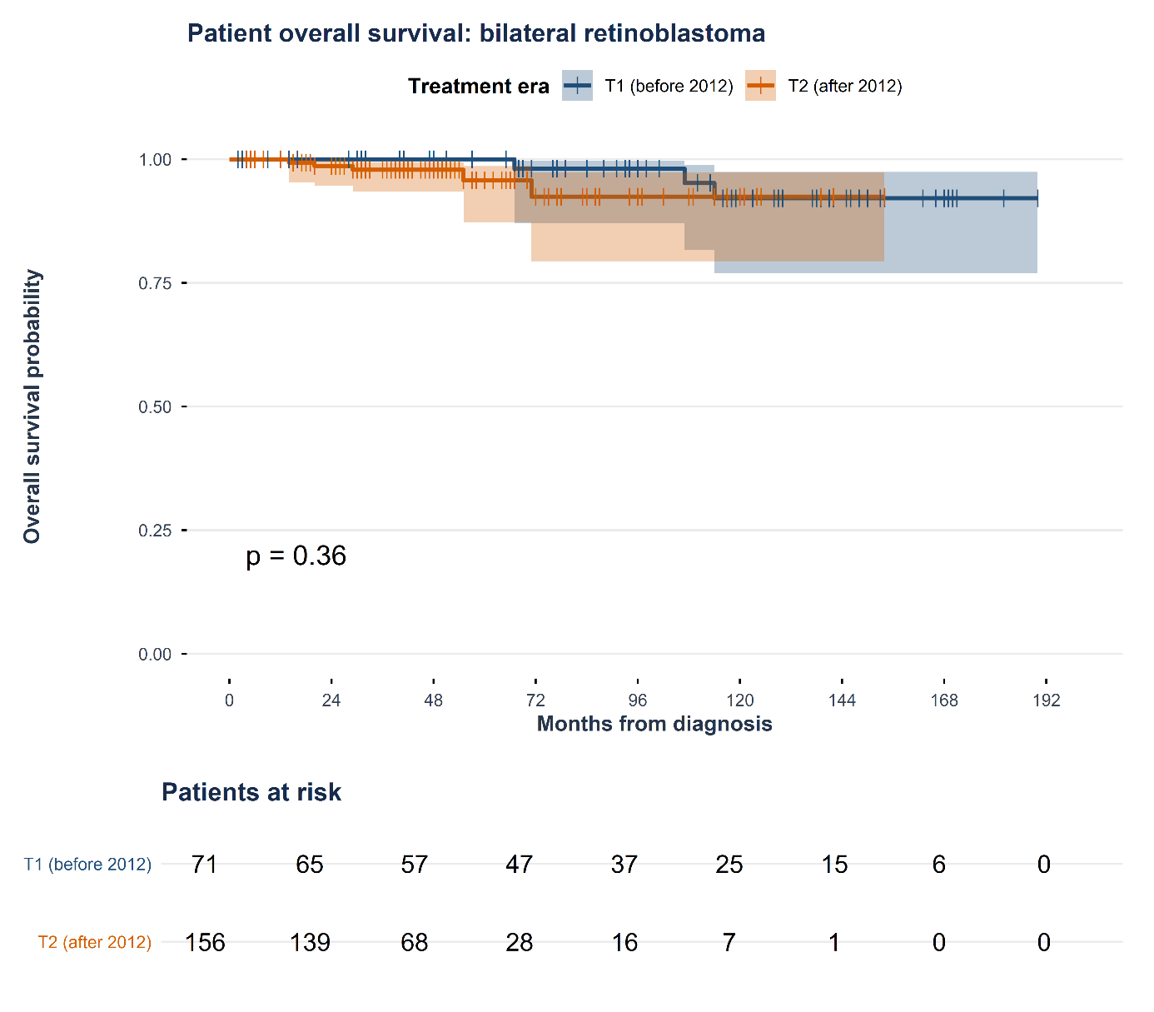
Figure S6B. Patient overall survival in bilateral retinoblastoma by treatment era. Sparse deaths and small late risk sets limit precision.

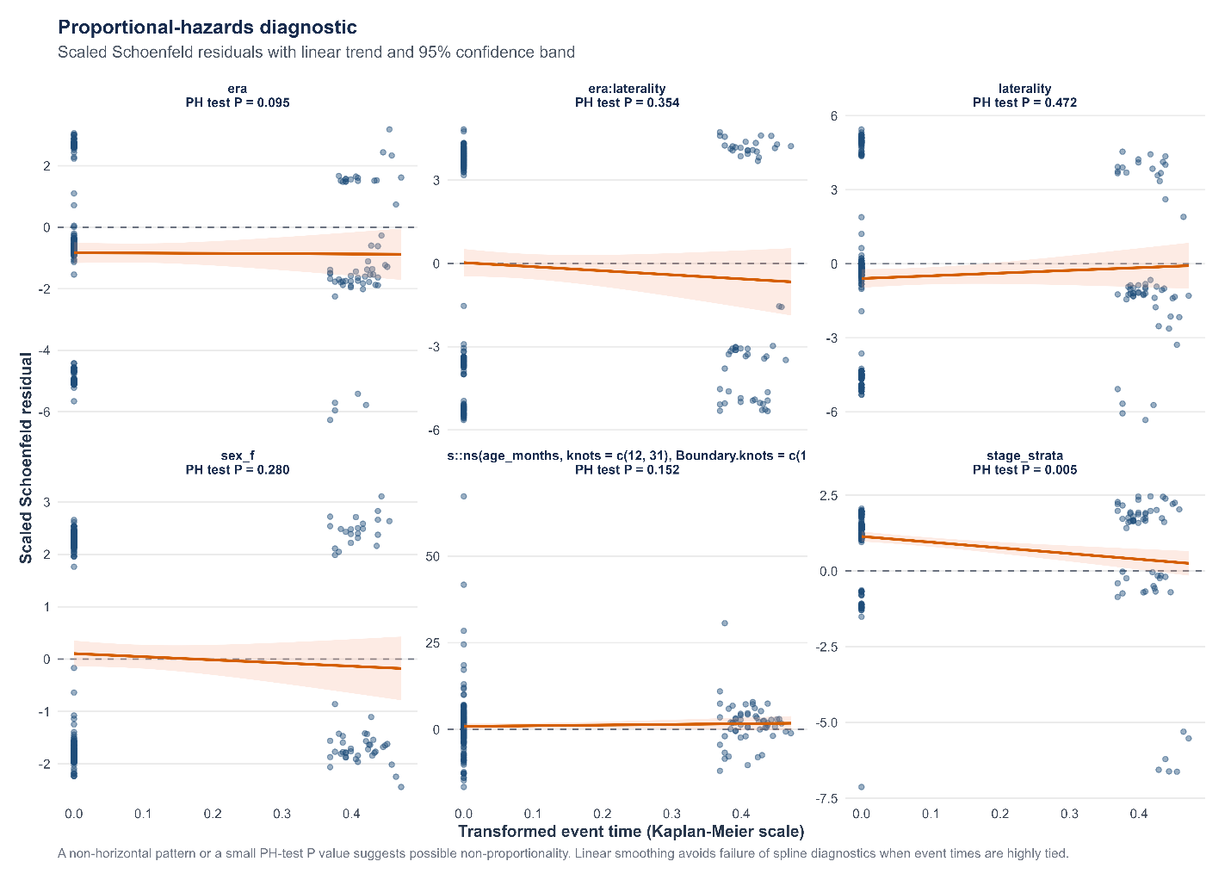
Figure S7. Scaled Schoenfeld-residual diagnostics for the adjusted globe-loss Cox model. The grouped ICRB severity term shows evidence of nonproportionality; the global test P value is 0.072.

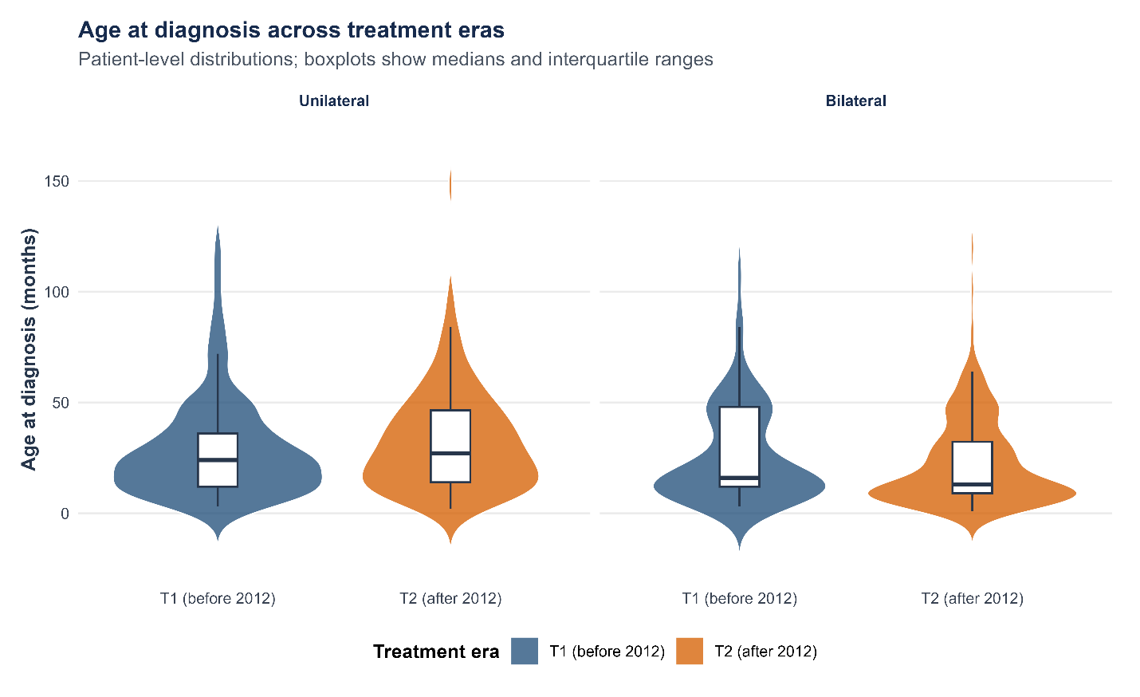
Figure S8. Patient-level age-at-diagnosis distributions by era and laterality. Violin density and embedded boxplots show medians and IQRs.

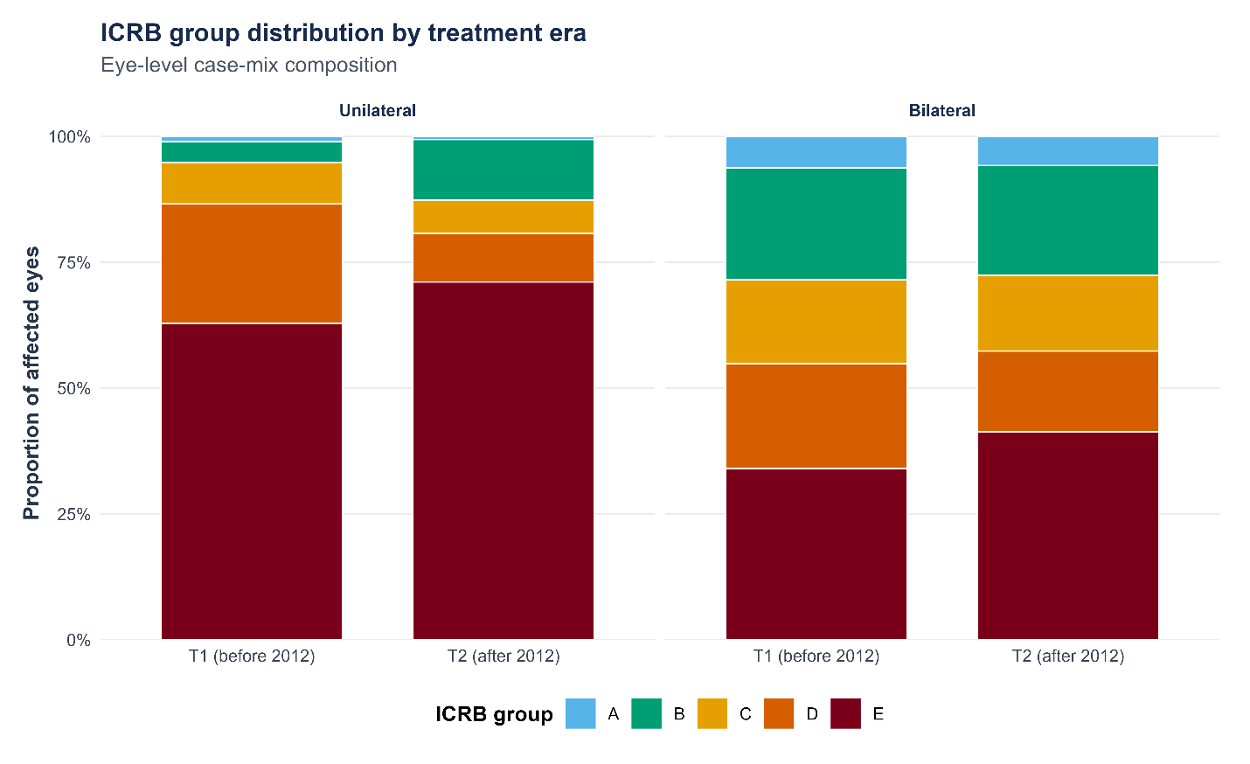
Figure S9. Eye-level ICRB group distribution by era and laterality. Bars show the case-mix composition of affected eyes within each era-by-laterality stratum.

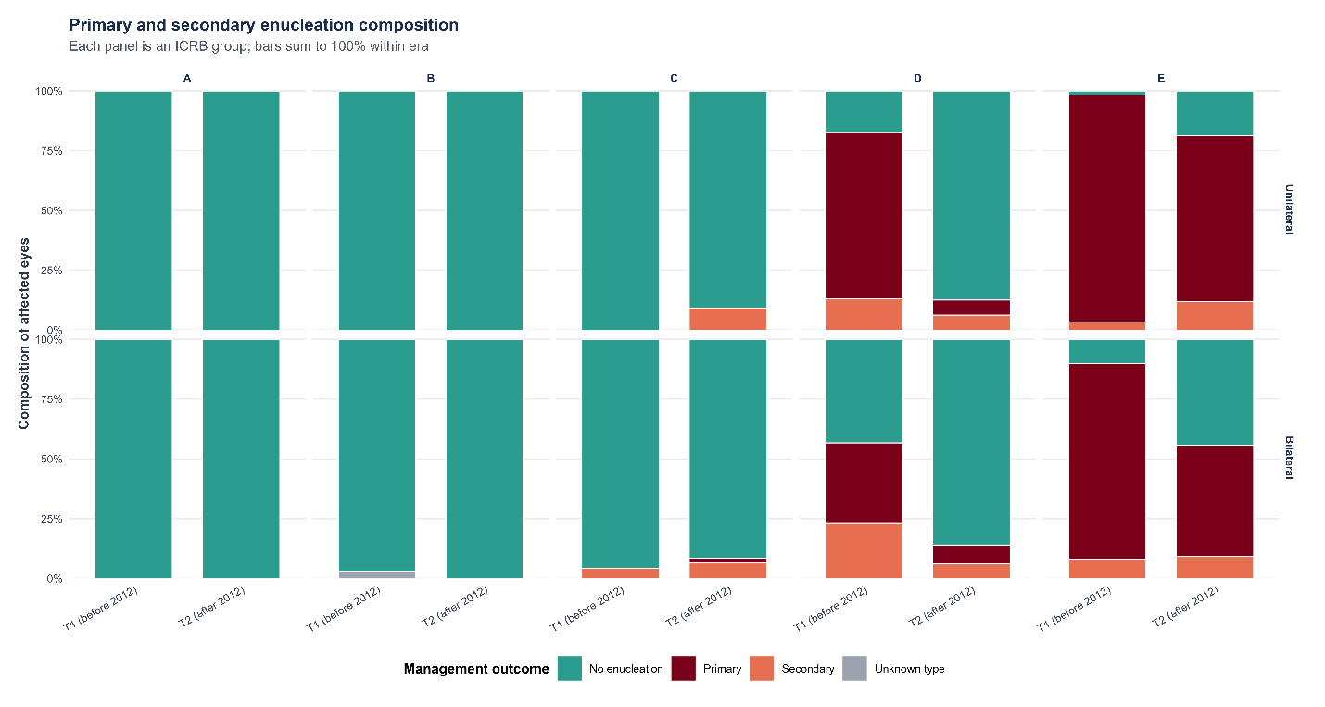
Figure S10. Primary and secondary enucleation composition by ICRB group, era, and laterality. Bars sum to 100% within each stratum; the single unknown-type enucleation is retained explicitly.

