Supplementary Figure 1. Patient Selection. Out of the 1104 unique patients identified in the original I-SPY2 and ACRIN trials, patients were excluded for absence of a usable cropped DCE series at both timepoints (n = 312), an empty tumor segmentation (n = 36), image-processing failure (n = 2) or incomplete clinical data (n=1). The final analyzed cohort comprised 753 patients.

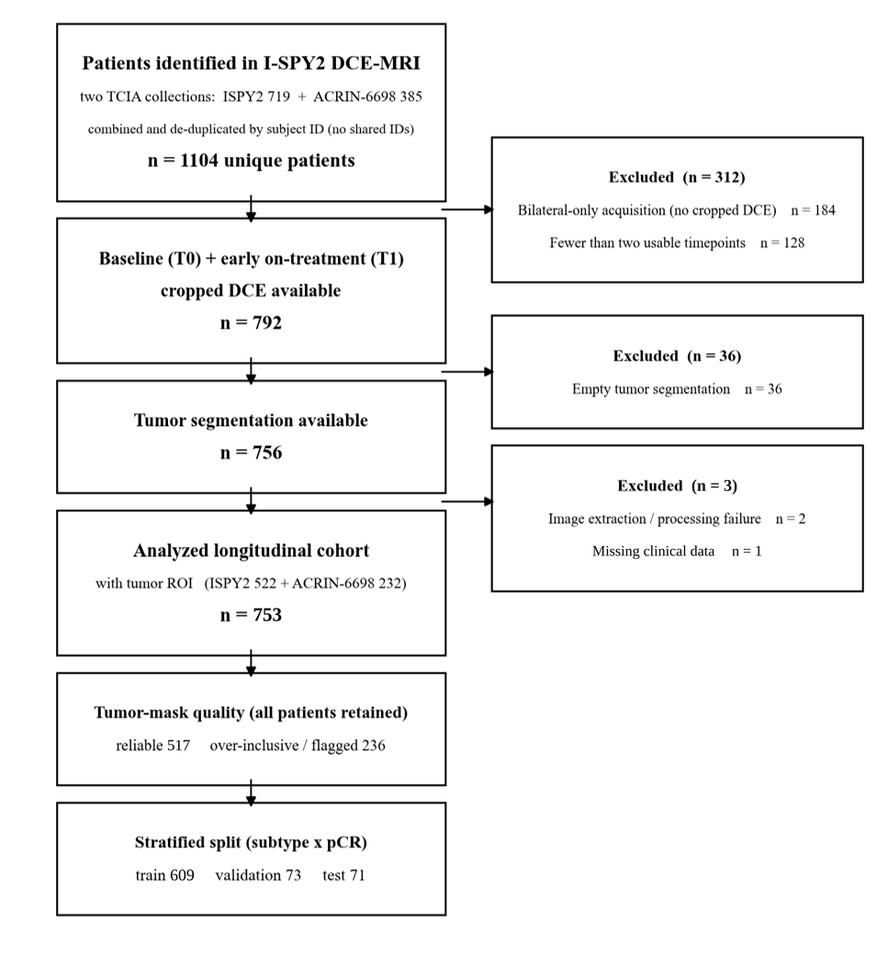

Supplementary Figure 2. Interpretable, concept-grounded reports. Two representative examples of the model’s correct, confident cases (a predicted responder and non-responder) are presented below, alongside the model’s analysis on variables that favor pCR versus weigh against pCR.

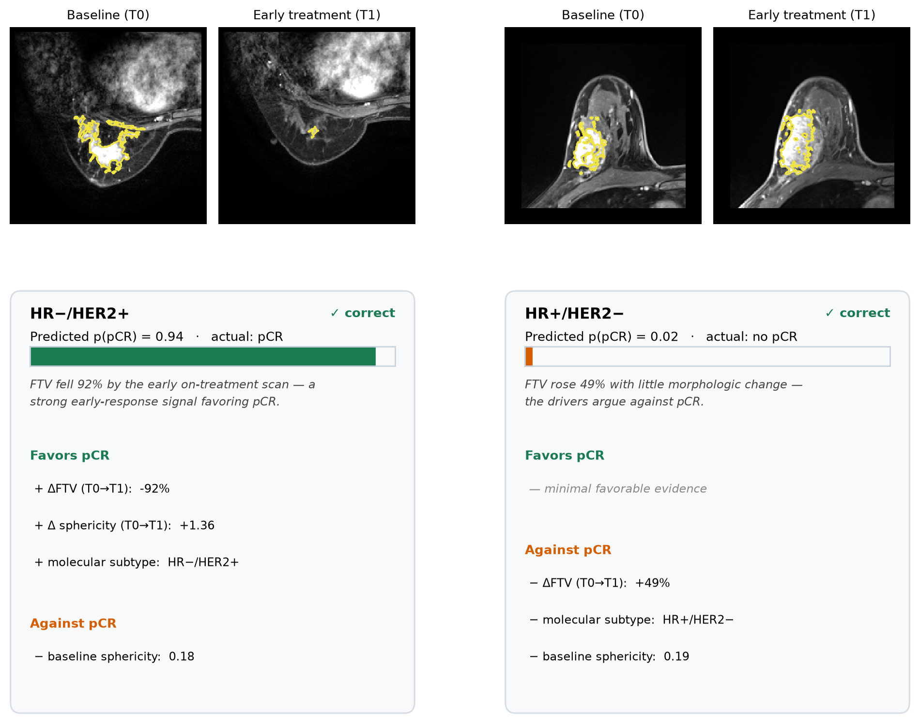

Supplementary Figure 3. Model performance stratified by molecular subtype versus treatment group. The OOF performance of model (pCR AUROC with 95% bootstrap CIs) was measured after patients were stratified by (a) molecular subtype and (b) treatment group. Due to the small size of the patient strata, estimates were treated as exploratory only.

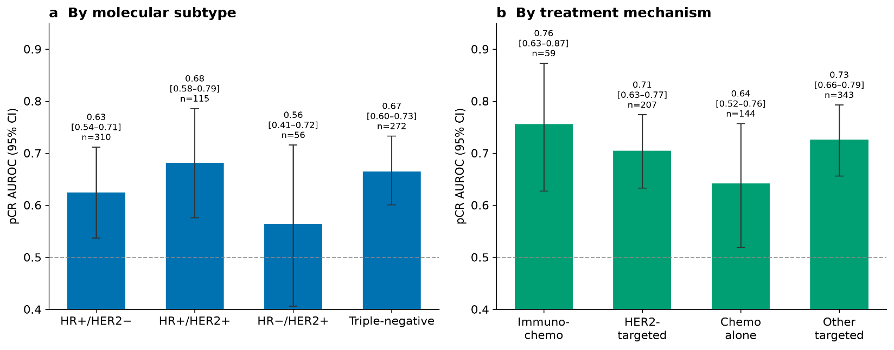

Supplementary Table 1. I-SPY2 longitudinal cohort (T0 + T1 complete, n = 754) by treatment-arm-diverse stratified split. Cells are n (column %); the last column is the pCR rate within each stratum. Of the 754 patients with paired baseline (T0) and early on-treatment (T1) DCE-MRI, 753 had a complete concept-and-outcome record and constituted the analytic cohort for all discrimination and calibration estimates; the single patient lacking a pathologic complete response label was retained for imaging and concept description but excluded from outcome analyses.

Characteristic | Overall (754) | Train (610) | Val (73) | Test (71) | pCR rate
Treatment arm
Chemotherapy alone | 144 (19%) | 119 (20%) | 13 (18%) | 12 (17%) | 18%
Paclitaxel * | 144 (19%) | 119 (20%) | 13 (18%) | 12 (17%) | 18%
Other targeted | 343 (45%) | 277 (45%) | 35 (48%) | 31 (44%) | 27%
Paclitaxel + AMG 386 * | 88 (12%) | 74 (12%) | 5 (7%) | 9 (13%) | 27%
Paclitaxel + Ganitumab * | 80 (11%) | 64 (10%) | 11 (15%) | 5 (7%) | 19%
Paclitaxel + Ganetespib * | 78 (10%) | 62 (10%) | 8 (11%) | 8 (11%) | 27%
Paclitaxel + ABT 888 + Carboplatin * | 54 (7%) | 40 (7%) | 7 (10%) | 7 (10%) | 31%
Paclitaxel + MK-2206 * | 43 (6%) | 37 (6%) | 4 (5%) | 2 (3%) | 33%
HER2-targeted | 207 (27%) | 166 (27%) | 19 (26%) | 22 (31%) | 40%
Paclitaxel + Neratinib * | 77 (10%) | 62 (10%) | 6 (8%) | 9 (13%) | 23%
T-DM1 + Pertuzumab * | 41 (5%) | 31 (5%) | 6 (8%) | 4 (6%) | 59%
Paclitaxel + Pertuzumab + Trastuzumab * | 31 (4%) | 24 (4%) | 4 (5%) | 3 (4%) | 65%
Paclitaxel + Trastuzumab | 22 (3%) | 18 (3%) | 0 (0%) | 4 (6%) | 23%
Paclitaxel + MK-2206 + Trastuzumab | 21 (3%) | 18 (3%) | 1 (1%) | 2 (3%) | 48%
Paclitaxel + AMG 386 + Trastuzumab | 15 (2%) | 13 (2%) | 2 (3%) | 0 (0%) | 33%
Immunotherapy | 59 (8%) | 47 (8%) | 6 (8%) | 6 (8%) | 49%
Paclitaxel + Pembrolizumab * | 59 (8%) | 47 (8%) | 6 (8%) | 6 (8%) | 49%
Race
White | 589 (78%) | 472 (77%) | 59 (81%) | 58 (82%) | 30%
Black or African American | 97 (13%) | 83 (14%) | 6 (8%) | 8 (11%) | 28%
Asian | 51 (7%) | 39 (6%) | 7 (10%) | 5 (7%) | 31%
Other / multiracial | 14 (2%) | 13 (2%) | 1 (1%) | 0 (0%) | 43%
Unknown | 3 (0%) | 3 (0%) | 0 (0%) | 0 (0%) | —
Menopausal status
Premenopausal | 358 (47%) | 291 (48%) | 38 (52%) | 29 (41%) | 29%
Postmenopausal | 232 (31%) | 189 (31%) | 21 (29%) | 22 (31%) | 32%
Perimenopausal | 26 (3%) | 22 (4%) | 2 (3%) | 2 (3%) | 38%
Indeterminate / not applicable | 106 (14%) | 83 (14%) | 8 (11%) | 15 (21%) | 31%
Unknown | 32 (4%) | 25 (4%) | 4 (5%) | 3 (4%) | 26%
Ethnicity
Not Hispanic or Latino | 660 (88%) | 534 (88%) | 61 (84%) | 65 (92%) | 28%
Hispanic or Latino | 93 (12%) | 75 (12%) | 12 (16%) | 6 (8%) | 43%
Unknown | 1 (0%) | 1 (0%) | 0 (0%) | 0 (0%) | —
MammaPrint (70-gene, descriptive only)
High risk | 362 (48%) | 284 (47%) | 41 (56%) | 37 (52%) | 42%
Low risk | 391 (52%) | 325 (53%) | 32 (44%) | 34 (48%) | 20%
Unknown | 1 (0%) | 1 (0%) | 0 (0%) | 0 (0%) | —
Age (IQR)
Median | 49 (42-56) | 49 (42-56) | 47 (40-56) | 50 (41-58) | —

The split is stratified on regimen × subtype so the held-out test set is treatment-arm-diverse (immunochemotherapy 5/42 vs 1/42 in the inherited baseline split). Treatment arm confounds with molecular subtype by trial design (the immunochemotherapy arm is entirely HER2-negative).

Supplementary Table 2. I-SPY1 / ACRIN-6657 external validation cohort characteristics.
Characteristics of the independent external validation cohort. The model was applied unchanged after I-SPY2 development. Analytic subsets differ by the variables each analysis required. For comparison, the I-SPY2 development cohort had a 30.3% pCR rate (228/753) with 41% HR+/HER2−, 15% HR+/HER2+, 7% HR−/HER2+, and 36% triple-negative disease. T0, baseline; T1, early treatment; pCR, pathologic complete response; QC, quality control.

Characteristic | I-SPY1 / ACRIN-6657 (external)
Subjects, paired T0 + T1, QC-passed | 115
Molecular subtype — no. (%)
HR+/HER2− | 47 (41%)
HR+/HER2+ | 15 (13%)
HR−/HER2+ | 20 (17%)
Triple-negative | 29 (25%)
Unknown | 4 (3%)
Age group — no. (%)
< 45 y | 50 (43%)
45–60 y | 53 (46%)
> 60 y | 11 (10%)
Unknown | 1 (1%)
Pathologic complete response (of 110 with outcome)
pCR — no. (%) | 36 (32.7%)
HR+/HER2− | 7/44 (16%)
HR+/HER2+ | 6/15 (40%)
HR−/HER2+ | 10/20 (50%)
Triple-negative | 11/28 (39%)
Treatment
Regimen | single standard anthracycline–taxane (no randomized arm)
Analytic subsets
Concept fidelity | 115
7B language-readout evaluation | 110
Concept-and-clinical / subtype-stratified | 107

Supplementary Table 3. Operational definitions of the eleven imaging concepts.
For each concept, the table lists the operational definition, the variable type, the feature or rule used to compute the reference value, and, for categorical concepts, the cut point. Categorical thresholds were calibrated on the I-SPY2 training set (derivation n = 982) and held fixed for all subsequent evaluation, including the external cohort. FTV, functional tumor volume; IBSI, Image Biomarker Standardization Initiative; NME, non-mass enhancement; BPE, background parenchymal enhancement; SI, signal intensity; T0, baseline; T1, early treatment.

Concept | Operational definition | Variable type | Feature / rule for reference value | Cut point (categorical only)
Baseline (T0) tumor morphology concepts
Functional tumor volume (FTV) | Volume of enhancing tumor at baseline | Continuous (cm³) | I-SPY functional tumor volume (voxels meeting the trial's early percent-enhancement and signal-enhancement-ratio thresholds) from the vendor feature sheet where available; otherwise the IBSI enhancing-tumor volume from the feature engine | —
Sphericity | Degree to which the tumor approximates a sphere | Continuous (0–1) | IBSI-compliant sphericity of the 3-D lesion (surface area of an equal-volume sphere ÷ lesion surface area); vendor sheet value where available | —
Shape | BI-RADS mass shape (round/oval vs irregular) | Categorical (2-level) | Thresholded IBSI sphericity | sphericity ≥ 0.285 → round/oval; < 0.285 → irregular
Margin | BI-RADS mass margin | Categorical (3-level) | Spiculation index (boundary surface-roughness) from the shape engine | spiculation ≤ 0.349 → circumscribed; ≥ 0.444 → spiculated; between → irregular
Mass vs non-mass enhancement (NME) | Enhancement morphology per BI-RADS | Categorical (2-level) | Lesion solidity combined with the count of significant enhancing components | NME if solidity ≤ 0.237 or ≥ 3 significant foci; otherwise mass
Multifocality | More than one enhancing focus | Categorical (2-level) | Connected-component count of the tumor mask, counting only components ≥ 10% of the largest (noise filter) | ≥ 2 significant components → multifocal; else unifocal
Background parenchymal enhancement (BPE) | Enhancement of non-tumoral fibroglandular tissue | Categorical (2-level) | Median early percent enhancement, (SI_early − SI_pre)/SI_pre × 100, of fibroglandular tissue outside the tumor, derived mask-free from a pre-contrast parenchyma proxy (tumor excluded); vendor sheet BPE where available | > top cohort tertile (66.7th pct) → marked; else low (minimal/mild/moderate)
Early on-treatment (T1) kinetics concept
T1 wash-in (initial) enhancement rate | Early contrast uptake at the early-treatment timepoint | Categorical (3-level) | Mean early percent enhancement, (SI_early − SI_pre)/SI_pre × 100, within the tumor ROI at T1 | ≤ 115.2 → slow; ≥ 138.7 → fast; between → medium
Delta-radiomic concepts (T0 → T1)
Change in FTV (ΔFTV) | Early volumetric response | Continuous (relative %) | Relative change in FTV, (FTV_T1 − FTV_T0)/FTV_T0 | —
Change in sphericity (Δsphericity) | Change in tumor roundness | Continuous (relative %) | Relative (scale-free) change in sphericity, (Sphericity_T1 − Sphericity_T0)/Sphericity_T0 — the percent change, not the absolute difference | —
Shrinkage pattern | Spatial pattern of tumor regression | Categorical (4-level) | Diameter-based residual-component rule (Fukada 2016; RadioGraphics 2021): near-complete response → concentric; < 5% longest-diameter reduction → no change; otherwise by count of ≥ 5 mm residual components (1 → concentric, 2 → concentric core + satellite, ≥ 3 → diffuse/multicentric) | concentric / both / diffuse / no change

