Supplementary material

Table S1. Public datasets and multi-omics resources used in this study. This table summarizes all public datasets included in the present study, including bulk transcriptomic cohorts, single-cell RNA-seq datasets, spatial transcriptomic data, somatic alteration data and proteomic resources. For each dataset, the data type, sequencing or microarray platform, sample size, tumor and non-tumor sample numbers, survival information, analytical purpose and species are provided.
Dataset | Data type | Platform | Sample size | Tumor samples | Normal/non-tumor samples | Survival data | Main use | Species
TCGA-PAAD | bulk RNA-seq/mutation/CNV | RNA-seq | 183 | 183 | 0 | Yes | genomic analysis/Meta/scissor analysis | Human
ICGC | bulk transcriptomics | RNA-seq | 142 | 142 | 0 | Yes | scissor analysis | Human
GSE15471 | bulk transcriptomics | microarray | 78 | 42 | 36 | No | external validation/Meta/DEG | Human
GSE28735 | bulk transcriptomics | microarray | 90 | 45 | 45 | Yes | external validation/Meta/DEG | Human
GSE62452 | bulk transcriptomics | microarray | 130 | 69 | 61 | Yes | external validation/Meta/DEG | Human
GSE71729 | bulk transcriptomics | microarray | 233 | 145 | 88 | No | Meta | Human
GSE91035 | bulk transcriptomics | microarray | 50 | 27 | 23 | No | Meta | Human
GSE196009 | bulk transcriptomics | microarray | 19 | 13 | 6 | No | Meta | Human
GSE171485 | bulk transcriptomics | Illumina | 12 | 6 | 6 | No | Meta | Human
GSE183795 | bulk transcriptomics | microarray | 244 | 139 | 105 | Yes | training /Meta/DEG | Human
GSE190903 | bulk transcriptomics | Illumina | 6 | 6 | 0 | No | GSVA | Mouse
GSE291033 | bulk transcriptomics | Illumina | 12 | 6 | 6 | No | GSVA | Human
GSE155698 | single-cell RNA-seq | 10X | 55854 cells/19 | 16 | 3 | No/limited | cell annotation/myeloid analysis | Human
GSE197177 | single-cell RNA-seq | 10X | 39572 cells/5 | 4 | 1 | No/limited | cell annotation/myeloid analysis | Human
GSE212966 | single-cell RNA-seq | 10X | 69105 cells/12 | 6 | 6 | No/limited | cell annotation/myeloid analysis | Human
GSE242230 | single-cell RNA-seq | 10X | 47261 cells/25 | 25 | 0 | No/limited | cell annotation/myeloid analysis | Human
GSE263733 | single-cell RNA-seq | 10X | 52797 cells/28 | 23 | 5 | No/limited | cell annotation/myeloid analysis | Human
GSE141017 | single-cell RNA-seq | 10X | 41139 cells/10 | 9 | 1 | No/limited | cell annotation/myeloid analysis | Mouse
GSE272362 | spatial transcriptomics | 10X | 45278 spots/13 | 10 | 3 | No/limited | spatial validation | Human

Fig. S1. Single-cell transcriptomic analysis in human and mouse PDAC datasets. A. Human single-cell UMAP plot. B. Cell proportions by sample. C. Mouse t-SNE plot by time point. D. Dot plot of marker genes used for mouse single-cell annotation. E. Sankey diagram showing cell-type composition. F. Ro/e analysis across mouse disease time points.

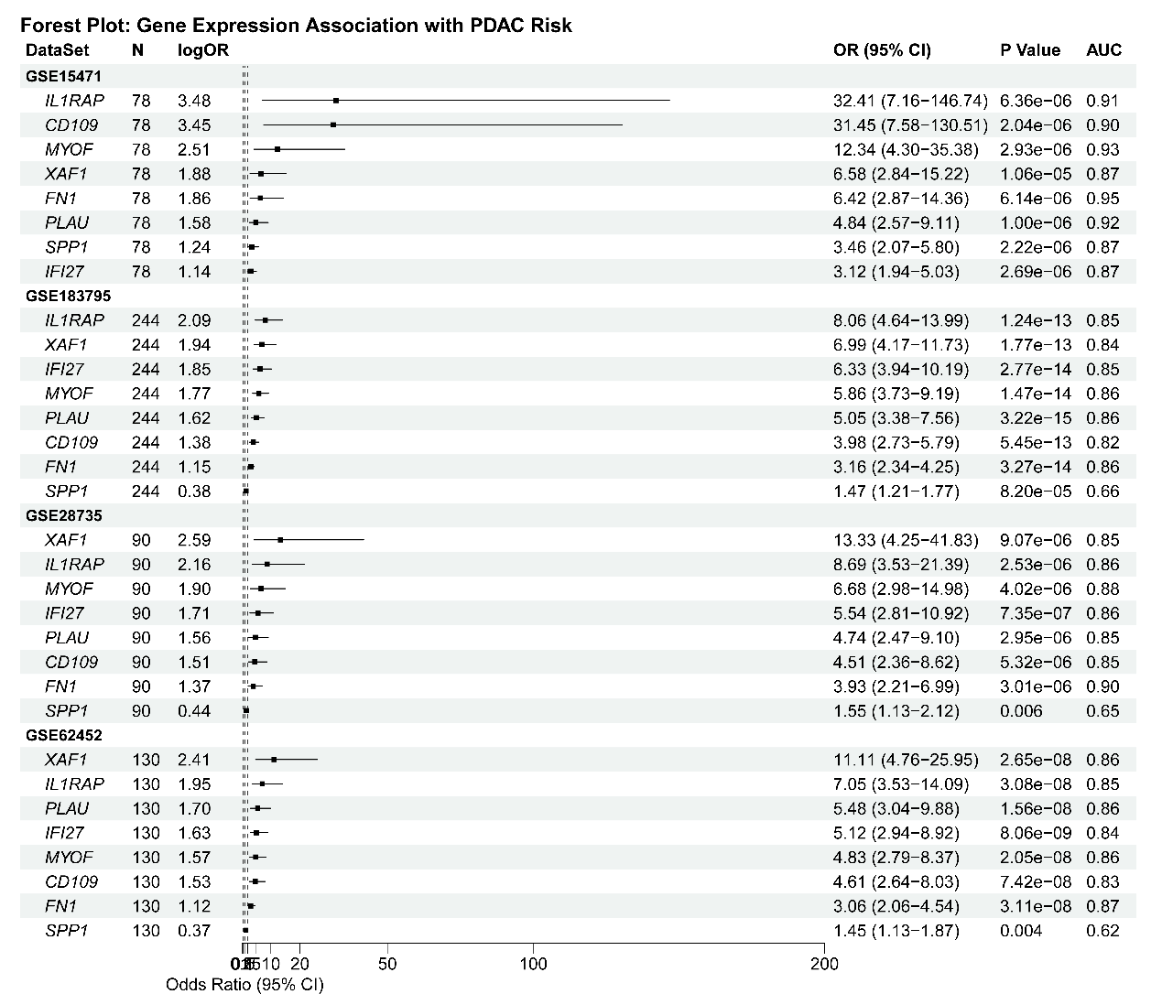
Fig. S2. Single-gene meta-analysis of SMDS component genes across PDAC datasets.
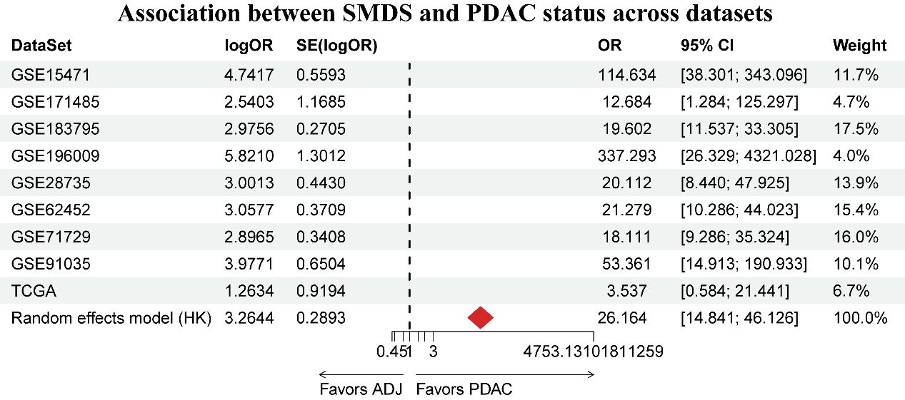
Fig. S3. Meta-analysis of SMDS gene-set activity across PDAC datasets.
Fig. S4. Comparison of SMDS gene protein expression. A. Protein expression levels of SMDS genes. B. GO and KEGG enrichment analysis of differentially expressed proteins.
Fig. S5. Spatial transcriptomic distribution of SMDS genes and correlations with estimated spot composition. A. SMDS score density across sections. B. Distribution of malignant, mixed and normal regions. C. Comparison of SMDS scores across regions. D. Correlation between cell-proportion heatmaps and SMDS scores. E. Spatial density of SMDS gene expression. F. Comparison of SMDS gene expression across regions. G. Comparison of SMDS gene expression between malignant and non-malignant regions. H. Correlation between cell-proportion heatmaps and SMDS gene expression.
Fig. S6. Nomograms and prediction curves for individual datasets. A. Nomograms for individual cohorts. B. Calibration or prediction curves for individual cohorts.
Fig. S7. Spatial transcriptomic distribution of SMDS component genes. NP, normal pancreatic section; T, PDAC section.

Fig. S8. Association between SMDS genes and prognosis. A. Forest plot of survival regression results across datasets. B. Kaplan-Meier curves for SMDS scores in individual datasets.

Fig. S9. Human Protein Atlas immunohistochemistry evidence for SMDS proteins. Representative normal pancreatic and pancreatic tumor tissue cores are shown for CD109, FN1, IFI27, IL1RAP, MYOF, PLAU, SPP1 and XAF1. Antibody identifiers are shown after each gene name. These public images were used as qualitative supportive protein-level evidence rather than cohort-level quantitative validation.

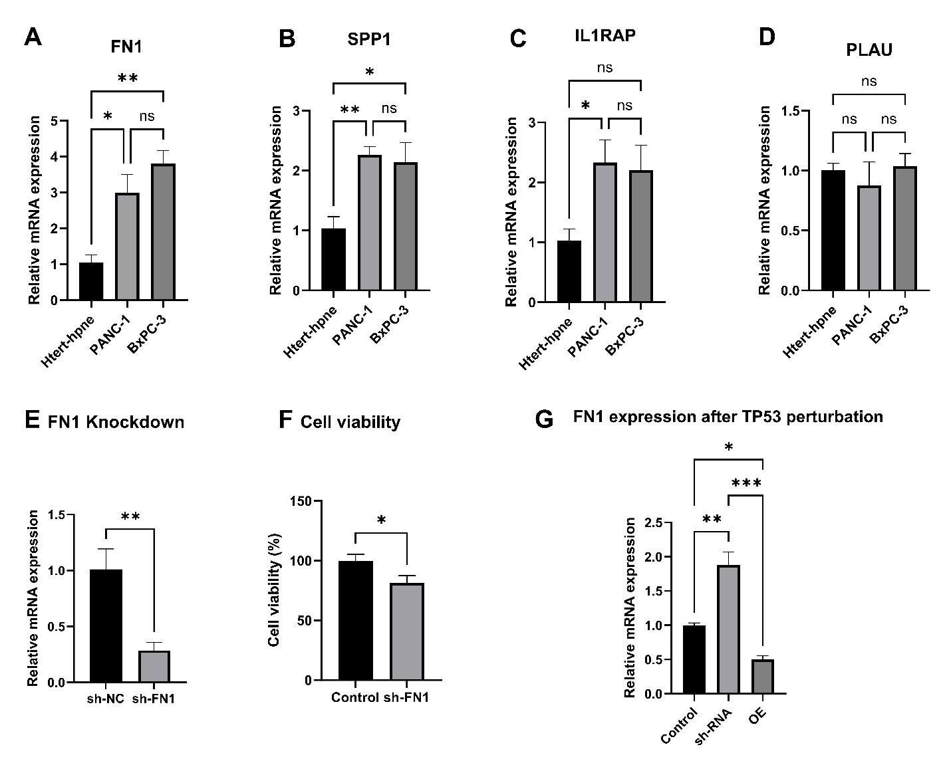
Fig. S10. Experimental validation of representative SMDS genes and the TP53-FN1 relationship in PDAC cells. (A-D) qRT-PCR analysis of FN1, SPP1, IL1RAP and PLAU expression in hTERT-HPNE, PANC-1 and BxPC-3 cells. (E) qRT-PCR validation of FN1 knockdown efficiency. (F) CCK-8 assay showing reduced cell viability after FN1 silencing. (G) FN1 mRNA expression after TP53-targeting shRNA-mediated knockdown or TP53 overexpression. Bars show mean +/- SD from three replicates; CCK-8 groups were plated in triplicate wells. Three-group comparisons (A-D and G) used one-way ANOVA followed by uncorrected Fisher's least significant difference test; two-group comparisons (E and F) used two-tailed unpaired Student's t-tests. *P<0.05, **P<0.01, ***P<0.001; ns, not significant.

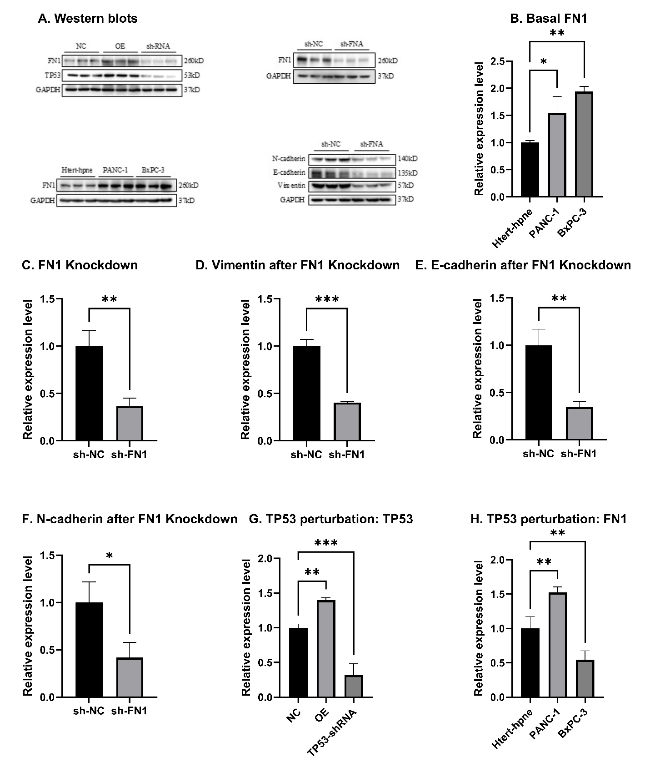
Fig. S11 Integrated Western blot validation and densitometric quantification of FN1- and TP53-related perturbations. (A) Representative blots showing FN1 and TP53 abundance after TP53 overexpression or TP53-targeting shRNA, FN1 abundance after FN1-targeting shRNA, basal FN1 abundance in hTERT-HPNE, PANC-1 and BxPC-3 cells, and N-cadherin, E-cadherin and vimentin abundance after FN1 silencing. (B-H) Densitometric quantification of the indicated proteins. Band intensities were measured in ImageJ, normalized to GAPDH and then normalized to the indicated control group, and values were organized in GraphPad Prism for planned comparisons. Bars show mean +/- SD from three replicate lanes. Indicated planned pairwise comparisons used two-tailed unpaired Student's t-tests. *P<0.05, **P<0.01, ***P<0.001.

Table S2. Model-selection rule and selected-model performance summary for the 113 candidate combinations.
Item | Specification
Scissor phenotype | Survival/prognosis annotation from TCGA-PAAD and ICGC bulk cohorts was used to identify Scissor-positive myeloid states; PDAC versus non-tumor disease status was used downstream for diagnostic tissue-classification modeling.
Candidate feature set | Twenty-one candidate features obtained by intersecting tumor-regulatory genes with survival-linked Scissor-positive myeloid-associated genes upregulated in PDAC tissue.
Candidate modeling framework | A total of 113 machine-learning combinations assembled from penalized regression, support-vector machine, random forest, XGBoost, gradient boosting and neural-network approaches.
Primary objective | Tissue discrimination between PDAC and non-tumor pancreas across the four core transcriptomic cohorts. This disease-status endpoint was distinct from the survival phenotype used for Scissor-based feature discovery.
Selection criterion | Consistently high validation AUC across GSE15471, GSE183795, GSE28735 and GSE62452, prioritizing cross-cohort stability, compact feature number and biological interpretability rather than maximum training-set AUC alone.
Selected model | Eight-gene SMDS comprising FN1, SPP1, XAF1, IL1RAP, PLAU, CD109, IFI27 and MYOF.
Selected-model performance | The selected model showed AUCs of 0.918-0.990 across the four core cohorts, as shown in Figure 5A.
Important note | This table documents the selection rule and selected-model summary. Because Scissor discovery used survival annotation and the final model was optimized for PDAC versus non-tumor tissue discrimination, prognostic analyses should be interpreted as secondary exploratory evidence.

