Supplementary Material

Statistical analysis
Because the process of modelling, choosing variables, and creating a final models can be customised to each researcher's preferences, we cover this in more detail in the following Statistical Analysis section. In reporting the methodological considerations and the obtained results, Logical Explanations & Visualizations of Estimates in Linear mixed models (LEVEL), recommendations for reporting multilevel data and analyses were followed (Monsalves et al., 2020).
A multilevel modelling (MLM) framework was adopted to appropriately account for the hierarchical and longitudinal structure of the data. Model development followed a stepwise procedure, beginning with null (intercept-only) models and progressing to increasingly complex specifications. Model selection was guided by likelihood ratio testing and the Akaike Information Criterion (AIC), ensuring an optimal balance between goodness-of-fit and model parsimony. Assumptions of normality, homoscedasticity, and model fit were assessed through a visual inspection of diagnostic plots.
As with standard regression approaches, each model parameter was accompanied by a standard error, from which 95% confidence intervals (CIs) were derived to quantify statistical uncertainty (Monsalves et al., 2020). A key advantage of the MLM framework in this context was its ability to simultaneously examine both mean-level changes and variance structures, enabling the investigation of disparities not only in average outcomes but also in within-group variability over time.
Given well-established sex differences in physical fitness levels and developmental trajectories, all analyses were conducted separately for boys and girls. Previous research has consistently shown that girls exhibit lower levels of most physical fitness components and follow different developmental patterns compared to boys (Ortega et al., 2023), justifying stratified modelling. Also notable in terms of data cleaning, since measurements were collected in non–research settings, i.e., schools, we wanted to address the biologically implausible values in anthropometric data (height, weight, BMI). We flagged biologically impossible changes, either weight loss/gain and shrinking/large height changes over time, based on the widely used approach developed using guidelines from the World Health Organisation. We flagged all weight values that were either −5.0≤ or ≥5.0 weight for age z-scores, height values that were either −5.0≤ or ≥3.0 height for age z-scores, and weight for height or BMI values that were either −4.0≤ or ≥5.0 weight for height or BMI z-scores. We used the AnthroPlus package (Schumacher et al., 2021) for this task.
To account for complex growth and developmental patterns during childhood and adolescence, centile values were used instead of raw scores for all physical fitness measures. The dependent variables included BMI, triceps skinfold thickness, 600-m run, 60 s sit-ups, bent arm hang and standing broad jump. Interpretation of outcomes differed by domain: for body composition and cardiorespiratory fitness higher values indicated poorer performance, whereas for muscular fitness, higher values reflected better performance.
Time was modelled as a categorical variable, comparing two measurement points (2010 and 2019). Additional categorical predictors included weight status, school-level intervention, and age group. Height percentile was included as a continuous covariate to adjust for biological maturation, which is known to vary systematically across weight status groups, with children living with obesity typically maturing earlier than their normal-weight peers (S. Chung, 2017).
The fixed-effects structure of the models included a three-way interaction between weight status, intervention group, and time, allowing for the examination of differential intervention effects across subgroups and over time. To further address the study’s focus on disparities, the final models incorporated heteroscedastic variance structures, allowing residual variances to differ across weight status groups, intervention conditions, and time points. This approach was central to testing the hypothesis that school-based interventions may differentially influence both average outcomes and variability, potentially widening or narrowing inequalities.
As stated in the final manuscript, given the large number of stratified models and outcomes, we only present the results of the final selected models (based on optimal fit criteria) with full details in the Supplementary Material 2.
To aid interpretation, model-based predicted values were extracted for each outcome across time and subgroup combinations. These predictions were used to visualise trends in both central tendency (mean trajectories) and dispersion (variance patterns). Additionally, subgroup-specific variance estimates were examined longitudinally to assess changes in within-group variability, providing further insight into the evolution of disparities over time.
All statistical analyses were performed with R version 4.4.3 [2025-02-28 ucrt] (R Core Team, 2025). A list of all packages that were used for statistical analyses, namely tidyverse (Wickham et al., 2019) for data manipulation, ggplot2 (Wickham, 2016) for visualization, nlme (Pinheiro et al., 2026) for multilevel modelling, easystats (Lüdecke et al., 2022) and broom.mixed (Bolker & Robinson, 2024) for obtaining model results, and gt (Iannone et al., 2026) for producing tables. We will upload and make the code we used in this paper openly available on GitHub (https://github.com/antonio-martinko) upon publication.

Intervention and control descriptions
Intervention name: Slovenian Healthy Schools Network
Information adapted from: https://nijz.si/programi/slovenska-mreza-zdravih-sol/
Intervention description:
The concept of health-promoting schools emerged in the 1980s through collaboration among the World Health Organization, the Council of Europe, and the European Commission. These institutions recognized that systematically planned health promotion programs could significantly influence students’ well-being, including satisfaction, self-image, health-related behaviours, and overall attitudes toward health and life. This led to the establishment of the European Network of Healthy Schools, which addresses health-related challenges among children and adolescents. The network emphasizes program development in areas such as nutrition, physical activity, and mental health, alongside evaluation of preventive interventions, student participation, teacher education, and cooperation with local and regional stakeholders.
Slovenia joined the network in 1993 with 12 schools and has since expanded to include 436 primary and secondary schools, student dormitories, and specialized institutions (339 primary schools [74.4% of all primary schools], 71 secondary schools [46% of all secondary schools], 9 boarding schools [25.7% of all boarding schools] and 17 institutions for children and adolescents with special needs). The Slovenian network operates under the coordination of the National Institute of Public Health and is part of the broader European Healthy Schools Network (SHE Network).
The Healthy Schools approach is based on a holistic understanding of health, encompassing physical, mental, social, and environmental dimensions for all members of the school community. Health promotion is integrated into all aspects of school life, including curricula, teacher education, school organization, extracurricular activities, and collaboration with families and the wider community. Importance is placed on fostering a positive school climate, as evidence indicates strong associations between students’ connectedness to school, academic achievement, and reduced engagement in risky behaviours.
Core components of school health promotion, as outlined in the Ottawa Charter for Health Promotion, include: (1) the development of school health policies that define goals, priorities, and actions in collaboration with all stakeholders; (2) the provision of a safe and supportive physical environment; (3) the cultivation of a positive social environment through strong interpersonal relationships and inclusive practices; (4) the development of students’ individual skills and competencies through participatory and experiential learning; and (5) collaboration with health services to support monitoring, counselling, and health education.
Healthy schools aim to systematically enhance well-being by promoting positive self-image, strengthening relationships within the school community, encouraging active student participation, improving the physical and social environment, and fostering connections between schools, families, and communities. They also emphasize the role of teachers as models of healthy behaviour and the importance of integrating nutrition, health education, and external health services into the educational process.
Implementation is characterized by systematic planning, continuous evaluation, and regular reporting of activities. Through coordinated efforts across multiple domains, healthy schools seek to influence both individual behaviours and broader social and environmental determinants of health, ultimately improving quality of life within the school setting.
Healthy Schools regularly report on their activities and publish a yearly annual report.
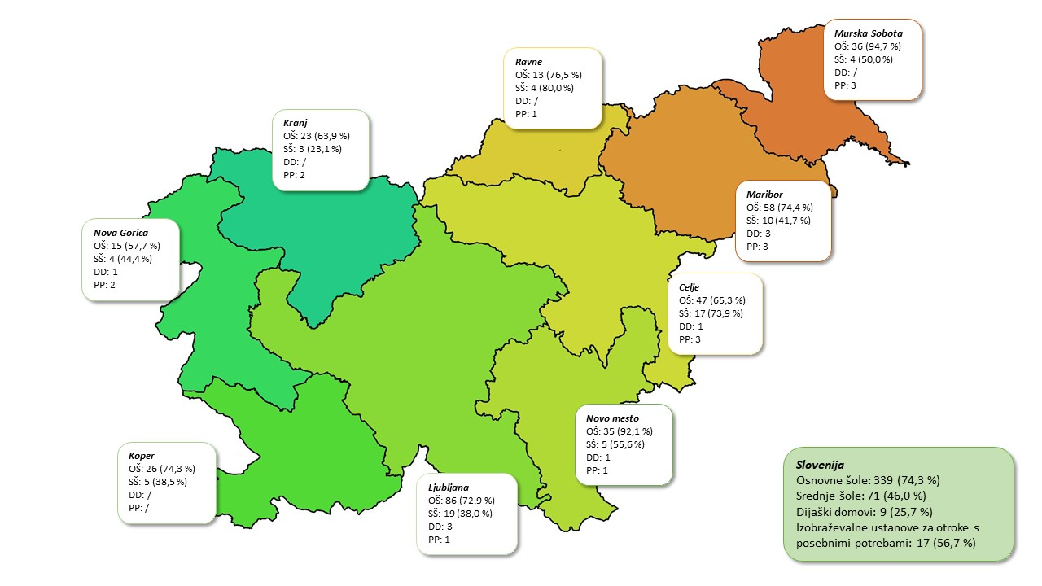
Figure S3.1 Layout of the Healthy Schools network with a list of healthy schools.
Intervention name: Healthy Lifestyle
Information adapted from: Jurić, P., Jurak, G., Morrison, S. A., Starc, G., & Sorić, M. (2023). Effectiveness of a population-scaled, school-based physical activity intervention for the prevention of childhood obesity. Obesity (Silver Spring, Md.), 31(3), 811–822. https://doi.org/10.1002/oby.23695
Intervention description:
The Healthy Lifestyle intervention was a nationwide school-based program implemented in Slovenia between 2011 and 2018. It was designed to increase physical activity among children aged 6 to 14 by providing two additional physical education (PE) lessons per week for grades 1–6 and three additional lessons for grades 7–9, effectively enabling daily PE participation. In lower grades, where PE is typically delivered by classroom teachers, the additional lessons were conducted by specialist PE teachers, thereby enhancing both the quantity and quality of instruction.
The intervention was funded by the European Social Fund, with the dual objective of promoting physical activity among schoolchildren and creating employment opportunities for recently graduated PE teachers. Schools received funding for part-time employment of teachers but were required to provide appropriate sports facilities and equipment. The program was implemented as an elective activity, organized immediately after regular school hours, and was accessible to all students on a voluntary basis. Emphasis was placed on engaging children who were not involved in organized sports or who exhibited difficulties in somatic and motor development.
The program focused on improving physical fitness and fostering lifelong active lifestyles. Teachers were required to include a diverse range of activities, covering at least twelve different sports over a three-year period, with priority given to locally established sports. The curriculum also incorporated urban sports and included basic education on healthy dietary and lifestyle habits. For students with developmental difficulties, smaller, specialized groups (maximum of ten students) were organized to allow for a more individualized approach. Although childhood obesity was not a primary target, increased physical activity contributed to improved energy balance and weight management among participating children.
The intervention was administered by the Ministry of Education, Science and Sport of the Republic of Slovenia and coordinated at the national level by the Slovenian Sports Agency Planica, which oversaw implementation, monitoring, and annual calls for school participation. The program expanded progressively, starting with 78 schools in the 2010/11 school year and reaching a total of 216 participating schools by its final year.
Despite its growth, the intervention encountered significant challenges, including a temporary suspension of funding during the 2015/16 school year due to administrative delays, which led to reduced program delivery as schools were required to cover teacher salaries independently. Ultimately, the program was discontinued in 2018 due to the inability of the Ministry to secure sustained national funding.
Table S3.1 Participation in Healthy Lifestyle intervention and related costs in the period of 2010–2018
School year | 2010/2011 | 2011/2012 | 2012/2013 | 2013/2014 | 2014/2015 | 2015/2016 | 2016/2017 | 2017/2018
Participants (N) | 18,993 | 24,202 | 26,000 | 27,600 | 30,261 | 29,549 | 35,640 | 32,245
Lessons (N) | 33,190 | 60,505 | 68,306 | 70,866 | 72,054 | 53,527 | 69,613 | 51,893
Annual costs (€) | 1,156,322 | 1,754,087 | 2,007,291 | 2,026,940 | 2,070,681 | 1,752,964 | 2,618,384 | 2,341,557
Annual costs per child (€) | 60.88 | 72.48 | 77.20 | 73.44 | 68.43 | 59.32 | 73.47 | 72.62

Control name: no-intervention group
Information adapted from: Education at a Glance 2025: Slovenia, Osnovnošolsko izobraževanje | GOV.SI (Available at: https://www.oecd.org/en/publications/education-at-a-glance-2025_1a3543e2-en/slovenia_ab939e96-en.html)
Control description:
Schools assigned to the no-intervention group did not participate in either the Slovenian Healthy Schools Network or the Healthy Lifestyle programme. Instead, they implemented the regular national school physical education (PE) curriculum and related school-based physical activity programmes. It should be noted that the "no-intervention" condition in Slovenia does not represent an absence of physical activity promotion. Rather, it reflects participation in the country's standard educational system, which provides one of the most comprehensive and systematically organized school-based physical education programmes in Europe.
Physical education is a compulsory subject throughout primary and secondary education, with the overarching aims of promoting lifelong physical activity, developing motor competence, supporting healthy physical and psychosocial development, and fostering positive attitudes towards an active lifestyle. The nationally prescribed curriculum is implemented across all public schools, ensuring equitable access to high-quality physical education.
At the ISCED 1 level (Grades 1–5), pupils receive three compulsory PE lessons per week. During Grades 1–3, PE is primarily taught by classroom teachers, although specialist PE teachers may also deliver instruction. Many schools additionally implement a tandem teaching model, in which classroom teachers and specialist PE teachers jointly conduct lessons. In Grades 4 and 5, PE may be taught either by classroom teachers or specialist PE teachers. PE class size is limited to 28 pupils, and all schools have dedicated indoor and outdoor sports facilities.
At the ISCED 2 level (Grades 6–9), pupils receive three compulsory PE lessons per week in Grade 6 and two compulsory lessons per week in Grades 7–9. However, most schools also offer the optional subject Sport, resulting in approximately 80% of pupils participating in three PE lessons per week. At this level, PE is taught exclusively by specialist PE teachers. Classes are typically sex-segregated and limited to 20 pupils, allowing for high-quality instruction and individual feedback.
In addition to compulsory PE, Slovenian schools provide numerous opportunities for organized physical activity, including sports days, outdoor education programmes (school camps), extracurricular sports clubs, inter-school competitions, and programmes for talented young athletes. These activities are considered an integral part of the educational process and substantially increase children's opportunities to engage in regular physical activity.
A distinctive feature of the Slovenian system is the exceptionally high qualification standard required of PE teachers. Specialist PE teachers are required to complete a five-year university programme (Master's degree in Physical Education) together with formal pedagogical certification. Consequently, Slovenia ranks among the European countries with the highest level of teacher specialization in physical education. Moreover, unlike many other European countries where PE in the early years of primary education is delivered almost exclusively by generalist classroom teachers, specialist PE teachers are frequently involved already at the ISCED 1 level through direct teaching or tandem teaching arrangements.
Another internationally recognized strength of the Slovenian model is its close integration with scientific research and national monitoring systems. Initial teacher education is closely linked with the Faculty of Sport at the University of Ljubljana, while the SLOfit national surveillance system has monitored the physical fitness and motor development of nearly the entire school-aged population for more than four decades. Standardized SLOfit assessments provide teachers with objective information to individualize instruction, identify children with low physical fitness or motor competence, monitor secular trends, and support evidence-based educational and public health policies. This nationwide surveillance programme is internationally recognized as a model of best practice.
Overall, the Slovenian school PE system combines a compulsory national curriculum, substantial instructional time, highly qualified specialist teachers, excellent school sports infrastructure, extensive extracurricular physical activity opportunities, and a unique national monitoring system. Consequently, even pupils in the no-intervention group were exposed to a high-quality, evidence-informed school physical activity environment throughout the study period.

Grouping:
Schools joined the interventions on a voluntary basis, and enrolment was not restricted to a specific time period. Consequently, some schools entered the interventions at the beginning of the study, whereas others joined later. This non-random and staggered allocation represents an important limitation of the study, as baseline differences between intervention groups cannot be excluded.
Baseline fitness results across the four school groups indicated that schools with generally below-average physical fitness among their pupils were more likely to participate in either the Healthy Schools Network (HSN) or Healthy Lifestyle (HLS) intervention alone. In contrast, schools participating in both interventions, as well as schools with no intervention, generally had pupils with above-average physical fitness. Notably, at the beginning of the study, pupils with both excess weight (EW) and normal weight (NW) attending no-intervention schools exhibited the highest levels of physical fitness among all groups.

