Changes in physicochemical, heavy metals and air quality in life episode of Aplocheilus panchax along Mahanadi industrial belt of India as a function of social lockdowns

Biswaranjan Paital^{1,*}, Pawan K. Agrawal²

¹Redox Regulation Laboratory, Department of Zoology, Odisha University of Agriculture and Technology, College of Basic Science and Humanities, Bhubaneswar-751003, India.
²Main Building, Odisha University of Agriculture and Technology, College of Basic Science and Humanities, Bhubaneswar-751003, India.

*Address of correspondence
Biswaranjan Paital, Redox Regulation Laboratory, Department of Zoology, Odisha University of Agriculture and Technology, College of Basic Science and Humanities, Bhubaneswar-751003, India, Tel: 91-674-2397029, Fax: 91-0674-2397970, E-mail: biswaranjanpaital@gmail.com
Supplementary Table S1. Standardized coefficient for canonical variables of environmental parameters taken alone as a function of COVID-19 timings and site of water stream in relation to the industrial belt in Mahanadi River.

Parameters | Root 1 | Root 2 | Root 3 | Root 4 | Root 5
DO | 0.752 | 1.225 | -0.810 | 0.721 | -0.1662
Temp | 0.143 | -0.866 | 0.480 | 0.053 | -0.900
pH | -0.437 | -1.673 | -0.063 | 0.080 | 0.004
Conductivity | 1.183 | -0.398 | -0.095 | 0.361 | 0.036
TDS | -0.085 | -0.132 | -0.713 | -0.747 | -0.137
EV | 7264.078 | 4132.464 | 227.218 | 19.339 | 0.0654
CP | 0.624 | 0.979 | 0.9983 | 0.99999 | 1.000000

Environmental parameters as a function of COVID-19 timings (pre and during COVID-19 timings) and site (up, mid and downstream of Mahanadi River industrial belts near Jagatpur, Cuttack are included in the DFA analyses. The bold data indicate their significant contribution in segregating the groups distinctly as a function of the variable. DO-dissolved oxygen, Temp-temperature, TDS-total dissolved solid, EV-Eigen value, CP-cumulative proportion.

Supplementary Table S2. Standardized coefficient for canonical variables of heavy metals taken alone as a function of COVID-19 timings and site of water stream in relation to the industrial belt in Mahanadi River.

Parameters | Root 1 | Root 2 | Root 3 | Root 4 | Root 5
Fe | 2.059 | 1.152 | 0.009 | -0.042 | 0.295
Cu | 0.495 | -1.414 | 0.270 | -0.068 | 0.372
Ni | 1.420 | 0.613 | -0.120 | -0.809 | -0.395
Cd | -0.935 | -0.877 | -0.214 | 0.599 | -0.319
Pb | 1.088 | 0.330 | -1.097 | 0.157 | 0.020
Zn | -0.606 | 0.731 | 0.387 | 0.535 | -1.158
EV | 8332.583 | 2116.150 | 43.65867 | 20.74055 | 0.21563
CP | 0.793 | 0.994 | 0.99801 | 0.99998 | 1.00000
Heavy metals as a function of COVID-19 timings (pre and during COVID-19 timings) and site (up, mid and downstream of Mahanadi River industrial belts near Jagatpur, Cuttack are included in the DFA analyses. The bold data indicate their significant contribution in segregating the groups distinctly as a function of the variable. EV-Eigen value, CP-cumulative proportion.

Supplementary Fig. S1 Statewide audit reports of Central Pollution Control Board on the current industrial activities in India.
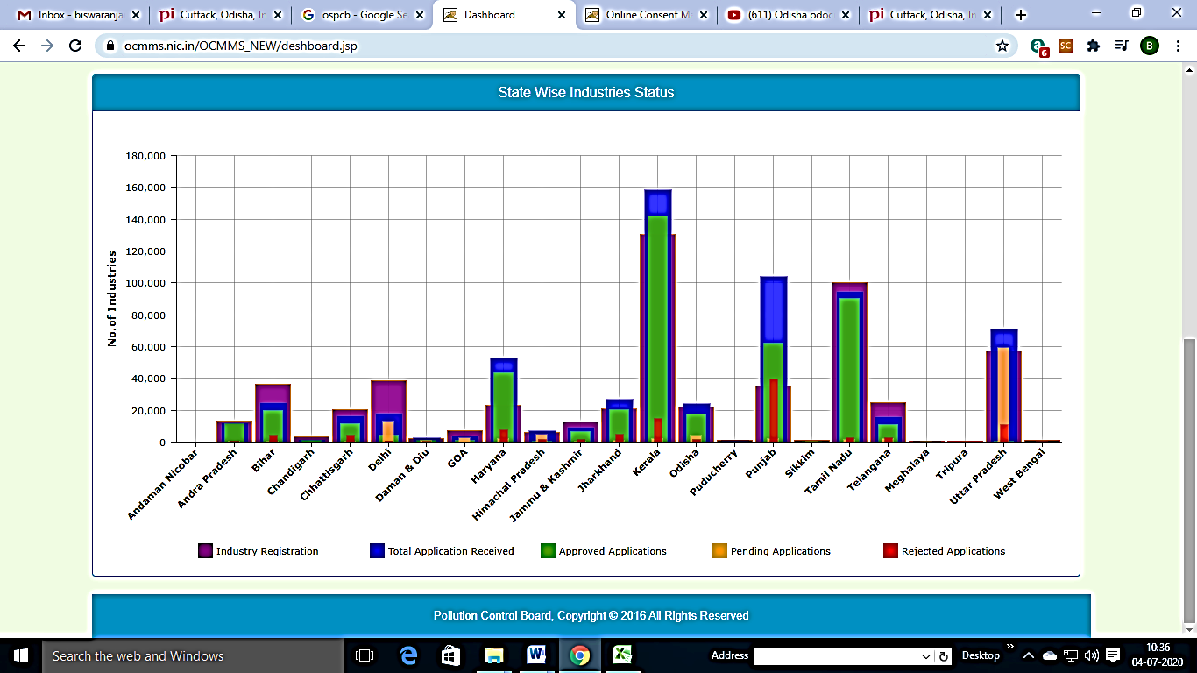
State wise reports indicating the approved numbers of the industries with maintaining pollution control limits of their effluents or emissions in India as on 3rd July 2020 (Source: CPCB, 2020). However, many of its landscapes had been experiencing pollution, for example, New Delhi, Lucknow (Uttar Pradesh), Varanasi (Uttar Pradesh), Mumbai (Maharashtra) and Kolkata (Waste Bengal) had been facing a long term pollution issues. Possibly, it is due to not a stringent environmental audit conducted for the industries which are the primary source of pollution in India cities.
References
CPCB, 2020. ENVIS Resource Partner on Control of Pollution Water, Air and Noise. http://www.cpcbenvis.nic.in/ , retrieved on 4.7.2020

