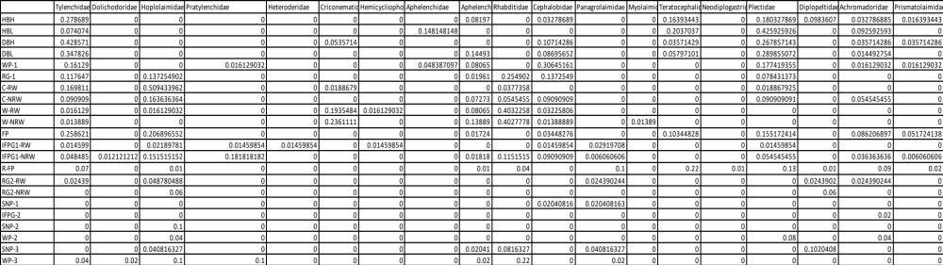
Table 2: Relative abundance of nematode families in various peatland habitats based on morphological identification.
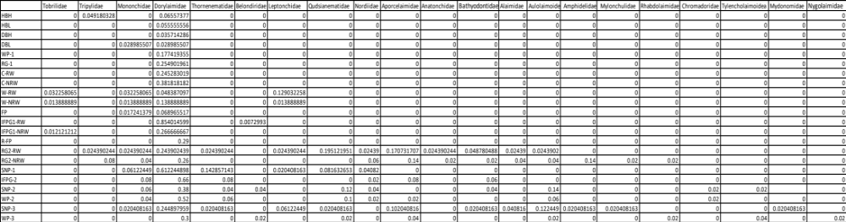

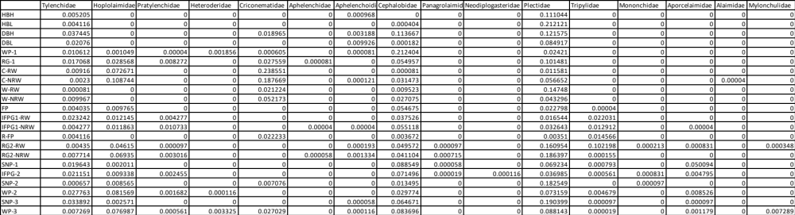
Table 3: Relative abundance of nematode families in various peatland habitats based on molecular identification.
