S1 Appendix: Standard Operating Protocol (SOP) for Fishing Village Selection
Figure 1. Sampling and selection of fishing communities and study participants in Bunda District, Tanzania

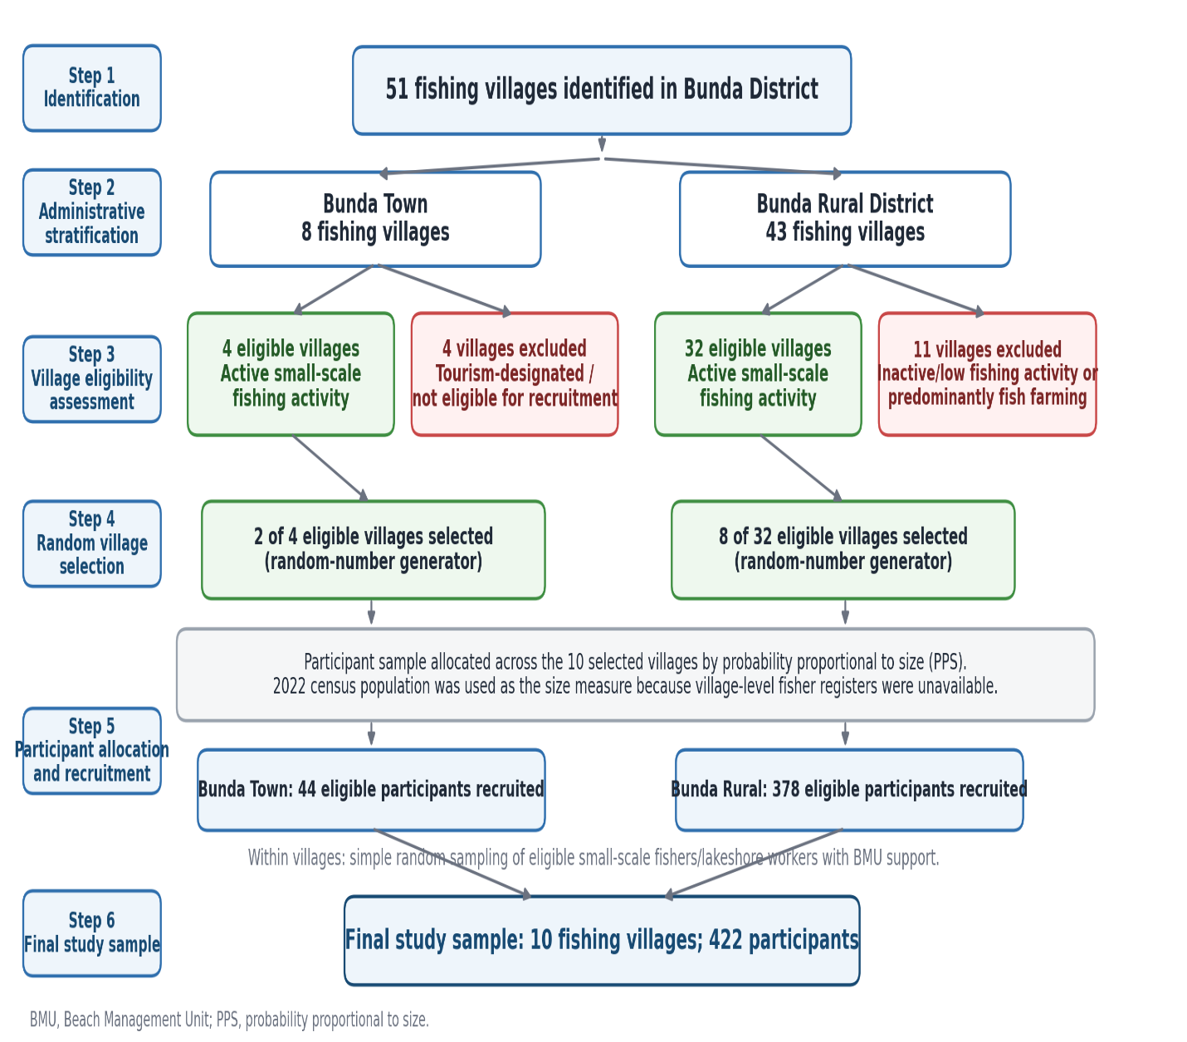
Figure legend. Fishing villages were identified, stratified by administrative area, screened for active small-scale fishing activity, and randomly selected. Participant sample sizes were allocated to selected villages using PPS, with the 2022 census population used as the size measure because village-level fisher registers were unavailable. Eligible participants were then selected within villages by simple random sampling with BMU support. Abbreviations: BMU, Beach Management Unit; PPS, probability proportional to size.

Bunda District (Northwest Tanzania)
