Supplementary Information A: Excel File
The supplementary information Excel file contains seven worksheets. The first worksheet ‘Site Data’ contains geographical and environmental information about the sites (both modern and ancient) used in this study, and includes peatlands described in Inglis et al. (2019, 2020), Amariei (2024), Zheng et al. (2014, 2015), and Yang et al. (2026). The second ‘Biomarkers’ worksheet contains δ¹³C data for hopanes, hopenes and n-alkanes, as well as the associated standard deviations (standard deviations only available for this study. The third worksheet ‘Biomarker Integrations’ contains concentration (new sites) for n-alkanes and hopanes. The fourth worksheet ‘Hopene Ratios’ contains the diploptene/ (diploptene + C₃₁ hopanes) ratio for a selection of sites from Inglis et al., 2018¹ (some crossover with Inglis et al., 2019) and the new sites. The fifth worksheet ‘Bulk Data’ contains the total organic carbon (TOC, C %), δ¹³C_{TOC}, C/N ratio, and N (%) of new sites. A sixth worksheet ‘Microbial Community Profile’ contains the 16S rRNA bacterial and archaeal community composition as relative abundances, as well as the DNA concentration of samples. The seventh worksheet, ‘Paleo δ¹³C’ includes information on the sites included in the paleo study, including δ¹³C data for hopanes, hopenes and n-alkanes and reconstructed pH values from CBT_{peat.}¹⁻⁷

Supplementary Information B
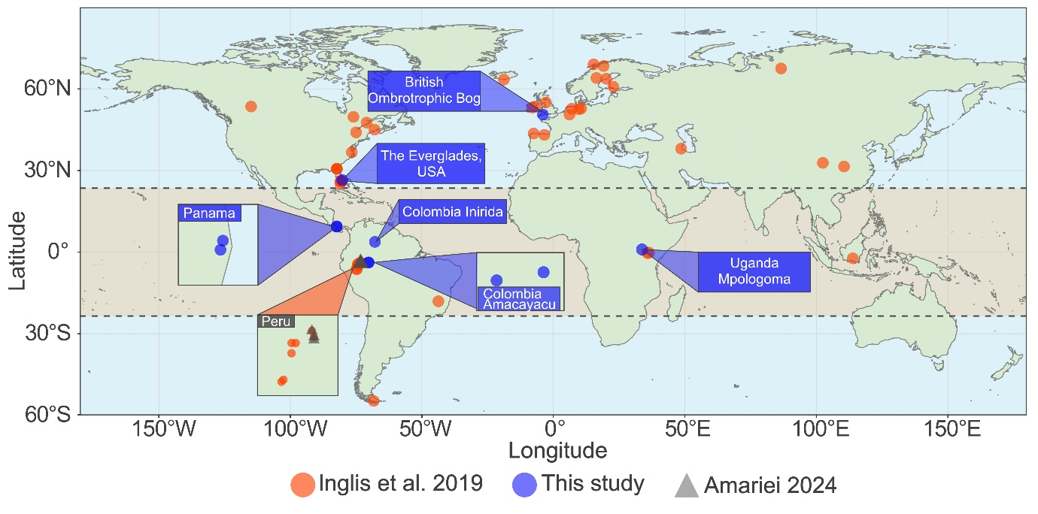
1. Sample Sites and Sampling Methods
Supplementary Figure 1. A global map showing peatland sites used in this study. Sites include those compiled and generated by Inglis et al., 2019 (n = 44, filled red circles), data from Peru (n = 3, A. Amariei, 2024, filled grey triangles) and new sites from this study (CERES project, n = 8, filled blue circles). Sites from this study are annotated on the graph. Sites with similar geographical locations, e.g. Colombia Amacayacu Cananguchal and Colombia Amacayacu Pantano from the new (CERES) dataset, will overlap on the above figure and so an inset map shows relative locations. The tropical region is highlighted in pale orange between the two dashed lines.

As part of the ERC-awarded and UKRI-funded CERES project (Climate, Energy and Carbon in the Earth System), we have collected new biomarker and microbiological data from several sites. Although all data are treated as a single dataset, several of those sites are particularly important for biomarker interpretation and so site information is provided for each of these. This information is also included in another paper based on CERES data,⁸ but is included here pending publication.
Ethics Statement: This work comprises analyses from globally distributed peatlands. In all cases, material has been collected via local partnerships and exported using appropriate permits. Samples from Panama sites were collected with support from the Smithsonian Tropical Research Institute. Sample collection from Uganda and Colombia has been done in collaboration with local partners who are included as co-authors. In the case of the Uganda sites, formal partnerships with Makerere University and the Wetlands Management Department (Ministry of Water and Environment, Uganda) are recognised via Mutually Agreed Terms and samples have been transferred among institutions via Material Transfer Agreements in support of organic matter characterisation and microbiological analyses. The 16S analysis is a purely taxonomic description, falling out of scope of the Nagoya Protocols.
Site Descriptions:
1.1. San San Pond Sak, Panama (Two Sites)
Panama’s San San Pond Sak (SSPS) is a tropical wetland area of the Bocas del Toro Province including the 80 km² Changuinola peatland - a domed peat swamp complex south-east of the Rio Changuinola.⁹⁻¹¹ Structurally, the largely ombrotrophic Changuinola peat swamp is split into seven vegetation communities,⁹ mostly driven by a strong nutrient gradient.^{10,11} In 2019, sites along a SW-NE transect were sampled, and sampling and more detailed site information is available in Schneider et al. (2025).¹² Here we focus on the mixed forest swamp (SSPS2; Raphia taedigera and Campnosperma panamensis) and sawgrass (SSPS4; Myrica-Cyrilla) sites.
1.2. The Everglades, Florida USA
Situated in southern Florida, USA, The Everglades covers an area of 6000 km² where peat accumulation has occurred over the past ~4000 years.¹³ The mean annual air temperature in this sub-tropical wetland is ~ 23 °C,¹⁴ and mean annual rainfall is 1507 mm, with 75% precipitation occurring during the wet season (May – October).¹⁵ Sampling was conducted in early May 2019. A 1m core was collected from the Loxahatchee National Wildlife Refuge’s Water Conservation Area 1 (WCA-1) in the Everglades, from a persistently flooded ditch (water depth > 1m at the time of sampling). At this location, vegetation is primarily Nymphaea odorata water lily remains, although sawgrass hummocks were nearby. In this site, and much of the Northern Everglades, elevated nutrient levels are observed due to substantial agricultural runoff.^{16,17}
1.3. Mpologoma Swamp, Uganda
Mpologoma Swamp is a peatland in eastern Uganda, north of Lake Victoria in the town of Tirinyi. The peatland spans approximately 12,195 km² and is found in the Kyoga Water management zone.¹⁸ The sampling location constitutes a 3m deep peat layer, and experiences high seasonal fluctuations in the water table, approximately from 5 cm to 1.5 m above the peat surface, and Cyperus papyrus is its dominant vegetation. The average annual rainfall is 1215 – 1238 mm per annum,¹⁹ and in this area there exists a bimodal rainfall pattern (March-May, and December- February). Surrounding the wetland, but over 100 m from our sampling site, are a large number of farms, with a vast amount of the peatland repurposed for crops or cattle grazing. Additionally, the peatland supports subsidence for local residents, with many using the land and water for washing clothes and living requirements. The range in annual air temperature is between 24 and 36 °C.¹⁹ The peatland also has a high hydraulic conductivity connectivity with the Mpologoma River, and the sampling site for this study was within 500 m of the river (0.966667N, 33.737778E). Sampling was conducted in July 2024, out of the wet season and along a transect away from the Mpologoma River. Nonetheless, at the time of sampling the water table was always above the height of the peat, and at some sites, up to 1 m above the peat surface; in general, the water table ranged from just above the surface to ~1.8 m across multiple dry season sampling campaigns.
1.4. Amacayacu, Colombia (Two Sites)
We collected cores from two peatlands of Parque Nacional Natural Amacayacu, a Colombian National Park. Annually, this tropical location receives ~3300 mm of precipitation, with distinct seasonal variations – a dry season (July/August) and a wet season (February/March). Year round, the average temperature is ~ 26°C (IDEAM Aeropuerto Vasquez Cobo, Leticia, https://bart.ideam.gov.co/cliciu/leticia/tabla.htm).
Located approximately 3 km from the Amazon River is Cananguchal, a palm swamp, believed to have been accumulating peat over the past ~ 600 years. Being situated in close proximity to the river, the site floods frequently during the wet season. At the centre of the site the peat depth is around 1.5 m, and the site is primarily vegetated by the palm Mauritia flexuosa with minor species including stunted Ceiba petandra and Melastomataceae. Sampling was conducted in August 2022 using a Russian corer extracting three cores, approximately 10 meters laterally spaced in the centre and extending to basement at 153, 191 and 151 cm.
The Amacayacu Pantano (CAP) is an herbaceous peat swamp located on the banks of the Amazon River. At the peatland’s centre, the primary vegetation is Montrichardia arborescens, and at the edges stunted trees such as Triplaris americana (Tangarana), Ficus (Matapalo) and Pachira (Punga) become more dominant, together with Cyperus articulates (Piri Piri). Due to wet conditions even during peak dry season, two monoliths and 2 deeper Russian cores were recovered from the edge of the peatland, where the peat is shallower with a gradual transition from primarily peat material at 45 cm to a clay/organic mixture at 76 cm deep. Being near the banks of the Amazon River, its water table tracks the river stages and experiences seasonal fluctuations of the water table from ~5 cm to > 2 m above the peat surface.
1.5. Inirida Hardwood, Colombia
The hardwood swamp close to Inírida (CIH; 3°45'02.6"N 67°49'45.7"W) is a shallow peat swamp featuring an uncharacterized community of tropical rainforest species with a dominance of hardwood trees. The mean annual air temperature is ~ 26 °C (IDEAM Puerto Inírida), and the mean annual precipitation is ~ 3100 mm, with prevailing seasonal variation - dry season (January/February) and wet season (June/July). The swamp, representative of a white-sand peatland,²⁰ features a characteristic basement of white sand, and at its deepest extends only 75 cm below the peat surface. Sampling was conducted in August 2022 using a Russian corer.
1.6. Tor Royal Bog, Dartmoor UK
The small domed mire, Tor Royal, is situated at an altitude of 390 m within Dartmoor National Park, South-West England, and has been thought to have been accumulating peat over the last ~6000 years.²¹ Across the site the main vegetation is Sphagnum, ericaceous shrubs, sedges, and grasses,²² and this is mainly attributed to the mostly pristine nature of this Site of Special Scientific Interest (SSSI). At its deepest, the peat extends 6.2 m below the surface,²¹ and the average water table depth occurs at ~ 30 cm below the peat surface. At Princetown; 2km north of the site, the average temperature is 8.1 °C,²³ and the annual average precipitation is 1974 mm (Met Office, 2007). Being a temperate site, the rainfall patterns are relatively consistent throughout the year. Sampling was conducted in April 2018, and a 1m length core was collected from the centre of the dome.

2. Bulk organic matter characteristics of CERES peat.
Total organic carbon (TOC, %) contents at most sites exhibit little downcore variability (Fig. S2, A), being generally around 40% as expected for peat, except for a few intervals with markedly lower TOC contents in the Everglades Lilypad Swamp and British Ombrotrophic Bog at 47 and 20 cm, respectively. Consistently lower and more variable values occur in the Colombia Inirida, Colombia Amacayacu Pantano, and Uganda tropical peatlands, likely reflecting the input of clays, especially at the river-associated Colombia Amacayacu Pantano and Uganda sites. The latter also exhibits a downcore decrease in TOC at about 50 cm, roughly coinciding with an increase in bulk density between 25 and 50 cm.
As expected, the δ¹³C_{TOC} values do not vary markedly downcore in any site. The largest fluctuations are observed in Uganda Papyrus Swamp (-15 to -19‰), and these are statistically different to δ¹³C_{TOC} in other sites (p << 0.01). Organic matter at the C₄-dominated Uganda Papyrus Swamp is ¹³C-enriched relative to the sites with C₃ vegetation, as expected. However, there is also variation among the C₃-dominated sites. Those sites that are dominated by Sphagnum and lilypad vegetation (British Ombrotrophic Bog and Everglades Lilypad Swamp, respectively) are somewhat ¹³C-enriched relative to sites with palm vegetation (up to 5.8 and 4.9‰, respectively) and hardwood vegetation (up to 6.2 and 5.5‰, respectively). For the Everglades Lilypad Swamp, this is consistent with the emerged/submerged vegetation and associated CO₂ limitation.²⁴ It is also likely that methanotrophy has contributed to isotopic variation.^{24,25} The site dominated by Montrichardia (Colombia Amacayacu Pantano), which has porous tissues through which methane can escape the bog, exhibits the lowest δ¹³C_{TOC} values, up to 3.4‰ depleted relative to the hardwood and palm sites. However, this is not expressed at the British Ombrotrophic Bog, despite the dominance of Sphagnum, which tends to be associated with low δ¹³C values due to methanotrophic symbionts.²⁵
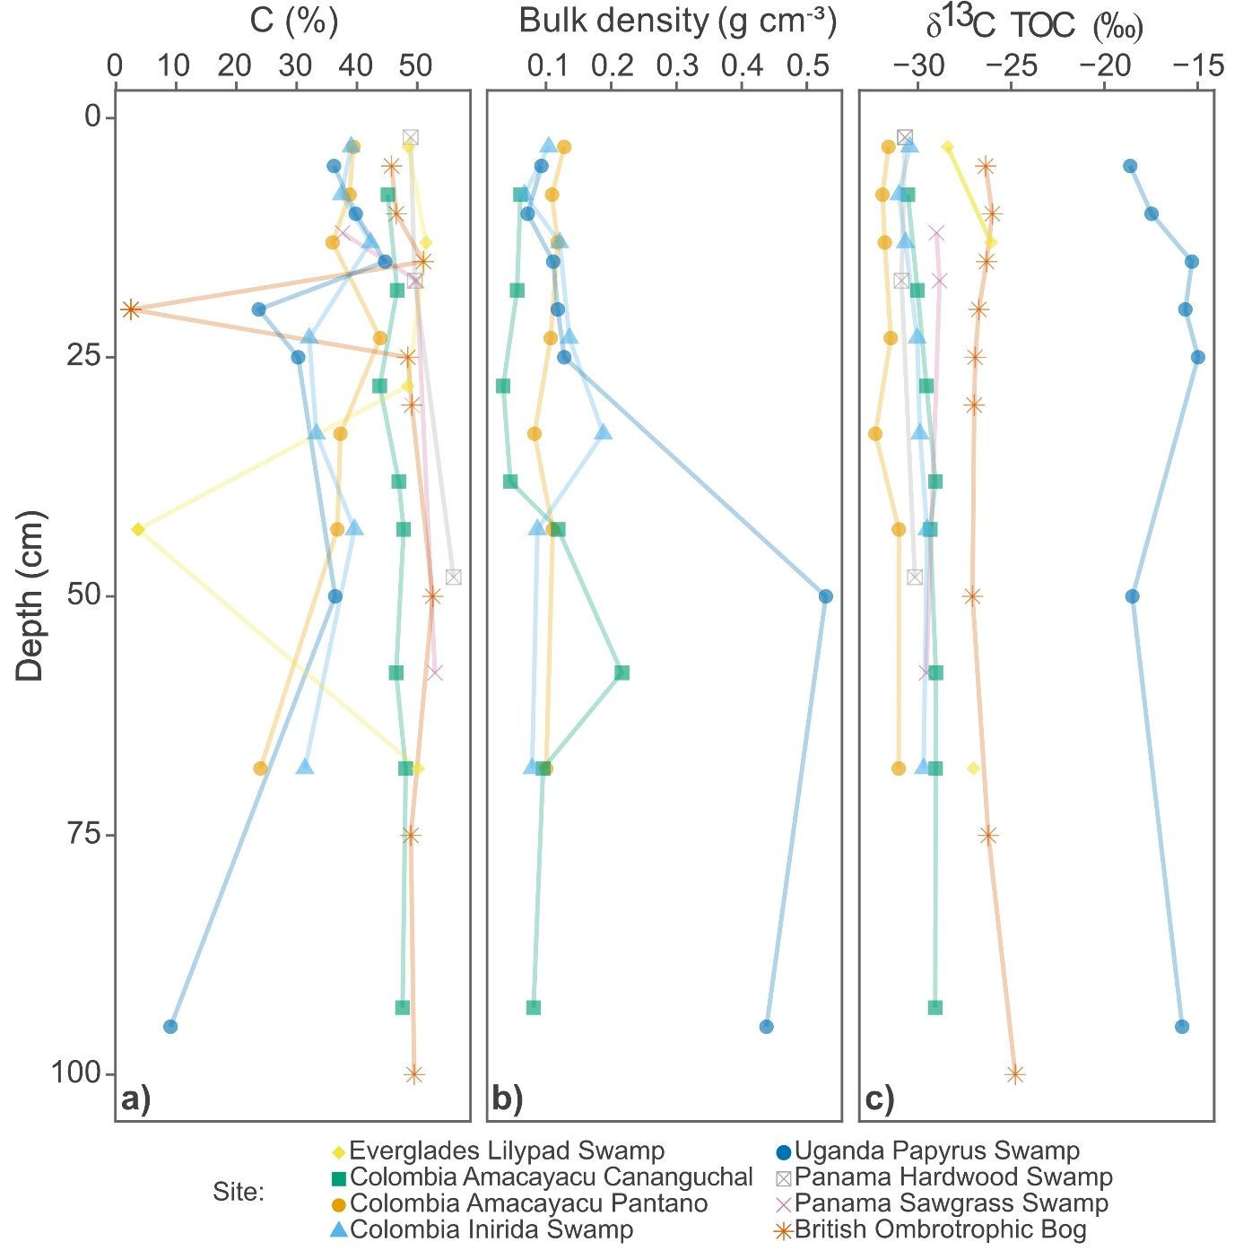
Supplementary Figure 2. Depth profiles showing bulk peat characteristics. Depth profiles for the top 100 cm of new (CERES) sites including Everglades Lilypad Swamp (filled yellow diamonds), Colombia Amacayacu Cananguchal (filled green triangles), Colombia Amacayacu Pantano (filled orange circles), Colombia Inirida Swamp (filled blue triangles), Uganda Papyrus Swamp (filled blue circles), Panama Hardwood Swamp (open grey square with cross through), Panama Sawgrass Swamp (pink cross), British Ombrotrophic Bog (orange star), showing: a) Total organic carbon (C, %) content in each sample; b) Bulk density (g cm⁻³) for a subset of the newly added sites; and c) bulk organic matter δ¹³C_{TOC} (‰).

3. Hydrocarbon Biomarkers Present in CERES peats
The CERES peatland apolar fractions contain a variety of hydrocarbons, including n-alkanes, hopane/enes, as are commonly observed in peatlands,²⁵ and the previously studied sites for which hopane/ene isotopic data have been generated.³ Figure S3 shows a representative chromatogram (including an m/z 71 (b) and m/z 191 (c) mass chromatogram), highlighting the variety of hopanes/enes.
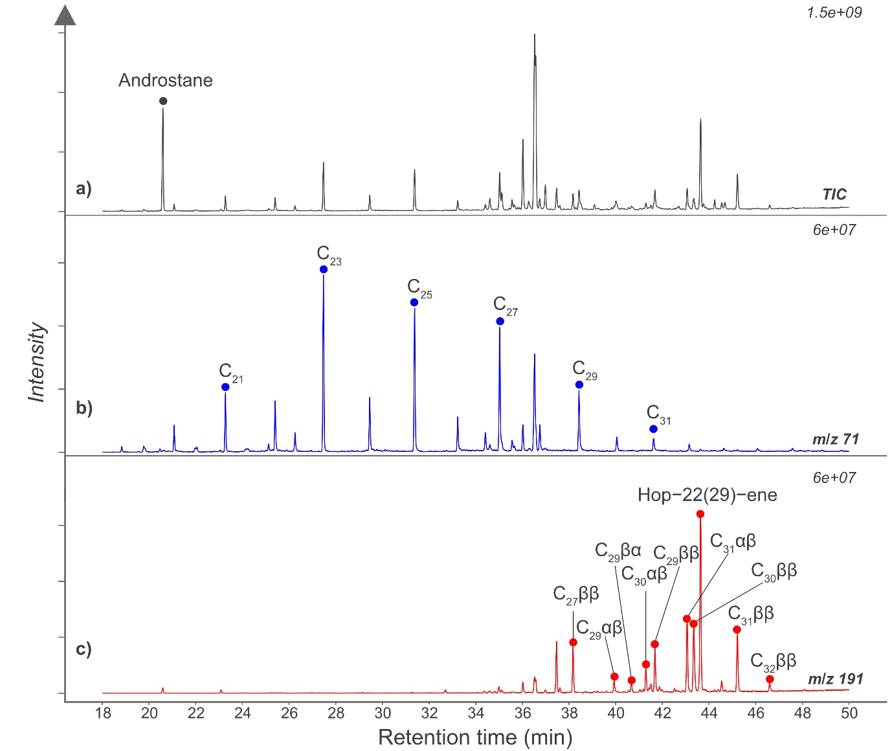
Supplementary Figure 3. Partial gas chromatograms from a GCMS analysis of The Everglades Lilypad Swamp (USWCA1) 0 - 5 cm. (a) the Total Ion Chromatogram (TIC) with the androstane standard peak labelled (grey), (b) the m/z 71 mass chromatogram showing odd carbon number n-alkanes from C₂₁ – C₃₁, exhibiting the expected odd-over-even predominance (blue), and (c) the m/z 191 mass chromatogram showing C₂₇ to C₃₂ hopanes and hopenes, occurring in a variety of stereochemical configurations (red). The retention time (RT) is shown on the x axis (minutes), and the relative intensity is shown on the y axis.
N-alkanes were identified based on mass spectra and retention times (RTs; Fig. S3, b); only odd n-alkane carbon isotopic compositions are included in this study since these were the dominant hydrocarbon components of the peat aliphatic and adductable fractions. Hopanoids (hopanes and hopenes; Fig. S3, c) were identified from their mass spectra and relative retention times. Hop-22(29)-ene, or diploptene (RT = 43.6 mins), was abundant in most samples and contained the characteristic mass fragments: m/z 410 (C₃₀H₅₀), 395 (C₂₉H₄₇), 367 (C₂₇H₄₃), 191 (C₁₄H₂₃), 189 (C₁₄H₂₁).^{26,27} Hopanes include C₂₇ to C₃₂ pseudo-homologues, in a variety of stereochemical configurations,¹ including: C₂₇ ββ (17β,21β(H)-22,29,30-trisnorhopane, RT = 38.2 mins), C₂₉ αβ (17α,21β(H)-norhopane, RT = 39.9 mins), C₂₉ βα (17β,21α(H)- norhopane, RT = 40.7 mins), C₃₀ αβ (17α,21β(H)-hopane, RT = 41.3 mins), C₂₉ ββ (17β,21β(H)-norhopane, RT = 41.70 mins), C₃₁ αβ (17α (H), 21β (H) homohopane, RT = 43.1 mins), C₃₀ ββ (17β, 21β(H)-hopane, RT = 43.3 mins), C₃₁ ββ (17β,21β(H)-homohopane, RT = 45.2 mins), and C₃₂ ββ (17β,21β(H)-bishomohopane, RT = 46.6 mins).
Diploptene δ¹³C values were determined for most samples, and this was our target compound given previous studies confirming that it is most sensitive to methanotroph contributions.^{3,24,28-30} δ¹³C values of C₃₁ αβ hopane were determined in most samples, but in a few high pH settings, concentrations were too low for accurate δ¹³C analyses. For other hopanes, even with isolation and high injection volumes, δ¹³C values could be determined in only limited samples – especially the αβ-, βα- and ββ-C₂₉ and C₃₀ hopanes. C₂₇ ββ-hopane δ¹³C values were only determined for samples that had been urea adducted since it co-eluted with n-C₂₉ in our analyses, but not all samples required urea adduction.
Methanotrophs require both methane and oxygen, such that their depth of maximum occurrence will vary among sites with changes in the water table. Therefore, for the modern dataset, we have included samples from the top 100 cm from each site. To test the viability of this approach, figure S4 shows the downcore variation in δ¹³C_{hopanoid}. This is minor, likely because methanotrophy occurs in very shallow peat, and underlying layers have preserved that original signal. Nonetheless, there is some variation in δ¹³C_{diploptene} in the top 50 cm of cores. This is greatest in the Colombia Inirida Swamp where there is a large negative shift at 30 cm to -44‰. The British Ombrotrophic Bog also exhibits high δ¹³C_{diploptene} variability, particularly at 75 cm depth. C₃₁ hopanes (αβ and ββ) exhibit smaller fluctuations in δ¹³C with depth, consistent with its overall lower variability across the entire dataset.
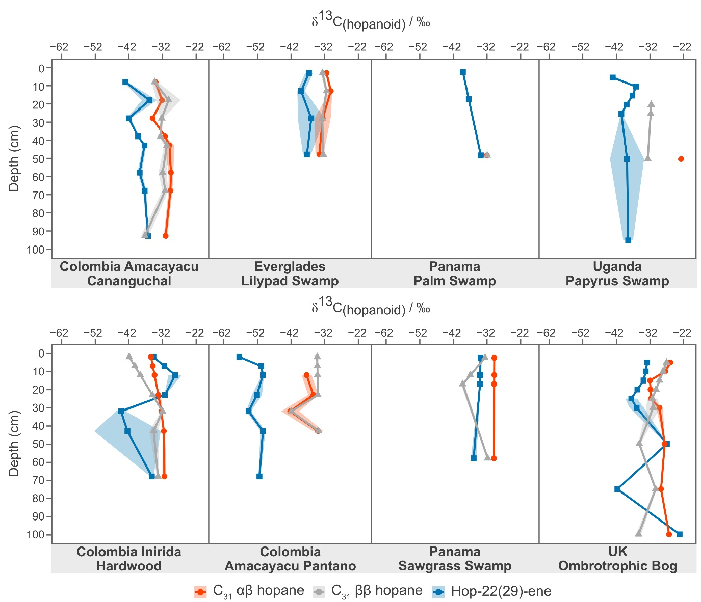
Supplementary Figure 4. Downcore variations in δ¹³C_{hopanoid} for C₃₁ hopanes, and hop-22(29)-ene in CERES sites. The hopane isotope data has been plotted for the top 100 cm of each new site. C₃₁ αβ hopane 22R (filled red circles), C₃₁ ββ hopane (filled grey triangles), and hop-22(29)-ene (filled blue squares) averages have been plotted downcore with their associated shaded standard deviation deduced from duplicate measurements. These values, including the standard deviations, are included in supplementary excel file A.
Hopanoid distributions varied as expected for modern peat samples¹: C₃₁ αβ hopane, C₃₁ ββ hopane, and Hop-22(29)-ene (diploptene) were most abundant and nearly ubiquitous, and C₂₇, C₂₉, C₃₀, and C₃₂ hopanes occurred in low abundance and were detected in only some samples (supplementary information A). The most abundant hopanoids differed among sites, often with pH as previously reported.¹ Of the new sites, the C₃₁ αβ hopane was the most abundant hopane/ene in the Colombia Inirida Swamp, Colombia Amacayacu Pantano, Panama Hardwood Swamp, Panama Sawgrass Swamp, and British Ombrotrophic Bog. In contrast, diploptene was the most abundant hopane/ene in the sites with higher pH, the Uganda Papyrus Swamp, Colombia Amacayacu Pantano, and Everglades Lilypad Swamp. Similar to the relationship between pH and Δ¹³C_{dip-alk}, the diploptene to C₃₁ hopane (ββ, αβ 22R, αβ 22S combined) ratio increases with pH, showing an increase in the abundance of diploptene at higher pH (Fig. S5, a), and decreases with Δ¹³C_{dip-alk} (Fig. S5, b).

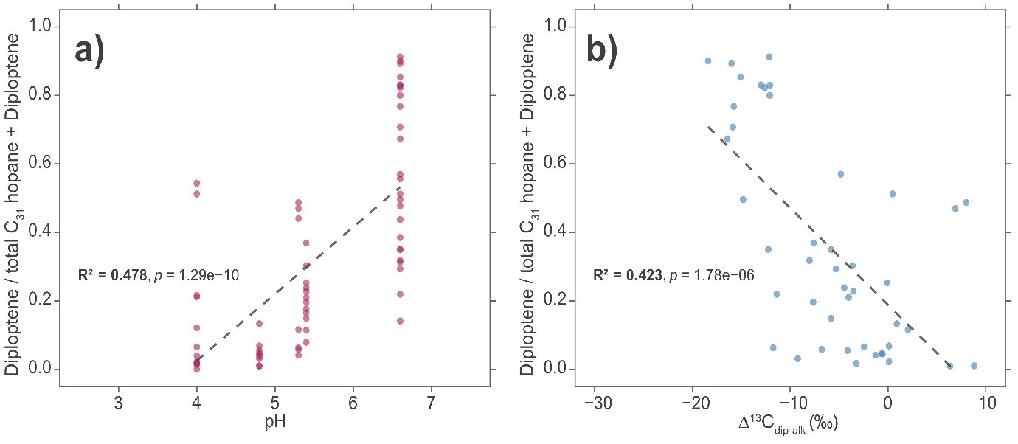
Supplementary Figure 5. Ratio of diploptene versus a) measured pH, and b) diploptene carbon isotopic composition. The relationship for each (new) CERES site between the ratio of diploptene/ (total C₃₁ hopanes + diploptene), where C₃₁ hopanes included are C₃₁ αβ 22R and 22S and C₃₁ ββ hopanes, with a) measured pH (filled pink circles), and b) Δ¹³C_{dip-alk} (filled blue circles). Here, each depth is treated as a unique datapoint, and the pH used is that observed at the site at the time of sampling. Only depths from the top 100 cm are considered. A simple linear regression was calculated to determine R² and significance values for a) and b).

4. TOC and leaf wax δ¹³C values and correcting hopanoids for changes in organic substrates.
Due to isotopic differences in the organic substrate for the heterotrophic endmember of the hopanoid-producing bacterial community, correction of δ¹³C_{hopanoid} is necessary to make meaningful comparisons among sites. Since the δ¹³C_{TOC} represents the total plant biomass available for microbial heterotrophs, it is likely the most suitable for correcting hopanoids (Δ¹³C_{hopanoid – TOC}). However, δ¹³C_{TOC} was only available for the new sites (in part, because n-alkane and hopane/ene δ¹³C values can be determined in the same analysis), requiring us to explore which δ¹³C_{n-alkane} is most appropriate. Crucially, there was significant variability among δ¹³C values of n-alkane homologues at a given site. The TOC-n-alkane offset also differed; in sites where δ¹³C_{TOC} and δ¹³C_{n-alkane} are available, there was an average ¹³C-enrichment in δ¹³C_{TOC} of +5.0‰ in C₃ peatlands, and an average +9.2‰ in C₄ peatlands.
Saturated aliphatic fractions contained a range of n-alkanes (n-C₁₉ to n-C₃₃) typical for peatland settings, with a notable odd over even n-alkane dominance.^{25,31} The most abundant n-alkanes varied by site, but most samples were largely dominated by long-chain (n-C₂₇ to n-C₃₃) n-alkanes, with a lesser contribution from mid-chain (n-C₂₁ to n-C₂₅), and short chain (< n-C₂₁) homologues.
Mid- and long-chain n-alkane δ¹³C values averaged -32.6 and -32.9‰, respectively, but the range was very large, from -19 to -43‰ (σ = 2.8) and from -23 to -46‰ (σ = 2.7), respectively, and significant site-by site variation was observed. This average is similar to Inglis et al. (2019), -33 and -32‰, respectively, but our ranges were much larger, driven by the addition of ¹³C-enriched peat from C₄ vegetation. Comparing tropical (MAT > 20 ℃) and temperate sites, long- (-34 versus -32‰, σ = 3.1 and 1.3, respectively) and mid-chain (-30 vs -34 ‰, σ = 2.9 and 1.7, respectively) n-alkane δ¹³C values significantly differed (p << 0.01), reflecting differences in TOC δ¹³C values and the dominant n-alkanes produced by different vegetation. In particular, both long- (-27 vs -33‰, σ = 1.6 and 2.2, respectively) and mid-chain (-24 vs -33‰, σ = 2.3 and 1.9, respectively) n-alkane values significantly differ between C₃ and C₄ peat (p << 0.01), as expected.^{32,33} However, a large range occurs even at the C₃-dominated sites – as also seen in TOC δ¹³C values.
Furthermore, the δ¹³C values of peat n-alkanes differed dramatically among homologues, typically by 4 to 6‰ but often over 10‰, as seen previously.³ This partially reflects differences inherited from the plant community.²⁴ Long chain n-alkanes are typically ¹³C-depleted relative to co-occurring mid-chain n-alkanes.³⁴ The least variation between mid- and long-chain n-alkane δ¹³C is exhibited at the Sphagnum site, Tor Royal, with an average 0.7‰ difference. Most n-alkanes are derived from leaf waxes, and so their isotopic signature can be ascribed to isotopic fractionations associated with their biosynthesis. Leaf wax chain elongation occurs via stepwise addition of carbon units to a C₁₆ acid, followed by decarboxylation to obtain the n-alkane,³⁴ such that higher molecular weight n-alkanes are associated with additional biosynthetic steps, each with an additional isotopic fractionation. Compounding differences among n-alkanes in plants, mixing of plant inputs with different predominant chain lengths and carbon isotopic compositions will also generate variability among homologues.²⁵ In fact, there is only a weak (but significant) correlation between δ¹³C_{mid-chain} versus δ¹³C_{long-chain} (R² = 0.07, p << 0.01), and the absence of a stronger relationship suggests that the mid and long chain n-alkanes in the peat are derived from different plant species.³ Consequently, biomass correction factors will be highly dependent on the chosen n-alkane.
To explore which n-alkane provides the greatest fidelity for representing bulk sedimentary organic matter, we compared the n-alkane and TOC δ¹³C values (Fig. S6). The differences are significant by a repeated-measures mixed-effects model suggesting that no single n-alkane is universally appropriate for biomass correction, which is perhaps expected given the differences in dominant n-alkane homologues among different peat-forming plant species,²⁵ and pairwise comparisons suggested that most n-alkane/bulk δ¹³C significantly differed from each other (excluding n-C₂₁ vs n-C₂₃, n-C₂₁ vs n-C₂₅, n-C₂₃ vs n-C₂₅, n-C₂₇ vs n-C₃₃, n-C₂₉ vs n-C₃₁). Moreover, as indicated by Tukey-adjusted pairwise comparisons, the bulk δ¹³C was significantly higher than all individual n-alkane homologues (p << 0.01 for all comparisons). This offset between n-alkanes and TOC was highly variable among and within sites; for example the offset between n-C₂₇ and TOC δ¹³C values at the C₃ dominated sites ranged from (-2.1 to -11.7‰), perhaps due to seasonal impacts on leaf wax δ¹³C values arising from changes in humidity or methane incorporation via symbionts,²⁴ (and references therein). We suggest that δ¹³C_{TOC} be used to generate hopane Δ¹³C values in the future, although even that is complicated by bacterial preferential consumption of isotopically distinct plant biomolecules (i.e. ¹³C-enriched carbohydrates).³¹
Here, we have corrected most data using n-C₂₇, to maximise consistency with previously published data; the exception is the C₄ papyrus peat from Mpologoma, for which we use n-C₂₃. This choice yields a relatively narrow range of Δ¹³C_{TOC-n-alkane-} of +2.1 to +11.7‰ across the entire dataset. The δ¹³C_{n-alkane} data obtained from Inglis et al. (2019) and A. Amariei (2024) was limited, but δ¹³C_{n-C27} was available for almost all samples. For the Irish Ballyduff Bog (Inglis et al. 2019), δ¹³C_{n-C27} was not available for a large proportion of samples, and hence δ¹³C_{n-C29} was used for all depths at this site. The isotopic difference between δ¹³C of n-C₂₇ and n-C₂₉ is statistically significant but small, consistently less than 1.3‰. If δ¹³C_{n-C27} could not be obtained for some depths at a site, then the average of available δ¹³C_{n-C27} data at that site was used for that sample. The standard deviation for the average δ¹³C_{n-C27} at a given site ranged from 0.36 to 2.76 ‰. These two adjustments impact Δ¹³C values (up to 3‰), but those are far lower than the total range observed.
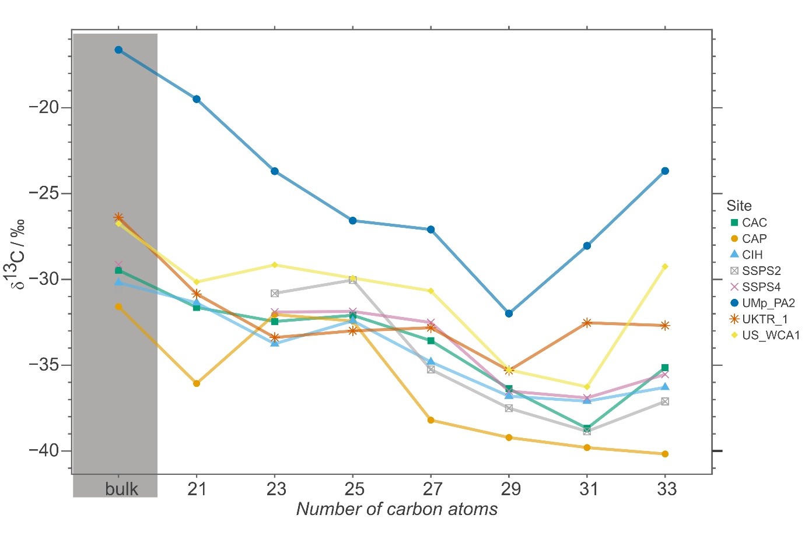
Supplementary Figure 6. Variation across carbon chain length and bulk peat in average δ¹³C in CERES sites. The change in δ¹³C_{TOC}, and δ¹³C_{n-alkanes} across CERES sites is shown, with site abbreviations and symbols as follows: Colombia Amacayacu Cananguchal (CAC, filled green triangles), Colombia Amacayacu Pantano (CAP, filled orange circles), Colombia Inirida Swamp (CIH, filled blue triangles), Panama Hardwood Swamp (SSPS2, open grey square with cross through), Panama Sawgrass Swamp (SSPS4, pink cross), Uganda Papyrus Swamp (UMp_PA2, filled blue circles), British Ombrotrophic Bog (UKTR_1, orange star), Everglades Lilypad Swamp (USWCA1, filled yellow diamonds). Each value is averaged across the top 100 cm of the site, and standard deviations are reported (supplementary excel A). The data have not been interpolated so where blanks appear in the graph are where the δ¹³C_{n-alkane} could not be obtained.
Figure S7 shows the effect of choosing different n-alkanes to generate Δ¹³C_{dip-alk} values. High molecular weight n-alkanes showed larger average offsets with TOC (-7.6, -7.7, -6.2‰ for n-C₂₉, n-C₃₁, n-C_{33,} respectively), whereas the offset between δ¹³C_{n-C21} and δ¹³C_{TOC} was only -2.2‰. However, these differences are relatively consistent, except at Uganda Papyrus Swamp, such that the choice of n-alkane affects absolute Δ¹³C_{dip-alk} but not trends. For example, the relationships between Δ¹³C_{dip-alk} and pH have varying y-intercepts depending on the n-alkane used, but similar slopes and similar correlation coefficients (Fig. S7).
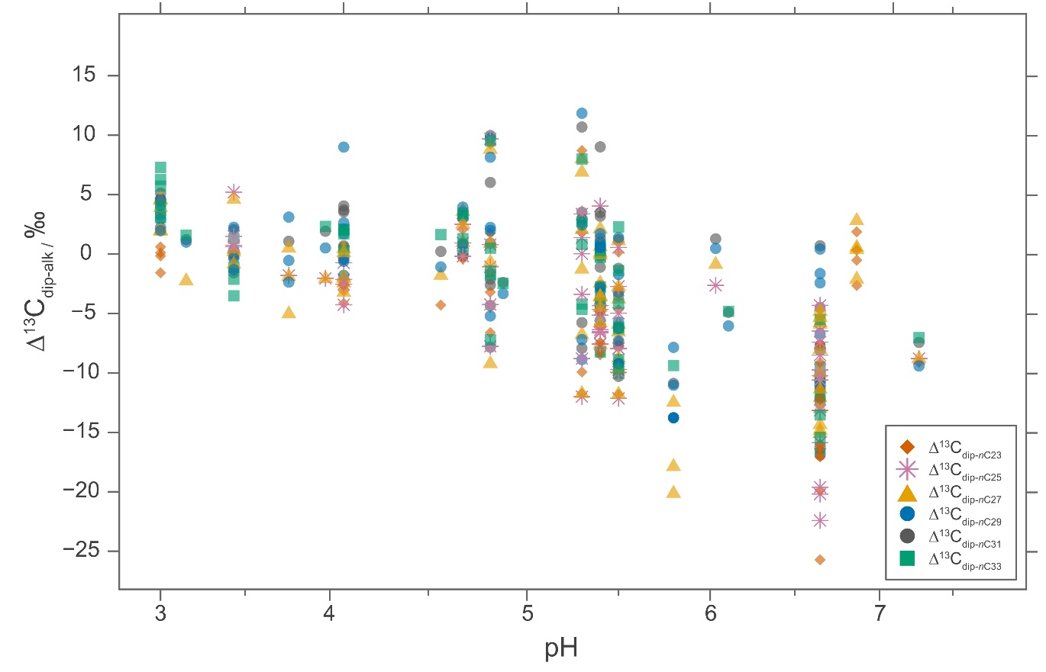
Supplementary Figure 7. The variation in Δ¹³C_{diploptene- n-alkane} when δ¹³C of different n-alkanes are used. The effect of correcting diploptene with the δ¹³C of different odd length n-alkanes (n-C₂₃ to n-C₃₃), and their correlation with pH using data from the top 100 cm only: n-C₂₃ (R² = 0.3, p << 0.01, n = 54, filled red diamonds); n-C₂₅ (R² = 0.4, p << 0.01, n = 55, pink star), n-C₂₇ (R² = 0.3, p << 0.01, n = 74, filled yellow triangle), n-C₂₉ (R² = 0.3, p << 0.01, n =72, filled blue circle), n-C₃₁ (R² = 0.3, p << 0.01, n = 68, filled grey circle), n-C₃₃ (R² = 0.5, p << 0.01, n = 57, filled green square). In this analysis, average δ¹³C_{n-alkane} has not been used meaning there are fewer datapoints for n-C₂₇ compared with the main figure (Fig. 2), giving a different value for R². Figure 2 (main text) uses the most appropriate n-alkane to correct the respective sites, and uses averages where values are missing. A simple linear regression was used to calculate R² and significance values.

5. The relationship between hopanoid δ/Δ¹³C values and Mean Annual Temperature (MAT).
Our new data significantly expand that of Inglis et al., 2019, resulting in a significant increase in the number of sites featuring low δ¹³C_{diploptene} values (up to -56‰). Almost all those new sites are tropical, and it appears that low δ/Δ¹³C values are associated with such settings. To explore that we plot MAT vs Δ¹³C_{dip-alk} (Fig. S8), observing only a very weak relationship (R² = 0.077, p < 0.001). It is likely that temperature exerts some control on Δ¹³C_{dip-alk} via its role in stimulating both methanogenesis and methanotrophy. However, we suggest that this relationship instead reflects the fact that the tropical sites (at least in our dataset) had higher pH and were minerotrophic, factors that appear to have a stronger control on methane cycling, as discussed in the main text.
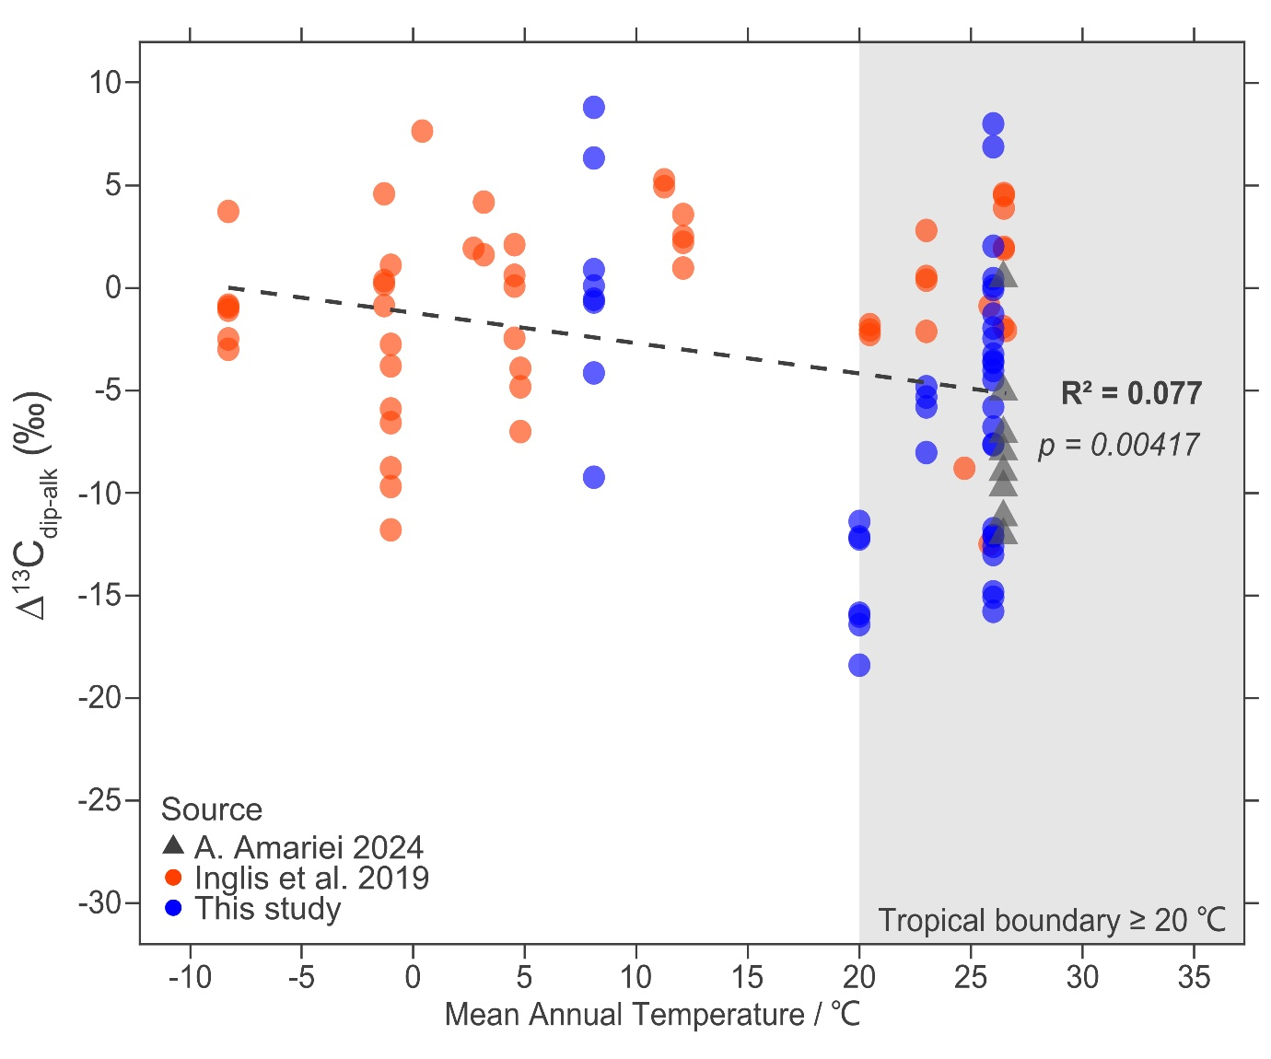
Supplementary Figure 8. The relationship between mean annual temperature and Δ¹³C_{dip-alk.} Crossplot to show the relationship between Δ¹³C_{dip-alk} and Mean Annual Temperature (MAT, °C) for the top 100 cm of the combined dataset. The data has been colour coded as before and includes all data from the top 100 cm from Inglis et al., 2019 (filled red circles, n = 52 ); Amariei, 2024 (filled grey triangles, n = 8); and this study (filled blue circles, n = 45). A simple linear regression was conducted to determine R² and significance values.
6. Microbial community profiles ℃
To explore the methanotrophic oxidising bacterial (MOB) community, we examined microbial 16S rRNA from these new peatlands (Figs. 3, S9). MOB represented a small portion of the whole bacterial community (up to 17.6%), but did exhibit the anticipated depth profiles, with the highest proportions typically occurring at/near the surface (Fig. S9) and decreasing with depth where anoxic conditions prevailed. The highest methanotroph proportions occurred in the British Ombrotrophic Bog (17.6%) and the lowest in the Everglades Lilypad Swamp (0.06%). Surprisingly, sites with the lowest Δ¹³C_{dip-alk} values did not have highest methanotroph proportions, accounting for only 5.9% of the bacterial population in Colombia Amacayacu Pantano (13 cm depth), and 2.2% in Uganda Papyrus Swamp (surface). Lipid and 16S rRNA biomarkers for microorganisms record fundamentally different aspects of the microbial community, including their temporal and spatial distribution. The former can persist for centuries or longer, recording an integrated temporal signal. That enhanced preservation potential also means that lipids integrate a microbial signal over a wider depth range (i.e. hopanoids in deep peat were likely formed in the past in shallow peat). In flooded sites, that could also mean their generation in overlying waters, and it is possible that the ¹³C-depleted hopenes at Colombia Amacayacu Pantano and Uganda Papyrus Swamp partially derive from those, given nearly persistent flooding.
Type II methanotrophs were more abundant than Type I methanotrophs at all sites (Fig. S9), although in the Everglades Lilypad Swamp, methanotrophs could not be ascribed as Type I or Type II. However, in the Colombia Amacayacu Pantano and Uganda Papyrus Swamp, Type I methanotrophic bacteria represented up to 36% of the total (Type I+II) MOB pool, far higher than the other sites (<5%) and coinciding with the lowest Δ¹³C_{dip-alk}. These observations are consistent with studies that show Gammaproteobacteria (Type I) are the active population in methane emitting environments, whereas Alphaproteobacteria (Type II) grow at low methane concentrations,^{35,36} although other studies complicate these interpretations.³⁷⁻⁴⁰
Type I methanotrophs (Gammaproteobacteria) and Type II methanotrophs (Alphaproteobacteria) differ in their carbon assimilation pathways, utilising the ribulose monophosphate versus serine pathway, respectively. ^{29,37,41-43} The former typically produce biomass and lipids with greater ¹³C-depletion.⁴⁴⁻⁴⁶ Therefore, low Δ¹³C_{dip-alk} values could partially reflect greater proportions of the Type I MOB²⁴ that produce more ¹³C-depleted lipids. As the isotopic difference between groups is only ca. 10‰,⁴⁴ and the change in Type I vs Type II methanotrophs proportions is only about 1/3 of the total methanotroph population, this is unlikely to drive the up to 30‰ differences in Δ¹³C_{dip-alk} observed here, but it is likely to be a contributing factor.
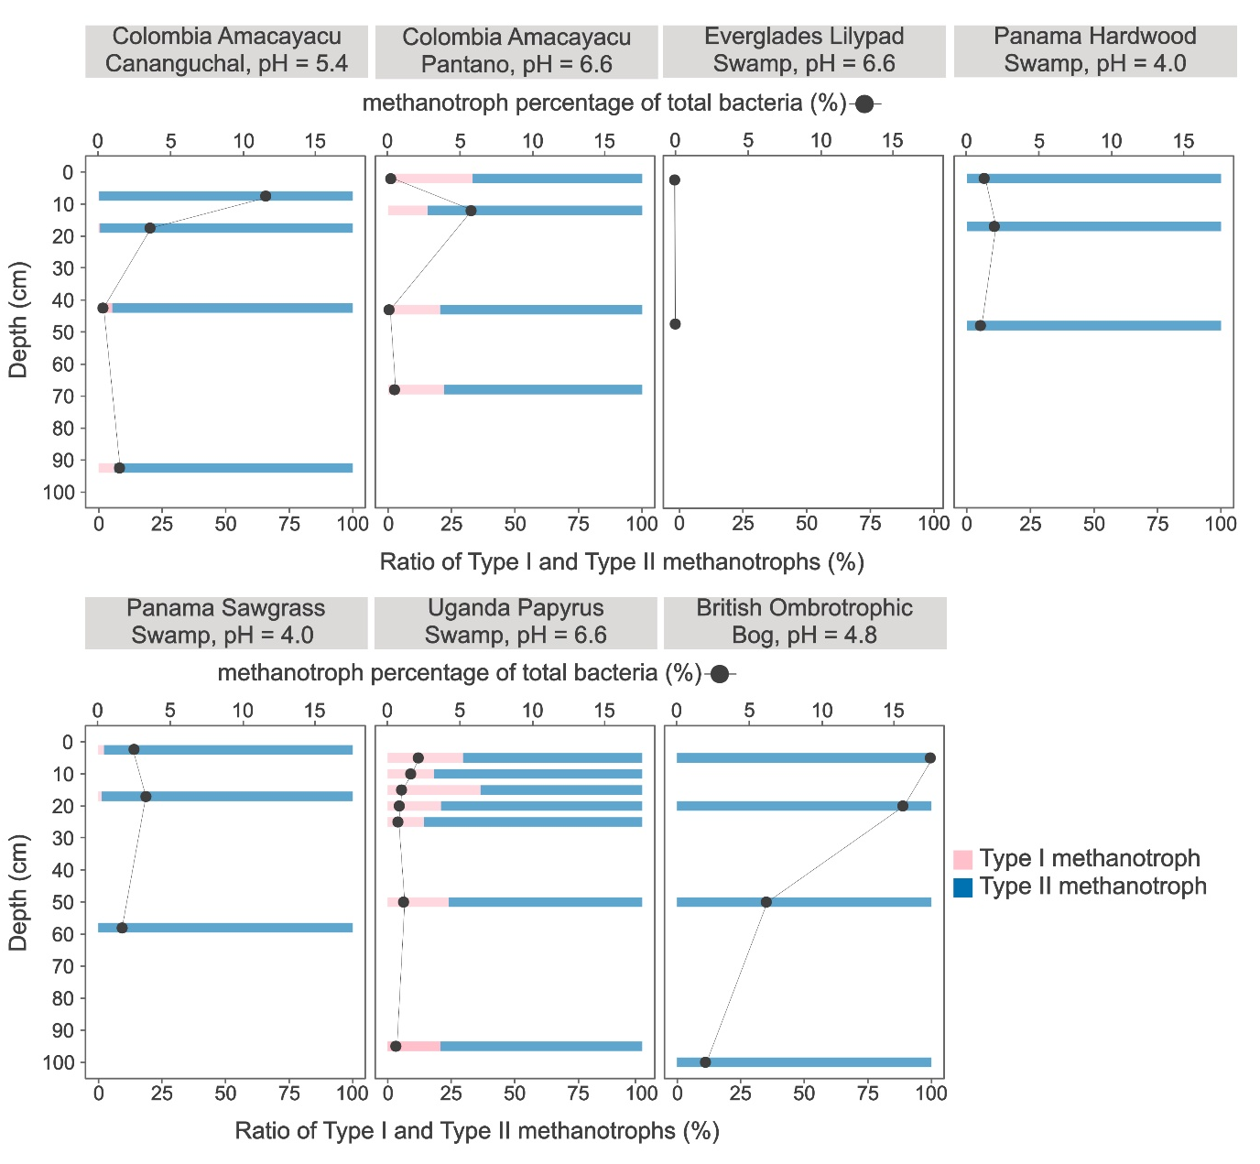
Supplementary Figure 9. Downcore variation in methanotroph population (%) and Type I versus Type II ratio in CERES sites. The downcore trend across the top 100 cm showing the ratio of Type I (pink) to Type II (blue) methanotrophic bacteria for each of 8 new sites (bottom axis scale and horizontal bar chart). The downcore trend in % methanotrophic bacteria of the total bacterial population at each site is also shown (top axes and line graph with filled grey circles). Nb. The total bacterial population for each site will not be equal. Nb.2. Colombia Inirida does not have microbial data so is not included in this figure. Where methanotrophic bacteria have been identified in the absence of Type I or Type II MOB, it is likely that genes capable of methane oxidation in other bacteria have been identified.
We explore the relationships between the % of methanotrophs (of total bacteria) and the Type I/Type (I + II) MOB ratio with Δ¹³C_{dip-alk} (Fig. S10). Interestingly, significant correlation is observed between the percentage Type I/Type (I+II) MOB ratios (R² = 0.9, p << 0.01) but is not observed between the former (R² = 0.27, p > 0.05; Fig. S10).
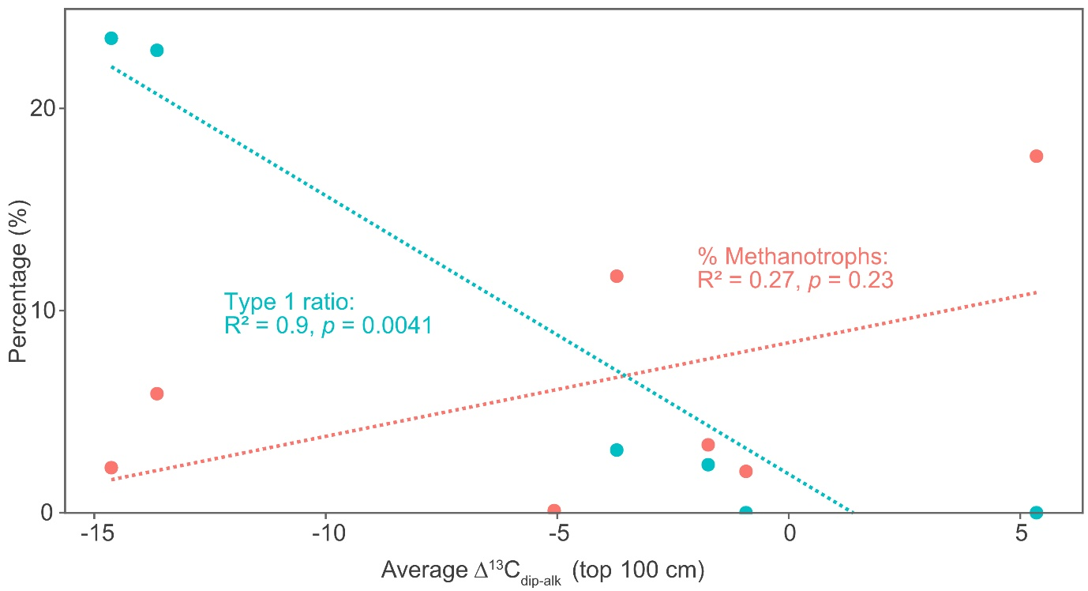
Supplementary Figure 10. The relationship between Type I/(Type I + II) MOB ratios with Δ¹³C_{dip-alk,} and the methanotroph % of total bacteria with Δ¹³C_{dip-alk}. The Δ¹³C_{dip-alk} and Type I % of Type (I+II) pool have been averaged across the top 100 cm of each site, whereas the greatest methanotroph % of bacteria has been used which is the surface sample in CAC, UMp_PA2, UKTR_1, 12 cm depth in CAP, 17 cm depth in SSPS2 and SSPS4, and at 47.5 cm in USWCA1. Colombia Inirida (CIH) is not included since microbiology data was not available. A simple regression analysis was used to calculate R² and p values. The relationship between the % of methanotrophic bacteria of the total bacterial pool versus Δ¹³C_{dip-alk} is shown in pink (filled pink circles, n = 8) and the relationship between the % of Type I MOB of the Type (I+II) MOB pool versus Δ¹³C_{dip-alk} is shown in blue (filled blue circles, n = 6). N.b. There are only up to 6 datapoints for each relationship correlation.
The relative methanogen and methanotroph populations in CERES sites are shown in figure S11 and are shown as their percentage in the archaeal and bacterial communities, respectively. The methanogen community is typically highest at the surface except in British Ombrotrophic Bog and the Everglades Lilypad Swamp, and at all sites their presence was sustained throughout the core. The relative abundance of methanogens was greatest in Colombia Amacayacu Pantano and Uganda Papyrus Swamp, the two sites with lowest Δ¹³C values, representing up to 80% of the Archaea near the peat surface. These two sites are both associated with high methane fluxes (see below).

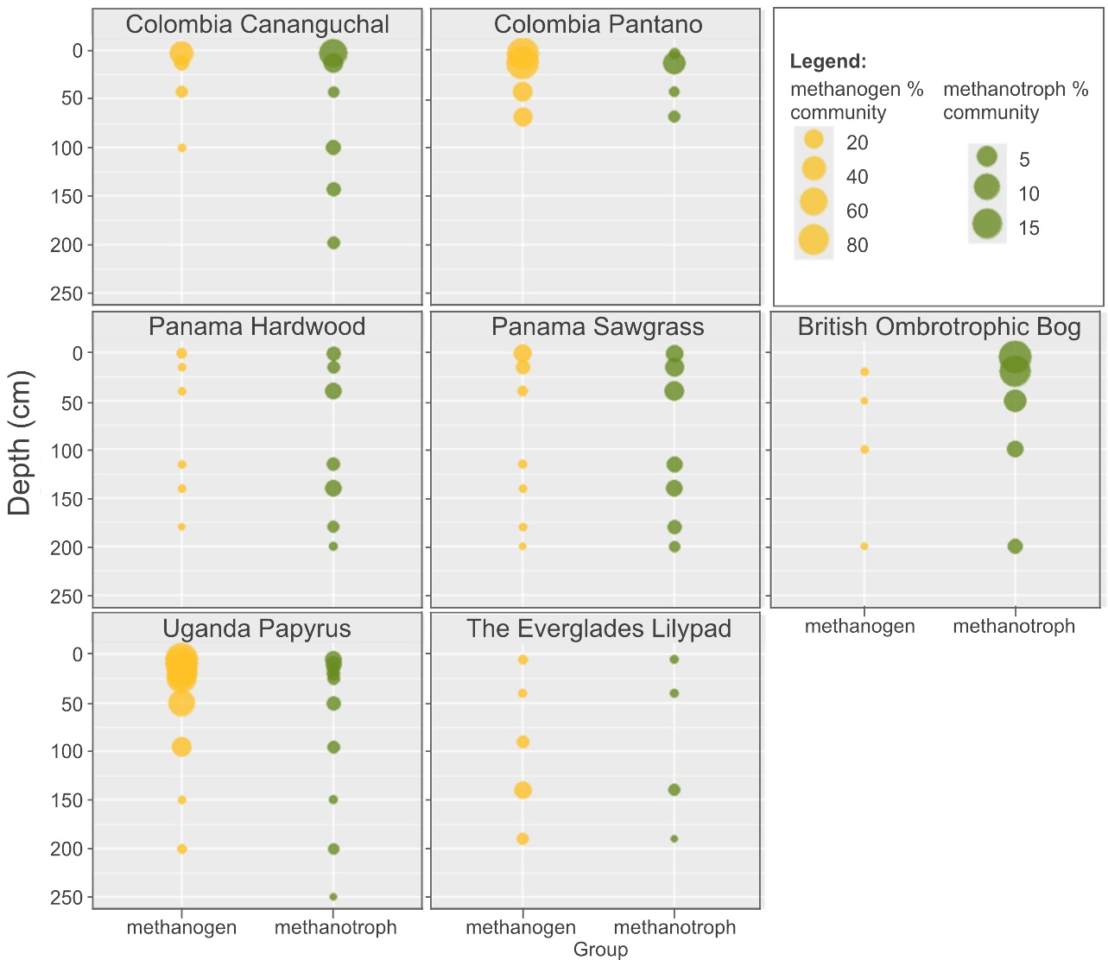
Supplementary Figure 11. The relative proportions of methanogen and methanotrophs of the total archaeal and bacterial communities respectively. To quantify the percentage of methanogens and methanotrophs within the archaeal and bacterial community respectively, 42 methanogens and 35 methanotrophs were filtered and their abundance calculated. This was then converted to a percentage of the relevant community across all sites and depths and plotted as seen here. All data processing was carried out in R. The methanogen community size is shown in yellow on the left of each graph and the methanotroph in green on the right of each graph. The size of the circles represents different percentages in methanogen (yellow) or methanotroph (green) communities according to the key on the bottom right corner of the graph. Note that methanotroph data are the same as in figure S9 and included for comparison, and Colombia Inirida is excluded due to no available microbial data.

7. Methane emissions at sites with low Δ¹³C values
Methane emissions can be measured using a variety of approaches, at varying spatial and temporal scales, making direct comparisons challenging. Nonetheless, there is strong evidence that methane emissions were high at each of the three sites featuring low Δ¹³C values.
Uganda (Mpologoma) Papyrus Swamp: Ecosystem-scale CH₄ exchange at Mpologoma was measured continuously using a tower-mounted open-path gas analyser and the eddy-covariance technique. Fluxes were calculated at 30-min resolution and subjected to standard quality-control procedures. Manual chamber measurements were also conducted to characterise pathway-scale CH₄ release from soil/water surfaces and plant-mediated emissions within the papyrus wetland. These eddy-covariance and chamber observations provide ecosystem- and pathway-scale context for the microbial analyses, while quantitative flux estimates, temporal analyses and cross-site comparisons are presented separately.⁴⁷ Crucially, both ecosystem-scale eddy-covariance observations and chamber measurements identified Uganda Papyrus Swamp as a sustained high-CH₄ papyrus wetland relative to published natural-wetland records.⁴⁷ This ecosystem context strengthens interpretation of the microbial community described here, placing downcore methane-cycling patterns within a persistently wet, high-emitting papyrus system.
Colombia Amacayacu Sites (CAP and CAC): Methane flux data from were collected via chambers during research conducted at Pontificia Universidad Javeriana (Bogotá, Colombia) under the supervision of Juan Carlos Benavides, within the framework of a project funded by the USAID PEER/NAS programme. Methane fluxes differed markedly between the two sites. At Pantano (CAP), all measurements were positive, with a median flux of 2.56 mg CH₄ m⁻² h⁻¹ (IQR 0.81–13.21; mean ± SE = 25.9 ± 11.0; range <0.01–339.5; n = 35), indicating a consistent and strong net CH₄ source. In contrast, Cananguchal (CAC) showed frequent CH₄ uptake: the median flux was negative (−1.95 mg CH₄ m⁻² h⁻¹; IQR −3.49 to 8.08), and 10 of 17 measurements (59%) corresponded to net uptake, although the mean flux remained slightly positive and not significantly different from zero (mean ± SE = 3.9 ± 7.8; n = 17). Fluxes at CAC spanned a wide range (−77.4 to +62.4 mg CH₄ m⁻² h⁻¹), consistent with concurrent methanogenesis and methanotrophy and indicating near-neutral net exchange rather than a clear net sink. These data are consistent with sites featuring low Δ¹³C values (i.e. CAP) being associated with high methane emissions.
Peruvia Sites from the West Amazonian Basin (including Buena Vista Site): Peatland methane emissions from the Peruvian sites investigated here have been previously determined via a floating static chamber approach.⁴⁸ A subsequent corrigendum⁴⁹ revealed that the diffusive flux estimates in the original study had been underestimated, and that this underestimation was enhanced at the forested sites. Correcting for this revealed that all the Peruvian sites, including those included here from Amariei (2024) had high methane emissions, compared to other tropical peatlands. Crucially, this correction highlighted that the emissions were markedly higher in the forested sites than the palm sites, the former including both analyses with low Δ¹³C values and the latter including both analyses with higher ones.
In summary, all sites with Δ¹³C values lower than -15‰ are associated with high methane emissions. And in both Peru and Colombia, direct comparative investigations show the highest emissions at the sites with lowest Δ¹³C values.

8. Compilation of ancient δ¹³C_{hopanoid} values
We compiled ancient δ¹³C_{hopanoid} values from various sites where pH reconstructions were available (or could be generated from available data) from either branched glycerol dialkyl glycerol tetraether (brGDGT) or hopane isomerization proxies.² pH values were reconstructed using equations (1) and (2) below.
${CBT}_{peat}=\log_{10}\left(\left[GDGTIb\right]+\left[GDGTIIa’\right]+\left[GDGTIIb\right]+\left[GDGTIIb^{'}\right]+\left[GDGTIIIa^{'}\right]\right)$ (1)
$$/(\left[GDGTIa\right]+\left[GDGTIIa\right]+\left[GDGTIIIa\right])$$

$pH=(2.49*{CBT}_{peat})+8.07$ (2)
Sites include those from previous investigations where reconstructed pH was available: Cobham,³ Otaio Gorge,⁵⁰ Hani,^{6,7} and Hongyuan,^{4,5} as well as deeper peat (>100 cm) from this study (CAC, SSPS2, SSPS4, USWCA1, UMp_PA2).
For Otaio Gorge Δ¹³C_{dip-alk} and Cobham, n-C₂₉ δ¹³C was used for correction despite δ¹³C_{TOC} being available, to maintain consistency with the modern dataset. Δ¹³C_{dip-alk} was calculated with n-C₂₇ for Hongyuan, n-C₃₁ for Hani, and n-C₂₇ (n-C₂₃ in the case of UMp_PA2) for data from this study. Differences in the n-alkane used for each paleo site is due to availability of the n-alkane in these collated datasets. Based on the average n-alkane variability in the modern dataset (variability = -33.3 to -32.0‰), it is unlikely that using different n-alkanes for correction would change the data, especially since the only significantly differing average n-alkane δ¹³C values from the modern dataset are C₂₁ versus C₂₉ (p = 0.05), and C₂₉ versus C₃₃ (p = 0.02).

References
1 Inglis, G. N. et al. Distributions of geohopanoids in peat: Implications for the use of hopanoid-based proxies in natural archives. Geochimica et Cosmochimica Acta 224, 249-261, doi:10.1016/j.gca.2017.12.029 (2018).
2 Naafs, B. D. A. et al. Introducing global peat-specific temperature and pH calibrations based on brGDGT bacterial lipids. Geochimica et Cosmochimica Acta 208, 285-301, doi:10.1016/j.gca.2017.01.038 (2017).
3 Inglis, G. N., Naafs, B. D. A., Zheng, Y., Schellekens, J. & Pancost, R. D. δ13C values of bacterial hopanoids and leaf waxes as tracers for methanotrophy in peatlands. Geochimica et Cosmochimica Acta 260, 244-256, doi:10.1016/j.gca.2019.06.030 (2019).
4 Zheng, Y. et al. Peatland GDGT records of Holocene climatic and biogeochemical responses to the Asian Monsoon. Organic Geochemistry 87, 86-95, doi:10.1016/j.orggeochem.2015.07.012 (2015).
5 Zheng, Y. et al. Holocene variations in peatland methane cycling associated with the Asian summer monsoon system. Nat Commun 5, 4631, doi:10.1038/ncomms5631 (2014).
6 Yang, H. et al. Different environmental controls on archaeal and bacterial GDGT distributions in Chinese peatlands. Organic Geochemistry 215, doi:10.1016/j.orggeochem.2026.105174 (2026).
7 Huang, X. et al. Environmental factors affecting the low temperature isomerization of homohopanes in acidic peat deposits, central China. Geochimica et Cosmochimica Acta 154, 212-228, doi:10.1016/j.gca.2015.01.031 (2015).
8 Vreeken, M. et al. Enrichment of lignin reveals consistent anaerobic degradation and persistent vegetation signatures in the organic matter of diverse lowland tropical peatland profiles doi:https://doi.org/10.5194/egusphere-2026-3069 (submitted).
9 Phillips, S., Rouse, G. E. & Bustin, R. M. Vegetation zones and diagnostic pollen profiles of a coastal peat swamp, Bocas del Toro, Panama. Palaeogeography, Palaeoclimatology, Palaeoecology 128, 301-338 (1997).
10 Troxler, T. G. Patterns of phosphorus, nitrogen and δ15N along a peat development gradient in a coastal mire, Panama. Journal of Tropical Ecology 23, 683-691, doi:10.1017/s0266467407004464 (2007).
11 Sjögersten, S., Cheesman, A. W., Lopez, O. & Turner, B. L. Biogeochemical processes along a nutrient gradient in a tropical ombrotrophic peatland. Biogeochemistry 104, 147-163, doi:10.1007/s10533-010-9493-7 (2011).
12 Schneider, V. et al. Environmental indications and controls of bacterial membrane lipids in a tropical peatland from Panama. Organic Geochemistry 210, doi:10.1016/j.orggeochem.2025.105094 (2025).
13 Wright, W. & Comas, X. Estimating methane gas production in peat soils of the Florida Everglades using hydrogeophysical methods. Journal of Geophysical Research: Biogeosciences 121, 1190-1202, doi:10.1002/2015jg003246 (2016).
14 Abtew, W., Obeysekera, J. & Iricanin, N. Pan evaporation and potential evapotranspiration trends in South Florida. Hydrological Processes 25, 958-969, doi:10.1002/hyp.7887 (2010).
15 Abiy, A. Z., Melesse, A. M., Abtew, W. & Whitman, D. Rainfall trend and variability in Southeast Florida: Implications for freshwater availability in the Everglades. PLoS One 14, e0212008, doi:10.1371/journal.pone.0212008 (2019).
16 Wang, H. et al. Surface water sulfate dynamics in the northern Florida Everglades. J Environ Qual 38, 734-741, doi:10.2134/jeq2007.0455 (2009).
17 Wright, A. L., R, R. K. & Newman, S. Biogeochemical Response of the Everglades Landscape to Eutrophication Global J. Environ. Res., 2, 102-109 (2008).
18 Bunyangha, J., Majaliwa, M. J. G., Muthumbi, A. W., Gichuki, N. N. & Egeru, A. Past and future land use/land cover changes from multi-temporal Landsat imagery in Mpologoma catchment, eastern Uganda. The Egyptian Journal of Remote Sensing and Space Science 24, 675-685, doi:10.1016/j.ejrs.2021.02.003 (2021).
19 Chombo, O., Lwasa, S. & Makooma, T. M. Spatial Differentiation of Small Holder Farmers’ Vulnerability to Climate Change in the Kyoga Plains of Uganda. American Journal of Climate Change 07, 624-648, doi:10.4236/ajcc.2018.74039 (2018).
20 Winton, R. S. et al. Widespread carbon-dense peatlands in the Colombian lowlands. Environmental Research Letters 20, doi:10.1088/1748-9326/adbc03 (2025).
21 Charman, D. J., Aravena, R., Bryant, C. L. & Harkness, D. D. Carbon isotopes in peat, DOC, CO2, and CH4 in a Holocene peatland on Dartmoor, southwest England. Geology 27, 539-542 (1999).
22 Amesbury, M. J., Charman, D. J., Fyfe, R. M., Langdon, P. G. & West, S. Bronze Age upland settlement decline in southwest England: testing the climate change hypothesis. Journal of Archaeological Science 35, 87-98, doi:10.1016/j.jas.2007.02.010 (2008).
23 Burt, T. P. & Holden, J. Changing temperature and rainfall gradients in the British Uplands. Climate Research 45, 57-70, doi:10.3354/cr00910 (2010).
24 Pancost, R. D. Biomarker carbon and hydrogen isotopes reveal changing peatland vegetation, hydroclimate and biogeochemical tipping points. Quaternary Science Reviews 339, doi:10.1016/j.quascirev.2024.108828 (2024).
25 Naafs, B. D. A. et al. The potential of biomarker proxies to trace climate, vegetation, and biogeochemical processes in peat: A review. Global and Planetary Change 179, 57-79, doi:10.1016/j.gloplacha.2019.05.006 (2019).
26 Summons, R. E. a. J., L.L., . Hopenes and hopanes methylated in ring-A: correlation of the hopanoids from extant methylotrophic bacteria with their fossil analogues., 182-200 (1992).
27 Sessions, A. L. et al. Identification and quantification of polyfunctionalized hopanoids by high temperature gas chromatography-mass spectrometry. Org Geochem 56, 120-130, doi:10.1016/j.orggeochem.2012.12.009 (2013).
28 van Winden, J. F. et al. Bacteriohopanepolyol signatures as markers for methanotrophic bacteria in peat moss. Geochimica et Cosmochimica Acta 77, 52-61, doi:10.1016/j.gca.2011.10.026 (2012).
29 Rush, D. et al. The Bacteriohopanepolyol Inventory of Novel Aerobic Methane Oxidising Bacteria Reveals New Biomarker Signatures of Aerobic Methanotrophy in Marine Systems. PLoS One 11, e0165635, doi:10.1371/journal.pone.0165635 (2016).
30 Osborne, K. A. et al. Methanotroph-derived bacteriohopanepolyol signatures as a function of temperature related growth, survival, cell death and preservation in the geological record. Environ Microbiol Rep 9, 492-500, doi:10.1111/1758-2229.12570 (2017).
31 Pancost, R. D. & Sinninghe Damsté, J. S. Carbon isotopic compositions of prokaryotic lipids as tracers of carbon cycling in diverse settings. Chemical Geology 195, 29-58, doi:10.1016/s0009-2541(02)00387-x (2003).
32 Badewien, T., Vogts, A. & Rullkötter, J. n-Alkane distribution and carbon stable isotope composition in leaf waxes of C3 and C4 plants from Angola. Organic Geochemistry 89-90, 71-79, doi:10.1016/j.orggeochem.2015.09.002 (2015).
33 Bi, X., Sheng, G., Liu, X., Li, C. & Fu, J. Molecular and carbon and hydrogen isotopic composition of n-alkanes in plant leaf waxes. Organic Geochemistry 36, 1405-1417, doi:10.1016/j.orggeochem.2005.06.001 (2005).
34 Lichtfouse, E. Isotope and biosynthetic evidence for the origin of long-chain aliphatic lipids in soils. The Science of Nature Naturwissenschaften 85, 76-77, doi:10.1007/s001140050456 (1998).
35 Cai, Y., Zheng, Y., Bodelier, P. L., Conrad, R. & Jia, Z. Conventional methanotrophs are responsible for atmospheric methane oxidation in paddy soils. Nat Commun 7, 11728, doi:10.1038/ncomms11728 (2016).
36 Ho, A. et al. Conceptualizing functional traits and ecological characteristics of methane-oxidizing bacteria as life strategies. Environ Microbiol Rep 5, 335-345, doi:10.1111/j.1758-2229.2012.00370.x (2013).
37 Hanson, R. S. & Hanson, T. E. Methanotrophic Bacteria. Microbiol. Rev. 60, 439-471 (1996).
38 Dunfield, P. F. L., Werner; Henckel, Thilo; Knowles, Roger; Conrad, Ralf. High-Affinity Methane Oxidation by a Soil Enrichment Culture Containing a Type II Methanotroph. Applied and Environmental Microbiology 65, 1009-1014 (1999).
39 Dunfield, P. F. C., Ralf. Starvation Alters the Apparent Half-Saturation Constant for Methane in the Type II Methanotroph Methylocystis Strain LR1. Appl Environ Microbiol 66, 4136-4138 (2000).
40 Knief, C. & Dunfield, P. F. Response and adaptation of different methanotrophic bacteria to low methane mixing ratios. Environ Microbiol 7, 1307-1317, doi:10.1111/j.1462-2920.2005.00814.x (2005).
41 Kusch, S. & Rush, D. Revisiting the precursors of the most abundant natural products on Earth: A look back at 30+ years of bacteriohopanepolyol (BHP) research and ahead to new frontiers. Organic Geochemistry 172, doi:10.1016/j.orggeochem.2022.104469 (2022).
42 Semrau, J. D., DiSpirito, A. A. & Yoon, S. Methanotrophs and copper. FEMS Microbiol Rev 34, 496-531, doi:10.1111/j.1574-6976.2010.00212.x (2010).
43 Graef, C., Hestnes, A. G., Svenning, M. M. & Frenzel, P. The active methanotrophic community in a wetland from the High Arctic. Environ Microbiol Rep 3, 466-472, doi:10.1111/j.1758-2229.2010.00237.x (2011).
44 Jahnke, L. L., Summons, R. E., Hope, J. M. & Des Marais, D. J. Carbon isotopic fractionation in lipids from methanotrophic bacteria II: The effects of physiology and environmental parameters on the biosynthesis and isotopic signatures of biomarkers. Geochimica et Cosmochimica Acta 63 (1999).
45 Cordova-Gonzalez, A., Birgel, D., Kappler, A. & Peckmann, J. Carbon stable isotope patterns of cyclic terpenoids: A comparison of cultured alkaliphilic aerobic methanotrophic bacteria and methane-seep environments. Organic Geochemistry 139, doi:10.1016/j.orggeochem.2019.103940 (2020).
46 Summons, R. E., Jahnke, L. L. & Roksandic, Z. Carbon isotopic fractionation in lipids from methanotrophic bacteria: Relevance for interpretation of the geochemical record of biomarkers Geochimica et Cosmochimica Acta 58, 2853-2863, doi:0016-7037(94)00083-2 (1994).
47 Abrahamsen, A. et al. Exceptional methane emissions from an African papyrus wetland. Research Square, Version 1., doi:10.21203/rs.3.rs-10680330/v1 (submitted).
48 Arn Teh, Y., Murphy, W. A., Berrio, J.-C., Boom, A. & Page, S. E. Seasonal variability in methane and nitrous oxide fluxes from tropical peatlands in the western Amazon basin. Biogeosciences 14, 3669-3683, doi:10.5194/bg-14-3669-2017 (2017).
49 Arn Teh, Y., Murphy, W. A., Berrio, J.-C., Boom, A. & Page, S. E. Corrigendum to“Seasonal variability in methane and nitrous oxide fluxesfrom tropical peatlands in the western Amazon basin” published in Biogeosciences, 14, 3669–3683, 2017. Biogeosciences, doi:https://doi.org/10.5194/bg-14-3669-2017-corrigendum (2018).
50 Inglis, G. N. et al. Terrestrial methane cycle perturbations during the onset of the Paleocene-Eocene Thermal Maximum. Geology 49, 520-524, doi:10.1130/g48110.1 (2020).

