Additional File 1
Title
Evaluation of the microalga Tetradesmus lagerheimii for biomass production and elimination of endocrine disrupting chemicals in paper mill wastewater
Authors and Affiliations
Samira Reuscher^{1,2}, Gerd Klock^{1,2}, Laura Grünewald³, Antje Kersten³, Samuel Schabel³, Rüdiger Graf^{1,2}
¹Bioprocess Engineering, Department of Chemical Engineering and Biotechnology, University of Applied Sciences, Darmstadt, Germany
²European University of Technology, European Union
³Chair of Paper Technology and Mechanical Process Engineering, Technical University Darmstadt, Germany
Journal
Journal of Applied Phycology
Corresponding Author
Samira Reuscher
University of Applied Sciences Darmstadt
Department of Chemical Engineering and Biotechnology
Germany
samira.reuscher@h-da.de

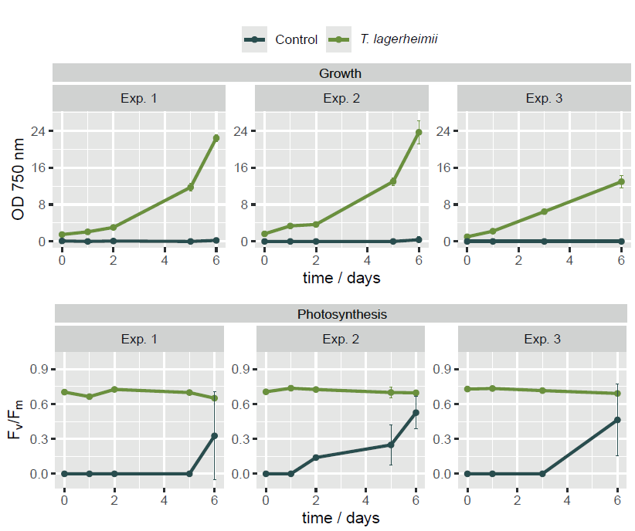
Supp Fig. 1 Growth curves (optical density 750 nm) and photosynthesis (F_{v}/F_{m}) during a six-day cultivation in wastewater. The photosynthetic activity in the controls indicates growth of native microalgal strains. Mean ± SD, N = 3, n = 1

