Supplementary material:
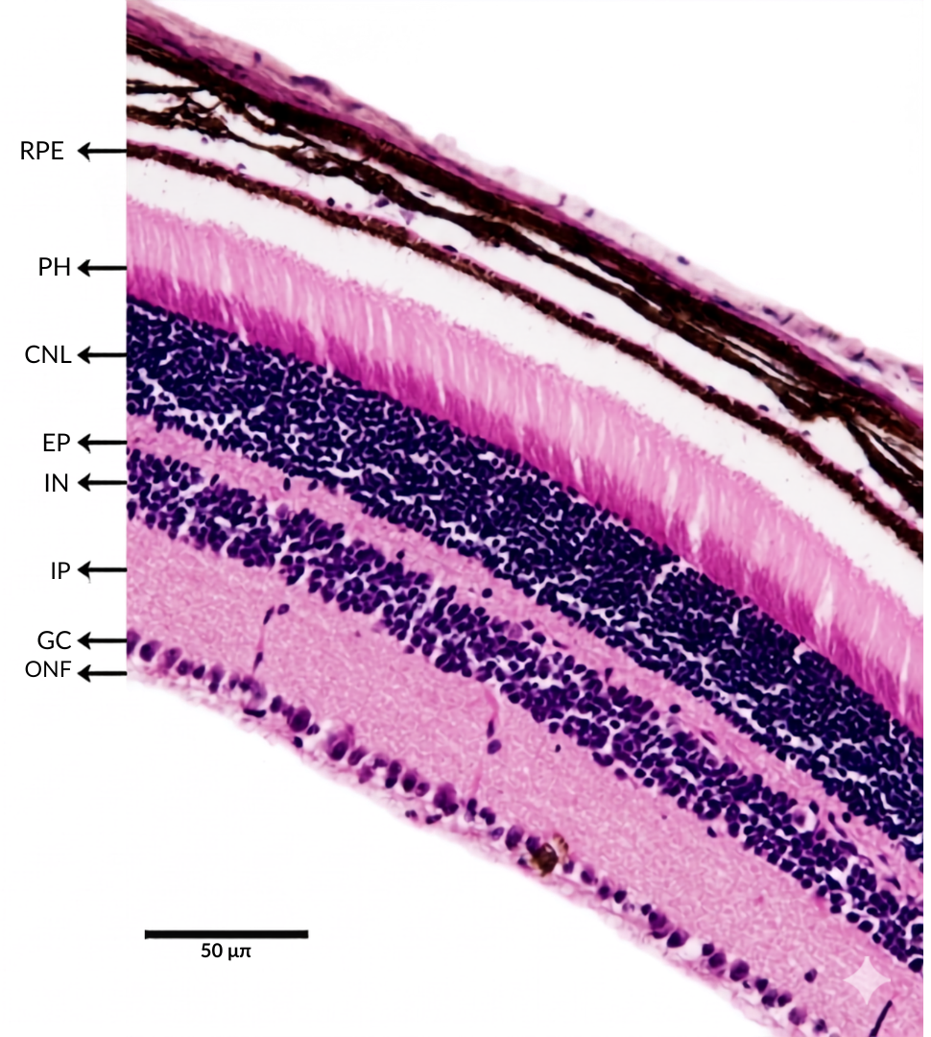

Legend: Retinal layers analyzed at 20x magnification: retinal pigment epithelium (RPE); photoreceptors (PH); outer nuclear layer (CNL); outer plexiform layer (EP); inner nuclear layer (IN); inner plexiform layer (IP); ganglion cell layer (GC); and optic nerve fibers (ONF).

