Understanding Water Sustainability Governance Through Rural Landscape Perspectives: A Case Study of the Shoalhaven, Australia

Contents of Supplementary Material

Item | Description
Supplementary Table S1 | Organisational background of key informants participating in the study
Supplementary Table S2 | Key informants' definitions of water sustainability, with key themes identified per participant
Supplementary Table S3 | Communication quotes by preferred channel and stakeholder group
Supplementary Table S4 | Anticipated consequences of ecosystem deterioration
Supplementary Table S5 | SDG understanding by participant - classification and active incorporation status
Supplementary Table S6 | Research priority themes - participant codes and disciplinary scope
Supplementary Figures S1–S9 | Figures with captions listed below
Supplementary Material B | Semi-structured interview guide - 19 thematic questions

Supplementary Table S1 - Organisational background of key informants participating in the study (n = 15)
Participants were drawn from eight stakeholder groups to ensure cross-sectoral representation: local government (n=3), state government (n=1), water utility (n=1), local environmental groups (n=4), conservation trust and land management (n=2), environmental NGO and research groups (n=2), industry and private sector (n=1), and academic research (n=1) which is reported in section 2.2,
Stakeholder group label | Description | Count (n) | Share (%)
Local Government | Responsible for environmental health, strategic planning, and water quality management | 3 | 20.0%
State Government | Responsible for natural resource management and extension activities | 1 | 6.7%
Water utility | Managing public water supply, wastewater treatment, and recycled water systems | 1 | 6.7%
Local environmental group | Local environmental community groups engaged in riverbank restoration, water monitoring, and environmental advocacy | 4 | 26.7%
Conservation Trust and Land Management | Natural resource and facilities managers responsible for catchment-scale land and water stewardship on trust lands | 2 | 13.3%
Environmental NGO and Research Group | Environmental engineers and landscape planners engaged in catchment rehydration, landscape function research, and community-based restoration programmes | 2 | 13.3%
Industry and Private Sector | responsible for industrial water use, wastewater treatment, and environmental compliance | 1 | 6.7%
Academic and Research | University-based researchers engaged in environmental communication, visual research methods, and water sustainability teaching | 1 | 6.7%
Total |  | 15 | 100%

Supplementary Table S2 - Key Informants' Definitions of Water Sustainability (Verbatim)
Definitions are presented verbatim to preserve the diversity of framings. These definitions underpin the thematic analysis reported in Section 3.1 of the main manuscript. One participant may contribute to multiple themes.
ID | Definition of Water Sustainability (verbatim) | Key Themes
P1 | "I think it basically means that our river systems, streams and so on do not decline in quality, including the ecosystems that they support" | Ecological non-deterioration; Ecosystem protection
P2 | “Keeping what we've got now or what we had in the past the same, or that it's not going to deteriorate, that's going to cause major problems. So, whether that's fish life or water quality or whatever, we should try to maintain that quality” | Ecological non-deterioration; Historical baseline preservation
P3 | “Water sustainability for me means that what we do on our property doesn't impact negatively on water availability for the broader landscape” | Land-use responsibility; Non-impact principle; Landscape-scale thinking
P4 | “Balancing the life-sustaining needs of the population with production and the natural environment with the end goal of limiting impacts to water quality and the catchment health. It kind of comes into that sort of triple bottom line approach of social, environmental and economic sustainability” | Balancing human and ecological needs; Triple bottom line; Catchment health
P5 | "It's about not overusing, making sure the resource is not used, over-extraction or anything like that. And that you're maintaining the health of the river ecosystem, maintaining that river health with or improving it” | Resource limits and non-extraction; Ecosystem restoration; River health
P6 | “Water sustainability is having our landscapes functioning to the point that water is moving and being stored and being cycled through our landscape in a way that provides us all of those beneficial ecosystem services. The environment's happy, but also the people are therefore happy” | Landscape function and ecosystem services; Water cycling; Human-ecological co-benefit
P7 | “Water sustainability is the use of the water resource that facilitates human health and protects environmental sustainability” | Balancing human and ecological needs; Environmental non-degradation; Human health protection
P8 | “The use of water is environmental and commercial, and it should be used wisely wherever needed” | Wise use principle; Impact awareness; Commercial-environmental balance
P9 | “I think we really need to understand our water cycles. Water is a finite thing. It doesn't disappear and get created easily. It just cycles through different systems, and human impact has vastly changed those systems” | Conceptual critique; Water cycle understanding; Finite resource awareness
P10 | "It's the management of our water resources in such a way that they are not diminished in either quantity or quality, quantity is availability” | Resource management; Quantity-quality non-diminishment
P11 | “Having a good quality of environment for both the current and future situations, not only for human consumption but also for other sorts of environmental demands” | Intergenerational equity; Dual human-environmental purpose
P12 | “From a customer perspective as well as an environmental perspective, it's the ability to get water to the customer and obviously in an environmentally friendly way... economical supply of water, economically and environmentally” | Service delivery framing; Economic-environmental balance; Climate consideration
P13 | “Being able to access fresh, clean sources of water for as long as forever. And doing so in a way that's not cost-prohibitive or resource-prohibitive... just getting it in a sustainable long-term fashion” | Long-term access; Affordability; Climate-aware suppl
P14 | “Water sustainability is not how much water we have, it is about how healthy water is, how clean our systems are, and how well the biodiversity in the systems functions” | Balancing human and ecological needs; Water health beyond quantity; Biodiversity functioning
P15 | “The basic bottom line is that we have sufficient water to meet initially our domestic needs and then also our farming needs. Management of water resources comes into that” | Resource sufficiency; Practical domestic and agricultural framing

Supplementary Table S3 - Communication Quotes by Channel and Stakeholder Group
Key informant quotes illustrating preferred communication approaches for water sustainability information in the Shoalhaven rural context. Full quotes are presented verbatim. These findings are discussed in Section 3.3 of the main manuscript.
ID | Quote | Communication Channel
P1 | "You've got social media and all sorts of things these days; it's got to be more than just producing leaflets. Things like YouTube, TikTok." | Social media and Digital platforms (YouTube, TikTok)
P2 | "We were writing a lot of press releases, and we were able to gain access to local radio stations saying what we're doing. We put out a flyer out, we had a webpage, we went from four or five volunteers to hundreds because we did the marketing at a local, voluntary level." | Press releases; local radio; flyers; website
P3 | "We attempt to do it through our education programmes, and school groups participate in tree planting events. We also advertise environmental walks and talks by experts or by local Indigenous people. I and some colleagues will often present at events, workshops and forums through Landcare networks." | School education; environmental walks and talks; website; landcare forums
P4 | "The first one we always do is one-on-one advice. Another way is extension workshops, bringing community members into a room to discuss it, get their questions, get them collaborating. We also do letterbox drops of information flyers to try and interact with targeted landholders." | One-on-one advice; extension workshops; letterbox drops; interagency meetings
P5 | "One of the best ways to communicate is through actually being out there, planting trees, stopping erosion, doing it. We produced a video about what we do with students, school excursions, educational resources for schools. Always come from a positive point of view; there's pride in your river." | Demonstration; video; school resources; media; signage
P6 | "Through demonstration, getting people in the paddock, walking around and actually looking at our waterways. Before and after photos are very powerful. If you can do aerial photos that show water and hydration in the landscape, that's a nice combination. For policymakers, having a theory of change document that outlines the process of holistic water management." | Field demonstration; photography; aerial imagery; theory of change documents; school curriculum; cultural events
P7 | "Having an open data set to the community, that's our AQUADATA system. Environmental scorecards are a very good way to communicate and monitor change. We went back 15 years to the State of Catchments report cards looking at water quality indicators, but that's dropped away because no one has time and it's not resourced or mandated." | Open data platform (AQUADATA); environmental scorecards; website; signage; social media; media releases
P8 | "You going to do a TikTok or a newsletter on the local community bulletin board, or an ad on TV? It needs a really broad range of approach. Education is really key for future generations, from primary school, from early childhood education, just teaching the value of a glass of water. | Multi-channel marketing; early childhood education; regulatory compliance
P9 | "We have email networks that people can be on. Landcare is a very good avenue to try and spread the word to local communities. I run our Facebook page, that's just to disseminate information on whatever projects we're working on. Getting the message out there is very tricky." | Email networks; Landcare workshops; Facebook; community events
P10 | "We've been actively lobbying policymakers and politicians to support our proposed changes to water policy. If we want to engage with politicians, we write them letters and we ring them up. It's easier to communicate through an institutional framework as opposed to as an individual. | Letters to politicians; fact sheets; institutional lobbying; field days; research publications
P11 | ""The State Environment Report is an ideal tool but it has dropped from government and is no longer mandatory. Social media would be a good option but a lack of usage, particularly in the environmental space, disconnects the purpose." | State environment reporting; social media
P12 | “Meetings between the major stakeholders. Then it's making sure the information is disseminated through the website, water quality newsletters here and there. We also do a lot of tours for groups and engage with University students.” | Stakeholder meetings; website; newsletters; tour groups; university partnerships
P13 | A water festival will be a good start, bringing it to the attention of people. Visualisation of things, whether in newsletters or on council websites, is an annual report bringing it forward and making it easy to access | Water festival; council website; newsletters; visualisation; annual reports
P14 | Telling stories visually helps as well, the use of visual metaphors. We need to move away from colonial ways of viewing water as a resource we own and control. Communicating about the interconnectedness of systems is what we need to focus on | Visual storytelling; visual metaphors; audience-specific communication
P15 | “The most effective way is having the information available on a website. Social media like Facebook for reaching residents. Letterbox drops for a smaller area. For politicians, initially the written word, letters.” | Website; Facebook; letterbox drops; letters to politicians

Supplementary Table S4 - Anticipated Consequences of Ecosystem Deterioration
Ten impact themes identified from key informant responses about consequences of continued ecosystem deterioration over the next 5–30 years in the Shoalhaven region. Discussed in Section 3.4 of the main manuscript.
Impact Theme | Participant Quotes and Evidence
Fisheries and aquaculture decline | Fish stocks are going to be reduced. No oysters." (P2). "No oysters for Christmas, the oyster farmers couldn't harvest because of the state of the river." (P5). Recreational fishing probably won't exist. Industry, commercial and oyster farms will probably be impacted as well." (P13)
Tourism and recreation impacts | If you use that example of St George's Basin, it's a gradual decline that could impact on things like recreational fishing, that waterway is a very popular recreational fishery." (P1). "Visually, tourists aren't going to want to come and see a brown, dirty, full of rubbish creek or river or beachfront." (P9). "The value of the area for tourism very strongly hinges on the quality of our waterways, the community places a high value on them. And so the consequences would be a strong pressure on government to take action." (P7))
Biodiversity loss and species extinction | Declining biodiversity resulting from all sorts of potential things, it's death by a thousand cuts." (P3). "We will see loss of flora and fauna communities, which could then lead to erosion on the waterway, then leading to sedimentation, which creates risk to recreation and risks of loss of our primary industries." (P4). Species will be threatened. Our valuable ecosystems will be disrupted; for example, we have salt marshes and other wetlands that will be impacted. Aquatic community extinction. Shoalhaven is an important bioregion for the Sydney Basin and it may be threatened." (P11).
Agricultural production and food supply | If our agricultural and rural industries are no longer able to use water because the quality has deteriorated so much, what are they going to do? Where are they going to get water from? Are some of the industries going to die?" (P2). "Loss of our primary industries on the south coast will lead to socioeconomic impacts as we lose that main driver of our economy." (P4). "The impacts on commercial fisheries, oysters and aquaculture would be significant." (P7). "The oyster farmers couldn't harvest because of the state of the river." (P5)
Landscape resilience and microclimate loss | The big thing is the dehydration of our landscape. With that, the lack of ability of our landscapes to create cool microclimates, to buffer temperature extremes, to filter water, but also have water in our landscapes for longer. Our landscapes will just be a lot drier, which makes them more brittle and more susceptible to shocks." (P6). With removal of trees, those pumps of the water cycle, you can seriously alter where the water is kept. The land will be drier, when it does rain the ground is harder and the water will run off into the creeks and end up in the ocean rather than staying on the land." (P9
Erosion cascade and sedimentation | Loss of flora and fauna communities could lead to erosion on the waterway, then leading to sedimentation in the waterway, which creates risk to recreation." (P4). "We'll see more of that fast-flowing water that causes erosion, causes flooding downstream, more flooding." (P6). "Erosion will continue or worsen if climate change changes the way that we expect.” (P13).
Climate-driven disasters, floods and bushfires | Our landscapes will be more brittle and more susceptible to shocks, when we have a drought or a fire, we see mass-scale destruction, and the landscapes won't bounce back as quickly as they would if they had been more functional and intact." (P6). "The consequences are deterioration in biodiversity, an increase in climate-related disasters, flooding, and potentially even more severe bushfires." (P14
Socioeconomic and community impacts | Loss of primary industries on the south coast will lead to socioeconomic impacts as we lose that main driver of our economy." (P4). "Tourism isn't going to want to come, visually a brown dirty creek or river will put people off." (P9)
Urban development and infrastructure failure | "Increased urban footprint in the Shoalhaven will increase runoff from housing, increased demand on water use, councils have just realised they don't have capacity for those two or three new housing estates." (P8)
Wetland and salt marsh disruption | Our valuable ecosystems will be disrupted, for example we have a salt marsh and other wetlands that will be impacted. Aquatic community extinction. Shoalhaven is an important bioregion for the Sydney Basin, and it may be threatened." (P11)

Supplementary Table S5 - SDG Understanding by Participant
Classification of each key informant's stated understanding of SDGs 6, 11 and 15. Classification criteria: Deep = specific SDG targets or active professional integration described; Moderate = general familiarity with specific SDGs but limited application; Basic = general awareness without SDG-specific knowledge; No understanding = explicit non-recognition. Discussed in Section 3.5 of the main manuscript.
ID | Participant Statement | Classification | Active incorporation
P1 | "I've got no idea. Never even heard of them." | No understanding | No
P2 | "Oh yeah, I've heard about it, but I just can't, we'll keep on doing what we've been doing, propagating mangroves." | Basic understanding | Partial
P3 | "I dunno what they are. I don't have a lot of faith in global framework approaches, it needs to be much more local. | No understanding | No
P4 | "I was somewhat familiar, particularly SDG 6, 11 and 15, I did go and look them up. But those goals aren't really talked about at all during my time at LLS or even in local government." | Moderate Understanding | No
P5 | "I dunno if it's really related but we are getting solar panels and a battery car. The water tank is part of our commitment. It's all tokenistic but it's what we can do as individuals." | No understanding | No
P6 | "This might be a question a little bit above me. My understanding of each goal is not as good as it could be, but the commitment is there." | Basic understanding | Partial
P7 | "The only time I come across the SDGs is when talking to students. They don't impact on my day-to-day work, they're up here, and I'm here looking at the river." | Basic understanding | No
P8 | "I know them. I probably agree with what the United Nations has to say. Those non-tangible assets were always not on the balance sheet, you want to see the bottom line. How much money did you make? Not how much water did you pollute?" | Basic understanding | No
P9 | "I used to know what sustainable development was. I wouldn't know now. But ironically, my whole job supports those goals, all the projects we work on, whether it's biodiversity or ecosystem health, they're all water related. | Basic understanding | Indirect
P10 | "Well, I live by them. My every breath is dedicated to supporting those goals, has been since the late 1980s, and I will continue till my dying day." | Deep understanding | Yes
P11 | "These goals are not driven through the council; there is no mandatory engagement with these goals." | Basic understanding | No
P12 | "No idea. What are these? I've never heard of it. Obviously I don't have a problem with anything to support sustainability, basically fully supportive." | No understanding | No
P13 | Off the top of my head I can't remember which ones they are. But it's all in our sustainability report, we've listed out what we do for each of these goals." | Moderate Understanding | Partial
P14 | "I think these goals are great and I work with them at my university. These are really relevant to us as researchers, it's a lens through which to look at your questions and consider what contribution you're making." | Deep understanding | Yes
P15 | "No, no, I don't know. SDGs are really hard for third world countries. I just can't believe how ignorant the world still is." | No understanding | No

Supplementary Table S6 - Research Priority Themes with Participant Codes
Nine research priority themes identified through thematic analysis. Priority levels reflect frequency of mention and urgency expressed across the 15 key informant interviews. Themes are not mutually exclusive. Discussed in Section 3.8 of the main manuscript.
Research Priority Theme | Priority | Participant  Codes | Key Issues / Priorities Identified | Relevant Disciplines
1. Water quality  and pollution monitoring | High | P1, P5, P8,  P12, P13, P15 | • PFAS contamination from military base affecting human and ecosystem health  • Nutrient loading exceeding ANZAC guideline thresholds  • Microplastics in waterways inadequately monitored  • Gross pollutants from urban runoff entering creek systems untreated | Environmental chemistry;  water quality science;  toxicology; public health
2. Ecosystem health  and biodiversity assessment | High | P3, P4, P7,  P9, P11 | • Shoalhaven waterway ecosystem health lacks consistent baseline data  • Fauna and macroinvertebrate surveys fragmented across agencies  • Artificial wetland effectiveness as water management tools under-researched  • Riparian vegetation condition not monitored at catchment scale | Freshwater ecology;  restoration ecology;  biodiversity science;  estuarine ecology
3. Urbanisation and  stormwater management | High | P1, P2,  P5, P13 | • New developments lack mandatory detention pond requirements  • Stormwater runoff volumes exceeding drainage infrastructure capacity  • Flash flooding increasing in established communities  • Urbanisation-biodiversity trade-offs not quantified | Urban hydrology;  environmental planning;  stormwater engineering;  catchment management
4. Governance fragmentation  and policy effectiveness | High | P6, P10,  P11, P12 | • No single authority with catchment-wide water sustainability mandate  • Fragmented accountability across Council, WaterNSW, NRAR, LLS and EPA  • Policy effectiveness for water sustainability outcomes not evaluated  • Water licensing constraints blocking utility capacity expansion | Environmental governance;  public policy;  institutional analysis;  water law
5. Environmental flows and  floodgate management | Medium-High | P4, P7, P10 | • Suitability of current environmental flow regime inadequately assessed  • Approximately 30 floodgates on Shoalhaven floodplain preventing tidal reintroduction  • Sydney extraction and local environmental flows in conflict during drought  • Marine algal bloom risk under reduced freshwater flow regimes unquantified | Hydrology;  environmental water management;  estuarine science;  floodplain ecology
6. Community engagement and  landholder behaviour change | Medium-High | P6, P10,  P13, P14 | • Community understanding of water sustainability concepts limited  • Landholder willingness to adopt water-sustainable practices poorly understood  • Education campaigns lack systematic evaluation of behaviour change outcomes  • People-river connectivity as a determinant of stewardship behaviour understudied | Environmental psychology;  social marketing;  extension science;  rural sociology
7. Recreation and land use  impacts on water systems | Medium-High | P4, P5,  P9, P15 | • Wake boating bank erosion documented but not independently quantified  • Oyster farmer water quality data not integrated into governance frameworks  • Land use change from dairy to cropping generating unassessed runoff impacts  • Current riparian management status on agricultural properties poorly documented | Recreation management;  agricultural science;  aquaculture; water quality;  land use planning
8. Indigenous knowledge  integration in water governance | Medium | P8 | • Yuin Nation custodial knowledge absent from formal water governance frameworks  • PFAS contamination disproportionately impacting Jervis Bay Aboriginal communities  • Water as cultural kin incompatible with current volumetric management frameworks  • Co-design of Indigenous-inclusive water monitoring frameworks not undertaken | Indigenous studies;  social-ecological systems;  cultural water values;  environmental justice
9. Water supply affordability  and infrastructure planning | Medium | P11, P12 | • Cost of water supply delivery to growing coastal communities not assessed  • REMS wastewater recycling scheme impact on catchment health not formally evaluated  • Licensing constraints under NRAR blocking capacity expansion  • Long-term water security under extended drought and population growth unplanned | Water resources engineering;  utility management;  water economics;  climate adaptation
Note: Priority levels reflect frequency of mention and urgency expressed across key informant responses. Participant codes reflect primary contribution to each theme; some participants contributed to multiple themes. P1–P15 refer to anonymised key informants as used throughout the main manuscript.
Supplementary Figures S1 – S9 - Captions and Cross-References
Label | Caption
Supplementary Figure S1 | Stakeholder perceptions of the current state of water sustainability in the Shoalhaven rural region. Refer to Section 3.1 of the main manuscript.
Supplementary Figure S2 | Key factors influencing perceived water sustainability in the Shoalhaven rural landscape as identified by key informants across government, agricultural, community, and environmental sectors. Refer to Section 3.1 of the main manuscript.
Supplementary Figure S3 | Four categories of indicators used by key informants to assess water sustainability in the Shoalhaven region. Refer to Section 3.2 of the main manuscript
Supplementary Figure S4 | Institutional, community-based, and technical frameworks used or recognised by key informants for assessing water sustainability in rural Shoalhaven. Refer to Section 3.2 of the main manuscript.
Supplementary Figure S5 | Key informant suggestions for better ways to assess water sustainability in the Shoalhaven region. Refer to Section 3.2 of the main manuscript.
Supplementary Figure S6 | Pathways identified by key informants for incorporating First Nations knowledge into rural water sustainability governance in the Shoalhaven region. Refer to Section 3.3 of the main manuscript.
Supplementary Figure S7 | Lollipop chart showing the relative prominence of human activities impacting water resources in the Shoalhaven rural region, based on coded key informant statements. Refer to Section 3.6 of the main manuscript
Supplementary Figure S8 | Stakeholder groups and collaboration themes identified by key informants as most important for improving rural water sustainability in the Shoalhaven region. Refer to Section 3.7 of the main manuscript.
Supplementary Figure S9 | Nine priority research domains for assessing and improving rural water sustainability in the Shoalhaven region, identified by key informants. Refer to Section 3.8 of the main manuscript.

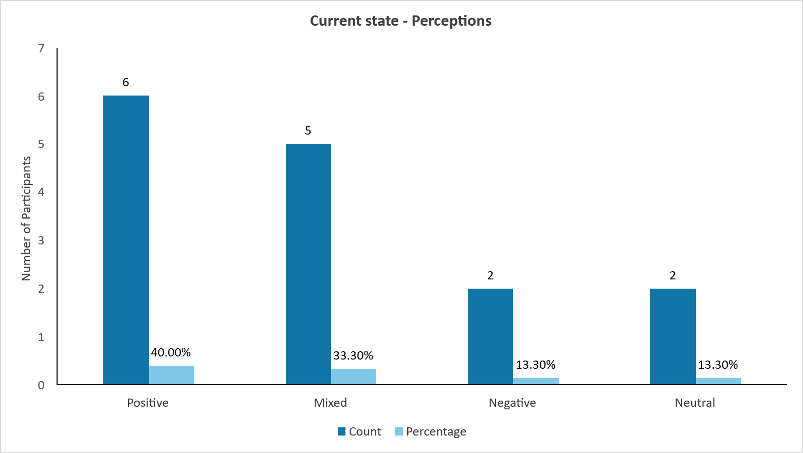
Figure S1. Stakeholder perceptions of the current state of water sustainability in the Shoalhaven rural region, categorised as positive, mixed, negative, or neutral based on key informant interview responses (n=15)

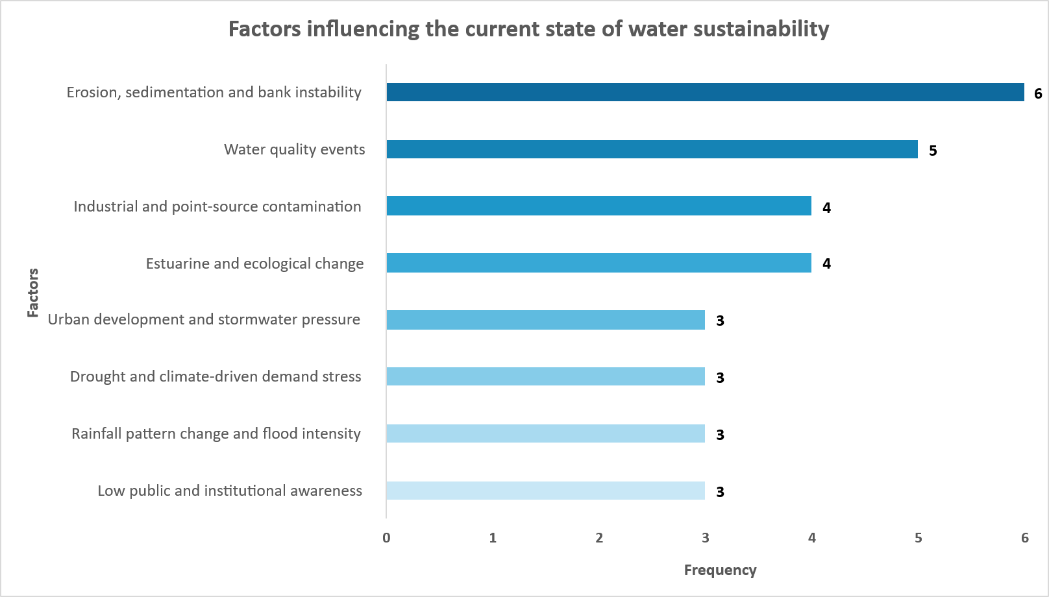
Figure S2. Key factors influencing perceived water sustainability in the Shoalhaven rural landscape as identified by key informants across government, agricultural, community, and environmental sectors.

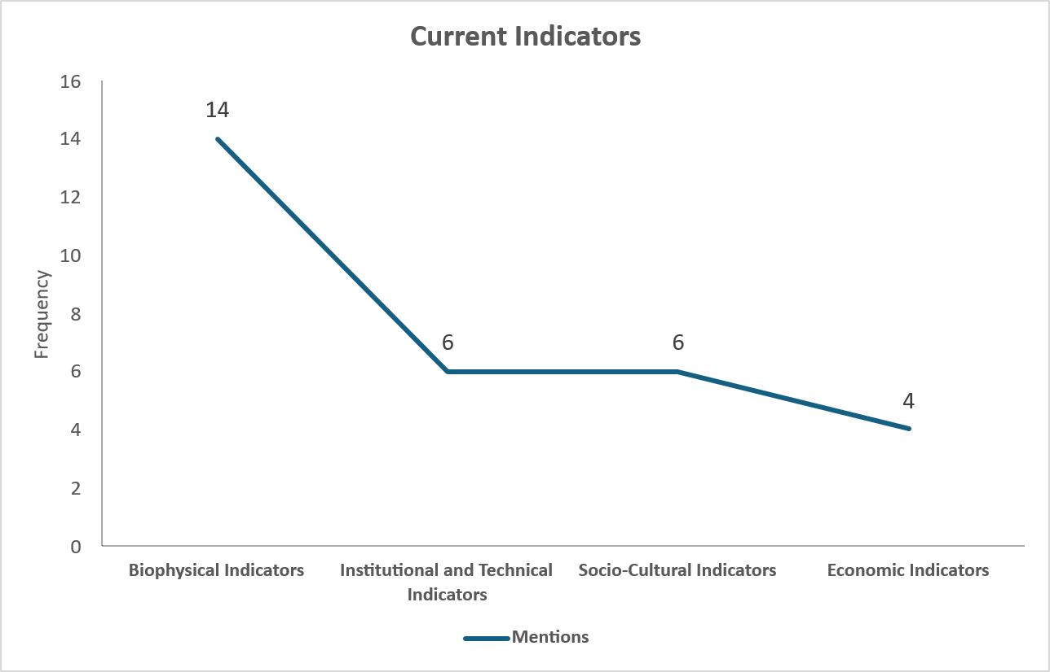
Figure S3. Four categories of indicators used by key informants to assess water sustainability in the Shoalhaven region

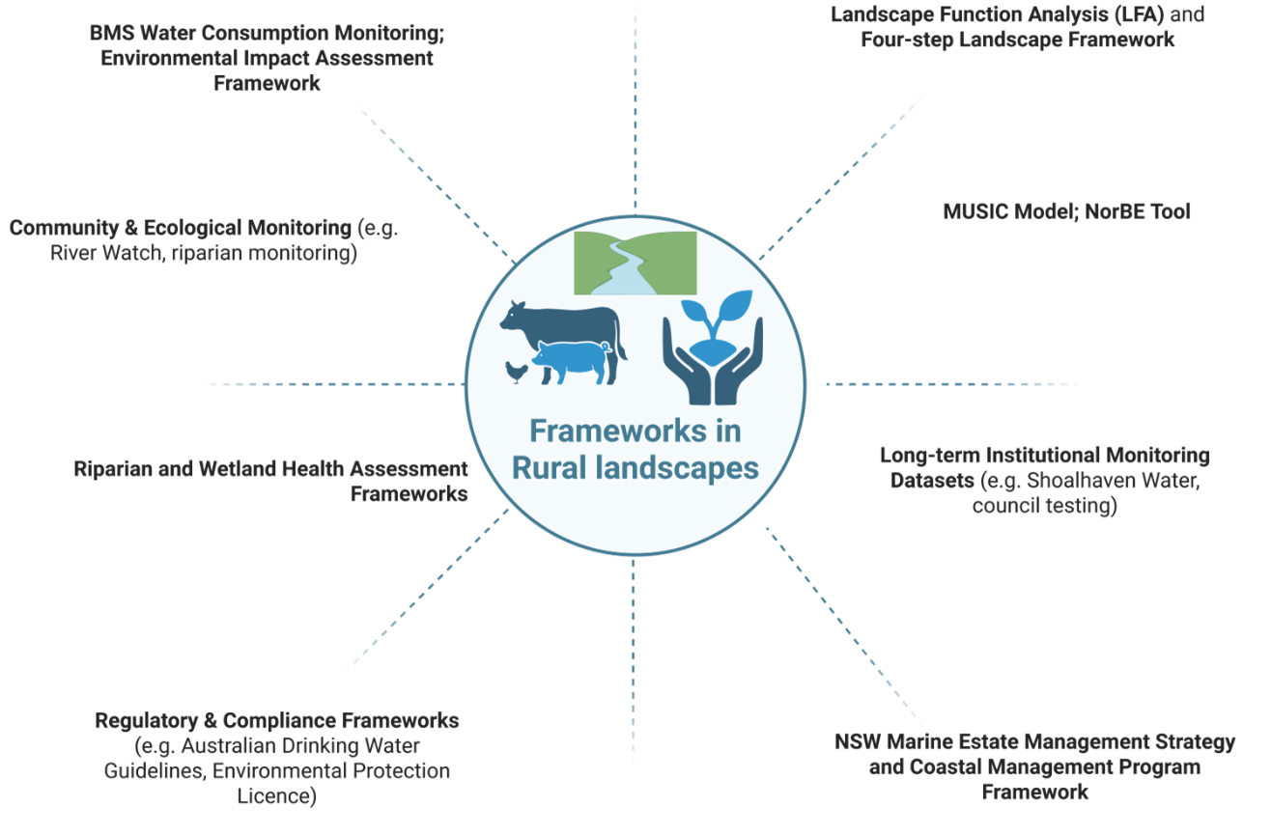
Figure S4. Institutional, community-based, and technical frameworks used or recognised by key informants for assessing water sustainability in rural Shoalhaven

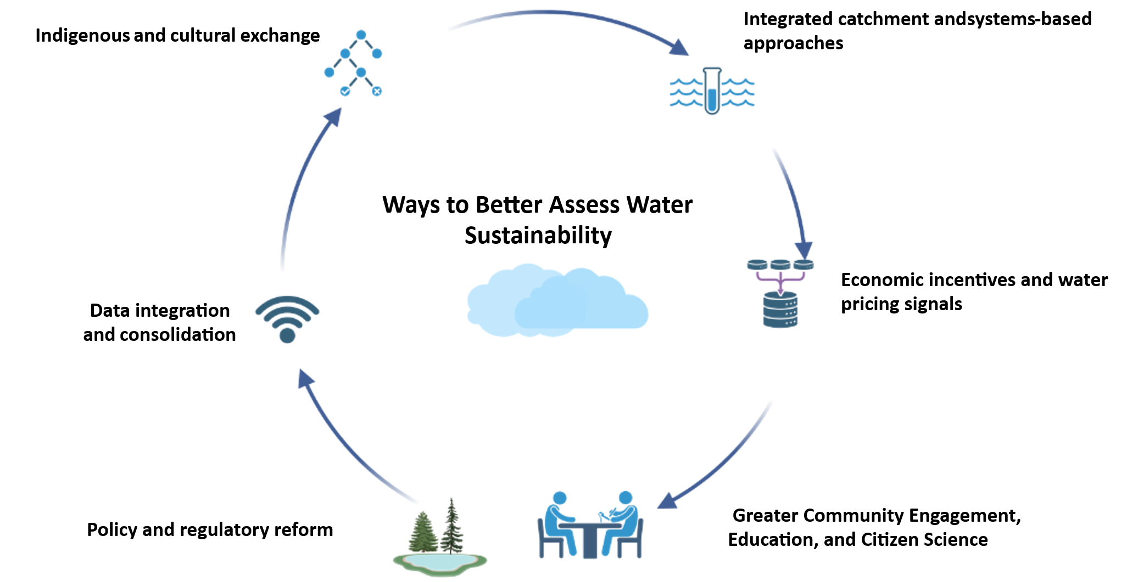
Figure S5. Key informant suggestions for better ways to assess water sustainability in the Shoalhaven region

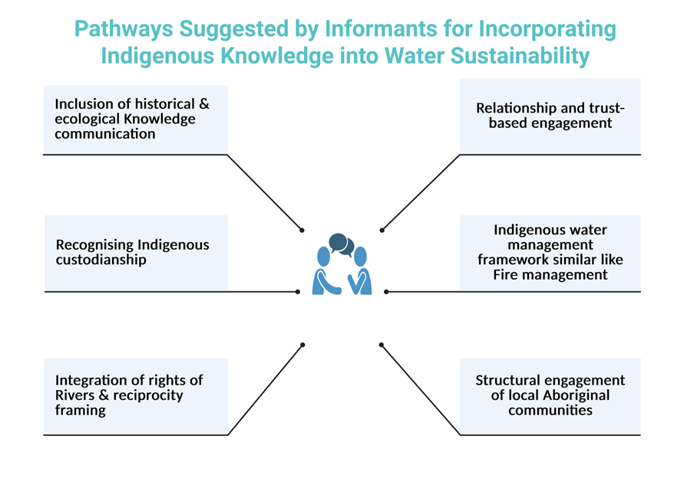
Figure S6. Pathways suggested by key informants for engaging with First Nations knowledge in rural water sustainability governance in the Shoalhaven region.

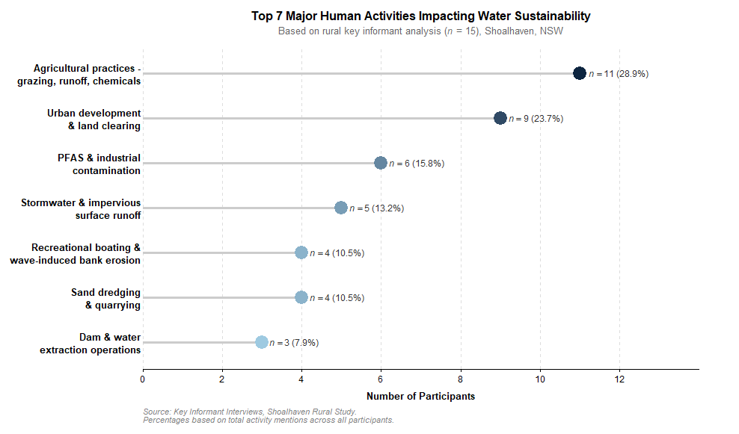
Figure S7. Lollipop chart showing the relative prominence of human activities impacting water resources in the Shoalhaven rural region, based on coded key informant statements
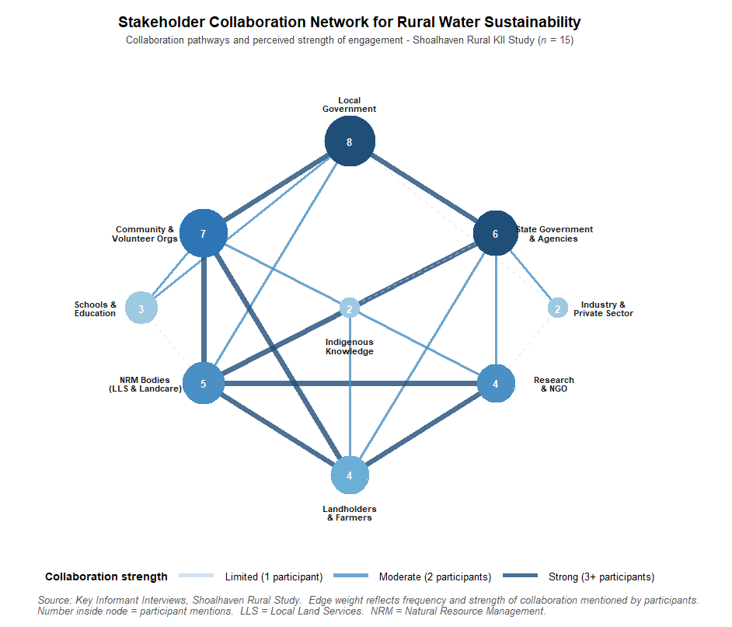
Figure S8. Stakeholder groups and collaboration themes identified by key informants as most important for improving rural water sustainability in the Shoalhaven region
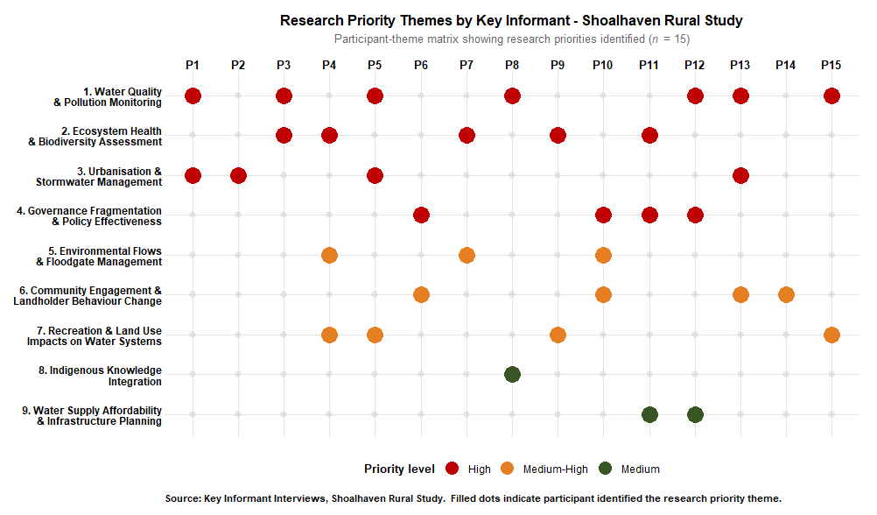
Figure S9. Nine priority research domains for assessing and improving rural water sustainability in the Shoalhaven region, identified by key informants
Supplementary Material B - Semi-Structured Interview Guide
The following 19 thematic questions were used for all key informant interviews conducted between September 2024 and September 2025. Questions were used flexibly to allow participants to expand on topics most relevant to their professional and community experience. Ethics approval: WSU HREC H16103.
Section I: General Background Information
1. Name
2. Age range
3. Gender
4. Education level
5. Suburb/postcode
6. Landscape classification: Rural (Shoalhaven LGA)
7. Occupation and organisation
8. Years of experience in water / environmental field

Section II: Thematic Interview Questions
Q | Theme | Interview Question
1 | Definition of water sustainability | Based on your previous knowledge and expertise, what is the meaning and interpretation of the term 'water sustainability' for you in a rural context?
2 | Current state | What is the current state of water sustainability in the Shoalhaven region? How would you describe it overall?
3 | Signs of decline | What are the apparent signs of declining water sustainability in the Shoalhaven rural landscape?
4 | Indicators | What indicators can we use to measure water sustainability in your area? What do you currently use or monitor?
5 | Frameworks | Are there any steps or frameworks you use or are familiar with to assess water sustainability in rural contexts?
6 | Better assessment methods | What are better ways to assess water sustainability in the Shoalhaven region? What improvements would you recommend?
7 | Communication | What are the most effective ways to communicate the status of water sustainability to different stakeholders, community, government, farmers, and others?
8 | Indigenous knowledge | Could you share your thoughts about pathways for incorporating Indigenous knowledge and wisdom into sustainable water management in the Shoalhaven region?
9 | Ecosystem health | What are your thoughts on the current health of water-related ecosystems in the rural Shoalhaven area, rivers, wetlands, creeks, and aquifers?
10 | Consequences of deterioration | If the current trajectory of ecosystem deterioration continues, what consequences do you foresee for the Shoalhaven region in the next 5, 10, and 30 years?
11 | SDGs (6, 11 and 15) | What is your understanding of Sustainable Development Goals 6, 11, and 15, and how are they relevant to water sustainability in this region?
12 | Pressures on water sustainability | What is affecting water sustainability in the Shoalhaven rural landscape? What are the main pressures on water resources?
13 | Human activities | What are the major human activities impacting water resources and sustainability in the Shoalhaven region?
14 | Successful initiatives | What are the current successful initiatives that have improved water sustainability in the Shoalhaven region?
15 | Short, medium and long-term actions | What short-term, medium-term, and long-term actions should be taken to improve water sustainability in rural Shoalhaven?
16 | Stakeholder collaboration | What role can the community and other stakeholders play in improving water sustainability? What collaborative approaches would be most effective?
17 | Sufficiency of current actions | In your view, are the current actions sufficient to improve water sustainability in this region? Why or why not?
18 | Stakeholder responsibility | Who can be most effective in improving rural water sustainability, government, councils, water authorities, industry, community, or others?
19 | Priority research areas | What are the priority research areas needed to better understand and improve water sustainability in the rural Shoalhaven landscape?

Note: The consent form is retained by Western Sydney University in accordance with WSU HREC Protocol H16103 and is not included in this supplementary file for participant privacy reasons. Ethics queries may be directed to humanethics@westernsydney.edu.au.

