Genome-wide identification, characterization and expression profiles of heavy metal ATPase 3 (HMA3) in plants
Ahmad Humayan Kabir^{1*}, Urmi Das¹, AFM Mohabubul Haque¹, Amit Kumar Dutta², Gholamreza Gohari^{3*}, Md Abu Reza²

¹Molecular Plant Physiology Laboratory, Department of Botany, University of Rajshahi, Rajshahi 6205, Bangladesh; AHK: ahmad.kabir@ru.ac.bd, UD: dasurmi2911@gmail.com, AFMMH: mahabub_90@yahoo.com
²Department of Genetic Engineering and Biotechnology, University of Rajshahi, Rajshahi 6205, Bangladesh; AKD: amitdutta_81@yahoo.com, MAR: reza.gen@ru.ac.bd
³Department of Horticulture, Faculty of Agriculture, University of Maragheh, Iran; gohari.gh@maragheh.ac.ir
*Corresponding author: gohari.gh@maragheh.ac.ir (GG)
*Co-corresponding author: ahmad.kabir@ru.ac.bd (AHK)

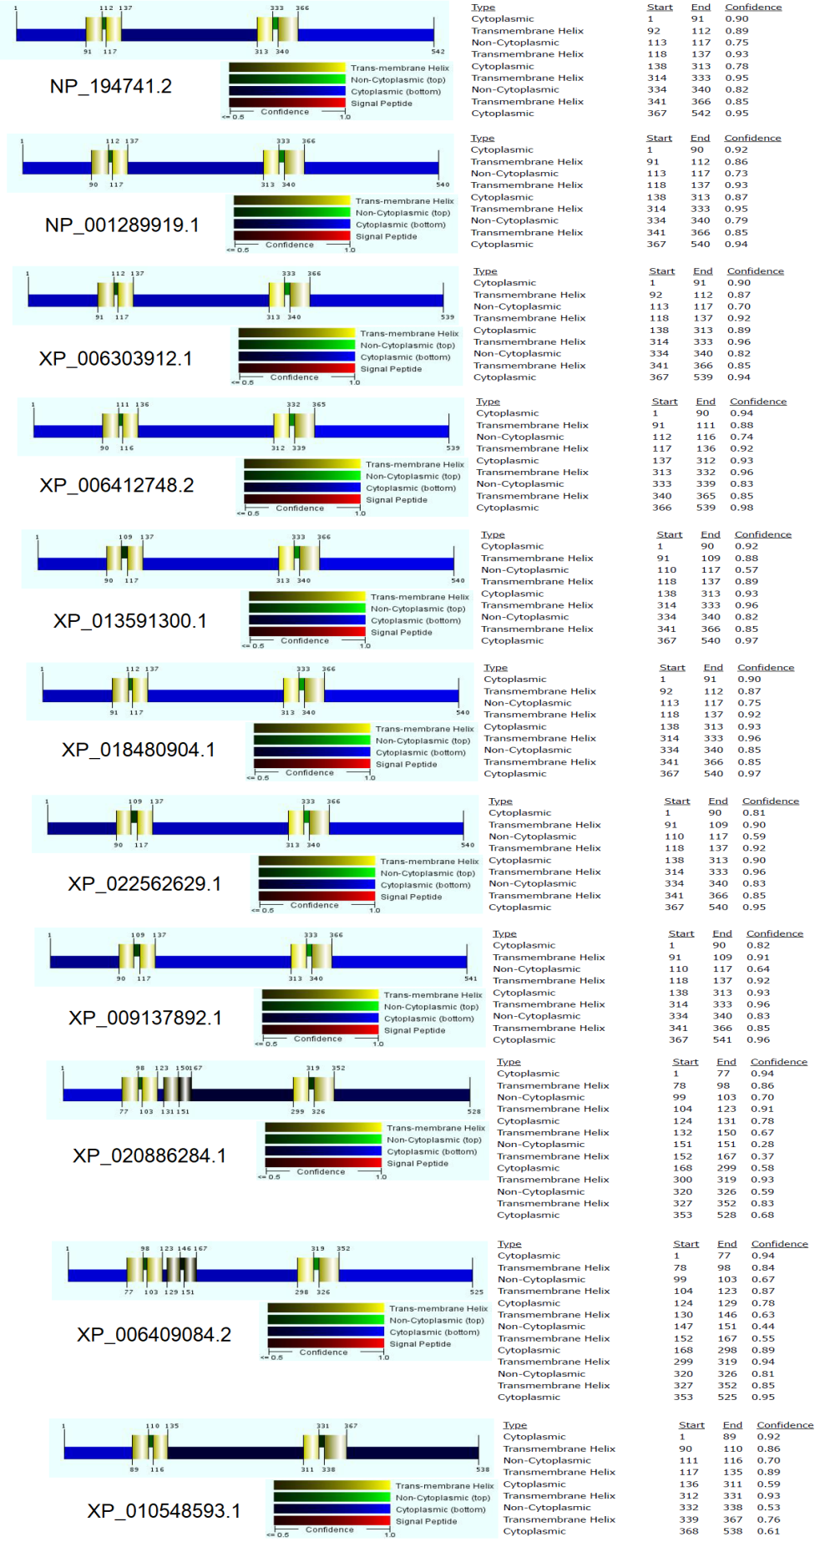
Fig. S.1. Prediction of transmembrane helix of HMA3 protein homologs.
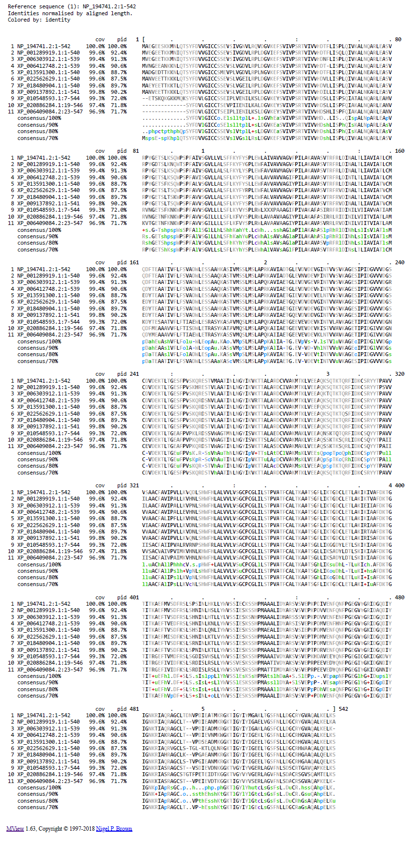
Fig. S.2. Multiple sequence alignment of HMA3protein homologs.

