Supplementary Figure 1 Kaplan-Meier curves for OS and CSS in the subgroups before PSM. (A-B) Kaplan-Meier curves for OS and CSS in patients with single HCC no more than 2 cm; (C-D) Kaplan-Meier curves for OS and CSS in patients with single HCC between 2-3 cm; (E-F) Kaplan-Meier curves for OS and CSS in patients with single HCC between 3-5 cm; (G-H) Kaplan-Meier curves for OS and CSS in patients with multiple tumors.
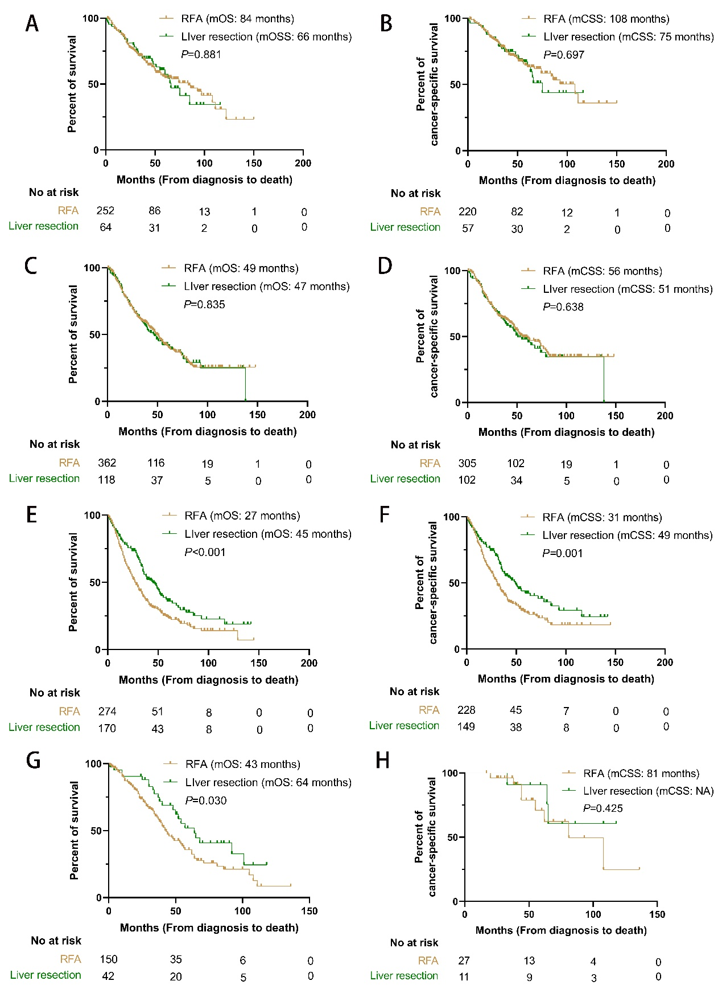
Supplementary Figure 2 Kaplan-Meier curves for OS and CSS in the subgroups after PSM. (A-B) Kaplan-Meier curves for OS and CSS in patients with single HCC no more than 2 cm; (C-D) Kaplan-Meier curves for OS and CSS in patients with single HCC between 2-3 cm; (E-F) Kaplan-Meier curves for OS and CSS in patients with single HCC between 3-5 cm; (G-H) Kaplan-Meier curves for OS and CSS in patients with multiple tumors.
