Supplementary Figures
Integrative genomic analyses reveal regional and cellular convergence between uterine fibroids and endometriosis
Vijayachitra Modhukur^{1,2*}, Prakash Lingasamy^{1,3}, Naisarg Patel^{1,2}, Andres Salumets^{1,2,4*}
- Celvia CC AS, Tartu, Estonia
- Department of Obstetrics and Gynaecology, Institute of Clinical Medicine, University of Tartu, L. Puusepa 8, Tartu, Estonia
- Nalam Biosciences OÜ, Tartu, Estonia
- Division of Obstetrics and Gynaecology, Department of Clinical Science, Intervention and Technology (CLINTEC), Karolinska Institutet, and Karolinska University Hospital, Stockholm, Sweden

* To whom correspondence should be addressed.
Dr. Vijayachitra Modhukur, Department of Obstetrics and Gynaecology, Institute of Clinical Medicine, University of Tartu, Tartu, Estonia. E-mail: vijayachitra.modhukur@ut.ee

Prof. Andres Salumets, Division of Obstetrics and Gynaecology, Department of Clinical Science, Intervention and Technology (CLINTEC), Karolinska Institutet, and Karolinska University Hospital, Stockholm, Sweden. E-mail: andres.salumets@ki.se

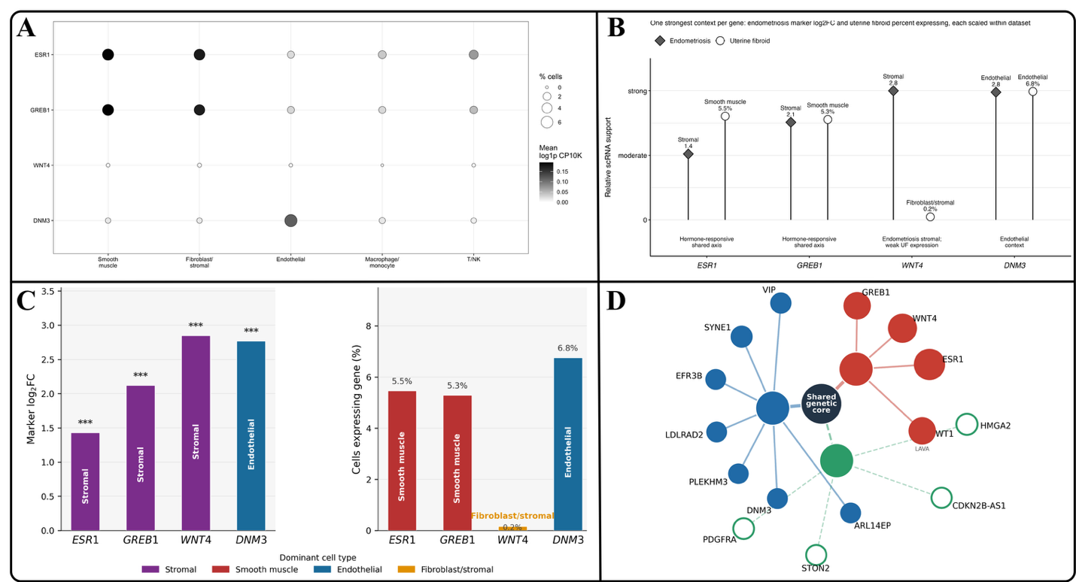
Supplementary Figure S1 Single-cell contextualisation of genes significant in both trait-specific MAGMA analyses. (A) Expression of selected genes across major cell compartments. (B) Descriptive cell context for selected genes across the endometriosis and uterine fibroid datasets. (C) Cell-type expression context for ESR1, GREB1, WNT4 and DNM3. (D) Network view integrating shared MAGMA genes with local-correlation and disease-context annotations. The panels provide expression context and do not establish causal genes or cell types.

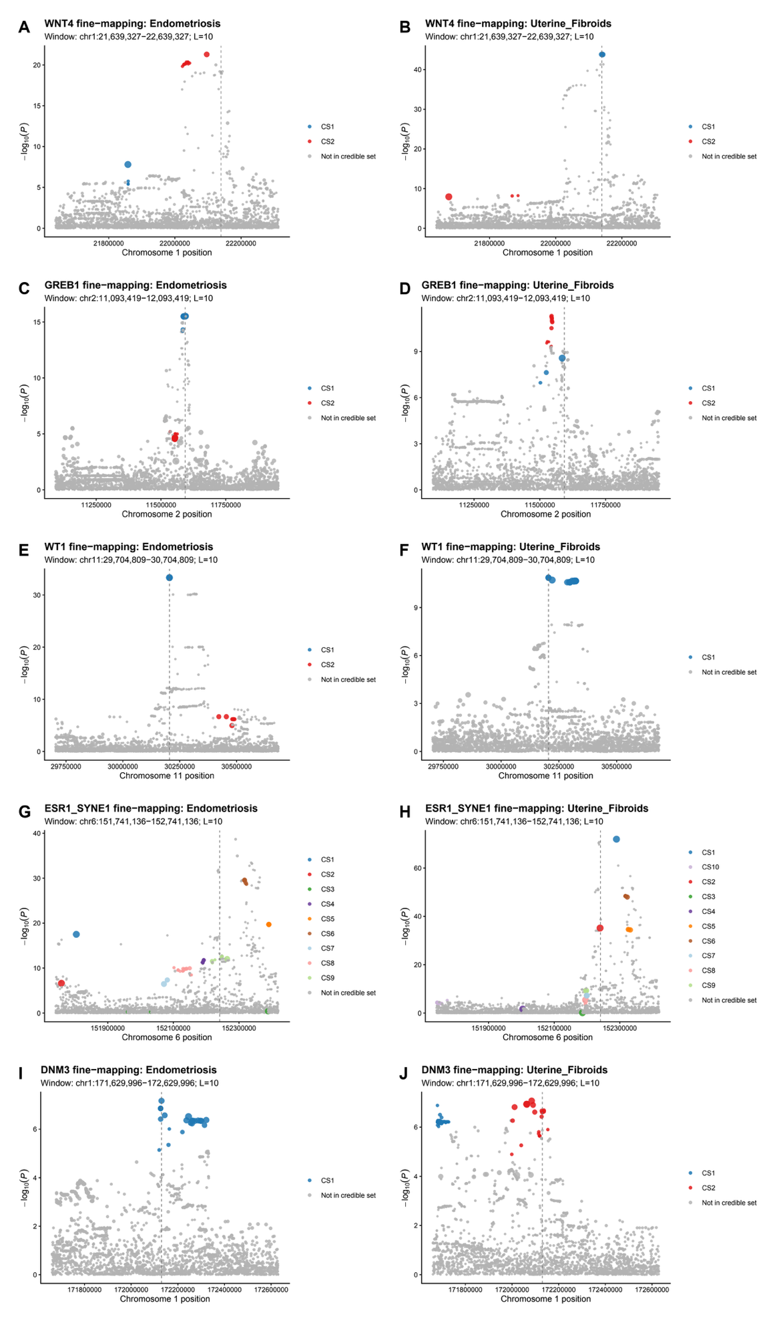
Supplementary Figure S2 SuSiE fine-mapping of shared genomic loci. Regional association plots show endometriosis and uterine fibroid results for WNT4 (A, B), GREB1 (C, D), WT1 (E, F), ESR1/SYNE1 (G, H) and DNM3 (I, J). Coloured points indicate variants assigned to SuSiE 95% credible sets; grey points were not assigned to a credible set. The multiple-signal pattern at ESR1/SYNE1 is consistent with allelic complexity.

