Supplementary Material

Supplementary Table S1. Scan-to-scan repeatability
Glucose concentration (mM) | CoV %
Glucose concentration (mM) | 1.5µT/5s | 1.6µT/5s | 1.7µT/5s | 2µT/5s
1 | 1.16 | 1.06 | 1.22 | 1.55
2 | 0.69 | 0.66 | 0.95 | 0.92
3 | 2.31 | 1.03 | 0.89 | 1.03
4 | 0.86 | 1.79 | 2.10 | 1.91
5 | 0.85 | 1.20 | 0.35 | 2.16
6 | 1.47 | 1.06 | 0.80 | 1.05
7 | 0.56 | 1.25 | 1.67 | 1.99
8 | 1.90 | 1.71 | 1.40 | 1.80
9 | 1.49 | 1.47 | 0.88 | 1.58
10 | 2.33 | 2.07 | 0.47 | 1.88
Mean | 0.95 | 1.16 | 0.71 | 1.39

Glucose concentration (mM) | CoV %
Glucose concentration (mM) | 1.5µT/5s | 1.6µT/5s | 1.7µT/5s | 2µT/5s
1 | 4.79 | 1.69 | 0.21 | 2.27
2 | 2.52 | 4.29 | 2.16 | 0.91
3 | 2.52 | 3.64 | 4.23 | 0.91
4 | 0.23 | 0.78 | 0.29 | 6.73
5 | 2.77 | 0.21 | 1.35 | 0.72
6 | 0.94 | 2.17 | 2.42 | 0.45
7 | 3.14 | 0.62 | 1.24 | 3.27
8 | 4.06 | 7.20 | 4.83 | 8.41
9 | 0.60 | 5.15 | 5.53 | 1.84
10 | 2.53 | 4.71 | 4.44 | 1.18
Mean | 1.74 | 3.12 | 2.78 | 2.22

Supplementary Table S2. Inter-session repeatability

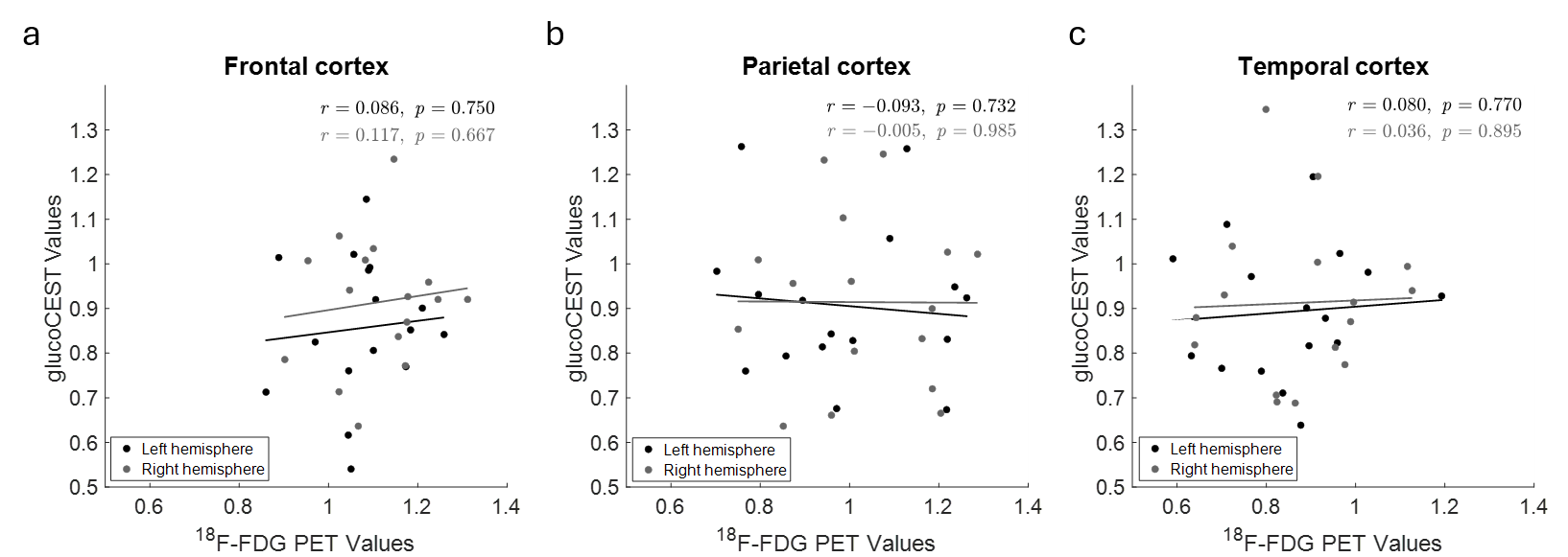
Supplementary Figure S1. Correlation between ¹⁸F-FDG PET and glucoCEST values across cortical regions. Correlations between ¹⁸F-FDG PET and glucoCEST values are shown for (a) the frontal, (b) parietal, and (c) temporal cortex. Each data point represents an individual hemispheric measurement from 16 patients included in the analysis (out of 18 available participants). Black points and regression lines represent the left hemisphere, whereas grey points and regression lines represent the right hemisphere. Pearson correlation coefficients (r) and corresponding p values are indicated on each plot. Correlation analyses were performed separately for each hemisphere and cortical region.
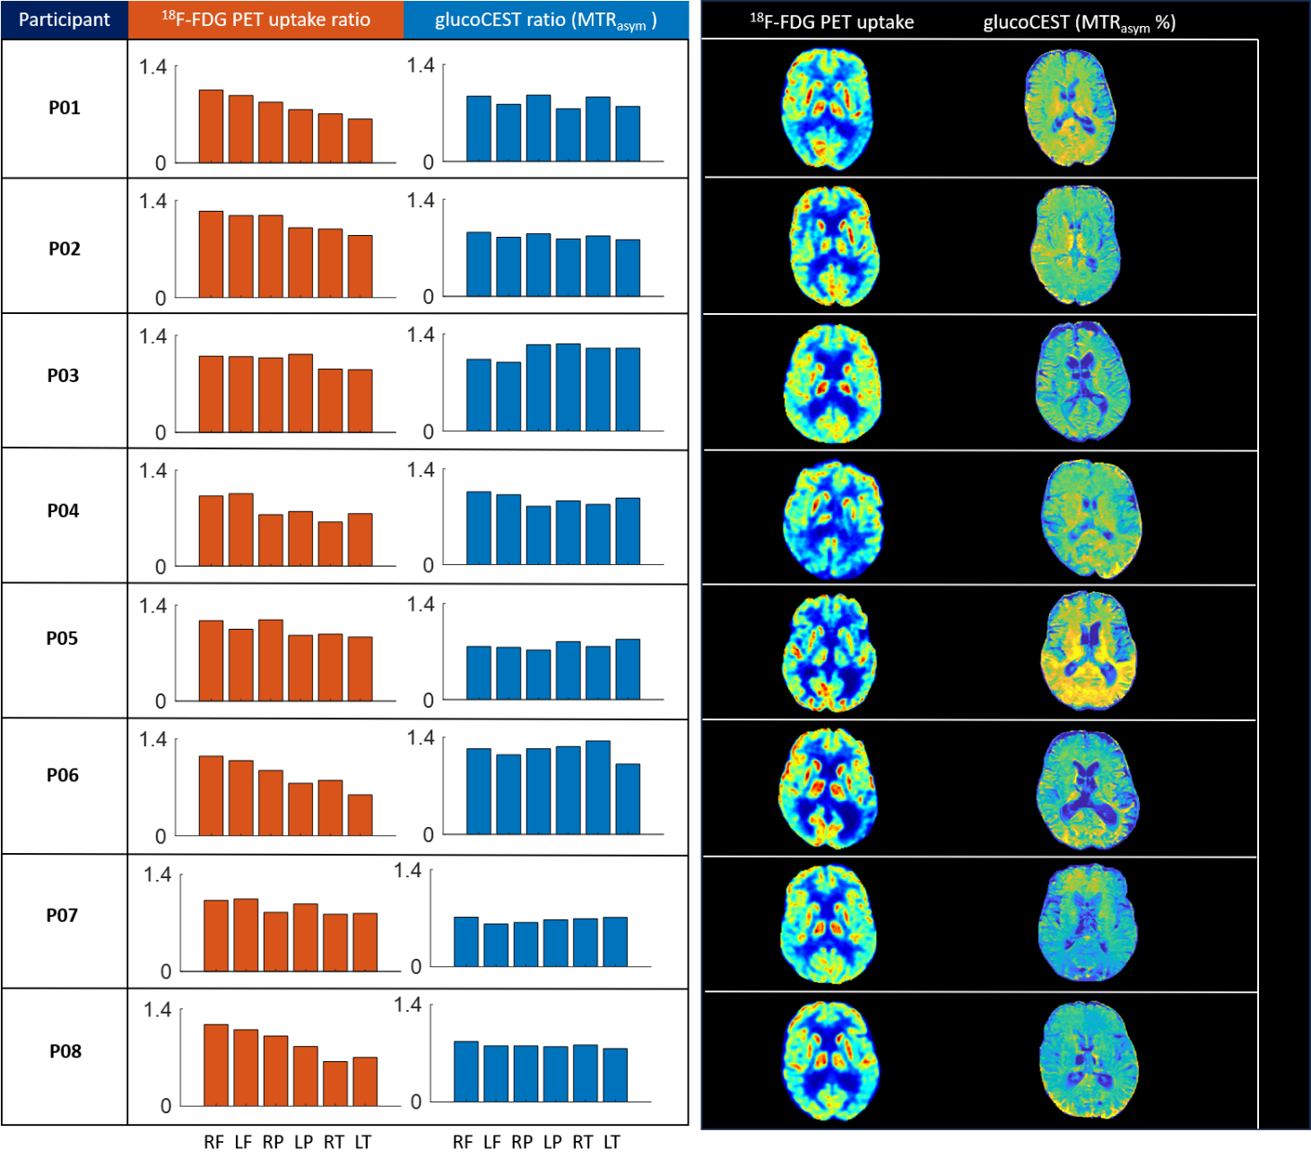
Supplementary Figure S2a. Regional signal intensity and corresponding images for P01-08. Bar plots on the left showing fluorodeoxyglucose positron emission tomography (¹⁸F- FDG-PET) and glucoCEST values, both normalised to thalamus, for regions of interest (ROIs) in frontal, parietal, and temporal cortex in both hemispheres. Corresponding ¹⁸F- FDG-PET images (raw image intensity display) and glucoCEST images are shown on the right for each participant. Each row represents an individual patient. The glucoCEST images are displayed using a fixed colour scale (0–14). ¹⁸F- FDG-PET images are shown with individual intensity scaling for visualisation; blue indicates lower tracer uptake and red indicates higher tracer uptake. RF = right frontal cortex, LF = left frontal cortex, RP = right parietal cortex, LP = left parietal cortex, RT = right temporal cortex, LT = left temporal cortex.

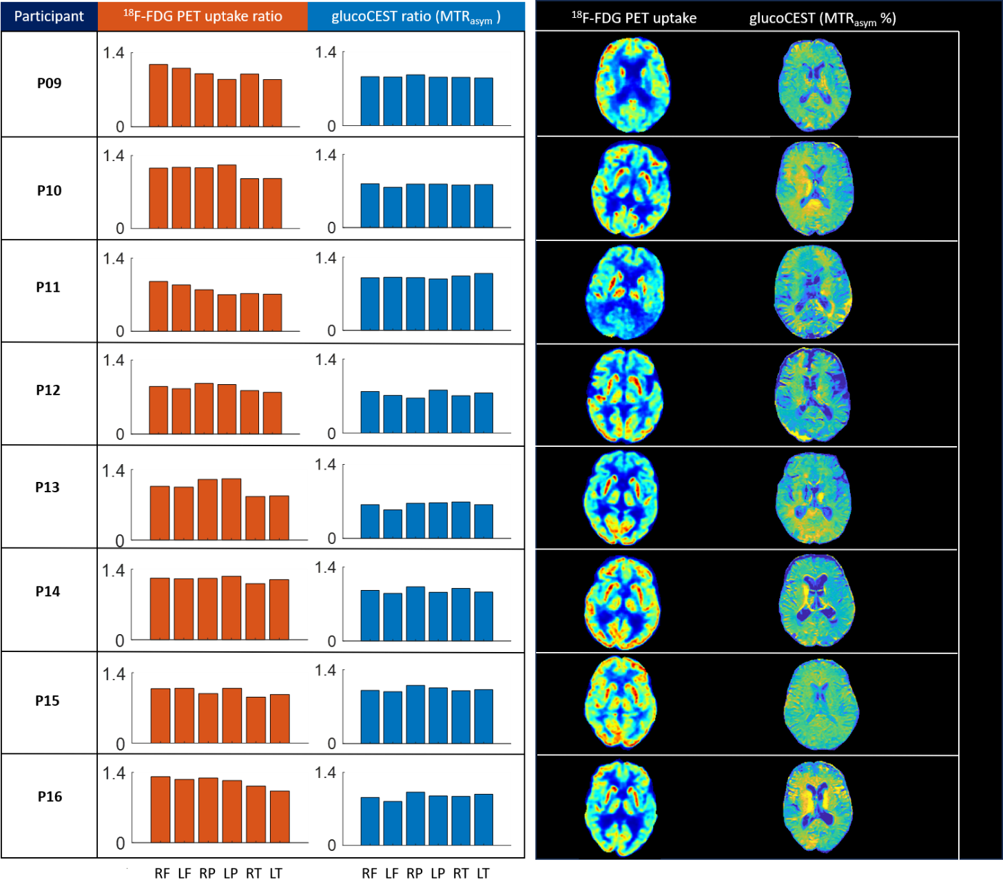
Supplementary Figure S2b. Regional signal intensity and corresponding images for P09-16. Bar plots on the left showing fluorodeoxyglucose positron emission tomography (¹⁸F- FDG-PET) and glucoCEST values, both normalised to thalamus, for regions of interest (ROIs) in frontal, parietal, and temporal cortex in both hemispheres. Corresponding ¹⁸F- FDG-PET images (raw image intensity display) and glucoCEST images are shown on the right for each participant. Each row represents an individual patient. The glucoCEST images are displayed using a fixed colour scale (0–14%). ¹⁸F- FDG-PET images are shown with individual intensity scaling for visualisation; blue indicates lower tracer uptake and red indicates higher tracer uptake. RF = right frontal cortex, LF = left frontal cortex, RP = right parietal cortex, LP = left parietal cortex, RT = right temporal cortex, LT = left temporal cortex.

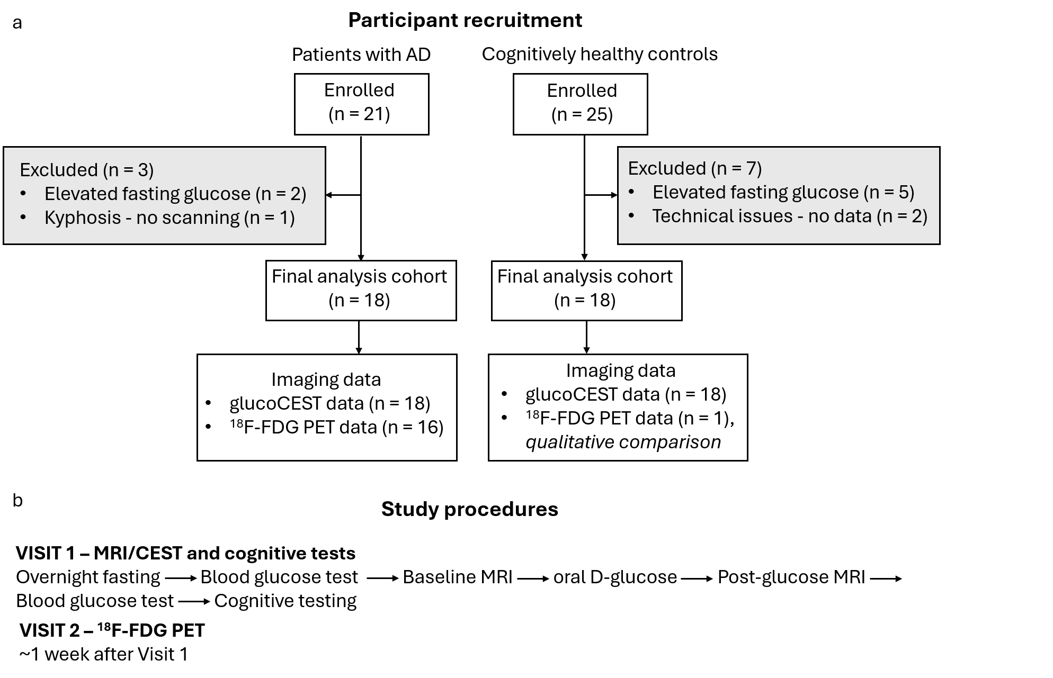
Supplementary Figure S3. Flowcharts of participant recruitment and study procedures. (a) Participant enrolment, exclusions, final study cohort, and available imaging data. (b) Study procedures for Visits 1 and 2.

