Supporting Information

Ultralight ultrafast enzymes

Xuepei Zhang¹, Zhaowei Meng¹, Christian M. Beusch¹, Hassan Gharibi¹, Qing Cheng²,
Luciano Di Stefano^{1,3}, Jijing Wang¹, Amir A. Saei^{1,4}, Ákos Végvári¹, Massimiliano Gaetani^{1,5,6}, Roman A. Zubarev^{1,7,8}*

¹ Division of Chemistry I, Department of Medical Biochemistry and Biophysics, Karolinska Institutet, SE-17 177 Stockholm, Sweden
² Division of Biochemistry, Department of Medical Biochemistry and Biophysics, Karolinska Institutet, Stockholm, Sweden
³ European Research Institute for the Biology of Aging, University Medical Center Groningen, University of Groningen, The Netherlands
⁴ Department of Cell Biology, Harvard Medical School, Boston, MA, USA
⁵ Chemical Proteomics Core Facility, Department of Medical Biochemistry and Biophysics, Karolinska Institute, Stockholm 17177, Sweden
⁶ Chemical Proteomics, Science for Life Laboratory (SciLifeLab), Stockholm 17177, Sweden
⁷ The National Medical Research Center for Endocrinology, 115478 Moscow, Russia
⁸ Department of Pharmacological & Technological Chemistry, I.M. Sechenov First Moscow State Medical University, Moscow, Russia

General
Supplementary Figure 1. Dose-response effect on E.coli growth.
Supplementary Figure 2. Comparison of T_{m} of proteins in Normal and Ultralight samples.
Supplementary Figure 3. Verification of luciferase YY5 fracI by mass spectrometry and activity comparison of Normal and Ultralight enzyme.
Supplementary Figure 4. Trx expression plasmid information and verification of Trx by mass spectrometry.
Supplementary Figure 5. BsDHFR expression plasmid information and verification of BsDHFR by mass spectrometry.
Supplementary Figure 6. Verification of Pfu by mass spectrometry and activity comparison of Normal and Ultralight enzyme.
Supplementary Table 1. Slope result of proteins in E.coli grown in Normal and Depleted M9 media.
Supplementary Table 2. T_{m} result of proteins in E.coli grown in Normal and Depleted M9 media.
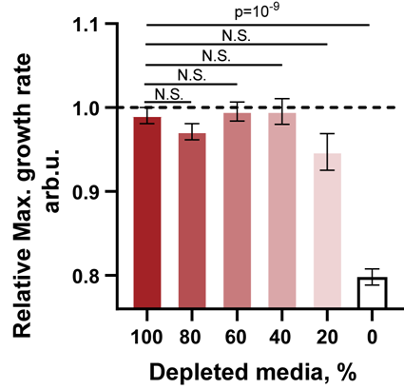
Supplementary Fig. 1. Dose-response effect on E.coli growth. Dose-response effect of the Depleted media dilution by the Normal media on maximum growth rate of E. coli bacteria (n=8).
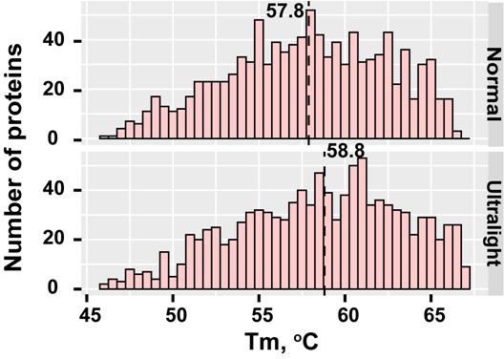
Supplementary Fig. 2. Comparison of T_{m} of proteins in Normal and Ultralight samples. Histogram of Tm of proteins in E.coli grown in Normal media (top) and Depleted medium (bottom). The lines indicate the median Tm values (n=3).

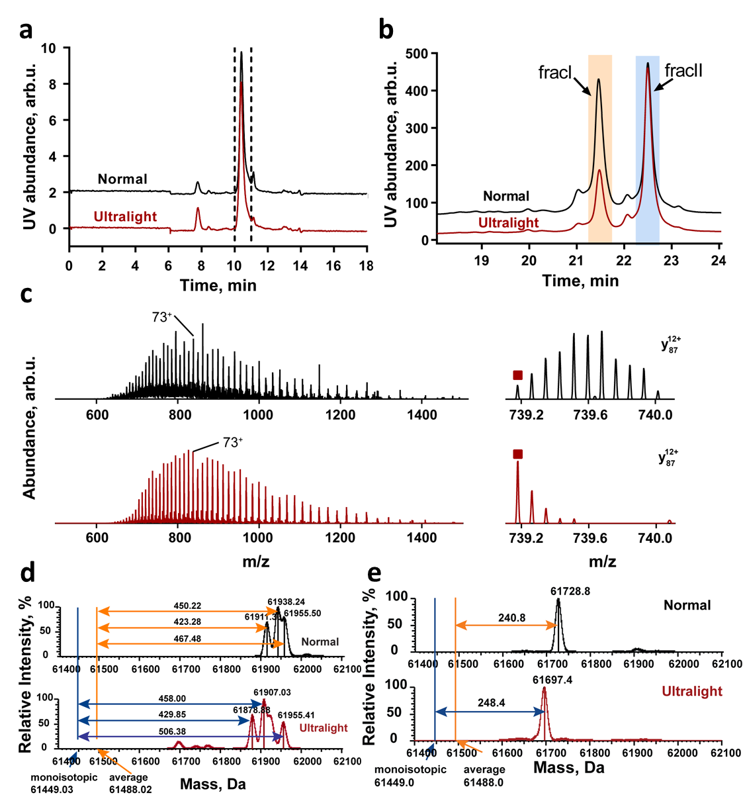
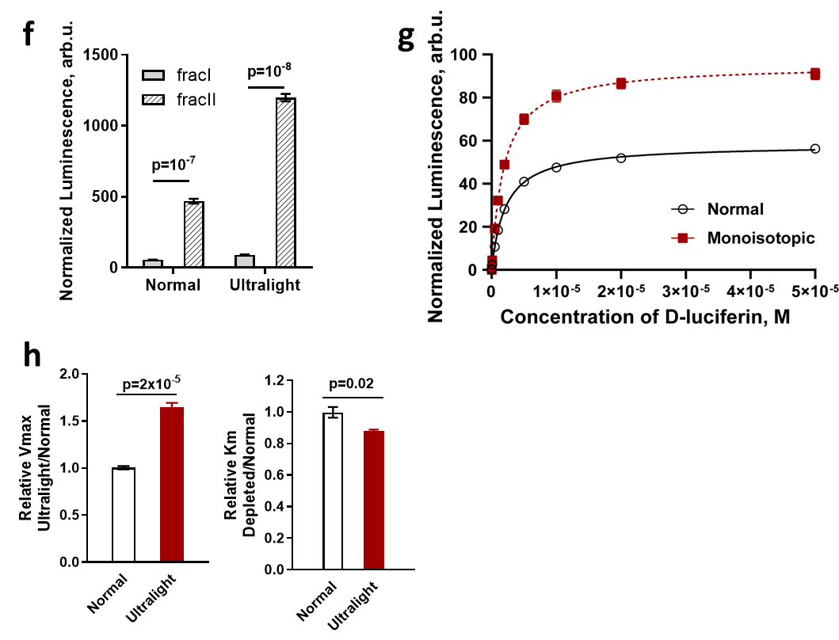
Supplementary. Fig. 3. Verification of luciferase YY5 fracI by mass spectrometry and activity comparison of Normal and Ultralight enzyme. a, Purification of Normal and Ultralight luciferase YY5 by size exclusion chromatography (SEC). The fraction eluted from 10-11 min was confirmed as luciferase YY5 and used for further purification. b, Purification of Normal and Ultralight luciferase YY5 by strong cation exchange (SCX) chromatography using a NaCl gradient. Two fractions with components of Luciferase YY5, fracI and fracII were collected for activity measurement. c, Electrospray ionization mass spectra from SEC of Normal and Ultralight BsDHFR (left) and a backbone fragment obtained by MS/MS of molecular ion, squares - the monoisotopic peaks. Deconvolution result of intact MS analysis of fracI (d) and fracII (e) in Normal and Ultralight luciferase YY5. f, The enzyme activity of the two components in Normal and Ultralight luciferase YY5 when the concentration of D-luciferin was 50 mM (n=4). g, Activity of luciferase YY5 fracI purified by SEC and SCX. Different concentrations (0-50mM) of D-luciferin were used for enzyme assay. The luminescence of each fraction was normalized to the total UV absorbance of the fraction on SCX. The data were fitted to the Michaelis-Menten equation using software GraphPad Prism 8 to calculate apparent Vmax and Km (n=4). h, Relative kinetic parameters including Vmax (left) and Km (right) of Normal and Ultralight luciferaseYY5 fracI (n=4).

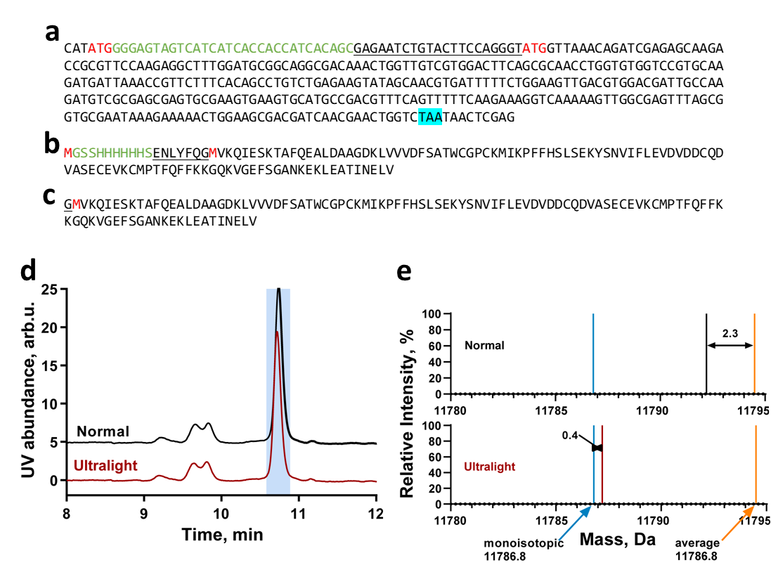
Supplementary. Fig. 4. Trx expression plasmid information and verification of Trx by mass spectrometry. a, DNA sequence of the Trx expression cassette. b, Protein sequence of the Trx. His-tag: underlined letter, Trx coding sequence: black, Methionine (ATG): red letter, Stop codon (TAA): highlighted in turquoise. c, Protein sequence of Trx after removal of His-tag by TEV protease. d, Purification of recombinant Trx by SEC. e, Charge deconvolution result of MS analysis of SEC obtained from Normal and Ultralight Trx samples.

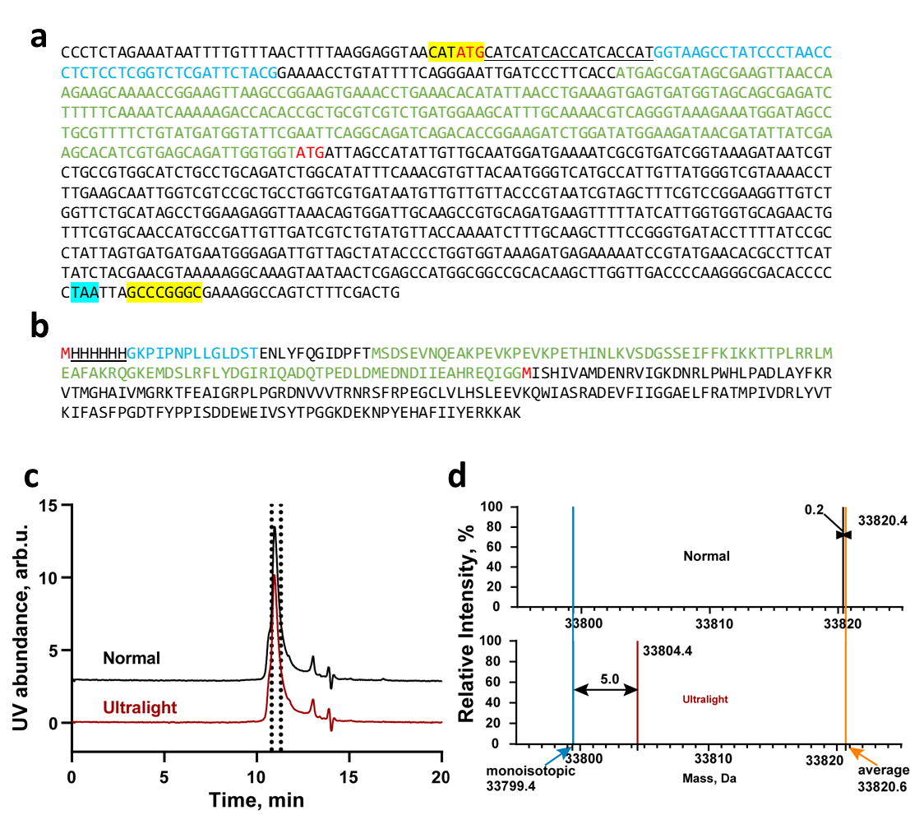
Supplementary. Fig. 5. BsDHFR expression plasmid information and verification of BsDHFR by mass spectrometry. a, DNA sequence of the BsDHFR expression cassette. b, protein sequence of the BsDHFR. His-tag: underlined letter, V5 epitope tag: blue letter, SUMO sequence: green letter, BsDHFR coding sequence: black, Methionine (ATG): red letter, Stop codon (TAA): highlighted in turquoise, Restriction sites: NdeI (CATATG) and NotI (GCCCGGGC). c, Purification of recombinant BsDHFR by SEC. d, Charge deconvolution result of MS analysis of SEC obtained from Normal and Ultralight BsDHFR samples.

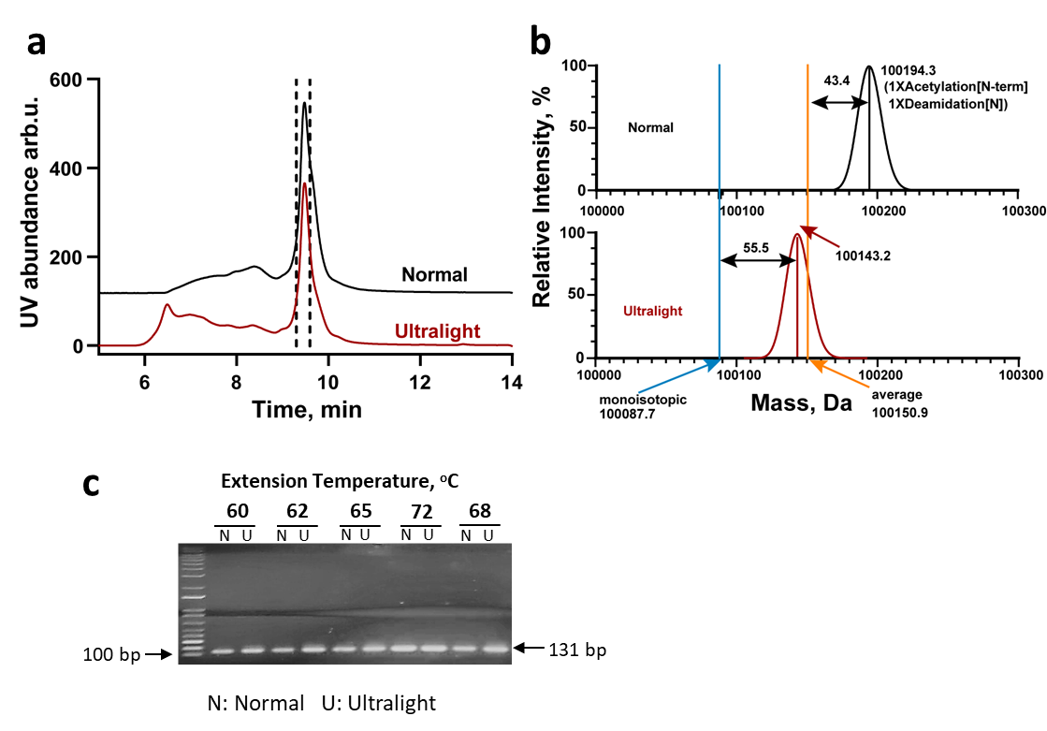
Supplementary. Fig. 6. Verification of Pfu by mass spectrometry and activity comparison of Normal and Ultralight enzyme. a, Purification of recombinant Pfu by SEC. b, Charge deconvolution result of MS analysis of SEC obtained from Normal and Ultralight Pfu samples. c, Conventional agarose gel electrophoresis of PCR products after PCR at different extension temperatures.

