Supplementary material
Table S1 Electroanatomical mesh and graph characteristics per patient. Projection error is the distance from a mapping site to its nearest mesh vertex. The geodesic-to-Euclidean ratio is computed over retained graph edges.
Patient | Mesh vertices | Faces | Nodes | Edges | Mean degree | Median edge (mm) | Geo/Eucl ratio
1 | 4268 | 8742 | 157 | 790 | 10.06 | 6.31 | 1.046
2 | 5121 | 10404 | 104 | 518 | 9.96 | 9.52 | 1.049
3 | 5670 | 11536 | 90 | 427 | 9.49 | 10.80 | 1.069
4 | 4084 | 8377 | 471 | 2380 | 10.11 | 2.92 | 1.000
5 | 3795 | 7779 | 46 | 232 | 10.09 | 12.23 | 1.087
6 | 5285 | 10566 | 839 | 4183 | 9.97 | 3.15 | 1.000
7 | 7193 | 14771 | 76 | 377 | 9.92 | 8.80 | 1.061
8 | 4020 | 8270 | 129 | 642 | 9.95 | 6.35 | 1.058
9 | 4014 | 8158 | 50 | 260 | 10.40 | 8.84 | 1.051
Total / median | - | - | 1962 | 9809 | 9.97 | 8.80 | 1.005

Table S2 Ten most discriminative expert descriptors by univariate AUC (n = 1716 labelled electrograms). All 38 descriptors were significant after Benjamini-Hochberg correction. Direction indicates whether the descriptor increases or decreases in AVPs.
Descriptor | AVP (median) | Physiol. (median) | AUC | Direction | Cliff's delta
Bipolar RMS (mV) | 0.045 | 0.176 | 0.973 | decrease | -0.946
Peak-to-peak amplitude (mV) | 0.489 | 1.958 | 0.970 | decrease | -0.939
log peak-to-peak amplitude | 0.398 | 1.085 | 0.970 | decrease | -0.939
log CARTO voltage | 0.449 | 1.132 | 0.968 | decrease | -0.936
CARTO bipolar voltage (mV) | 0.566 | 2.102 | 0.968 | decrease | -0.936
Absolute maximum (mV) | 0.306 | 1.352 | 0.968 | decrease | -0.935
Multiscale energy, level 3 | 0.083 | 0.808 | 0.941 | decrease | -0.883
Peak-to-peak, 30-400 Hz (mV) | 0.307 | 1.345 | 0.938 | decrease | -0.876
Multiscale energy, level 2 | 0.066 | 0.858 | 0.930 | decrease | -0.859
Unipolar maximum negative slope | -300.3 | -844.7 | 0.918 | increase | 0.837

Table S3 AUC-ROC per held-out patient, averaged over three seeds. Patient 6 combines the highest mapping density with the highest AVP prevalence and is the hardest case for every deep model.
Patient | Voltage rule | XGBoost | 1-D CNN | BiLSTM | Transformer | ST-GCN no volt. | ST-GCN
1 | 0.916 | 0.957 | 0.950 | 0.831 | 0.877 | 0.714 | 0.923
2 | 0.993 | 0.987 | 0.977 | 0.938 | 0.935 | 0.944 | 0.971
3 | 0.993 | 0.999 | 0.913 | 0.828 | 0.915 | 0.972 | 0.985
4 | 0.976 | 0.988 | 0.948 | 0.978 | 0.973 | 0.885 | 0.973
5 | 0.857 | 0.906 | 0.915 | 0.816 | 0.814 | 0.943 | 0.923
6 | 0.940 | 0.937 | 0.760 | 0.553 | 0.791 | 0.708 | 0.858
7 | 0.893 | 0.992 | 0.886 | 0.898 | 0.897 | 0.852 | 0.867
8 | 0.999 | 1.000 | 0.950 | 0.946 | 0.963 | 0.982 | 0.997
9 | 1.000 | 0.989 | 0.936 | 0.918 | 0.942 | 0.947 | 0.983

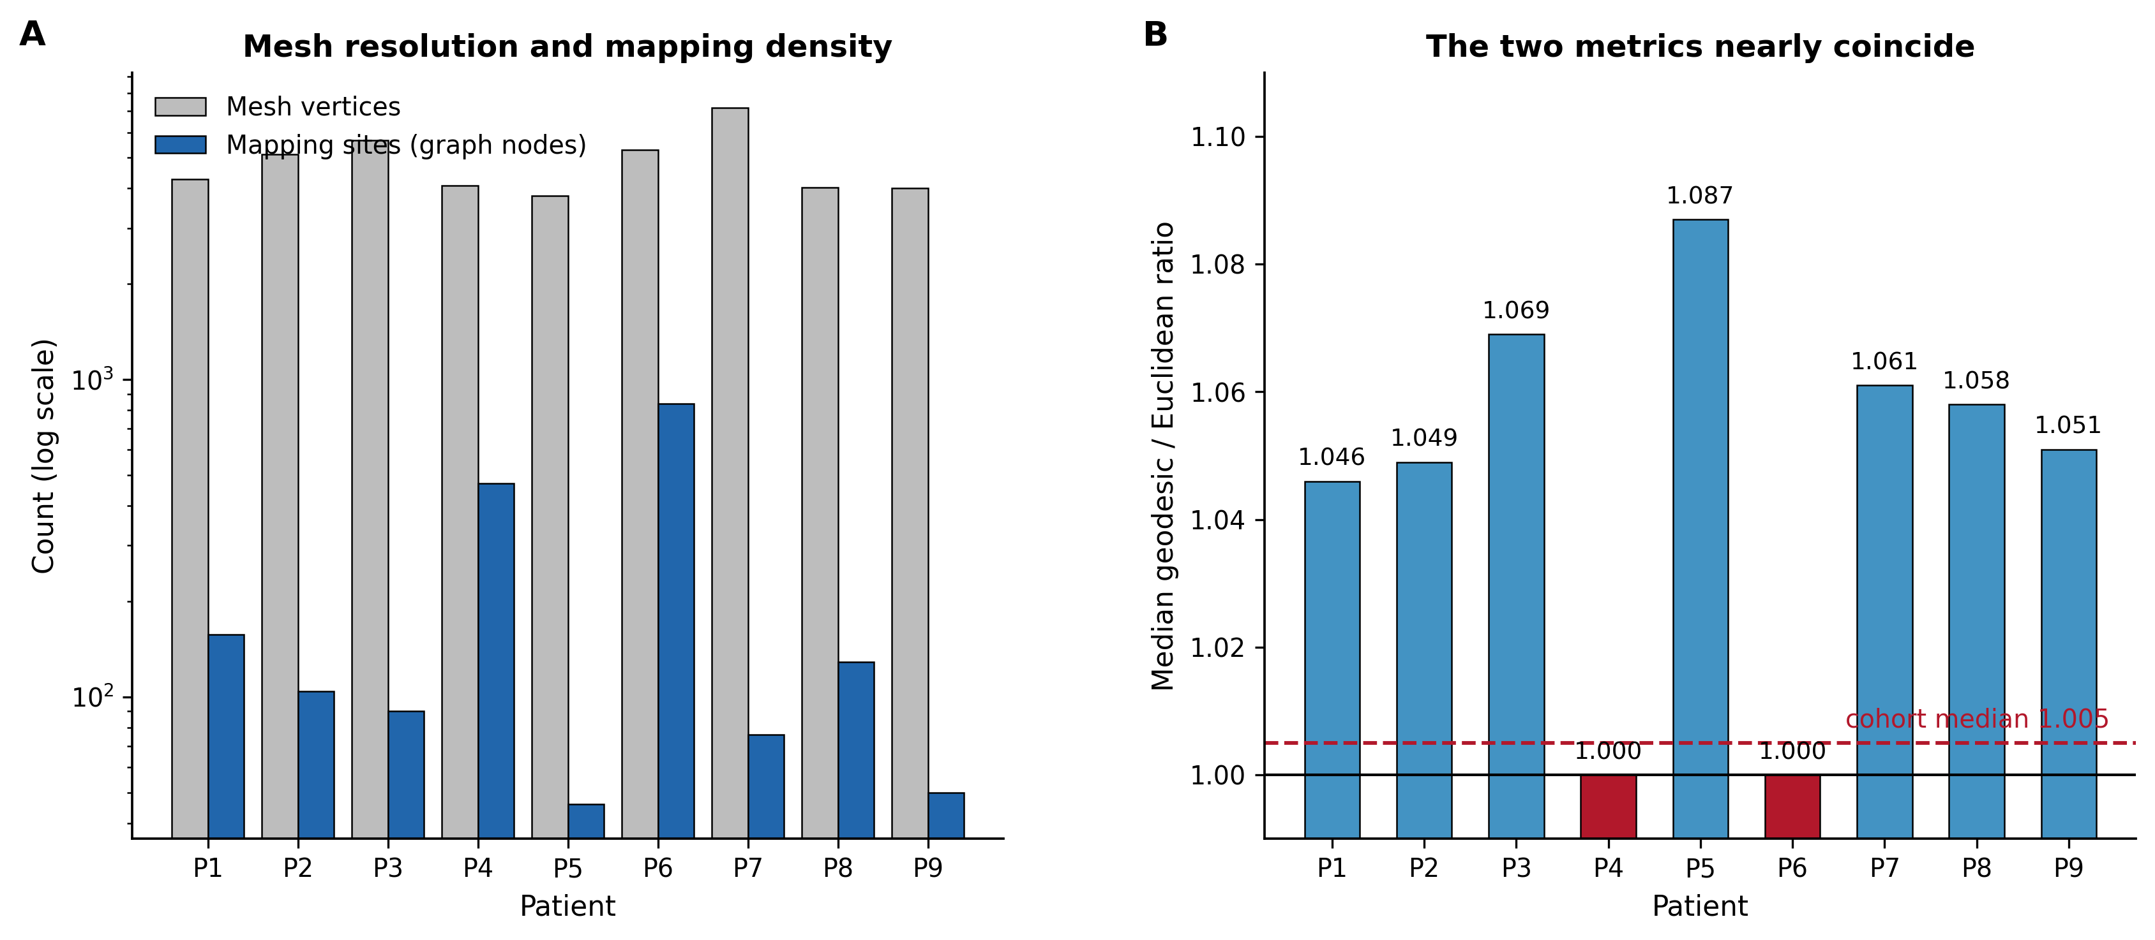
Fig. S1 Electroanatomical graph characteristics. a Mesh resolution and mapping density per patient on a logarithmic scale. b Median ratio of geodesic to Euclidean distance over retained graph edges; the two metrics nearly coincide at the scale of a k-nearest-neighbour neighbourhood, which explains why the corresponding ablation produced no measurable difference.
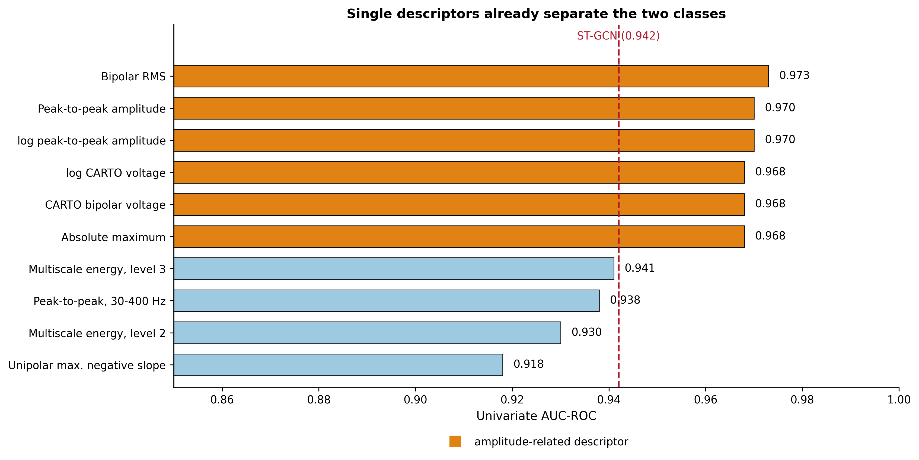
Fig. S2 Ten most discriminative expert descriptors ranked by univariate AUC. Descriptors related to signal amplitude are shown in orange. The dashed line marks the AUC of the proposed model, which a single descriptor already matches.
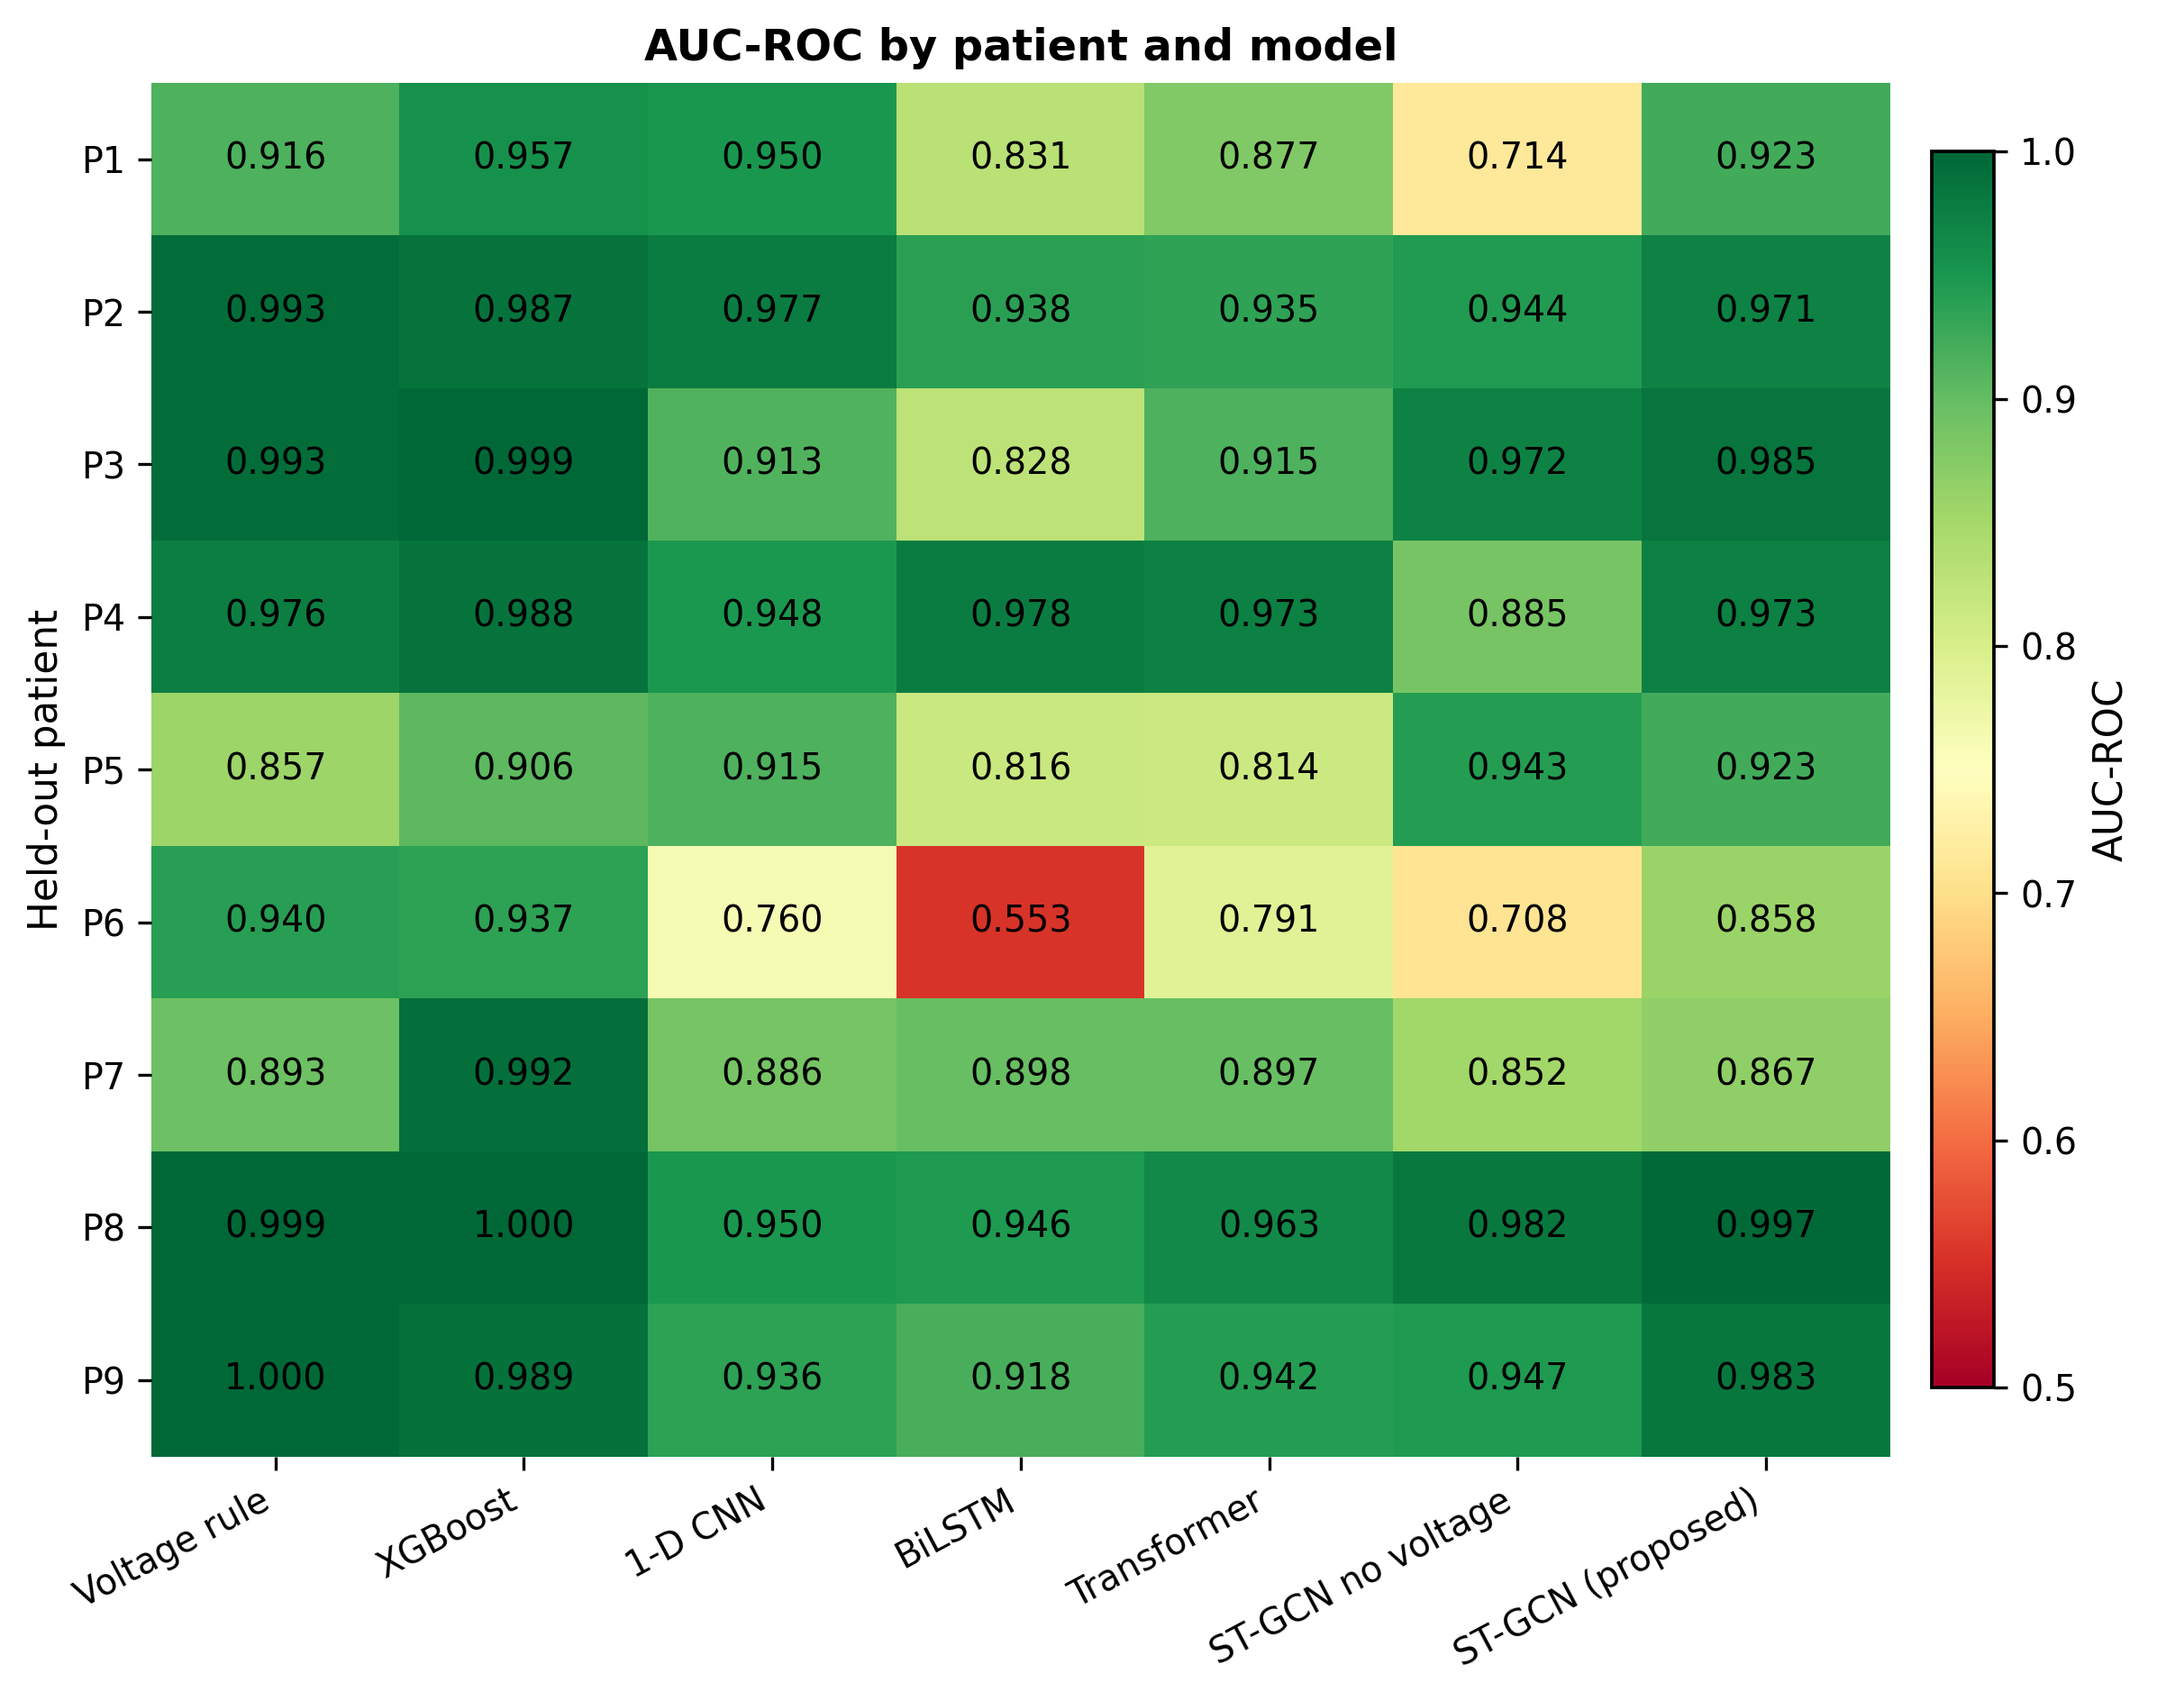
Fig. S3 AUC-ROC by held-out patient and model, averaged over three seeds. Patient 6 combines the highest mapping density with a high abnormal-potential prevalence and is the hardest case for every deep model, while the voltage rule handles it well.

