Decadal shifts of organic contaminants in oceanic plankton
Jessica Patrone^{1,2}, Jordi Dachs¹, Maria Vila-Costa¹, Naiara Berrojalbiz Castrillejo¹, Cristóbal Galbán-Malagón^{3,4}, Maria Christina Nika^{1,5}, Nikolaos Thomaidis⁵, Ruben Gil Solsona¹*, Pablo Gago-Ferrero¹*
¹Department of Environmental Chemistry, IDAEA-CSIC, Barcelona, Spain
²University of Barcelona, Barcelona, Spain
³GEMA Center (Genomics, Ecology and Environment), Universidad Mayor, Santiago de Chile, Chile.
⁴Data Observatory Foundation, Providencia, Chile
⁵University of Athens, Athens, Greece

Content:
SI 1. Semiquantification
Figure S1
Figure S2

SI 1. Semiquantification
Semi-quantification was performed using a Quantitative Structure–Ionization Relationship (QSIR) model trained in solvent. The predictive performance of the model was evaluated independently. It showed encouraging results, with 80% of the training-set predictions (10th–90th percentiles) falling within approximately a three-fold deviation from the corresponding experimental values, as described elsewhere (manuscript in preparation).
To adapt the model to the instrumental conditions used in the present study, its predictions were harmonized using calibration curves acquired within the same analytical batch as the study samples. After this instrumental harmonization, the dispersion remained within a range considered suitable for semi-quantitative purposes (Figure S1), with the large majority of compounds falling within approximately a six-fold deviation in positive ionization mode and within approximately a five- to eight-fold deviation in negative ionization mode.
Nevertheless, because the QSIR model was originally trained using solvent-based measurements, it does not explicitly account for compound-specific matrix effects. In our experiments, application of the solvent-trained model to complex biological matrices tended to result in systematically underestimated concentrations, consistent with ion suppression affecting the analytical response.
To partially account for this source of bias, matrix effects were experimentally determined for all compounds included in the calibration set and evaluated as a function of chromatographic retention time (Figure S2). An empirical relationship describing the observed matrix-effect pattern across the chromatographic gradient was then derived separately for each ionization mode. For compounds without an authentic standard, the expected matrix effect was estimated from the locally observed behavior of calibration compounds eluting at similar retention times. This correction was applied assuming that in the absence of compound-specific data, the matrix effect varies smoothly along the chromatographic gradient and depends mainly on the co-eluting matrix components.

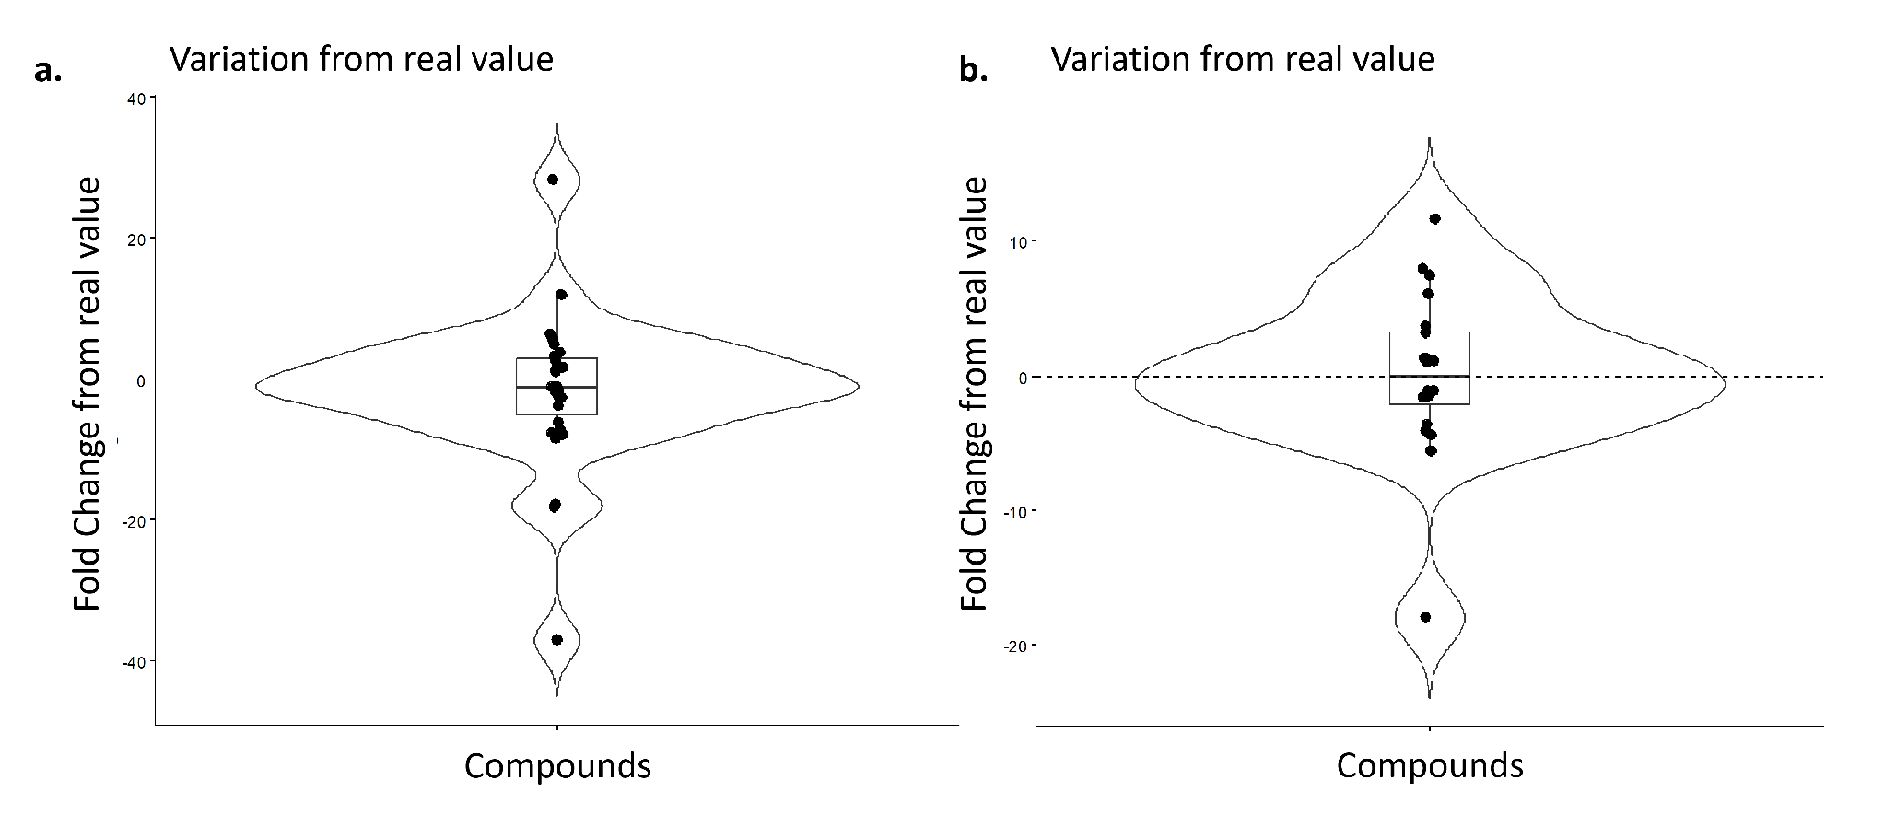
Figure S1. Deviation between semi-quantified and experimentally determined concentrations for the compounds in the calibration set, after harmonization of QSIR model predictions with calibration curves acquired in the same analytical batch as the study samples. Each point corresponds to one compound; the violin shows the density of the fold-change distribution. Respectively: (a) positive ionization mode; (b) negative ionization mode.

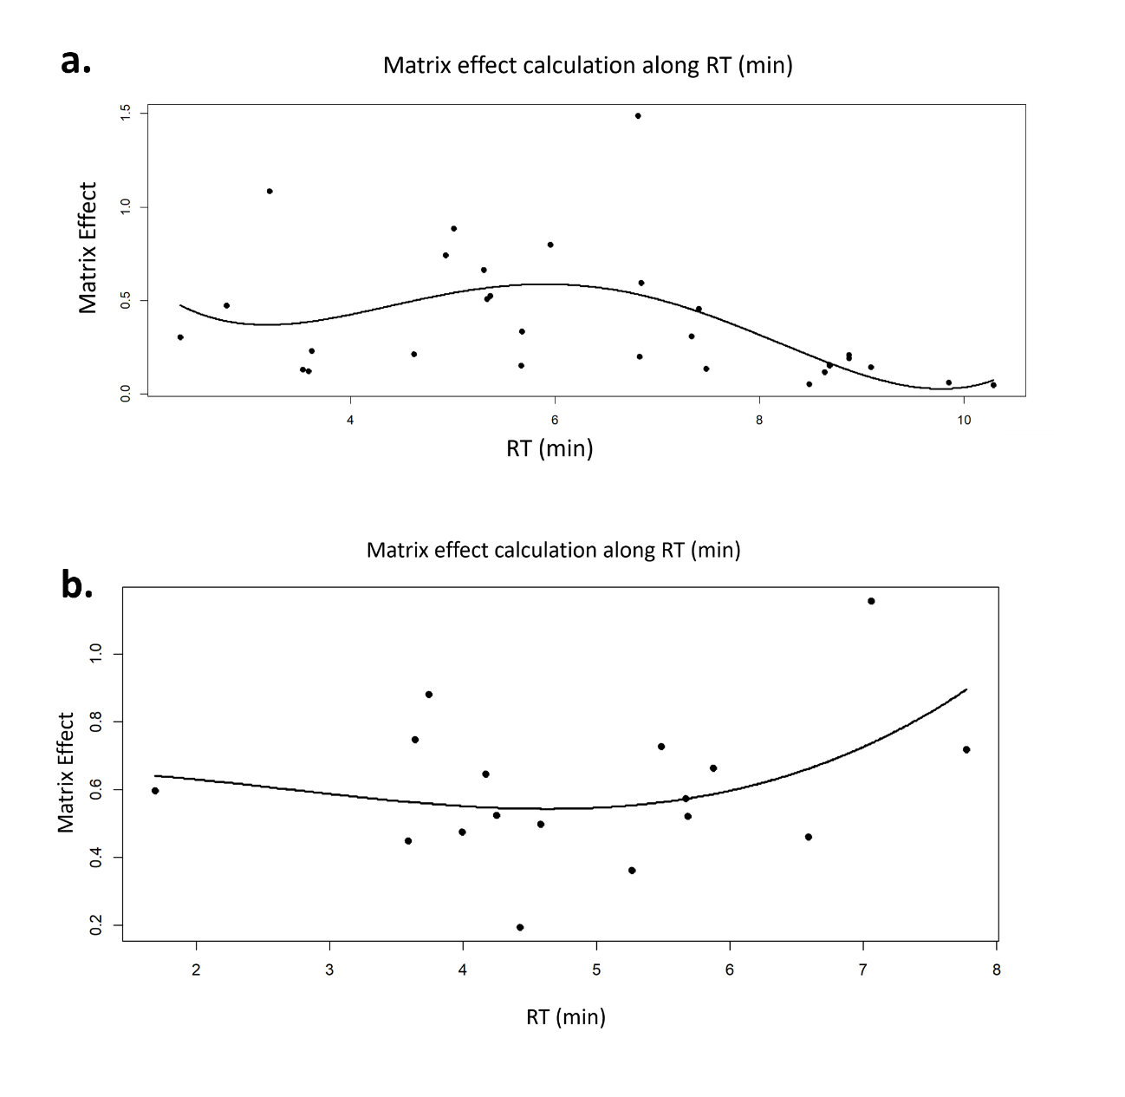Figure S2. Matrix effect (ME) experimentally determined for the compounds of the calibration set in positive (a) and negative (b) ionization mode, plotted as a function of chromatographic retention time (RT, min). Each point corresponds to one compound; ME values below 1 indicate ion suppression and values above 1 ion enhancement. The solid line is the fitted regression describing the matrix-effect pattern across the chromatographic gradient.

