Material and methods
RP-HPLC and SEC-HPLC Analyses
Purity and aggregation status of anti-HER2^{P}, anti-HER3^{P}, and the anti-HER2/HER3^{P} bispecific antibody were analyzed using reversed-phase high-performance liquid chromatography (RP-HPLC) and size-exclusion chromatography (SEC-HPLC), respectively. All chromatographic analyses were performed using a Vanquish™ HPLC system (Thermo Scientific™, Waltham, MA) controlled by Chromeleon™ software version 7.3.1. For RP-HPLC, a Waters XBridge™ Protein BEH C4 column (3.5 μm, 4.6 x 150 mm; Waters Corporation, Milford, MA) was employed. The mobile phase consisted of 40% deionized water and 60% acetonitrile (ACN), and the flow rate was set at 0.5 mL/min. UV absorbance was monitored at 280 nm to evaluate the purity of each antibody construct. For SEC-HPLC, a YMC-Pack Diol-200/S-2 μm/20 nm column (YMC Co., Ltd., Kyoto, Japan) was used. The mobile phase comprised 40% phosphate-buffered saline (PBS) and 60% distilled water (DW), with a flow rate of 0.5 mL/min. The chromatograms were recorded at 280 nm. Aggregation and oligomeric states were assessed based on retention time, allowing distinction between monomeric, homodimeric, and heterodimeric forms of the antibody constructs.

Results
Size analysis of bispecific antibodies using HPLC
The observed molecular mass slightly exceeded the theoretical value, possibly due to glycosylation or conformational changes in the Fc fusion domain. SEC-HPLC was used to evaluate the molecular size distribution and the presence of aggregates. The elution times of anti-HER2^{P} and anti-HER3^{P} were 5.146 and 4.838 min, respectively, and the anti-HER2/HER3^{P} bispecific antibody, located at the intermediate position between the two antibodies, eluted at 4.913 min. This retention pattern supports the successful formation of heterodimers. However, the additional peak observed before the main peak suggests the presence of higher molecular weight aggregates in the bispecific antibody sample (sFig. 2). RP-HPLC analysis was performed to assess the purity of the antibody product. Compared with the monospecific antibodies anti-HER2^{P} and anti-HER3^{P}, the anti-HER2/HER3^{P} bispecific antibody had a relatively higher proportion of secondary peaks appearing after the main peak. This suggests that monospecific antibodies without Fc mutations have higher structural homogeneity than bispecific antibodies constructed using the KIH method (sFig.1).

sFigure 1. Size-exclusion chromatography (SEC-HPLC) analysis of bispecific and monospecific antibodies. The elution profiles of anti-HER2ᴾ, anti-HER3ᴾ, and anti-HER2/HER3ᴾ antibodies were compared by SEC-HPLC to assess molecular size. Chromatographic runs were performed on a YMC-Pack Diol-200 column with PBS as the mobile phase at a flow rate of 0.5 mL/min, and UV absorbance was monitored at 280 nm. Retention times of the main peaks were recorded for each antibody to evaluate molecular size distribution and potential aggregation.

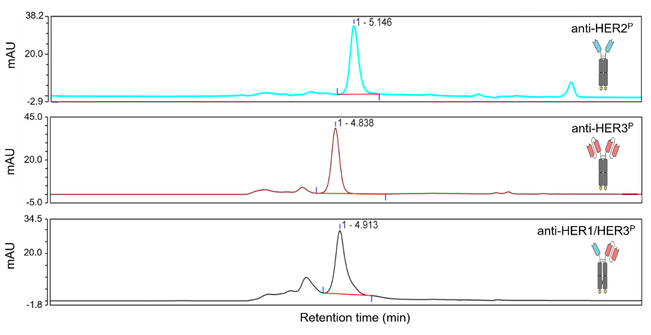
sFigure 2. RP-HPLC analysis of anti-HER2ᴾ, anti-HER3ᴾ, and anti-HER2/HER3ᴾ antibodies. Purified antibodies were analyzed by reversed-phase high-performance liquid chromatography (RP-HPLC) using a C4 column (3.5 μm, 4.6 × 150 mm). The mobile phase consisted of 40% deionized water and 60% acetonitrile, with a flow rate of 0.5 mL/min. UV absorbance was measured at 280 nm.
