SUPPLEMENTARY MATERIAL
Focal therapy versus radical prostatectomy: a propensity score-matched comparison of failure-free survival
SUPPLEMENTARY METHODS
Covariate balance was evaluated before and after matching using standardized mean differences and variance ratios. The 5-year absolute failure-free-survival difference and 5-year restricted mean failure-free-time difference used 10,000 nonparametric bootstrap samples of matched pairs (seed 20260805), conditional on the fixed matched sample. The biopsy-measurement sensitivity analysis retained only pairs in which biopsy tissue involvement was observed for both members and repeated the marginal Cox model with pair-clustered robust variance. For focal therapy, primary failure was the first nonfocal active treatment or metastatic progression; a second focal ablation remained within the organ-preserving strategy. For radical prostatectomy, any postoperative radiotherapy and/or systemic therapy was a primary failure whether its intent was adjuvant or salvage. First failure events were classified from linked longitudinal treatment records; treatments recorded on the same event date were considered concurrent. Prespecified subgroup analyses fitted treatment, the binary subgroup indicator, and their interaction in the marginal Cox model with pair-clustered robust variance. Analyses used Python 3.12.13, NumPy 2.3.5, pandas 2.2.3, scikit-learn 1.8.0, and SciPy 1.17.0; maximum-cardinality matching used the HiGHS backend through scipy.optimize.milp.

Table S1. Complete covariate balance before and after propensity-score matching.
Variable | Eligible focal  (n=274) | Eligible prostatectomy  (n=2,000) | |SMD|  before | Variance ratio  before | Matched focal  (n=207) | Matched prostatectomy  (n=207) | |SMD|  after | Variance ratio  after
Age, years | 68.7 (62.4–73.3) | 64.5 (59.1–69.0) | 0.490 | 1.34 | 67.4 (61.7–72.3) | 66.7 (62.7–71.0) | 0.028 | 1.59
Age missing | 0 (0.0) | 1 (0.1) | 0.032 | — | 0 (0.0) | 0 (0.0) | 0.000 | —
PSA, ng/mL | 5.99 (4.50–8.28) | 6.96 (5.17–10.00) | 0.320 | 0.72 | 6.10 (4.51–8.39) | 6.05 (4.87–8.48) | 0.033 | 1.13
PSA >20 ng/mL | 8 (2.9) | 117 (5.9) | 0.143 | — | 5 (2.4) | 4 (1.9) | 0.033 | —
Treatment year | 2022 (2019–2024) | 2021 (2017–2024) | 0.366 | 0.61 | 2022 (2019–2024) | 2021 (2019–2024) | 0.036 | 1.09
Positive biopsy cores, % | 12.5 (7.8–17.4) | 30.0 (16.7–47.8) | 1.231 | 0.09 | 13.5 (8.7–18.2) | 13.6 (8.3–19.6) | 0.083 | 0.88
Positive-core percentage missing | 3 (1.1) | 207 (10.3) | 0.407 | — | 3 (1.4) | 4 (1.9) | 0.037 | —
Prior active surveillance | 87 (31.8) | 226 (11.3) | 0.514 | — | 58 (28.0) | 60 (29.0) | 0.021 | —
ASA I | 11 (4.0) | 67 (3.4) | 0.035 | — | 9 (4.3) | 10 (4.8) | 0.023 | —
ASA II | 126 (46.0) | 1221 (61.1) | 0.306 | — | 110 (53.1) | 111 (53.6) | 0.010 | —
ASA III | 15 (5.5) | 169 (8.5) | 0.117 | — | 13 (6.3) | 13 (6.3) | 0.000 | —
ASA unavailable/other | 122 (44.5) | 543 (27.2) | 0.368 | — | 75 (36.2) | 73 (35.3) | 0.020 | —
PI-RADS 1–2/no lesion | 44 (16.1) | 194 (9.7) | 0.191 | — | 39 (18.8) | 40 (19.3) | 0.012 | —
PI-RADS 3 | 49 (17.9) | 100 (5.0) | 0.413 | — | 35 (16.9) | 34 (16.4) | 0.013 | —
PI-RADS 4–5 | 138 (50.4) | 545 (27.3) | 0.488 | — | 101 (48.8) | 99 (47.8) | 0.019 | —
PI-RADS unavailable | 43 (15.7) | 1161 (58.1) | 0.977 | — | 32 (15.5) | 34 (16.4) | 0.026 | —
ISUP grade group 1 | 99 (36.1) | 533 (26.7) | 0.205 | — | 73 (35.3) | 73 (35.3) | 0.000 | —
ISUP grade group 2 | 133 (48.5) | 731 (36.5) | 0.244 | — | 103 (49.8) | 103 (49.8) | 0.000 | —
ISUP grade group 3 | 38 (13.9) | 407 (20.3) | 0.173 | — | 28 (13.5) | 28 (13.5) | 0.000 | —
ISUP grade group 4 | 4 (1.5) | 221 (11.1) | 0.404 | — | 3 (1.4) | 3 (1.4) | 0.000 | —
ISUP grade group 5 | 0 (0.0) | 108 (5.4) | 0.338 | — | 0 (0.0) | 0 (0.0) | 0.000 | —
MRI stage cT1–2 | 226 (82.5) | 758 (37.9) | 1.023 | — | 174 (84.1) | 174 (84.1) | 0.000 | —
MRI stage cT3a | 6 (2.2) | 89 (4.5) | 0.126 | — | 2 (1.0) | 2 (1.0) | 0.000 | —
MRI stage cT3b | 0 (0.0) | 15 (0.8) | 0.123 | — | 0 (0.0) | 0 (0.0) | 0.000 | —
MRI unavailable | 42 (15.3) | 1138 (56.9) | 0.960 | — | 31 (15.0) | 31 (15.0) | 0.000 | —
Treatment period 2014–2016 | 7 (2.6) | 396 (19.8) | 0.569 | — | 3 (1.4) | 3 (1.4) | 0.000 | —
Treatment period 2017–2019 | 67 (24.5) | 407 (20.3) | 0.099 | — | 59 (28.5) | 59 (28.5) | 0.000 | —
Treatment period 2020–2022 | 83 (30.3) | 453 (22.7) | 0.174 | — | 64 (30.9) | 64 (30.9) | 0.000 | —
Treatment period 2023–2026 | 117 (42.7) | 744 (37.2) | 0.112 | — | 81 (39.1) | 81 (39.1) | 0.000 | —
Values are median (IQR) or n (%). SMDs for PSA use log-transformed PSA. Positive-core percentage SMDs and variance ratios use observed values, with missingness reported separately. Variance ratios are focal therapy divided by radical prostatectomy and are shown for continuous variables only. Exact-matching variables necessarily have postmatching SMD 0. ASA, American Society of Anesthesiologists; IQR, interquartile range; ISUP, International Society of Urological Pathology; MRI, magnetic resonance imaging; PI-RADS, Prostate Imaging Reporting and Data System; PSA, prostate-specific antigen; SMD, standardized mean difference.

Table S2. Eligible focal-therapy patients retained versus not retained after matching.
Variable | Matched focal  (n=207) | Unmatched focal  (n=67) | |SMD|
Age, years | 67.4 (61.7–72.3) | 71.9 (64.5–76.3) | 0.442
PSA, ng/mL | 6.10 (4.51–8.39) | 5.60 (4.27–7.95) | 0.135
PSA >20 ng/mL | 5 (2.4) | 3 (4.5) | 0.113
Treatment year | 2022 (2019–2024) | 2023 (2020–2024) | 0.243
Positive biopsy cores, % | 13.5 (8.7–18.2) | 9.1 (5.0–12.3) | 0.678
Positive-core percentage missing | 3 (1.4) | 0 (0.0) | 0.171
Prior active surveillance | 58 (28.0) | 29 (43.3) | 0.323
ISUP grade group 1 | 73 (35.3) | 26 (38.8) | 0.073
ISUP grade group 2 | 103 (49.8) | 30 (44.8) | 0.100
ISUP grade group 3 | 28 (13.5) | 10 (14.9) | 0.040
ISUP grade group 4 | 3 (1.4) | 1 (1.5) | 0.004
ISUP grade group 5 | 0 (0.0) | 0 (0.0) | 0.000
MRI stage cT1–2 | 174 (84.1) | 52 (77.6) | 0.164
MRI stage cT3a | 2 (1.0) | 4 (6.0) | 0.276
MRI stage cT3b | 0 (0.0) | 0 (0.0) | 0.000
MRI unavailable | 31 (15.0) | 11 (16.4) | 0.040
PI-RADS 1–2/no lesion | 39 (18.8) | 5 (7.5) | 0.342
PI-RADS 3 | 35 (16.9) | 14 (20.9) | 0.102
PI-RADS 4–5 | 101 (48.8) | 37 (55.2) | 0.129
PI-RADS unavailable | 32 (15.5) | 11 (16.4) | 0.026
Cryotherapy | 150 (72.5) | 53 (79.1) | 0.155
Irreversible electroporation | 57 (27.5) | 14 (20.9) | 0.155
Values are median (IQR) or n (%). SMDs compare matched with unmatched focal-therapy patients; the table describes the population to which the matched estimand applies. IQR, interquartile range; ISUP, International Society of Urological Pathology; MRI, magnetic resonance imaging; PI-RADS, Prostate Imaging Reporting and Data System; PSA, prostate-specific antigen; SMD, standardized mean difference.
Table S3. Composition and clinical context of the first failure event.
First primary failure event | Focal therapy, n (%); median months | Radical prostatectomy, n (%); median months
Salvage radical prostatectomy | 21 (10.1); 37.2 | —
Salvage LDR brachytherapy | 6 (2.9); 47.5 | —
External-beam radiotherapy without concurrent ADT | — | 9 (4.3); 22.2
Radiotherapy with concurrent ADT | 1 (0.5); 19.4 | 3 (1.4); 18.3
ADT without concurrent local therapy | 9 (4.3); 57.2 | 4 (1.9); 29.1
Metastatic progression before active post-index treatment | 2 (1.0); 23.0 | 1 (0.5); 3.8
Total primary failures | 39 (18.8) | 17 (8.2)

Values are n (% of the full treatment group); median months from index treatment to the first event. Concurrent radiotherapy and ADT were recorded on the same event date. In the prostatectomy arm, every active postoperative treatment was counted whether the clinical intent was adjuvant or salvage. Among focal-therapy failures, 37/39 were preceded by a positive post-treatment biopsy (ISUP grade group 1, n=6; grade group 2, n=15; grade group 3, n=7; grade group 4, n=9). Of 16 prostatectomy treatment events, 15 had a pretreatment PSA measurement (median 0.27 ng/mL; range 0.03–1.47); this PSA is descriptive and did not determine event classification. A second focal ablation was not a primary failure: 20 patients underwent a second ablation, 4 later experienced primary failure, and none underwent a third ablation. Among 40 focal-therapy patients with a positive post-treatment biopsy and no primary failure, 14 underwent a second focal ablation and 26 received no active retreatment. ADT, androgen-deprivation therapy; ISUP, International Society of Urological Pathology; LDR, low-dose-rate; PSA, prostate-specific antigen.

Table S4. Prespecified exploratory subgroup analyses.

Displayed category | Focal n/events | Radical prostatectomy n/events | HR (95% CI) | p for interaction
Overall matched cohort | 207/39 | 207/17 | 1.99 (1.13–3.51) | —
ISUP grade group ≥2 | 134/27 | 134/11 | 2.12 (1.04–4.33) | 0.740
PSA ≥10 ng/mL | 34/9 | 35/6 | 0.96 (0.31–2.96) | 0.157
Biopsy tissue involvement ≥5% | 86/14 | 70/6 | 2.16 (0.80–5.85) | 0.977
MRI-visible lesion (PI-RADS 3–5) | 136/25 | 133/15 | 1.41 (0.75–2.66) | 0.609
Age <70 years | 132/25 | 146/13 | 1.84 (0.92–3.67) | 0.744

HRs compare focal therapy with radical prostatectomy within the displayed category. Each interaction p value tests the treatment-by-subgroup interaction across the full binary subgroup, not the statistical significance of the category-specific HR. Analyses were exploratory and no multiplicity adjustment was applied. The overall row reproduces the primary marginal Cox model. CI, confidence interval; HR, hazard ratio; ISUP, International Society of Urological Pathology; MRI, magnetic resonance imaging; PI-RADS, Prostate Imaging Reporting and Data System; PSA, prostate-specific antigen.

Figure S1. Covariate balance before and after propensity-score matching.
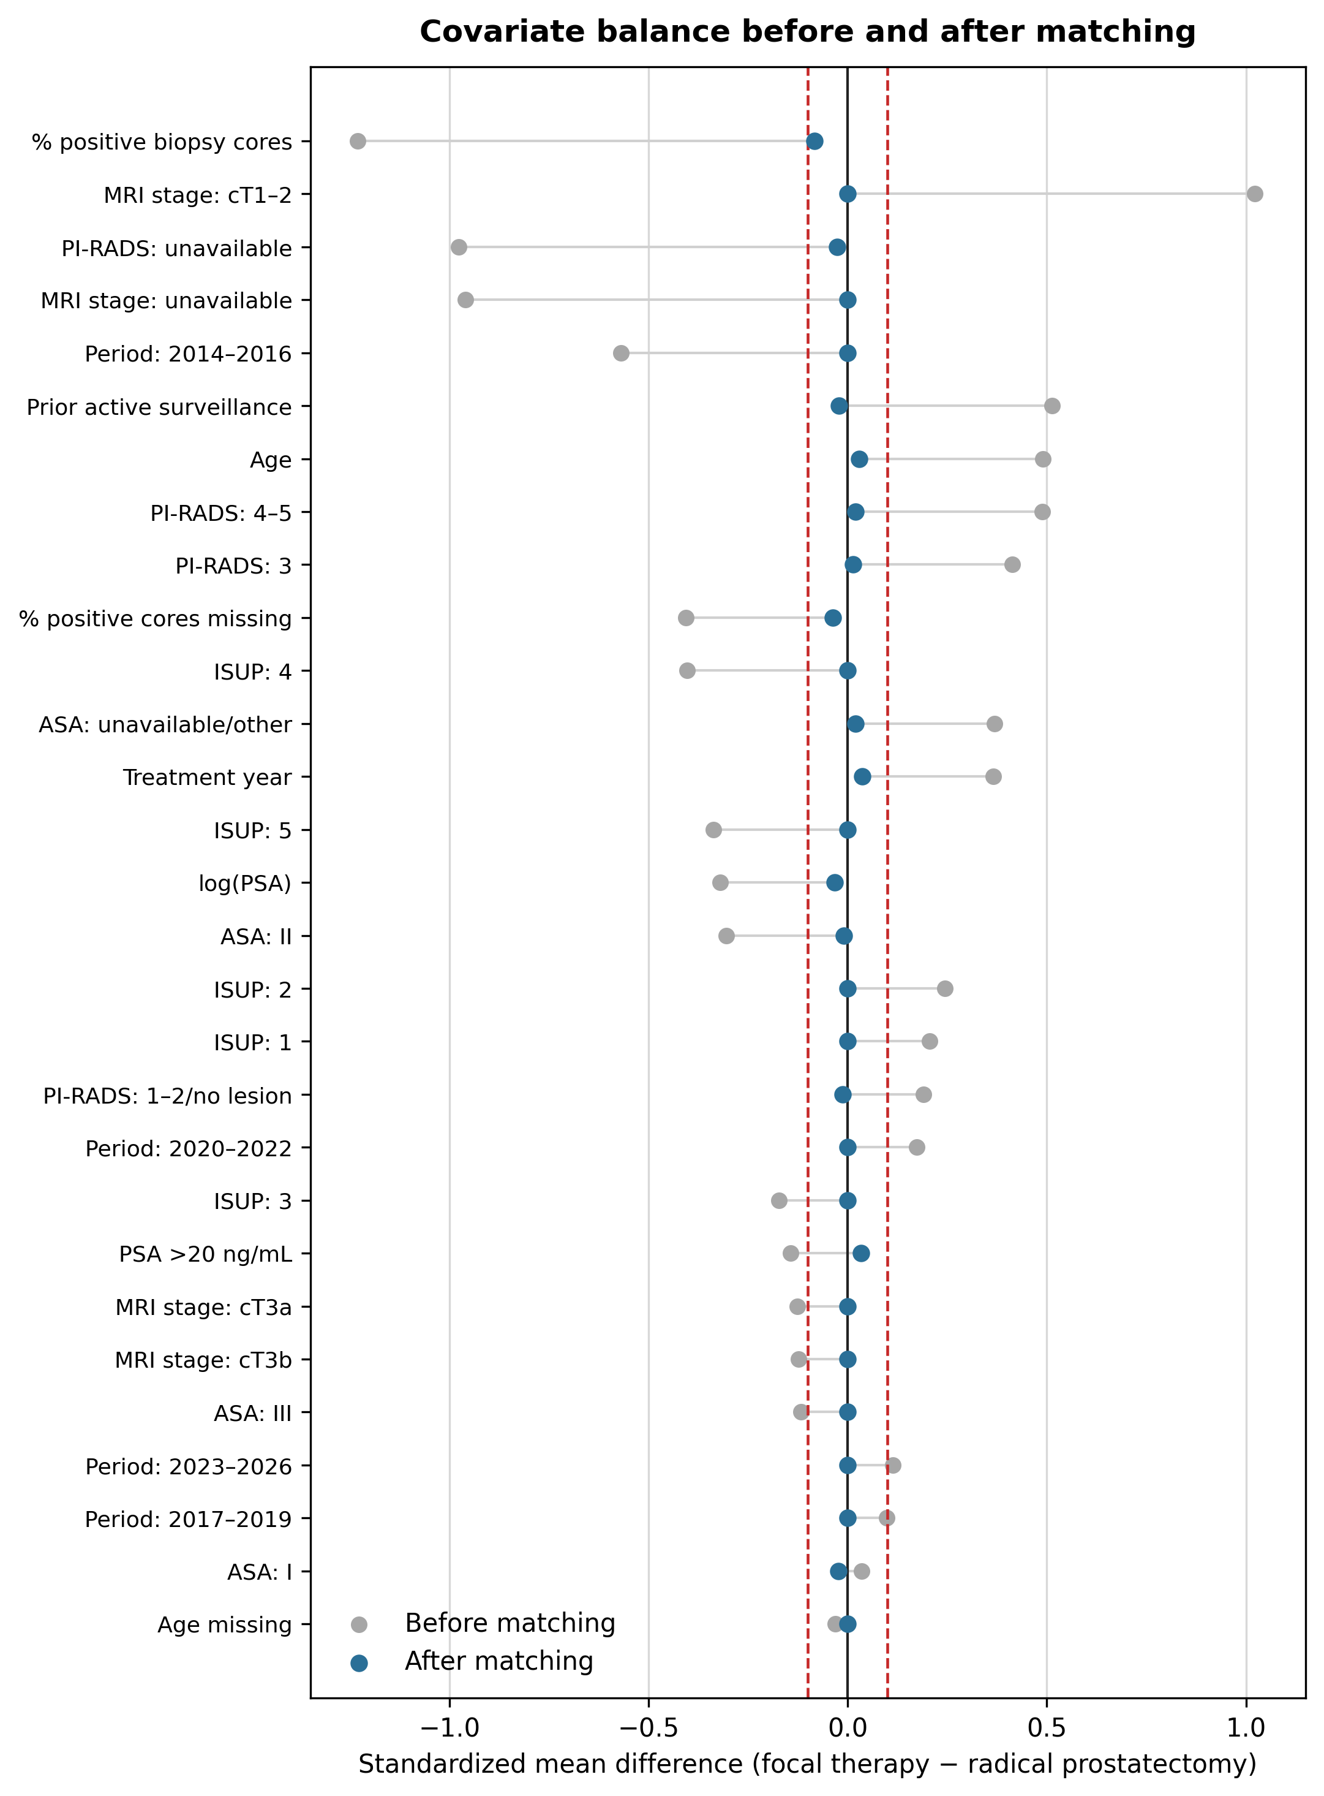
Signed standardized mean differences are shown for the eligible and matched cohorts. Dashed vertical lines denote |SMD|=0.10. Exact matching produced zero postmatching imbalance for ISUP grade group, treatment period, and MRI stage.

Figure S2. Distribution of key continuous baseline covariates.
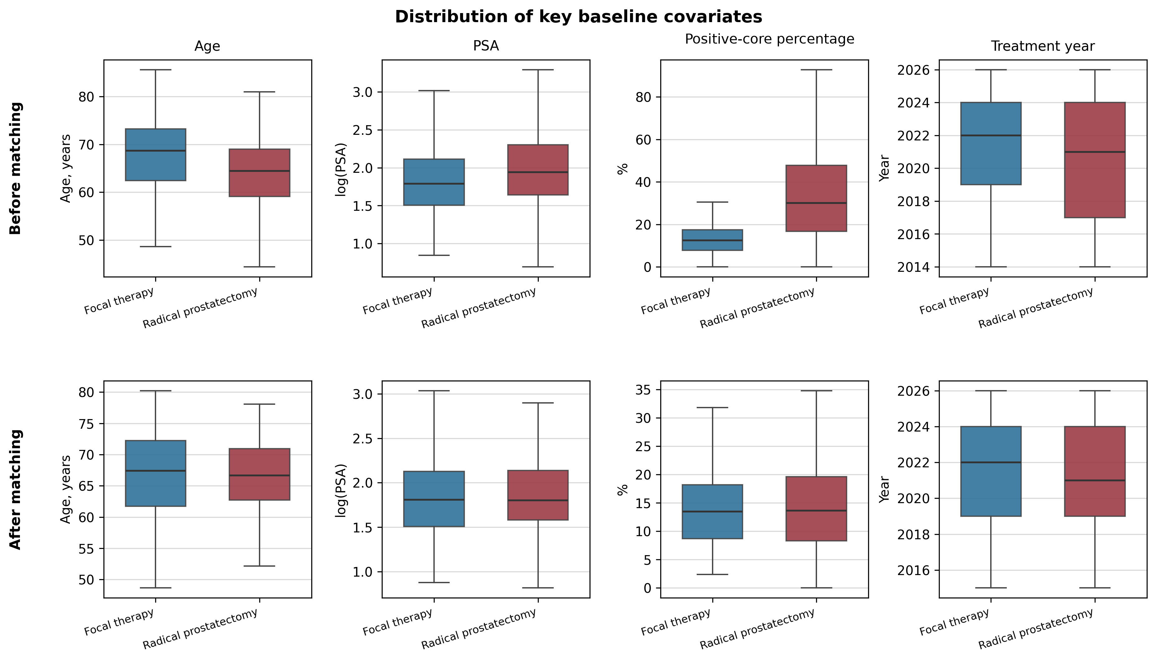
Boxplots show age, log-transformed PSA, positive-core percentage, and treatment year before and after matching. Boxes indicate the interquartile range and center lines the median; whiskers use the conventional 1.5×IQR rule.

