High-dose rapamycin excerts a temporary impact on T. reesei through gene trFKBP12
Ai-Ping Pang,¹ Haiyan Wang,¹ Funing Zhang,¹ Xin Hu,¹ Fu-Gen Wu,¹ Zhihua Zhou,² Wei Wang, ³ Zuhong Lu, ^{1*} Fengming Lin, ^{1*}

¹State Key Laboratory of Bioelectronics, School of Biological Science and Medical Engineering, Southeast University, Nanjing, China
² Key Laboratory of Synthetic Biology, Institute of Plant Physiology and Ecology, Shanghai Institutes for Biological Sciences, Chinese Academy of Sciences, Shanghai, China
³ State Key Lab of Bioreactor Engineering, New World Institute of Biotechnology, East China University of Science and Technology, Shanghai, China.
*Correspondence: linfengming@seu.edu.cn; zhlu@seu.edu.cn
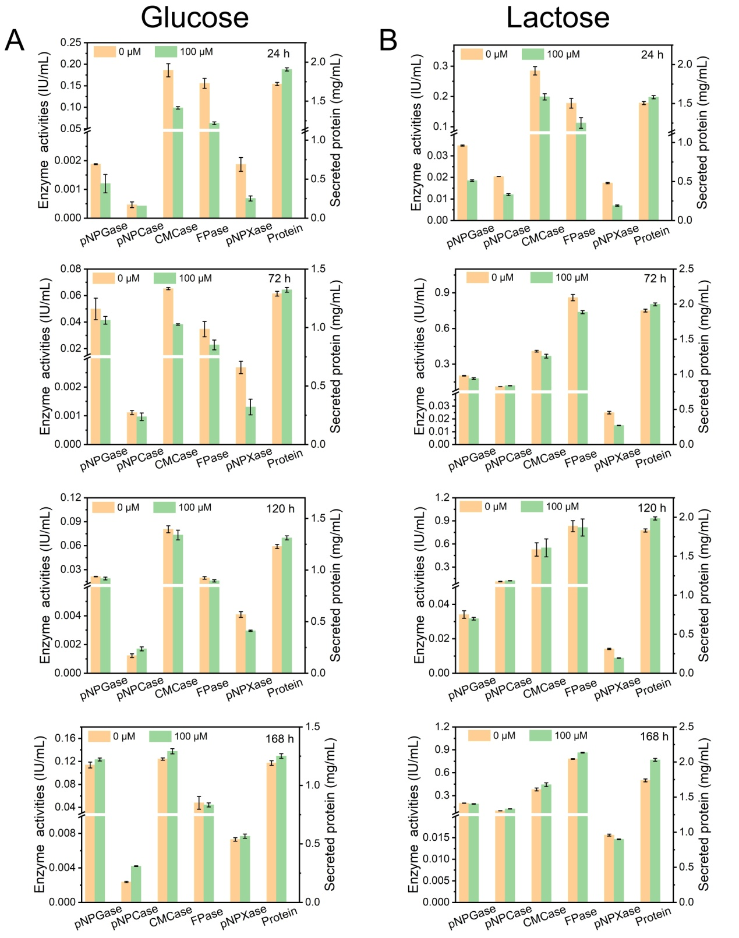
Figure S1 Effects of 100 μM rapamycin on (hemi)cellulase activities and protein secretion of T. reesei RUT-C30 cultured in TMM+2% glucose (A) and TMM+2% lactose (B) at 24 h, 72 h, 120 h, and 168 h, respectively. FPase: the filter paper activity; pNPCase: the CBH activity; CMCase: the CMC activity; pNPGase: the β-glucosidase activity; Secreted protein: secreted protein concentration; pNPXase: the β-xylosidase activity. Data are represented as the mean of three independent experiments and error bars express the standard.
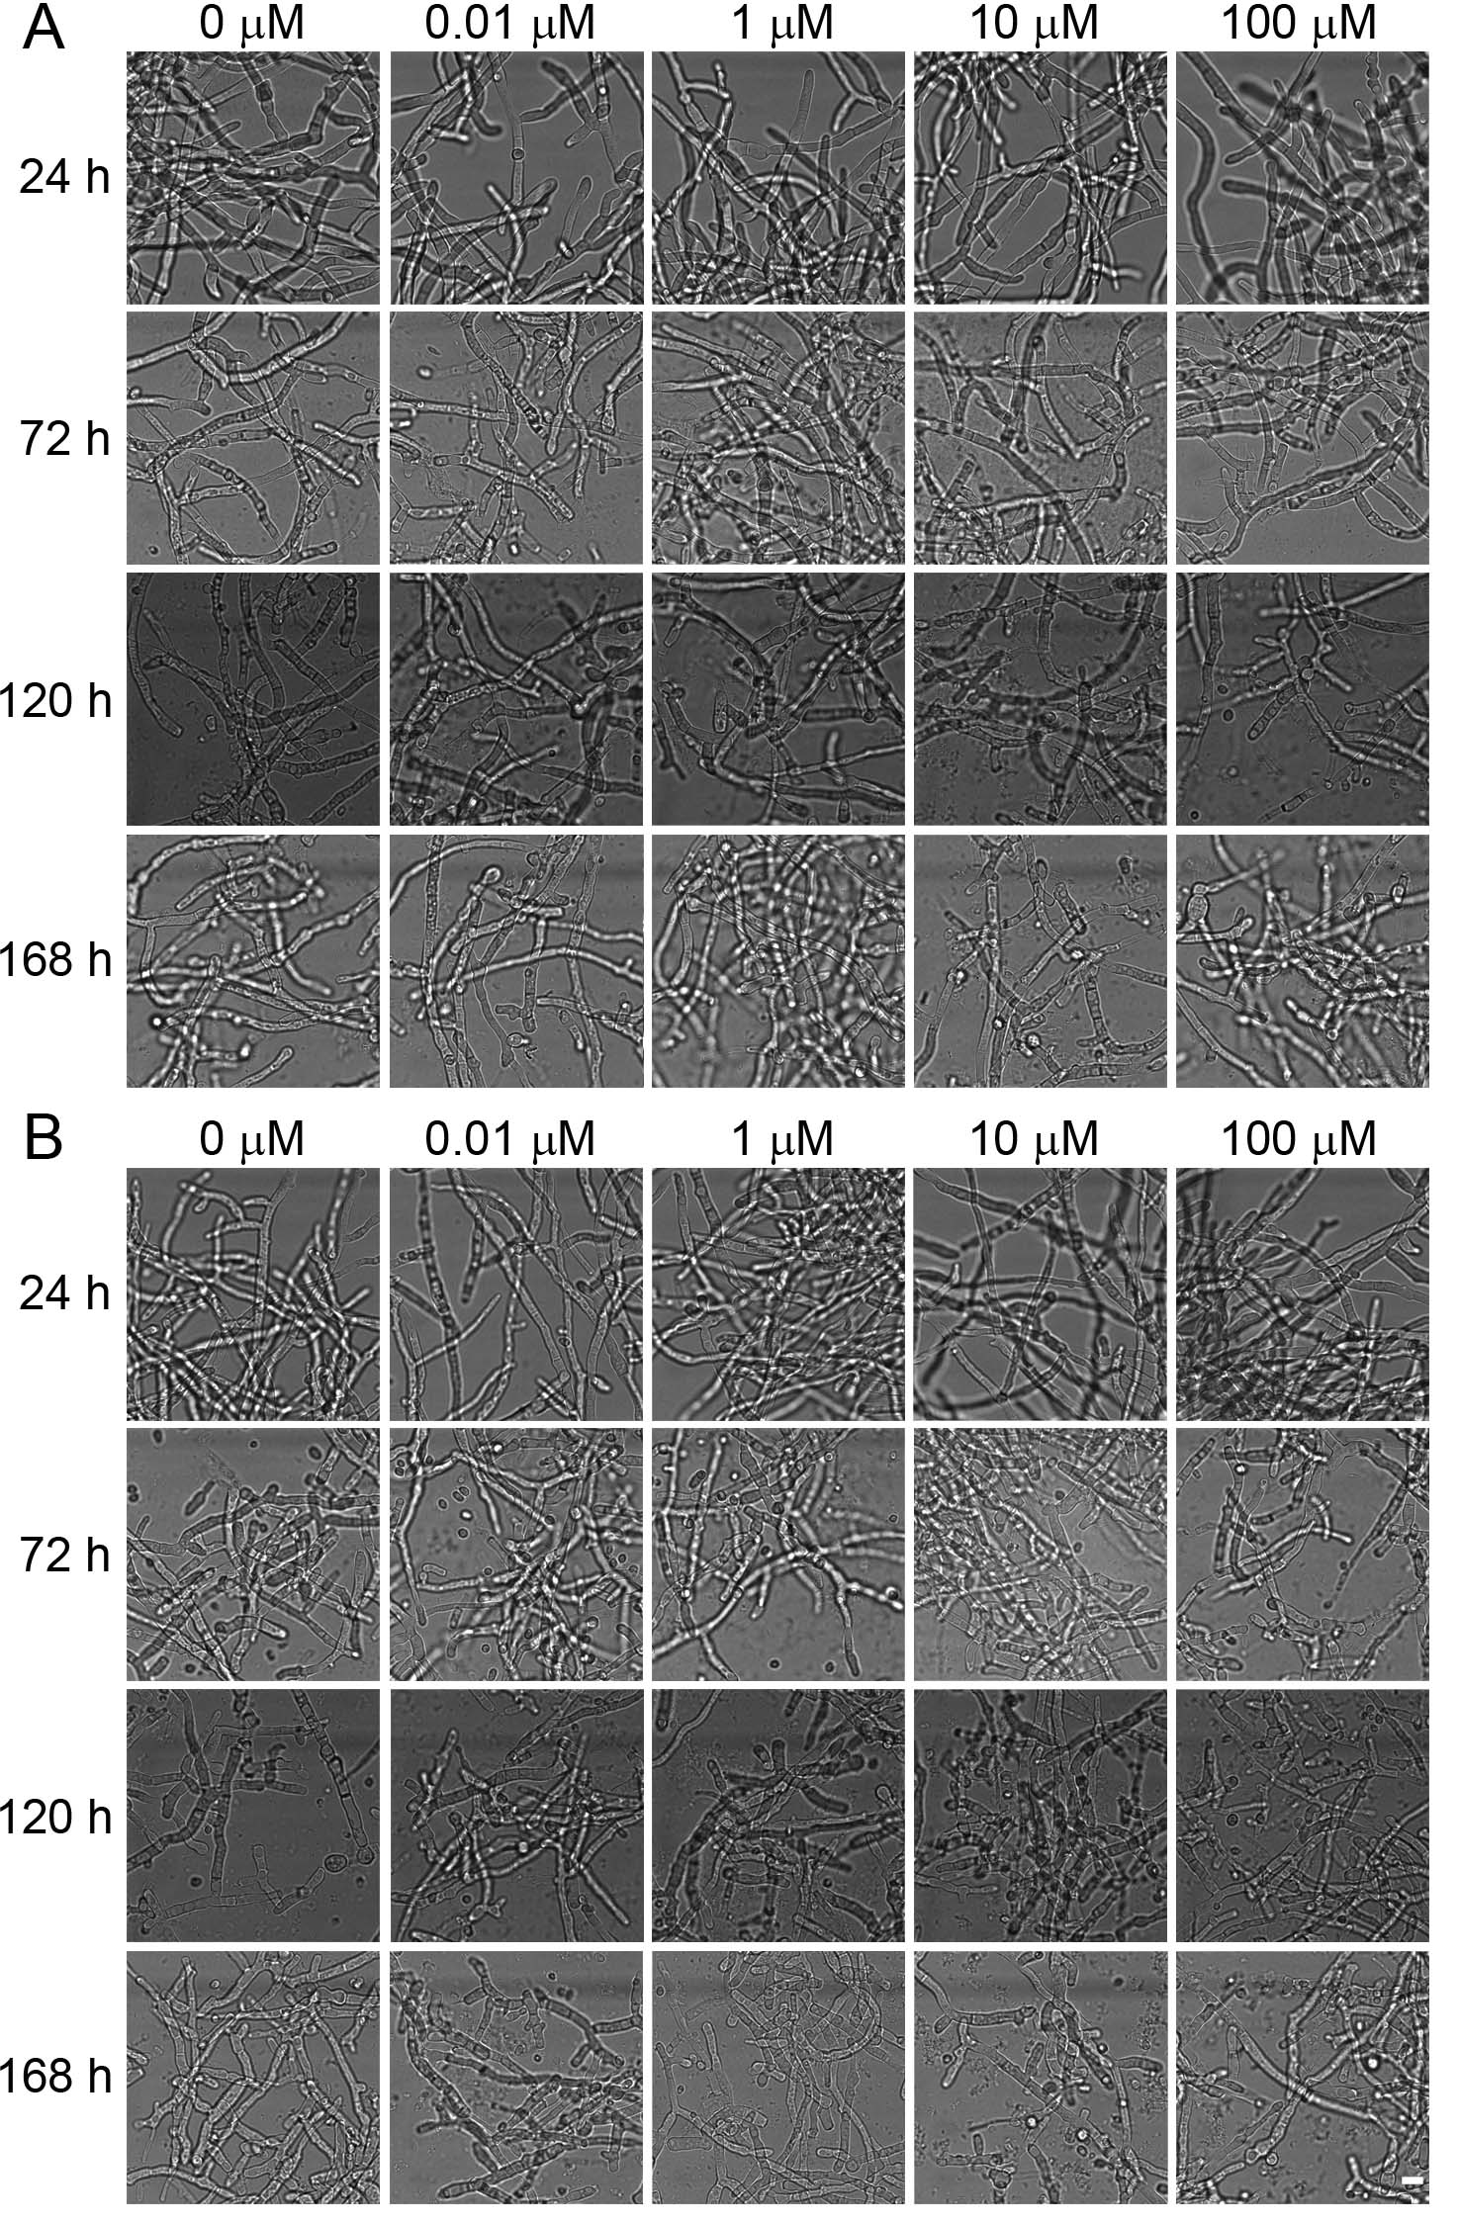
Figure S2 Hyphal morphology of T. reesei RUT-C30 cultured in TMM+2% glucose (A) or lactose (B) with different concentrations of rapamycin at 24, 72, 120, and 168 h, which was observed under CLSM. Scale bar =10 μm.

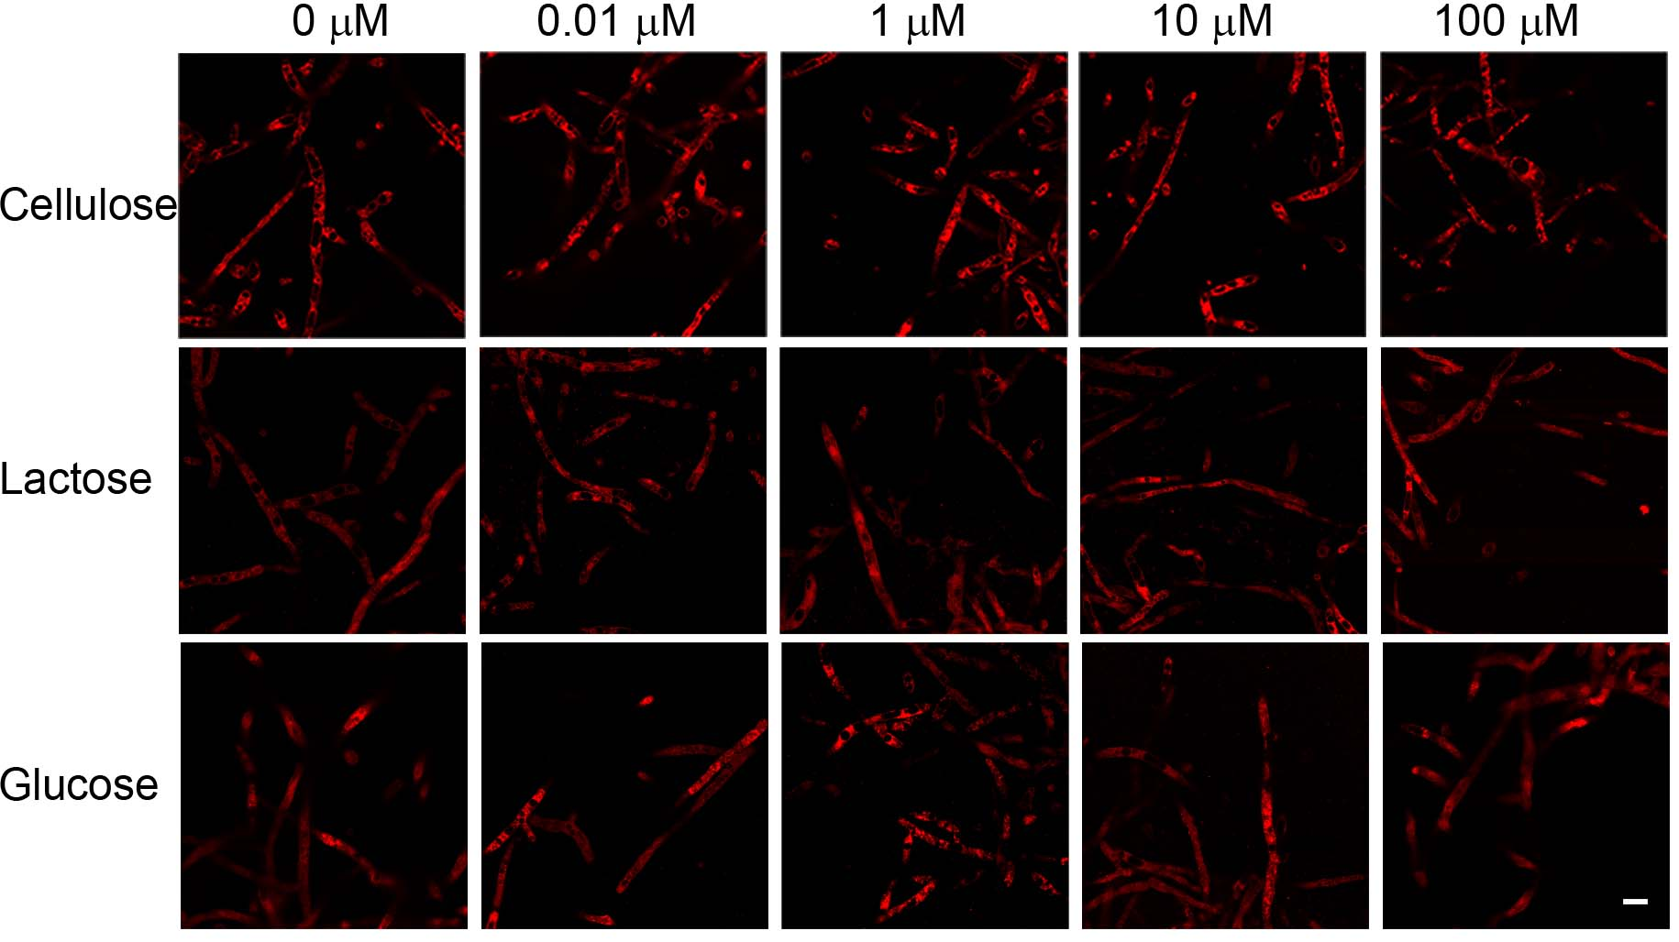
Figure S3 The lipid content of T. reesei RUT-C30 on TMM+2% cellulose, lactose, or glucose with various concentrations of rapamycin. The blue circles in (A) represented mycelial radius at 120 h. The lipid content of RUT-C30 at 24 h stained with Nile Red was observed under CLSM. Scale bar =10 μm.

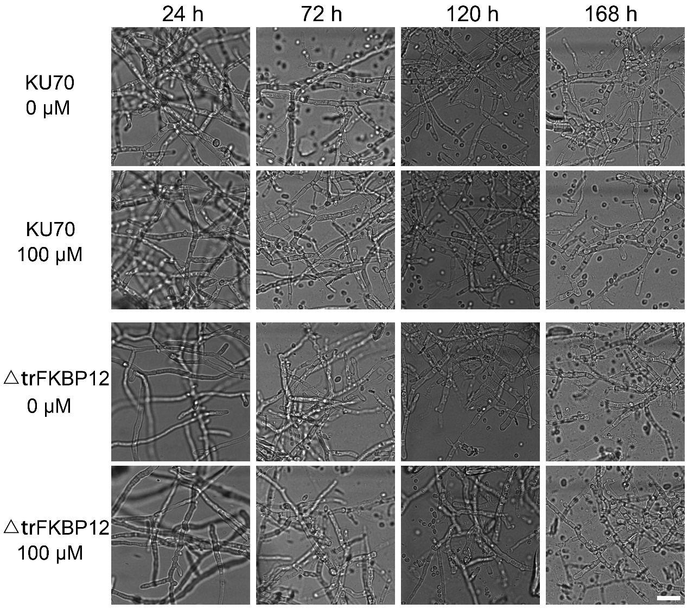
Figure S4 Hyphal morphology of T. reesei △FKBP12 and KU70 cultured in TMM+2% cellulose with/ without 100 μM rapamycin at 24, 72, 120, and 168 h, which was observed under CLSM. Scale bar =20 μm.

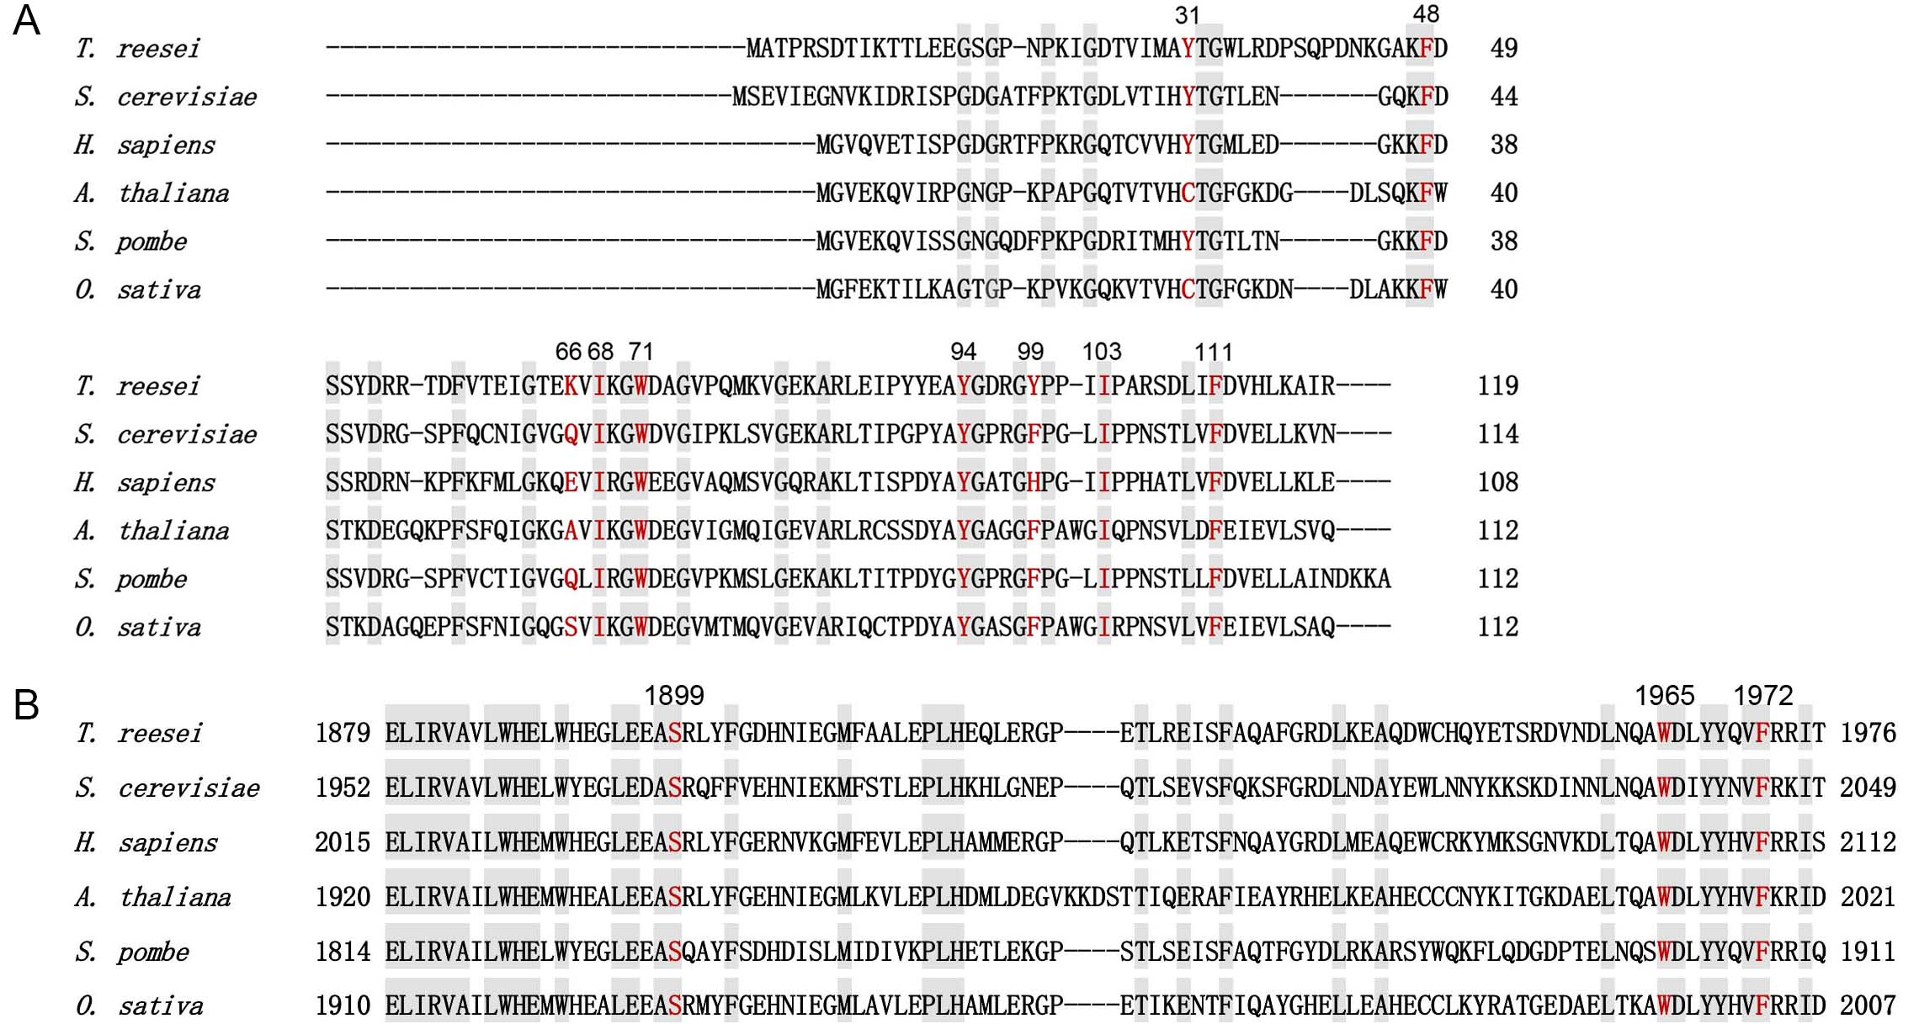
Figure S5 FKBP12 (A) and TOR (B) sequence alignments with those of Saccharomyces cerevisiae, Homo sapiens, Arabidopsis thaliana, Schizosaccharomyces pombe, and Oryza sativa. Amino acid residues that form the hydrophobic rapamycin-binding pocket of FKBP12 (A) are in red. Mutation of amino acid residues of TOR (B) in red confers rapamycin resistance.

