Supplementary Materials
Supplementary Figures
Figure S1. All eight repeat classes across the population size gradient. Boxplots showing genomic fraction of each repeat class for the three species, with individual haplotypes as jittered points. Exact p-values for all pairwise comparisons are reported in Table S1. Provides the complete data underlying Figure 1C.
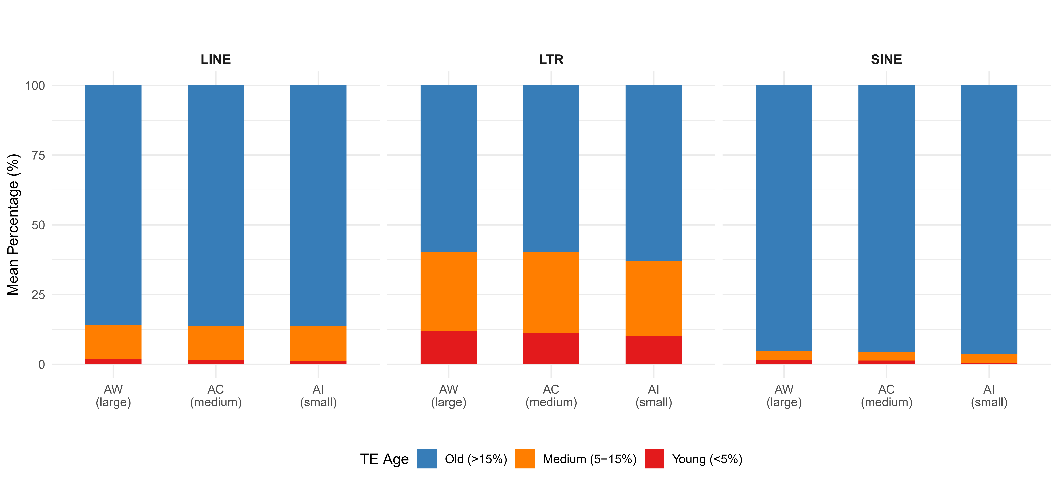
Figure S2. TE age composition by category and species. Stacked bar charts showing the mean proportion of young (<5% Kimura), medium (5–15%), and old (>15%) TE insertions for LINE, LTR, and SINE elements. Note the different baseline compositions: LINE ~86% old, LTR ~60% old, SINE ~95% old. AI consistently shows reduced young fraction and increased old fraction.
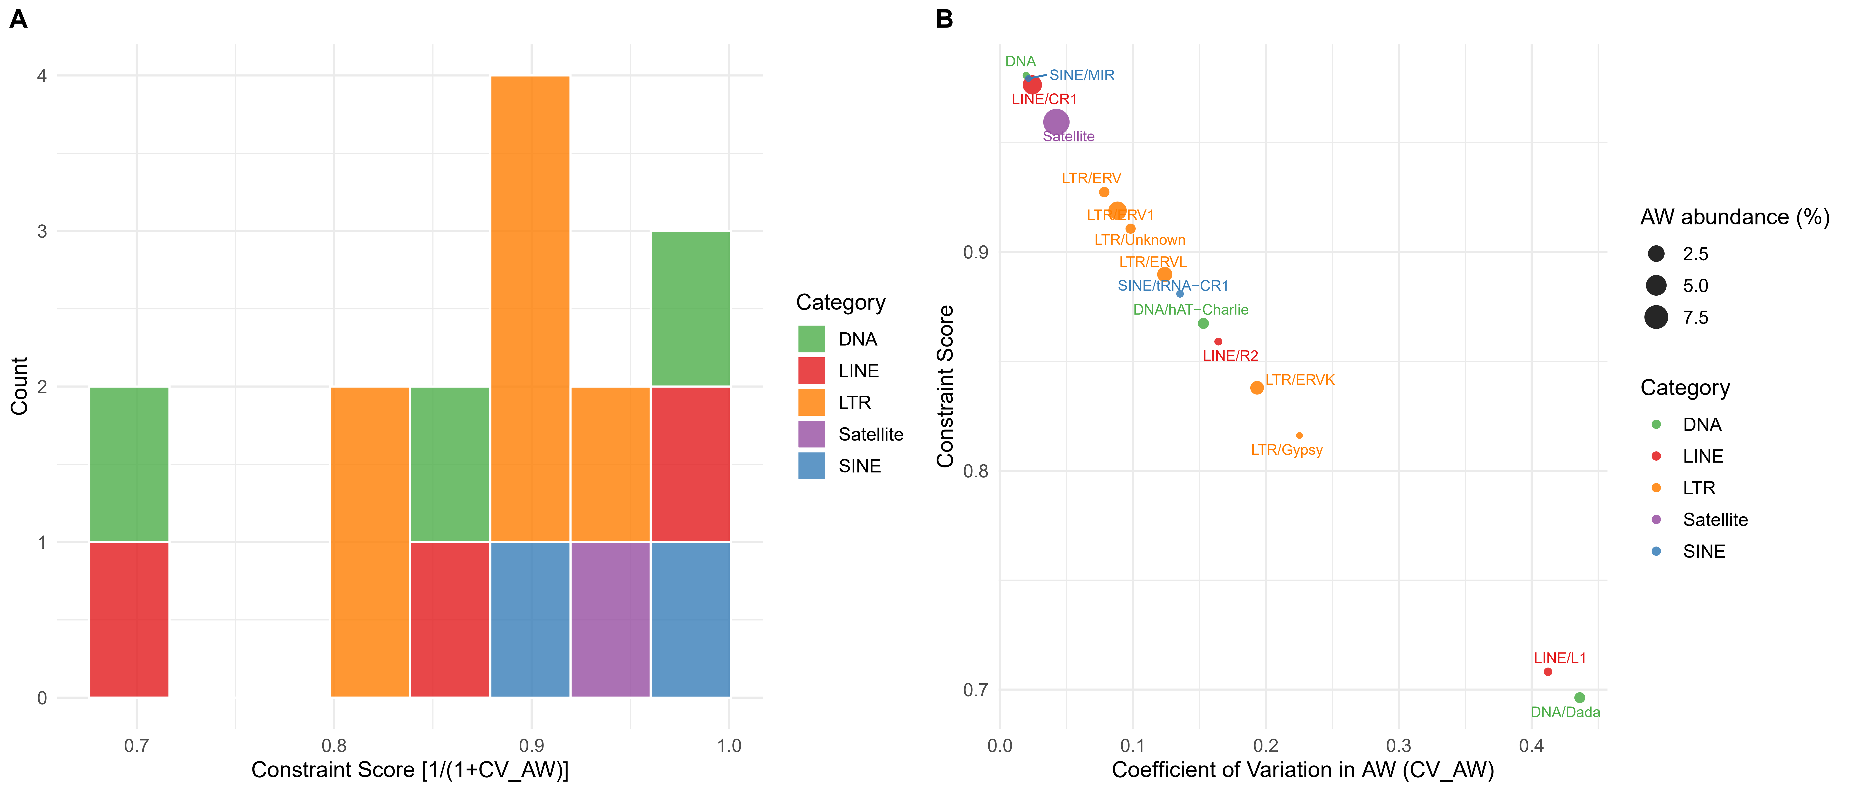
Figure S3. Detailed view of constraint score distributions. (A) Histogram of constraint scores across 15 TE subfamilies, colored by category. Distribution is bimodal with high-constraint (>0.90) and moderate-to-low constraint clusters. (B) Relationship between CV_AW and constraint score, with point size proportional to mean AW abundance. Abundant subfamilies tend to have lower CV (higher constraint).
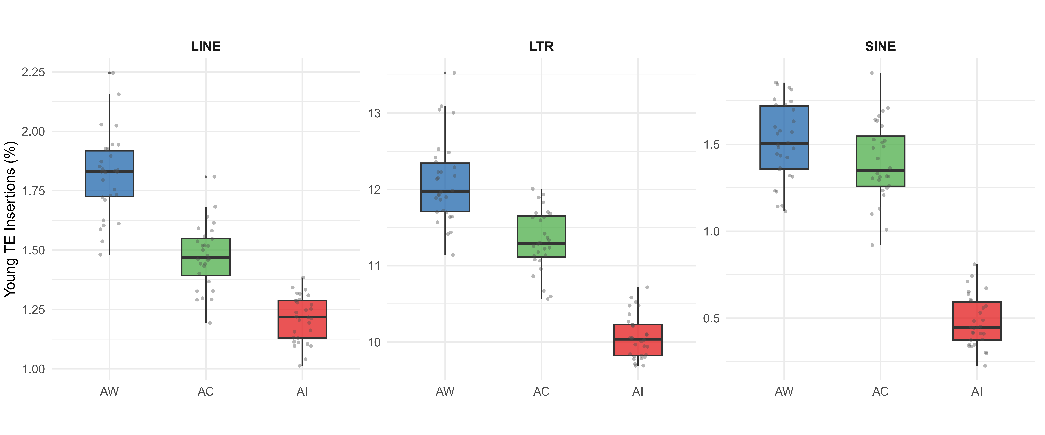
Figure S4. AC (medium Ne) shows intermediate young TE proportions. Boxplots of young TE insertion percentage across LINE, LTR, and SINE. AC consistently falls between AW and AI, demonstrating a graded relationship between Ne and the efficiency of purifying selection against young TE insertions.

Supplementary Tables
Table S1. Repeat element abundance statistics across species. Mean genomic fraction (%), standard deviation, AI/AW abundance ratio, Kruskal-Wallis H and p-value, and Mann-Whitney U results (AW vs. AI) for eight major repeat classes.
Table S2. TE age structure and copy number statistics by category and species at the individual level. Mean and standard deviation of young TE%, old TE%, and total TE copy number per individual for LINE, SINE, and LTR across the three species (N = 15, 14, 15 individuals). Kruskal-Wallis tests compare all three species; Mann-Whitney U tests compare AW vs. AI.
Table S3. Subfamily-level constraint analysis. For 15 TE subfamilies: category, mean genomic fraction in AW and AI (%), AI/AW ratio, CV_AW, and constraint score [1/(1+CV)]. Sorted by AI/AW ratio.
Table S4. Sensitivity analysis of young-TE thresholds. Proportion of young TE insertions (LINE/SINE/LTR combined, based on an unbiased sample of 50,000 copies per species) under young-insertion thresholds of 3-7% divergence, and the corresponding relative change in AI and AC versus AW.

