Additional file 1. Roster provenance, commercial-track admission verification, annual funnel, and encoding coverage (Figure S1; Tables S1–S4)
Manuscript: "Selective uptake of medicines outside China's National Reimbursement Drug List by commercial specialty-drug rosters: a multi-product audit of the 2020–2025 negotiation cohorts," submitted to BMC Health Services Research.

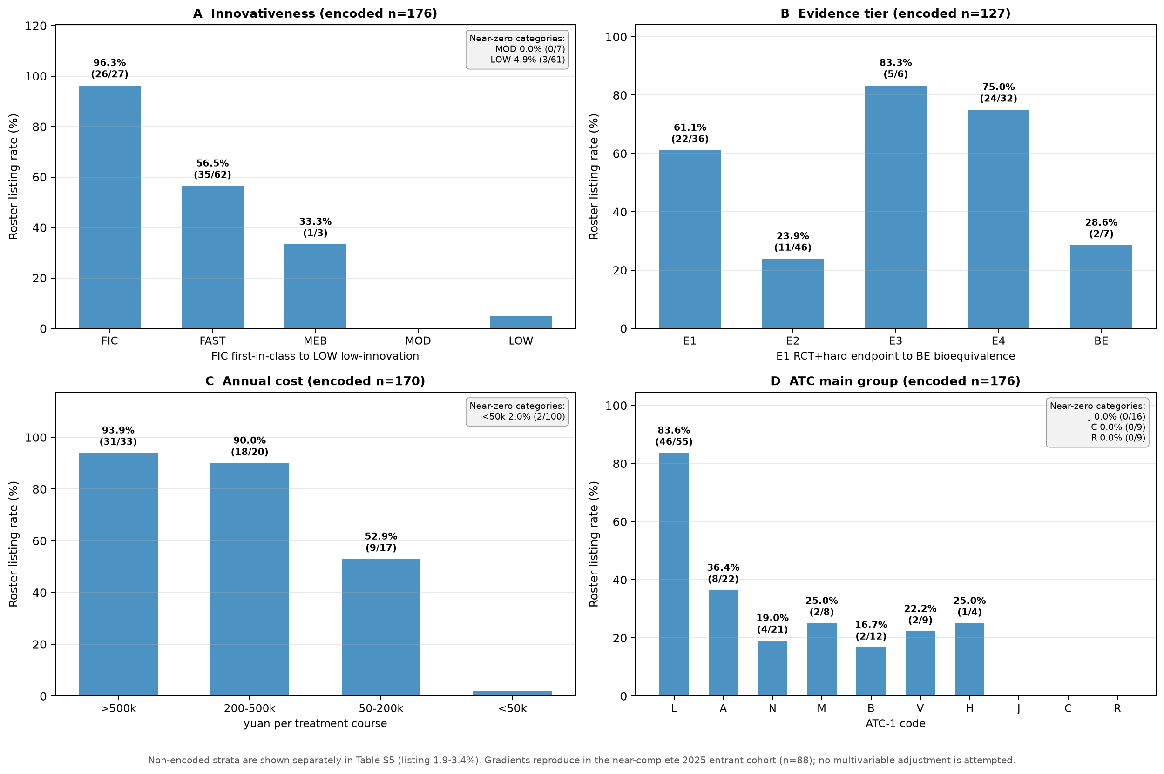
Figure S1. Roster-listing gradients within attribute-encoded subsets of the main pool (descriptive; unadjusted; each attribute reported on its own encoded denominator). (A) Innovativeness (encoded n=176, incl. 16 TCM shown in Table S5). (B) Evidence tier by study design and endpoint type (encoded n=127). (C) Annual treatment cost (encoded n=170). (D) ATC main group (encoded n=176; D/G/S groups, all zero-listing, are omitted). Non-encoded strata are shown separately in Table S5 (listing 1.9–3.4%); gradients reproduce in the near-complete 2025 entrant cohort (n=88).

Table S1. Full source provenance for the 14 products (all URLs accessed 2026-09-08)

# | Product full name | Underwriter | Roster version / effective date | Official URL (verified open) | Source type
1 | 北京普惠健康保 2026 | PICC & China Life lead; Taikang/CPIC/PingAn/Beijing Life co-insurance | 2026 roster (launched 2025-11; adjusted to 176 drugs 2026-08-07, retroactive to 2026-01-01) | https://news.bjd.com.cn/2026/08/07/11904764.shtml ; Beijing Healthcare Security Administration: https://ybj.beijing.gov.cn/2020_zwfw/2020_cjwt/202511/t20251112_4278670.html | Official media roster release; government Q&A
2 | 沪惠保 2026 (Shanghai city-customised supplementary medical insurance) | CPIC Life lead, co-insurance body | 2026 claims notice (2026-04); enrolment from 2026-05-25 | https://mcdpro.cbit.com.cn/hhb/static-file/cms/tk/site/mcdpro.cbit.com.cn/hhb/static-file/SXYHB/shanghailanmu/1111709934518534144.html | Co-insurance official claims-notice page
3 | 深圳惠民保 2026 | China Life Shenzhen et al. (5 insurers) | 2026-05-06 (enrolment 2026-05-07) | https://hsa.sz.gov.cn/ztzl/szhmb/cbdy/content/post_10593003.html | Municipal healthcare-security bureau page
4 | 苏惠保 2026 | Soochow Life lead | 2025-10-20 launch | http://js.cnr.cn/tyjk/20251020/t20251020_527402324.shtml ; terms: https://cschannel.alipay.com/mobile/helpDetail.htm?help_id=201736332723 | Official media launch report; full terms text
5 | 惠蓉保 2026 (Chengdu) | 10-insurer co-insurance (Sichuan/Chengdu bureaus guided) | announced 2026-05-11; effective 2026-07-01 | https://cdyb.chengdu.gov.cn/ylbzj/c128983/2026-05/11/content_829dcf7261e84086b318a05a7bca00c6.shtml | Municipal healthcare-security bureau announcement
6 | 南京宁惠保 phases III–VI | PICC lead; co-insurance | phase III 28 drugs (2022-09-19); IV 36 (2023-09-19); V 45 (2024-09-19); VI 50 (2025-09-16) | VI: https://www.nanjing.gov.cn/zzb/ywdt/msxx/202509/t20250917_5650868.html ; V: https://www.nanjing.gov.cn/zzb/ywdt/msxx/202410/t20241012_5125767.html ; IV: https://www.jiangsu.gov.cn/art/2023/9/20/art_88959_11024815.html ; III: insurer brochure hosted by Nanjing University | Municipal/provincial government pages; insurer brochure for phase III
7 | 东莞莞家福 2025/2026 | co-insurance (Dongguan bureaus guided) | no dedicated roster (open formulary); statement 2025-02-27; 2026 edition launched 2026-04-22 | https://static.nfnews.com/content/202502/27/c11031144.html | Government-contributed policy explainer
8 | 广州穗岁康 2026 | China Life lead; PICC P&C/PingAn P&C/CPIC P&C co-insurance | open formulary ("no drug-rostering limit"); proposal 2025-12-22 | https://www.gz.gov.cn/zt/zzyyzq/tzgg/content/post_10608829.html | Municipal government joint proposal
9 | 众安尊享e生 2026 (series since 2016-08) | ZhongAn Online P&C | 2026 specialty-drug roster PDF; product page | roster: https://static.zhongan.com/upload/online/material/1765784826536.pdf ; product: https://m.zhongan.com/gp/99633347 | Insurer official roster PDF + product page
10 | 好医保·长期医疗 / filed 悠臻保2025款 (series since 2018-05) | PICC Health | filing 人保健康[2025]063号; product page 2026-06-01 | https://www.picchealth.com/picchealth/webfile/629925/2026-06-01/7100.html | Insurer official product/terms page
11 | 平安e生保·百万医疗 2026旗舰版 (series since 2016) | PingAn Health Insurance | released 2025-12-01 | https://ehis-ows.health.pingan.com/health_new/news/articles/14987979559889024469 | Insurer official release
12 | 蓝医保·长期医疗 E款 (series since 2022-04) | CPIC Health Insurance | product explainer 2026-06-17; terms-appendix PDF 2026-02-11 | explainer: https://m.cpic.com.cn/c/2026-06-17/1883958.shtml ; PDF (downloaded & parsed by team): https://www.cpic.com.cn/upload/resources/file/2026/02/11/93040.pdf | Insurer official page + terms-appendix PDF
13 | 太保附加互联网特定药品费用B款医疗保险 | CPIC Health Insurance | filing 太平洋健康险[2025]051号; roster PDF 2026-01-28 | PDF (downloaded & parsed by team): https://www.cpic.com.cn/upload/resources/file/2026/01/28/92822.pdf | Insurer official roster PDF
14 | 泰康在线住院费用医疗保险2025版K款 (roster YWTY020) | Taikang Online P&C | roster PDF 2026-04-30 (87 pages; names applicable terms) | PDF (downloaded & parsed by team): https://www.tk.cn/tkcms/article/252f4776b873fc3b76a7459acf51fa7b.pdf | Insurer official roster PDF

Notes: (i) Every URL was opened and verified to contain the roster, terms clause, or policy statement quoted; access date 2026-09-08. (ii) All six high-limit products are annual terms updates of multi-year series (series-launch years given), not new products; the "no historical versions" statement in carrier communications refers to per-year terms versions, which are superseded rather than archived publicly. (iii) Nanjing 宁惠保 had no specialty-drug roster in phases I–II (2021–2022 benefit years); roster-based diffs begin at phase III. (iv) Products 7–8 are open-formulary by official design; this is a coverage-policy feature, not missing data. (v) The blue medical insurance E款 terms-appendix PDF (product 12) contains the negative-list clause quoted in Table 1 row 12 / §2.3.

Table S2. Identity verification for the 19 inaugural commercial-track (CHI) admissions

Chinese name | English/INN | Class & target | Indication(s) | NMPA approval | Application history
阿基仑赛注射液 | axicabtagene ciloleucel | CD19 CAR-T | r/r large B-cell lymphoma | 2021 | BMI 2021–2024 (4 cycles); commercial 2025
瑞基奥仑赛注射液 | relmacabtagene autoleucel | CD19 CAR-T | r/r LBCL | 2021 | BMI 2022–2025 (4 cycles); commercial 2025
伊匹木单抗注射液 | ipilimumab | anti-CTLA-4 mAb | melanoma, mesothelioma (combo) | 2021 | BMI first application 2021; HMB 2022; commercial 2025
达妥昔单抗β注射液 | dinutuximab beta | anti-GD2 mAb | high-risk neuroblastoma | 2021-08 | HMB 2022 (before BMI application 2023); commercial 2025
盐酸沙丙蝶呤片 | sapropterin dihydrochloride | BH4 analogue | phenylketonuria (PKU) | 2023 | BMI 2023; commercial 2025
那西妥单抗注射液 | naxitamab | anti-GD2 mAb | r/r neuroblastoma | 2022-11 | BMI 2024; commercial 2025
泽沃基奥仑赛注射液 | zevorcabtagene autoleucel | BCMA CAR-T | r/r multiple myeloma | 2024-02-23 | BMI 2024; commercial 2025
纳基奥仑赛注射液 | inaticabtagene autoleucel | CD19 CAR-T | r/r B-cell ALL / LBCL | 2023-11 | BMI 2024; commercial 2025
注射用替度格鲁肽 | teduglutide | GLP-2 analogue | short-bowel syndrome | 2024-02 (Takeda) | BMI 2024; commercial 2025
仑卡奈单抗注射液 | lecanemab | anti-amyloid-β mAb | early Alzheimer's disease | 2024 | BMI 2025; commercial 2025
多奈单抗注射液 | donanemab | anti-amyloid-β mAb | early Alzheimer's disease | 2024 | BMI 2025; commercial 2025
注射用维拉苷酶β | velaglucerase β | enzyme replacement | Gaucher disease (domestic, CANbridge) | 2025-05-13 | commercial 2025 only; never filed BMI
伊基奥仑赛注射液 | equecabtagene autoleucel | BCMA CAR-T | r/r multiple myeloma | 2023-06-30 | BMI 2025; commercial 2025
氢溴酸他泽司他片 | tazemetostat | EZH2 inhibitor | follicular lymphoma; epithelioid sarcoma | 2025 | BMI 2025 (not listed); HMB 2026; commercial 2025 (CHI-admitted)
埃纳妥单抗注射液 | elranatamab | BCMA×CD3 bispecific | r/r multiple myeloma | 2025 | HMB 2026; commercial 2025 only; never filed BMI
塔奎妥单抗注射液 | talquetamab | GPRC5D×CD3 bispecific | r/r multiple myeloma | 2025 | HMB 2026; commercial 2025 only; never filed BMI
注射用泽尼达妥单抗 | zanidatamab | HER2 bispecific | biliary tract cancer | 2025 | commercial 2025 only; never filed BMI
甲苯磺酰胺注射液 | tosylamide | intratumoural ablative agent | malignant tumour ablation | 2022 | BMI 2025; HMB 2026; commercial 2025
注射用芦比替定 | lurbinectedin | transcription modulator | small-cell lung cancer | 2024 | HMB 2026; commercial 2025 only; never filed BMI

All 19 identities were verified against NMPA approval records and NHSA commercial-track application materials; class and target fields follow the approved labelling (inaticabtagene autoleucel 纳基奥仑赛/源瑞达 is a CD19 CAR-T for r/r B-ALL/LBCL; talquetamab 塔奎妥单抗 is a GPRC5D×CD3 bispecific; teduglutide 替度格鲁肽/瑞唯抒 is a GLP-2 analogue for short-bowel syndrome). A further listed ingredient, ravulizumab (瑞利珠单抗, 伟立瑞), appears on Beijing Puhui 2026's overseas-drug sub-roster; at roster publication (2025-11) its PNH indication had not yet received NMPA approval (approved 2026-08-20), and it is included under the overseas/Hainan pilot precedent—a genuine listing flagged as an overseas-drug case. Of the 19, exactly 5 never filed for basic-track listing (velaglucerase β, elranatamab, talquetamab, zanidatamab, lurbinectedin); the other 14 are dual-track.

Table S3. Annual NRDL funnel, 2020–2025 (basic track; 2025 commercial track shown separately)

Cycle | Formal-review pool | Negotiation/bidding entrants | Successes | Newly listed (incl. direct) | Listing rate
2020† | 704 | — | — | 119 | 16.9%
2021 | 174 | — | 67 negotiated | 74 (+7 direct) | 42.5%
2022 | 199 | — | — | 108 | 54.3%
2023 | 226 | — | — | 126 | 55.8%
2024 | 249 | — | — | 91 | 36.5%
2025 basic | 311 | 127 (+2 direct) | 112 (105 negotiation + 7 bidding; 88.2% of entrants) | 114 (incl. 50 Class-1) | 36.7%
2025 renewals | 224 reviewed | 178 renewed (148 simple, mean −8.4% for 15; 30 renegotiated, mean −13.8%) | — | 8 failures (4.3%) + 21 routine removals = 29 exits | —
2025 commercial | 141 filed | 121 passed review (79 dual-track) | 19 admitted | 19 | —

† 2020 pool compiled under a broader scope; rates from 2021 use NHSA negotiation-cycle denominators. The 2021 denominator of 174 formal-review-passing applicants follows the NHSA published formal-review list [12]; the count of 74 newly listed (67 negotiated + 7 direct) follows the NHSA official interpretation of the 2021 results [24]. Sources: NHSA annual communiqués and formal-review announcements [11–17,24].

Table S4. Encoding coverage and the 9 listed main-pool ingredients outside the encoded subset
Per-attribute encoding coverage among the 578 main-pool ingredients: innovativeness/ATC/rarity 176 (30.4%); evidence tier 127 (21.9%); price 170 (29.4%); registration class 208 (36.0%). Listed ingredients outside the innovativeness-encoded subset (n=9): imiglucerase, elosulfase alfa, liposomal doxorubicin, interferon α-2b gel, laronidase, pralatrexate, mobocertinib, agalsidase beta, alglucosidase alfa. These are predominantly long-marketed high-cost specialty drugs (lysosomal enzyme replacement, liposomal chemotherapy) that fall outside recent-innovation coding frames; their listing indicates rosters also cover established specialty drugs. Encoded vs non-encoded group comparison and the 2025 single-year sensitivity cohort are in §3.5 and Audit Appendix A3.

