SUPPLEMENTARY MATERIAL
Online Resource 1 Evolution of the EtG C2/C1 ratio according to the postmortem interval (PMI)
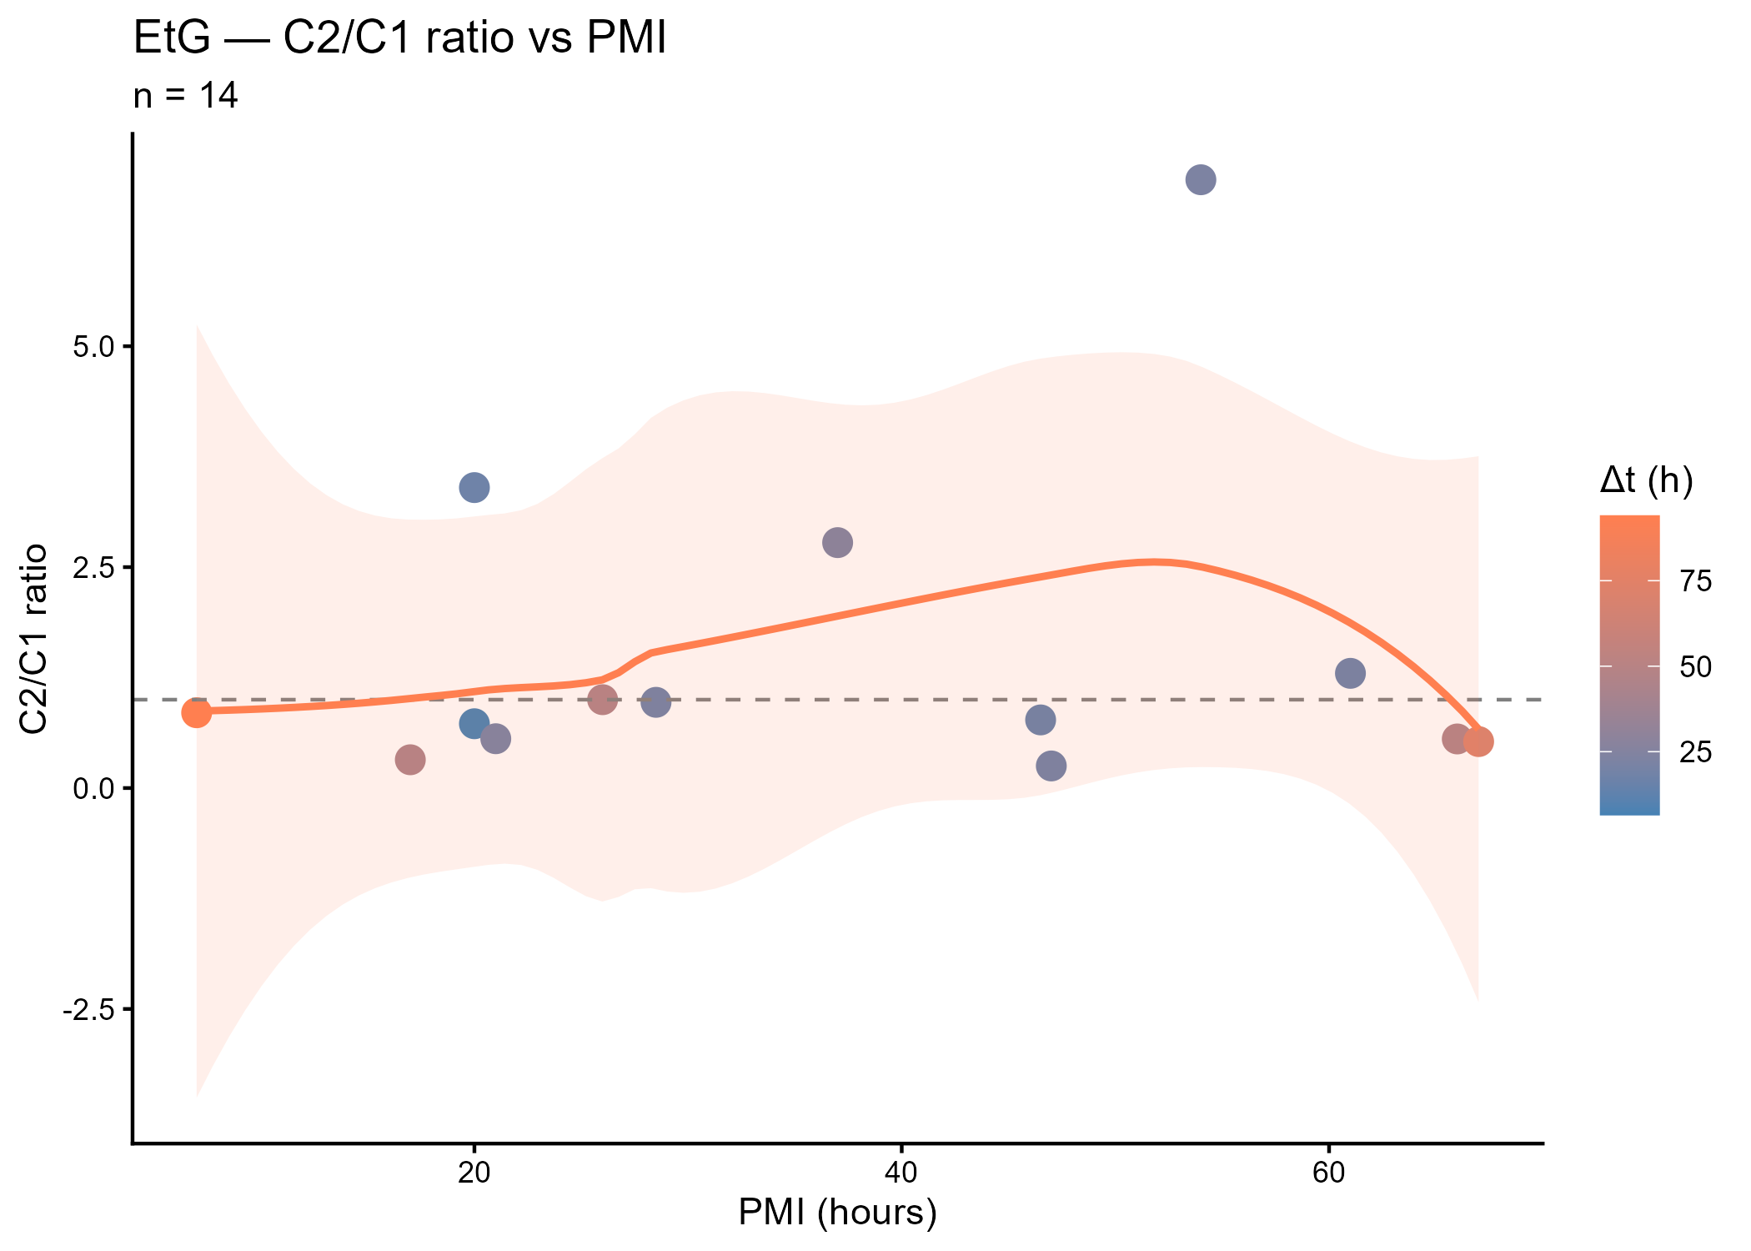
Online Resource 2 Evolution of the EtG C2/C1 ratio according to total PMI
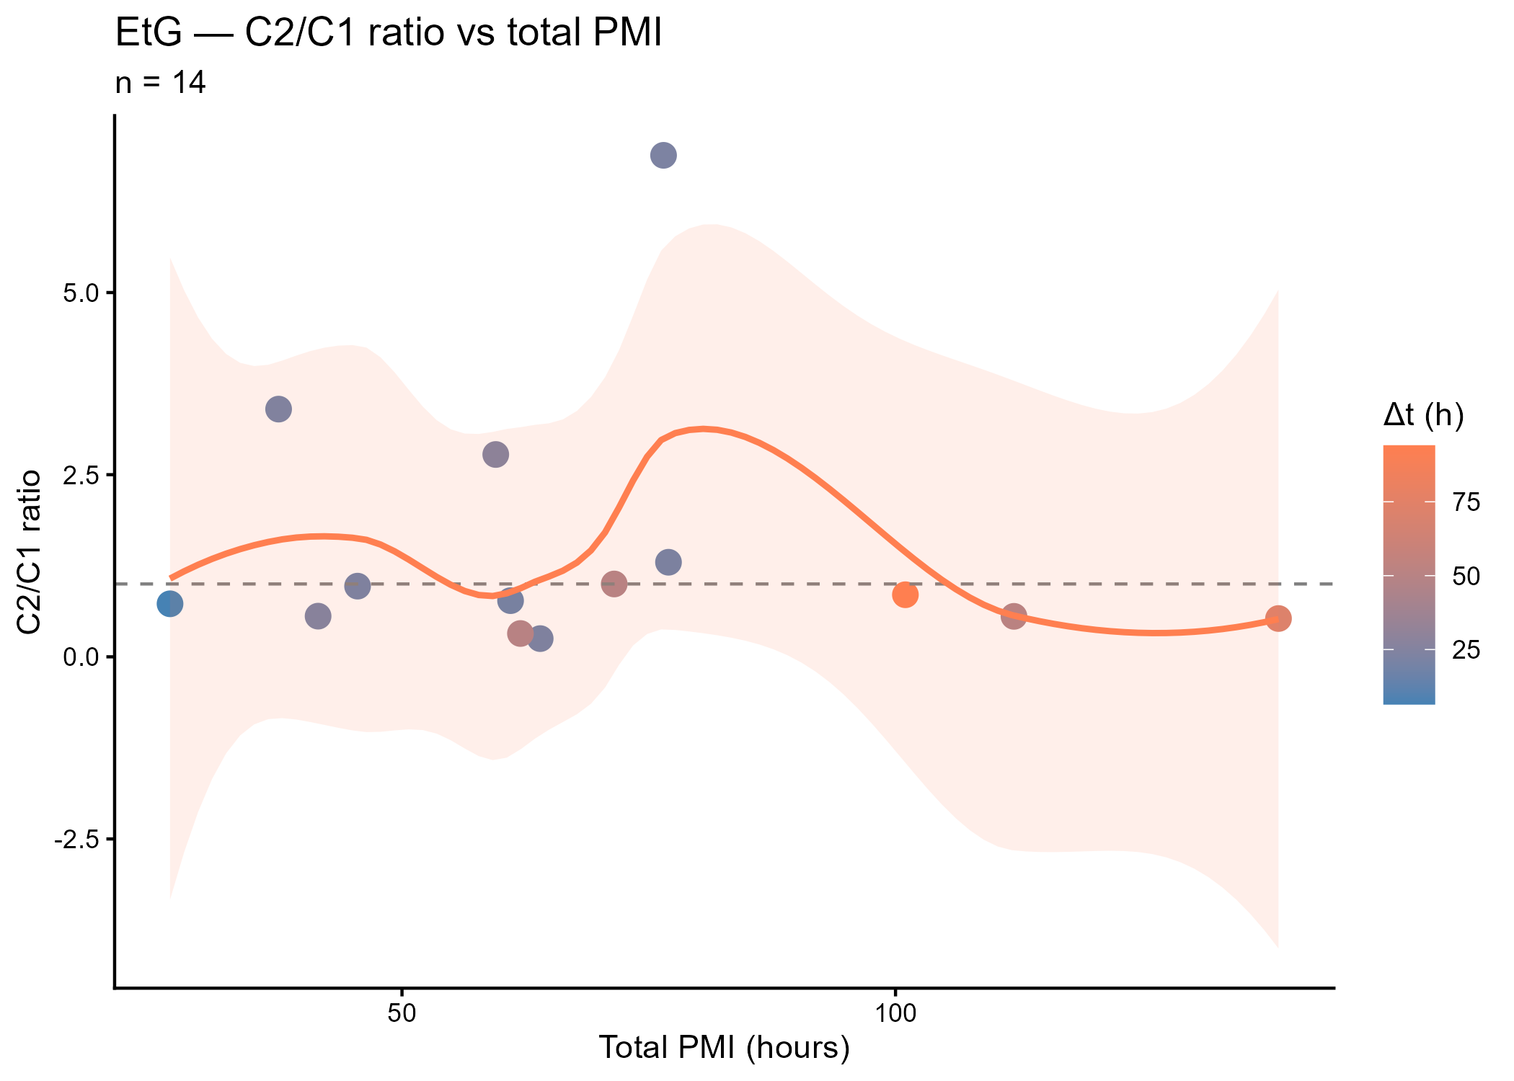
Online Resource 3 Bland-Altman analysis of EtG concentrations between T1 and T2
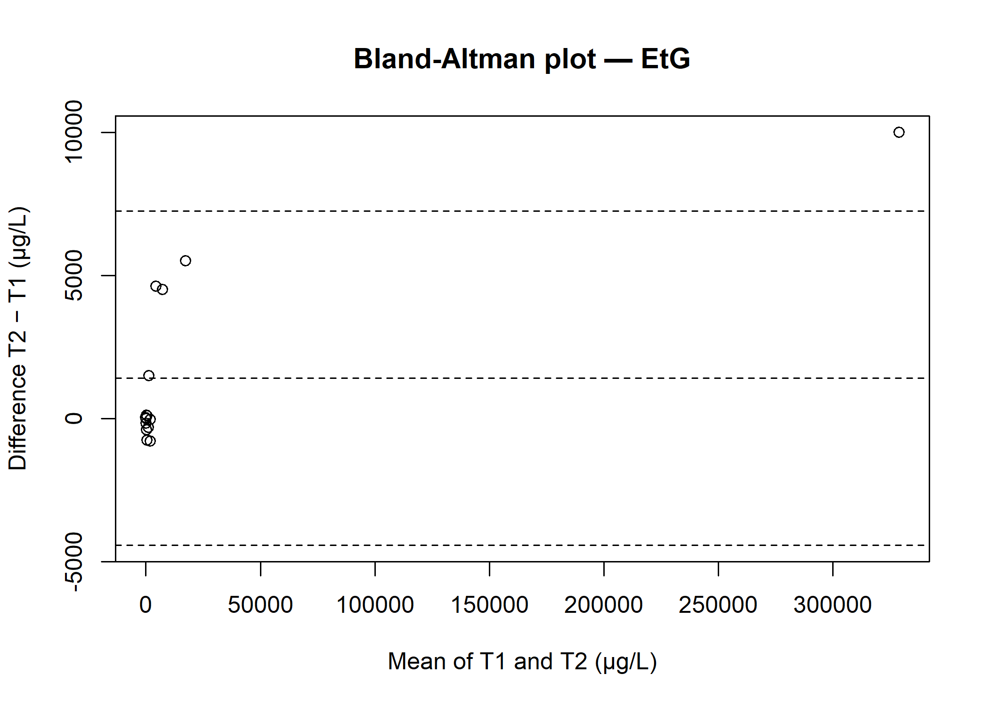
Online Resource 4 Evolution of the PEth 16:0/18:1 C2/C1 ratio according to total PMI
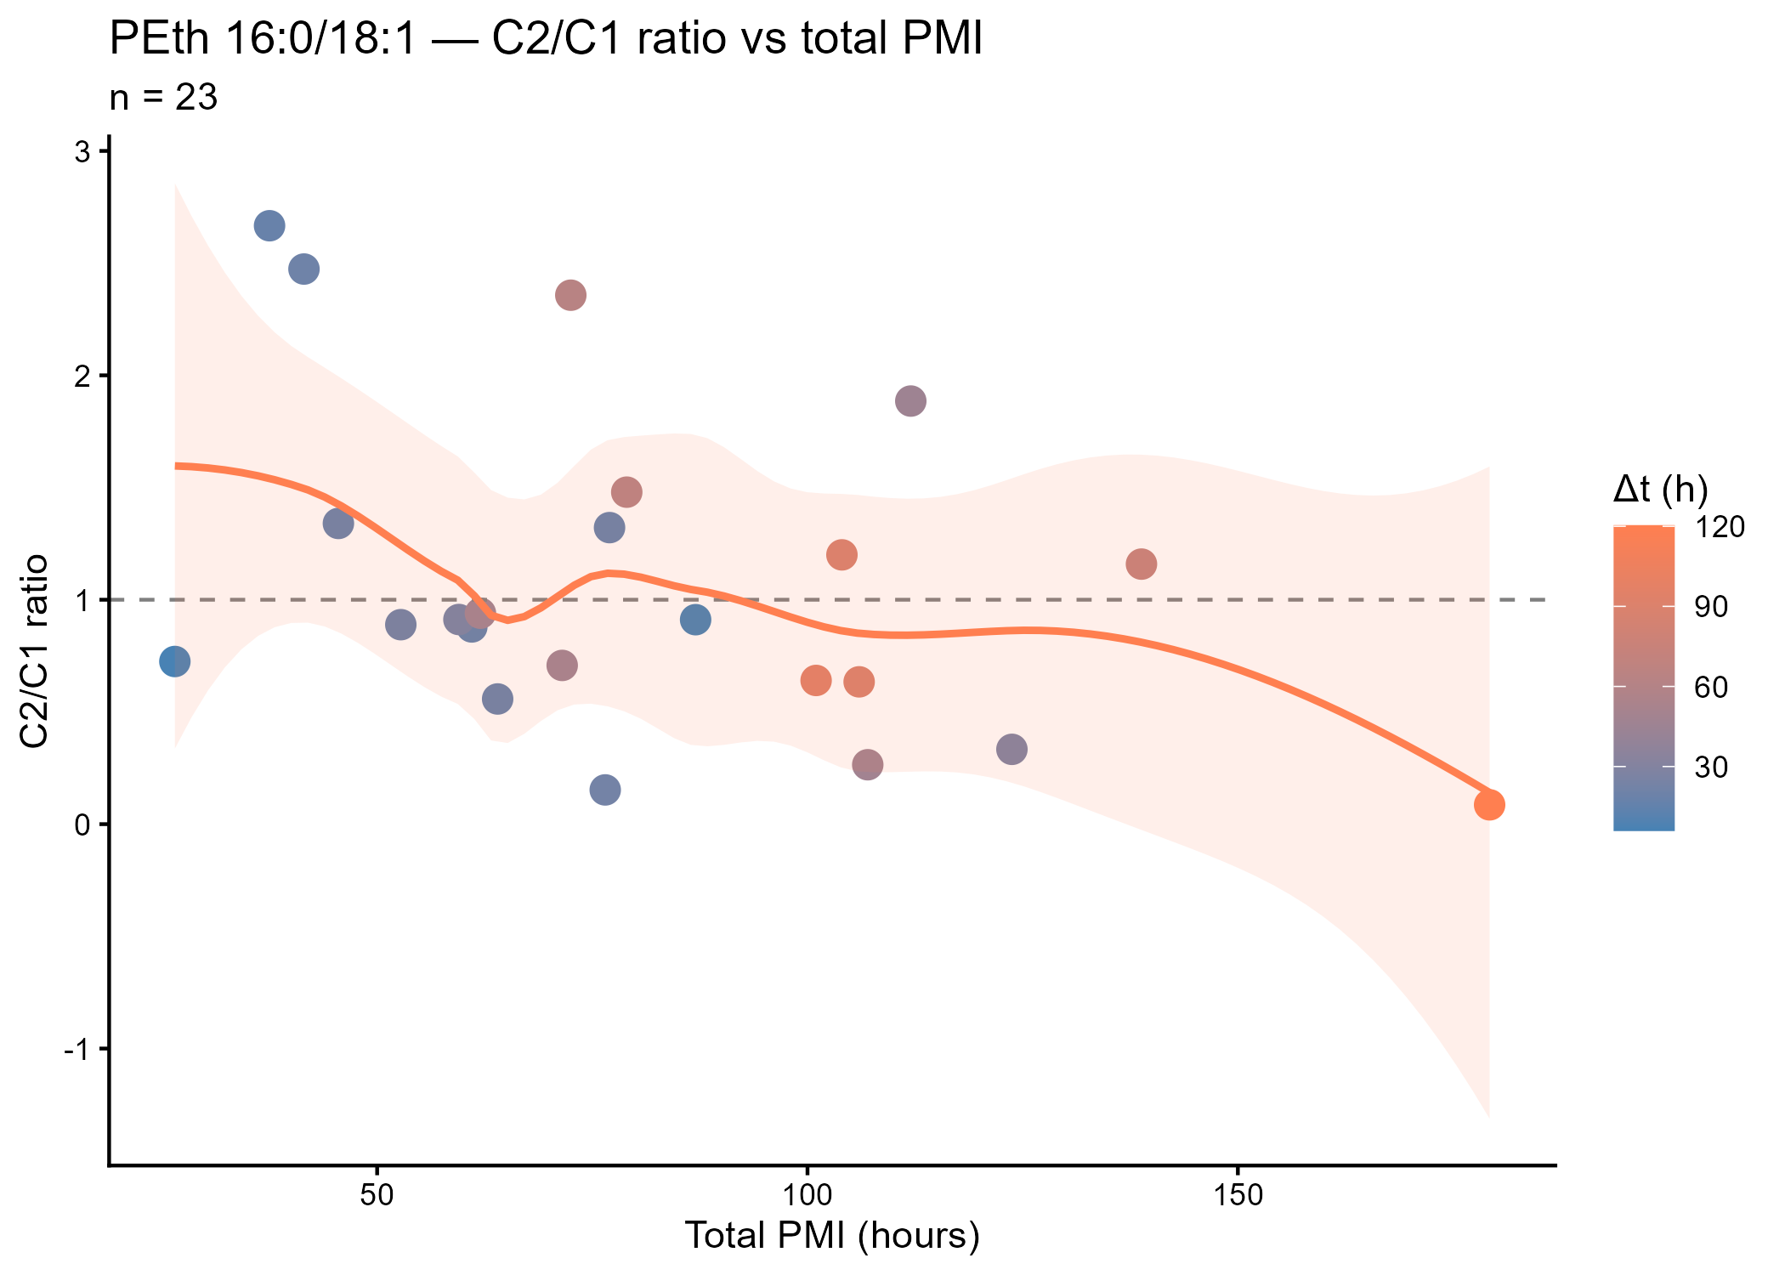
Online Resource 5 Evolution of the PEth 16:0/20:4 C2/C1 ratio according to the inter-sampling interval (Δt)
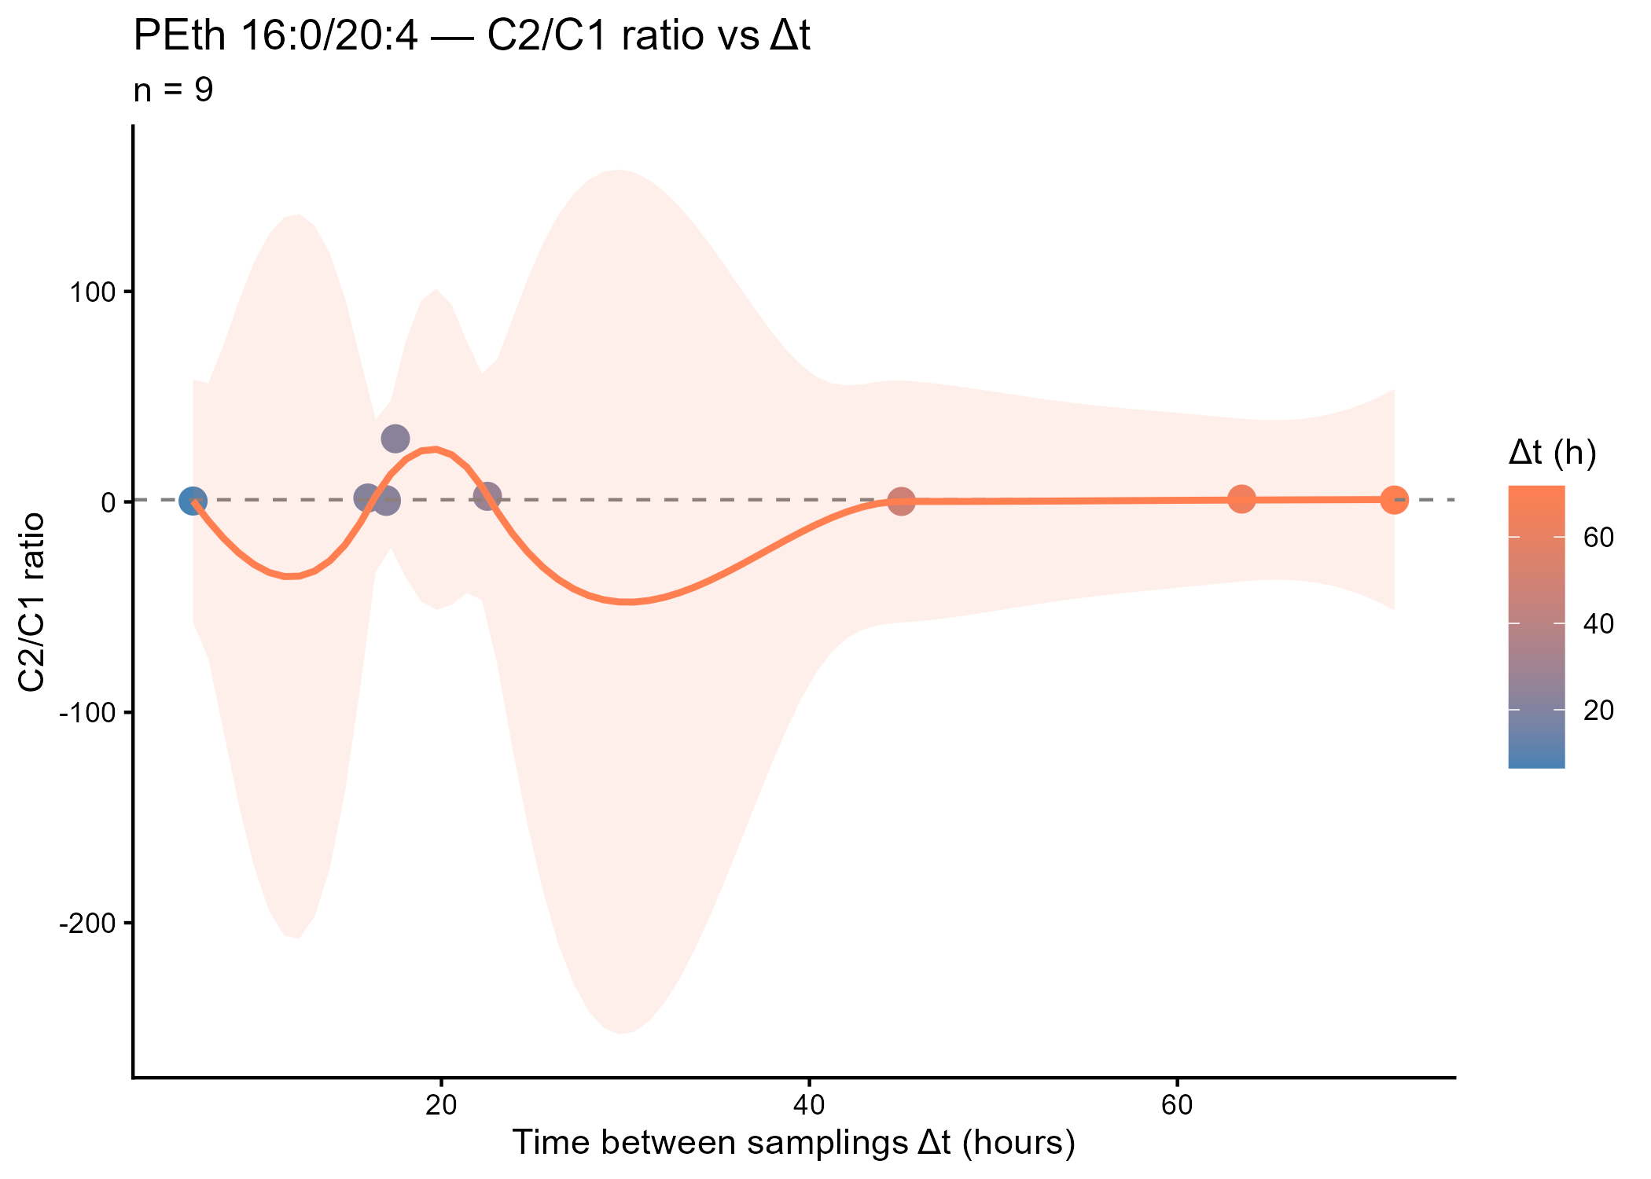
Online Resource 6 Evolution of the PEth 16:0/20:4 C2/C1 ratio according to the postmortem interval (PMI)
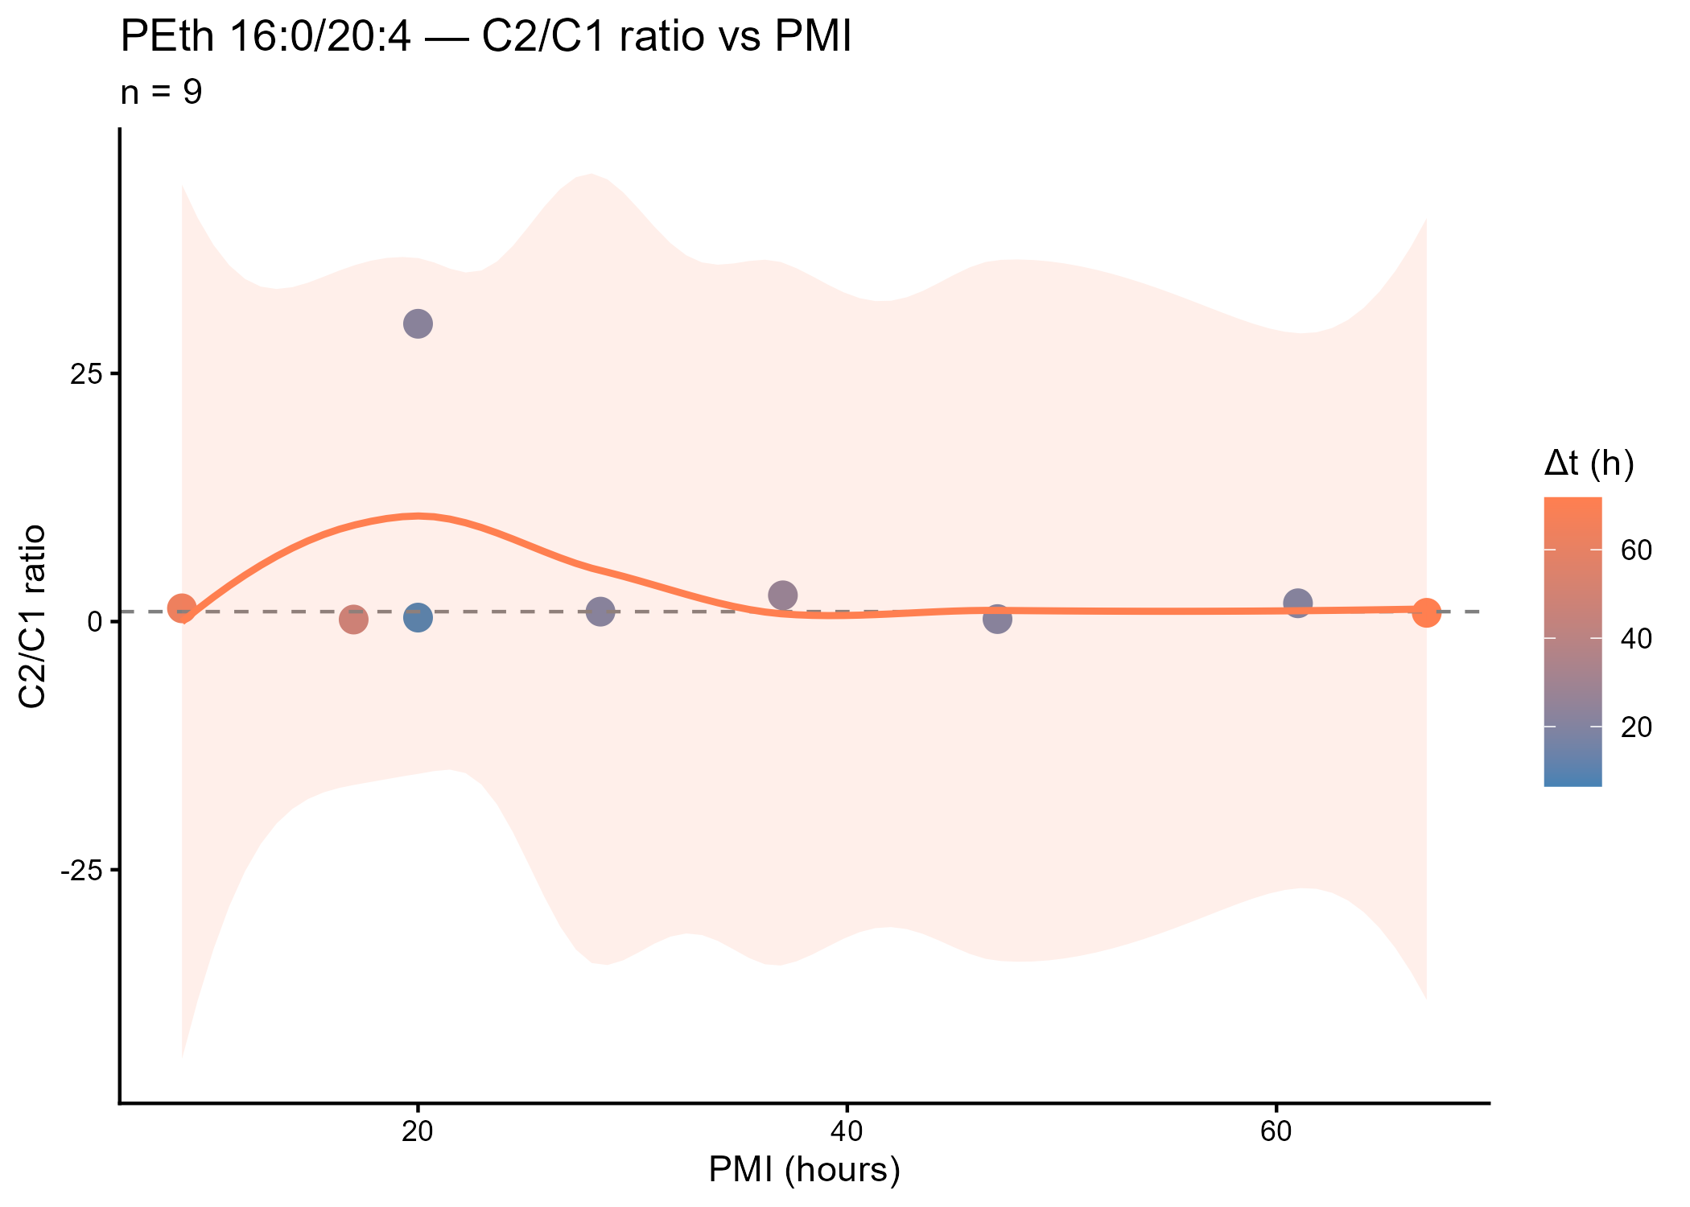
Online Resource 7 Evolution of the PEth 16:0/20:4 C2/C1 ratio according to total PMI
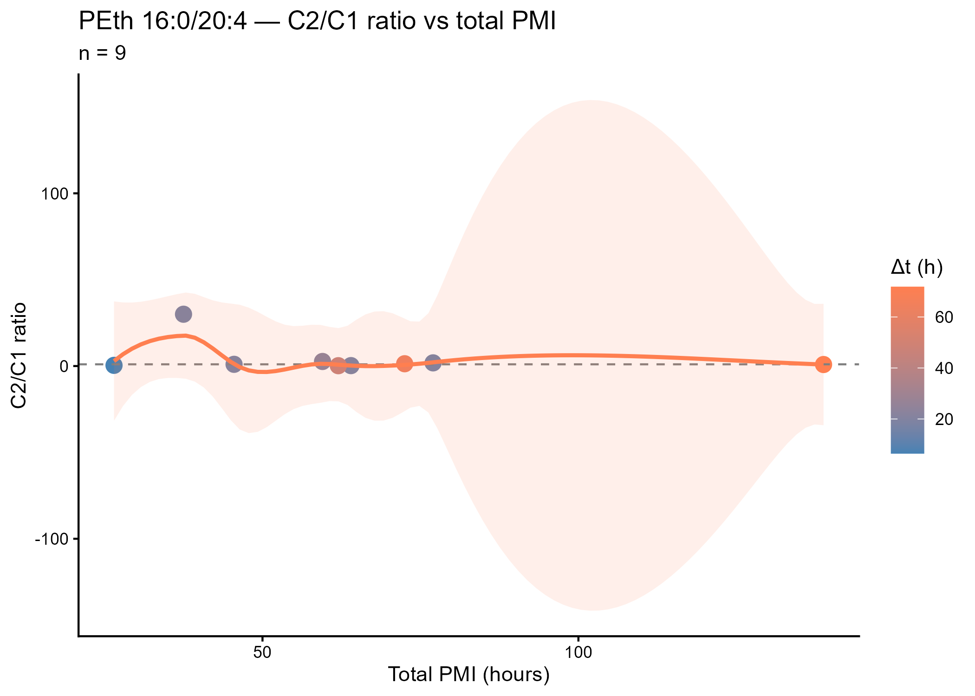
Online Resource 8 Evolution of the methadone and EDDP C2/C1 ratio according to the inter-sampling interval (Δt)
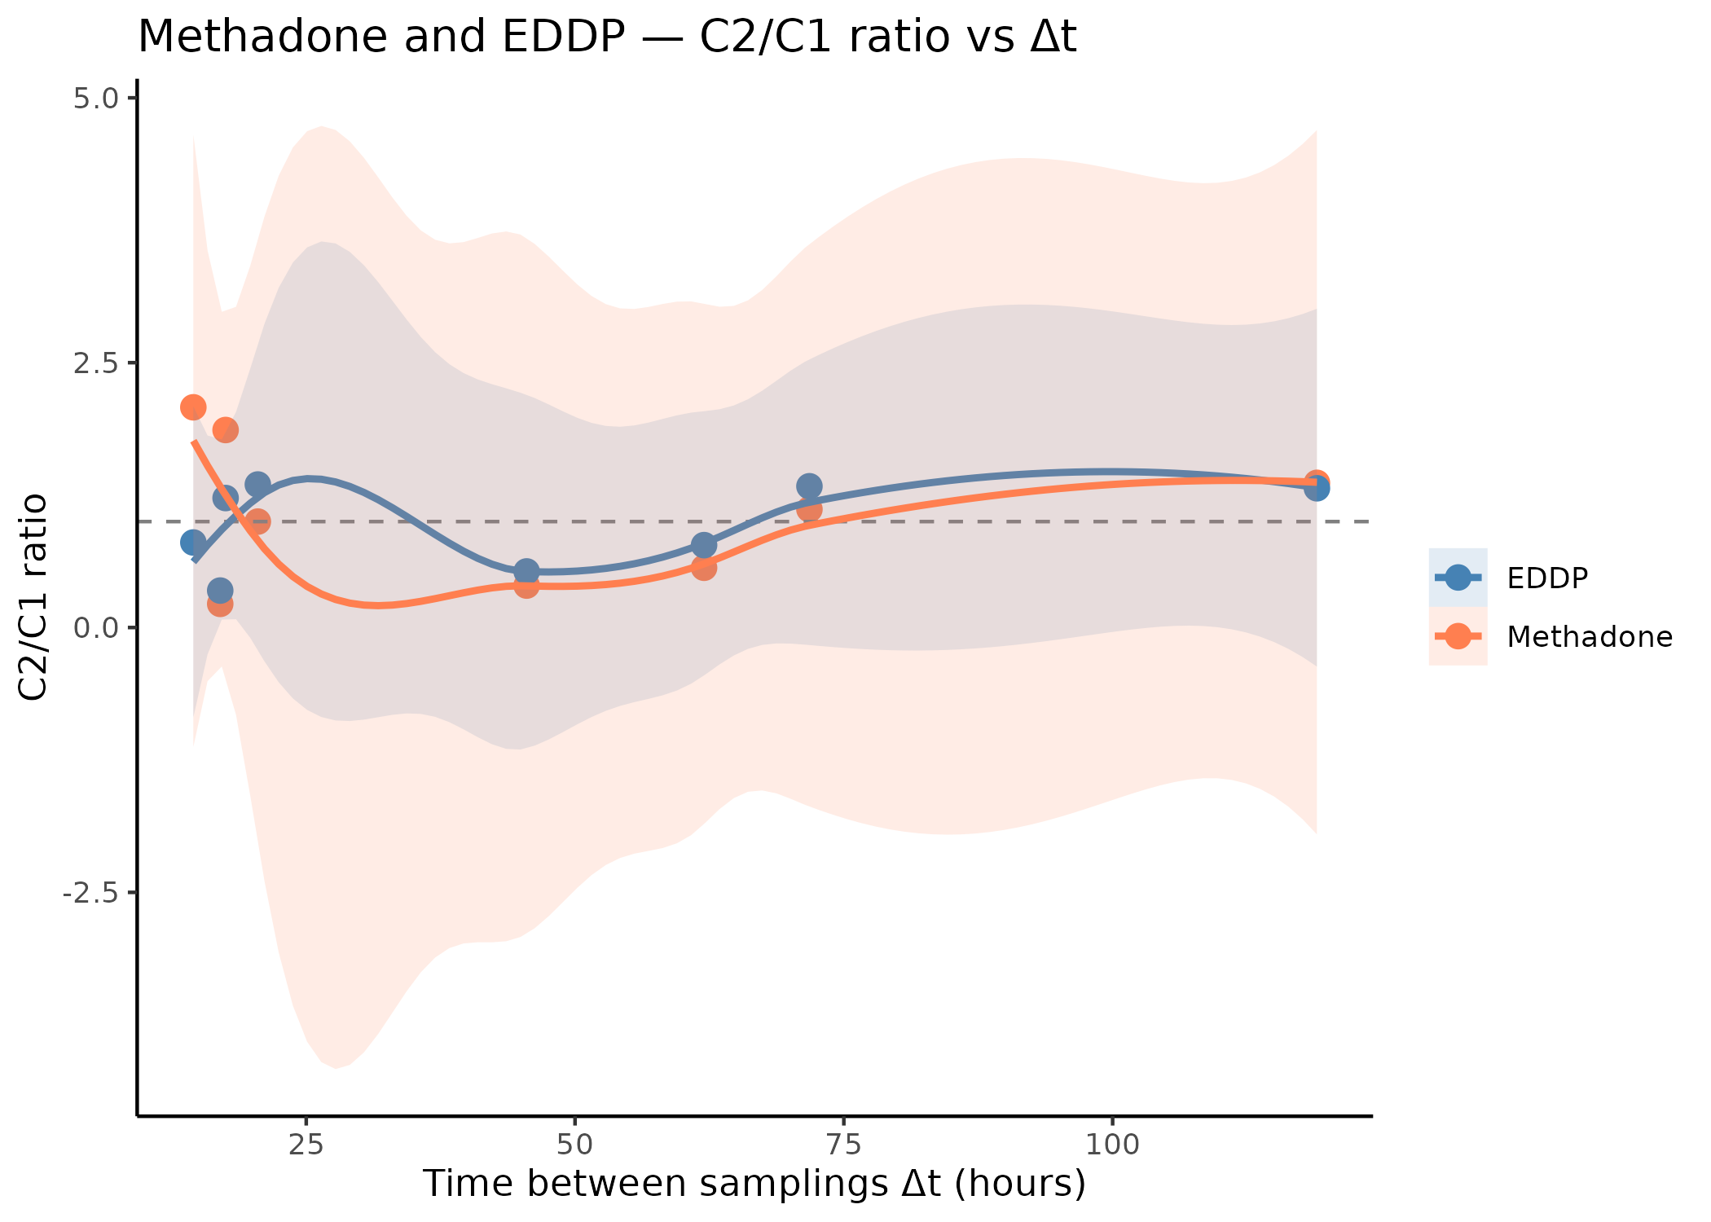
Online Resource 9 Evolution of the methadone and EDDP C2/C1 ratio according toPMI
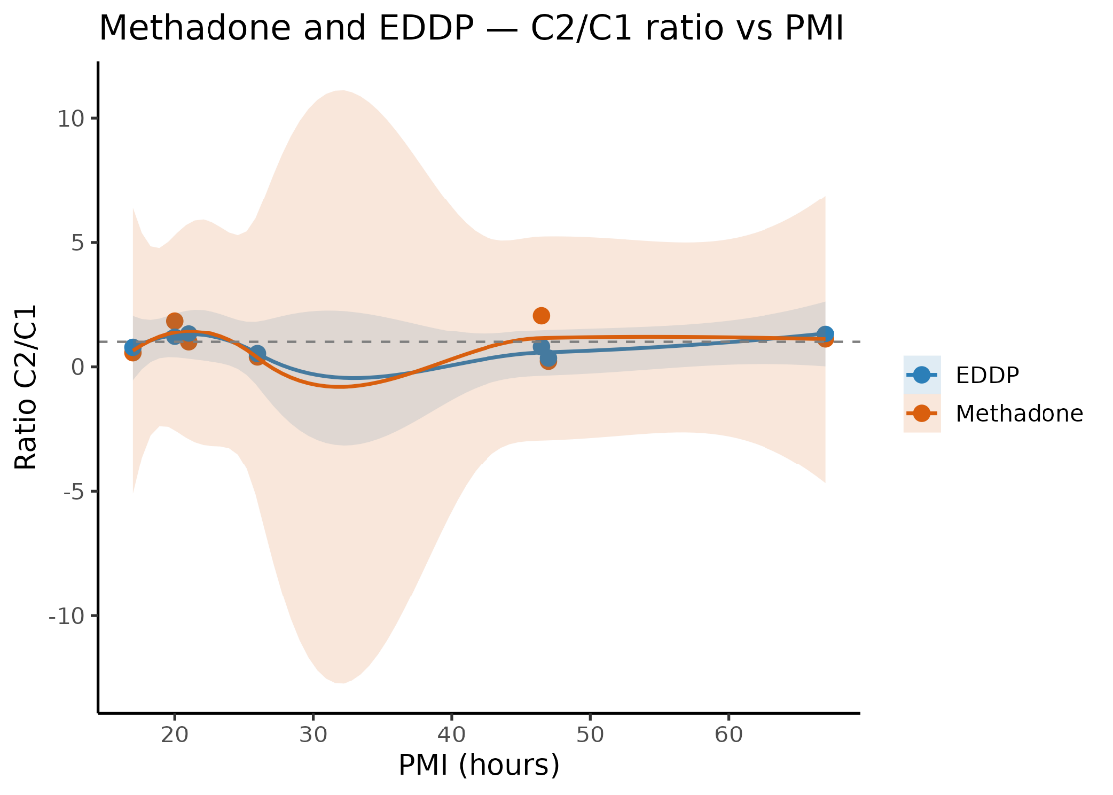
Online Resource 10 Evolution of the methadone and EDDP C2/C1 ratio according to total PMI
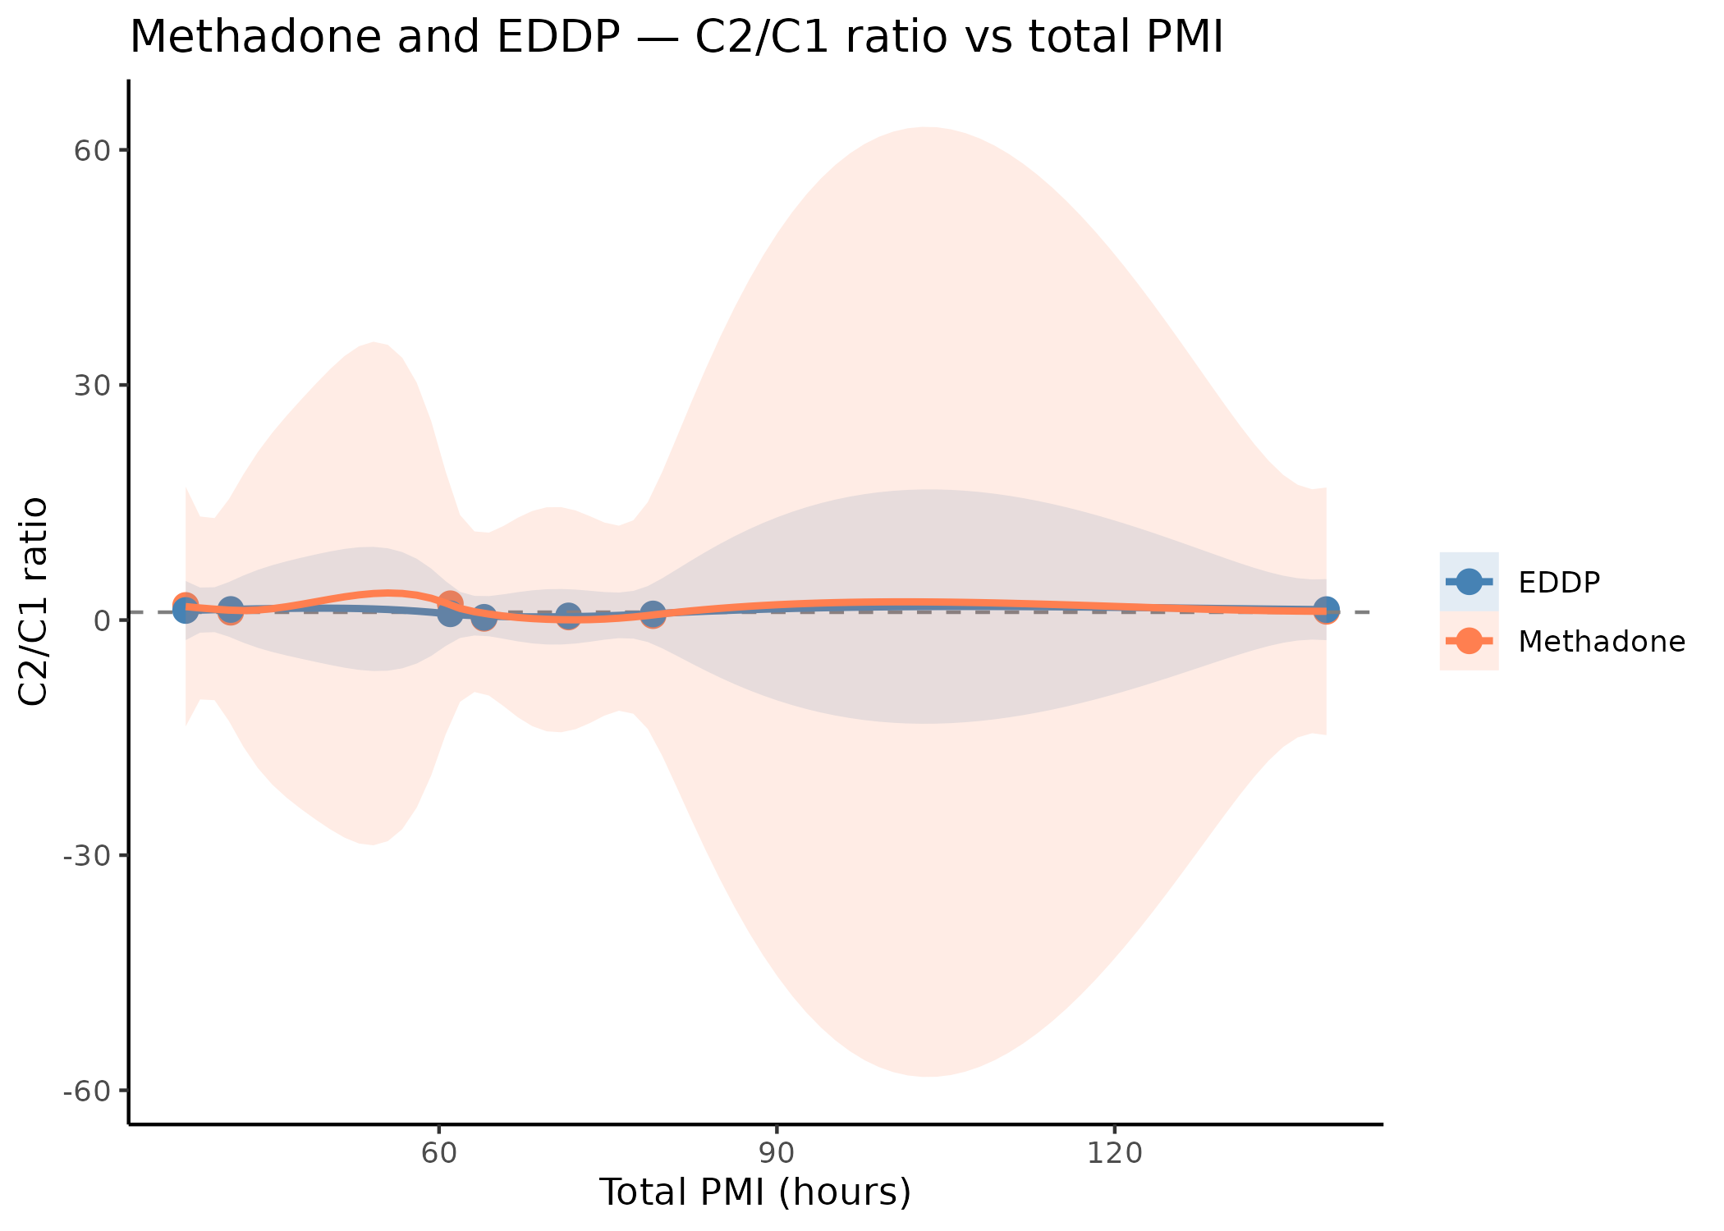
Online Resource 11 Evolution of the cocaine and BZE C2/C1 ratio according to the postmortem interval (PMI)
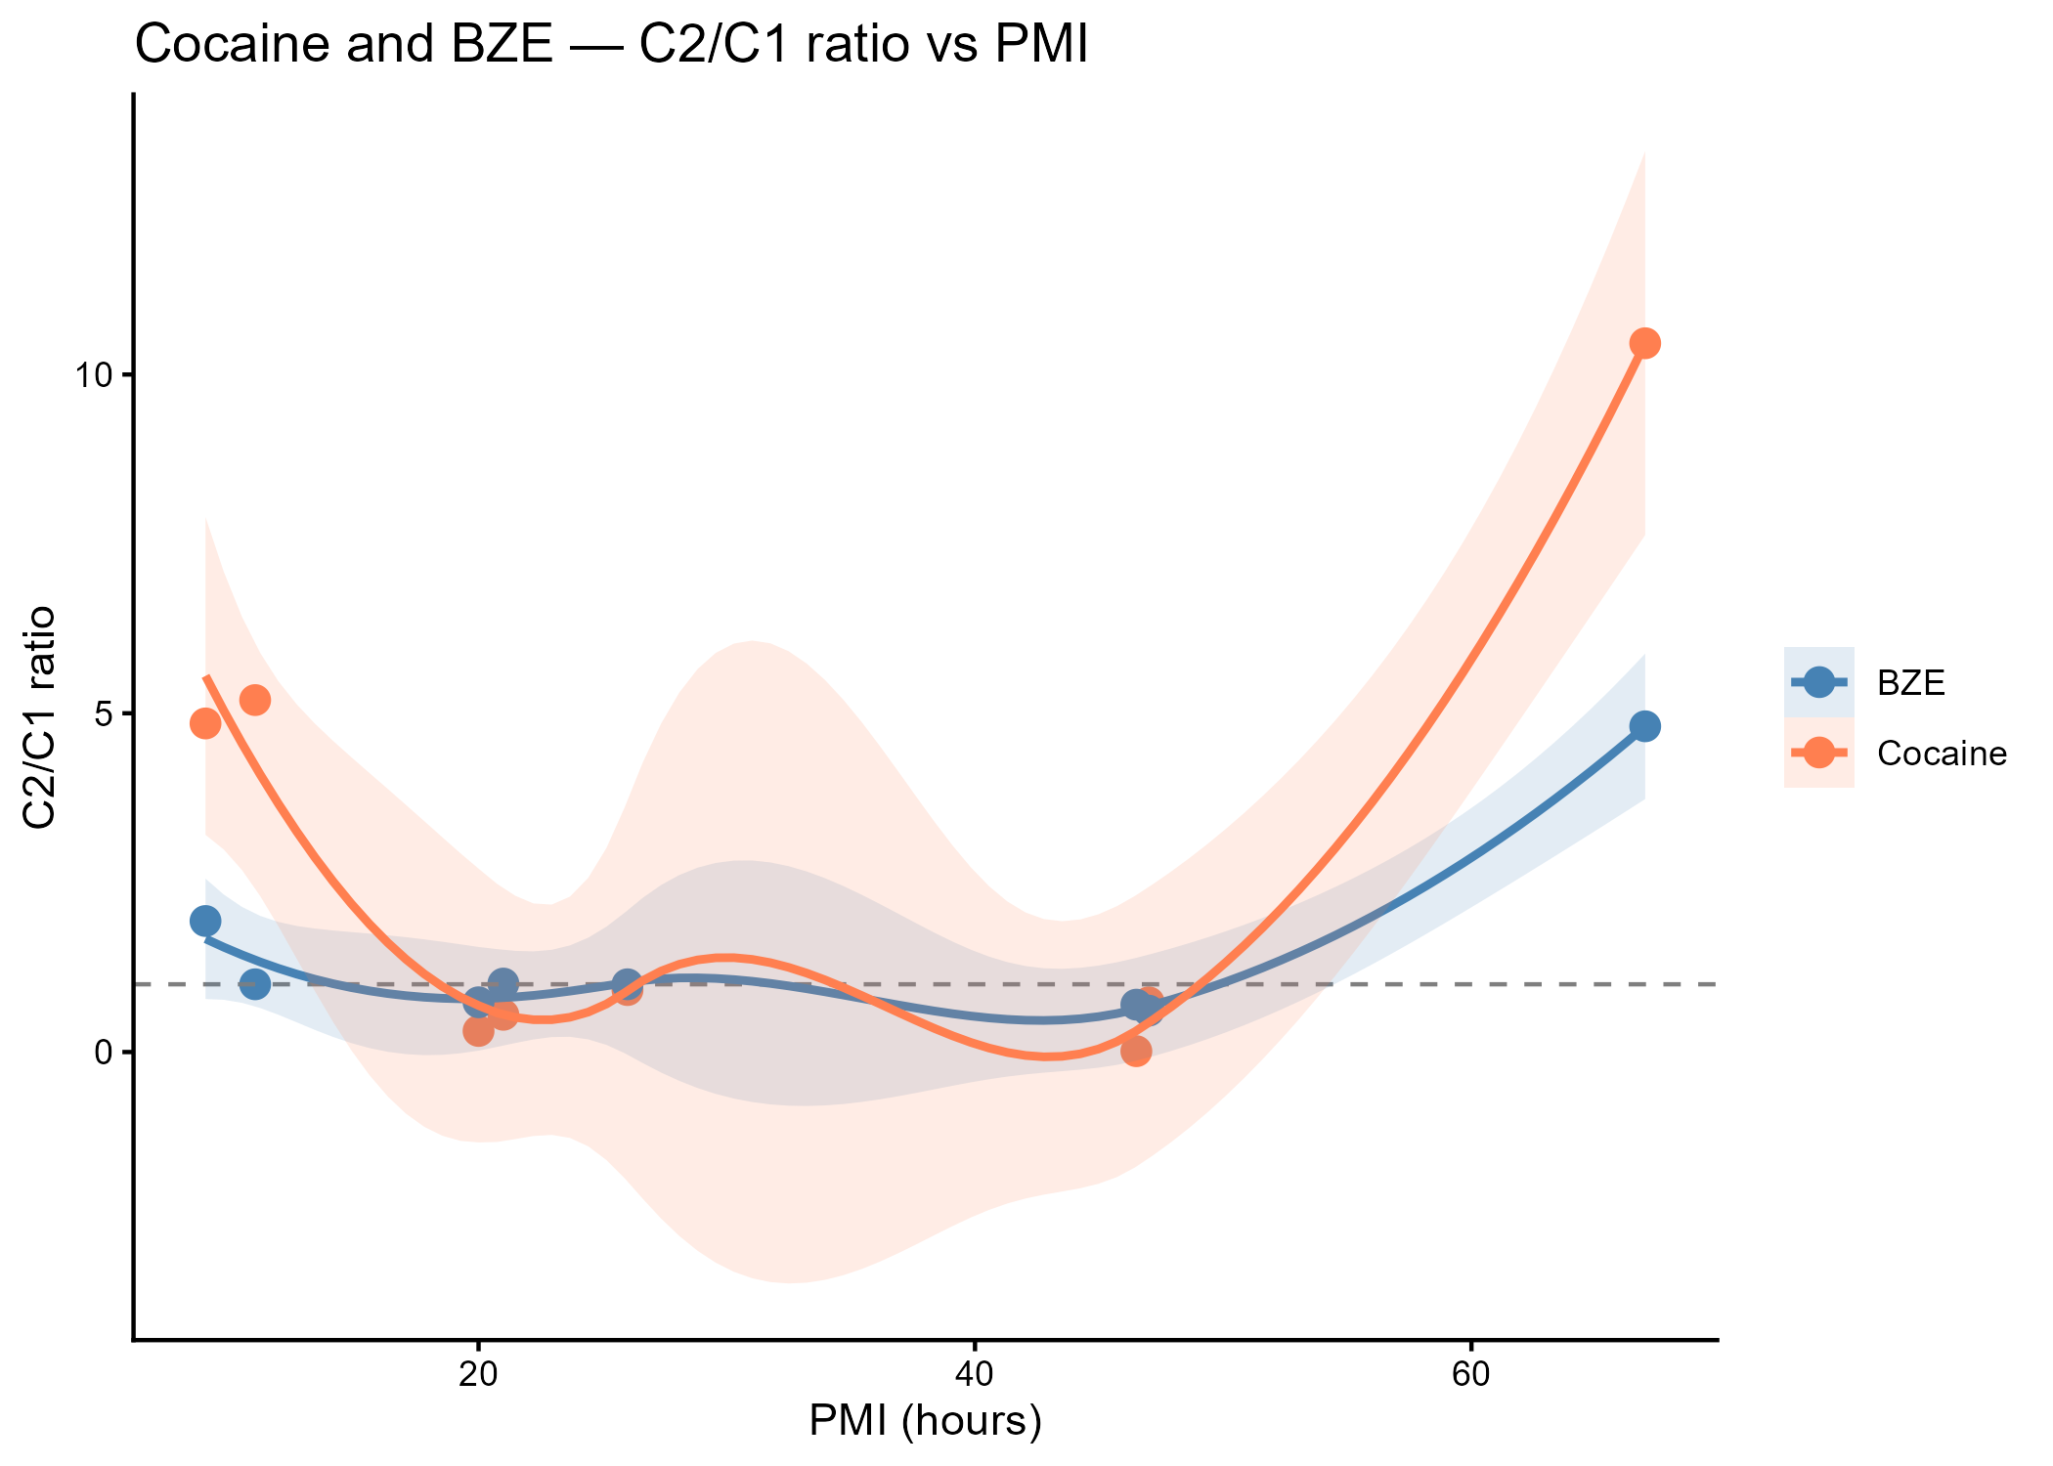
Online Resource 12 Evolution of the cocaine and BZE C2/C1 ratio according to total PMI
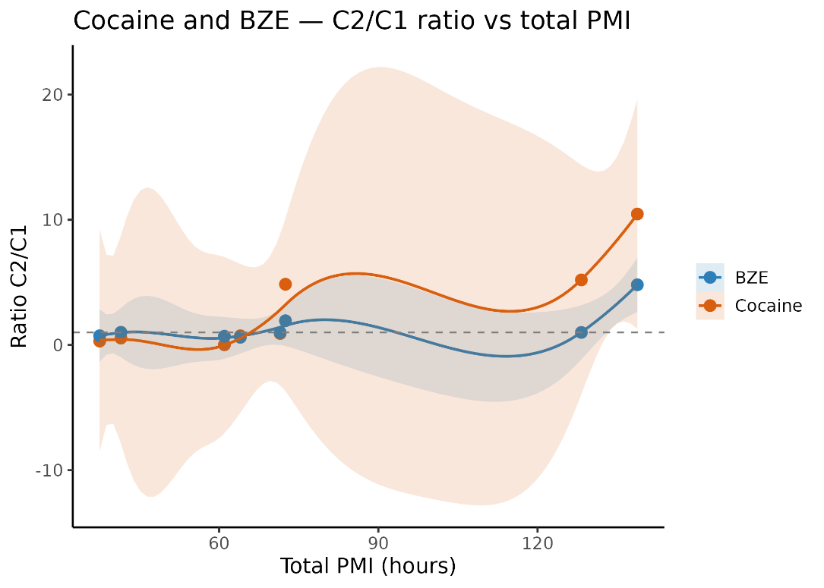

Online Resource 13 Evolution of the EME C2/C1 ratio according to the postmortem interval (PMI)
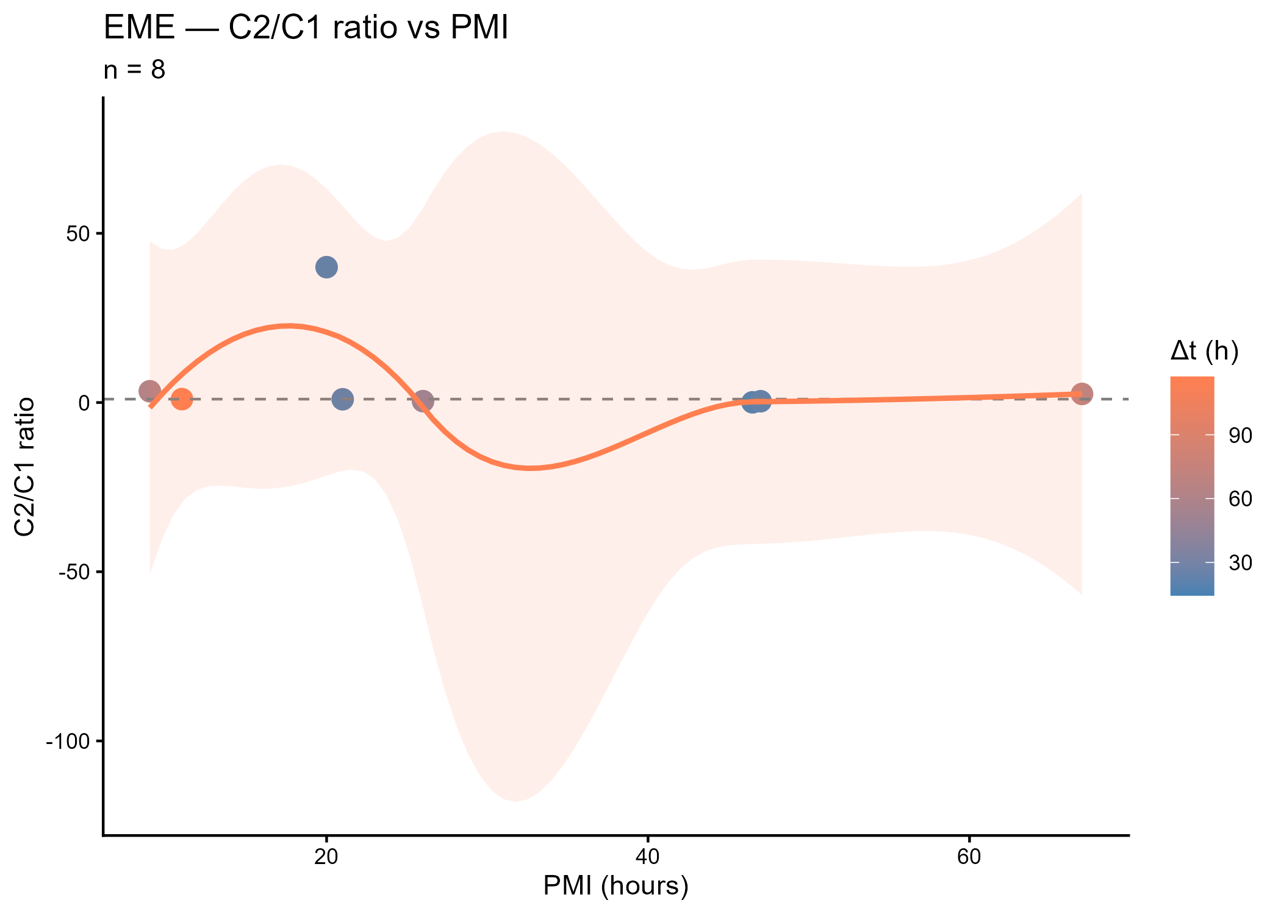
Online Resource 14 Evolution of the EME C2/C1 ratio according to total PMI
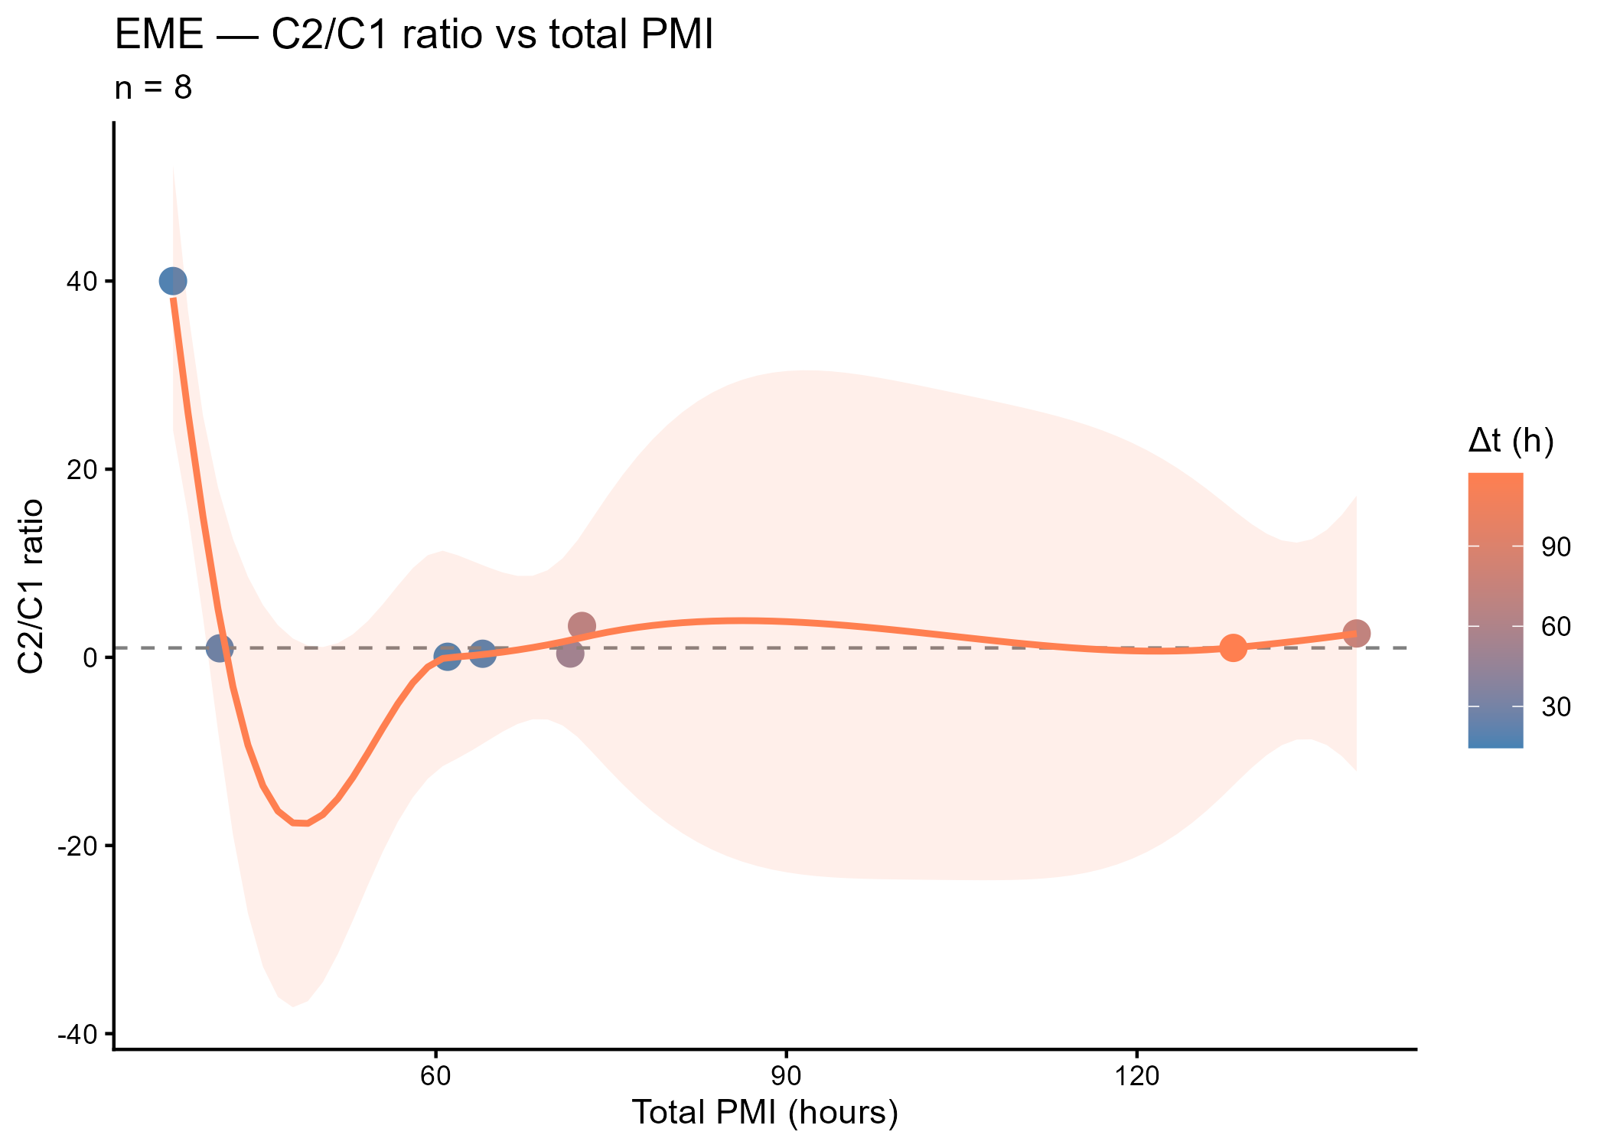
Online Resource 15 Evolution of the oxazepam and nordiazepam C2/C1 ratio according to the inter-sampling interval (Δt)
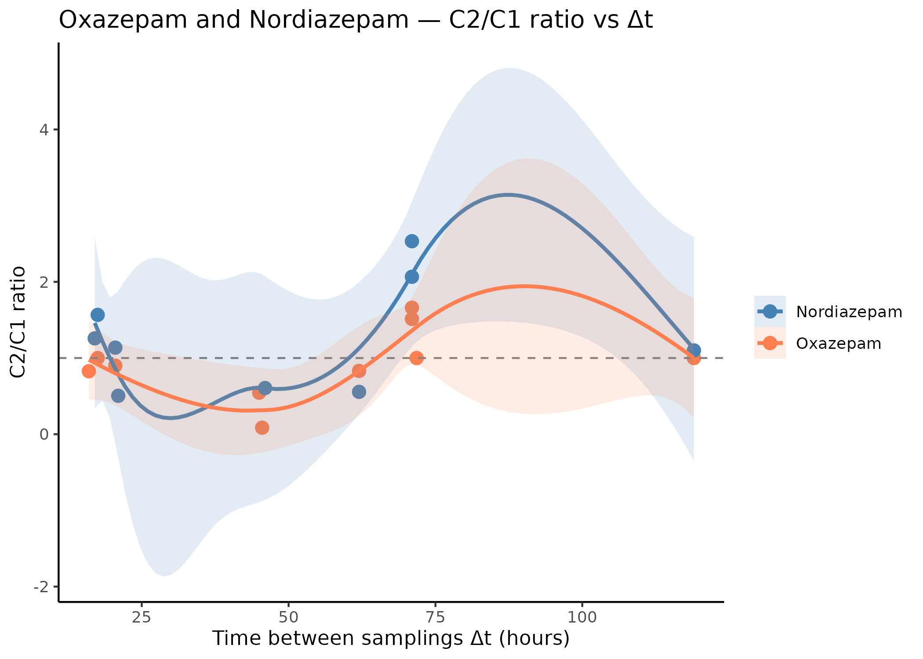
Online Resource 16 Evolution of the oxazepam and nordiazepam C2/C1 ratio according to total PMI
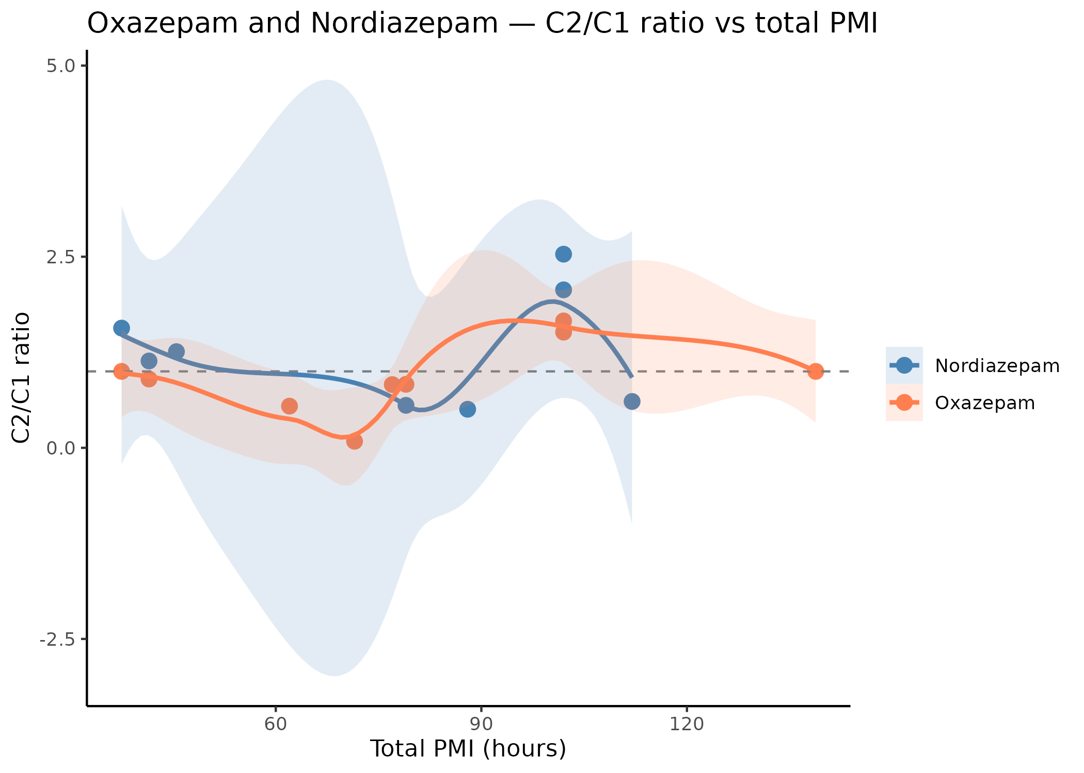
Online Resource 17 Evolution of the diazepam C2/C1 ratio according to the inter-sampling interval (Δt)
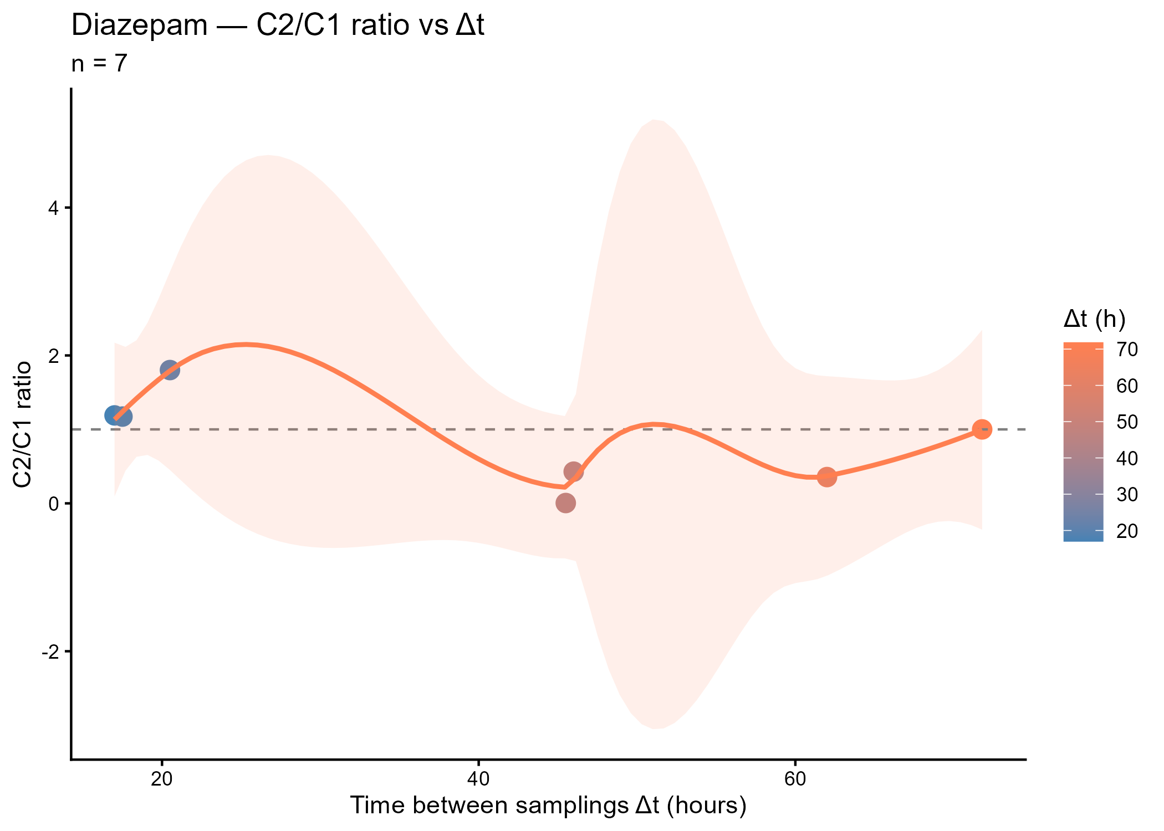
Online Resource 18 Evolution of the diazepam C2/C1 ratio according to total PMI
