Supplementary Methods

Title: Seasonal turnover and diet breadth shape long-term occurrence patterns of oil-collecting bees in the Brazilian Cerrado

Paulo M. Sousa*, Akira Shibata, Guilherme Durães, Antonio J. C. Aguiar, Panagiotis Theodorou, Aline C. Martins, Belinda Kahnt

* Corresponding author: Martin-Luther-University Halle-Wittenberg, Hoher Weg 8, 06120 Halle (Saale), Germany, email: sousapaulo16@gmail.com

Supplementary Tables

Table S1: Number of unique collection events for Centris and Epicharis per season within each decade.

Decade | Season | Collection events
70’s | Dry | 81
70’s | Rainy | 62
70’s | Total | 143
80’s | Dry | 53
80’s | Rainy | 29
80’s | Total | 82
90’s | Dry | 69
90’s | Rainy | 40
90’s | Total | 109
2000’s | Dry | 35
2000’s | Rainy | 44
2000’s | Total | 79
2010’s | Dry | 43
2010’s | Rainy | 35
2010’s | Total | 78
2020’s | Dry | 72
2020’s | Rainy | 86
2020’s | Total | 158
Sum | Dry | 353
Sum | Rainy | 296
Sum | Total | 649
Average ± SD | Dry | 58.8 ± 18.0
Average ± SD | Rainy | 49.3 ± 21.2
Average ± SD | Total | 108.17 ± 35.05

Table S2: Number of unique collection events for Centris and Epicharis per season within each five-year time bin.

Time period | Season | Collection events
1976-1979 | Dry | 81
1976-1979 | Rainy | 62
1976-1979 | Total | 143
1980-1984 | Dry | 27
1980-1984 | Rainy | 12
1980-1984 | Total | 39
1985-1989 | Dry | 26
1985-1989 | Rainy | 17
1985-1989 | Total | 43
1990-1994 | Dry | 6
1990-1994 | Rainy | 2
1990-1994 | Total | 8
1995-1999 | Dry | 63
1995-1999 | Rainy | 38
1995-1999 | Total | 101
2000-2004 | Dry | 13
2000-2004 | Rainy | 5
2000-2004 | Total | 18
2005-2009 | Dry | 59
2005-2009 | Rainy | 81
2005-2009 | Total | 140
2010-2014 | Dry | 18
2010-2014 | Rainy | 13
2010-2014 | Total | 31
2015-2019 | Dry | 25
2015-2019 | Rainy | 22
2015-2019 | Total | 47
2020-2023 | Dry | 35
2020-2023 | Rainy | 44
2020-2023 | Total | 79
Sum | Dry | 353
Sum | Rainy | 296
Sum | Total | 649
Average ± SD | Dry | 35.3 ± 24.3
Average ± SD | Rainy | 29.6 ± 26.1
Average ± SD | Total | 32.45 ± 24.75
Table S3: For each species included in the study the total number of collection events is given. For species that met filtering thresholds to be analysed (bold) the mean and standard deviation of relative occurrence across all seasons and decades is given. Discrete and continuous diet classifications are also given. Species were either classified as generalists specialist (discrete) or assigned a continuous score in which higher values indicate a broader oil-host range. Species marked with † met the filtering thresholds for five-year time bins but not for decadal bins.

Scientific name | Collection events | Relative occurrence | Discrete classification | Continuous classification
C. aenea Lepeletier, 1841 | 70 | 0.11 ± 0.07 | Generalist | 2.79
C. americana (Klug, 1810) | 1 | - | - | -
C. analis (Fabricius, 1984) | 22 | 0.04 ± 0.03 | Generalist | 1.71
C. aurantis Vivallo, 2022 | 2 | - | - | -
C. auriger Vivallo, 2022 | 1 | - | - | -
C. brasilictis Vivallo, 2022 | 3 | - | - | -
C. burgdorfi Friese, 1901 | 1 | - | - | -
C. collaris Lepeletier, 1841 | 44 | 0.06 ± 0.05 | Specialist | 0.9
C. dentata Smith, 1854 | 2 | - | - | -
C. denudans Lepeletier, 1841 | 5 | - | - | -
C. dorsata Lepeletier, 1841 | 19 | 0.02 ± 0.03 | Specialist | 0.67
C. flamigera Vivallo, 2022 | 4 | - | - | -
C. flavifrons (Fabricius, 1775) | 3 | - | - | -
C. fuscata Lepeletier, 1841 | 102 | 0.15 ± 0.13 | Generalist | 2.81
C. klugii Friese, 1900 | 1 | - | - | -
C. longimana Fabricius, 1804 | 13 | 0.03 ± 0.03 | Specialist | 0.75
C. lutea Friese, 1900 | 33 | 0.06 ± 0.05 | Specialist | 0.75
C. machadoi Azevedo & Silveira, 2005 | 26 | 0.03 ± 0.04 | Specialist | 0.5
C. maranhensis Ducke, 1911 | 4 | - | - | -
C. mocsary Friese, 1900 | 23 | 0.03 ± 0.03 | Specialist | 0.88
C. morens (Perty, 1833) | 4 | - | - | -
C. nitens Lepeletier, 1841 | 65 | 0.10 ± 0.07 | Generalist | 1.71
C. quadrimaculata Packard, 1869 | 1 | - | - | -
C. rupestris Azevedo & Silveira, 2005 | 6 | 0.01 ± 0.02 | - | -
C. scopipes Friese, 1900 | 3 | - | - | -
C. spilopoda Moure, 1969 | 29 | 0.06 ± 0.09 | Generalist | 1.5
C. tarsata Smith, 1874 | 92 | 0.14 ± 0.08 | Generalist | 2.8
C. terminata Smith, 1874 | 8 | 0.02 ± 0.03 | - | -
C. tetrazona Moure & Seabra 1962 † | 6 | - | - | -
C. trigonoides Lepeletier, 1841 | 27 | 0.04 ± 0.04 | Generalist | 3.64
C. varia (Erichson, 1848) | 12 | 0.02 ± 0.02 | Generalistc | 1.5
C. violacea Lepeletier, 1841 | 25 | 0.03 ± 0.05 | Specialist | 0.75
C. vittata Lepeletier, 1841 | 4 | - | - | -
C. xanthobapta Vivallo, 2022 | 3 | - | - | -
C. xanthocnemis (Perty, 1833) | 8 | 0.01 ± 0.02 | - | -
E. albofasciata Smith, 1854 | 1 | - | - | -
E. analis Lepeletier, 1841 | 34 | 0.04 ± 0.07 | Specialist | 0.8
E. bicolor Smith, 1854 | 38 | 0.06 ± 0.05 | Specialist | 0.75
E. cockerelli Friese, 1900 | 21 | 0.03 ± 0.06 | Specialist | 0.5
E. dejeanii Lepeletier, 1841 | 3 | - | - | -
E. flava (Friese, 1901) | 107 | 0.17 ± 0.1 | Specialist | 0.83
E. iheringi Friese, 1900 | 24 | 0.03 ± 0.06 | - | -
E. sp1 | 1 | - | - | -
E. sp2 | 1 | - | - | -
E. xanthogastra Moure & Seabra, 1959 | 1 | - | - | -

Table S4: Generalised linear model results for relative occurrence and seasonality trends for each species. For each predictor (time and season), β estimates, z values, and p values are reported. Statistically significant effects (p < 0.05) are highlighted in bold.

Species | Time |  |  | Season
Species | Β estimate | Z value | P value | Β estimate | Z value | P value
C. aenea | 0.19 | 2.38 | 0.02 | -0.25 | -0.98 | 0.33
C. analis | 0.18 | 1.37 | 0.17 | 0.12 | 0.28 | 0.78
C. collaris | -0.32 | -3.1 | 0 | -0.22 | -0.69 | 0.49
C. dorsata | -0.96 | -3.81 | 0 | -0.76 | -1.42 | 0.16
C. fuscata | -0.13 | -1.91 | 0.06 | -2.06 | -6.45 | 0
C. longimana | -0.25 | -1.44 | 0.15 | 1.08 | 1.78 | 0.08
C. lutea | 0.33 | 2.89 | 0 | -0.38 | -1.03 | 0.3
C. machadoi | 0.02 | 0.14 | 0.89 | -3.12 | -3.05 | 0
C. mocsary | 0.08 | 0.65 | 0.51 | 1.48 | 2.88 | 0
C. nitens | -0.12 | -1.55 | 0.12 | 0.98 | 3.54 | 0
C. rupestris | -0.04 | -0.17 | 0.86 | NA | NA | NA
C. spilopoda | 0.93 | 5.24 | 0 | 0.32 | 0.8 | 0.42
C. tarsata | 0.07 | 1.07 | 0.28 | 0.03 | 0.13 | 0.9
C. terminata | 0.22 | 0.99 | 0.32 | 2.07 | 1.93 | 0.05
C. trigonoides | 0.21 | 1.7 | 0.09 | -3.23 | -3.16 | 0
C. varia | -0.05 | -0.27 | 0.79 | 1.31 | 1.95 | 0.05
C. violacea | -0.34 | -2.52 | 0.01 | NA | NA | NA
C. xanthocnemis | -0.23 | -1.06 | 0.29 | 1.36 | 1.65 | 0.1
E. analis | 0.36 | 3.08 | 0 | 1.51 | 3.46 | 0
E. bicolor | 0.28 | 2.6 | 0.01 | 1.06 | 2.86 | 0
E. cockerelli | 0.24 | 1.69 | 0.09 | 3.17 | 3.08 | 0
E. flava | -0.16 | -2.41 | 0.02 | 0.56 | 2.59 | 0.01
E. iheringi | 0.53 | 3.41 | 0 | 2.52 | 3.38 | 0

Table S5: Model diagnostics for generalised linear models assessing relative occurrence and seasonality trends for each species. For each model, p values for residual uniformity, dispersion, and outlier tests are reported. Collinearity among predictors was quantified using variance inflation factors . Statistically significant values (p < 0.05) are given in bold.

Species | Residuals |  |  | Collinearity
Species | Uniformity | Dispersion | Outliers | Collinearity
C. aenea | 0.84 | 0.93 | 1 | 1.01
C. analis | 0.63 | 0.57 | 1 | 1.01
C. collaris | 0.72 | 0.6 | 1 | 1
C. dorsata | 0.64 | 0.83 | 1 | 1
C. fuscata | 0.2 | 0.44 | 1 | 1
C. longimana | 0.56 | 0.94 | 1 | 1.01
C. lutea | 0.63 | 0.34 | 1 | 1.01
C. machadoi | 0.82 | 0.53 | 1 | 1
C. mocsary | 0.72 | 0.17 | 1 | 1.01
C. nitens | 0.82 | 0.58 | 1 | 1.01
C. rupestris | 0.98 | 0.06 | 0.02 | NA
C. spilopoda | 0.47 | 0.54 | 1 | 1
C. tarsata | 0.9 | 0.09 | 0 | 1.01
C. terminata | 0.7 | 0.57 | 1 | 1
C. trigonoides | 0.55 | 0.95 | 1 | 1
C. varia | 0.57 | 0.54 | 1 | 1.01
C. violacea | 0.21 | 0.02 | 0.08 | NA
C. xanthocnemis | 0.9 | 0.58 | 1 | 1.01
E. analis | 0.13 | 0 | 0.06 | 1
E. bicolor | 0.86 | 0.12 | 1 | 1.01
E. cockerelli | 0.84 | 0 | 0.1 | 1
E. flava | 0.08 | 0.4 | 0.14 | 1.01
E. iheringi | 0.93 | 0.03 | 1 | 1

Table S6: Summary of generalised linear models for species occurrence trends using either decadal or five-year bins. Reported are whether a species’ relative occurrence changed significantly over time (p < 0.05) or remained constant, and whether it was significantly more common in the dry season, the rainy season, or equally common in both. Species marked with a degree symbol (°) showed marginally significant temporal trends (0.05 < p < 0.06). Species marked with an asterisk (*) had no records in the rainy season. Centris tetrazona could not be analysed using decadal bins because it did not meet the inclusion threshold. Results that differed between the decadal and five-year binning approaches are highlighted in bold.

Species | Time |  | Seasonality
Species | Decadal bins | Five-year bins | Decadal bins | Five-year bins
C. aenea | Increasing | Increasing | Both | Both
C. analis | Constant | Constant | Both | Both
C. collaris | Decreasing | Decreasing | Both | Both
C. dorsata | Decreasing | Decreasing | Both | Both
C. fuscata | Decreasing ° | Decreasing ° | Dry | Dry
C. longimana | Constant | Constant | Both | Both
C. lutea | Increasing | Increasing | Both | Both
C. machadoi | Constant | Constant | Dry | Dry
C. mocsary | Constant | Constant | Rainy | Rainy
C. nitens | Constant | Constant | Rainy | Rainy
C. spilopoda | Increasing | Increasing | Both | Both
C. rupestris | Constant * | Constant * | Dry * | Dry *
C. tarsata | Constant | Constant | Both | Both
C. terminata | Constant | Constant | Rainy ° | Rainy °
C. tetrazona | NA | Constant | NA | Both
C. trigonoides | Constant | Constant | Dry | Dry
C. varia | Constant | Constant | Rainy ° | Rainy °
C. violacea | Decreasing * | Decreasing * | Dry * | Dry *
C. xanthocnemis | Constant | Constant | Both | Both
E. analis | Increasing | Increasing | Rainy | Rainy
E. bicolor | Increasing | Increasing | Rainy | Rainy
E. cockerelli | Constant | Increasing | Rainy | Rainy
E. flava | Decreasing | Decreasing | Rainy | Rainy
E. iheringi | Increasing | Increasing | Rainy | Rainy

Table S7: Model diagnostics for generalised linear mixed-effects models predicting species’ relative occurrence using discrete and continuous diet classifications. For each model, p values for residual uniformity, dispersion, and outlier tests are reported. Statistically significant values (p < 0.05) are shown in bold.

Model | Uniformity | Dispersion | Outliers
Occurrence ~ Diet_continuous + Seasonality | 0.002 | 0.12 | 0.16
Occurrence ~ Diet_discrete + Seasonality | 0.008 | 0.14 | 1

Table S8: Generalised linear mixed-effects model results for seasonal preferences in species’ relative occurrence using discrete or continuous diet classifications as predictors. For each model, β estimates, standard errors (SE), z values, and p values are reported for all comparisons.

Season comparison | Diet classification | Estimate | SE | Z value | P value
“Both” vs. “Dry” | Discrete | -0.24 | 0.38 | -0.63 | 0.8
“Both” vs. “Rainy” | Discrete | -0.53 | 0.35 | -1.49 | 0.29
“Dry” vs. “Rainy” | Discrete | -0.29 | 0.42 | -0.69 | 0.77
“Both” vs. “Dry” | Continuous | -0.03 | 0.35 | -0.07 | 1
“Both” vs. “Rainy” | Continuous | -0.56 | 0.32 | -1.77 | 0.18
“Dry” vs. “Rainy” | Continuous | -0.54 | 0.41 | -1.32 | 0.38

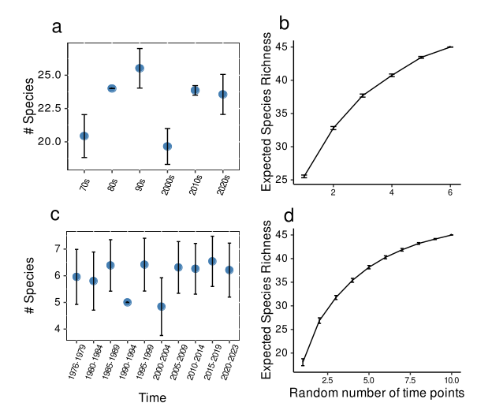
Figures

Figure S1: Rarefied species richness and species accumulation curves for Centris and Epicharis in the Federal District based on decadal (a–b) and five-year (c–d) time bins. Black bars represent standard errors around mean rarefied species richness estimates. Species accumulation curves were generated using random subsampling of time points (100 permutations), with vertical bars indicating standard errors of the mean number of sampled species.
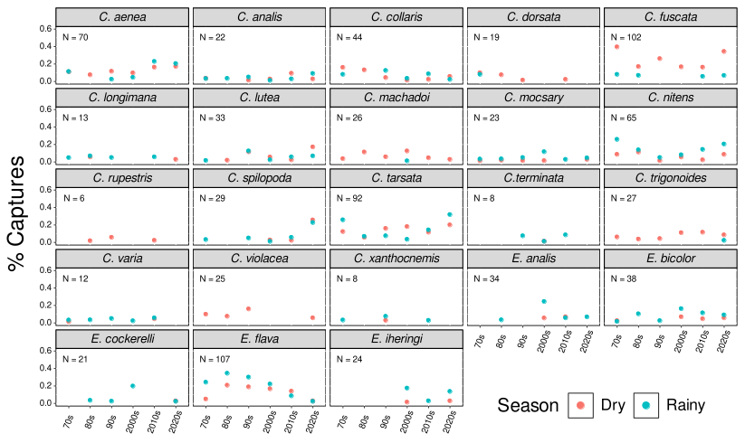
Figure S2: Species’ relative occurrence across time and seasons. For each species, relative occurrence, defined as the proportion of collection events in which the species was recorded, is shown across decades (x-axis). Records from the dry season are shown in red and those from the rainy season in blue. The total number of presence records for each species is indicated in the upper left corner of each panel.
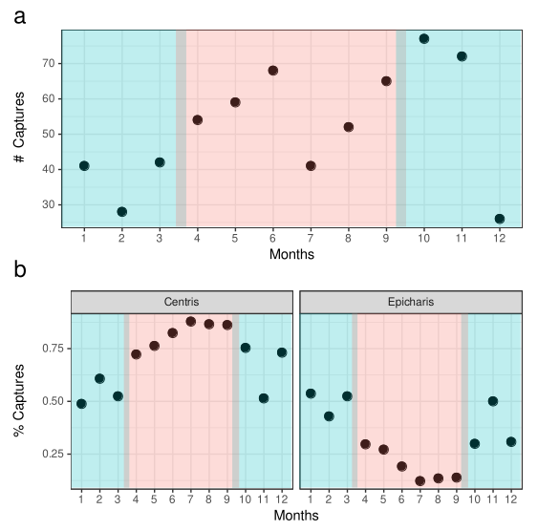
Figure S3: Monthly distribution of collection events for Centris and Epicharis. (a) Total number of collection events (presence records) per month, summed across all years. (b) Relative number of monthly collection events, shown separately for Centris and Epicharis. Months belonging to the rainy season are shown in blue and months of the dry season in red.

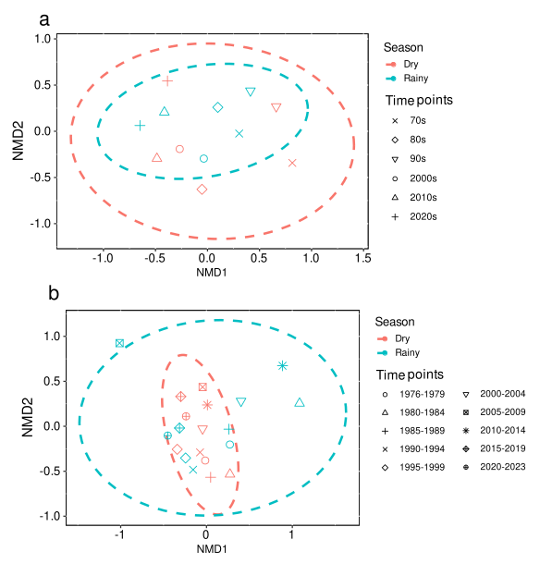
Figure S4: Non-metric multidimensional scaling (NMDS) ordinations of species assemblages based on (a) decadal and (b) five-year time bins. Each point represents the species assemblage for a given season within a given time bin. Ellipses depict the dispersion of assemblages. Red points and ellipses correspond to the dry season, and blue points and ellipses correspond to the rainy season.

Literature references from the diet classification

Most of the oil-host records were taken from the supplementary materials of Giannini et al., 2013 (10.1016/j.ecolmodel.2013.02.032) and additions were made using:
Aguiar, C.M.L., 2003. Flower visits of Centris bees (Hymenoptera: Apidae) in an area of Caatinga (Bahia, Brazil). Studies on Neotropical Fauna and Environment 38, 41-45.
Aguiar, C.M.L., Zanella, F.C.V., Martins, C.F., Carvalho, C.A.L., 2003. Plantas visitadas por Centris spp. (Hymenoptera: Apidae) na Caatinga para obtenção de recursos florais. Neotropical Entomology 32, 247–259.
Aguiar, A.J.C., Melo, G.A.R., 2009. Notes on oil sources for the bee genus Caenonomada (Hymenoptera, Apidae, Tapinotaspidini). Revista Brasileira Entomologia 53, 154-156.
Albuquerque, P.M.C., Rêgo, M.M.C., 1989. Fenologia das abelhas visitantes do mirici (Byrsonima crassifolia, Malpighiaceae). Boletim do Museu Paraense Emílio Goeldi 5, 153-17.
Albuquerque, P.M.C., Mendonça, A.J.C. 1996. Anthophoridae (Hymenoptera; Apoidea) e flora associada em uma formação de cerrado no município de Barreirinhas, MA, Brasil. Acta Amazonica 26, 45-54.
Arroyo, M.T.K., Primack, R.B., Armesto, J.J., 1982. Community studies in pollination ecology in the high temperate Andes of Central Chile. I. Pollination mechanisms and altitudinal variation. American Journal of Botany 69, 82-97.
Barros, M.A.G., 1992. Fenologia da floração, estratégias reprodutivas e polinização de espécies simpátricas do gênero Byrsonima Rich (Malpighiaceae). Revista Brasileira de Biologia 52, 343-35.
Barônio, G. J. (2013). Disponibilidade de recursos florais oferecidos por três espécies de Malpighiaceae em um cerrado no sudeste brasileiro: a relação com seus visitantes florais.
Bezerra, E.L.S., 2004. Polinização e fenologia reprodutiva de Byrsonima gardneriana Juss e Stigmaphyllon paralias Juss. (Malpighiaceae) em área de Caatinga - Nordeste do Brasil. Msc theses. Universidade Federal de Pernambuco, Brazil.
Bezerra, E.L.S., Machado, I.C., Mello, M.A.R., 2009. Pollination networks of oil flowers: a tiny world within the smallest of all worlds. Journal of Animal Ecology 78, 1096-1101.
Camarotti, M.F., 2004. Comunidade de abelhas, nidificação de abelhas solitárias em cavidades preexistentes (Hymenoptera: Apoidea) e interação abelha-planta na Reserva Biológica Guaribas, Mamanguape, Paraíba, Brasil. PhD theses. Universidade Federal da Paraíba, Brazil.
Carneiro, L.T., Aguiar, A.J.C., Martins, C.F., Machado, I.C., Alves-dos-Santos, I., 2015. Krameria tomentosa oil flowers and their pollinators: Bees specialized on trichome elaiophores exploit its epithelial oil glands. Flora - Morphology, Distribution, Functional Ecology of Plants.
Carvalho, P.D., Borba, E.L., Lucchese, A.M., 2005. Variação no número de glândulas e produção de óleo em flores de Stigmaphyllon paralias A. Juss. (Malpighiaceae). Acta Botanica Brasilica 19, 209-214.
Damon, A.A., Cruz-López, L., 2006. Fragrance in relation to pollination of Oncidium sphacelatum and Trichocentrum oerstedii (Orchidaceae) in the Soconusco Region of Chiapas, Mexico. Selbyana 27, 186–19.
Dórea, M.C., Santos, F.A.R., Lima, L.C.L., Figueroa, L.E.R., 2009. Análise polínica do resíduo pós-eclosão de ninhos de Centris tarsata Smith (Hymenoptera, Apidae, Centridini). Neotropical Entomology 38, 197-202.
Freitas, B.M., Alves, J.E., Brandão, G.F., Araujo, Z.B., 1999. Pollination requirements of West Indian cherry (Malpighia emarginata) and its putative pollinators, Centris bees, in NE Brazil. Journal of Agricultural Science 133, 303-311.
Freitas, L., Sazima, M., 2006. Pollination biology in a tropical high-altitude grassland in Brazil: interactions at the community level. Annals of the Missouri Botanical Garden 93, 465-516.
Gaglianone, M.C., 2003. Abelhas da tribo Centridini na Estação Ecológica de Jataí (Luís Antonio, SP): composição de espécies e interações com flores de Malpighiaceae. In: Melo, G.A.R., Alves-dos-Santos, I. (Eds.), Apoidea Neotropica. UNESC, Criciúma, pp. 279-284.
Gaglianone, M. C. (2001). Nidificação e forrageamento de Centris (Ptilotopus) scopipes Friese (Hymenoptera, Apidae). Revista Brasileira de Zoologia, 18(suppl 1), 107–117. https://doi.org/10.1590/s0101-81752001000500008
Gimenes, M., Oliveira, P., Almeida, G.F., 2002. Estudo das interações entre as abelhas e as flores em um ecossistema de restinga na Bahia. In: 5th Encontro sobre Abelhas de Ribeirão Preto. Universidade de São Paulo, Ribeirão Preto, pp. 117-121
Gimenes, M., Lobão, C.S., 2006. A polinização de Krameria bahiana B.B. Simpson (Krameriaceae) por abelhas (Apidae) na restinga, BA. Neotropical Entomology 35, 440-445.
Gonçalves, R.B., Melo, G.A.R., 2005. A comunidade de abelhas (Hymenoptera, Apidae s. l.) em uma área restrita de campo natural no Parque Estadual de Vila Velha, Paraná: diversidade, fenologia e fontes florais de alimento. Revista Brasileira de Entomologia 49, 557-571.
Gottsberger, G., 1986. Some pollination strategies in neotropical savannas and forests. Plant Systematics and Evolution 152, 29-45.
Guimarães, M. M., Souza, C. S., Sigrist, M. R., Miliato, K. B. M., & Maia, F. R. da. (2021). Assessment of interactions between oil flowers and floral visitors in world biomes. Biological Journal of the Linnean Society, 134(2), 366–380. https://doi.org/10.1093/biolinnean/blab078
Machado, I.C., Siqueira Filho, J.A., Lopes, A.V.F., Vogel, S., 1997. Organização e polinização das flores de óleo de Krameria tomentosa (Krameriaceae). In: XLVIII Congresso Nacional de Botânica. Sociedade Botânica do Brasil, Crato, pp. 19.
Machado, I.C., Vogel, S., Lopes, A.V., 2002. Pollination of Angelonia cornigera Hook. (Scrophulariaceae) by long-legged oil-collecting bees in NE Brazil. Plant Biology 4, 352-359.
Machado, I.C., 2004. Oil-collecting bees and related plants: a review of the studies in the last twenty years and case histories of plants occur - ring in NE Brazil. In: Solitary bees, conservation, rearing and management for pollination. Editora Universitária, Fortaleza, CE, 255–280.
Magalhães, L.M.F., Oliveira, D., Ohashi, O.S., 1997. Pollination and pollen vectors in acerola, Malpighia punicifolia L. Acta Horiculturae 437, 419-423.
Martins, A.C., Aguiar, J.C., Alves-dos-Santos, I., 2013. Interaction between oil-collecting bees and seven species of Plantaginaceae. Flora - Morphology, Distribution, Functional Ecology of Plants.
Martins, A.C., Gabriel A.R. Melo, Renner, S.S., 2015. Gain and loss of specialization in two oil-bee lineages, Centris and Epicharis (Apidae), Evolution, Volume 69, Issue 7, 1835–1844.
Milet-Pinheiro, P., Schlindwein, C., 2008. Comunidade de abelhas (Hymenoptera, Apoidea) e plantas em uma área do Agreste pernambucano, Brasil. Revista Brasileira de Entomologia 52, 625-636.
Moura, D.C., 2003. Riqueza e abundância de abelhas em diferentes estágios de degradação da caatinga como indicadores ambientais no entorno da Usina Hidrelétrica de Xingó, Recife, Brasil. PhD theses. Universidade Federal de Pernambuco, Pernambuco, Brazil.
Neves, E.L.,Viana, B.F., 2001. Ocorrência de Epicharis bicolor Smith (Hymenoptera: Apidae: Centridini) nas caatingas da margem esquerda do médio Rio São Francisco, Bahia. Neotropical Entomology, 30: 735-736.
Oliveira, R., Schlindwein, C., 2009. Searching for a manageable pollinator for acerola orchards: the solitary oil-collecting bee, Centris analis (Hymenoptera: Apidae: Centridini). Journal of Economic Entomology 102, 265-273.
Ramalho, M., Silva, M., 2002. Relação Centridini-flora oleífera: influência sobre a diversidade em uma comunidade tropical. In: V Encontro sobre Abelhas. Ribeirão Preto, Universidade de São Paulo, Ribeirão Preto, pp. 122-127.
Rasmussen, C., 1999. Coevolution of the oil bee-Calceolaria system in the Andes of Peru. Msc theses. University of Århus, Denmark.
Ribeiro, E.K.M.D., Rêgo, M.M.C., Machado, I.C.S., 2008. Cargas polínicas de abelhas polinizadoras de Byrsonima chrysophylla Kunth. (Malpighiaceae): fidelidade e fontes alternativas de recursos florais. Acta Botanica Brasilica 22, 165-171.
Sazima, M., Sazima, I., 1989. Oil-gathering bees visit flowers of eglandular morphs of the oilproducing Malpighiaceae. Botanica Acta 102, 106-111.
Schlindwein, C., 1995. Wildbienen und ihre Trachtpflanzen in einer südbrasilianischen Buschlandschaft: Fallstudie Guaritas, Bestäubung bei Kakteen und Loasaceen. Verlag Ulrich E. Grauer, Stuttgart, 148 p.
Schlindwein, C., 2000. A importância de abelhas especializadas na polinização de plantas nativas e conservação do meio ambiente. In: IV Encontro sobre Abelhas. Universidade de São Paulo, Ribeirão Preto, pp. 131-141.
Sigrist, M.R., Sazima, M., 2004. Pollination and reproductive biology of twelve species of Neotropical Malpighiaceae: stigma morphology and its implications for the breeding system. Annals of Botany 94, 33–41.
Silva, M., & Gimenes, M. (2013). Centris aenea. 60(3), 317–322. https://doi.org/10.13102/sociobiology.v60i3.xxx-xxx
Silvera, K. 2002. Adaptive radiation of oil-reward compounds among neotropical orchid species (Oncidiinae). PhD theses. University of Florida, Florida.
Simpson, B.B., Neff, J.L., Seigler, D., 1977. Krameria, free fatty acids and oil-collecting bees. Nature 267, 150-151.
Simpson, B.B., 1989. Krameriaceae. Flora Neotropica 49, 1-109.
Simpson, B.B., Neff, J.L., Dieringer, G., 1990, The production of floral oils by Monttea (Scrophulariaceae) and the function of tarsal pads in Centris bees. Plant Systematics and Evolution 173, 209-222.
Teixeira, L.A.G., Machado, I.C., 2000. Sistema de polinização e reprodução de Byrsonima sericea DC (Malpighiaceae). Acta Botanica Brasilica 15, 1-12.
Vinson, S.B., Frankie, G.W., Williams, H.J., 1996. Chemical ecology of bees of the genus Centris (Hymenoptera, Apidae). Florida Entomologist 79, 109-129.
Vivallo, F., Zanella, F.C.V., Toro, H., 2002. Las especies chilenas de Centris (Wagenknechtia) Moure, 1950 (Hymenoptera: Apidae). Acta Entomoogica Chilena 26, 59-80.
Vivallo, F., Zanella, F.C.V., Toro, H., 2003. Las especies chilenas de Centris (Paracentris) Cameron, 1903 y Centris (Penthemisia) Moure, 1950 (Hymenoptera: Apidae). In: Melo, G.A.R., Alves-Dos-Santos, I., (Eds.). Apoidea Neotropica. UNESC, Criciúma, pp. 77-83.
Vivallo, F., Melo, G.A., 2009. Taxonomy and geographic distribution of the species of Centris of the hyptidis group (Hymenoptera: Apidae: Centridini), with description of a new species from central Brazil. Zootaxa 2075, 33–44.
Vogel, S., 1974. Ölblumen und ölsammelnde Bienen. Tropische und Subtropische flanzenwelt 7, 285-547.
Vogel, S., Machado, I.C.S., 1991. Pollination of four sympatric species of Angelonia (Scrophulariaceae) by oil-collecting bees in NE Brazil. Plant Systematics and Evolution 178, 153-178.
Zanella, F.C.V., 2002. Sistemática, filogenia e distribuição geográfica das espécies sul-americanas de Centris (Paracentris) Cameron, 1903 e de Centris (Penthemisia) Moure, 1950, incluindo uma análise filogenética do 'grupo Centris' sensu Ayala, 1998 (Hymenoptera, Apoidea, Centridini). Revista Brasileira de Entomologia 46, 435-488.

