Supplementary Information

Table S1. Physicochemical properties of synthesized MOFs
Property | Cu-BTC | MIL-100(Fe)
Yield (%) | 58.3 ± 1.2 | 74.9 ± 1.6
Particle size (nm) | 70.4 ± 3.1 | 89.6 ± 4.0
Zeta potential (mV) | -45.2 ± 1.3 | -38.4 ± 1.6

Table S2. Example calibration data
Drug | Equation | R² | LOD (µg/mL)
IBU | y=0.0102x+0.004 | 0.9992 | 1.2
CIP | y=0.0145x+0.003 | 0.9996 | 0.8
PARA | y=0.0088x+0.002 | 0.9989 | 1.5

Table S3. Example Entrapment Efficiency (n=3)
Drug | MOF | Condition | EE (%) | Mean ± SD
IBU | Cu-BTC | ACN | 99.1 | 99.1 ± 0.7
IBU | MIL-100 | ACN | 100.0 | 100.0 ± 0.0
CIP | Cu-BTC | pH5 | 82.6 | 82.6 ± 1.1
CIP | MIL-100 | pH7 | 81.8 | 81.8 ± 0.9
PARA | Cu-BTC | pH5 | 89.3 | 89.3 ± 1.8
PARA | MIL-100 | pH7 | 84.7 | 84.7 ± 2.1

Table S4. Example kinetic parameters
System | Model | Rate constant | R² | Interpretation
IBU/Cu-BTC | PSO | 0.015 | 0.997 | Chemisorption
IBU/MIL-100 | PSO | 0.021 | 0.999 | Chemisorption
CIP/Cu-BTC | PSO | 0.034 | 1.000 | Chemisorption
PARA/Cu-BTC | PSO | 0.009 | 0.989 | Hydrogen bonding

Placeholder Figures
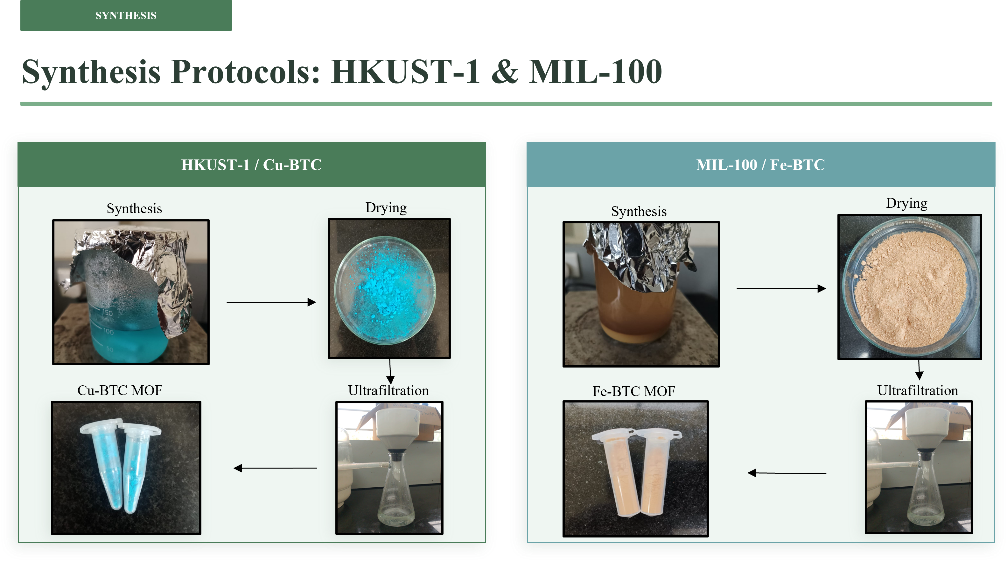
Figure S1. Room temperature synthesis protocol for Cu-BTC and MIL-100.

Figure S2. UV-Visible calibration curves of (a) ibuprofen (IBU), (b) paracetamol (PARA), and (c) ciprofloxacin (CIP) at varying concentrations in aqueous buffers of pH 5.0 and pH 7.0.
Figure S3 DLS distribution of Cu-BTC and MIL-100 (a) representing the particle size and (b) representing the zeta potential.

