Supplementary Materials
Germline pharmacogenomic predictors of treatment-related toxicity in non-small cell lung cancer: a systematic review of the discovery-to-implementation gap
Contents
Supplementary Table S1. Study characteristics of the 35 included studies (36 reports): study design, sample size, disease stage, treatment modality, gene, mechanism, toxicity type, Newcastle-Ottawa Scale score, multiple-testing-correction status, and independent-validation status.
Supplementary Table S2. Allele frequencies of 31 SNP variants and 5 HLA alleles across global ancestral populations (gnomAD v4.1 + AFND), supporting Sections 4.7 and 4.8.4.
Supplementary Table S3. Winner's-curse (regression-to-the-mean) correction of the priority-variant effect estimates that report a ratio measure, under conditional maximum-likelihood and median-unbiased shrinkage.
Supplementary Figure S1. Geographic distribution and treatment types of the 35 included studies (36 reports) across 15 countries.
Supplementary Figure S2. Newcastle-Ottawa Scale scores of the 35 included studies (36 reports).
Supplementary Figure S3. Effect size against sample size for the 27 associations that report both a ratio estimate and an NSCLC-specific sample size (supporting Section 3.6).
Supplementary Figure S4. XRCC1 rs25487 cross-study comparison (supporting Section 3.6).
Supplementary Methods. Search documentation, verbatim search strings, screening and extraction procedures, detail of the two quantitative analyses, deviations from the registered protocol, and limitations of the review process (supporting Sections 2.3, 2.4, 2.7 and 4.7).
Note: Supplementary Tables S1-S3 and Supplementary Figures S1-S4 are embedded in this file, after the detailed legends. Supplementary Methods are provided as a separate Word file (Additional file 1). High-resolution PNG and editable SVG versions of the supplementary figures are available from the authors on request.
Detailed legends
Supplementary Figure S1. Geographic distribution and treatment types of the 35 included studies (36 reports).
Each country is represented by a pie chart whose area is proportional to the number of studies conducted there and whose sectors give the treatment modality studied: chemotherapy alone (n=16), immunotherapy alone (n=8), targeted therapy alone (n=3), and combination regimens including chemoradiotherapy and chemoimmunotherapy (n=8). The 35 included studies span 15 countries on five continents. The dominant contributors are China (8 studies), India (4 studies), and Australia, Spain and the United States (3 studies each). Two multinational studies (Saad 2025, USA/South Korea; Weidhaas 2023, USA/Canada) are plotted once each, at the non-US partner country, to avoid double-counting; the United States pie therefore contains only the three exclusively US studies. Counting single-country studies only, 16 of the 35 studies (45.7%) were conducted in Asia. This East-Asian and South-Asian over-representation has implications for ancestry-specific interpretation of variant frequencies (Section 4.7).
Supplementary Figure S2. Newcastle-Ottawa Scale scores of the 35 included studies (36 reports).
Horizontal bar plot of the total Newcastle-Ottawa Scale (NOS) score of each included study (possible range 0-9), taken from Supplementary Table S1. Scores ranged from 5 to 9 (mean 6.5, median 7). Eighteen studies (51.4%) were of high quality (NOS >=7), 17 (48.6%) of moderate quality (NOS 5-6), and none of low quality (NOS <=4). The dashed line marks the high-quality threshold. Li 2024 (congress abstract) and Cheung 2025 report the same 42-patient cohort and are shown as a single bar, scored using the full report. Comparability was the weakest domain, with most studies scoring below the maximum available for the adjustment of confounders.
Supplementary Figure S3. Effect size against sample size across the reported associations.
Each point is one variant-cohort association, plotted by absolute reported effect size (ratio estimate, log scale) against NSCLC-specific sample size (log scale). Points are colored by biological mechanism; circles denote associations that increase toxicity risk and triangles those that are protective; markers with pale fill denote associations with P >= 0.05. This is not a funnel plot: standard errors are not uniformly available across the 35 included studies, so funnel-plot asymmetry cannot be assessed. All 27 associations that report both a ratio estimate and an NSCLC-specific sample size are plotted; the two GPR68 and GRID2 estimates from the whole-genome sequencing sub-study are excluded because no NSCLC-specific denominator was reported. The Spearman correlation quoted in Section 3.6 (rho = -0.64, P = 0.002; bootstrap 95% CI -0.83 to -0.29 over 10,000 resamples) is computed on the 20 risk-increasing associations (circles) alone, because the seven protective associations (triangles) lie on the opposite side of the null. The concentration of large effect estimates in small cohorts is consistent with the winner's-curse and small-study-effects pattern discussed in Sections 3.6 and 4.6.
Supplementary Figure S4. XRCC1 rs25487 cross-study comparison.
Reported odds ratios (log scale) for XRCC1 rs25487 (Arg399Gln) from the three NSCLC cohorts that examined it: Tiwari et al. 2022 (n=52, Indian, platinum chemotherapy, severe hematologic toxicity, OR=16.33, p=0.003); Bushra et al. 2020 (n=285, Bangladeshi, platinum chemotherapy, hematologic toxicity of any grade, OR=2.00, p=0.008); and Yang & Liu 2020 (n=486, Chinese, platinum chemotherapy plus thoracic radiotherapy, acute radiation esophagitis grade >=2, OR=0.50, p=0.043). With only three studies a formal funnel plot or Egger's test is not applicable; the figure illustrates the direction-of-effect inconsistency and the inverse relationship between sample size and reported magnitude quantified in Section 3.6 (Spearman rho = -0.64, P = 0.002). The direction reversal occurs between two different treatment and endpoint contexts (chemotherapy-induced hematologic toxicity versus radiation esophagitis) and supports treatment-aware rather than variant-only risk stratification (Section 4.8.4).
Supplementary Table S1. Study characteristics of the 35 included studies (36 reports).
For each study the table reports the first author and year, DOI, country or region, study design, NSCLC sample size and disease stage, treatment modality, gene(s) examined, mechanistic category, toxicity type, effect measure, Newcastle-Ottawa Scale (NOS) score, multiple-testing-correction (MTC) status, and independent-validation (IV) status. Li 2024 and Cheung 2025 report the same 42-patient Chinese cohort and are presented as a single merged row with both DOIs, which is why the table has 35 data rows for 36 reports.
Supplementary Table S2. Allele frequencies of 31 SNP variants and 5 HLA alleles across global ancestral populations.
Frequencies retrieved from gnomAD v4.1 (autosomal SNPs) and the Allele Frequency Net Database (AFND v3.0, HLA alleles). Population codes: AFR (African/African American), AMR (Latino/Admixed American), EAS (East Asian), NFE (Non-Finnish European), SAS (South Asian). HLA ancestry groups follow AFND: European, African, Asian, Latin American. Variants are stratified by mechanism. Frequencies are drawn from general-population reference databases rather than disease-specific NSCLC cohorts. This table supports the ancestry-specific risk discussion in Section 4.7 and the implementation considerations in Section 4.8.4.
Supplementary Table S3. Winner's-curse correction of the priority-variant associations that report a ratio estimate.
For each discovery association the table reports the gene and variant, discovery study, effect measure, reported estimate with 95% confidence interval, and the bias-corrected estimates under two shrinkage estimators (conditional maximum-likelihood and conditional median-unbiased) with the corresponding attenuation. Nine cohort-level estimates across seven unique variants are shown; the remaining five priority variants lack a ratio estimate suitable for correction, or report an estimate incompatible with its interval, and are documented in the table footnotes.

Supplementary Table S1. Study characteristics of the 35 included NSCLC pharmacogenomic studies (36 reports).
First Author, Year | DOI | Country/Region | Study Design | N (NSCLC) | NSCLC Stage | Treatment | Gene(s) | Mechanism | Toxicity Type | Effect Measure | NOS | MTC | IV
Abed 2024 | 10.3390/cancers16173102 | Australia | Prospective cohort | 53 | Advanced/metastatic | IT + CT | HLA | M3 (Immune regulation) | irAE (any grade) | HR, RR | 7 | No | No
Abed 2022 | 10.1016/j.ejca.2022.05.021 | Australia | Prospective cohort | 179 | Advanced/metastatic | IT | HLA-I//HLA-II | M3 (Immune regulation) | irAEs | RR | 9 | No | No
Aguado-Barrera 2021 | 10.3390/cancers13061447 | Spain | Cohort | 178 | I-IV | RT ± CT | Multiple (BLM, FGF14, HSPB1...) | M2/M4 | Radiation-induced esophagitis | OR | 6 | Yes | Yes
Barnet 2025 | 10.1073/pnas.2314258122 | Australia | Prospective cohort | 144 | IV | IT | NOD2 | M3 (Immune regulation) | General toxicity (irAEs) | p-value | 7 | Yes | No
Björn 2020 | 10.1038/s41397-019-0099-8 | Sweden | Prospective cohort | 212 | I-IV (37.3% IV) | CT | Multiple (DOCK8, SERPINA5, etc....) | M1/M2/M3/M4 | Thrombocytopenia | OR, HR | 7 | Yes | Yes
Bushra 2020 | 10.1007/s11033-020-05771-2 | Bangladesh | Cohort | 285 | Advanced | CT | XRCC1, GSTP1, XPC, ERCC1 | M1/M2 | GI, hematologic | OR | 5 | No | No
Cafiero 2025 | 10.3390/genes16030265 | Italy | Prospective cohort | 70 | I-IV (28.6% IV) | CT | Multiple | M1/M2/M3 | General, hematologic, GI, fatigue, cutaneous, pain, dyspnea | OR | 6 | No | No
Cheung 2025 [46]ᵃ | 10.1016/j.jtocrr.2024.100754; 10.1200/JCO.2024.42.16_suppl.8620 | China | Cohort | 42 | I, III, IV | IT / IT + CT | HLA | M3 (Immune regulation) | Pneumonitis, hepatitis, pruritus, bullous pemphigoid | p-value, HR (for survival) | 5 | No | No
Devika 2024 | 10.7759/cureus.64849 | India | Prospective cohort | 123 | IV | CT | NRF2 | M1 (Drug metabolism) | Hematologic toxicity | OR, HR | 6 | No | No
Gonzalez-Hernandez 2026 | 10.3390/jcm15041486 | Spain | Retrospective cohort | 124 | IV | IT ± CT | IL7 | M3 (Immune regulation) | Multiple (general, skin, hepatic, endocrine) | OR | 7 | No | No
Guijarro-Eguinoa 2023 | 10.3390/ijms24129843 | Spain | Retrospective cohort | 55 | III-IV (54.4% IV) | CT | Multiple | M1 (Drug metabolism) | GI, hematologic, fatigue | HR (survival only) | 5 | No | No
Heersche 2025 | 10.1016/j.jtho.2024.11.025 | Netherlands | Prospective cohort (multicenter) | 215 | Advanced/metastatic | Targeted therapy (alectinib) | ABCB1, CYP3A4, PPARα, POR, CYP3A5 | M1 (Drug metabolism) | Severe toxicity (grade ≥3) | p-value (percentage difference) | 7 | Yes | No
Hu 2021 | 10.4149/neo_2021_201116n1229 | China | Cohort | 163 | I-IV | CT | CDA | M1 (Drug metabolism) | Hematologic | p-value | 5 | No | No
Huang 2024 | 10.1200/JCO.2024.42.16_suppl.3090 | Singapore | Cohort | 188* | Stage IV predominant | IT | chr3:163402331 (locus no anotado) | Unknown | irAE grade ≥3 | OR (adj.) | 5 | Yes | No
Huang 2022 | 10.1200/JCO.2022.40.16_suppl.2547 | Singapore | Cohort | 111* | Stage IV predominant | IT | LOC105373202 | Unknown | irAE grade ≥3 | OR (unadj.) | 5 | Yes | No
Jiang 2024 | 10.1038/s41598-023-48546-y | USA | Prospective cohort | 85 | Metastatic | IT | HLA | M3 (Immune regulation) | Endocrine irAEs | p-value, HR (PRS) | 5 | No | No
Kaur 2025 | 10.1007/s12094-024-03800-1 | India | Retrospective cohort | 355 | I-IV | CT | hTERT MNS16A | M2 (DNA repair) | Hematologic, nephrotoxicity, hepatotoxicity | aOR, HR | 8 | No | No
Khan 2023 | 10.1186/s13073-023-01193-4 | USA | Retrospective cohort | NR† | Multiple stages | CT ± IT | GPR68, GRID2 | M4 (Target signaling) | CIPN | HR | 8 | Yes | No
Li 2021 | 10.3892/or.2021.7935 | China | Case-control | 506 | I-IV | CT | ERCC5 | M2 (DNA repair) | Myelosuppression, nausea, hepatic | OR | 8 | Yes | No
Luo 2021 | 10.1158/1078-0432.ccr-21-0921 | USA | Retrospective cohort | 729 | Advanced | IT | HLA | M3 (Immune regulation) | Thyroid dysfunction (irAE) | HR (PRS) | 9 | Yes | Yes
Mei 2024 | 10.1186/s12890-024-02983-1 | China | Case-control | 429 | III-IV | CT | CCND1 | M2 (DNA repair) | General, GI, hematologic | OR | 8 | No | No
Morau 2026 | 10.1038/s41598-026-38707-0 | Brazil | Retrospective cohort | 36 | III-IV | Targeted therapy | ABCB1 | M1 (Drug metabolism) | Gastrointestinal | OR | 6 | No | No
Polcaro 2025 | 10.1136/jitc-2025-012207 | Italy | Prospective cohort | 49 | Advanced | IT | PDCD1 (PD-1) | M3 (Immune regulation) | irAEs | p-value | 7 | No | Yes
Ritambhara/Tiwari 2022 | 10.4103/jcrt.jcrt_925_20 | India | Cohort | 52 | III-IV | CT | XRCC1, XPD, GSTM1, IL1RN, GSTP1, IL1B, GSTT1 | M1/M2/M3 | Hematologic, GI | OR, HR | 5 | No | No
Saad 2025 | 10.1200/JCO.2025.43.16_suppl.12129 | USA/South Korea | Pooled cohort (3 cohorts) | 152 | NR | IT | IL7 | M3 (Immune regulation) | irAE (any grade) | HR | 5 | No | Yes
Seguin 2025 | 10.3390/genes16040453 | Brazil | Prospective cohort | 110 | IV | CT | ABCB1 (rs1045642, rs1128503, rs2032582), ABCC2 (rs717620) | M1 (Drug metabolism) | Hematologic, renal, hepatic, GI | OR, HR | 7 | No | No
Sharma 2023 | 10.1002/jbt.23269 | India | Cohort | 407 | III-IV | CT | ABCB1, ABCC1, ABCC2, ABCG2 | M1 (Drug metabolism) | Hematologic, nephrotoxicity, GI, hepatotoxicity | OR, aOR | 6 | No | No
Spasic 2022 | 10.1177/15593258221111666 | Serbia | Observational cohort | 121 | M1 (94.2%) | CT | TP53, XRCC1, RAD51 | M2 (DNA repair) | General toxicity, neuropathy | OR | 6 | Yes | No
Takeda 2023 | 10.1186/s12885-023-11257-8 | Japan | Prospective cohort | 67 | I-IVB | CT | Multiple (MTHFR...) | M1 (Drug metabolism) | Hematologic and non-hematologic | OR, HR | 8 | Yes | No
Visser 2021 | 10.1136/thoraxjnl-2020-216504 | Netherlands | Prospective cohort | 161 | IV (87%) | CT | Multiple (ATIC...) | M1 (Drug metabolism) | Neutropenia, GI, fatigue | HR | 7 | Yes | No
Wang 2021 | 10.7150/jca.51621 | China | Prospective cohort | 1004 | III-IV | CT | ABCG2, SLC31A1 | M1 (Drug metabolism) | Hematologic, GI | OR, HR | 7 | Yes | No
Weidhaas 2023 | 10.1158/2767-9764.CRC-23-0084 | USA/Canada | Cohort | 328 | IIIA/IIIB | CRT ± Targeted therapy | KRAS | M4 (Target signaling) | Severe toxicity / 1-year mortality | OR, HR | 6 | No | No
Xin 2021 | 10.1007/s00432-020-03476-4 | China | Retrospective cohort | 42 | III-IV | Targeted therapy | Multiple (STAT1, ROS1...) | M3/M4 | Hepatotoxicity | OR | 5 | No | No
Yang & Liu 2020 | 10.1155/2020/3132786 | China | Cohort | 486 | NR | RT ± CT | XRCC1, XRCC2, XPD, MSH2 | M2 (DNA repair) | General toxicity | OR | 7 | No | No
Zheng 2021 | 10.1080/17425255.2021.1879048 | China | Cohort | 437 | III-IV | CT + Targeted therapy | EPO | M4 (Target signaling) | Hematologic | OR | 8 | No | No
ᵃSame 42-patient cohort reported in two publications (congress abstract Li 2024 [45] and full report Cheung 2025 [46]); counted as one study, so the review comprises 35 studies described in 36 reports.
*Sample size refers to the NSCLC subgroup of a mixed-tumor cohort. †The NSCLC-specific sample size was not reported.
CT, chemotherapy; DOI, digital object identifier; IT, immunotherapy; irAE, immune-related adverse event; IV, independent validation cohort; MTC, multiple-testing correction; M1, drug metabolism and transport; M2, DNA repair and cell cycle; M3, immune regulation; M4, target pathway signaling; NOS, Newcastle-Ottawa Scale; NR, not reported; NSCLC, non-small cell lung cancer; RT, radiotherapy; TT, targeted therapy.

Supplementary Table S2. Population allele frequencies of germline variants reportedly associated with treatment-related toxicity in non-small cell lung cancer (NSCLC), stratified by ancestry.
All frequencies represent the effect allele as reported in the original publication, with strand orientation verified against dbSNP and cross-validated against published European reference frequencies (Δ < 0.10). Population data: gnomAD v4.1 (SNPs; AC/AN per population, queried 2026-06-09) and Allele Frequency Net Database v3.0 (HLA, sample-size-weighted, queried 2026-06-09). NR = not reported / not catalogued.
Mechanism | Gene | Variant | Effect  allele | Study AF  (n) | NFE | EAS | SAS | AFR | AMR | Toxicity / Effect / p | Source / Notes
M1 Drug metabolism  / transport | ABCB1 | rs1128503 | T | 0.355  (n=110) | 0.436 | 0.624 | 0.605 | 0.178 | 0.486 | Vomiting  OR=13.55; p=0.0137 | Seguin 2025 (Brazil). AF from the paper's own  Table S2 (T 35.5%; TT 18, CT 42, CC 50);  its C-allele row (54.5%) is internally  inconsistent with those genotypes (64.5%).
M1 Drug metabolism  / transport | ABCB1 | rs2032582 | non-C (T/A) | 0.343  (n=110) | 0.455 | 0.558 | 0.650 | 0.074 | 0.451 | Diarrhea (gefitinib), non-CC vs CC:  OR=7.58 (1.16-49.51); p=0.0344  Nausea (carbo-paclitaxel): p=0.0341,  OR not estimable | Morau 2026 (Brazil, n=36; 33 evaluable for  diarrhea; effect size); Seguin 2025 (Brazil,  n=110; AF, C allele 0.657 reported).  Population columns are for the T allele.
M1 Drug metabolism  / transport | ABCB1 | rs1045642 | T  (= G in  c.3435A>G) | 0.577  (n=110) | 0.539 | 0.397 | 0.604 | 0.179 | 0.453 | No significant association with  ADRs or survival | Seguin 2025 (Brazil). AF from the paper's own  Table S2 (G 57.7%; AA 21, AG 51, GG 38).  The T allele of the 3435C>T nomenclature is  the G allele of c.3435A>G.
M1 Drug metabolism  / transport | ABCC1 | rs41410450 | A | 0.122  (n=407) | 8.09e-06 | 7.56e-04 | 3.48e-05 | 0.000 | 0.000 | Anemia, GA vs GG  aOR=2.70 (1.06-6.88); p=0.030  (crude OR=1.24, p=0.45) | Sharma 2023 (India). AF derived from  reported genotypes (315 GG, 85 GA, 7 AA);  ~10³-fold above gnomAD SAS.
M1 Drug metabolism  / transport | ABCC2 | rs717620 | T | 0.164  (n=110) | 0.202 | 0.205 | 0.112 | 0.054 | 0.132 | Hematologic/renal/hepatic/GI  (reported); p=NR | Seguin 2025 (Brazil). AF derived from the  paper's own Table S2 genotypes (CC 77, CT 30,  TT 3); its C-allele row (85.0%) implies 15.0%  and is inconsistent with those genotypes.
M1 Drug metabolism  / transport | ABCG2 | rs12505410 | A | 0.325  (n=1004) | 0.371 | 0.312 | 0.291 | 0.140 | 0.396 | Neutropenia  OR=2.29; p=0.005 | Wang 2021 (China)
M1 Drug metabolism  / transport | ATIC | rs12995526 | T | 0.554  (n=161) | 0.466 | 0.281 | 0.321 | 0.717 | 0.372 | Pemetrexed tox  HR=1.87; p=0.014 | Visser 2021 (Netherlands)
M1 Drug metabolism  / transport | MTHFR | rs1801133 | T | 0.353  (n=67) | 0.337 | 0.348 | 0.149 | 0.106 | 0.489 | Hematologic (protective)  OR=0.13; p=0.040 | Takeda 2023 (Japan)
M1 Drug metabolism  / transport | NRF2 | rs6721961 | A | NR | 0.116 | 0.272 | 0.138 | 0.068 | 0.146 | Hematologic (NS)  OR=0.46; p=0.159 | Devika 2024 (India)
M1 Drug metabolism  / transport | CDA | rs1048977  (435C>T) | T | 0.261  (n=163) | 0.323 | 0.267 | 0.268 | 0.381 | 0.311 | Leukopenia  C/T vs C/C: p=0.049;  C/T+T/T vs C/C: p=0.046 | Hu 2021 (China). AF derived from reported  genotypes (86 C/C, 69 C/T, 8 T/T);  rsID corrected from rs2072671 (79A>C).
M1 Drug metabolism  / transport | PPARα | rs1800206 (209G>A,  L162V) | A | NR  (n=215) | 0.066 | 0.000 | 0.025 | 0.009 | 0.043 | Severe toxicity (grade ≥3)  38% vs 11%; p=0.004 | Heersche 2025  (Netherlands)
M2 DNA repair  / cell cycle | XRCC1 | rs25487 | A | 0.380  (n=285) | 0.362 | 0.259 | 0.353 | 0.143 | 0.270 | Hematologic  OR=16.33 / 2.00 / 0.50; p=0.003 / 0.008 / 0.043 | Tiwari 2022 / Bushra 2020 (Bangladesh) / Yang & Liu 2020
M2 DNA repair  / cell cycle | ERCC5 | rs11069498 | A | 0.236  (n=117) | 0.594 | 0.231 | 0.490 | 0.274 | 0.384 | Cisplatin tox  OR=2.28; p=0.002 | Li 2021 (China)
M2 DNA repair  / cell cycle | CCND1 | rs9344 | A | 0.521  (n=NR) | 0.449 | 0.523 | 0.523 | 0.215 | 0.379 | General tox  OR=1.85; p=0.023 | Spasic 2022 (Serbia)
M2 DNA repair  / cell cycle | TP53 | rs1042522 | G | 0.350  (n=NR) | 0.748 | 0.605 | 0.507 | 0.376 | 0.714 | Combined w/ RAD51  OR=0.07; p=0.030 | Spasic 2022
M2 DNA repair  / cell cycle | RAD51 | rs1801320 | C | 0.085  (n=NR) | 0.057 | 0.100 | 0.000 | 0.500 | 0.500 | Combined w/ TP53  OR=0.07; p=0.030 | Spasic 2022
M2 DNA repair  / cell cycle | hTERT | MNS16A VNTR | Short | NR | NR | NR | NR | NR | NR | Nephrotoxicity (borderline)  aOR=0.54; p=0.050 | Not a SNP catalogued in gnomAD (VNTR or unmappable); Kaur 2025
M3 Immune  regulation | DOCK8 | rs7025610 | G | 0.073  (n=212) | 0.066 | 0.037 | 0.134 | 0.436 | 0.119 | Thrombocytopenia  HR=2.35; p=5.19×10⁻⁴ | Björn 2020 (Sweden)
M3 Immune  regulation | STAT1 | rs10208033 | A | 0.420  (n=42) | 0.405 | 0.662 | 0.406 | 0.642 | 0.518 | Hepatotoxicity (crizotinib)  OR=8.97; p=0.030 | Xin 2021 (China)
M3 Immune  regulation | IL7 | rs16906115 | T | 0.097  (n=124) | 0.084 | 0.293 | 0.094 | 0.339 | 0.169 | irAEs  OR=4.64; p=0.020 | González-Hernández 2026 (Spain)
M3 Immune  regulation | IL7 | rs16906062 | C | 0.074  (n=152) | 0.064 | 0.281 | 0.048 | 0.139 | 0.181 | irAEs  HR=2.30; p=0.017 | Saad 2025 (US/Korea)
M3 Immune  regulation | PDCD1 | rs10204525 | C | 0.770  (n=49) | 0.898 | 0.246 | 0.797 | 0.658 | 0.607 | irAEs  (CC vs CT); p=0.0053 (gr.1-2); p<0.0001 (gr.3-4) | Polcaro 2025 (Italy)
M3 Immune  regulation | HLA-A | *03 | Allele carrier | NR (group)  (156) | 0.109 | 0.012 | 0.045 | 0.061 | 0.055 | irAE protective (NS)  RR=0.35; p=0.066 | Hu 2021 (China)
M3 Immune  regulation | HLA-DRB1 | *04:01 | Allele carrier | 0.082  (n=179) | 0.074 | 0.011 | 0.014 | 0.032 | 0.021 | irAE risk  RR=1.55; p=0.011 | Abed 2022 (Australia)
M3 Immune  regulation | HLA-DRB1 | *15:01 | Allele carrier | 0.090  (n=179) | 0.111 | 0.076 | 0.094 | 0.028 | 0.044 | irAE protective  RR=0.18; p=0.029 | Abed 2022
M3 Immune  regulation | HLA-DPB1 | *02 | Allele carrier | 0.182  (n=42) | 0.137 | 0.190 | 0.219 | 0.125 | 0.088 | Pneumonitis  (carriership); p=0.009 | Cheung 2025 (China)
M3 Immune  regulation | HLA-DRB4 | (carriership) | Allele carrier | 0.155  (n=42) | 0.270 | 0.290 | 0.220 | 0.180 | 0.280 | Endocrine irAEs  (carriership); p=0.0139 | DRB4 not separately typed in AFND; values inferred from DR4/7/9 haplotype family (Solberg 2008); Cheung 2025
M3 Immune  regulation | HLA-DQA2 | rs9268543 | PRS | 0.158  (n=729) | 0.158 | 0.069 | 0.082 | 0.053 | 0.151 | Thyroid dysfunction  HR=1.34-1.39 (PRS); p=8.73×10⁻³ / 0.010 | Luo 2021 (US, discovery)
M3 Immune  regulation | NOD2 | rs2066844 | T (R702W) | NR | 0.048 | 1.01e-04 | 3.59e-04 | 0.007 | 0.022 | irAE number and type similar in  LoF carriers and non-carriers;  no variant-level test | Barnet 2025 (Australia). Pooled NOD2 LoF  alleles 16.25% vs 6.58% expected, p=0.0021;  per-variant cohort AF not reported. Table S6:  grade 3-4 in 7/22 irAE events in 12 carriers  vs 9/48 events in 28 non-carriers; no test.
M3 Immune  regulation | NOD2 | rs2066847 | GC insertion (1007fs) | NR | 0.022 | 5.04e-05 | 0.002 | 0.002 | 0.008 | irAE number and type similar in  LoF carriers and non-carriers;  no variant-level test | Barnet 2025 (Australia). Pooled NOD2 LoF  alleles 16.25% vs 6.58% expected, p=0.0021;  per-variant cohort AF not reported. Table S6:  grade 3-4 in 7/22 irAE events in 12 carriers  vs 9/48 events in 28 non-carriers; no test.
M4 Target pathway  signaling | FGF14 | rs4772468 | T | 0.148  (n=178) | 0.149 | 0.279 | 0.237 | 0.280 | 0.231 | RT esophagitis  OR=4.36; p=0.029 | Aguado-Barrera 2021 (Spain)
M4 Target pathway  signaling | GPR68 | rs61745750 | A (rare coding) | 0.012  (n=NR) | 8.96e-04 | 0.000 | 0.000 | 1.66e-04 | 3.42e-05 | CIPN  HR=2.44; p=1.59×10⁻⁶ | Khan 2023 (US)
M4 Target pathway  signaling | GPR68 | rs61745752 | T (rare coding) | 0.005  (n=NR) | 1.89e-06 | 0.000 | 0.000 | 0.000 | 0.000 | CIPN  HR=2.44; p=1.59×10⁻⁶ | Khan 2023
M4 Target pathway  signaling | GRID2 | rs17020773 | C | 0.032  (n=NR) | 0.030 | 0.020 | 0.052 | 0.052 | 0.033 | CIPN  HR=1.85 (1.50-2.31); p=2.03×10⁻⁸ (all)  HR=1.96 (1.56-2.47); p=6.36×10⁻⁹ (taxane) | Khan 2023
M4 Target pathway  signaling | SERPINA5 | rs3790036 | G | 0.183  (n=212) | 0.175 | 0.481 | 0.134 | 0.039 | 0.233 | Thrombocytopenia  HR=1.91; p=1.47×10⁻³ | Björn 2020
M4 Target pathway  signaling | EPO | rs1617640 | T | NR | 0.404 | 0.195 | 0.357 | 0.344 | 0.282 | Hematologic  OR=1.78; p=0.019 | Zheng 2021 (China)
M4 Target pathway  signaling | KRAS | KRAS-variant (3'UTR miRNA site) | variant | NR | NR | NR | NR | NR | NR | Severe tox (NS)  OR=1.18; p=0.690 | Not a SNP catalogued in gnomAD (VNTR or unmappable); Weidhaas 2023
Non-characterized | chr3:163402331 | rs146525069 | G | 0.027  (n=188) | 0.000 | 0.000 | 0.000 | 0.000 | 0.000 | irAE grade ≥3  OR=17.08; p=7.29×10⁻⁸ | Huang 2024 (Singapore)
Non-characterized | LOC105373202 | rs5915369 | T | 0.052  (n=111) | 0.198 | 0.028 | 0.179 | 0.026 | 0.148 | irAE grade ≥3  OR=27.80; p=6.6×10⁻⁸ | Huang 2022 (Singapore)

Methodological notes. (1) gnomAD v4.1 frequencies were retrieved on 2026-06-09 via the GraphQL API; AC and AN were extracted per superpopulation and allele frequency was computed as AC/AN, with exome data preferred when available. (2) The effect allele was identified from the original publication. For variants in genes located on the minus strand (e.g., ABCB1, XRCC1, NRF2, ATIC, IL7, EPO), publication-strand alleles were mapped to the gnomAD forward strand using dbSNP allele annotations; frequencies in this table represent the effect-allele frequency on the publication strand. Strand orientation was independently validated against published European (NFE) reference allele frequencies (1000G, PharmGKB) to a tolerance of Δ < 0.10. (3) HLA allele frequencies derive from AFND v3.0 (Gonzalez-Galarza et al. Nucleic Acids Res 2020), with sample-size-weighted means across populations classified to each superpopulation (HLA-A*03 n=17,451; HLA-DRB1*04:01 n=27,814; HLA-DRB1*15:01 n=29,732; HLA-DPB1*02:01 n=11,750). (4) HLA-DRB4 is not separately typed in AFND; values are inferred from the combined frequencies of DRB1*04, DRB1*07 and DRB1*09 haplotypes (Solberg 2008). (5) NR indicates that the variant was either not catalogued in gnomAD (rare or non-SNV; e.g., the KRAS-variant 3'UTR LCS6 polymorphism and the hTERT MNS16A VNTR) or the original publication did not report a cohort MAF. (6) Mechanism categories follow the manuscript taxonomy: M1 = drug metabolism/transport; M2 = DNA repair/cell cycle; M3 = immune regulation; M4 = target pathway signaling. (7) In the 'Toxicity / Effect / p' column, p=NR indicates that the primary publication did not report a variant-specific p-value for that association; where three estimates are listed they correspond, in order, to the three cohorts named in the last column. Non-characterized = variant with no established functional annotation.

Supplementary Table S3. Winner's-curse-corrected effect estimates for the priority variants.
Gene / variant | Discovery study | Measure | Reported estimate (95% CI) | Corrected, conditional ML | Corrected, median-unbiased | Attenuation, conditional ML | Attenuation, median-unbiased
XRCC1 rs25487 | Tiwari 2022 (n=52) | OR | 16.33 (2.66-100.26) | 10.65 | 12.65 | 37% | 24%
XRCC1 rs25487 | Bushra 2020 (n=285) | OR | 2.00 (1.19-3.35) | 1.51 | 1.67 | 49% | 33%
XRCC1 rs25487 | Yang & Liu (n=486) | OR | 0.50 (0.26-0.99) | 0.84 | 0.97 | 67% | 95%
ABCG2 rs12505410 | Wang 2021 (n=1,004) | OR | 2.29 (1.28-4.10) | 1.84 | 2.00 | 35% | 23%
IL7 rs16906115 | González-Hernández 2026 (n=124) | OR | 4.64 (1.50-17.20) | 1.91 | 2.41 | 75% | 61%
IL7 rs16906062 | Saad 2025 (n=152) | HR | 2.30 (1.16-4.60) | 1.34 | 1.42 | 74% | 68%
HLA-DRB1*04:01 | Abed 2022 (n=179) | RR | 1.55 (1.10-2.06) | 1.36 | 1.43 | 35% | 23%
FGF14 rs4772468 | Aguado-Barrera 2021 (n=178) | OR | 4.36 (1.15-16.46) | 1.51 | 1.21 | 85% | 94%
ATIC rs12995526 | Visser 2021 (n=161) | HR | 1.87 (1.14-3.09) | 1.30 | 1.43 | 66% | 51%

Both estimators adjust a reported effect for the fact that it was published only because it crossed a significance threshold. Standard errors were derived from the published confidence intervals and the ascertainment threshold was set at the two-sided 0.05 level used by each discovery study. Attenuation is the proportion of the excess effect (the distance of the estimate from the null) removed by correction.
Two estimators are reported because no single correction is clearly preferable here. Benchmarking across simulated and real genome-wide data has shown that conditional-likelihood corrections, including the conditional maximum-likelihood estimator used in the first corrected column, tend to overcorrect relative to empirical-Bayes, bootstrap and FDR-based alternatives (Forde et al., PLoS Genet 2023). Those alternatives, however, estimate the degree of shrinkage empirically from the full vector of summary statistics of a single study, and cannot be applied to individually selected estimates drawn from nine separate studies with different traits, populations and reporting thresholds. The conditional median-unbiased estimator is the applicable and less aggressive member of the same family, and is reported alongside so that the two bracket a plausible range. Conclusions are unchanged across the two: seven of nine corrected estimates fall below 2.0 under the median-unbiased estimator and eight of nine under conditional maximum likelihood.
Because most discovery studies tested several variants without adjusting the reported threshold, the effective selection threshold was stricter than 0.05 and both sets of corrections are therefore conservative: the true attenuation is likely larger than either column indicates.
Effect measures are pooled across odds ratios, hazard ratios and risk ratios. All are treated as log-ratio estimates with approximately normal sampling distributions, which is the assumption the correction requires; they are not otherwise interconverted, and the corrected values should be read within measure rather than compared across measures.
Five priority variants are not shown. HLA-DPB1*02 and PDCD1 rs10204525 were reported as carrier proportions rather than ratio estimates, as was PPARα 209G>A (Heersche et al., 2025). For the GPR68 coding variants the reported point estimate (HR=2.44) is not compatible with the reported interval (1.52–2.72), whose geometric mean is 2.03, so no correction was attempted. MTHFR rs1801133 (Takeda et al., 2023), a protective single-cohort association (OR=0.13, n=67, p=0.04), was not carried through the winner's-curse correction.

Supplementary Figure S1.
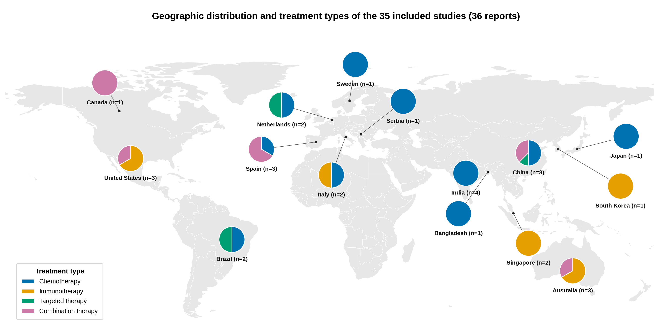
Supplementary Figure S2.
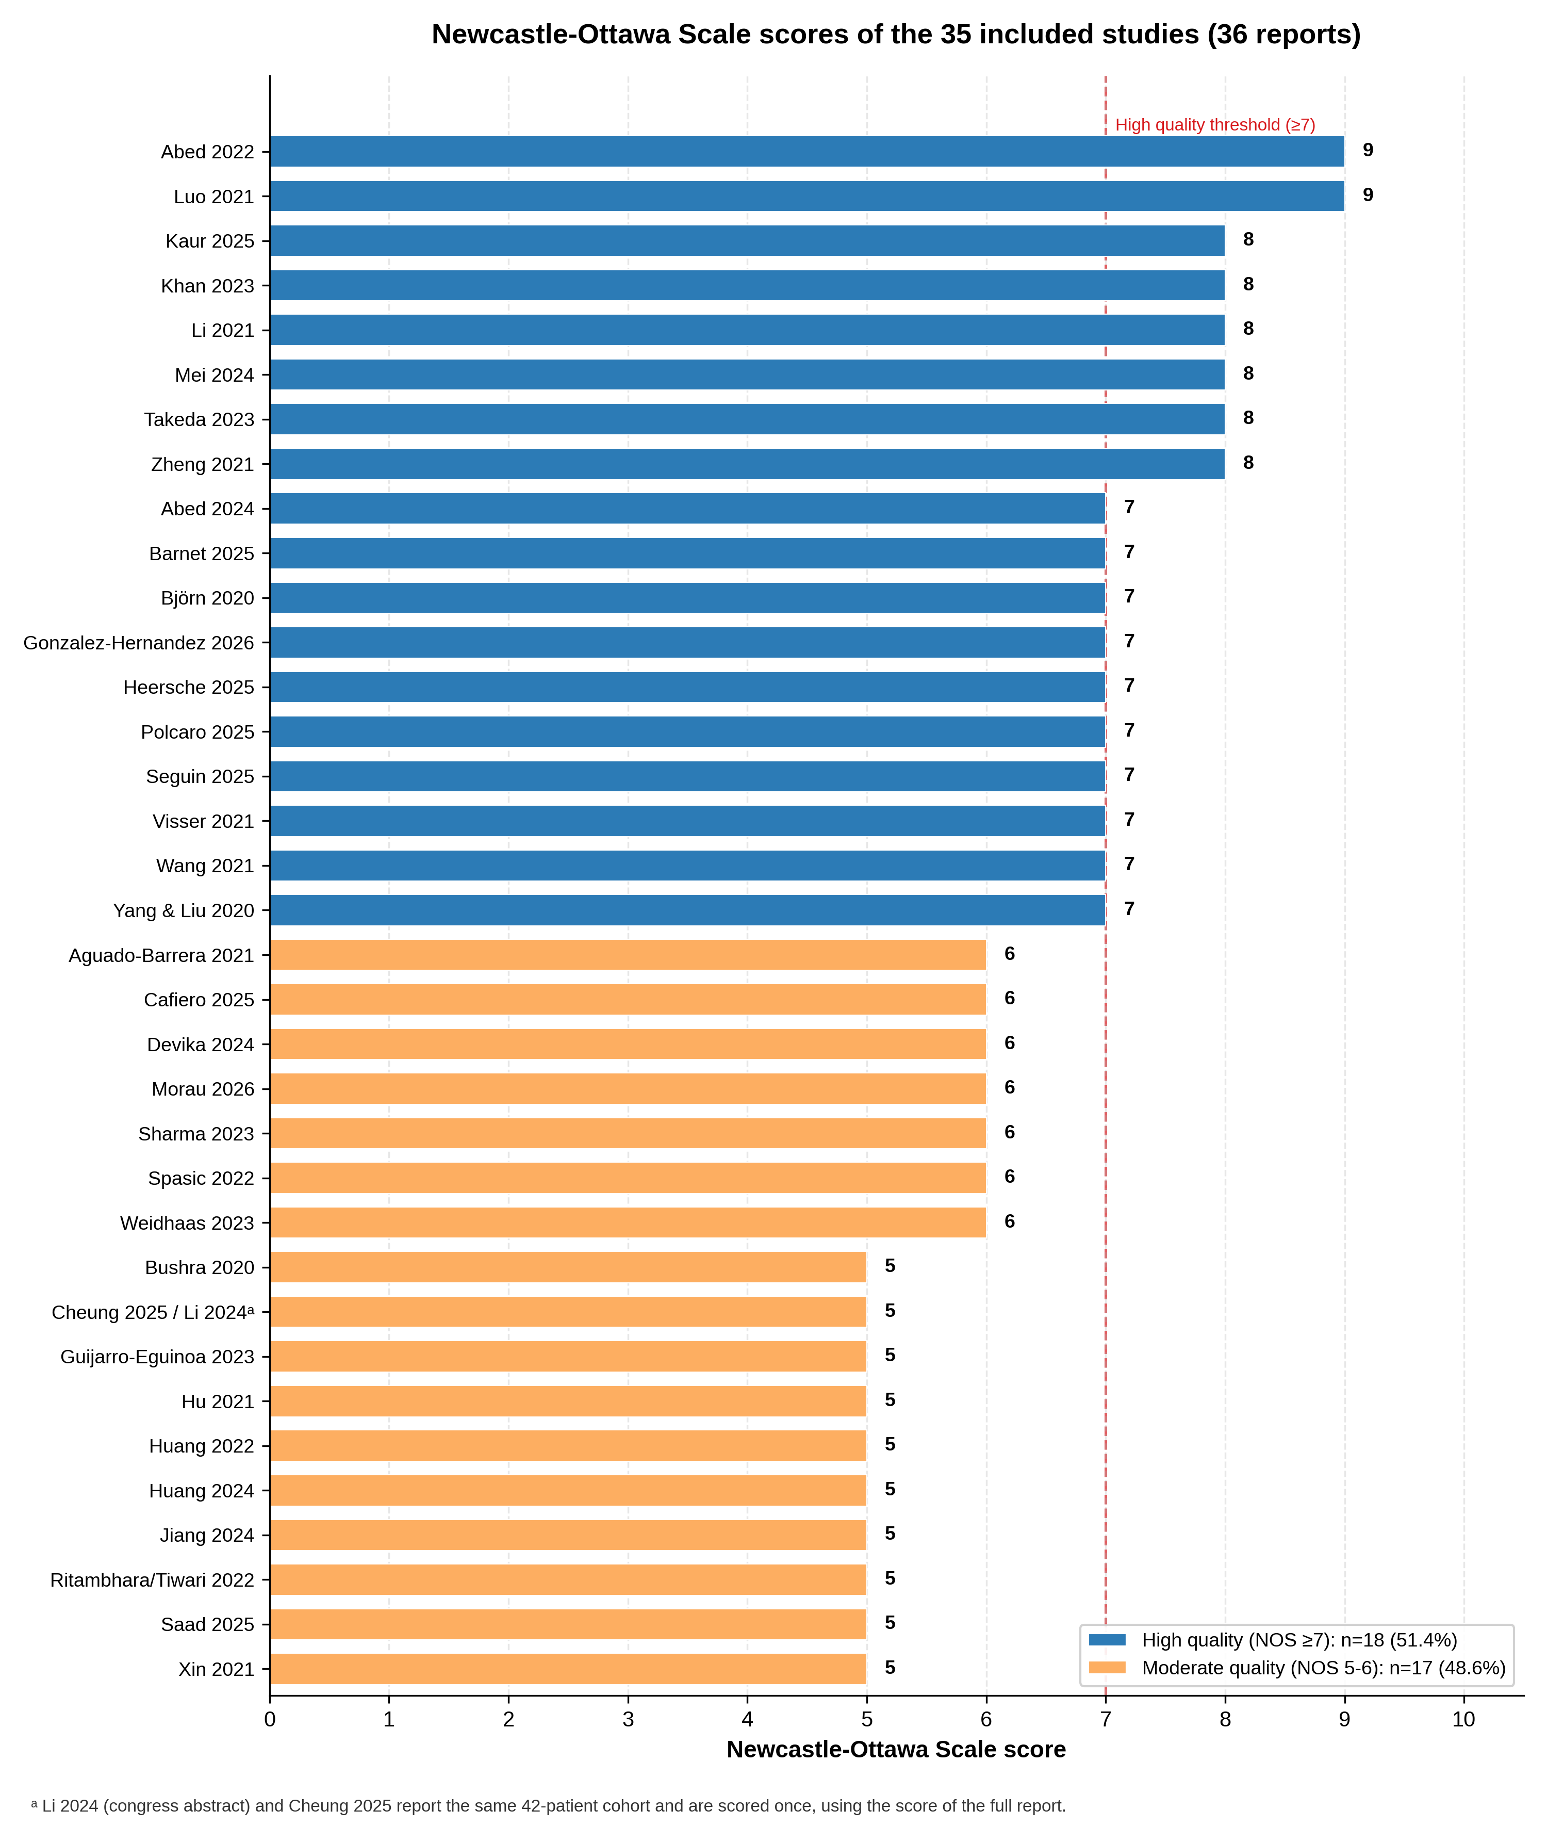
Supplementary Figure S3.
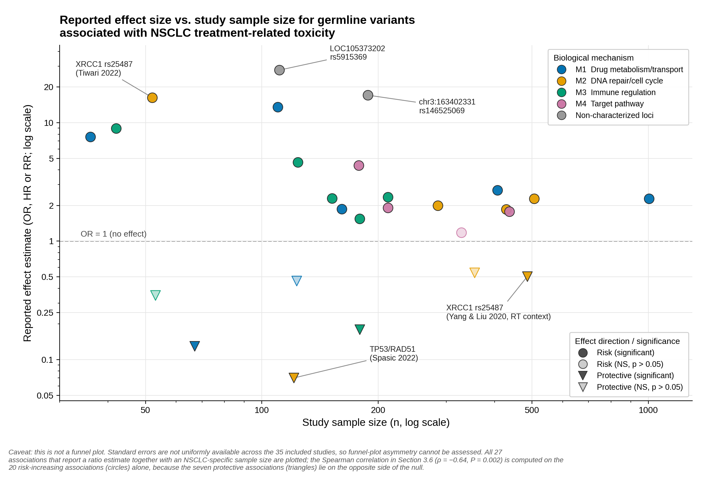
Supplementary Figure S4.
