Supporting Information for

Dynamic amorphous confinement stabilizes crystalline IrO₂ for ultra-durable proton exchange membrane water electrolysis
Bingqian Pang^{1,†}, Yun Liu^{1,†}, Yixiang He^{2,†}, Zhenye Kang^{1,*}, Hui Chen³, Shuyu Zhang⁴, Jing Li¹, Yuliang Yuan¹, Peng Rao¹, Xiaodong Shi¹, Wenjuan Shi^{1,*}, Xinlong Tian^{1,*}
¹State Key Laboratory of Tropic Ocean Engineering Materials and Materials Evaluation, Hainan Provincial Key Lab of Fine Chem, School of Marine Technology and Equipment, Hainan University, Haikou, 570228, China
²State Key Laboratory of Molecular Engineering of Polymers, Department of Macromolecular Science, Fudan University, Shanghai, 200433, China
³State Key Laboratory of Inorganic Synthesis and Preparative Chemistry, College of Chemistry, Jilin University, Changchun, 130012, China
⁴State Key Laboratory of Photovoltaic Science and Technology, College of Intelligent Robotics and Advanced Manufacturing, Institute for Electric Light Sources, Fudan University, Shanghai, 200433, China
*Corresponding authors: zkang@hainanu.edu.cn (Z. Kang); wjshi@hainanu.edu.cn (W. Shi); tianxl@hainanu.edu.cn (X. Tian)
†These authors contributed equally to this work.

1. Experimental

1.1 Materials
All chemicals are analytical grade, including iridium chloride (IrCl_{3,} AR, 99.0%), PAHs (M_{w}≈17500), Sodium nitrate (NaNO3, AR, 95.0%), isopropanol (AR, 99.5%) and ethanol (AR, 99.7%). Commercial IrO₂ catalyst used were Macklin's 99.9% metals basis, Ir ≥ 84.5%.

1.2 Synthesis of DAC-IrO₂
In a typical synthesis, 0.5 mmol of iridium trichloride (IrCl₃·xH₂O), 2.0 mmol of sodium nitrate (NaNO₃), and 0.2 g of polycyclic aromatic hydrocarbons (PAHs, e.g., pyrene or anthracene) were dissolved in 20 mL of deionized water under stirring. The mixture was then heated to 80 °C and stirred continuously for 3 hours to allow the molten PAHs to uniformly coat the precursor salts, forming a homogeneous organic-inorganic intermediate. Subsequently, the solvent was completely removed by evaporation at 80 °C, and the resulting solid powder was dried in an oven at 80 °C overnight.
The dried precursor was then transferred to a muffle furnace and calcined in air at 400 °C for 3 hours with a ramping rate of 5 °C min⁻¹. During calcination, the PAHs decomposed into an amorphous carbon layer that acted as a nanoreactor, confining the iridium species. Meanwhile, NaNO₃ decomposed to provide a strongly oxidative atmosphere, promoting the conversion of IrCl₃ to IrO₂. Under spatial confinement, part of the IrO₂ formed fine crystalline nanocrystals, while the remainder constituted a continuous amorphous IrO₂ matrix. The carbon template was completely removed by oxidation, yielding a pure DAC-IrO₂ composite with a porous architecture. The final product was collected after natural cooling to room temperature and stored for further characterization.

1.3 Structural and Microstructure Characterization
X-ray diffraction (XRD, DX-2700BH) is employed to identify the crystal structure and chemical composition of these as-prepared samples. X-ray photoelectron spectroscopy (XPS, Thermo Kalpha) is conducted to identify the valence states of the elements. Morphology characterization and energy-dispersive spectroscopy (EDX) analysis are performed using scanning electron microscopy (SEM, TESCAN MIRA4) and transmission electron microscopy (TEM, Thermo scientific Talos F200X G2). Raman instrument type: WITec alpha 300R, Germany; laser: 532 nm. Raman instrument type: WITec alpha 300R, Germany; laser: 532 nm. Measurement of catalyst porosity using BET (ASAP2020).

1.4 Electrochemical measurements
Electrochemical characterizations are performed in a custom three electrode electrochemical cell coupled to a potentiostat (SP240, Biologic). The cell is cleaned with sulfuric acid and boiled in DI-water several times before testing to minimize the content of residual impurities. The OER activity test is carried out in a three-electrode cell. A catalyst coated glassy carbon electrode (GCE) served as the working electrode with platinum (Pt) wire as the counter electrode, and Ag/AgCl as the reference electrode. 5 mg of catalyst is added in 1 mL of a mixture solvent containing ethanol and Nafion (5%) (with a volume ratio of 49:1) under sonication. 22 μL of ink is deposited on the surface of a glassy carbon electrode (GCE) (loading of ~112 µg_{Ir} cm⁻²).
All catalysts ae activated by 20 cycles of cyclic voltammetry (CV) before electrochemical tests. To evaluate the activity of each electrocatalyst, linear sweep voltammetry (LSV) at a scan rate of 5 mV s⁻¹, and the linear portion of the Tafel polarization curve is fitted according to the following Tafel equation¹:
η = a + blog|j| (1)
where$ƞ$ is the overpotential, b is the Tafel slope, and j indicates the current density.
The electrochemical impedance spectra (EIS) is recorded at an overpotential of 10 mA cm⁻² in the frequency range from 10⁻¹ to 10⁵ Hz. In order to assess the electrochemical active area (ECSA) of the catalyst for the oxygen evolution reaction (OER), the C_{dl} of the electrocatalyst is measured using cyclic voltammograms within a non-Faraday reaction potential window² (0-0.1 V vs RHE) at scan rates of 10, 20, 40, 60, 80, and 100 mV s⁻¹. The difference in current densities (DJ = (J_{a}-J_{c}) at 0.05 V vs RHE) is linearly related to the different scan rates with the slope that was twice that of C_{dl}. Long term stability of catalyst is tested through the chronoamperometric curve³.
Synthesis of IrO₂ electrode: Prepare the catalyst solution and mix 5 mg of IrO₂ catalyst uniformly into the ethanol (0.990 mL) and Nafion solution (0.010 mL) mixture, the mixed solution was sonicated for two hours to obtain a homogeneous catalyst ink. Then 100 µL of the catalyst ink was loaded onto a 2 cm×1 cm carbon paper.

1.5 In-situ Raman and XPS measurements
Raman instrument type: WITec alpha 300R, Germany; laser: 532 nm. Raman instrument type: WITec alpha 300R, Germany; laser: 532 nm.
Experimental: Turn on the instrument, select the 532 nm laser, and assemble the in-situ Raman cell, including the connection of the working electrode, counter electrode, as well as the circulating system for the electrolyte. Adjust the incident and scattered light paths to ensure that the laser beam is correctly incident on the sample and that the scattered light passes through the spectral system of the Raman spectrometer. Adjust the focal length between the sample surface and the laser focus to ensure an optimal Raman signal. Start the Raman spectrometer for measurement and record the peak position and intensity of the Raman spectrum. Background corrections were applied to the acquired spectral data to eliminate the effects of the laboratory environment and instrumentation.
X-ray photoelectron spectroscopy (XPS) was acquired using a Thermo Scientific K-Alpha, which is equipped with an Al-Kα (1486.6 eV) X-ray source. Data analysis is conducted using Thermo Avantage software, with all test results calibrated utilizing the C 1s peak at 284.8 eV.

1.6 Electrochemical measurement of PEMWE
For PEMWE experiments and MEA preparation, Nafion115 and 212 membranes were pretreated by boiling in 3 wt% H₂O₂ solution, 5 wt% H₂SO₄ solution and distilled water for 1 h, respectively. CCMs were prepared by depositing anodic and cathodic catalysts on both sides of the Nafion 115 and 212 membranes using an ultrasonic sprayer (CHEERSONIC, China). The cathodic electrocatalyst was industrial platinum carbon (40 wt%), and the anodic electrocatalysts were IrO₂ or DAC-IrO₂. The Ir loading on the anode (DAC-IrO₂) were determined to be 0.2 mg_{Ir} cm⁻². For the preparation of catalyst inks, the mixed solution of isopropanol and distilled water has a weight ratio of 1.1:1. The catalyst loadings were tuned by deposited different amount of catalyst inks onto the N115 membrane. The ionomer content in the catalyst layers were also adjusted between 9-15 wt% at the anode by varying the ionomer dispersion volume in the catalyst inks, and the cathode Nafion ionomer content was maintained at 35 wt%. The suspension was sonicated in an ice water bath for 1 h to obtain the catalyst ink. The anodic and cathodic catalyst inks were sprayed on both sides of the Nafion 115 membrane. the active area of the CCM was 5 cm². In contrast to the steady-state conditions of the constant current life test, the accelerated cycling test applies fluctuating perturbation currents, which better simulate real-world conditions. The accelerated cycling test in this study employs the step-timing potential method. The cycling ladder is divided into five steps, each held at current densities of 0.1, 2.0 and 6.0 A cm⁻² for 30s of each, respectively.
The Au ribbons were implemented in the CCM by hot press as follows. First, the anode and cathode catalyst layers were ultrasonic sprayed onto one side of a piece of N211 membrane with a thickness of 13 ± 2 μm, respectively, leaving the other side void. The catalyst inks have been optimized for achieving good performance. The anode catalyst ink has a composition of catalyst powder, D520 ionomer, DI water, and nPA, with ionomer to catalyst weight ratio of 0.24 and water to nPA volume ratio of 1.3. The cathode catalyst ink has same solvent mixed with Pt/C with ionomer to catalyst weight ratio of 0.4 and water to nPA volume ratio of 1.3. The UAM4000L System (from CHEERSONIC, China) was adopted to deposit the catalyst layers, reaching a loading of 0.5±0.06 mg_{Ir} cm⁻² and 0.3±0.03 mg_{Pt} cm⁻² for anode and cathode, respectively. The details of the ultrasonic spray process can be found in previous work. Two Au ribbons were placed onto the surface of N115 (with a thickness of 151±4 μm) membrane at each side, and then the N115 membrane with Au ribbons were sandwiched by the catalyst coated N211 membrane (facing the uncoated N211 to the N115) under hot press at 120 ◦C and 1 MPa for 10 mins, forming the hierarchy configured and voltage sensing wire implemented CCM, which has a total thickness of about 175 μm that is similar to N117. There are five layers in the hierarchy configured CCM, includes a piece of N115 membrane, two pieces of N211 membrane, anode catalyst layer and cathode catalyst layer. These five layers provide four internal interfaces, making the CCM a layer-stacked structure that is named as hierarchy configuration.

1.7 Computational methods
Density functional theory (DFT) calculations were carried out using the ab initio simulation package VASP⁴. The generalized gradient approximation (GGA) with the Perdew–Burke–Ernzerhof (PBE) functional was employed to describe the exchange–correlation interactions⁵. The interactions between core and valence electrons were treated using the projector-augmented wave (PAW) method, with a plane-wave energy cutoff of 500 eV⁶. Long-range van der Waals interactions were accounted for using the DFT-D3 correction with Grimme’s scheme⁷. All geometries were fully optimized until the total energy and atomic forces converged to 1.0 × 10⁻⁷ eV per atom and 0.01 eV Å⁻¹, respectively. A Γ-centered k-point mesh of 2 × 2 × 1 was adopted for all slab calculations⁶.
The crystalline IrO₂ slab models were constructed based on the rutile IrO₂ unit cell (lattice parameters: 3.17 Å × 4.52 Å × 4.52 Å). Three-layer (3 × 2) IrO₂ (110) slabs were employed, with the bottom layer fixed and the upper two layers fully relaxed. The resulting supercell contained 48 Ir atoms and 85 O atoms, with lattice dimensions of 9.51 Å × 12.79 Å × 29.59 Å. A vacuum layer of 15 Å was introduced along the z direction to eliminate spurious interactions between periodic images.
Amorphous IrO₂ structures were generated using ab initio molecular dynamics (AIMD) simulations following the Parrinello–Rahman approach. Starting from crystalline IrO₂ configurations, the systems were heated to 3000 K and equilibrated for 10 ps, followed by quenching from 3000 K to 300 K over 10 ps. Subsequently, the structures were equilibrated at 300 K for an additional 10 ps to obtain stable amorphous geometries.
For the amorphous-crystalline IrO₂ heterophase model, the bottom atoms were fixed, while rest of the atoms were allowed to relax during simulations. To screen suitable transition-metal dopants, Ir atoms at the A, B, and C sites on the IrO₂ (110) surface were substituted with various transition-metal atoms.
The Gibbs free energy change (ΔG) for each elementary step was calculated according to:
$$ΔG=ΔE+ΔZPE-TΔS+ΔG_{pH}$$
where ΔE is the reaction energy obtained from DFT calculations, ΔZPE is the change in zero-point energy, and TΔS represents the entropy contribution at 300 K. ΔG_{pH} accounts for the correction due to proton concentration. In this work, acidic conditions (pH = 0) were assumed, and thus ΔG_{pH} was taken as zero.
The adsorption energy (ΔE_{ads}) of key OER intermediates (*OOH, *O, and *OH) were calculated relative to H₂O and H₂ at T=298.15 K, pH 0 using the following expressions:
$$ΔE_{*OOH}=E_{*OOH}+\frac{3}{2}E_{H_{2}}-E_{*}-2E_{H_{2}O}$$
$$ΔE_{*O}=E_{*O}+E_{H_{2}}-E_{*}-E_{H_{2}O}$$
$$ΔE_{*OH}=E_{*OH}+{\frac{1}{2}E}_{H_{2}}-E_{*}-E_{H_{2}O}$$
where * denotes the active adsorption site on the catalyst surface.

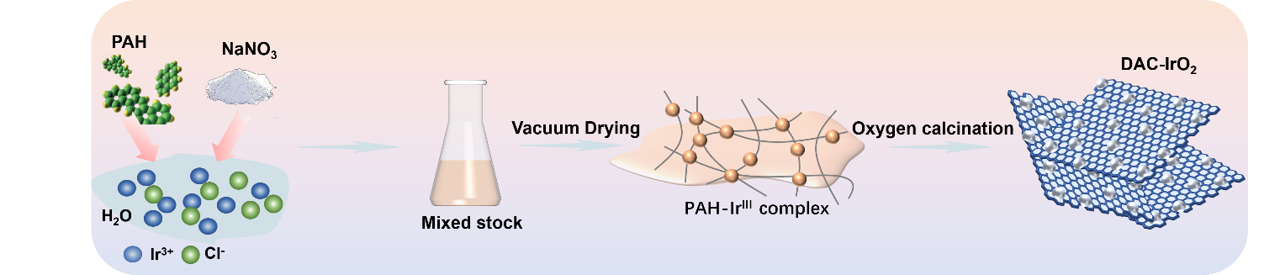
Fig. S1 Schematic illustration of the synthesis process for DAC-IrO₂

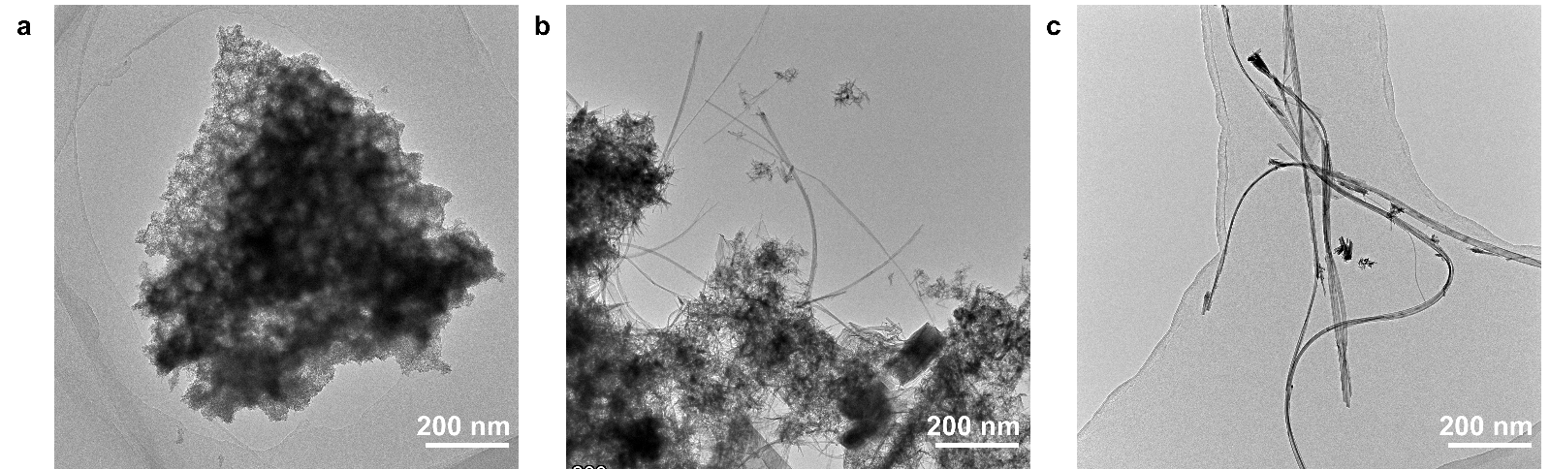
Fig. S2 SEM images of products obtained at different IrCl₃ to PAHs feed ratios (a) IrCl₃: PAHs=2:1, (b) IrCl₃: PAHs=1:1, (c) IrCl₃: PAHs=1:2.

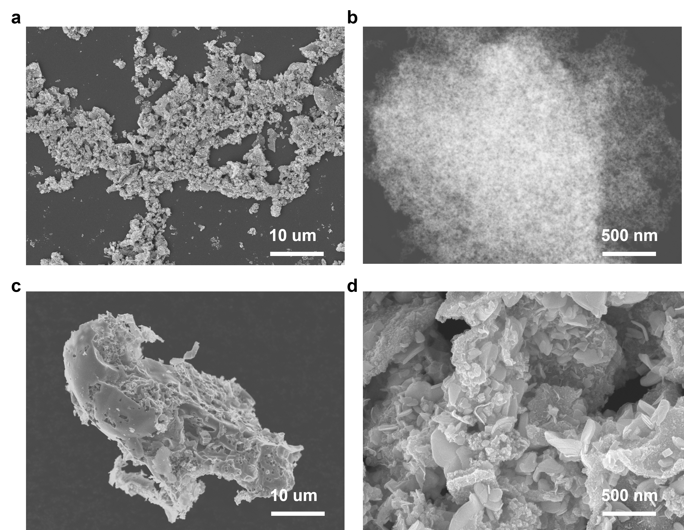
Fig. S3 SEM of (a-b) DAC-IrO₂, (c-d) IrO₂
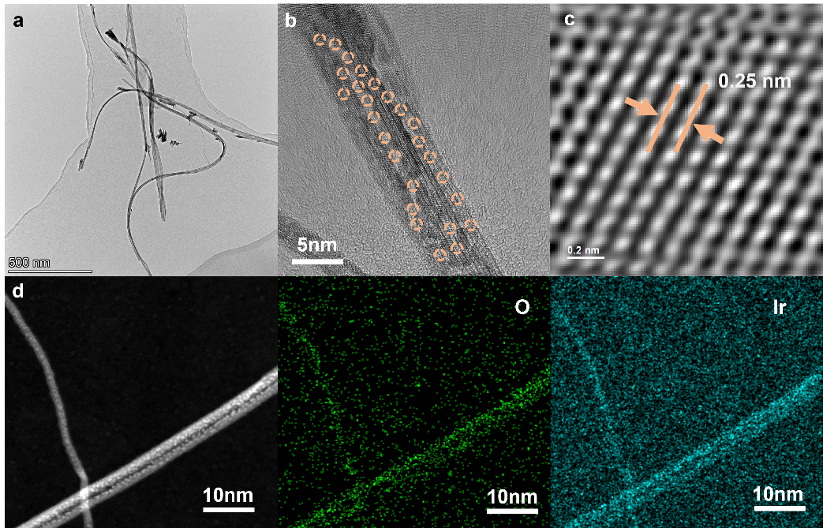
Fig. S4 (a-b) TEM image of IrO₂ nanowires (IrCl₃: PAHs=1:2), (c) HRTEM image with the measured spacing of IrO₂ nanowires. (d) HAADF-STEM images and corresponding EDX mapping.

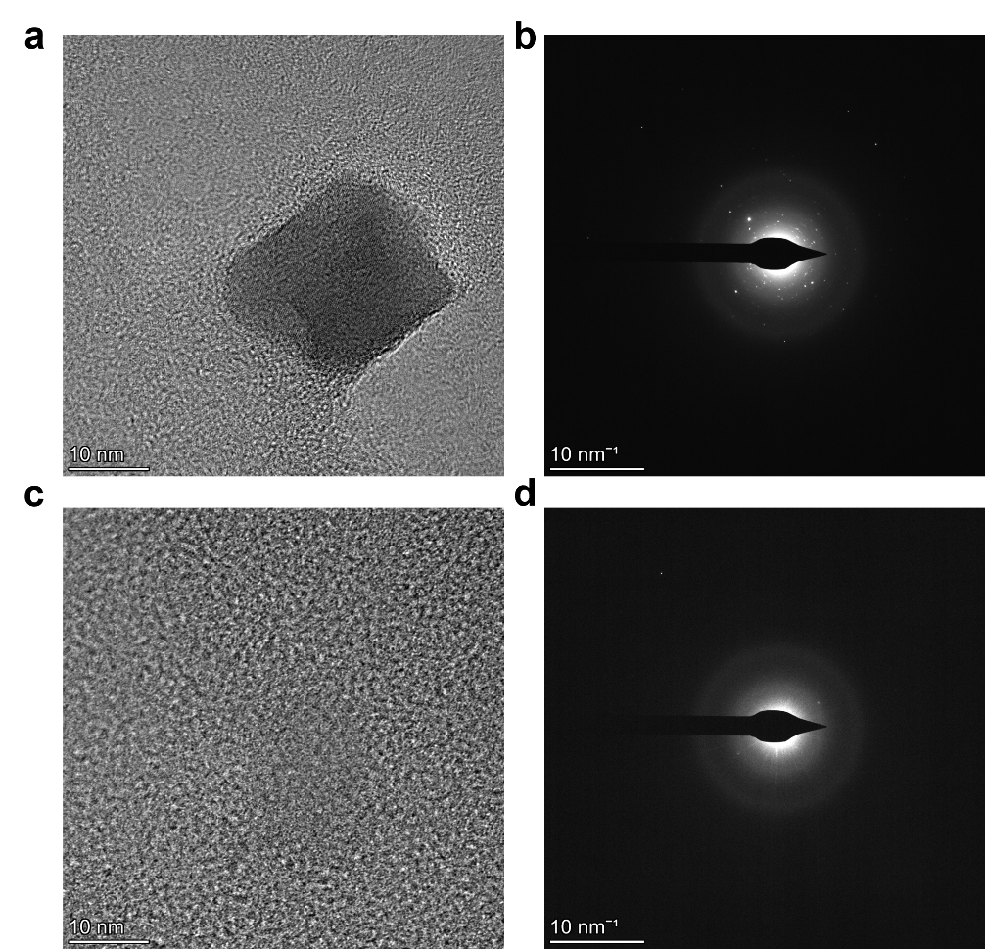
Fig. S5 (a) HRTEM image of crystalline nanoparticles loaded in an amorphous matrix; (b) corresponding selected area electron diffraction (SAED) map. (c-d) HRTEM image of the amorphous matrix and SAED map.

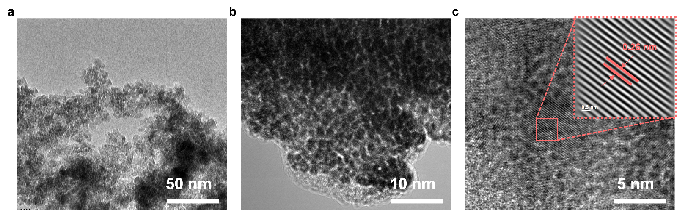
Fig. S6 TEM image of IrO₂.
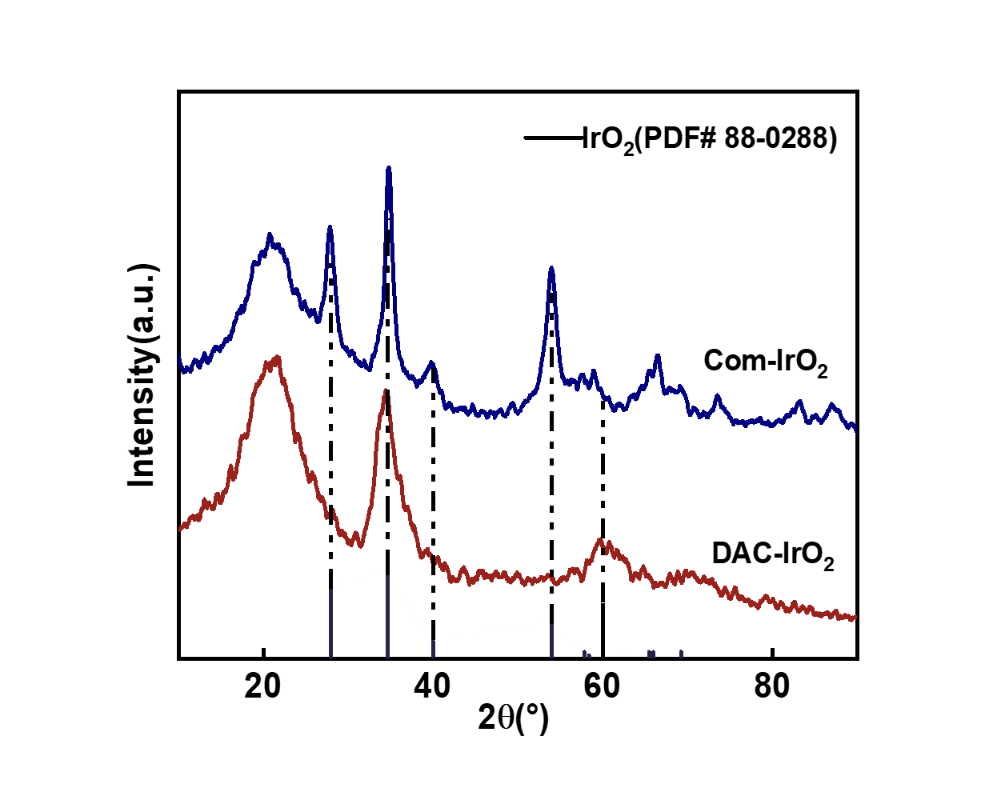
Fig. S7 XRD patterns of DAC-IrO₂ and commercial IrO₂.

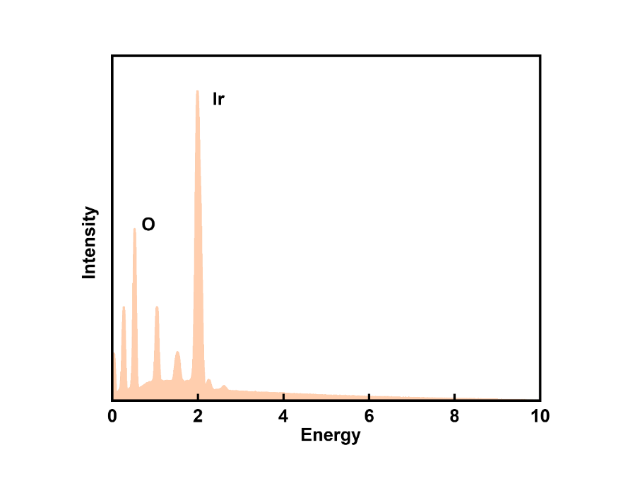
Fig. S8 EDX spectra of DAC-IrO₂ catalyst.

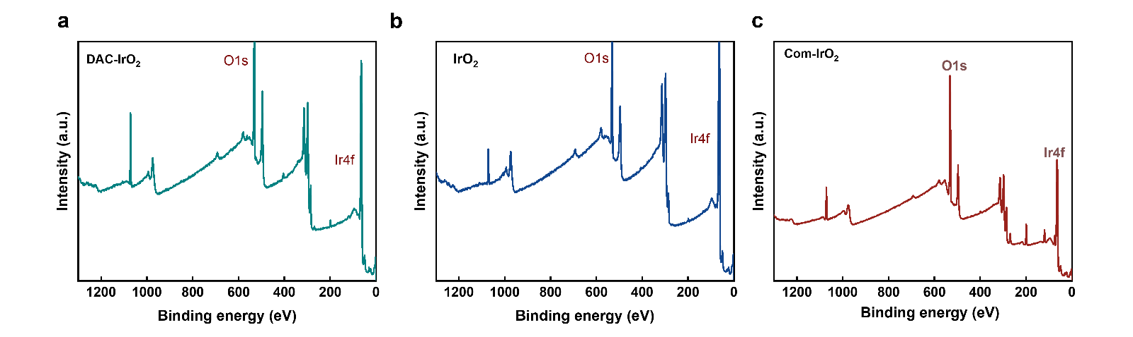
Fig. S9 XPS survey spectra.

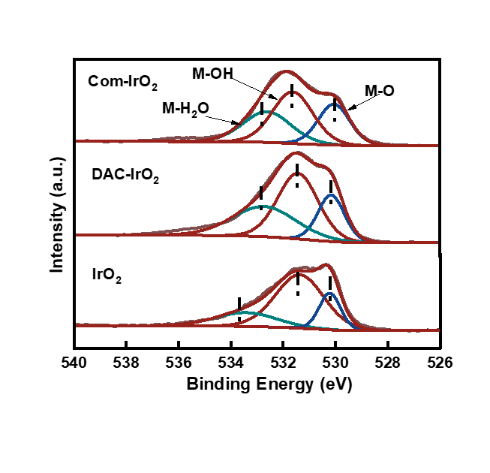
Fig. S10 The high-resolution of O 1s spectra.

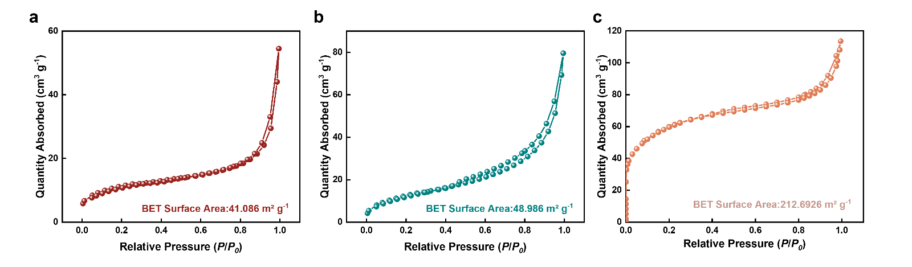
Fig. S11 N₂ isothermal adsorption curves of (a) IrO₂, (b) Com-IrO₂, (c) DAC-IrO₂

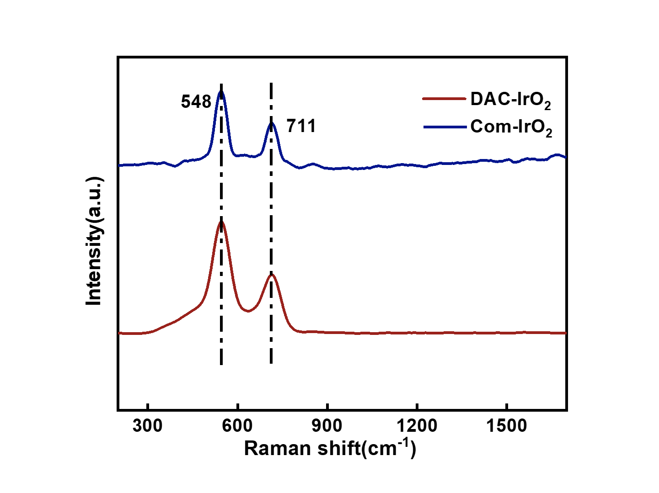
Fig. S12 Comparison of Raman spectra of different catalysts.

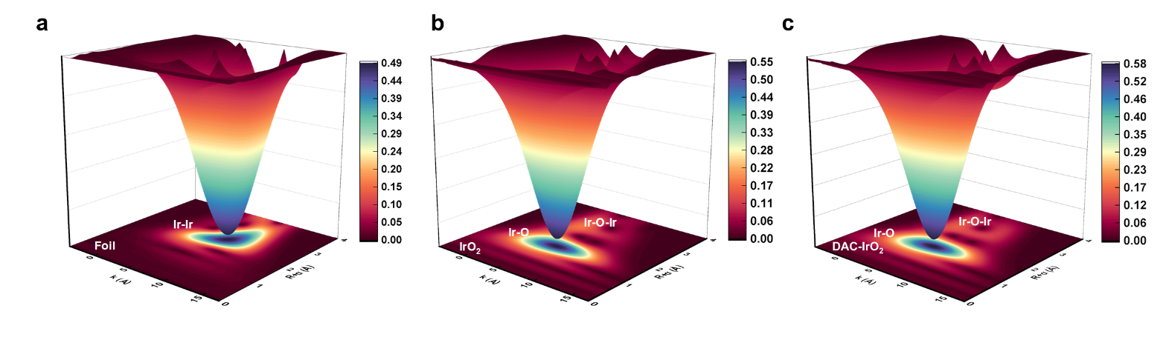
Fig. S13 Wavelet transformation EXAFS of (a) Ir foil, (b) IrO₂, (c) DAC-IrO₂.

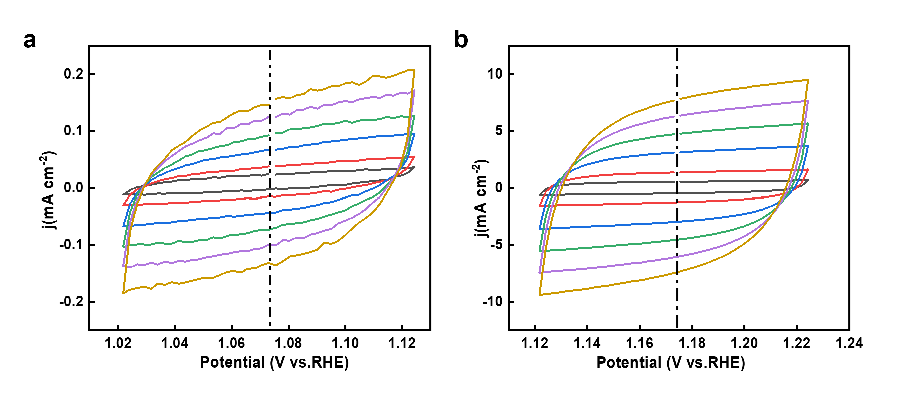
Fig. S14 (a) Com-IrO₂, (b) DAC-IrO₂’s CVs recorded in a non-faraday region of different catalysts for OER.

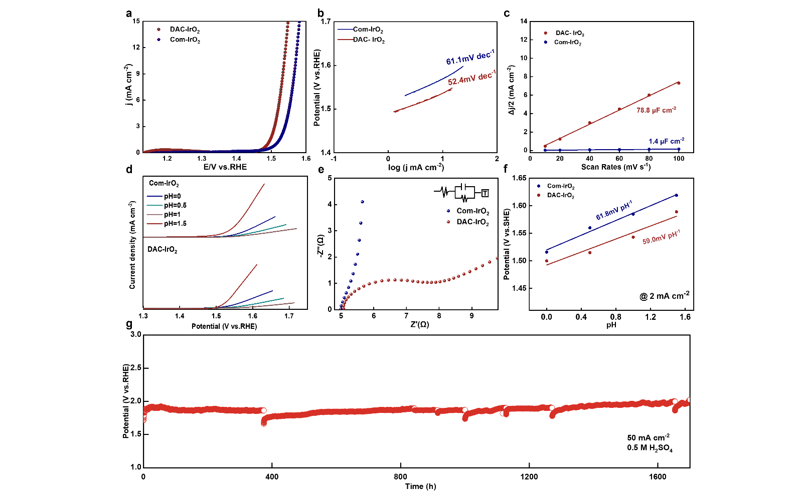
Fig. S15 (a) The polarization curves toward OER in the presence of DAC-IrO₂ and commercial IrO₂ in 0.5 M H₂SO₄. (b)Tafel slopes of DAC-IrO₂ and commercial IrO₂. (c) C_{dl} curves by plotting current density versus scan rate. (d) The polarization curves for OER of DAC-IrO₂ and commercial IrO₂ in H₂SO₄ electrolyte with different pH. (e) EIS was recorded at a geometric current density of 10 mA cm⁻². (f) pH dependence of DAC-IrO₂ and commercial IrO₂ on the OER potential on the SHE scales. (g) Chronopotentiometry curves for DAC-IrO₂ and commercial IrO₂ in 0.5 M H₂SO₄ in 50 mA cm⁻².

The electrochemical performance of the DAC-IrO₂ catalyst was evaluated in 0.5 M H₂SO₄ using a conventional three-electrode system. DAC-IrO₂ exhibits an overpotential of 289 mV at 10 mA cm⁻², superior to that of commercial IrO₂ (340 mV) (Fig. S15a). To further elucidate the catalytic mechanism, the oxygen evolution reaction (OER) activities of both DAC-IrO₂ and commercial IrO₂ were examined in H₂SO₄ electrolytes with varying pH levels (Fig. S15d). When referenced to the standard hydrogen electrode (SHE), the activity shows a distinct pH dependence within the range of 0 to 1.5. The potential-pH dependence for DAC-IrO₂ is 59.0 mV pH⁻¹, which is close to the value observed for commercial IrO₂ (~61.8 mV pH ⁻¹). This near-Nernstian slope of approximately 60 mV pH ⁻¹ suggests a proton-coupled electron transfer (PCET) process⁸. Moreover, the OER mechanism on Ir sites is consistent with the conventional adsorbate evolution mechanism (AEM) ⁸ (Fig. S15f). The durability of DAC-IrO₂ was assessed under constant-current operation at 50 mA cm⁻², demonstrating exceptional stability for over 1700 hours (Fig. S15g).
The Tafel slope of DAC-IrO₂ was determined to be 52.4 mV dec⁻¹, which is lower than those of commercial IrO₂ (61.1 mV dec⁻¹) (Fig. S15b), indicating enhanced interfacial charge-transfer kinetics and optimized adsorption behavior of reaction intermediates during the oxygen evolution process. The electrochemical active surface area (ECSA) was estimated from double-layer capacitance (C_{dl}) measurements based on cyclic voltammetry (CV) (Fig. S4). The C_{dl} value of DAC-IrO₂ (78.8 mF cm⁻²) and commercial IrO₂ (1.4 mF cm⁻²) (Fig. S15c), suggesting a larger ECSA and consequently more accessible active sites, which contribute to its superior acidic OER performance.
To further probe the reaction kinetics and interfacial charge-transfer properties, electrochemical impedance spectroscopy (EIS) was conducted. The Nyquist plots were fitted with an equivalent circuit model to extract the charge transfer resistance (R_{ct}). The R_{ct} value of DAC-IrO₂ (2.9 Ω) is markedly lower than commercial IrO₂ (135.3 Ω) (Table S2; Fig. S15e), demonstrating significantly accelerated electron transfer kinetics in the DAC-IrO₂ catalyst.

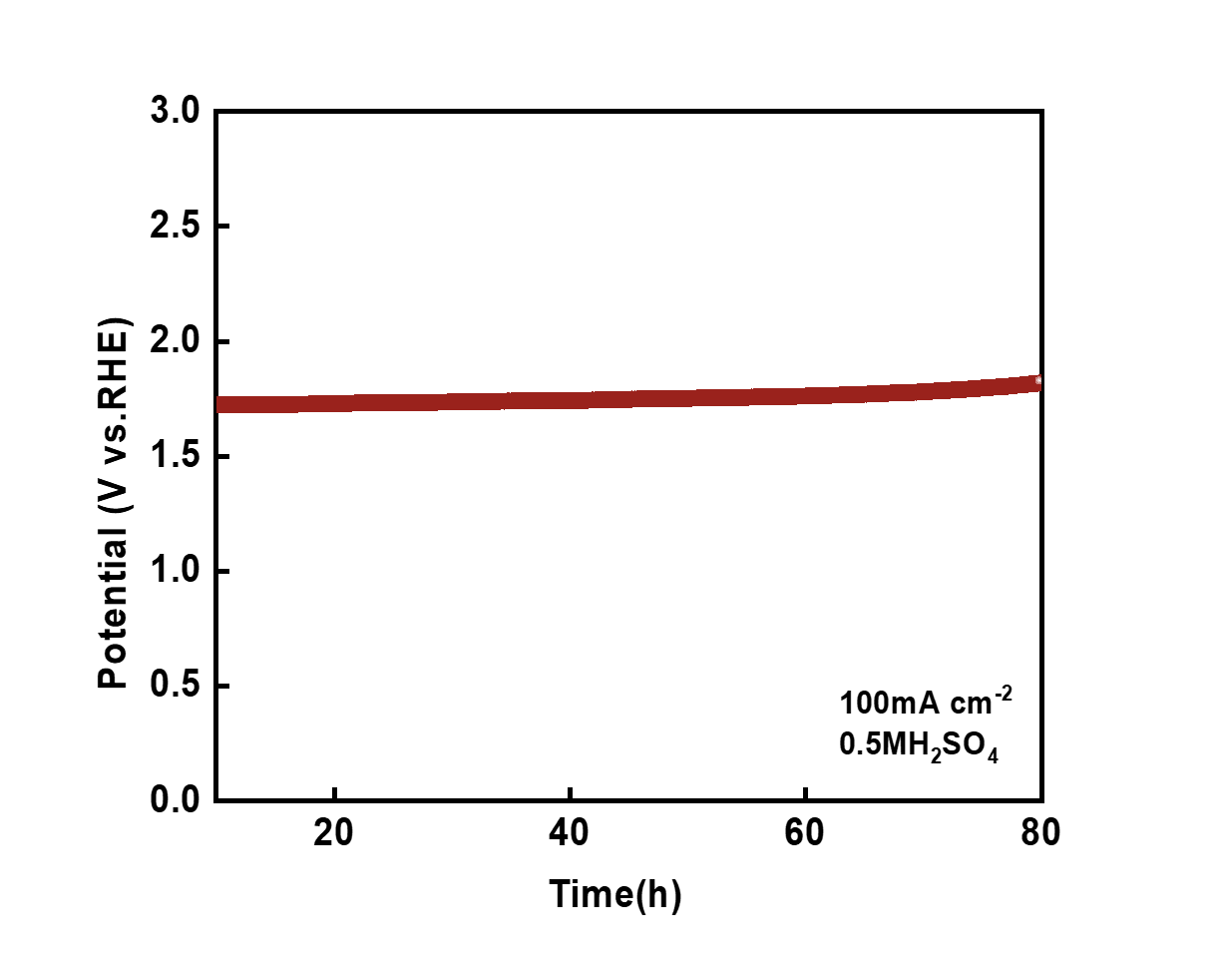
Fig. S16 Chronopotentiometry curves for DAC-IrO₂ in 0.5 M H₂SO₄ in 100 mA cm⁻².
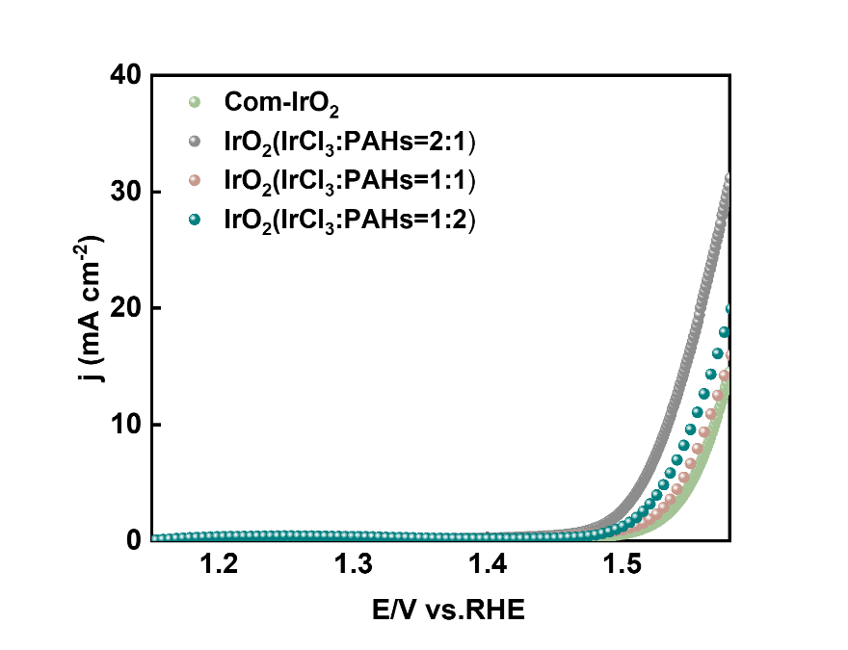
Fig. S17 The polarization curves of products obtained at different IrCl₃ to PAHs feed ratios

The catalyst’s morphology can be regulated by adjusting the IrCl₃ to PAHs feed ratios, and DAC-IrO₂ synthesized at IrCl₃: PAHs=2:1 exhibits a Cotton-like structure showing optimal performance.

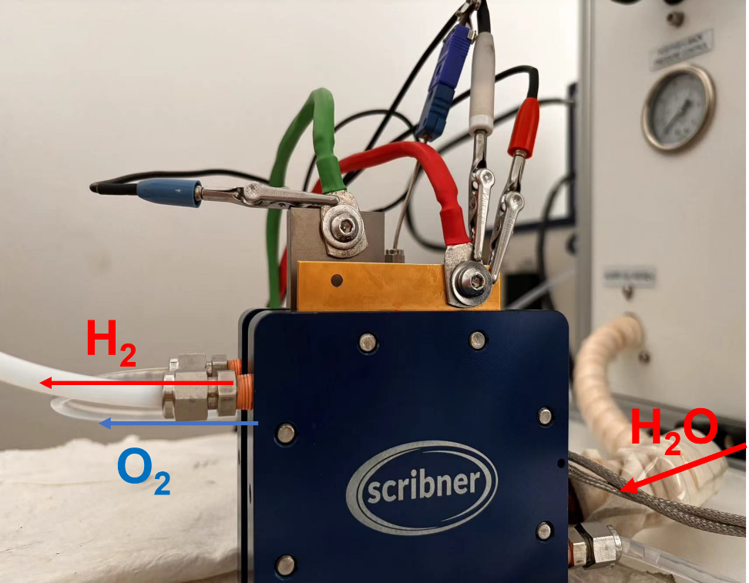
Fig. S18 Photograph of the PEMWE test setup.

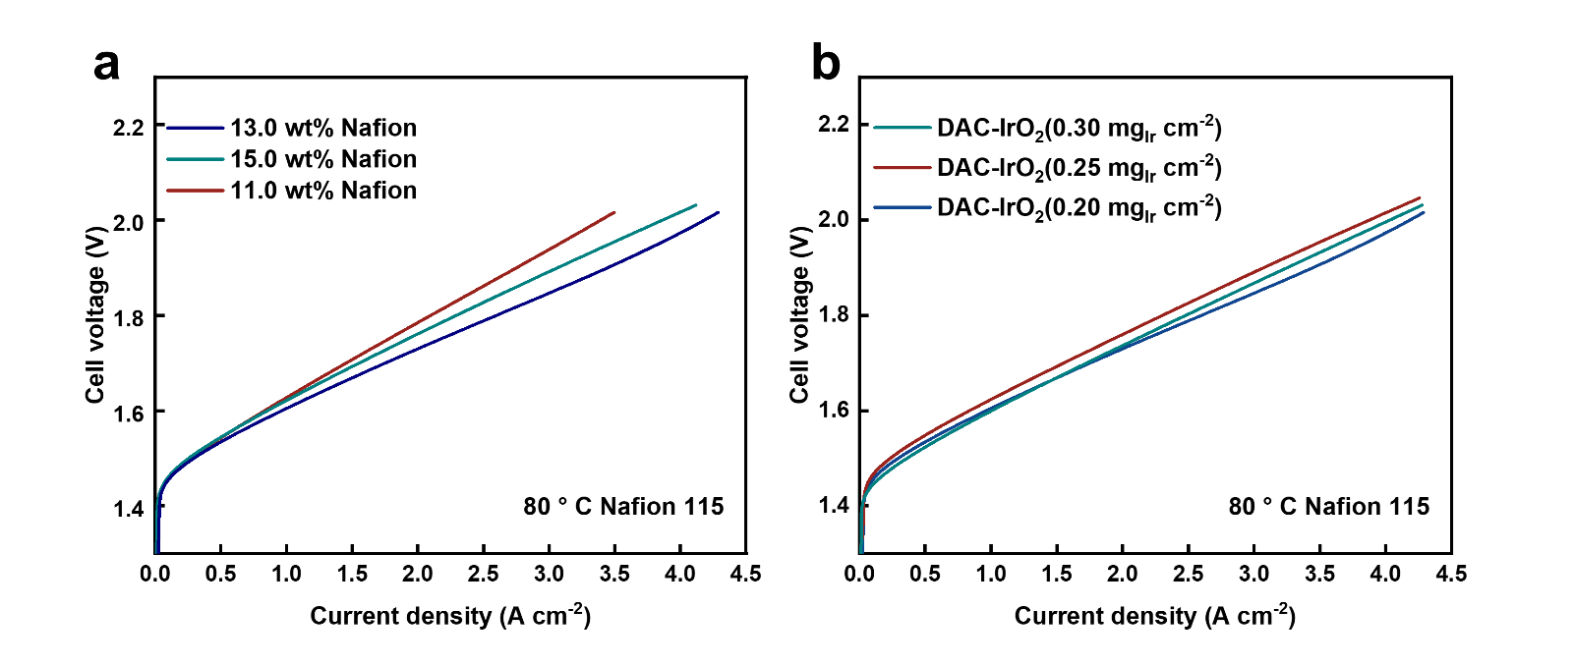
Fig. S19 (a) Polarization curves of PEMWE using different ionomer content (11.0 wt%-15.0 wt%) at the anode. (b) Polarization curves of PEMWE using different catalyst loadings (0.20-0.30 mg_{Ir} cm⁻²) of DAC-IrO₂ at the anode.

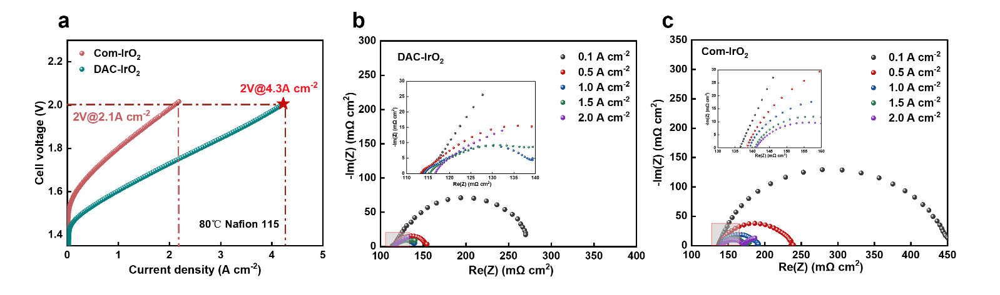
Fig. S20 (a) Polarization curves of PEMWE using Nafion 115 membranous. EIS curves of PEMWEs using (b) DAC-IrO₂ and (c) Com-IrO₂.

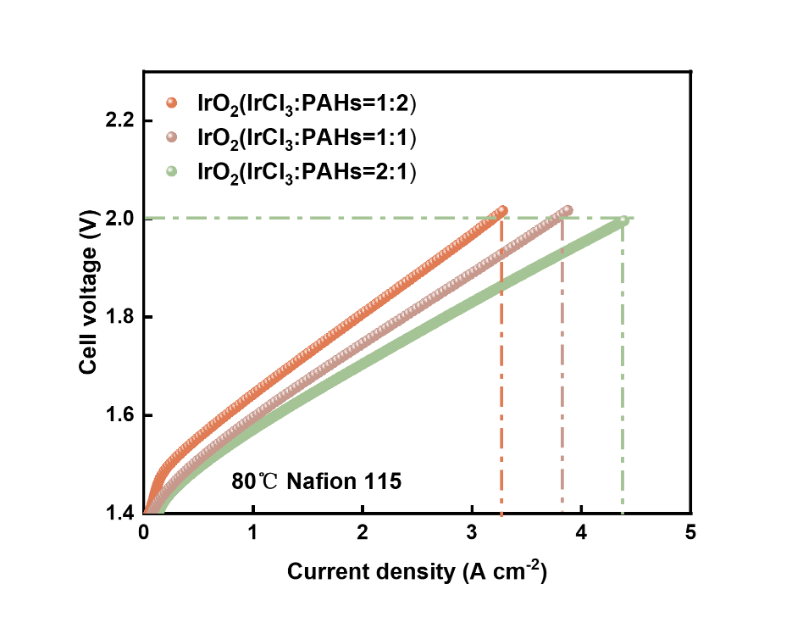
Fig. S21 Polarization curves of PEMWE of products obtained at different IrCl₃ to PAHs feed ratios.

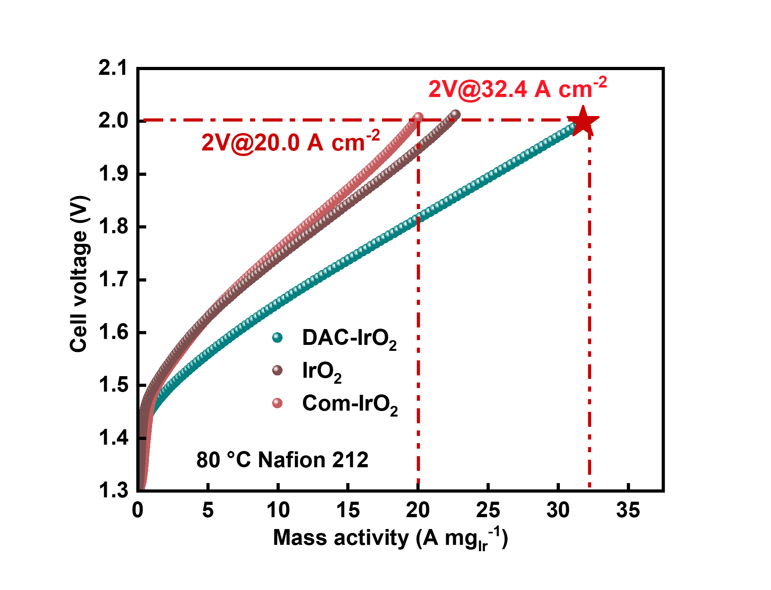
Fig. S22 Polarization curves of PEMWE normalized to Ir loadings.

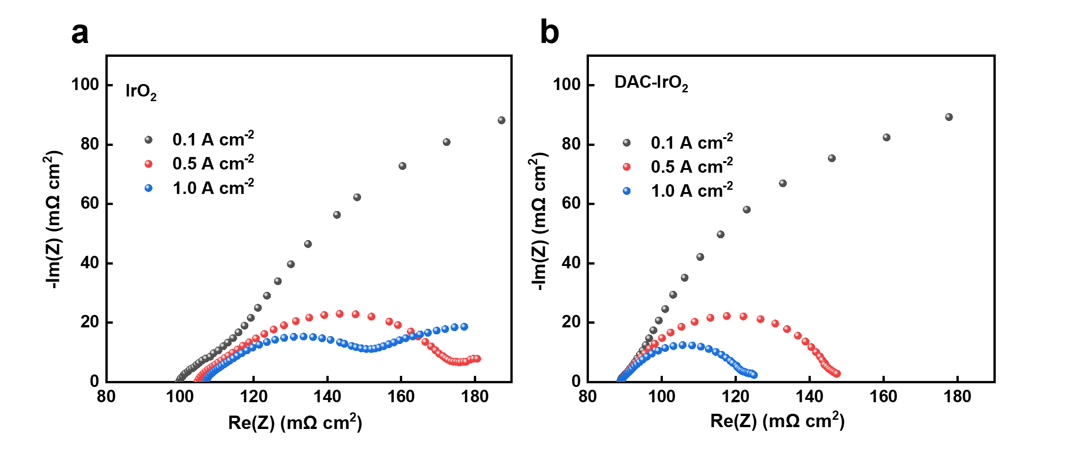
Fig. S23 Nyquist plots of (a) IrO₂ and (b) DAC-IrO₂ in Nafion 212 membrane

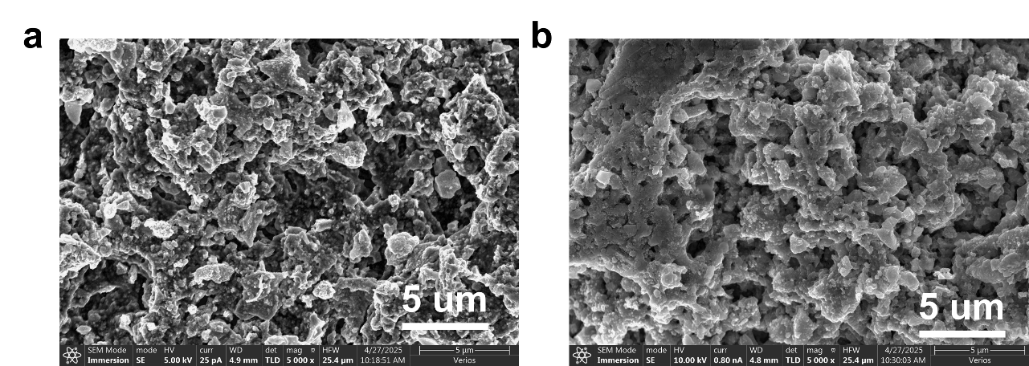
Fig. S24 SEM images of (a) N115 membrane catalyst layer before stability testing and (b) N115 membrane catalyst layer after stability testing.

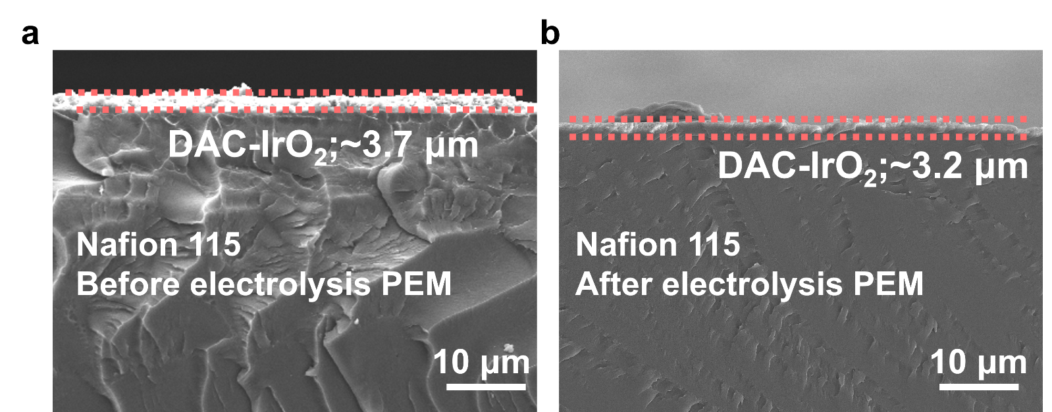
Fig. S25 Cross-sectional SEM images of CCM before and after 3400 h PEMWE operation.

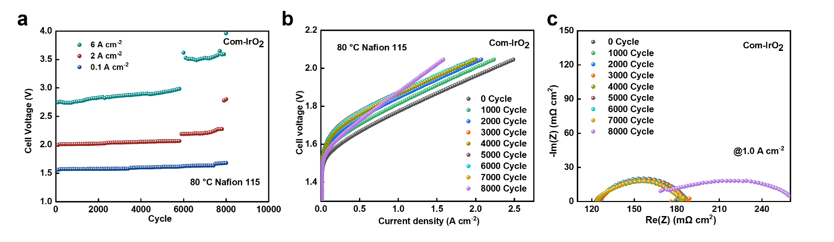
Fig. S26 (a)Voltage analysis at each current density for different AST cycles of Com-IrO₂. (b) Polarization curves of Com- IrO₂. (c) Nyquist plots of Com-IrO₂.

Table. S1 ICP of DAC-IrO₂.
Sample | Sample mass m₀ (g) | Volume V₀ (mL) | Elemental concentration of test solution C_{o} (mg/L) | Dilution f | Sample element content C_{x} (mg/kg) | Sample element content W (%)
IrO₂ | 0.0206 | 25 | 3.930 | 100 | 476263.424 | 47.63%
DAC-IrO₂ | 0.0193 | 25 | 2.568 | 100 | 333372.455 | 33.34%
Table S2. EXAFS data fitting results of the IrO₂ and the DAC-IrO₂ catalysts.

System | bond | CN | R (Å) | σ² (Å²)*10⁻³ | ΔE₀ (eV) | R factor (%)
Ir Foil | Ir-Ir | 12* | 2.71±0.01 | 2.2±0.7 | 9.0±0.8 | 0.4
IrO₂ | Ir-O | 5.7±0.6 | 1.98±0.01 | 3.1±1.4 | 5.7±0.6 | 0.5
DAC-IrO₂ | Ir-O | 6.0±0.8 | 2.00±0.01 | 2.6±1.9 | 11.3±1.5 | 0.9
CN, coordinate number; R, distance between absorber and backscatter atoms; σ², Debye-Waller factor; ΔE₀, inner potential correction to account for the difference in the inner potential between the sample and the reference compound; R-Factor = a measure of the quality of the EXAFS fit.

Table. S3 EIS simulating parameters of equivalent circuit element for OER.

Samples | Rs(Ω) | Rct(Ω) | Chi squared
Com-IrO₂ | 4.72 | 135.3 | 9.68×10⁻⁴
DAC-IrO₂ | 4.97 | 2.9 | 3.51×10⁻⁴

Table. S4 The comparison of ohmic resistance, activation resistance, and diffusion resistance for PEMWEs using IrO₂ and DAC-IrO₂ anodes.
Samples | R_{cell} (mΩ cm⁻²) | R_{ac} (mΩ cm⁻²) | R_{d} (mΩ cm⁻²)
IrO₂ | 100.12 | 58.12 | 0.25
DAC-IrO₂ | 89.19 | 15.23 | 0.02

Table. S5 The OER performances of different electrocatalysts in 0.5 M H₂SO₄ electrolyte.
Electrocatalysts | Overpotential  (mV@10 mA cm⁻²) | Stability | Reference
DAC-IrO₂ | 289 | 1700 h@50 mA cm⁻² | This work
IrRu NWs | 243 | 200 h@50 mA cm⁻² | ⁹
Ir-MnCo₂O_{4.5} | 238 | 700 h@20 mA cm⁻² | ¹⁰
Nb_{0.1}Ru_{0.9}O₂ | 204 | 100 h@10 mA cm⁻² | ¹¹
Ir-NiCo₂O₄NSs | 240* | 70 h@10 mA cm⁻² | ¹²
Ir/Nb₂O_{5-x} | 285 | 100 h@10 mA cm⁻² | ¹³
AuIr@CNT | 257 | 50 h@10 mA cm⁻² | ¹⁴
IrO_{x}-TiO₂-Ti | 200 | 110 h@10 mA cm⁻² | ¹⁵
IrRu@Te | 220 | 20 h@10 mA cm⁻² | ¹⁶
* Value calculated from curves shown in the respective reference.
Table. S6 Reported performances of PEMWE anode catalysts and corresponding parameters.
Catalysis | Membrane | Activity (A cm⁻²@1.8 V) | Stability | Reference
DAC-IrO₂ | 212 | 4.0 A cm⁻² | 3400 h @ 3 A cm⁻² | This work
(IrRu)O₂/C | 212 | 3.5 A cm⁻² | 250 h @ 1 A cm⁻² | ¹⁷
ICM_{activated} | 212 | 2.0 A cm⁻² | 400 h @ 1 A cm⁻² | ¹⁸
NbO_{0.05}Ir_{0.95}O₂ | 211 | 1.5 A cm⁻² | 1200 h @ 1.7V | ¹⁹
Ir/MnO_{x} | 117 | 2 A cm⁻² | 300 h @ 1 A cm⁻² | ²⁰
Ir-Mn IMC | 212 | 2.7 A cm⁻² | 2000 h @ 2 A cm⁻² | ²¹
Ir₇₅Ru₂₅ | 212 | 4.3 A cm⁻² | 500 h @ 1 A cm⁻² | ²²
i-Ir/TiO₂ | 212 | 4.0 A cm⁻² | 420 h @ 2 A cm⁻² | ²³
Ir-3MA | _ | 2.5 A cm⁻² | 1200 h @ 0.5 A cm⁻² | ²⁴
* Value calculated from curves shown in the respective reference.
References
(1) Wang, X.; Wang, J.; Yu, B.; Jiang, W.; Wei, J.; Chen, B.; Xu, R.; Yang, L. Facile synthesis MnCo₂O_{4. 5}@ C nanospheres modifying PbO₂ energy-saving electrode for zinc electrowinning. Journal of Hazardous Materials 2022, 428, 128212.
(2) Feng, S.; Wang, J.; Wang, W.; Wang, X.; Zhang, Y.; Chenchen; Ju, A.; Pan, J.; Xu, R. The Ni‐Mo‐S Catalyst@ Copper Foams with Excellent Stability and 1.5 V Drive Electrolytic Water. Advanced Materials Interfaces 2021, 8 (24), 2100500.
(3) Wang, X.; Wang, J.; Jiang, W.; Chen, C.; Yu, B.; Xu, R. Facile synthesis MnCo₂O₄ modifying PbO₂ composite electrode with enhanced OER electrocatalytic activity for zinc electrowinning. Separation and Purification Technology 2021, 272, 118916.
(4) Kresse, G.; Furthmüller, J. Efficiency of ab-initio total energy calculations for metals and semiconductors using a plane-wave basis set. Computational materials science 1996, 6 (1), 15–50.
(5) Perdew, J. P.; Burke, K.; Ernzerhof, M. Generalized gradient approximation made simple. Physical review letters 1996, 77 (18), 3865.
(6) Grimme, S.; Antony, J.; Ehrlich, S.; Krieg, H. A consistent and accurate ab initio parametrization of density functional dispersion correction (DFT-D) for the 94 elements H-Pu. The Journal of chemical physics 2010, 132 (15).
(7) Monkhorst, H. J.; Pack, J. D. Special points for Brillouin-zone integrations. Physical review B 1976, 13 (12), 5188.
(8) Wang, Y.; Zhang, M.; Kang, Z.; Shi, L.; Shen, Y.; Tian, B.; Zou, Y.; Chen, H.; Zou, X. Nano-metal diborides-supported anode catalyst with strongly coupled TaO(x)/IrO(2) catalytic layer for low-iridium-loading proton exchange membrane electrolyzer. Nat Commun 2023, 14 (1), 5119. DOI: 10.1038/s41467-023-40912-8.
(9) Pang, B.; Feng, S.; Xu, Y.; Chen, H.; Li, J.; Yuan, Y.; Zou, X.; Tian, X.; Kang, Z. Ru Doped Ir Nanowires for High‐Efficient and Durable Proton Exchange Membrane Water Electrolyzers. Advanced Functional Materials 2024, 34 (52), 2411062.
(10) Hua, K.; Li, X.; Rui, Z.; Duan, X.; Wu, Y.; Yang, D.; Li, J.; Liu, J. Integrating atomically dispersed ir sites in MnCo₂O_{4. 5} for highly stable acidic oxygen evolution reaction. ACS Catalysis 2024, 14 (5), 3712–3724.
(11) Liu, H.; Zhang, Z.; Fang, J.; Li, M.; Sendeku, M. G.; Wang, X.; Wu, H.; Li, Y.; Ge, J.; Zhuang, Z. Eliminating over-oxidation of ruthenium oxides by niobium for highly stable electrocatalytic oxygen evolution in acidic media. Joule 2023, 7 (3), 558–573.
(12) Yin, J.; Jin, J.; Lu, M.; Huang, B.; Zhang, H.; Peng, Y.; Xi, P.; Yan, C.-H. Iridium single atoms coupling with oxygen vacancies boosts oxygen evolution reaction in acid media. Journal of the American Chemical Society 2020, 142 (43), 18378–18386.
(13) Shi, Z.; Li, J.; Jiang, J.; Wang, Y.; Wang, X.; Li, Y.; Yang, L.; Chu, Y.; Bai, J.; Yang, J. Enhanced acidic water oxidation by dynamic migration of oxygen species at the Ir/Nb₂O_{5− x} catalyst/support interfaces. Angewandte Chemie International Edition 2022, 61 (52), e202212341.
(14) Hu, H.; Kazim, F. M.; Ye, Z.; Xie, Y.; Zhang, Q.; Qu, K.; Xu, J.; Cai, W.; Xiao, S.; Yang, Z. Electronically delocalized Ir enables efficient and stable acidic water splitting. Journal of Materials Chemistry A 2020, 8 (38), 20168–20174.
(15) Cheng, J.; Yang, J.; Kitano, S.; Juhasz, G.; Higashi, M.; Sadakiyo, M.; Kato, K.; Yoshioka, S.; Sugiyama, T.; Yamauchi, M. Impact of Ir-valence control and surface nanostructure on oxygen evolution reaction over a highly efficient Ir–TiO₂ nanorod catalyst. ACS catalysis 2019, 9 (8), 6974–6986.
(16) Yu, Z.; Si, C.; LaGrow, A. P.; Tai, Z.; Caliebe, W. A.; Tayal, A.; Sampaio, M. J.; Sousa, J. P.; Amorim, I.; Araujo, A. Iridium–iron diatomic active sites for efficient bifunctional oxygen electrocatalysis. ACS Catalysis 2022, 12 (15), 9397–9409.
(17) Park, Y.; Jang, H. Y.; Lee, T. K.; Kim, T.; Kim, D.; Kim, D.; Baik, H.; Choi, J.; Kwon, T.; Yoo, S. J. Atomic-level Ru-Ir mixing in rutile-type (RuIr) O2 for efficient and durable oxygen evolution catalysis. Nature Communications 2025, 16 (1), 1–15.
(18) Ko, W.; Shim, J.; Ahn, H.; Kwon, H. J.; Lee, K.; Jung, Y.; Antink, W. H.; Lee, C. W.; Heo, S.; Lee, S. Controlled Structural Activation of Iridium Single Atom Catalyst for High-Performance Proton Exchange Membrane Water Electrolysis. Journal of the American Chemical Society 2025, 147(3), 2369-2379.
(19) Ke, J.; Zhu, W.; Ji, Y.; Chen, J.; Li, C.; Wang, Y.; Wang, Q.; Huang, W.-H.; Hu, Z.; Li, Y. Optimizing Acidic Oxygen Evolution Reaction via Modulation Doping in Van der Waals Layered Iridium Oxide. Angewandte Chemie, e202422740.
(20) Wang, D.; Lin, F.; Luo, H.; Zhou, J.; Zhang, W.; Li, L.; Wei, Y.; Zhang, Q.; Gu, L.; Wang, Y. Ir-O-Mn embedded in porous nanosheets enhances charge transfer in low-iridium PEM electrolyzers. Nature Communications 2025, 16 (1), 181.
(21) Wang, S.; Shi, Y.; Shen, T.; Wang, G.; Sun, Y.; Wang, G.; Xiao, L.; Yan, C.; Wang, C.; Liu, H. Strong Heteroatomic Bond‐Induced Confined Restructuring on Ir‐Mn Intermetallics Enable Robust PEM Water Electrolyzers. Angewandte Chemie 2025, e202420470.
(22) Huynh, T. N.; Song, J.; Bae, H. E.; Sung, Y. E.; Kim, M. J.; Kwon, O. J. Enhancing Proton Exchange Membrane Water Electrolysis with a Checkered Carbon Matrix Containing Ir‐Ru Nanoparticles. Advanced Energy Materials 2024, 2402179.
(23) Li, Y.; Zhao, G.; Zuo, S.; Wen, L.; Liu, Q.; Zou, C.; Ren, Y.; Kobayashi, Y.; Tao, H.; Luan, D. Integrating Interactive Ir Atoms into Titanium Oxide Lattice for Proton Exchange Membrane Electrolysis. Advanced Materials 2024, 2407386.
(24) Liang, J.; Fu, C.; Hwang, S.; Dun, C.; Luo, L.; Shadike, Z.; Shen, S.; Zhang, J.; Xu, H.; Wu, G. Constructing Highly Porous Low Iridium Anode Catalysts Via Dealloying for Proton Exchange Membrane Water Electrolyzers. Advanced Materials 2024, 2409386.

