[Submitted to Scientific Reports]
Support Information

Hydrological Conditions Regulate Dissolved Organic Matter Composition and Molecular Weight in the Aquatic Continuum of a Large Freshwater Lake on the Qinghai-Tibet Plateau

Authors
Yuqin Wang^{1, 2, 3}, Junchuan Huang^{1*}, Pei Liu¹, Jianxun Cui¹, Xiaomei Cui⁴, Min Zhang^{1**}, Wangchuan Guo¹, Jungui Zhang¹, Congxin Yang¹
Affiliations
¹Research Center of Applied Geology of China Geological Survey, Chengdu 610036, China.
²College of Resources and Environment, Southwest University, Chongqing Key Laboratory of Agricultural Resources and Environment, Chongqing 400716, China.
³Middle Yarlung Zangbo River Natural Resources Observation and Research Station of Xizang Autonomous Region, Lhasa 850013, China.
⁴School of Ecology and Environment, Xizang University, Lhasa 850000, China.
Corresponding authors
*Junchuan Huang; E-mail address: hjunchuan@mail.cgs.gov.cn
**Min Zhang; E-mail address: minzhang1989@163.com

Support Information Contents
Total 2 Tables and 9 Figures
Tables
Table S1. Description of parameters for water chemistry. PAGE 4
Table S2. Summary of DOM molecular weight identified by HPLC-SEC. PAGE 5

Figures
Fig. S1. Values of DOC concentration and DOM parameters of UV-Vis absorbance. PAGE 6
Fig. S2. Values of DOM parameters of fluorescencent spectra. PAGE 7
Fig. S3. The mean relative abundances of assigned formulae numbers and identified molecular compounds in all collected samples in the aquatic continuum of Cuona lake. PAGE 8
Fig. S4. The mean relative abundance of molecular element compounds as defected by FT-ICR MS in all collected samples. PAGE 9
Fig. S5. The values of modified aromaticity index (AI_{mod}) in all collected samples. PAGE 10
Fig. S6. The value of nominal oxidation state of carbon (NOSC) in all collected samples identified by FT-ICR MS. PAGE 11
Fig. S7. The DOM saturation divided by the H/C and O/C values. PAGE 12
Fig. S8. The distribution of DOC concentration, DOM molecular weight, aromaticity and CDOM in Cuona lake, Cuojia lake, and Ganong Ma. PAGE 13
Fig. S9. DOM molecular variation along the Cuona Continuum, including processes of during inflow (Cuojia to Cuona Lake) (a), Rivers to Cuona Lake (b), and during outflow (Cuona Lake to Ganong Ma Lake) (c) of molecular compositions as identified by FT-ICR MS. PAGE 14

Tables
Table S1. Description of parameters for water chemistry (Mean ± SD values)
Sampling sites | Water type | pH | TDS  (mg L⁻¹) | DO  (mg L⁻¹) | Cl⁻  (mg L⁻¹) | HCO₃⁻  (mg L⁻¹)
CN | lake | 8.11±0.16 | 556.29±88.27 | 5.12±0.88 | 12.55±3.41 | 220.5±50.68
CJ | inflow lake | 8.72±0.24 | 687.5±30.42 | 8.46±1.08 | 12.33±1.55 | 218.33±16.8
BSQ | inflow river | 7.95±0.09 | 466.75±22.41 | 7.81±1..13 | 3.30±0.71 | 252.0±62.22
ZGQG | inflow river | 7.98±0.35 | 769.25±40.53 | 9.19±0.41 | 6.21±0.22 | 277.5±71.41
SQ | inflow river | 7.93±0.21 | 467.67±22.4 | 6.61±0.11 | 2.90±0.03 | 211±15.31
GN | outflow lake | 8.31±0.05 | 510.75±68.21 | 6.60±0.17 | 13.95±0.78 | 196±9.89
CN: Cuona Lake; CJ: Cuojia Lake; BSQ: BasoQu; ZGQG: Zhuogeiqugang; SQ: SangQu; GN: Ganong Ma Lake; TDS:Total Dissolved Solids; DO: Dissolved Oxygen; Cl⁻: Chloride ion.

Table S2. Summary of parameters of DOM molecular weight identified by HPLC-SEC
Sampling sites | Water type | M_{W} | M_{n} | M_{W}/M_{n} | < 5000 Da (%) | 5000-9570Da (%)
CN/S | CN lake | 3383 | 2852 | 1.19 | 90.46 | 9.48
CN/W | CN lake | 3314 | 2896 | 1.14 | 92.74 | 7.26
CN/E | CN lake | 3452 | 3255 | 1.06 | 97.97 | 2.03
CN/N | CN lake | 3595 | 3028 | 1.19 | 84.16 | 15.83
CN/M | CN lake | 3248 | 2965 | 1.10 | 98.31 | 1.69
CJ | inflow lake | 3440 | 2499 | 1.38 | 83.83 | 16.07
BSQ | inflow river | 4108 | 2983 | 1.38 | 68.67 | 31.02
SQ | inflow river | 4000 | 3516 | 1.14 | 77.13 | 22.87
ZGQG | inflow river | 3918 | 3198 | 1.23 | 75.48 | 24.47
WGQ | inflow river | 4052 | 3070 | 1.32 | 70.47 | 29.38
GN | outflow lake | 3739 | 3065 | 1.22 | 80.94 | 18.95
NQ | outflow river | 4053 | 3371 | 1.20 | 73.47 | 26.43
Sampling sites CN/S, CN/W, CN/E, CN/N, and CN/M were represented by five regions of Cuona Lake: east (CN/E), south (CN/S), west (CN/W), north (CN/N), and center (CN/M).
CN: Cuona Lake; CJ: Cuojia Lake; BSQ: BasoQu; ZGQG: Zhuogeiqugang; SQ: SangQu; GN: Ganong Ma Lake; WGQ: Wangga Qu; NQ: Nagqu River.

Figures
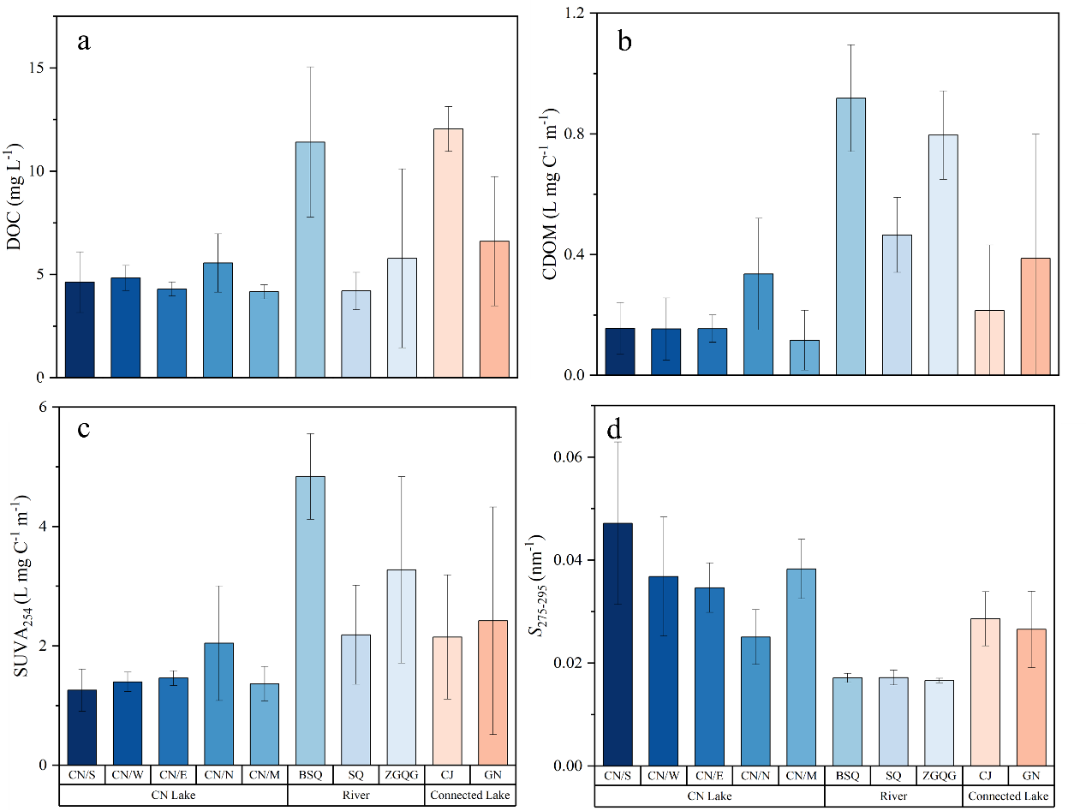
Fig. S1. Values of DOC concentration and DOM parameters of UV-Vis absorbance. Colors represent different sampling sites, and the whiskers represent standard deviation (SD) of each samples. Sampling sites CN/S, CN/W, CN/E, CN/N, and CN/M were represented by five regions of Cuona Lake: east (CN/E), south (CN/S), west (CN/W), north (CN/N), and center (CN/M). CN: Cuona Lake; CJ: Cuojia Lake; BSQ: BasoQu; ZGQG: Zhuogeiqugang; SQ: SangQu; GN: Ganong Ma Lake.

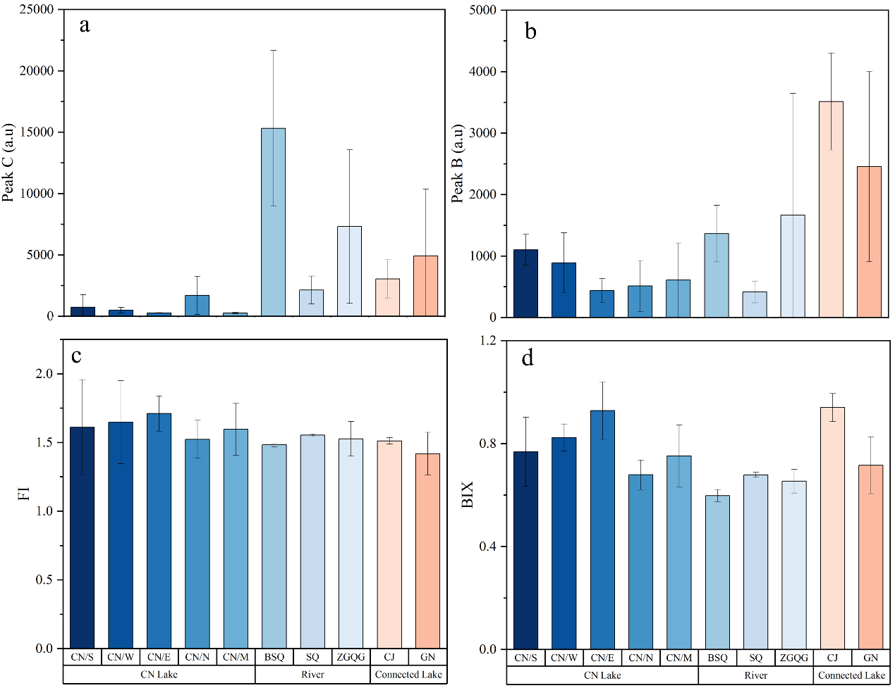
Fig. S2. Values of DOM parameters of fluorescence spectra. Colors represent different sampling sites, and the whiskers represent standard deviation (SD) of each samples. Sampling sites CN/S, CN/W, CN/E, CN/N, and CN/M were represented by five regions of Cuona Lake: east (CN/E), south (CN/S), west (CN/W), north (CN/N), and center (CN/M). CN: Cuona Lake; CJ: Cuojia Lake; BSQ: BasoQu; ZGQG: Zhuogeiqugang; SQ: SangQu; GN: Ganong Ma Lake.

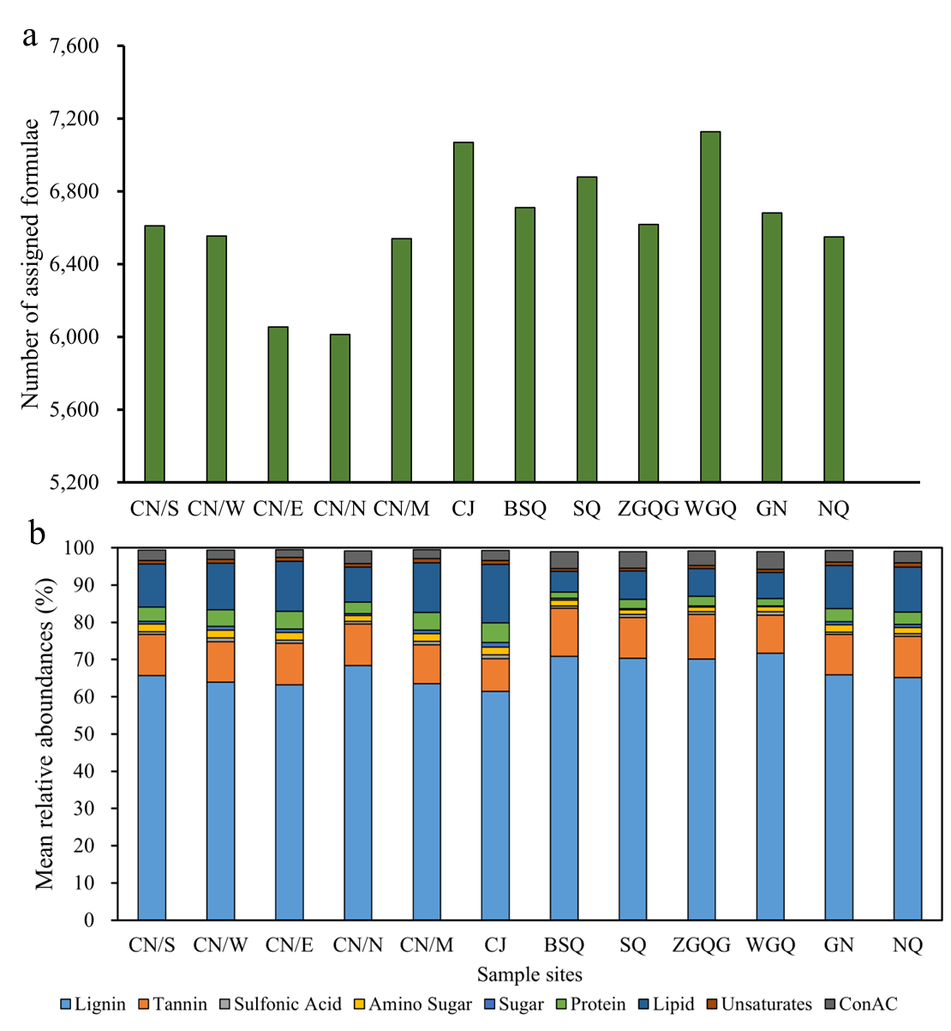
Fig. S3. The mean relative abundances of (a) numbers of assigned formulae and (b) identified molecular compounds as detected by FT-ICR MS in all collected samples in the aquatic continuum of Cuona lake. Sampling sites CN/S, CN/W, CN/E, CN/N, and CN/M were represented by five regions of Cuona Lake: east (CN/E), south (CN/S), west (CN/W), north (CN/N), and center (CN/M). CN: Cuona Lake; CJ: Cuojia Lake; BSQ: BasoQu; ZGQG: Zhuogeiqugang; SQ: SangQu; GN: Ganong Ma Lake; WGQ: Wangga Qu; NQ: Nagqu River.

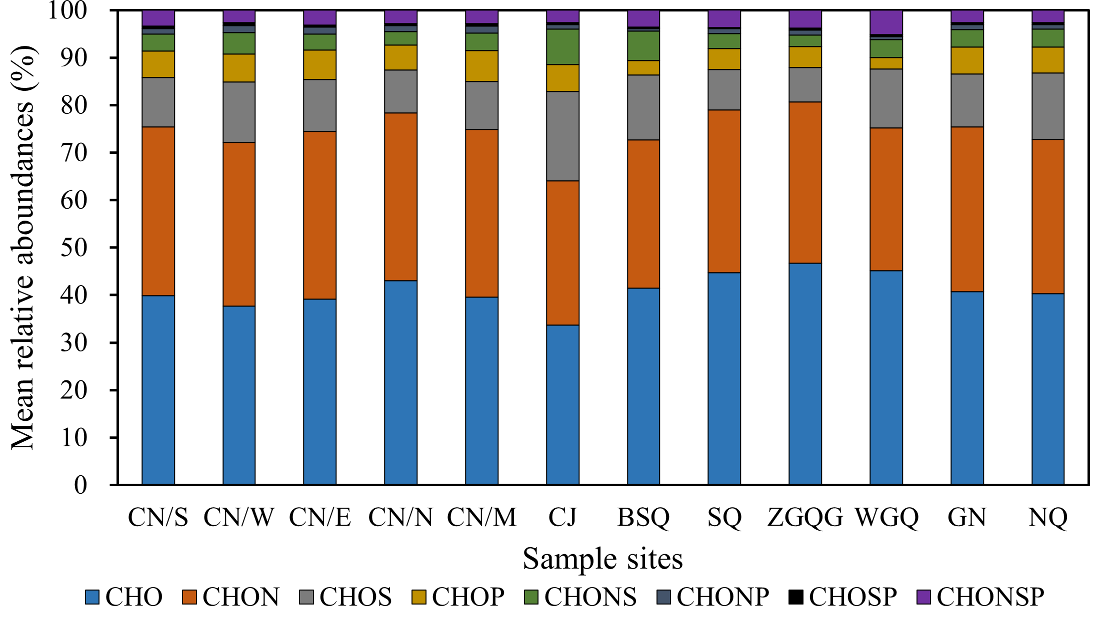
Fig. S4. The mean relative abundance of molecular element compounds as defected by FT-ICR MS of all collected samples. Sampling sites CN/S, CN/W, CN/E, CN/N, and CN/M were represented by five regions of Cuona Lake: east (CN/E), south (CN/S), west (CN/W), north (CN/N), and center (CN/M). CN: Cuona Lake; CJ: Cuojia Lake; BSQ: BasoQu; ZGQG: Zhuogeiqugang; SQ: SangQu; GN: Ganong Ma Lake; WGQ: Wangga Qu; NQ: Nagqu River.

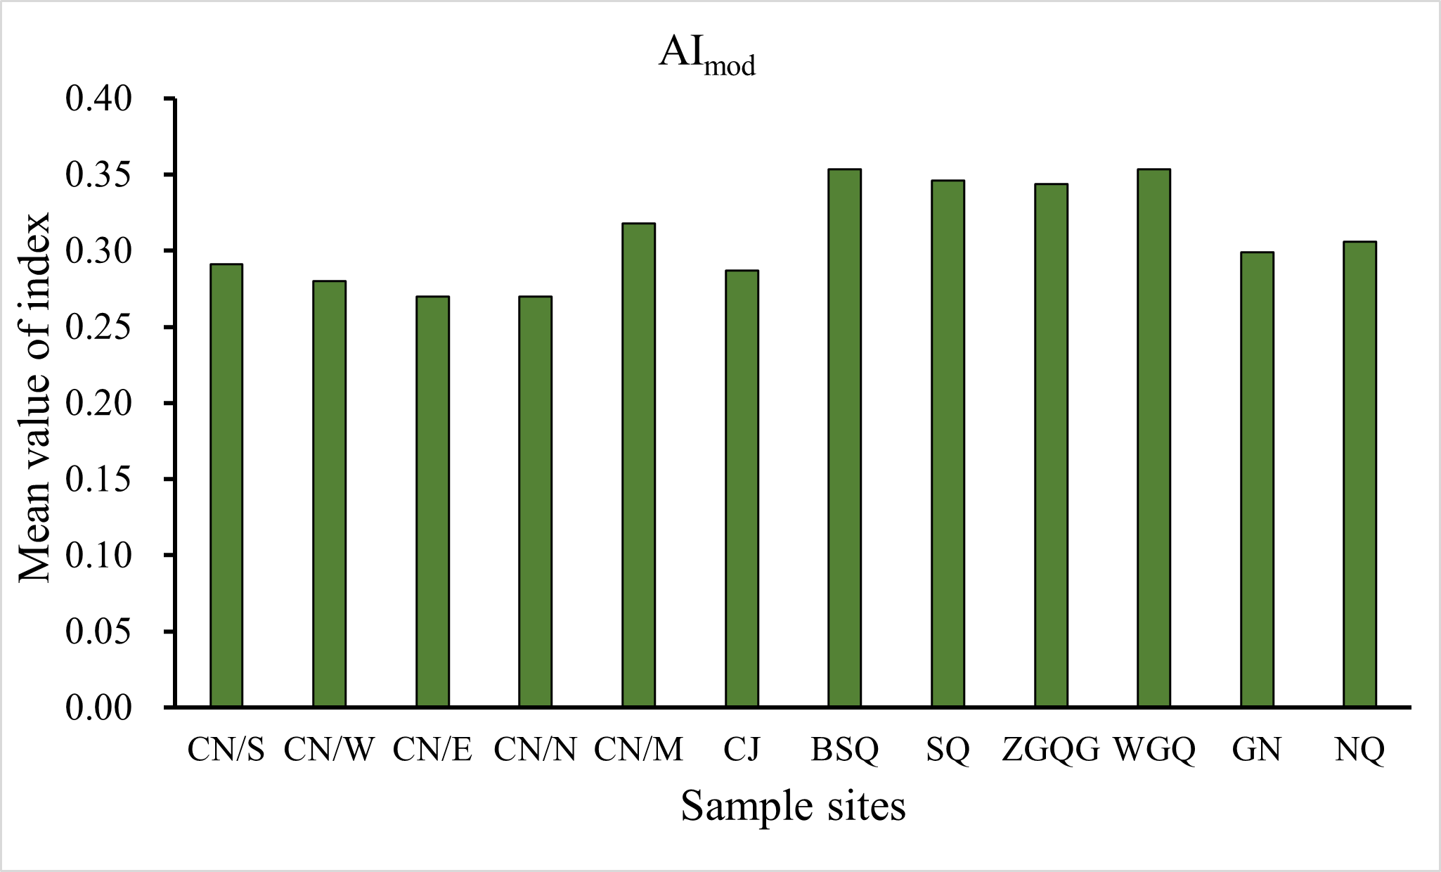
Fig. S5. The values of modified aromaticity index (AI_{mod}) in each collected samples. Sampling sites CN/S, CN/W, CN/E, CN/N, and CN/M were represented by five regions of Cuona Lake: east (CN/E), south (CN/S), west (CN/W), north (CN/N), and center (CN/M). CN: Cuona Lake; CJ: Cuojia Lake; BSQ: BasoQu; ZGQG: Zhuogeiqugang; SQ: SangQu; GN: Ganong Ma Lake; WGQ: Wangga Qu; NQ: Nagqu River.

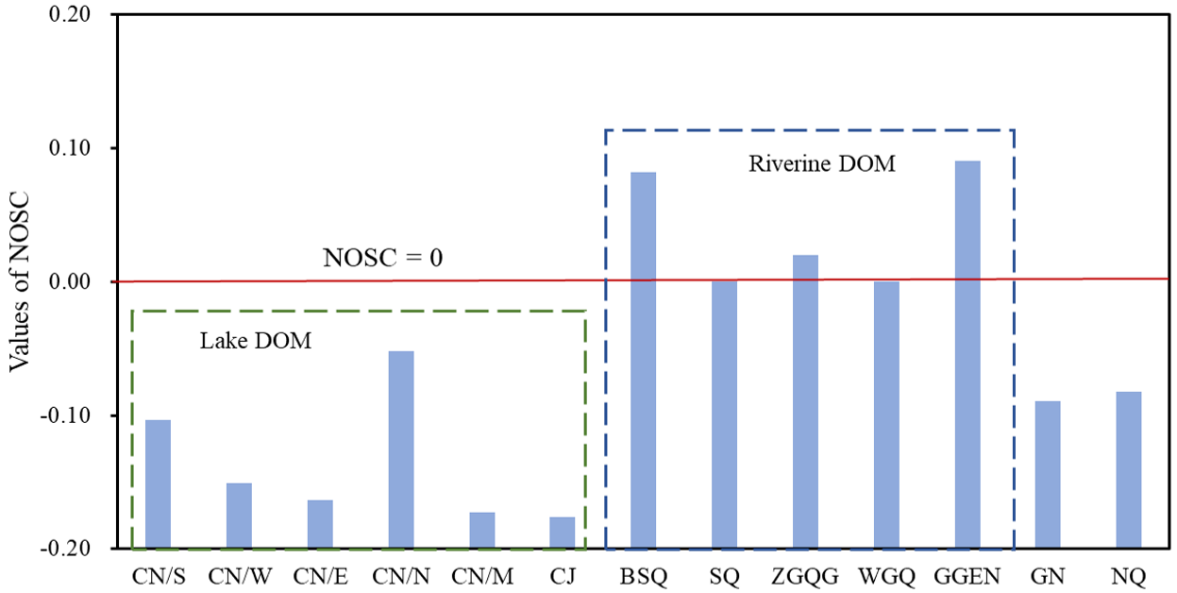
Fig. S6. The value of nominal oxidation state of carbon (NOSC) in all collected samples identified by FT-ICR MS. Sampling sites CN/S, CN/W, CN/E, CN/N, and CN/M were represented by five regions of Cuona Lake: east (CN/E), south (CN/S), west (CN/W), north (CN/N), and center (CN/M). CN: Cuona Lake; CJ: Cuojia Lake; BSQ: BasoQu; ZGQG: Zhuogeiqugang; SQ: SangQu; GN: Ganong Ma Lake; WGQ: Wangga Qu; NQ: Nagqu River.

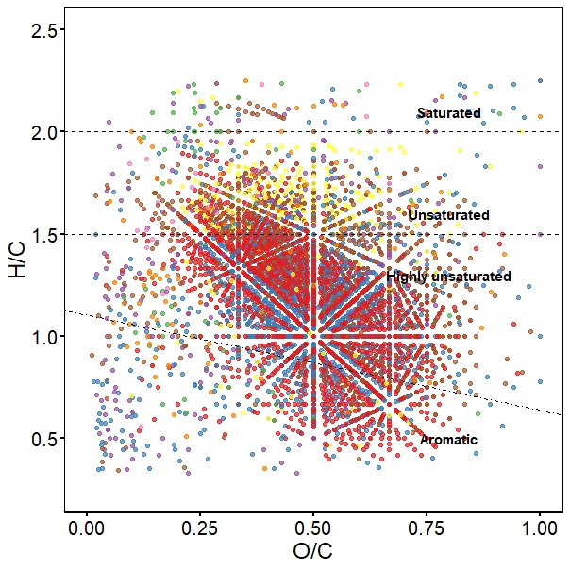
Fig. S7. The saturation divided of DOM samples are identified by the H/C and O/C values. The dots of different colors are denoted as element composition of identified molecular formulae. Different colors denote different molecular components identified by FT-ICR MS.

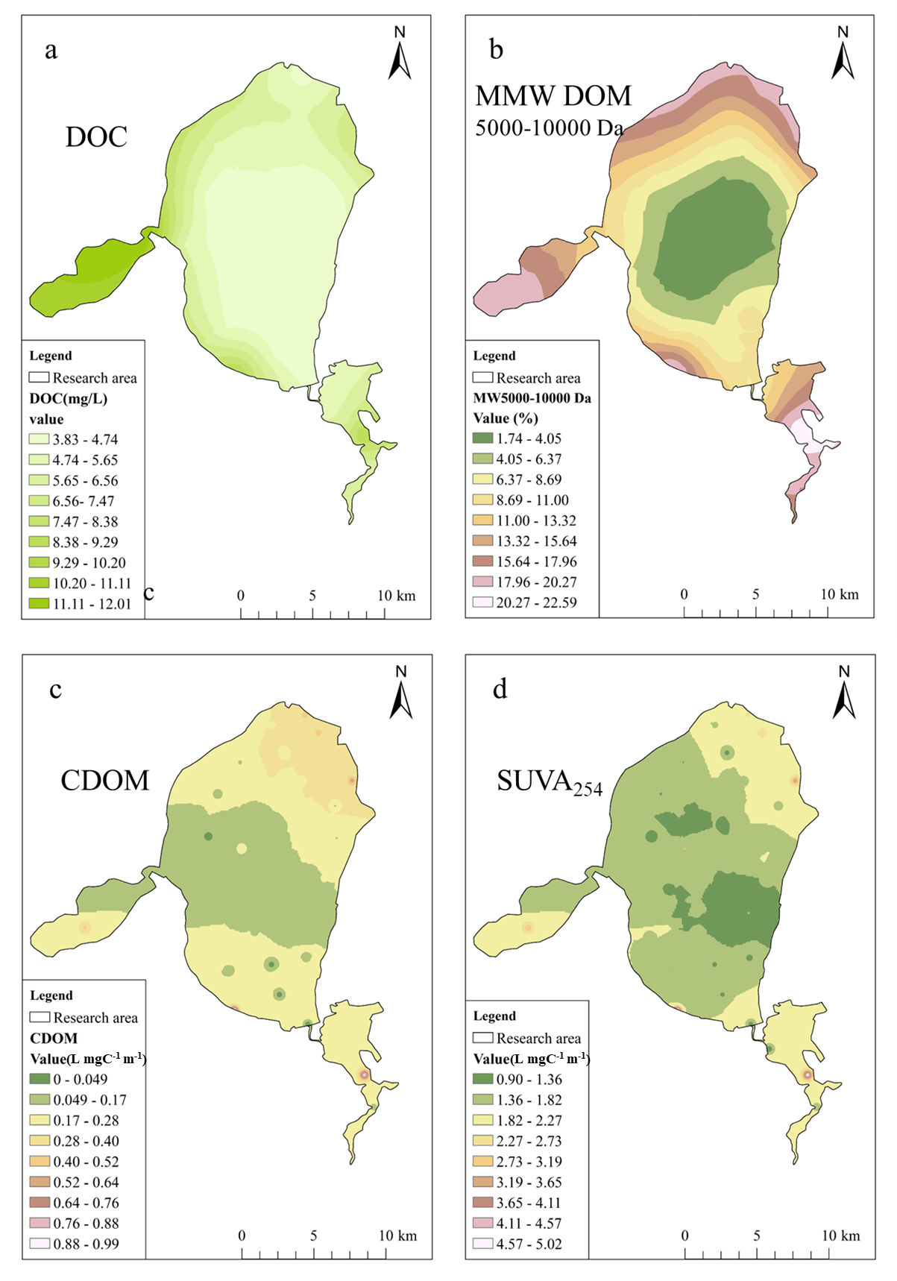
Fig. S8. The graph show the distribution of DOM concentration (a), medium molecular weight of DOM (MMW DOM) (b), CDOM (c) and the specific ultraviolet absorbance at 254 nm (SUVA₂₅₄) (d) in Cuona Lake, Cuojia Lake, and Ganong Ma.

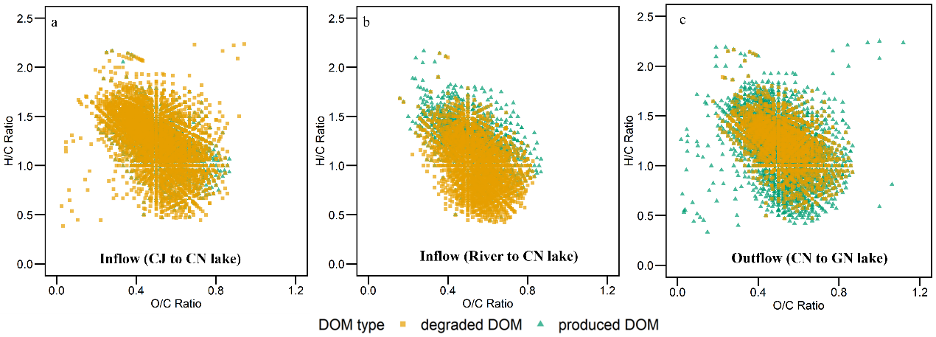
Fig. S9. DOM molecular variation along the Cuona Continuum, including processes of during inflow (Cuojia to Cuona Lake) (a), Rivers to Cuona Lake (b), and during outflow (Cuona Lake to Ganong Ma Lake) (c) of molecular compositions as identified by FT-ICR MS.

