Overexpression of a rice phospholipase C gene (OsPLC1) in Arabidopsis thaliana improves salinity stress tolerance
Min Yu^{1,2}, Dong Huang², Xiaoming Yin^{3,4}, Jiaojiao Bai¹*, Baolu Cui¹*
¹College of Pharmacy and Life Science, Jiujiang University, Jiujiang, 332005, China
²State Key Laboratory of Hybrid Rice, College of Life Sciences, Wuhan University, Wuhan, 430073, China
³Fujian Provincial Key Laboratory of Beverage Plant Extraction Technology for Enterprises, Zhangzhou, 363000, China
⁴Shanghai Jiao Tong University, Shanghai, China, 200000, China

*Correspondence: jjbai@sjziam.ac.cn (J.B.); 6090111@jju.edu.cn (B.C.)

Fig. S1
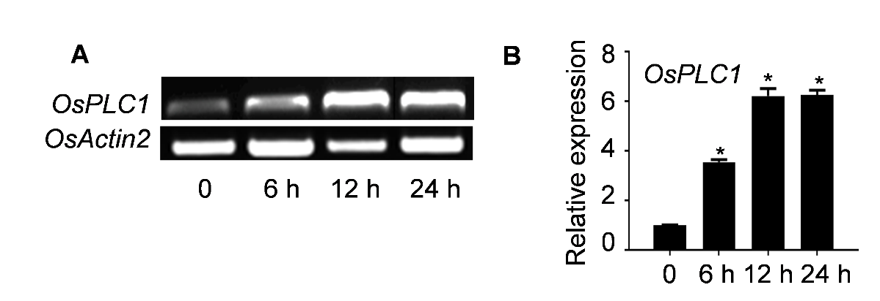

Fig. S1. Expression patterns of OsPLC1 under salt stress are characterized. Relative gene expression of OsPLC1 was analyzed by semi quantitative RT-PCR (A) and qRT-PCR (B). The 10-day-old seedlings of Nip were exposed to 200 mM NaCl, and samples were collected at 0, 6, 12 and 24 h. RNAs were extracted from leaves which were detached from treated-plants at indicated time points of treatments. The expression level of the OsActin2 (Os10g0510000) was used as an internal control. Data are the mean ± SD of three replicates (*P <0.05, Student’s t-test).

Fig. S2
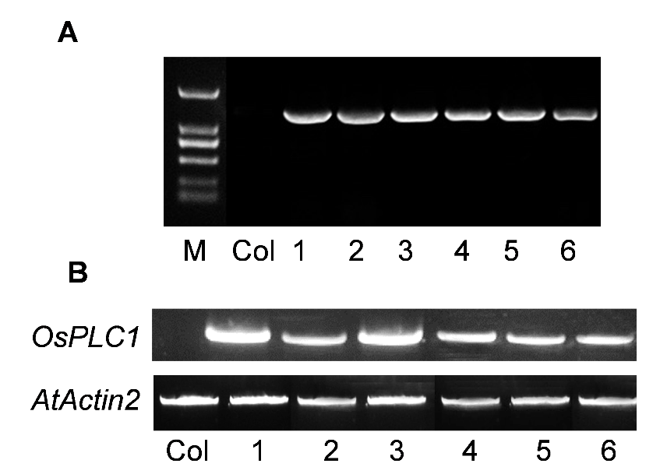
Fig. S2. OsPLC1 overexpressing Arabidopsis thaliana plants are identified. A. a PCR analysis of T0 OsPLC1 overexpressing transgenic Arabidopsis lines. B. Semi quantitative RT-PCR analyses of OsPLC1 gene expression in transgenic Arabidopsis homologous lines of T2 generation. A specific PCR product of 300 bp was amplified in all transgenic Arabidopsis lines. AtActin2 (At3g18780) gene was used as an internal control.

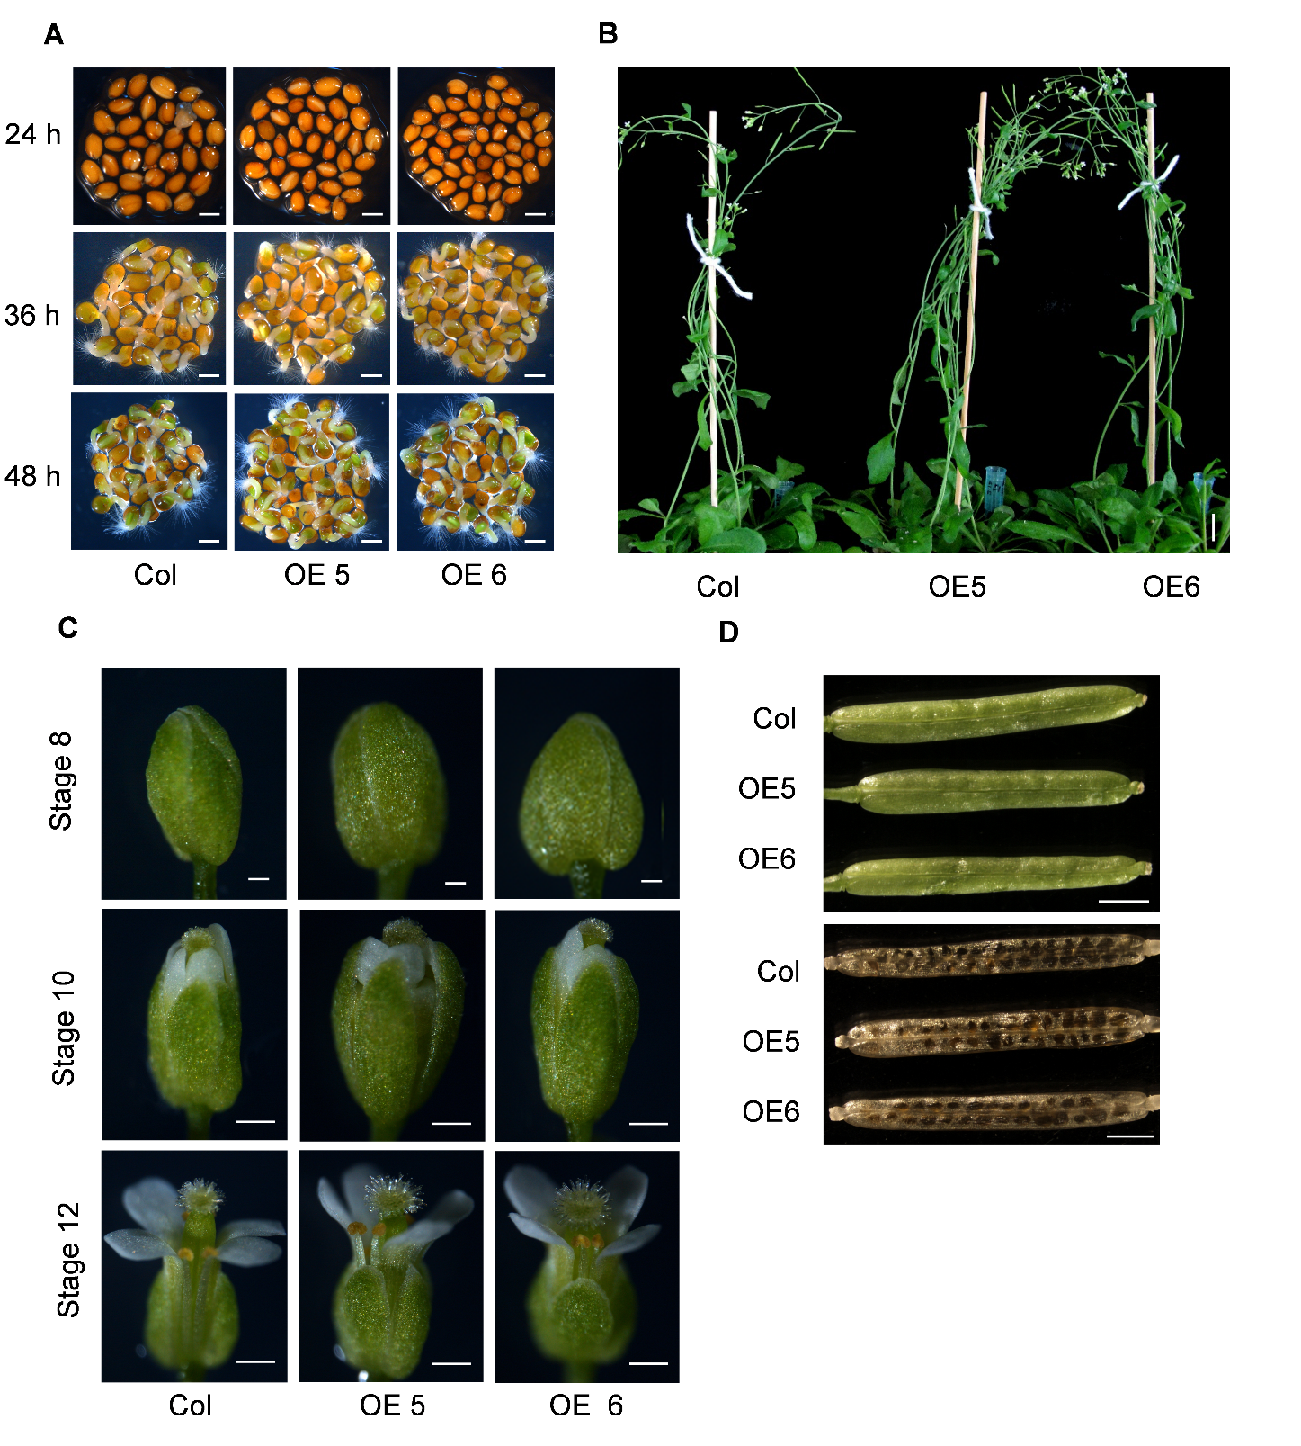
Fig. S3
Nip OE#4 OE#9 osplc1-1 osplc1-2

Fig. S3. The phenotypes of OsPLC1 overexpressing Arabidopsis plants are analyzed. A. No significant difference was observed in seed germination of Col, OE 5 and OE 6. Sterilized seeds were sown on 1/2 MS liquid medium and photographs were taken from 24 h to 48 h. Scale bars: 0.1 mm. B. Photograph of 40-day-old plants grown in nutrient soil were taken. Scale bars: 1.5 cm. C. The floral organs of Col, OE 5 and OE 6 were compared and photographs were taken at stage 8, 10 and 12. Scale bars: 1 mm. D. The silique of Col, OE 5 and OE 6 were compared. Scale bars: 1 mm.

Fig. S4
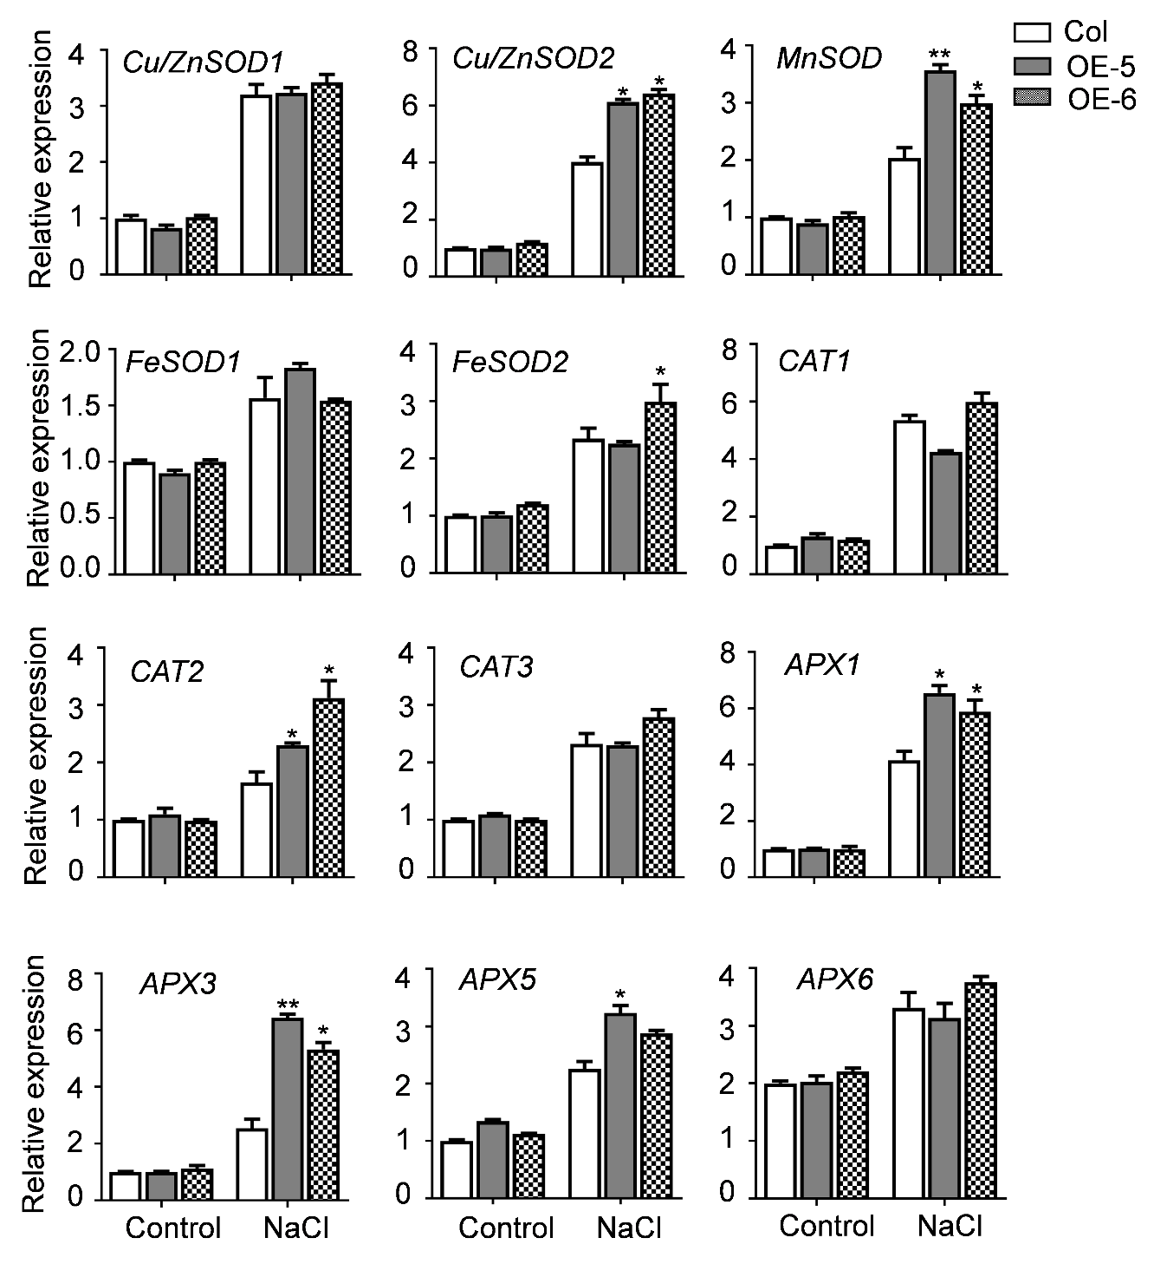
Fig. S4. Altered-expression levels of a set of antioxidant enzyme genes by NaCl are detected. Expression levels of genes were analyzed in the qRT-PCR experiments. RNAs were extracted from leaves of 10-day-old plants of Col and OsPLC1 overexpressing Arabidopsis plants which were treated by NaCl (200 mM) for 6 h. The expression level of the AtActin2 was used as an internal control. Data are the mean ± SD of three independent experiments (*P <0.05, **P <0.01, Student’s t-test).

Fig. S5
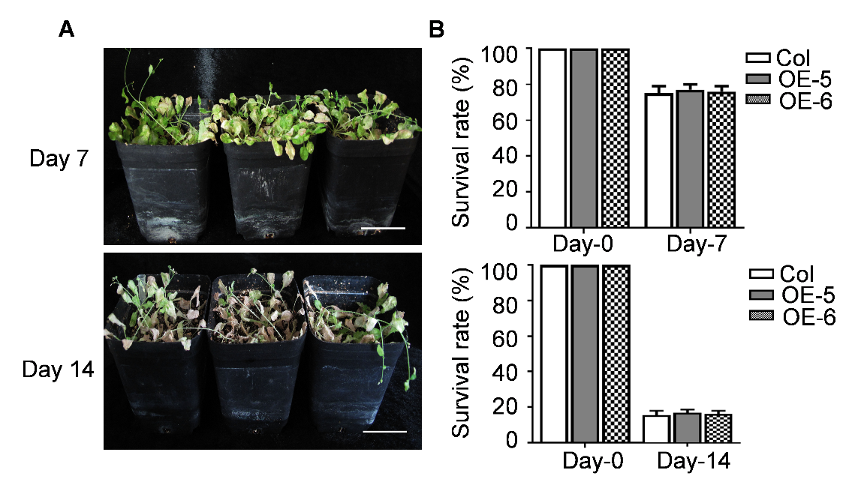
Fig. S5. Overexpression of OsPLC1 does not affect drought stress tolerance of transgenic plants. A. Performance of OsPLC1 overexpression lines and the Col during drought stress treatment in soil. 4-week-old plants of OE and Col lines grown in nutrient soil were subjected to drought stress for more 7 and 14 days. Scale bars: 6 cm. B. Survival rate (%) of plants for the Col and transgenic lines were calculated at day-7 and day-14. Data are the mean ± SD of three independent experiments (n = 30 for each experiment; *P <0.05, Student’s t-test).

Table S1. Primers used for plasmid construction, semi quantitative RT-PCR and qRT-PCR analysis
Name | Primer sequence
pBA-OsPLC1 | F: 5'-GAAGATCTATGGGCACGTACAAGTGCT-3'
(Plasmid construction) | R: 5'-GAAGATCTTTCAAACTCGAAGCGCATG-3'
AtActin2 | F: 5՚-ACCTTGCTGGACGTGACCTTACTGAT-3՚
(Semi quantitative RT-PCR) | R: 5՚-GTTGTCTCGTGGATTCCAGCAGCTT-3՚
OsPLC1 | F: 5՚-TTCACGCAGACCCACTTTGA-3՚
(Semi quantitative RT-PCR) | R: 5՚-AAAGTGTCGGTGTGTTGGGT-3՚
OsActin2 | F: 5՚-CCCCTCGTCTGCGATAATGG-3՚
(Semi quantitative RT-PCR) | R: 5՚-CCCAGTTGCTGACGATACCA-3՚
AtActin2 | F: 5՚-TGGATTCTGGTGATGGTGTG-3՚
(qRT-PCR) | R: 5՚-GTTTCCATCTCCTGCTCGTAG-3՚
DR22 | F: 5՚-GTAAACCCGGTAAAAGAACC-3՚
(qRT-PCR) | R: 5՚-TACACGAAAGGGTTTGCTCC-3՚
RAB18 | F: 5՚-TACCAGAACCGTCCAGGAGG-3՚
(qRT-PCR) | R: 5՚-CGTACTCGTCATACTGCTGC-3՚
DREB2A | F: 5՚-GTGTTGCCAACGGTTCATAC-3՚
(qRT-PCR) | R: 5՚-GAGGTATTCCGTAGTTGAGG-3՚
DREB2B | F: 5՚-GAAGAGTCTTGTGGAACCAG-3՚
(qRT-PCR) | R: 5՚-CCCAATACTGCTGCTCAAAC-3՚
RD29A | F: 5՚-CCTGAAGTGATCGATGCACC-3՚
(qRT-PCR) | R: 5՚-CAGTGGGTTTGGTGTAATCG-3՚
RD29B | F: 5՚-TTCTTGGCTCGGTGGTAAAC-3՚
(qRT-PCR) | R: 5՚-GGTGCCAAGTGATTGTGGAG-3՚
MYB20 | F: 5՚-ATGTACCAGTTTCCACTACC-3՚
(qRT-PCR) | R: 5՚-TCCTCTGCTTTCTCGTCGTG-3՚
MYB44 | F: 5՚-TCTAACCCAAACCGCATCTC-3՚
(qRT-PCR) | R: 5՚-ATTAAACCCGTGACTGCTCTC-3՚
NCED3 | F: 5՚-CCAGCAAGTCGTTTTCAAGC-3՚
(qRT-PCR) | R: 5՚-TCATCTGTTTCTGGCTCTTCC-3՚
SOS1 | F: 5՚-GTGAAGCAATCAAGCGGAAA-3՚
(qRT-PCR) | R: 5՚-TGCGAAGAAGGCGTAGAACA-3՚
SOS2 | F: 5՚-GCGAACTCAATGGGTTTTAAGT-3՚
(qRT-PCR) | R: 5՚-CTTACGTCTACCATGAAAAGCG-3՚
SOS3 | F: 5՚-CCGGTCCATGAAAAAGTCAAAT-3՚
(qRT-PCR) | R: 5՚-CTCTTTCAATTCTTCTCGCTCG-3՚
Zn/CuSOD1 | F: 5՚-GGTCCACATTTCAACCCCGA-3՚
(qRT-PCR) | R: 5՚-CTGCATGGACAACAACAGCC-3՚
Zn/CuSOD2 | F: 5՚-GATGGCGTGGCAGAAACAAC-3՚
(qRT-PCR) | R: 5՚-CCACCCTTTCCGAGGTCATC-3՚
MnSOD | F: 5՚-AATTCAACGGCGGAGGTCAT-3՚
(qRT-PCR) | R: 5՚-GCACCCTCAGCACTCATCTT-3՚
FeSOD1 | F: 5՚-AGCTTACGTGGACAACCTCA-3՚
(qRT-PCR) | R: 5՚-TTTCCTCCACCACCTGGTTT-3՚
FeSOD2 | F: 5՚-ACGGTTAGGGACAAAGGTGG-3՚
(qRT-PCR) | R: 5՚-AATCCAAGGTTTCCCGGCTC-3՚
CAT1 | F: 5՚-ACTACAGGCACATGGAAGGC-3՚
(qRT-PCR) | R: 5՚-ATGGCTGTGATTGGCTCCTC-3՚
CAT2 | F: 5՚-GCTCGATGTGACCAAGACCT-3՚
(qRT-PCR) | R: 5՚-GGCATAGGAGAAGACACGGG-3՚
CAT3 | F: 5՚-ACATGGAGGGTTTCGGTGTC-3՚
(qRT-PCR) | R: 5՚-TTAGTGGCGTGGCTGTGATT-3՚
APX1 | F: 5՚-GTCCATTCGGAACAATGAGGTTTGAC-3՚
(qRT-PCR) | R: 5՚-GTGGGCACCAGATAAAGCGACAAT-3՚
APX3 | F: 5՚-CCCAAAATCACATACGCAGACCTGTA-3՚
(qRT-PCR) | R: 5՚-AGTTGTCAAACTTCAGCGGCTCTTG-3՚
APX5 | F: 5՚-AGCTAAACCGTCCACACAACAAAGGT-3՚
(qRT-PCR) | R: 5՚-GTCCCAAAGTGTGACCTCCAGAGAGA-3՚
APX6 | F: 5՚-TGCAAAACGAAATAAGGAAAGTGGTG 3՚
(qRT-PCR) | R: 5՚-CACTCAGGGTTTCTGGAGGTAGCTTG-3՚

