PowerGLUE: A comprehensive benchmark for evaluating large language models in the electric power domain
Cuiqi Zheng¹, Chengwei Peng¹, Shouyu Liang¹, Zhuojun Cai¹, Zhichen Peng¹, Zehong Chen¹
¹ Artificial Intelligence Research Center, CSG Digital Grid Group Co., Ltd., Guangzhou, 510000, China
Correspondence: Shouyu Liang (lsynd@126.com)

Supplementary Information
This Supplementary Information documents the prompt templates used at the dataset construction and evaluation stages of PowerGLUE. Notes S1–S4 reproduce each template; the original Chinese prompt is provided together with its English translation, and the corresponding interface screenshots are shown in Supplementary Figures S1–S4.
The appendices below reproduce the prompt templates used at the construction and evaluation stages. Each template is given as the original Chinese text together with an English translation; the figures show the templates as configured in the corresponding pipeline stage.

Supplementary Note S1. Prompt template used for data classification
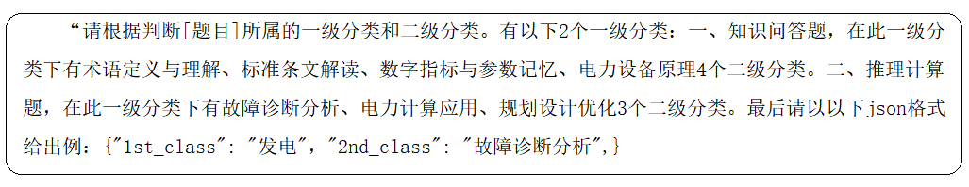
Supplementary Figure S1. Prompt template for model-assisted classification of candidate items (Chinese).
Chinese text:
“请根据判断[题目]所属的一级分类和二级分类。有以下2个一级分类：一、知识问答题，在此一级分类下有术语定义与理解、标准条文解读、数字指标与参数记忆、电力设备原理4个二级分类。二、推理计算题，在此一级分类下有故障诊断分析、电力计算应用、规划设计优化3个二级分类。最后请以下json格式给出例：{“1st_class”: “发电”, “2nd_class”: “故障诊断分析”, }”
English text:
"Please judge the first-level and second-level categories to which the [question] belongs. There are the following 2 first-level categories: I. Knowledge Q&A, under this first-level category, there are 4 second-level categories: terminology definition and understanding, standard clause interpretation, numerical indicators and parameter memorization, and power equipment principles. II. Reasoning and calculation questions, under this first-level category, there are 3 second-level categories: fault diagnosis analysis, power calculation application, and planning design optimization. Finally, please provide an example in the following json format: {"1st_class": "power generation", "2nd_class": "fault diagnosis analysis", }"

Supplementary Note S2. Prompt template used for knowledge-constrained item generation
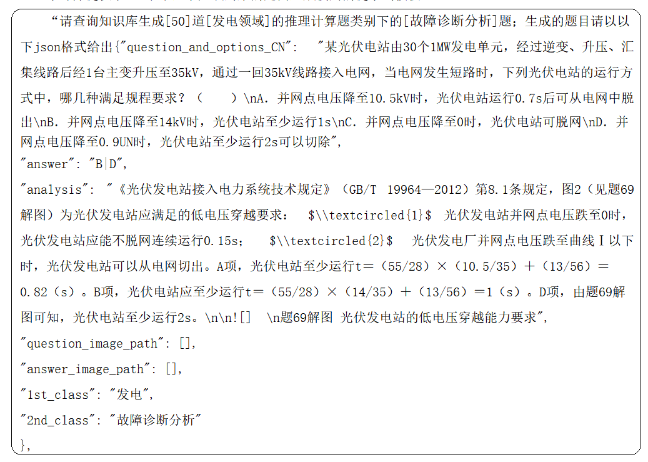
Supplementary Figure S2. Prompt template for retrieval-constrained generation of candidate items (Chinese).
Chinese text:
“请查询知识库生成[50]道[发电领域]的推理计算题类别下的[故障诊断分析]题；生成的题目请以下json格式给出{“question_and_options_CN”: “某光伏电站由30个1MW发电单元，经过逆变、升压、汇集线路后经1台主变升压至35kV，通过一回35kV线路接入电网，当电网发生短路时，下列光伏电站的运行方式中，哪几种满足规程要求？（ ）\nA. 并网点电压降至10.5kV时，光伏电站运行0.7s后可从电网中脱出\nB. 并网点电压降至14kV时，光伏电站至少运行1s\nC. 并网点电压降至0时，光伏电站可脱网\nD. 并网点电压降至0.9UN时，光伏电站至少运行2s可以切除”，“answer”: “BD”，“analysis”: “《光伏发电站接入电力系统技术规定》（GB/T 19964—2012）第8.1条规定，图2（见题69解图）为光伏发电站应满足的低电压穿越要求： ① 光伏发电站并网点电压跌至0时，光伏发电站应能不脱网连续运行0.15s； ② 光伏发电厂并网点电压跌至曲线Ⅰ以下时，光伏发电站可以从电网切出。A项，光伏电站至少运行t＝(55/28)×(10.5/35)＋(13/56)＝0.82（s）。B项，光伏电站应至少运行t＝(55/28)×(14/35)＋(13/56)＝1（s）。D项，由题69解图可知，光伏电站至少运行2s。\n\n题69解图 光伏发电站的低电压穿越能力要求”，“question_image_path”: []，“answer_image_path”: []，“1st_class”: “发电”，“2nd_class”: “故障诊断分析”}，”
English text:
"Please query the knowledge base to generate [50] [fault diagnosis analysis] questions under the [reasoning and calculation questions] category in the [power generation field]; please provide the generated questions in the following json format: {
"question_and_options_CN": "A certain photovoltaic (PV) power station consists of 30 1MW power generation units. After inversion, voltage boosting, and collection lines, the power is stepped up to 35kV by a main transformer and connected to the power grid through a 35kV line. When a short circuit occurs in the power grid, which of the following operation modes of the PV power station meet the regulatory requirements? ( )\nA. When the grid - connected point voltage drops to 10.5kV, the PV power station can be disconnected from the grid after operating for 0.7s.\nB. When the grid - connected point voltage drops to 14kV, the PV power station should operate for at least 1s.\nC. When the grid - connected point voltage drops to 0, the PV power station can be disconnected from the grid.\nD. When the grid - connected point voltage drops to 0.9UN, the PV power station can be disconnected after operating for at least 2s.",
"answer": "BD",
"analysis": "According to Article 8.1 of 'Technical Regulations for Photovoltaic Power Stations Connected to Power Systems' (GB/T 19964—2012), Figure 2 (see the solution diagram of Question 69) shows the low - voltage ride - through requirements that PV power stations should meet: ① When the grid - connected point voltage of the PV power station drops to 0, the PV power station should be able to operate continuously without disconnection for 0.15s; ② When the grid - connected point voltage of the PV power plant drops below Curve I, the PV power station can be disconnected from the grid. For Option A, the PV power station should operate for at least t = (55/28)×(10.5/35) + (13/56) = 0.82 (s). For Option B, the PV power station should operate for at least t = (55/28)×(14/35) + (13/56) = 1 (s). For Option D, it can be seen from the solution diagram of Question 69 that the PV power station should operate for at least 2s.\n\nSolution Diagram of Question 69: Low - voltage Ride - through Capability Requirements of PV Power Stations",
"question_image_path": [],
"answer_image_path": [],
"1st_class": "Power Generation",
"2nd_class": "Fault Diagnosis Analysis"
}, "

Supplementary Note S3. Prompt template used for auditing generated items
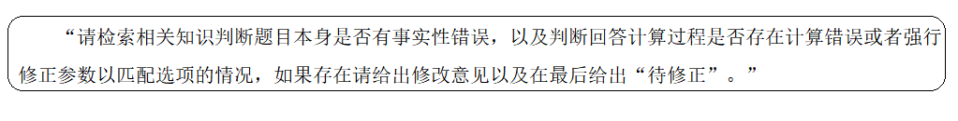
Supplementary Figure S3. Prompt template for auditing generated items (Chinese).
Chinese text:
“请检索相关知识判断题目本身是否有事实性错误，以及判断回答计算过程是否存在计算错误或者强行修正参数以匹配选项的情况，如果存在请给出修改意见以及在最后给出“待修正”。”
English text:
“Please retrieve relevant knowledge to determine whether the question itself contains factual errors, and whether the calculation process in the answer contains computational errors or cases where parameters are forcibly adjusted to match the options. If such problems exist, please provide revision suggestions and conclude with the label ‘to be corrected’.”

Supplementary Note S4. Prompt template used in the evaluation process
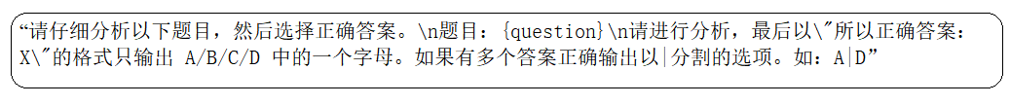
Supplementary Figure S4. Prompt template used for the zero-shot evaluation (Chinese).
Chinese text:
“请仔细分析以下题目，然后选择正确答案。\n题目： {question}\n请进行分析，最后以“所以正确答案： X”的格式只输出 A/B/C/D 中的一个字母。如果有多个答案正确输出以|分割的选项。如： A|D”
English text:
“Please carefully analyze the following question and select the correct answer.\nQuestion: {question}\nPlease analyze the question, and finally output only one letter from A/B/C/D in the format ‘Therefore the correct answer: X’. If multiple answers are correct, output the options separated by ‘|’, e.g., A|D.”

