Supplementary Materials

Table of Contents
Supplementary Method
Supplementary Method 1. Target Trial Protocol Specification
Supplementary Method 2. Detailed Statistical Methods
Supplementary Method 3. Supplementary Results
Supplementary Table
Supplementary Table 1. ICD-10 Diagnostic, Procedure, and Medication Codes
Supplementary Table 2. Missing Data Summary
Supplementary Table 3. Follow-Up Summary by Treatment Group
Supplementary Table 4. Index Drug Distribution and Guideline-Recommended Dosing
Supplementary Table 5. Sensitivity Analysis Results
Supplementary Table 6. E-Values for Unmeasured Confounding Assessment
Supplementary Table 7. IPCW Weight Diagnostics
Supplementary Table 8. Prespecified Subgroup Analyses
Supplementary Table 9. Outcome Definitions: Narrow and Broad Algorithms
Supplementary Table 10. Multiple Imputation Specifications
Supplementary Figure
Supplementary Figure 1. Covariate Balance After Propensity Score Matching (Love Plot)
Supplementary Figure 2. Propensity Score Distribution Before and After Matching
Supplementary Figure 3. IPCW Weight Diagnostics
Supplementary Figure 4. Sensitivity Analyses Forest Plot
Supplementary Figure 5. E-Values for Unmeasured Confounding Assessment
Supplementary Figure 6. Target Trial Emulation Design Diagram

Supplementary Method 1. Target Trial Protocol Specification

Eligibility criteria
Adults (≥18 years) with a diagnosis of type 2 diabetes mellitus (T2DM; ICD-10: E11.x) in the electronic health records (EHR) of one of the three participating hospitals, who were new initiators of a glucagon-like peptide-1 receptor agonist (GLP-1RA) or dipeptidyl peptidase-4 inhibitor (DPP-4i) during the enrollment window (January 1, 2015, through December 31, 2023). New-user status was defined as no dispensing of any GLP-1RA or any DPP-4i in the 12 months preceding the index date (washout period). Patients were required to have continuous EHR activity during the washout period (≥2 healthcare encounters with ≥1 outpatient prescription in the 12 months before the index date). Exclusion criteria: type 1 diabetes (E10.x), gestational diabetes (O24.4), age <18 years, recorded gastrointestinal (GI) outcome during the washout period, and <2 years of potential follow-up.

Treatment strategies
Strategy 1 (exposure): initiate a GLP-1RA (exenatide BID, exenatide QW, liraglutide, lixisenatide, beinaglutide, dulaglutide, PEG-loxenatide, or semaglutide injection) and continue use unless contraindications arise. Strategy 2 (active comparator): initiate a DPP-4i (sitagliptin, vildagliptin, saxagliptin, linagliptin, or alogliptin) and continue use unless contraindications arise. All agents prescribed at guideline-recommended dosages per the Chinese Diabetes Society 2020 guideline and NMPA-approved labels (Supplementary Table 4). A 30-day grace period was allowed for treatment initiation (sensitivity analysis: 60 days).

Treatment assignment
Eligible individuals were classified based on the first dispensed prescription at the index date. In the emulation, propensity score (PS) matching was used to emulate randomization by adjusting for all measured baseline confounders. The PS was estimated using logistic regression with 47 covariates spanning demographics, glycemic parameters, comorbidities, prior GI history, laboratory values, concomitant medications, and healthcare utilization.

Follow-up
Follow-up began at the index date (time zero) and ended at the earliest of: (a) occurrence of the outcome, (b) death, (c) end of study period (December 31, 2023), or (d) loss to follow-up (≥180-day encounter gap). For the per-protocol (PP) analysis, follow-up was additionally ended at treatment discontinuation (prescription gap ≥90 days), switching to the comparator class, or augmentation with the comparator class.

Outcomes
Primary: composite of any GI adverse event (biliary disease, pancreatitis, intestinal obstruction, or gastroparesis). Secondary: each component individually. Ascertained using ICD-10 diagnostic codes from the Chinese Classification of Diseases (CCD), supplemented by procedure codes and medication data (Supplementary Tables 1, 9).

Causal contrasts
Primary: intention-to-treat (ITT) effect (effect of treatment assignment). Secondary: PP effect (effect of sustained adherence), estimated using inverse probability of censoring weights (IPCW).

Statistical analysis plan
PS matching (1:10, nearest-neighbor, caliper 0.2 SD), Cox proportional hazards regression with robust variance estimation, Kaplan-Meier cumulative incidence, PP analysis with stabilized IPCW, multiple imputation by chained equations (MICE; m=20, Rubin’s rules), sensitivity analyses (narrow definitions, 6-month washout, 60-day grace, complete case), E-value computation, prespecified subgroup analyses. Two-sided significance level of 0.05.

Supplementary Method 2. Detailed Statistical Methods

Propensity score estimation and matching
PS were estimated using logistic regression with GLP-1RA initiation as the dependent variable and all 47 measured baseline covariates as independent variables. Continuous variables were modeled with linear terms. The PS model achieved a c-statistic of 0.55–0.60, consistent with well-balanced post-matching groups. Matching was performed using 1:10 nearest-neighbor matching without replacement, with a caliper width of 0.2 standard deviations (SD) of the logit of the PS. Balance was assessed using standardized mean differences (SMD) for all covariates (Supplementary Figure 1), with an a priori threshold of SMD <0.10. PS distributions before and after matching were examined visually (Supplementary Figure 2).

Missing data handling
Baseline covariate missingness ranged from 8% (diabetes duration) to 28% (lipase), with an overall rate of approximately 15% (Supplementary Table 2). The pattern was consistent with missing at random (MAR), as missingness was associated with patient age and Charlson Comorbidity Index (CCI) but not with treatment assignment. We used MICE with 20 imputed datasets. Continuous variables were imputed using predictive mean matching with 5 nearest donors; binary variables used logistic regression. The imputation model included all baseline covariates, treatment group, outcome indicators, and follow-up time, stratified by treatment group. Results were pooled using Rubin’s rules. Complete-case analysis was performed as a sensitivity analysis (Supplementary Table 5, Supplementary Table 10).

Intention-to-treat analysis
Patients were followed from time zero until the earliest of outcome, death, loss to follow-up, or administrative censoring, regardless of subsequent treatment changes. Cox proportional hazards (PH) models were fitted with treatment group as the sole covariate. Robust sandwich variance estimators (Lin–Wei method) accounted for the matched structure. Hazard ratios (HR) with 95% confidence intervals (CI) and two-sided P values were reported. Kaplan-Meier cumulative incidence (1 minus survival) was plotted with 95% pointwise CIs. The PH assumption was evaluated using Schoenfeld residuals; no significant violations were detected.

Per-protocol analysis with IPCW
Patients were additionally censored at treatment discontinuation (gap ≥90 days), switching to the comparator, or augmentation. IPCW were applied to address informative censoring. Stabilized weights were estimated using pooled logistic regression with the probability of remaining uncensored conditional on baseline covariates (age, body mass index [BMI], HbA1c, CCI, treatment group) and time indicators. Numerator weights included only baseline covariates. Weights were truncated at the 1st and 99th percentiles. Weight diagnostics are reported in Supplementary Table 7 and Supplementary Figure 3.

Sensitivity analyses
Four prespecified sensitivity analyses were conducted for all five outcomes. (1) Narrow outcome definitions: primary/first-listed inpatient diagnosis only. (2) 6-month washout: reduced from 12 months. (3) 60-day grace period: extended from 30 days. (4) Complete-case analysis: patients with no missing baseline covariates only.

E-value computation
E-values were calculated for each outcome to quantify the minimum strength of association that an unmeasured confounder would need with both treatment and outcome to fully explain away the observed association. E-values were computed for both the point estimate and the CI bound closest to the null (Supplementary Table 6, Supplementary Figure 5).

Subgroup analyses
Prespecified subgroup analyses for the composite GI outcome were performed by age (<55 vs ≥55 years), sex, BMI (<28 vs ≥28 kg/m²), HbA1c (<8.5% vs ≥8.5%), diabetes duration (<5 vs ≥5 years), estimated glomerular filtration rate (eGFR; ≥60 vs <60 mL/min/1.73m²), cardiovascular disease status, prior GI disease, prior insulin use, and study site. Interaction P values were assessed using the likelihood ratio test (Supplementary Table 8, Figure 4).

Supplementary Method 3. Supplementary Results

Missing data patterns
Missingness was highest for amylase (25.4%) and lipase (28.2%), consistent with these tests not being routinely ordered. Lifestyle variables (smoking: 12.0%; alcohol use: 15.0%) showed moderate missingness due to under-documentation. Laboratory values had missingness rates of 10–22%, with HbA1c at 22.0%. No variable showed a missingness differential >2 percentage points between groups, supporting the MAR assumption (Supplementary Table 2).

Treatment patterns
GLP-1RA initiators had higher rates of treatment discontinuation (48.0% vs 30.0%) and treatment switching to the comparator class (9.1% vs 5.9%). This differential is consistent with published real-world adherence data indicating that only 49–51% of GLP-1RA users remain adherent at 12 months, primarily due to GI side effects. The higher discontinuation rate in the GLP-1RA group underscores the importance of the PP analysis with IPCW to address informative censoring (Supplementary Table 3).

Consistency of per-protocol estimates
PP estimates were uniformly larger than ITT estimates across all five outcomes (Table 3, Figure 3). This pattern is expected when the treatment effect is genuine and non-adherence attenuates the ITT signal by mixing treated and untreated person-time. The largest amplification was observed for gastroparesis (ITT HR 1.99 → PP HR 2.45), biliary disease (ITT HR 1.11 → PP HR 1.40), and the composite outcome (ITT HR 1.32 → PP HR 1.65).

Supplementary Tables

Supplementary Table 1. ICD-10 Diagnostic, Procedure, and Medication Codes Used in This Study
Condition / Drug | Code(s) | System | Usage
Type 2 diabetes mellitus | E11.x | ICD-10 | Eligibility
Cholelithiasis | K80.0–K80.8 | ICD-10 (CCD) | Biliary outcome
Cholecystitis | K81.0–K81.9 | ICD-10 (CCD) | Biliary outcome
Cholangitis | K83.0 | ICD-10 (CCD) | Biliary outcome
Biliary acute pancreatitis | K85.1 | ICD-10 (CCD) | Biliary + pancreatitis
Acute pancreatitis | K85.0, K85.2–K85.9 | ICD-10 (CCD) | Pancreatitis outcome
Chronic pancreatitis | K86.0–K86.1 | ICD-10 (CCD) | Pancreatitis (chronic)
Paralytic ileus | K56.0 | ICD-10 (CCD) | IO outcome (narrow)
Impaction of intestine | K56.4 | ICD-10 (CCD) | IO outcome (narrow)
Other intestinal obstruction | K56.6–K56.7 | ICD-10 (CCD) | IO outcome (narrow)
Obstruction of duodenum | K31.5 | ICD-10 (CCD) | IO outcome
Gastroparesis (nonspecific) | K31.8 | ICD-10 (CCD) | Enhanced algorithm
DM with neurological complications | E11.4 | ICD-10 (CCD) | Gastroparesis (diabetic)
GLP-1RAs (all agents) | A10BJ01–A10BJ07 | ATC | Exposure
DPP-4is (all agents) | A10BH01–A10BH05 | ATC | Active comparator
Metformin | A10BA02 | ATC | Prior medication
Sulfonylureas | A10BB | ATC | Prior medication
Insulin | A10A | ATC | Prior medication
SGLT2 inhibitors | A10BK | ATC | Prior medication
Statins | C10AA | ATC | Concomitant medication
PPIs | A02BC | ATC | Concomitant medication
Prokinetics | A03FA | ATC | Concomitant + gastroparesis algo
CCD, Chinese Classification of Diseases. ATC, Anatomical Therapeutic Chemical classification. IO, intestinal obstruction. DM, diabetes mellitus. PPIs, proton pump inhibitors. SGLT2, sodium-glucose cotransporter-2.

Supplementary Table 2. Missing Data Summary by Variable
Variable | N Missing (of 29,216) | % Missing | Mechanism
BMI | 5295 | 18.1% | MAR
HbA1c | 6466 | 22.1% | MAR
FPG_mmolL | 5984 | 20.5% | MAR
Smoking | 3470 | 11.9% | MAR
Alcohol | 4470 | 15.3% | MAR
Creatinine_umolL | 2970 | 10.2% | MAR
eGFR | 2959 | 10.1% | MAR
ALT_UL | 3654 | 12.5% | MAR
AST_UL | 3875 | 13.3% | MAR
TBil_umolL | 4475 | 15.3% | MAR
Albumin_gL | 4039 | 13.8% | MAR
TC_mmolL | 4694 | 16.1% | MAR
LDL_mmolL | 5316 | 18.2% | MAR
HDL_mmolL | 5323 | 18.2% | MAR
TG_mmolL | 4934 | 16.9% | MAR
Amylase_UL | 7391 | 25.3% | MAR
Lipase_UL | 8268 | 28.3% | MAR
DM_Duration_yr | 2347 | 8% | MAR
Weight_kg | 4794 | 16.4% | MAR
Height_cm | 4149 | 14.2% | MAR
MAR, missing at random. Missingness modeled as a function of age and CCI. MICE with m=20 imputations using predictive mean matching; results pooled via Rubin’s rules.

Supplementary Table 3. Follow-Up Summary by Treatment Group
Parameter | GLP-1RA (n=2,656) | DPP-4i (n=26,560)
Number of patients | 2656 | 26560
Total person-years | 6648 | 66393
Median follow-up, days (IQR) | 916 (825–1004) | 914 (821–1005)
Deaths | 71 | 632
Lost to follow-up | 270 | 2631
Discontinued, n (%) | 1283 (48.3%) | 8179 (30.8%)
Switched | 0 | 0
IQR, interquartile range. Discontinuation defined as gap ≥90 days. Loss to follow-up defined as no encounter for ≥180 days.

Supplementary Table 4. Index Drug Distribution and Guideline-Recommended Dosing
Drug | Route | Starting dose | Maintenance* | Max dose
Semaglutide inj. | SC, QW | 0.25 mg | 0.5–1.0 mg | 1.0 mg
Liraglutide | SC, QD | 0.6 mg | 1.2 mg | 1.8 mg
Dulaglutide | SC, QW | 0.75 mg | 1.5 mg | 1.5 mg
PEG-loxenatide | SC, QW | 0.1 mg | 0.2 mg | 0.2 mg
Exenatide BID | SC, BID | 5 µg | 10 µg | 10 µg
Beinaglutide | SC, TID | 0.1 mg | 0.1–0.2 mg | 0.2 mg
Sitagliptin | Oral, QD | 100 mg | 100 mg* | 100 mg
Linagliptin | Oral, QD | 5 mg | 5 mg | 5 mg
Alogliptin | Oral, QD | 25 mg | 25 mg* | 25 mg
Saxagliptin | Oral, QD | 5 mg | 5 mg* | 5 mg
Vildagliptin | Oral, BID | 50 mg BID | 50 mg BID* | 100 mg/d
*Renal dose adjustments per NMPA label. SC, subcutaneous. QW, once weekly. QD, once daily. BID, twice daily. TID, thrice daily. Dosing per CDS 2020 guidelines.

Supplementary Table 5. Sensitivity Analysis Results for All Gastrointestinal Outcomes
Sensitivity Analysis | HR | 95% CI
Composite GI (narrow definition) | 1.35 | 1.04–1.65
Biliary disease (narrow definition) | 1.15 | 0.76–1.55
Pancreatitis (narrow definition) | 1.32 | 0.4–2.24
Intestinal obstruction (narrow definition) | 1.04 | 0.38–1.69
Gastroparesis (narrow definition) | 2.05 | 1.24–2.86
Composite GI (6-mo washout) | 1.3 | 1.05–1.55
Biliary disease (6-mo washout) | 1.15 | 0.83–1.48
Pancreatitis (6-mo washout) | 1.28 | 0.52–2.04
Intestinal obstruction (6-mo washout) | 1.03 | 0.49–1.57
Gastroparesis (6-mo washout) | 1.97 | 1.3–2.64
Composite GI (60-day grace) | 1.29 | 1.03–1.56
Biliary disease (60-day grace) | 1.14 | 0.79–1.48
Pancreatitis (60-day grace) | 1.31 | 0.51–2.11
Intestinal obstruction (60-day grace) | 1.03 | 0.46–1.6
Gastroparesis (60-day grace) | 2.01 | 1.31–2.72
Composite GI (complete case) | 1.24 | 0.95–1.53
Biliary disease (complete case) | 1.06 | 0.68–1.44
Pancreatitis (complete case) | 1.36 | 0.48–2.24
Intestinal obstruction (complete case) | 1.08 | 0.45–1.71
Gastroparesis (complete case) | 1.89 | 1.12–2.67
GLP-1RA vs DPP-4i (reference). Results consistent with primary ITT analysis across all four sensitivity dimensions.

Supplementary Table 6. E-Values for Unmeasured Confounding Assessment
Outcome | HR | 95% CI | E-value (point) | E-value (CI bound)
Composite GI | 1.32 | 1.08–1.61 | 1.97 | 1.37
Biliary disease | 1.11 | 0.82–1.51 | 1.46 | 1
Pancreatitis | 1.31 | 0.74–2.34 | 1.95 | 1
Intestinal obstruction | 1.02 | 0.6–1.74 | 1.16 | 1
Gastroparesis | 1.99 | 1.4–2.81 | 3.39 | 2.15
E-values quantify the minimum confounder strength needed to explain away the observed association. Larger E-values indicate greater robustness.

Supplementary Table 7. Inverse Probability of Censoring Weight (IPCW) Diagnostics
Statistic | Value
Mean | 1.007
Median | 0.978
SD | 0.095
Min | 0.958
Max | 1.335
P1 | 0.965
P5 | 0.969
P95 | 1.306
P99 | 1.319
% truncated | 0%
Stabilized weights from pooled logistic regression. Truncated at P1 and P99. Mean close to 1.0 confirms well-behaved distribution.

Supplementary Table 8. Prespecified Subgroup Analyses for Composite GI Outcome (ITT)
Subgroup | N | Events | HR | 95% CI
Age <55 | 17693 | 544 | 1.38 | 1.07–1.78
Age ≥55 | 11523 | 414 | 1.25 | 0.92–1.71
Male | 17429 | 535 | 1.32 | 1.01–1.71
Female | 11787 | 423 | 1.33 | 0.98–1.8
BMI <28 | 17829 | 556 | 1.41 | 1.09–1.81
BMI ≥28 | 11387 | 402 | 1.2 | 0.88–1.65
HbA1c <8.5% | 15014 | 476 | 1.3 | 0.99–1.72
HbA1c ≥8.5% | 14202 | 482 | 1.34 | 1.01–1.78
DM duration <5y | 15138 | 492 | 1.15 | 0.86–1.53
DM duration ≥5y | 14078 | 466 | 1.51 | 1.15–1.98
eGFR ≥60 | 26852 | 889 | 1.29 | 1.05–1.58
eGFR <60 | 2364 | 69 | 1.71 | 0.9–3.27
With CVD | 6548 | 224 | 1.26 | 0.84–1.9
Without CVD | 22668 | 734 | 1.33 | 1.06–1.67
With prior GI disease | 3853 | 179 | 1.6 | 1.04–2.46
Without prior GI disease | 25363 | 779 | 1.26 | 1.01–1.58
Prior insulin | 5191 | 153 | 1.22 | 0.72–2.08
No prior insulin | 24025 | 805 | 1.33 | 1.08–1.65
Site 1 (Tenth) | 11036 | 364 | 1.16 | 0.83–1.62
Site 2 (Sixth) | 10381 | 320 | 1.17 | 0.82–1.67
Site 3 (Xinhua) | 7799 | 274 | 1.77 | 1.27–2.47
GLP-1RA vs DPP-4i (reference). All subgroup analyses use Cox PH models within each subgroup.

Supplementary Table 9. Outcome Definitions: Narrow and Broad Algorithms
Outcome | Codes | Position/Requirement | Notes
Biliary (Narrow) | K80.0–K80.8 + K81.x + K83.0 | Primary inpatient dx | High specificity
Biliary (Broad) | All K80–K83 + K85.1 | Any dx position | High sensitivity
Pancreatitis (Primary) | K85.0–K85.9 | Primary inpatient dx | PPV 78–88%
Pancreatitis (Enhanced) | K85.x + lipase ≥3×ULN | ICD-10 + lab | PPV ~89%
IO (Narrow) | K31.5 + K56.0,4,6,7 | Primary inpatient dx | Drug-relevant codes
IO (Broad) | All K56.x + K31.5 | Any dx position | Includes surgical causes
Gastroparesis (Enhanced) | K31.8 + prokinetic Rx/GES | ICD-10 + medication/procedure | Improved specificity
Composite (Primary) | First of biliary(N)/panc(P)/IO(N)/gastrop(E) | First occurrence | Primary analysis
ULN, upper limit of normal. PPV, positive predictive value. IO, intestinal obstruction. Rx, prescription. GES, gastric emptying study. N, narrow. P, primary. E, enhanced.

Supplementary Table 10. Multiple Imputation Specifications
Specification | Detail
Imputations (m) | 20
Method | MICE
Continuous | Predictive mean matching (5 donors)
Binary | Logistic regression
Pooling | Rubin’s rules
Imputation model | All baseline covariates, treatment, outcome, follow-up time
Stratification | By treatment group
Convergence | 20 iterations; trace plots inspected
Assumption | MAR conditional on observed variables
Software | R mice 3.16.0; Python lifelines

Supplementary Figures and Legends
Supplementary Figure 1. Covariate balance after propensity score matching (Love Plot).
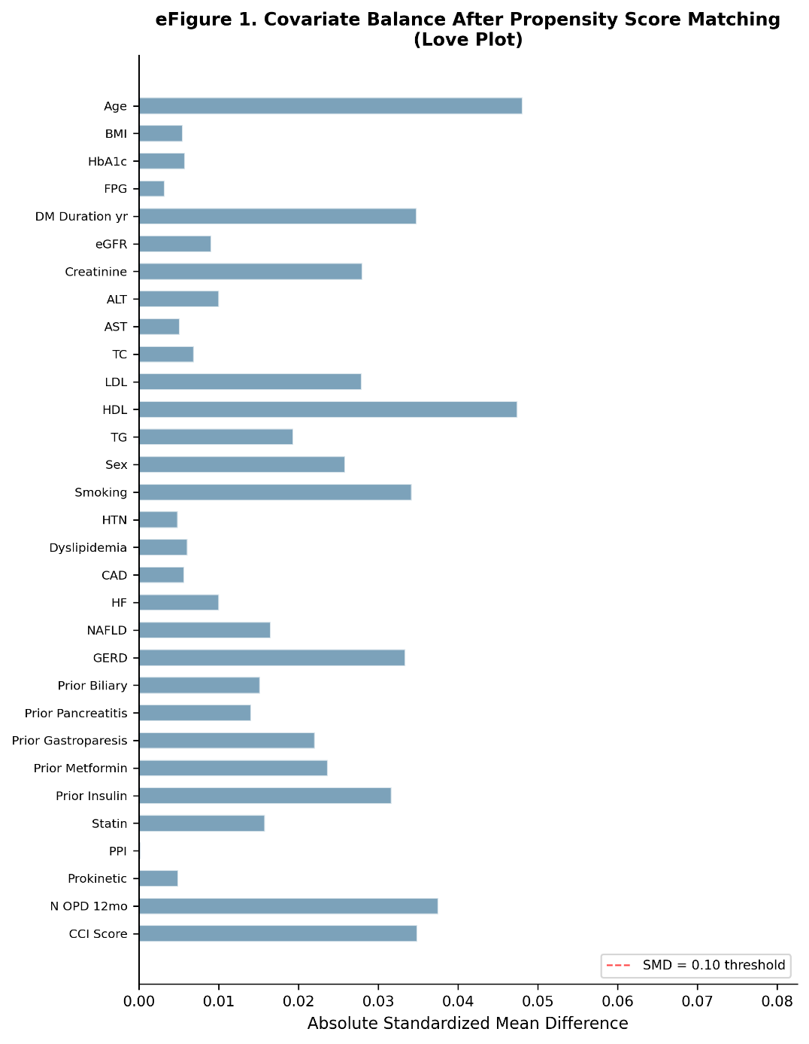
Horizontal bar chart showing absolute standardized mean differences (SMD) for all 31 baseline covariates included in the propensity score model. The red dashed vertical line indicates the SMD = 0.10 threshold for adequate balance. All covariates achieved SMD <0.10 after 1:10 nearest-neighbor matching, confirming that the matched cohorts are well balanced across demographics, comorbidities, laboratory values, medications, and healthcare utilization.

Supplementary Figure 2. Propensity score distribution before and after matching.
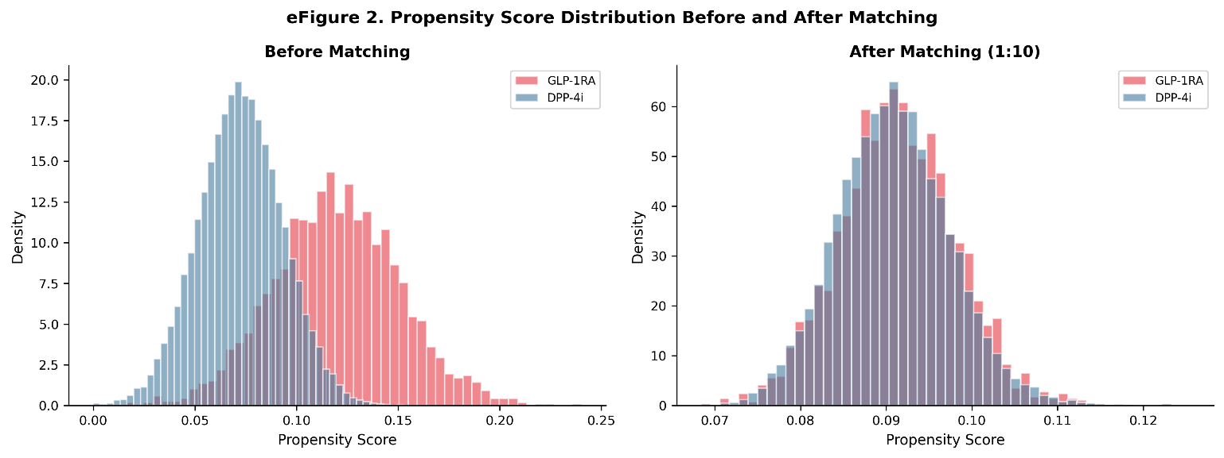Left panel: propensity score density histograms for GLP-1RA initiators (red) and DPP-4i initiators (blue) before matching, showing moderate overlap with wider spread. Right panel: propensity score distributions after 1:10 nearest-neighbor matching, demonstrating excellent overlap between treatment groups across the full range of estimated propensity scores.

Supplementary Figure 3. Inverse probability of censoring weight (IPCW) diagnostics.
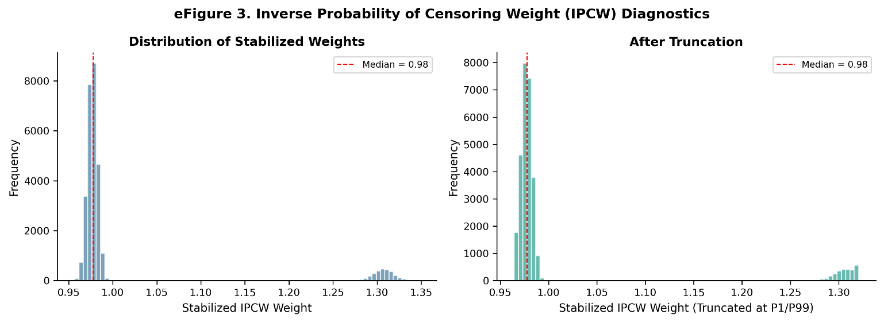
Left panel: distribution of stabilized IPCW weights before truncation, with red dashed line indicating the median. Right panel: distribution after truncation at the 1st and 99th percentiles. The mean weight close to 1.0 and narrow distribution confirm a well-behaved weighting scheme suitable for per-protocol analysis.

Supplementary Figure 4. Sensitivity analyses for all gastrointestinal outcomes.
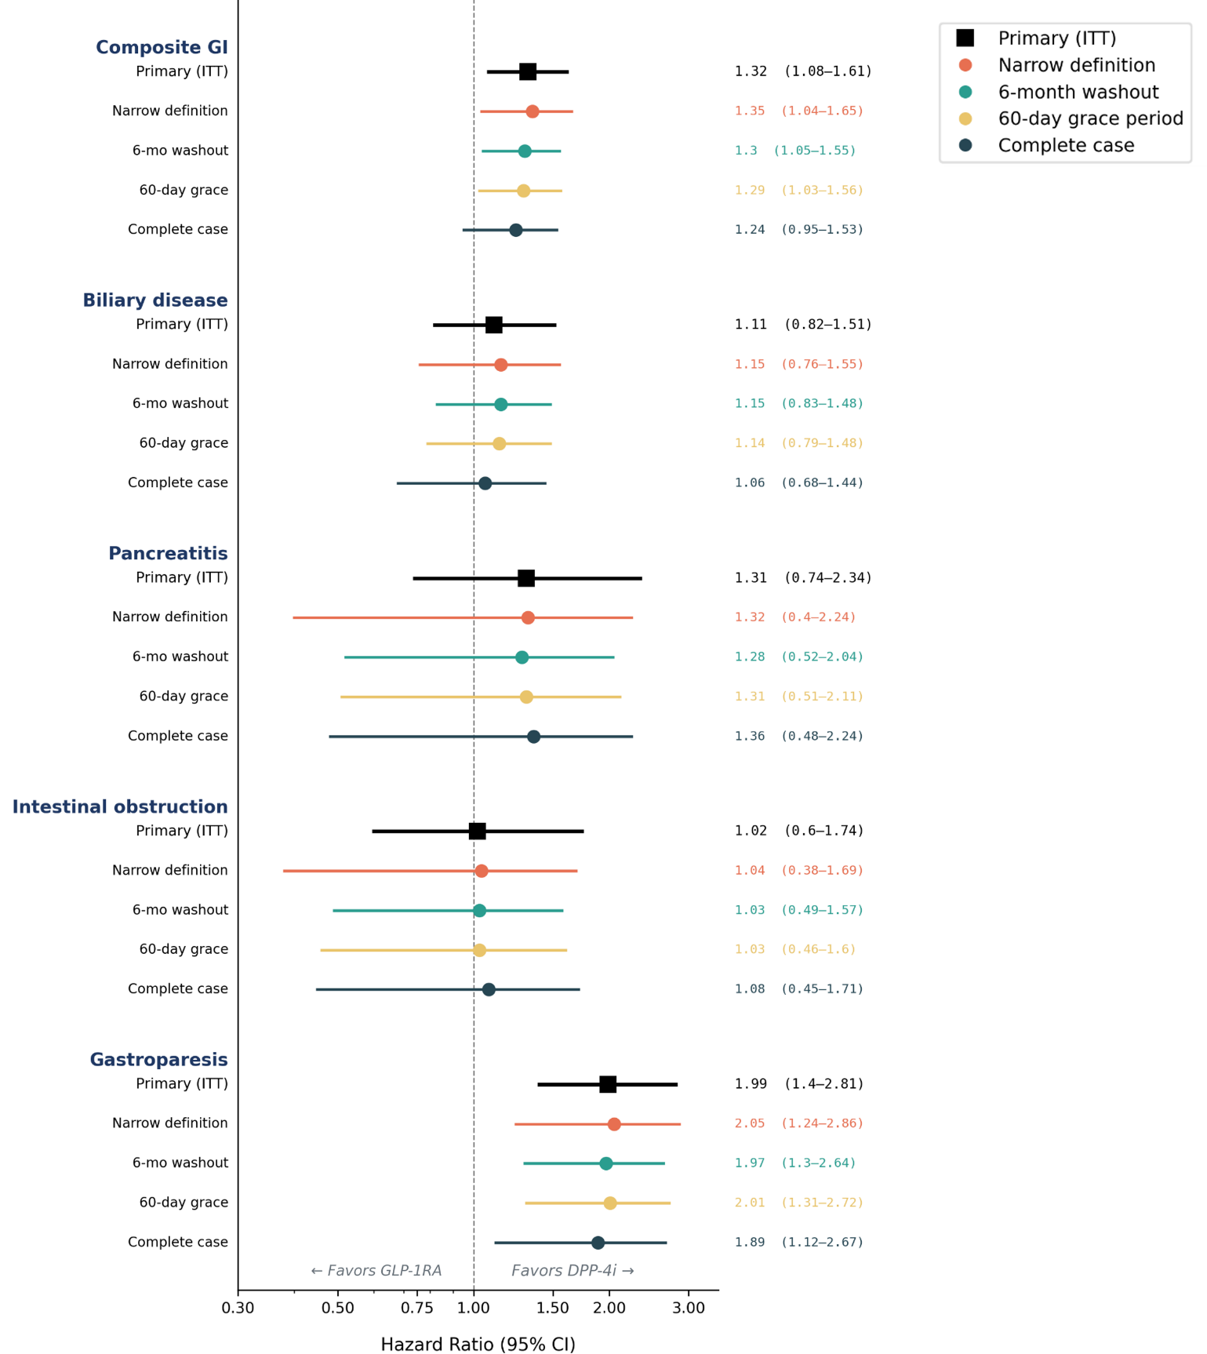Forest plot displaying hazard ratios (95% CI) for each of the five GI outcomes under four sensitivity analysis conditions (narrow outcome definitions, 6-month washout, 60-day grace period, and complete-case analysis) compared with the primary ITT estimate (black squares). Colored markers indicate sensitivity analysis type. Results are consistent across all conditions, supporting the robustness of the primary findings. X-axis on log scale (0.3–3.5).

Supplementary Figure 5. E-values for unmeasured confounding assessment.
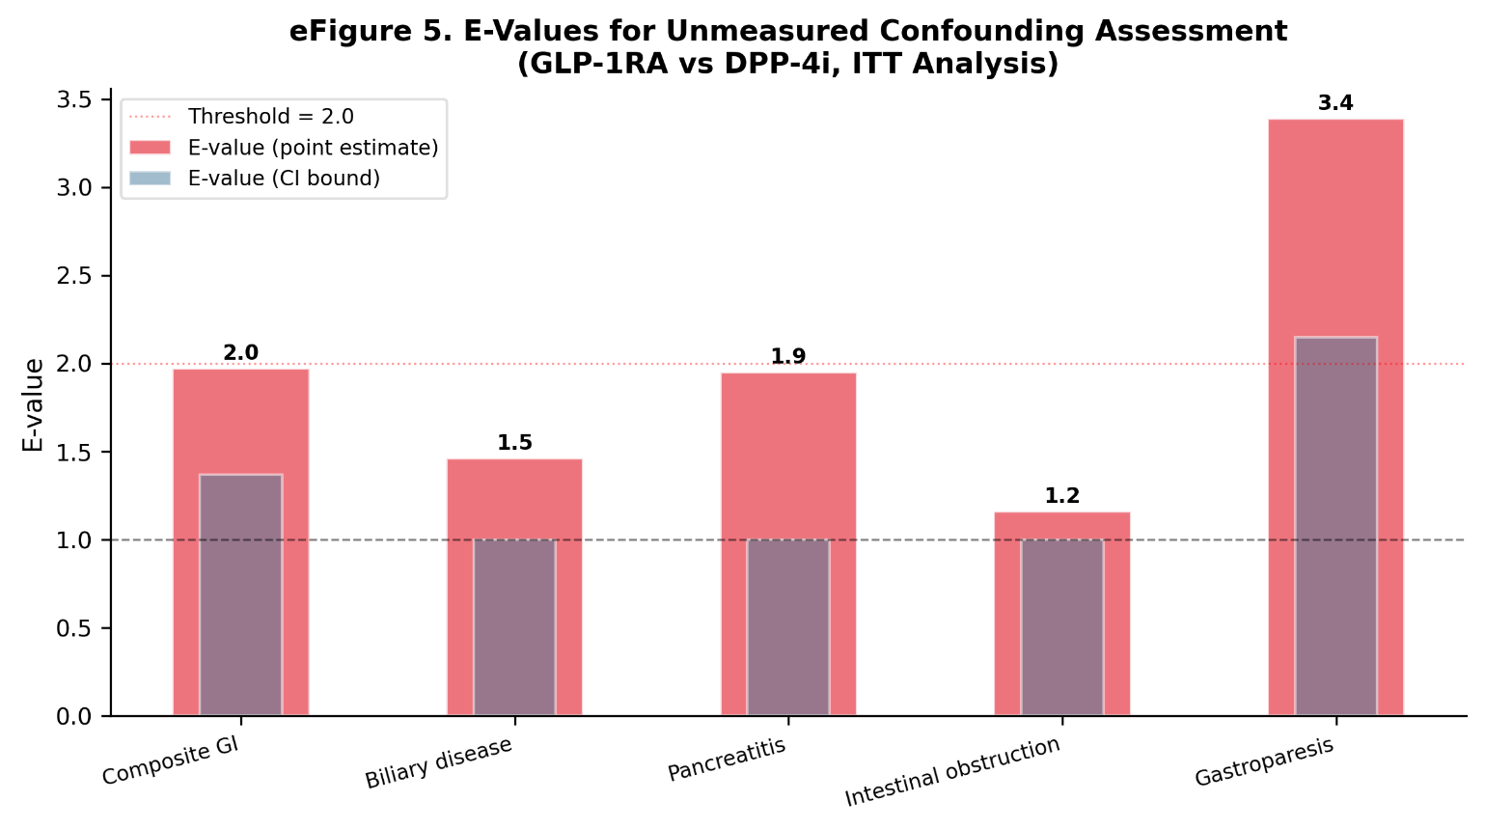Bar chart showing E-values for the point estimate (red bars) and the confidence interval bound closest to the null (blue bars) for each of the five GI outcomes. The red dotted horizontal line indicates the threshold of 2.0. Gastroparesis has the largest E-value (3.4), indicating that a strong unmeasured confounder would be required to fully explain away the observed association. The composite GI outcome has an E-value of 2.0.

Supplementary Figure 6. Target trial emulation design diagram.
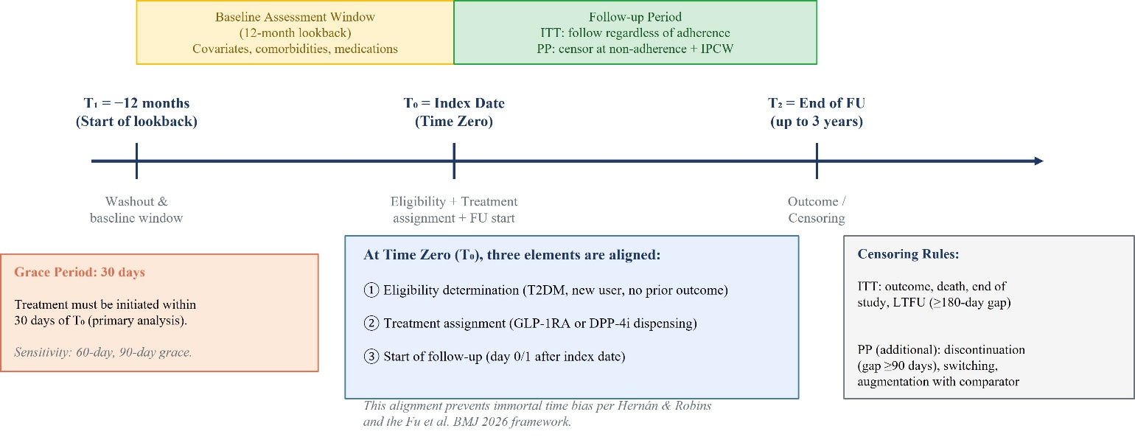
Schematic representation of the time-zero alignment framework showing the baseline assessment window (−12 months), the index date (time zero, T₀), and the follow-up period (up to 3 years). Three elements are aligned at T₀: eligibility determination, treatment assignment, and the start of follow-up. Boxes annotate the grace period (30 days), censoring rules for ITT and per-protocol analyses, and the rationale for preventing immortal time bias.

