Supplementary Materials

Text S1. Coulomb Failure Stress for Changing Strike of the EAF
From east to west, we find that the strike of the EAF is 19 km - 270°, 14 km - 277°, 6.5 km - 285°, 13 km - 298°. Hence, the average strike per kilometer is 280.7°. Below, we show the change in Coulomb Failure Stress of a similar receiver fault with strikes of 270°, 280°, 290°, 300°, and 310°.
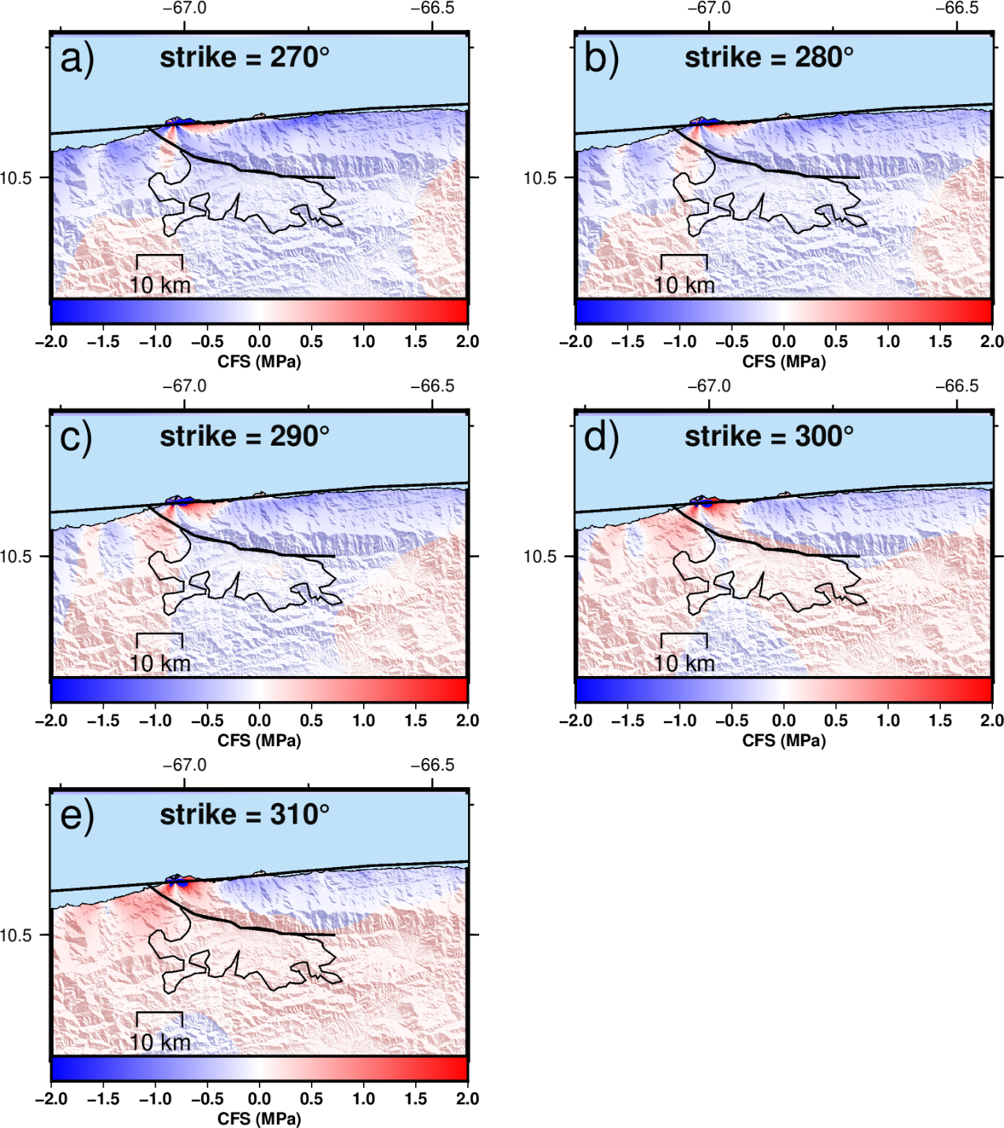
Fig. S1. Change in Coulomb Failure Stress following the SSF rupture for a receiver fault of dip = 76°, rake = 135° and strikes of (a) 270°, (b) 280°, (c) 290°, (d) 300°, (e) 310°.

Text S2.
Velocity, per pixel, was estimated by fitting the time series to the following equation that accounted for the seasonal and semiseasonal variation and steps that are due to unwrapping error.

$$x\left(t\right)={A_{i}H}_{i}(t)+B\sin\left(ht+ γ_{annual}\right)+ C\sin\left(2ht+γ_{semi-ann}\right)+v(t)$$

where $A_{i}$ are the amplitudes of the step functions $H_{i}(t)$, $B$ and $C$ are the amplitudes of the annual and semi-annual seasonal components, $γ$ is the phase lag of the annual and semi-annual seasonal components, and $v(t)$ is the velocity.

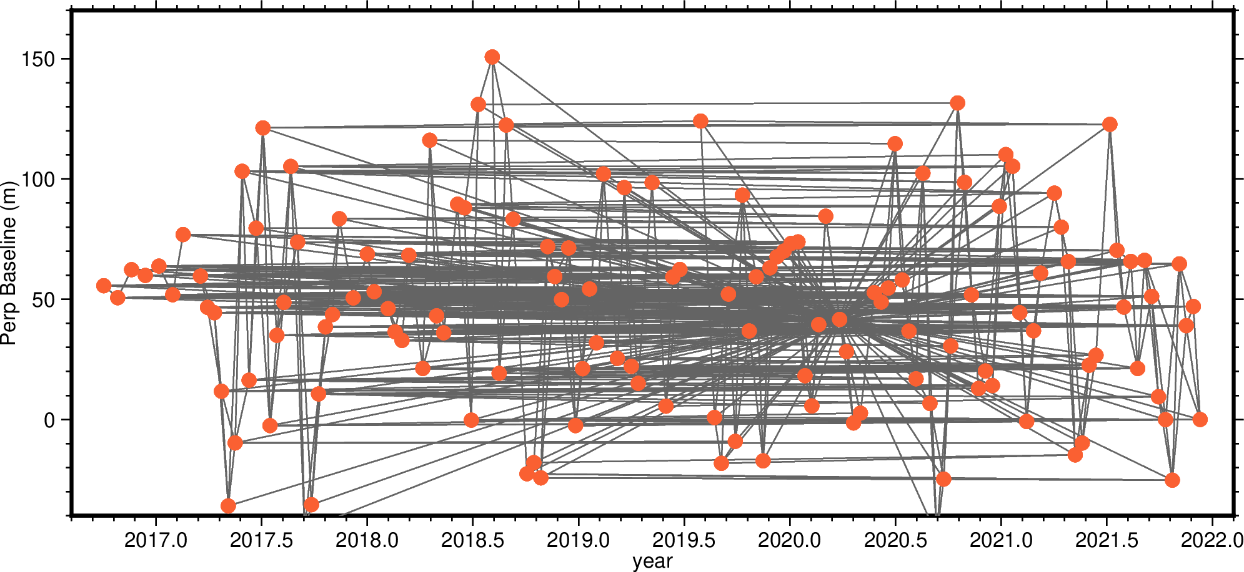
Fig. S2. Baselines used to create interferograms.

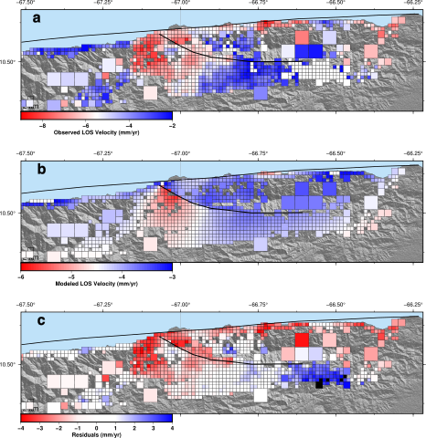
Fig. S3. San Sebastian and El Avila faults interseismic slip deficit inversion. a) Subsampled InSAR velocities. b) Model-predicted velocities. c) Model residuals. The model RMS was 1.8 mm/yr.

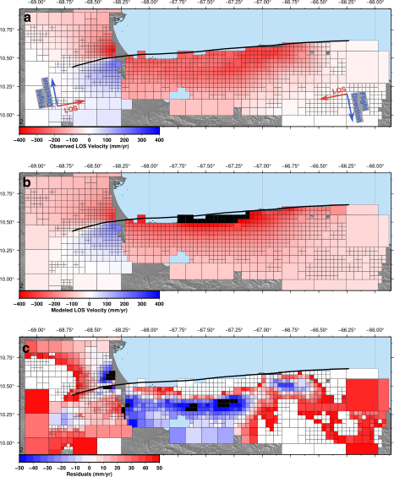
Fig. S4. June 24th 2026 doublet coseismic slip inversion. a) Subsampled InSAR velocities. b) Model-predicted velocities. c) Model residuals. The model RMS was 51 mm.

