Supplementary Table 1. Regions and Countries Classification.
Region | Countries
Africa | Angola, Algeria, Burundi, Benin, Burkina Faso, Botswana, Central African Republic, Côte d’Ivoire, Cameroon, Democratic Republic of the Congo, Republic of the Congo, Comoros, Cabo Verde, Djibouti, Egypt, Eritrea, Ethiopia, Gabon, Ghana, Guinea, The Gambia, Guinea-Bissau, Equatorial Guinea, Kenya, Liberia, Libya, Lesotho, Morocco, Madagascar, Mali, Mozambique, Mauritania, Mauritius, Malawi, Namibia, Niger, Nigeria, Rwanda, Sudan, Senegal, Sierra Leone, Somalia, São Tomé and Príncipe, Eswatini, Seychelles, Chad, Togo, Tunisia, Tanzania, Uganda, South Africa, Zambia, Zimbabwe.
South America | Argentina, Brazil, Bolivia, Chile, Colombia, Ecuador, Guyana, Peru, Paraguay, Suriname, Uruguay, Venezuela.
Central America | Belize, Costa Rica, Guatemala, Honduras, Nicaragua, Panama, El Salvador.
East Asia | China, Hong Kong, Japan, South Korea, Mongolia.
Oceania | Australia, Fiji, New Caledonia, New Zealand, Papua New Guinea, Solomon Islands, Tonga, Tuvalu, Vanuatu.
South and Southeast Asia | Afghanistan, Bangladesh, Bhutan, Brunei, Indonesia, India, Cambodia, Laos, Sri Lanka, Myanmar, Malaysia, Nepal, Pakistan, the Philippines, Singapore, Thailand, Timor-Leste, Vietnam.
Eurasia | Armenia, Azerbaijan, Belarus, Georgia, Kazakhstan, Kyrgyzstan, Moldova, Russia, Tajikistan, Turkmenistan, Ukraine, Uzbekistan.
Europe | Albania, Andorra, Austria, Belgium, Bulgaria, Bosnia and Herzegovina, Switzerland, Cyprus, Czechia, Germany, Denmark, Spain, Estonia, Finland, France, the United Kingdom, Greece, Croatia, Hungary, Ireland, Iceland, Italy, Kosovo, Liechtenstein, Lithuania, Luxembourg, Latvia, Monaco, Malta, Montenegro, the Netherlands, North Macedonia, Norway, Poland, Portugal, Romania, San Marino, Serbia, Slovakia, Slovenia, Sweden.
Middle East | Bahrain, Iran, Iraq, Israel, Jordan, Kuwait, Lebanon, Oman, Palestine, Qatar, Saudi Arabia, Syria, the United Arab Emirates, Yemen
North America | Canada, Mexico, United States

Supplementary Table 2. Best-performing forecasting methods and accuracy metrics by region.
Variable | Best Model | MAE | RMSE | MAPE | R²
Africa
GDP | Fourier Harmonic Trend  (w=24, period=24.75, h=3) | 7.14E+10 | 7.91E+10 | 2.51 | 0.71
MtCO₂ | ARIMA_Opt(3,1,0) | 19.80 | 24.41 | 1.38 | 0.36
Population | SSA recurrent (L=13, r=8) | 344156.04 | 452344.37 | 0.02 | 1.00
Primary Energy | Fourier Harmonic Trend (w=22, period=23.50, h=2) | 39.82 | 49.29 | 0.75 | 0.95
Central America
GDP | Fourier Harmonic Trend (w=13, period=18.50, h=3) | 2.3E+09 | 3.54E+09 | 0.80 | 0.99
MtCO₂ | Fourier Harmonic Trend (w=14, period=8.50, h=2) | 1.35 | 1.69 | 2.17 | 0.84
Population | Fourier Harmonic Trend (w=14, period=16.75, h=3) | 6906.71 | 8877.45 | 0.01 | 1.00
Primary Energy | Fourier Harmonic Trend (w=18, period=28.25, h=3) | 7.69 | 8.43 | 2.22 | 0.88
East Asia
GDP | Fourier Harmonic Trend (w=20, period=10.25, h=3) | 5.19E+11 | 5.95E+11 | 2.10 | 0.82
MtCO₂ | Fourier Harmonic Trend (w=29, period=26.50, h=3) | 223.19 | 246.35 | 1.64 | 0.89
Population | Fourier Harmonic Trend (w=15, period=22.25, h=3) | 549843.35 | 581977.75 | 0.03 | 0.84
Primary Energy | Fourier Harmonic Trend (w=22, period=8.75, h=2) | 336.61 | 435.36 | 0.69 | 0.99
South and Southeast Asia
GDP | Fourier Harmonic Trend (w=14, period=16.50, h=3) | 4.54E+10 | 4.89E+10 | 0.60 | 0.99
MtCO₂ | Local Damped Trend (w=5, phi=0.95) | 76.34 | 89.12 | 1.66 | 0.95
Population | Fourier Harmonic Trend (w=16, period=25.25, h=3) | 289025.96 | 416653.57 | 0.01 | 1.00
Primary Energy | SSA recurrent (L=7, r=2) | 271.54 | 348.89 | 1.45 | 0.96
South America
GDP | Fourier Harmonic Trend (w=13, period=15.75, h=3) | 5.39E+10 | 5.88E+10 | 1.30 | 0.97
MtCO₂ | Post-Peak Segmented Trend | 14.96 | 17.50 | 1.32 | 0.89
Population | Fourier Harmonic Trend (w=12, period=22.75, h=3) | 60981.36 | 69309.01 | 0.01 | 1.00
Primary Energy | Fourier Harmonic Trend (w=16, period=18.50, h=3) | 83.77 | 95.10 | 1.19 | 0.68
Eurasia
GDP | Fourier Harmonic Trend (w=27, period=29.75, h=3) | 1.3E+11 | 1.34E+11 | 4.81 | 0.80
MtCO₂ | Fourier Harmonic Trend (w=20, period=15.50, h=2) | 26.27 | 30.30 | 1.01 | 0.93
Population | Fourier Harmonic Trend (w=14, period=30.75, h=3) | 731892.67 | 869754.61 | 0.25 | 0.75
Primary Energy | Fourier Harmonic Trend (w=13, period=13.75, h=2) | 137.73 | 153.16 | 1.18 | 0.72
Europe
GDP | AutoReg tuned (lags=10, trend=ct) | 4.2E+11 | 4.7E+11 | 1.99 | 0.87
MtCO₂ | Exponential Smoothing (w=25, trend=add, damped=True, boxcox=True) | 61.27 | 76.19 | 1.75 | 0.88
Population | Fourier Harmonic Trend (w=20, period=19.75, h=2) | 396053.97 | 449957.40 | 0.07 | 0.94
Primary Energy | SSA recurrent (L=13, r=6) | 288.42 | 353.69 | 1.45 | 0.74
Middle East
GDP | Fourier Harmonic Trend (w=30, period=11.00, h=3) | 1.19E+11 | 1.21E+11 | 3.64 | 0.87
MtCO₂ | Fourier Harmonic Trend (w=19, period=30.25, h=3) | 15.67 | 18.63 | 0.72 | 0.94
Population | Fourier Harmonic Trend (w=19, period=30.00, h=3) | 655151.79 | 688762.19 | 0.24 | 0.99
Primary Energy | MLP (tuned+lags) | 107.74 | 116.79 | 1.05 | 0.96
North America
GDP | SSA recurrent (L=8, r=7) | 3.91E+11 | 5.9E+11 | 1.45 | 0.95
MtCO₂ | MLP (tuned+lags) | 46.83 | 56.49 | 0.78 | 0.92
Population | Fourier Harmonic Trend (w=13, period=18.50, h=3) | 735811.08 | 825958.18 | 0.15 | 0.97
Primary Energy | MLP (tuned+lags) | 131.33 | 169.68 | 0.41 | 0.83
Oceania
GDP | Fourier Harmonic Trend (w=27, period=29.00, h=3) | 1.06E+10 | 1.29E+10 | 0.55 | 0.99
MtCO₂ | ARIMA_Opt(4,0,2) | 8.70 | 9.58 | 1.94 | 0.56
Population | Fourier Harmonic Trend (w=13, period=14.75, h=3) | 95471.95 | 105101.14 | 0.22 | 0.99
Primary Energy | SSA recurrent (L=12, r=10) | 17.92 | 19.99 | 0.93 | 0.73

Supplementary Table 3. Summary of empirical transition ranges, absolute plausibility caps, and scenario-specific effective bounds used in scenario propagation [16, 17, 18, 55, 57].
Variable | Absolute plausibility cap (%.yr-1) | Scenario 1.5° (1.50) | Scenario 2°C (1.20) | Scenario NDC (1.00) | Energy Justice (1.25)
CO₂ emissions | -15 to +10 | −13.42 to +10.00 | −10.74 to +10.00 | −8.95 to +10.00 | −11.19 to +10.00
GDP | -10 to +12 | −10.00 to +12.00 | −10.00 to +12.00 | −10.00 to +12.00 | −10.00 to +12.00
Primary Energy Consumption | -10 to +12 | −10.00 to +12.00 | −8.27 to +12.00 | −6.89 to +12.00 | −8.61 to +12.00
Population | -3 to +4 | −0.69 to +4.00 | −0.55 to +3.59 | −0.46 to +3.00 | −0.57 to +3.74
Note: Region-specific transition bounds were derived from the 5th and 95th percentiles of observed annual changes over 1990–2023. Absolute plausibility caps were subsequently imposed to prevent exceptional historical shocks or measurement irregularities from generating implausibly wide future adjustment ranges. The caps therefore represent conservative modeling safeguards rather than values directly prescribed by literature. Their use is consistent with historically grounded approaches to scenario feasibility and technology-transition assessment [18, 55, 57]. Scenario-specific multipliers adjust the width of the empirical transition envelope to represent differences in transition stringency across pathways. The maximum annual regional reduction reported for a pathway is an ex post characteristic of the simulated trajectory and should not be interpreted as an exogenously imposed mitigation bound or as a direct measure of global scenario ambition.

Supplementary Table 4. Emission factor according to the fuel used.
Fuel | Emission factor (MtCO₂/TWh)
Coal | 1.0
Natural Gas | 0.45
Oil | 0.78
Petcoke | 1.05
Cogeneration | 0.55
Waste | 0.50
Other thermal fuels | 0.70

APPENDIX – A. Scenario Comparison with IAM scenarios
Supplementary Figures 1–5 compare the trajectories for the parameters (k, η, α, ε, Rate) with the five top IAM scenarios pathways, matching across the structural indicators from [9, 11]. Overall, the comparison indicates that the proposed pathways remain within the range of trajectories represented in the AR6 scenario ensemble, although the degree of agreement varies by indicator and pathway.
Supplementary Figure 1 compares the carbon intensity of economic activity, defined as CO₂ emissions per unit of economic output. The trajectories generally show declining carbon intensity across both the study pathways and their IAM matches, indicating a gradual decoupling of economic activity from emissions. However, differences remain in the pace of decline, particularly for the more ambitious mitigation pathways. This indicator accounts for some of the largest matching differences, suggesting that the modeled relationship between economic growth and emissions reduction does not always evolve at the same rate as in the closest IAM scenarios.
Supplementary Figure 2 presents the carbon intensity of energy, which measures CO₂ emissions per unit of energy consumed. Agreement is generally stronger for this indicator, particularly for the Reference, 2 °C, and NDC pathways. The declining trajectories observed in most cases indicate progressive reductions in the carbon content of the energy supply. Nevertheless, the comparison also shows that the study pathways do not necessarily reproduce the same rate of fuel substitution, electrification, or low-carbon technology deployment represented in the IAM scenarios.
Supplementary Figure 3 compares per-capita CO₂ emissions. The study pathways broadly follow the range of their closest IAM matches, but important differences emerge in both emissions levels and rates of decline. The Reference pathway remains close to baseline and no-policy IAM trajectories, whereas the mitigation pathways generally produce lower per-capita emissions. However, the 1.5 °C pathway is not consistently aligned with IAM scenarios formally classified as 1.5 °C-compatible. This confirms that proximity in the selected indicators does not imply equivalence in cumulative emissions or temperature outcome.
Supplementary Figure 4 compares the energy intensity of GDP, expressed as energy consumption per unit of economic output. Most trajectories decline over time, reflecting continued improvements in the efficiency with which economic activity uses energy. This indicator shows relatively close agreement for several of the GCAM-based matches associated with the 1.5 °C, NDC, and Energy Justice pathways. Greater divergence is observed for some Reference and 2 °C matches, indicating differences in assumptions regarding technological progress, structural economic change, and energy-efficiency improvement.
Supplementary Figure 5 presents energy use per capita. The IAM matches generally reproduce the direction of the study pathways, although differences in absolute levels persist. The Reference and more development-oriented trajectories maintain comparatively higher energy use, while the mitigation scenarios show more constrained growth or gradual reductions. The close overlap between the NDC and Energy Justice matches indicates that these two pathways have similar global energy-use profiles. Their principal differences therefore arise from regional allocation rules, equity criteria, and differentiated mitigation responsibilities rather than from markedly different global energy consumption.
Taken together, the five supplementary figures demonstrate that the study pathways are structurally comparable to scenarios contained in the AR6 IAM ensemble. The strongest agreement is generally observed for carbon intensity of energy and energy intensity of GDP, whereas larger differences occur in carbon intensity of economic activity and, in some cases, energy use per capita. The comparison therefore supports the plausibility of the modeled trajectories, but it should be interpreted as external scenario benchmarking rather than formal validation of their nominal temperature classifications.

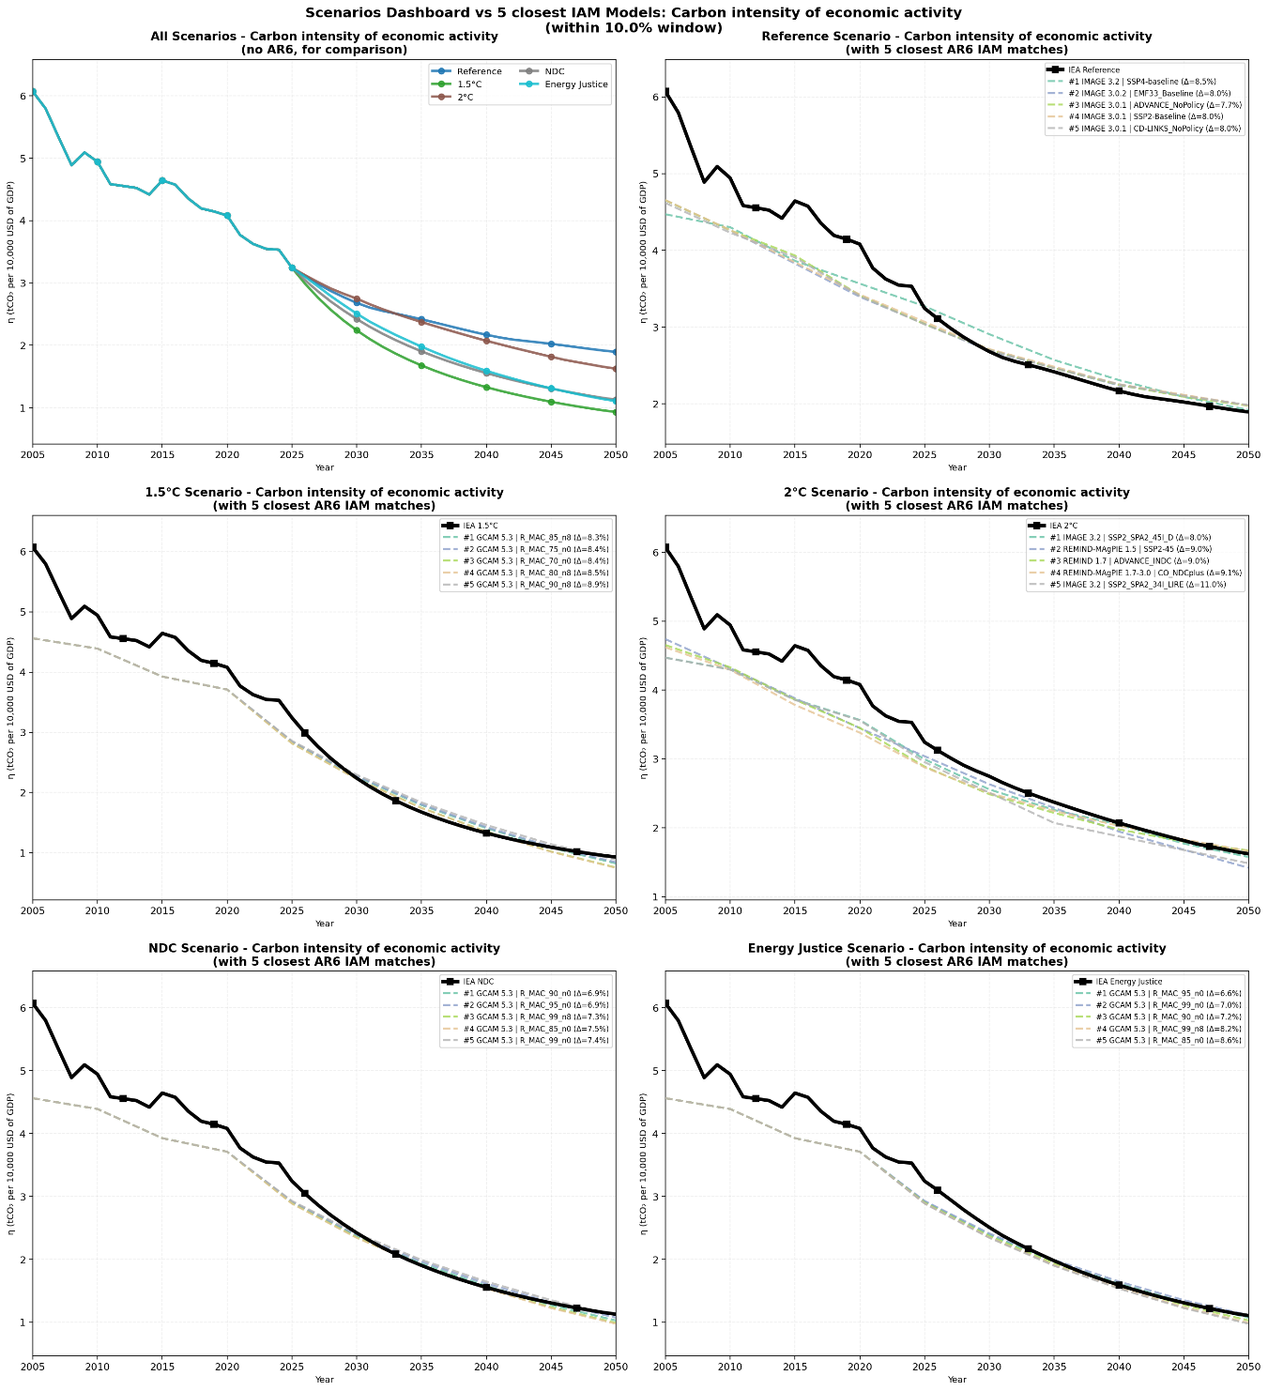
Supplementary Figure 1. Comparison of the Carbon Intensity of Economic Activity among the study scenarios and the five closest IAM scenarios
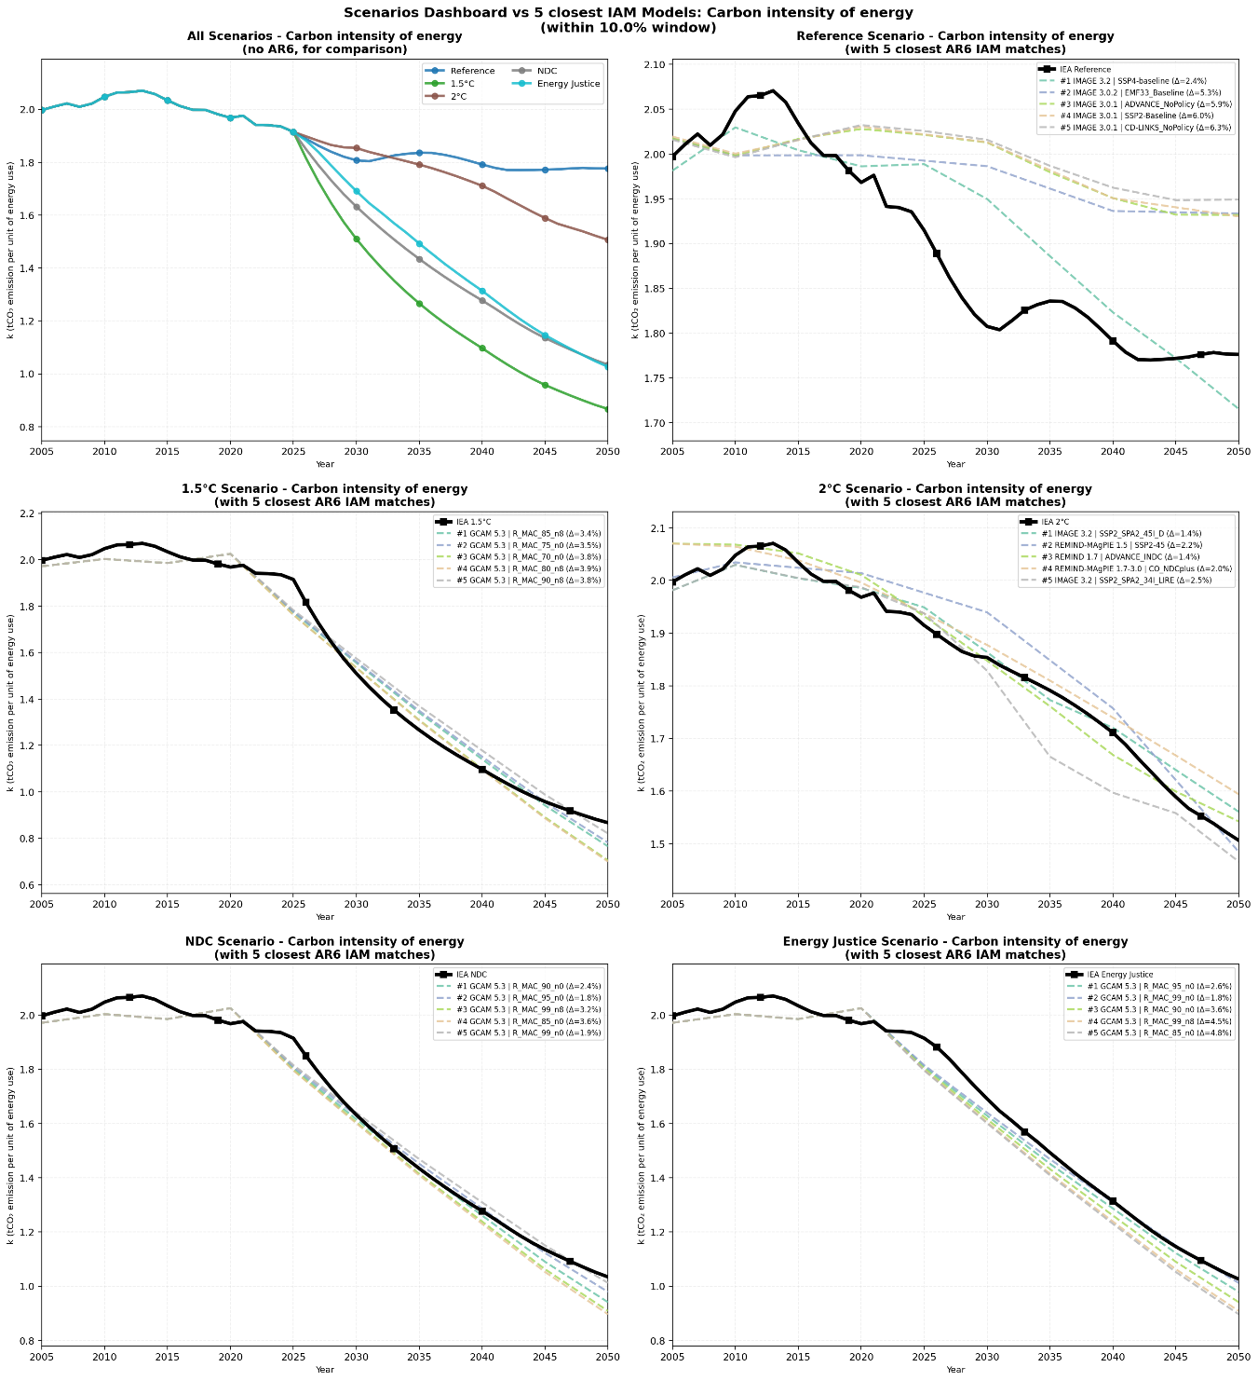
Supplementary Figure 2. Comparison of the Carbon Intensity of Energy among the study scenarios and the five closest IAM scenarios.
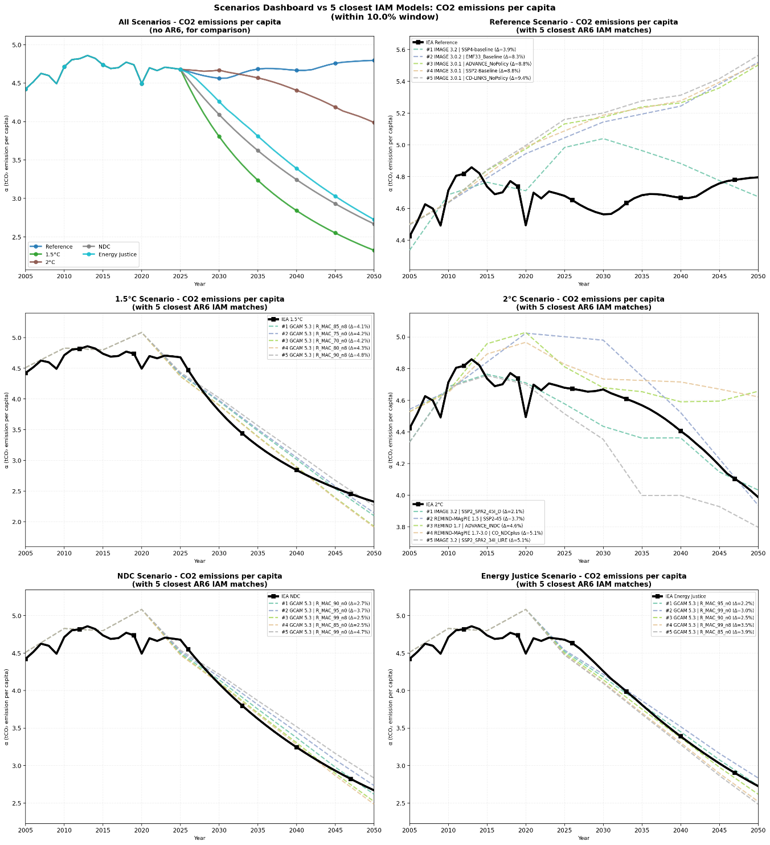
Supplementary Figure 3. Comparison of the Per capita CO₂ emissions among the study scenarios and the five closest IAM scenarios

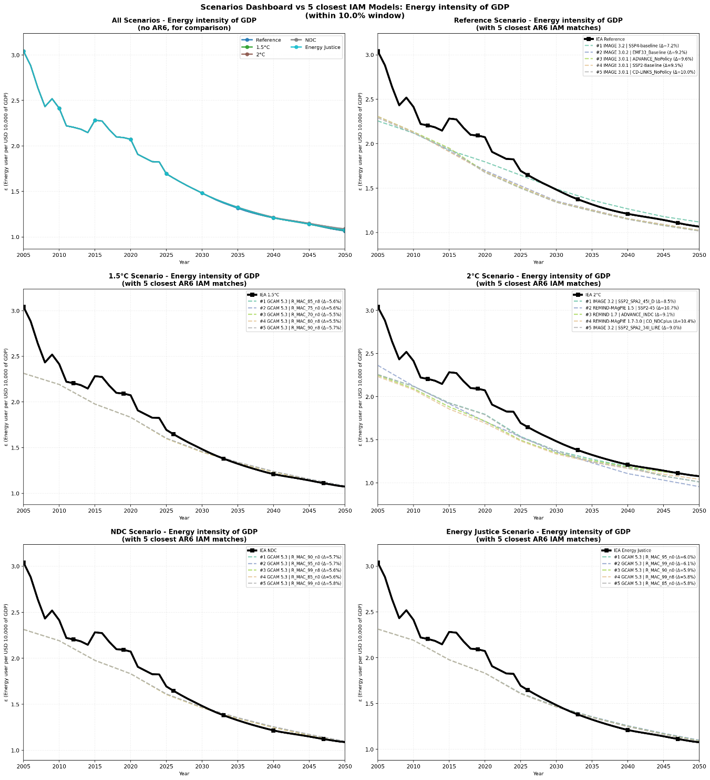
Supplementary Figure 4. Comparison of the Energy Intensity of GDP among the study scenarios and the five closest IAM scenarios.
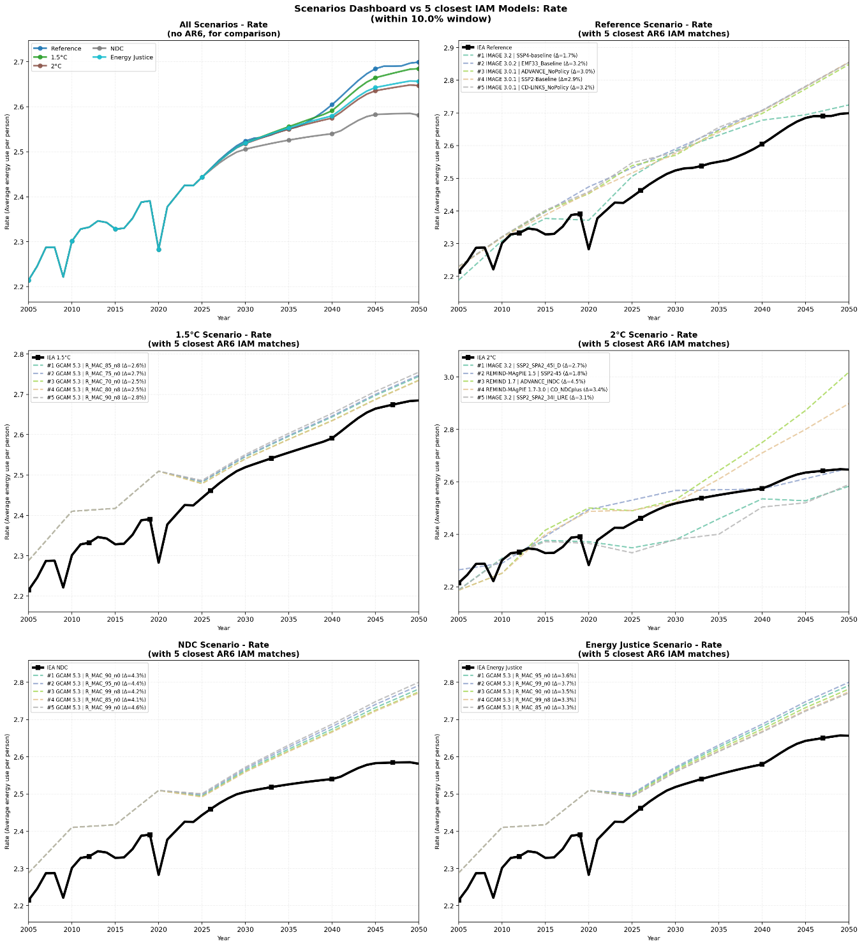
Supplementary Figure 5. Comparison of the average energy use per person among the study scenarios and the five closest IAM scenarios.

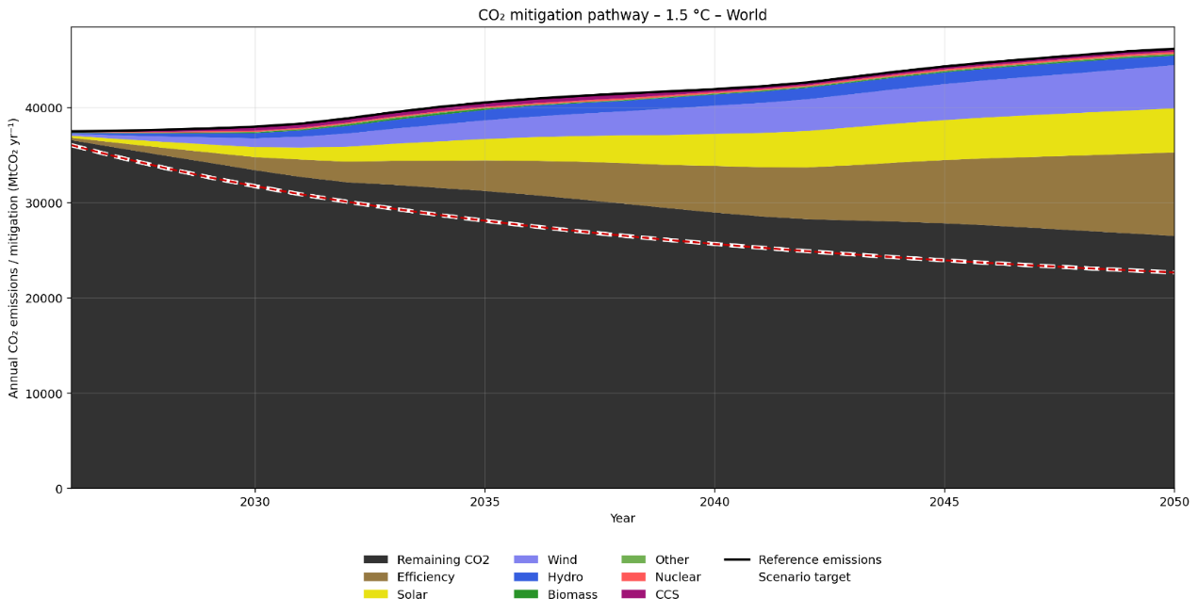
Supplementary Figure 6a. Annual CO₂ mitigation by technology with last 5 years growth rate for each scenario 1.5°C.

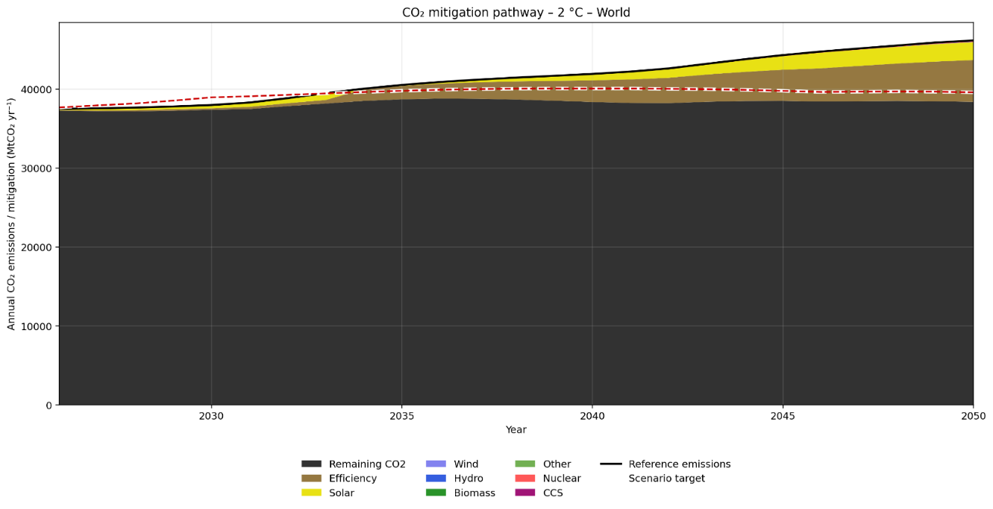
Supplementary Figure 6b. Annual CO₂ mitigation by technology with last 5 years growth rate for each scenario 2°C.

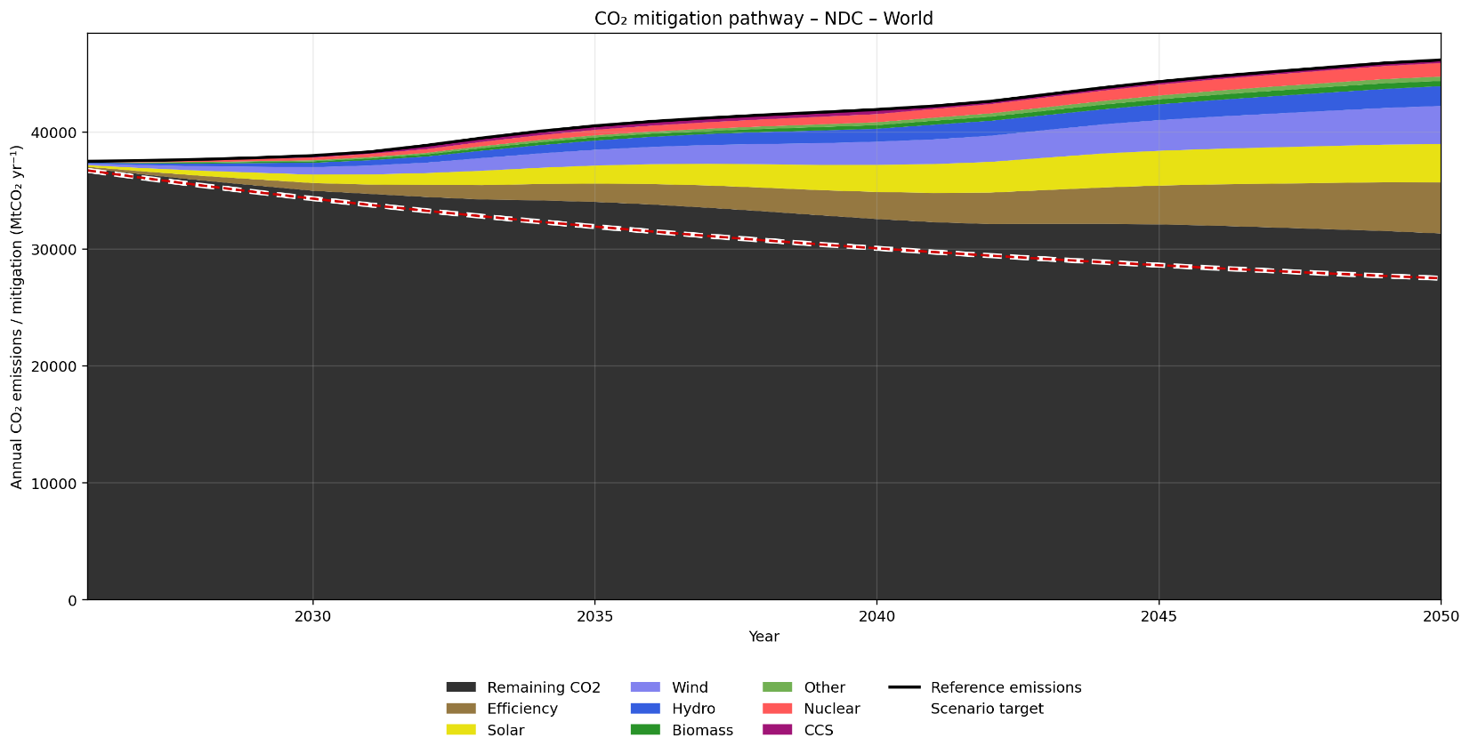
Supplementary Figure 6c. Annual CO₂ mitigation by technology with last 5 years growth rate
for each scenario NDC.

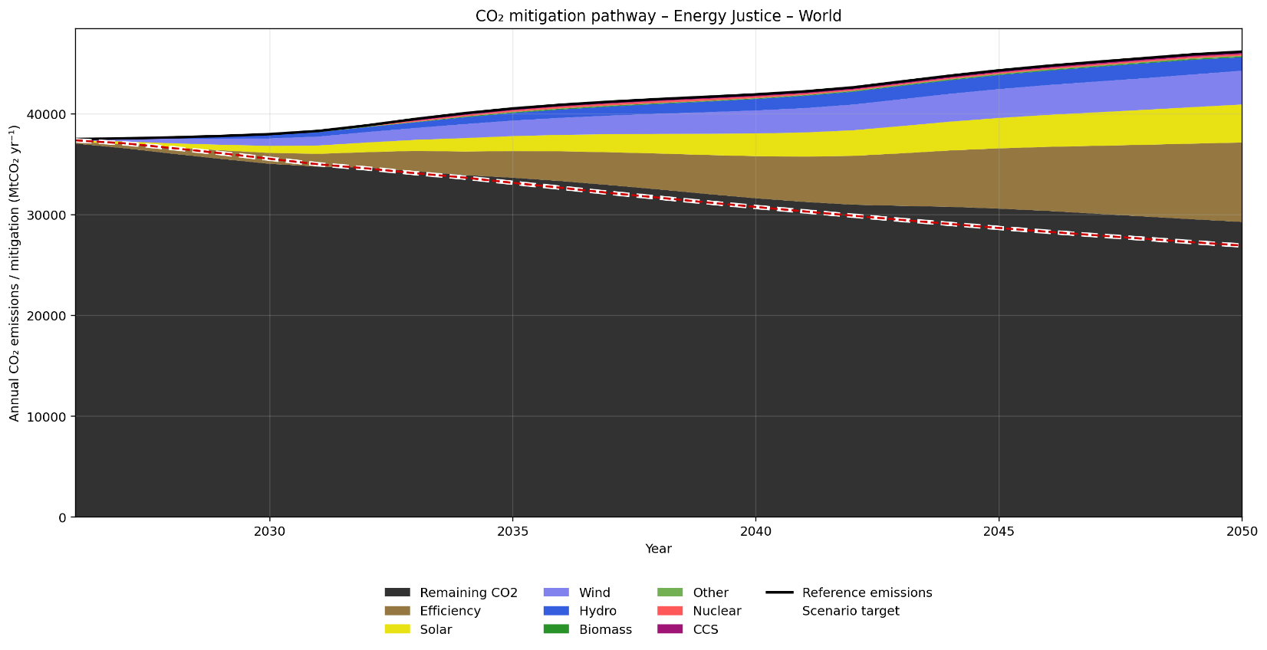
Supplementary Figure 6d. Annual CO₂ mitigation by technology with last 5 years growth rate for each scenario Energy Justice.

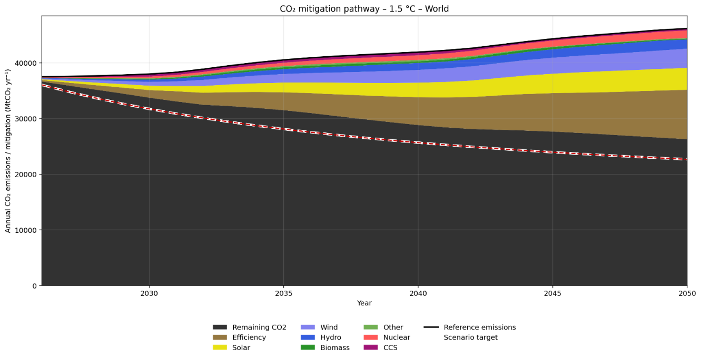
Supplementary Figure 7a. Annual CO₂ mitigation by technology with last 10 years growth rate for each scenario 1.5°C.

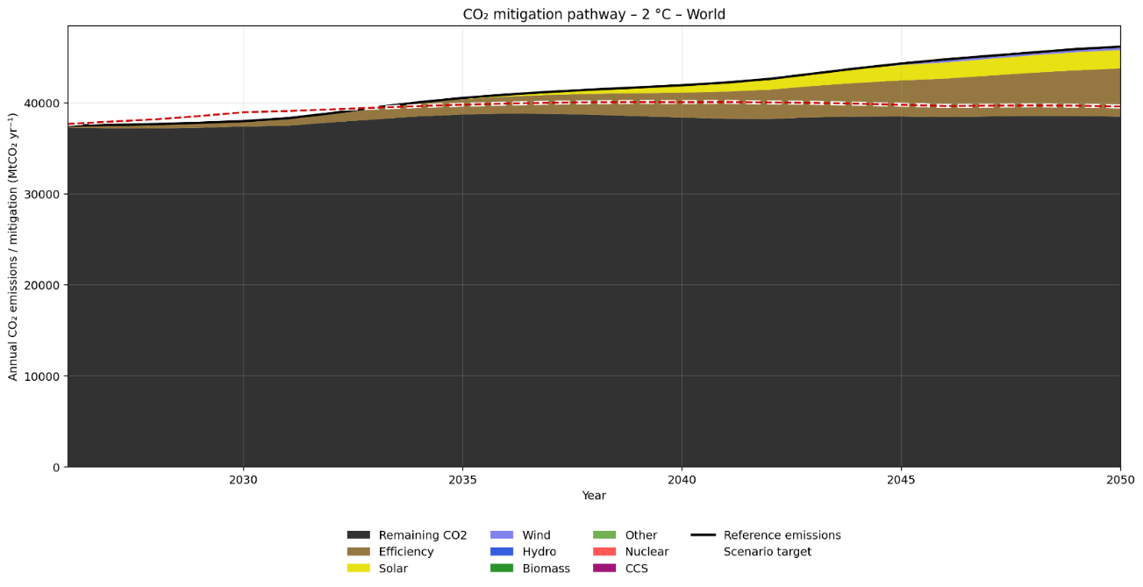
Supplementary Figure 7b. Annual CO₂ mitigation by technology with last 10 years growth rate for each scenario 2°C.

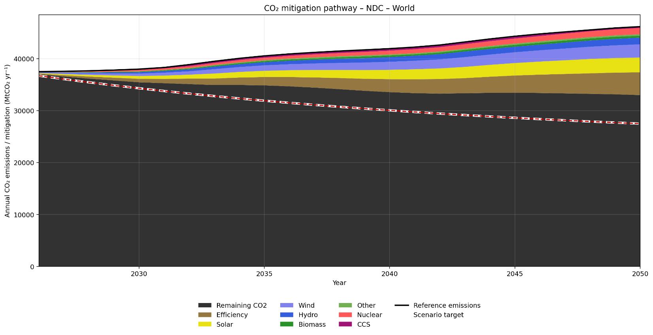
Supplementary Figure 7c. Annual CO₂ mitigation by technology with last 10 years growth rate for each scenario NDC.

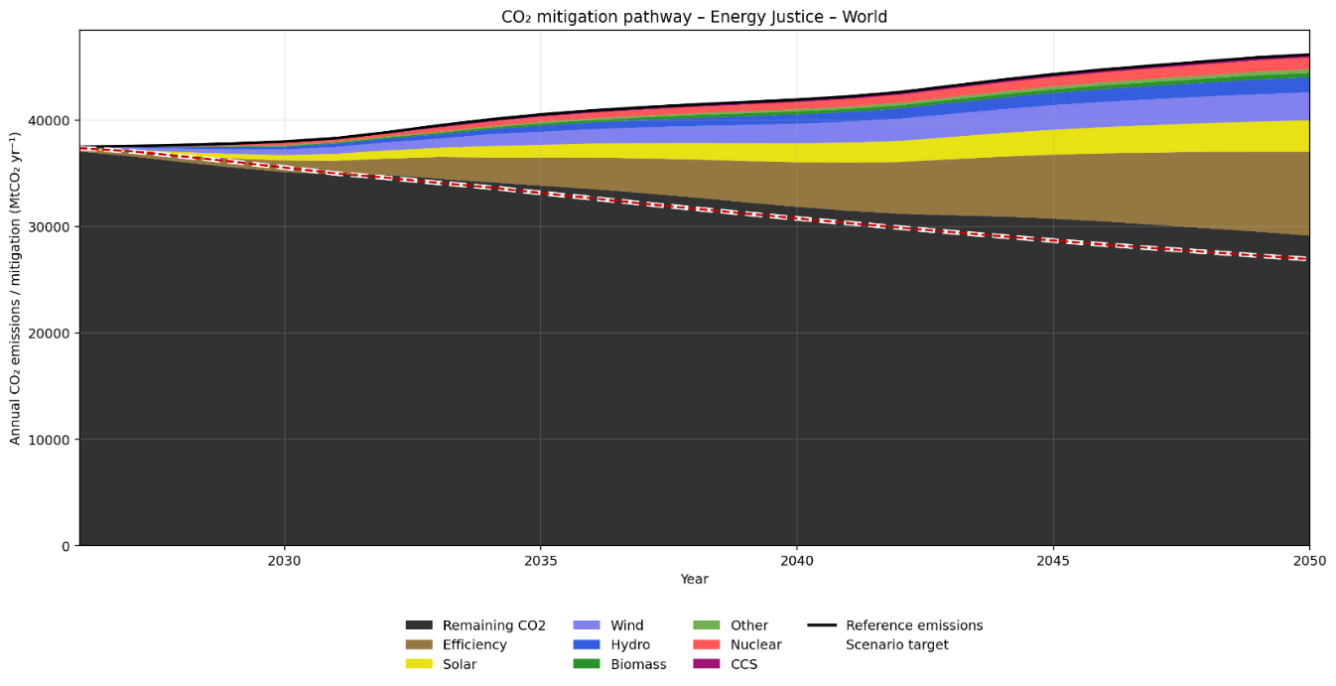
Supplementary Figure 7d. Annual CO₂ mitigation by technology with last 10 years growth rate for each scenario Energy Justice.

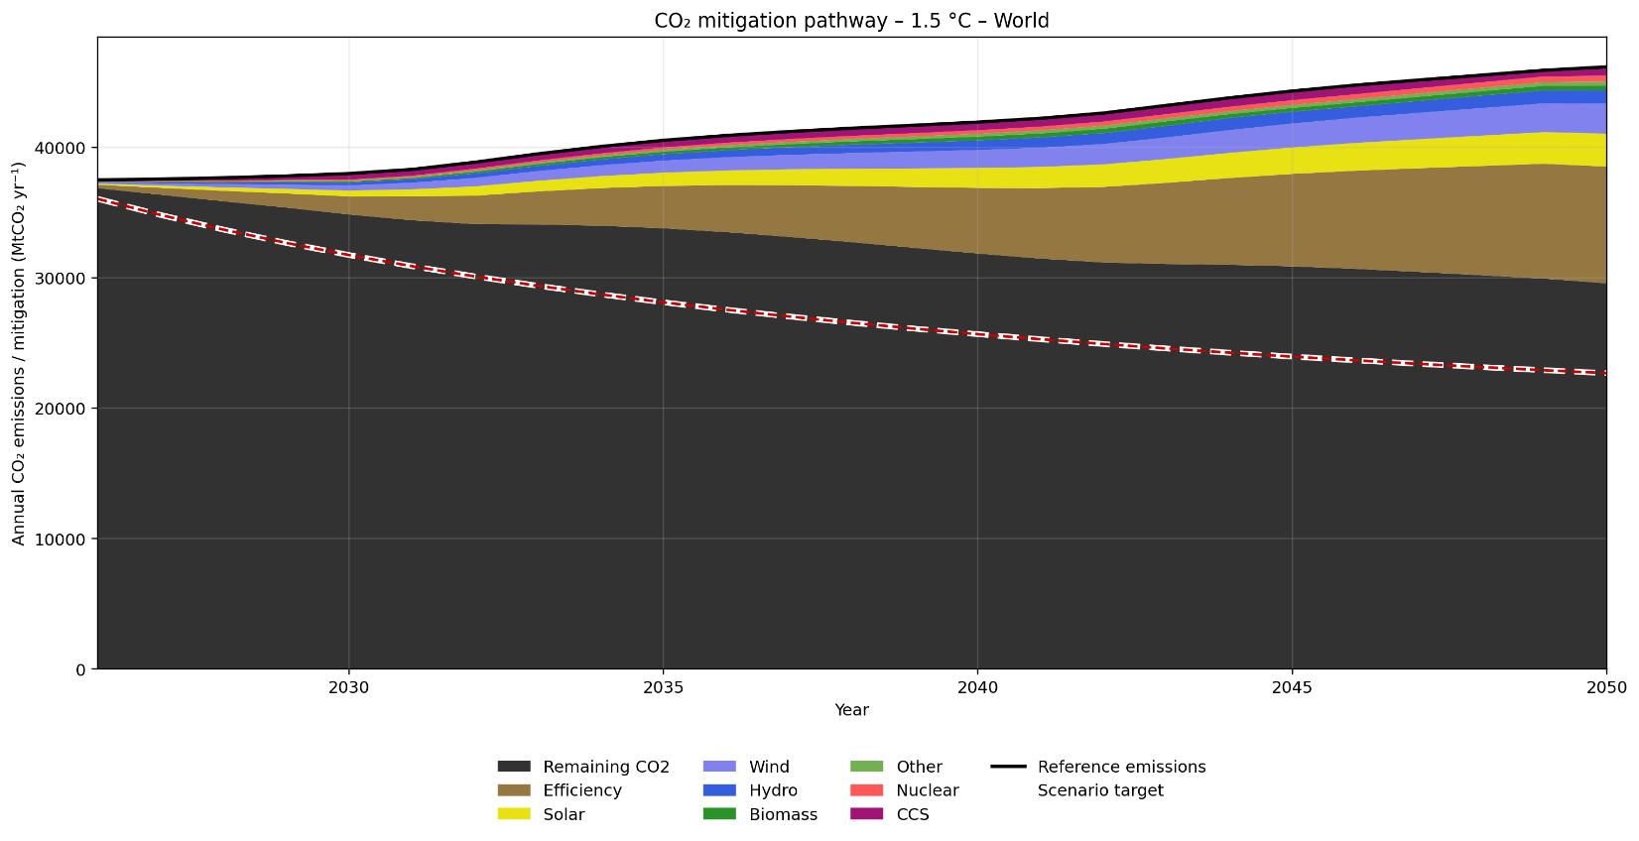
Supplementary Figure 8a. Annual CO₂ mitigation by technology with all years (2000-2025) growth rate for each scenario 1.5°C.

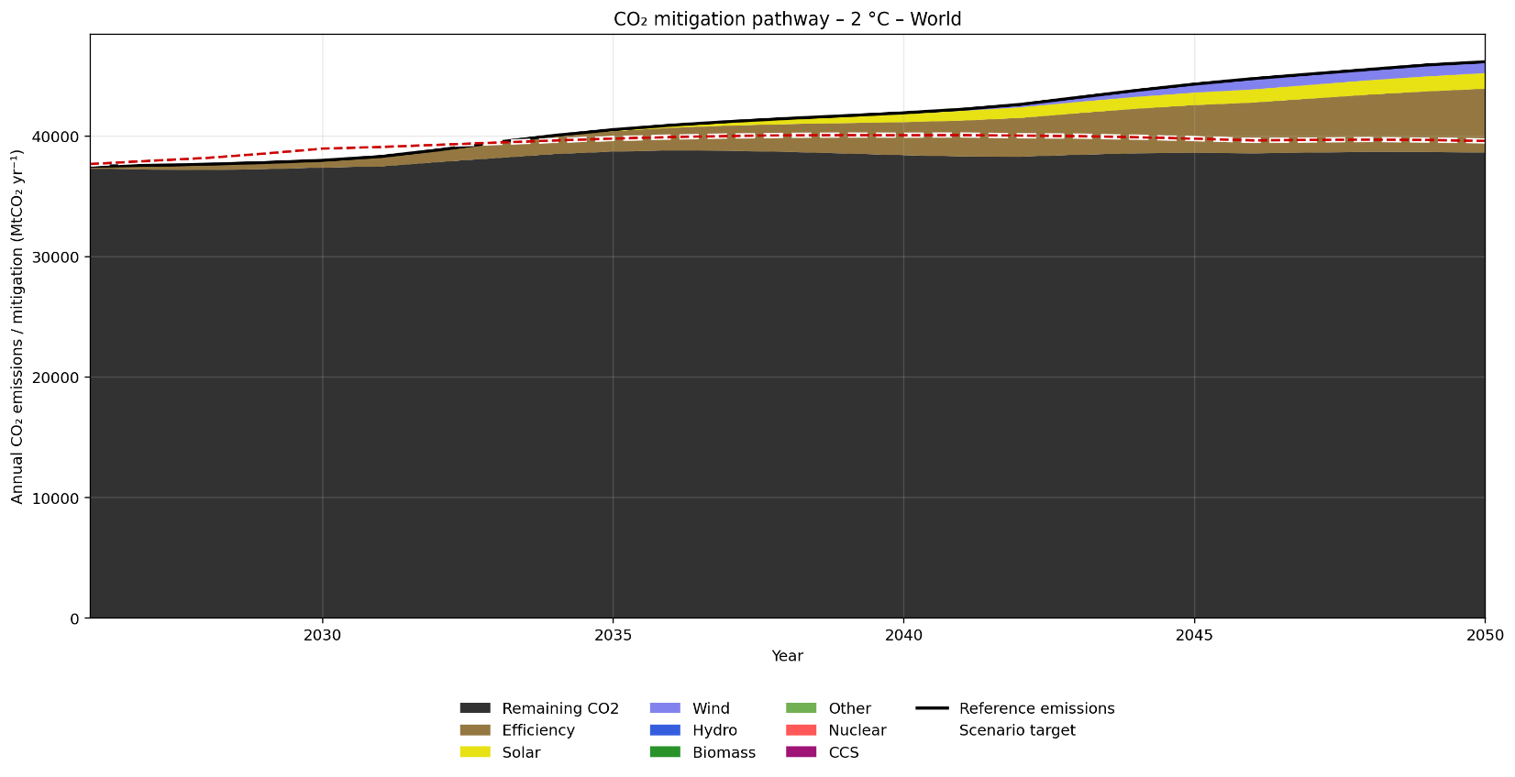
Supplementary Figure 8b. Annual CO₂ mitigation by technology with all years (2000-2025) growth rate for each scenario 2°C.
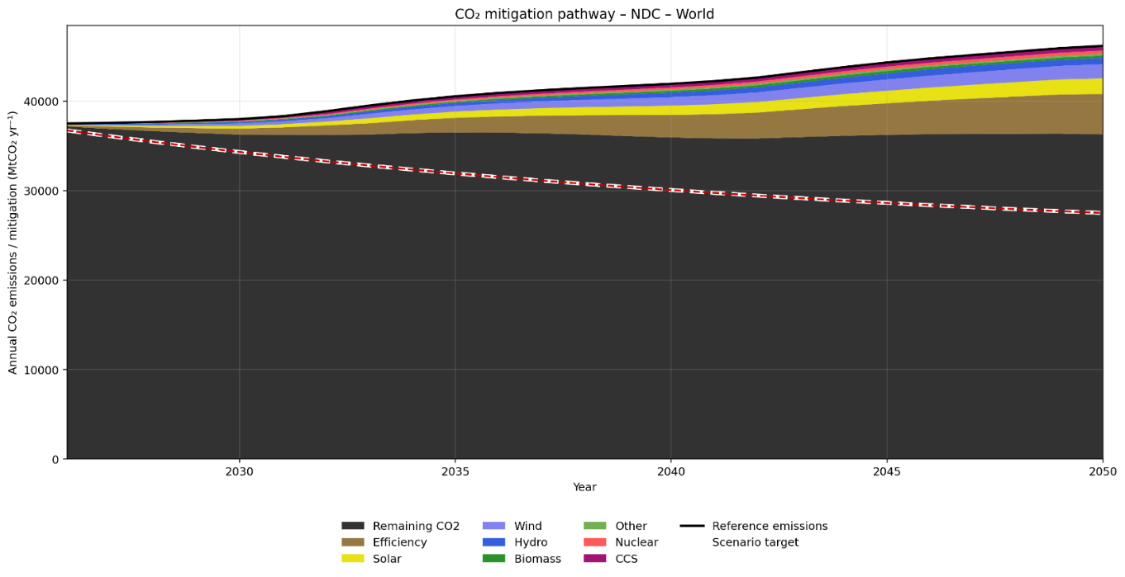
Supplementary Figure 8c. Annual CO₂ mitigation by technology with all years (2000-2025) growth rate for each scenario NDC.
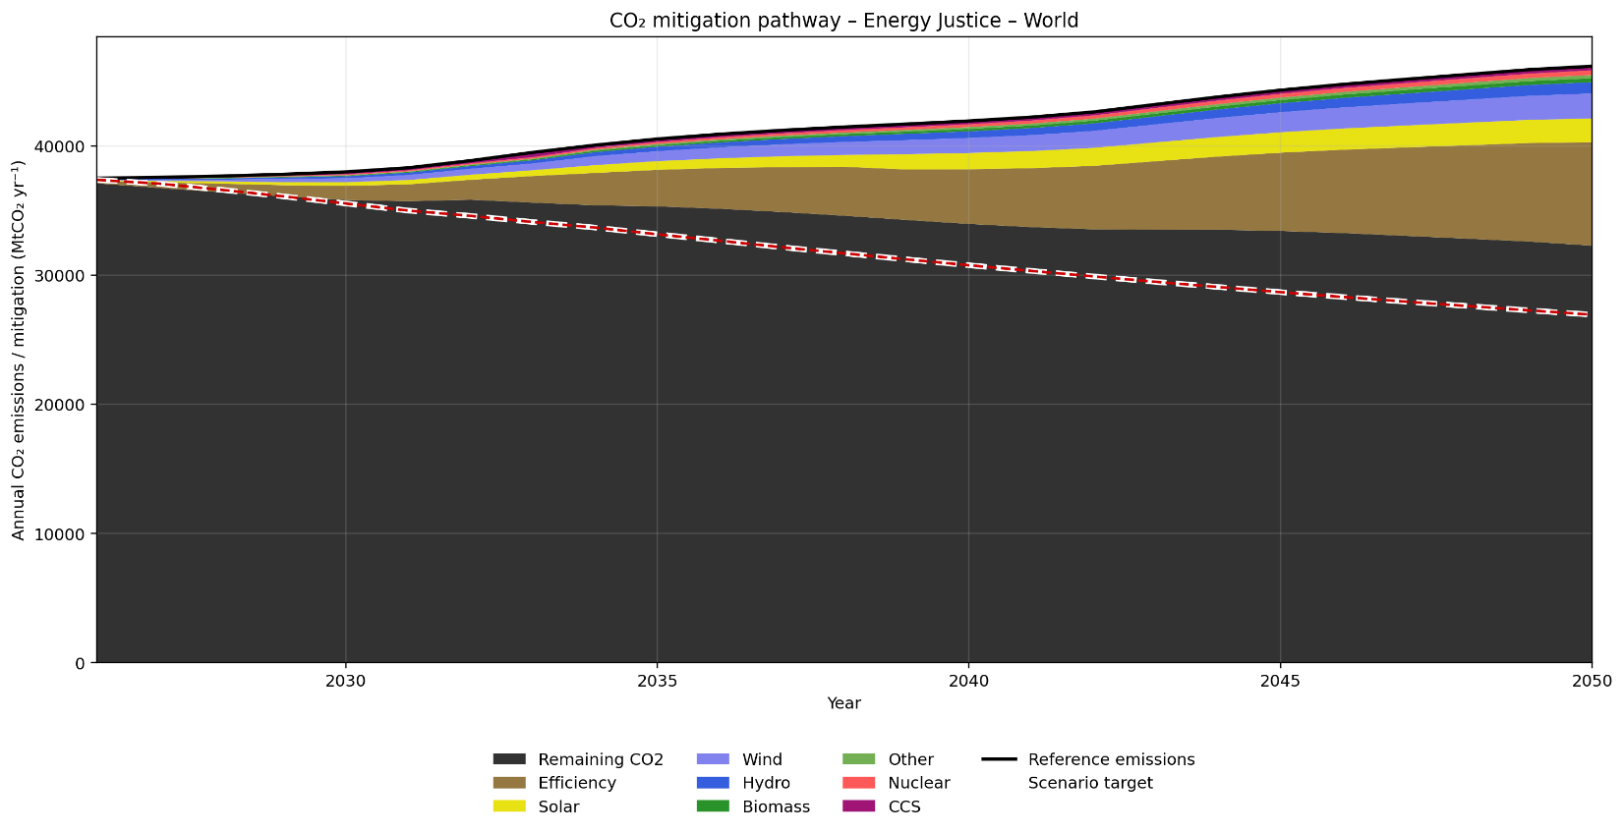
Supplementary Figure 8d. Annual CO₂ mitigation by technology with all years (2000-2025) growth rate for each scenario Energy Justice.

APPENDIX-B - Mitigation Technologies
Fuel switching can contribute to near-term emissions mitigation by replacing carbon-intensive generation with lower-carbon or renewable alternatives. In this study, the concept refers to changes in the electricity-generation mix from coal-, diesel-, and natural-gas-fired power plants toward solar, wind, hydropower, and biomass. The direction and pace of this transition were evaluated using three historical windows: the most recent five years, the last ten years, and the full 2000–2025 period, as shown in Supplementary Figures 9a–9c) [15]. These alternative windows capture short-term acceleration, medium-term structural change, and longer-term historical trends in the substitution of fossil-based electricity by renewable generation.
Supplementary Figure 9a indicates that, under the five-year trend, Central America and Eurasia still exhibit an increasing fossil-fuel share, whereas the remaining regions show stronger renewable-energy expansion accompanied by declining fossil-fuel participation. When the ten-year window is considered, Central America displays a clearer increase in renewable share and a corresponding reduction in fossil-based generation. Eurasia, by contrast, shows limited progress in reducing its fossil-fuel share, although a modest increase in renewable participation is observed. In other regions, the dominant pattern remains an increase in renewable generation and a decline in the fossil-fuel share.
The longer-term 2000–2025 trend shown in Supplementary Figure 9c reveals a different pattern for South America, where the renewable-energy share declines while the fossil-fuel share increases. This result may reflect the influence of hydrological variability, thermal-generation expansion, or slower recent growth in renewable capacity relative to electricity demand. In the remaining regions, the long-term trend is generally characterized by a reduction in fossil-fuel participation and an increase in renewable generation.
Overall, the comparison across the three historical windows demonstrates that the pace and direction of fuel switching are highly sensitive to the selected period of analysis. Recent trends may capture accelerated renewable deployment, whereas longer historical windows may reveal persistent structural dependence on fossil fuels or periods of slower transition. Consequently, fuel switching should be interpreted as a region-specific and path-dependent component of mitigation rather than as a uniform global process.
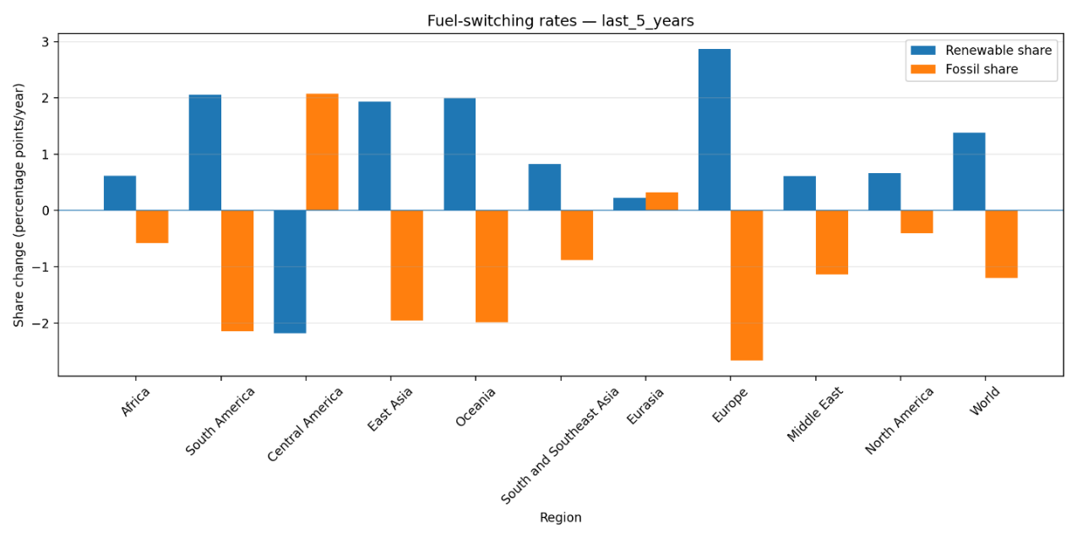
Supplementary Figure 9a. Switching fossil fuels by renewable energy with the last 5 years rate.
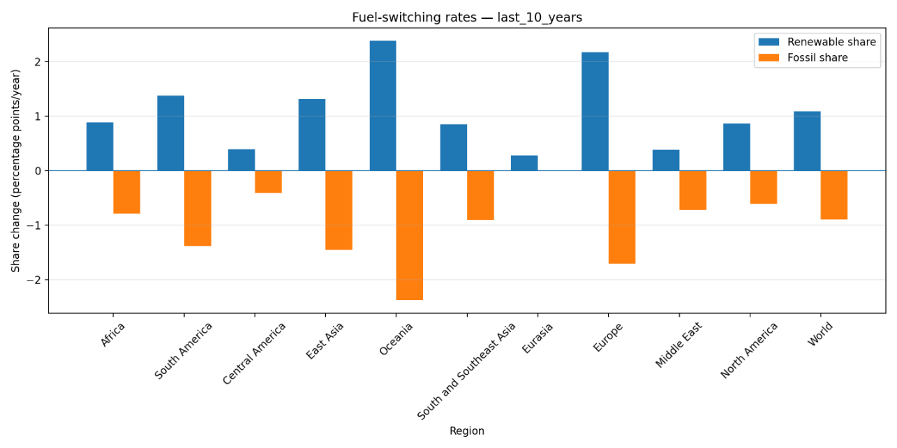
Supplementary Figure 9b. Switching fossil fuels by renewable energy with the last 10 years rate.
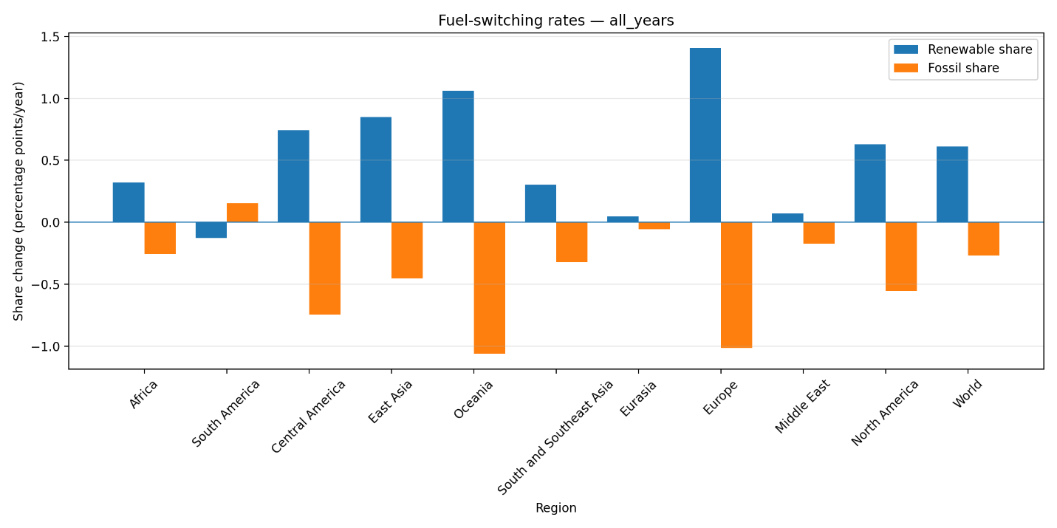
Supplementary Figure 9c. Switching fossil fuels by renewable energy with all years (2000-2025) rate.

APPENDIX C - CCUS database harmonization and regional projection
A multi-source procedure was developed to construct annual regional CCUS capacity pathways through 2050. The procedure combines project-level information from the KAPSARC mirror of the IEA CCUS Projects Database and the NETL Carbon Capture and Storage Database. It can also incorporate locally supplied files from the official IEA CCUS Projects Database, the Global CCS Institute CO2RE Database, and the Clean Air Task Force project tracker [40, 43, 44, 45, 46].
Because the original databases use different column names, units, country labels, project-status classifications, and reporting structures, the records were first converted into a common format. For each project, the harmonized database contains the data source, project name, country, ISO3 country code, region, project status, nominal annual capture capacity, expected or observed start year, sector, and CO₂ destination.
Countries were assigned to the regional classification used throughout the scenario analysis based primarily on their ISO3 codes. Records that could not be assigned unambiguously to one of the predefined regions were retained as Other/Unclassified rather than being allocated through unsupported assumptions.
Nominal project capacity was converted into a weighted operational capacity because announced, planned, under-construction, and operational projects do not have the same probability of contributing to future capture. For project p, the weighted capture capacity was calculated as:
Weighted capacityₚ = Nominal capacityₚ × Status weightₚ
Operational projects received a status weight of 1.00, projects under construction received 0.90, projects with a final investment decision received 0.80, projects in advanced development received 0.60, feasibility or planning projects received 0.35, and announced or early-development projects received 0.15. Cancelled, terminated, inactive, or suspended projects received a weight of zero and were excluded from the active capacity trajectory.
For each database source, region, and year, newly available weighted project capacities were aggregated according to their reported start years. The annual operational capacity was then calculated cumulatively:
Operational capacityᵣ,ₜ = Operational capacityᵣ,ₜ₋₁ + New weighted capacityᵣ,ₜ
where r denotes the region and t denotes the year.
The annual amount of CO₂ potentially captured was estimated by applying a utilization factor to the operational weighted capacity:
Estimated captured CO₂ᵣ,ₜ = Operational capacityᵣ,ₜ × UF
where UF is the assumed utilization factor, set to 0.85 in the main analysis. Therefore, the calculated variable represents operational capacity adjusted for project status and expected utilization.
Project information through 2030 was used to calibrate the subsequent projection. For each region, the mean annual capacity insertion was calculated from the first year with positive regional capacity through 2030:
Mean insertionᵣ = Operational capacityᵣ,₂₀₃₀ / Nᵣ
where Nᵣ is the number of calendar years between the first positive regional observation and 2030, inclusive. Years without newly recorded projects were included in this calculation, preventing the regional insertion rate from being overestimated by considering only years in which projects entered operation.
From 2031 to 2050, the estimated regional mean insertion was added annually:
Operational capacityᵣ,ₜ = Operational capacityᵣ,ₜ₋₁ + Mean insertionᵣ, t > 2030
The global trajectory was calculated as the exact annual sum of the regional trajectories rather than being projected independently. Separate projections were retained for each database source, allowing the trajectories to be compared using their correlation, mean symmetric percentage difference, and relative 2050 values.
The resulting annual CCUS series should be interpreted as a capacity-based capture proxy. The source databases primarily report nominal capture capacity rather than verified annual CO₂ captured and permanently stored. Consequently, the results do not represent confirmed geological sequestration and depend on project completion, operational availability, utilization, transport infrastructure, and storage performance.
Carbon-budget-constrained scenarios
For the budget-constrained scenarios, cumulative CO₂ emissions over 2026–2050 were adjusted through an iterative scaling procedure. At each iteration, region- and year-specific emissions trajectories were rescaled according to the difference between projected cumulative emissions and the target global budget, aligned with specific IPCC AR6 warming levels and success probabilities. The scaling procedure was repeated until the cumulative pathway converged within the specified budget tolerance [6, 52] or until the regional annual-change bounds (Supplementary Table 3) became binding, whichever occurred first. Because these bounds impose absolute plausibility limits on annual change independent of the budget target, full convergence to the nominal budget is not guaranteed, particularly for the most stringent (1.5°C) pathway.
Annual changes in CO₂ emissions, GDP, primary energy consumption, and population were restricted using region-specific bounds calibrated from historical annual variations and limited by absolute plausibility caps. These bounds are interpreted as empirical proxies for the historically observed pace of aggregate structural adjustment, rather than as direct measures of socio-technical or institutional inertia. Population was projected independently and entered the framework through its own annual bounds and through the calculation of per-capita indicators, rather than as an explanatory variable in the rolling Cobb–Douglas specification. Scenario-specific multipliers adjusted the strictness of the transition envelope without imposing predetermined regional emissions-reduction rates, while the record-high 2024–2025 estimates were retained as anchors to preserve continuity at the historical–projection boundary [52].
The rolling log–log Cobb–Douglas model was then used to evaluate the structural dynamics among CO2 emissions, GDP (affluence), primary energy consumption, and a time trend. The estimated coefficients were derived from rolling historical windows and were not fixed in advance or used to prescribe regional emissions reductions, ensuring a perfect decomposition of the drivers of change [53]. Population remained exogenous to this regression and was used only in the derivation of Kaya-based indicators such as GDP per capita, energy use per capita, and CO₂ emissions per capita.
Annual transition bounds were estimated separately for each region, variable and scenario using observed annual changes between 1990 and 2023. For region (i), variable (v) and year (t), the historical annual rate of change was calculated as:
$$r\left(i,v,t\right)=\frac{(X\left(i,v,t\right)-X(i,v,t-1)}{X(i,v,t-1)}$$
Where X represents CO₂ emissions, GDP, primary energy consumption, or population. The empirical lower and upper limits were defined by the 5th and 95th percentiles of the regional historical distribution:
$$q_{L}\left(i,v\right)=Q\left(0.05\right) 5th percentile of r\left(i,v,t\right)$$
$$q_{U}\left(i,v\right)=Q\left(0.95\right) 95th percentile of r(i,v,t)$$
To prevent exceptional shocks, measurement irregularities, or limited regional samples from producing implausibly wide transition ranges, the estimated quantiles were restricted by absolute plausibility limits. These limits were (-15%, +10%) for annual CO₂ changes, (-10%, +12%) for GDP, (-10%, +12%) for primary energy consumption, and (-3%, +4%) for population. When fewer than eight valid annual changes were available, the corresponding absolute limits were used directly.
Scenario-specific multipliers modified the empirical transition envelope without imposing predetermined regional reduction rates. For scenario (s), with multiplier (m_{s}), the final lower and upper bounds were calculated as
$$L\left(i,v,s\right)=\max\left(C_{L}\left(v\right)\right), if q_{L}<0, then n_{s} x q_{L}, else q_{L}/m_{s}$$
$$U\left(i,v,s\right)=\min\left(C_{U}\left(v\right)\right), if q_{U}>0, then m_{s}x q_{U}, else q_{U}/m_{s}$$
where $C_{L}\left(v\right)$ and $C_{U}\left(v\right)$ denote the absolute plausibility limits. The multipliers were 1.50 for the 1.5°C scenario, 1.20 for the 2°C scenario, 1.00 for the NDC scenario, and 1.25 for the Energy Justice scenario. The Reference trajectory was not reconstructed by the bounded scenario solver and retained the original selected forecasts.
For each projection year, the unconstrained candidate value $X^{*}\left(i,v,t\right)$ was converted into an annual change relative to the preceding simulated value. The final value was then obtained after three steps:
- Calculate the candidate annual change relative to the previous simulated value:

$$candidate change=\frac{X^{*}\left(i,v,t\right)-X(i,v,t-1)}{X(i,v,t-1)}$$

- Clip (restrict) this candidate changes to lie within the scenario-specific bounds:

$$clipped change=clamp (candidate change, L\left(i,v,s\right), U\left(i,v,s\right))$$

Where clamp means: if the value is below L, set it to L; if above U, set it to U; otherwise keep it unchanged.

- Compute the final simulated value for that year:

$$X\left(i,v,t\right)=X\left(i,v,t-1\right)x(1+clipped change)$$

This operation was applied recursively from 2026 to 2050. Consequently, each year’s value depends on the previously simulated value rather than being independently clipped against the original forecast. This ensures smooth, path-dependent trajectories. It is important to highlight the clipping is applied to annual changes, not to absolute levels, which preserves the natural dynamics of the variables. GDP, primary energy, and population candidates were taken from the Reference forecasts and restricted by their corresponding bounds before entering the emissions calculation. CO₂ emissions were bound after application of the scenario-specific mitigation rule. The 2024 and 2025 observations were preserved as baseline anchors.
Values in the scenario columns represent the minimum effective lower bound and maximum effective upper bound observed across the ten regions, rather than uniform bounds imposed on every region. Region-specific bounds were calculated from the 5th and 95th percentiles of historical annual percentage changes over 1990–2023, using 33 annual changes for each region–variable combination. Historical bounds were adjusted using scenario multipliers and restricted by variable-specific absolute plausibility caps. The minimum and maximum effective bounds observed across the ten regions are summarized in Supplementary Table 3. The Reference scenario was not processed by the bounded scenario solver.
Annual changes in CO₂ emissions, GDP, primary energy consumption, and population were restricted using region-specific bounds calibrated from historical annual variations and limited by absolute plausibility caps. These caps prevent exceptional historical shocks or measurement irregularities from producing excessively wide transition envelopes.
Although historical rates of change may reflect the combined influence of technological, economic, institutional, and policy conditions, the present framework does not separately identify or quantify these mechanisms. The derived transition bounds are therefore interpreted as empirical benchmarks of historically observed adjustment rates rather than as direct measures of socio-technical or institutional inertia.
Technology-based matching of the mitigation pathways - methodology
A technology-matching procedure was subsequently applied to evaluate whether the emissions reductions required by each scenario could be represented by the available mitigation pathways. The analysis covered the period from 2026 to 2050 and was performed for each region and for the world.
The procedure integrates three main inputs. First, the Rolling Cobb–Douglas model provides annual emissions and primary-energy trajectories for the Reference, 1.5 °C, 2 °C, NDC, and Energy Justice scenarios. Second, an external technology dataset provides annual estimates of avoided emissions associated with renewable and nuclear energy deployment. Third, the harmonized CCUS model provides annual regional estimates of capture capacity through 2050.
For each region r, scenario c, and year t, the required mitigation was calculated as the difference between Reference emissions and the emissions trajectory of the corresponding policy scenario:
Required mitigationᵣ,꜀,ₜ = max[CO₂Reference,ᵣ,ₜ − CO₂Scenario,ᵣ,꜀,ₜ]
Thus, the scenario trajectory determines the total emissions reduction that must be explained by the mitigation technologies. The technology module does not determine the scenario emissions pathway; instead, it evaluates whether the available technological potentials are sufficient to reproduce the difference between the Reference and policy trajectories.
The mitigation options considered were energy efficiency, solar energy, wind energy, hydropower, biomass, other renewable sources, nuclear energy, fuel switching, and carbon capture and storage.
Renewable and nuclear mitigation potentials were obtained from projected avoided-emissions trajectories. When technology-specific renewable estimates were available, they were used directly. When only a combined renewable estimate was available, it was disaggregated into solar, wind, hydropower, biomass, and other renewable sources using explicit regional shares. These shares were used only as a fallback and were reported separately from directly observed technology-specific estimates.
Scenario-specific multipliers were applied to the empirical technology deployment trajectories to represent differences in technological ambition among the scenarios. These multipliers modify the available deployment potential and do not impose direct percentage reductions on regional emissions.
Energy-efficiency mitigation was represented through a gradual reduction in energy intensity relative to the Reference pathway. The efficiency improvement increased linearly from zero in 2025 to a scenario-specific target in 2050:
Efficiency rate꜀,ₜ = Target꜀,₂₀₅₀ × (t − 2025)/(2050 − 2025)
The 2050 reductions in energy intensity were set to 20% for the 1.5 °C scenario, 15% for the 2 °C scenario, 10% for the NDC scenario, and 18% for the Energy Justice scenario. No additional efficiency reduction was imposed in the Reference scenario.
The corresponding avoided energy consumption was calculated as:
Avoided energyᵣ,꜀,ₜ = Primary energyReference,ᵣ,ₜ × Efficiency rate꜀,ₜ
This value was converted into avoided emissions using the Reference emissions intensity of primary energy:
$$Efficiency mitigationᵣ,꜀,ₜ = Avoided energyᵣ,꜀,ₜ × \frac{{CO}_{2}Referenceᵣ,ₜ}{PrimaryenergyReferenceᵣ,ₜ}$$
The observed difference in energy intensity between each scenario and the Reference pathway was retained only as a diagnostic variable. It was not added to the mitigation potential because doing so would double count the effect already represented by the explicit efficiency pathway.
Fuel-switching potential represented the gradual substitution of coal- and oil-based energy use by lower-carbon natural gas. For each region, the potential increased linearly from zero in 2025 to a predefined maximum share of Reference emissions in 2050:
Fuel-switching potentialᵣ,꜀,ₜ = CO₂Reference,ᵣ,ₜ × Maximum shareᵣ × Rampₜ × Multiplier꜀
where Rampₜ varies linearly from zero in 2025 to one in 2050. Fuel switching was treated as a transitional mitigation option and was not allowed to exceed the remaining annual mitigation requirement.
For each technology k, the allocated mitigation was calculated as:
Allocated mitigationₖ = min[Available potentialₖ, Remaining mitigation gap]
After allocating a technology, the remaining gap was updated as:
Remaining gapₖ = Remaining gapₖ₋₁ − Allocated mitigationₖ
The procedure continued until either the entire mitigation requirement was covered, or all available technology potentials had been used. The allocation order is therefore an accounting convention used to prevent double counting when total technological potential exceeds the required mitigation. It should not be interpreted as a cost-optimization result or as evidence that the technologies are perfectly interchangeable.
Total achieved mitigation was calculated as the sum of the allocated contributions:
Achieved mitigationᵣ,꜀,ₜ = Σₖ Allocated mitigationₖ,ᵣ,꜀,ₜ
The emissions remaining after the technology matching were then calculated as:
Remaining CO₂ᵣ,꜀,ₜ = CO₂Reference,ᵣ,ₜ − Achieved mitigationᵣ,꜀,ₜ
When the available technology pathways were insufficient, the unresolved portion was retained explicitly:
Unmet mitigationᵣ,꜀,ₜ = Required mitigationᵣ,꜀,ₜ − Achieved mitigationᵣ,꜀,ₜ
The annual coverage indicator was calculated as:
Coverageᵣ,꜀,ₜ = 100 × Achieved mitigationᵣ,꜀,ₜ / Required mitigationᵣ,꜀,ₜ

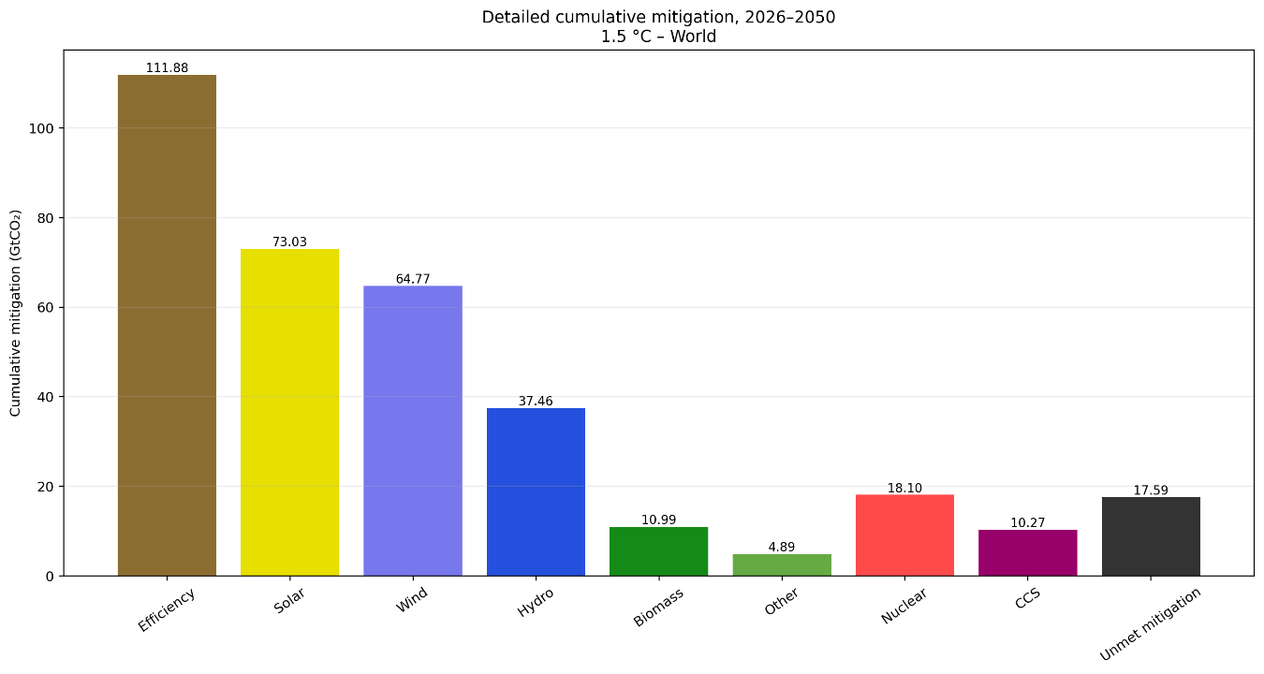
Supplementary Figure 10a. Detailed cumulative mitigation by technology for the 1.5 °C pathway, 2026–2050, based on the last five years of technology deployment.
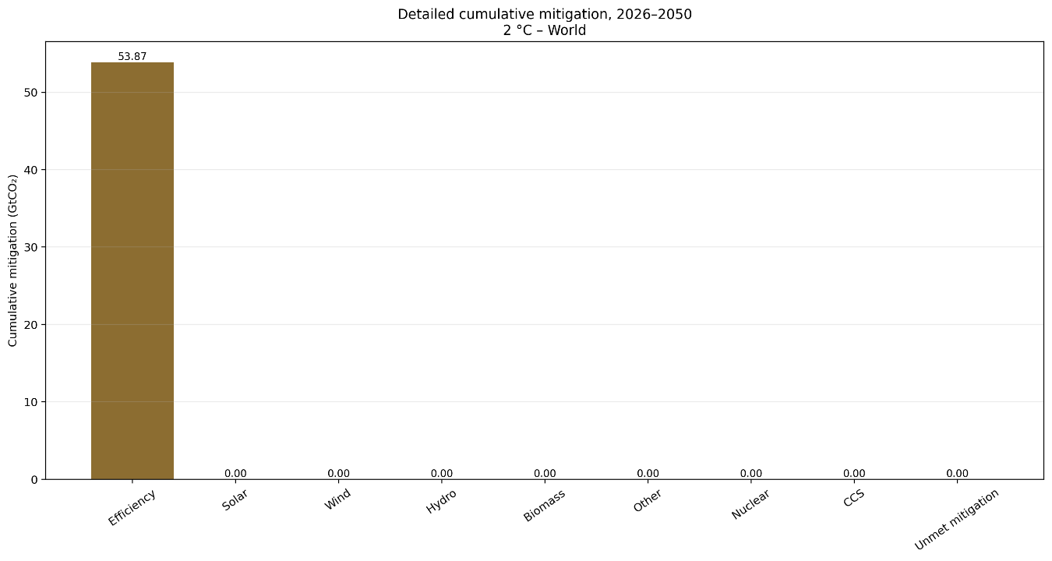
Supplementary Figure 10b. Detailed cumulative mitigation by technology for the 2 °C pathway, 2026–2050, based on the last five years of technology deployment
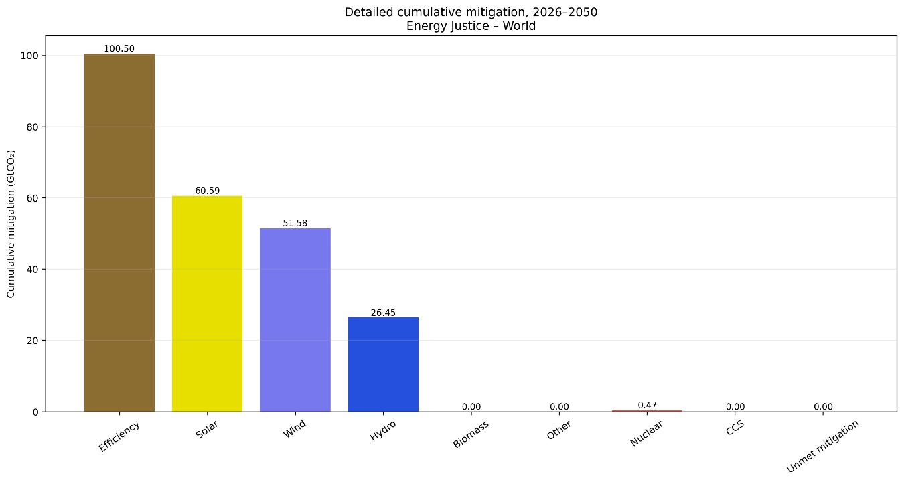
Supplementary Figure 10c. Detailed cumulative mitigation by technology for the Energy Justice pathway, 2026–2050, based on the last five years of technology deployment.
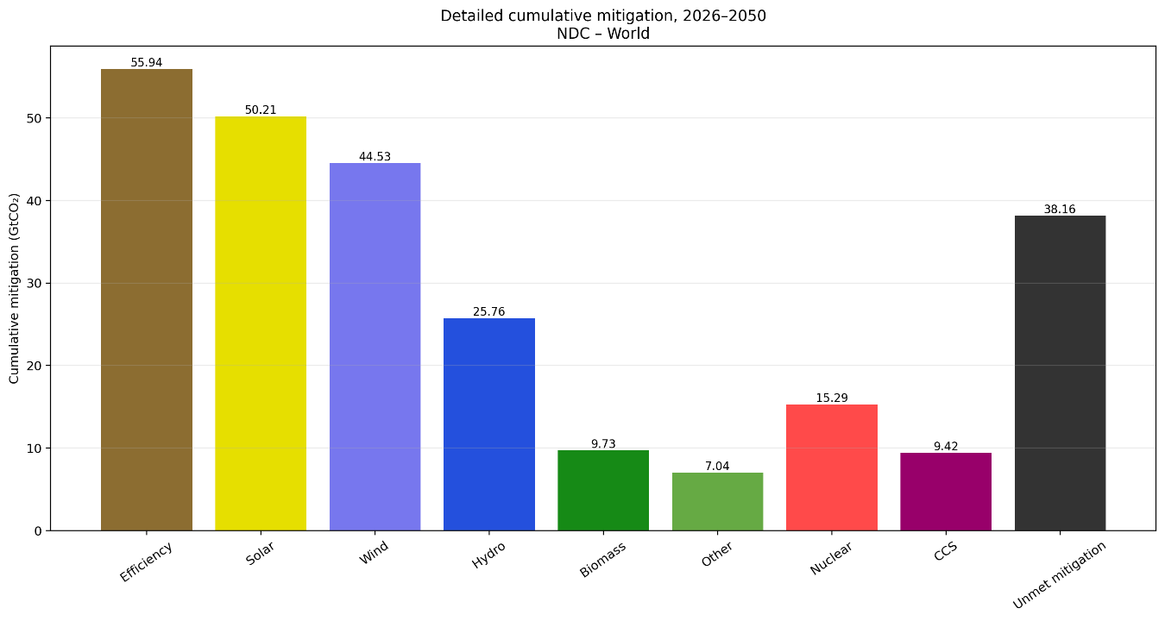
Supplementary Figure 10d. Detailed cumulative mitigation by technology for the NDC pathway, 2026–2050, based on the last five years of technology deployment.

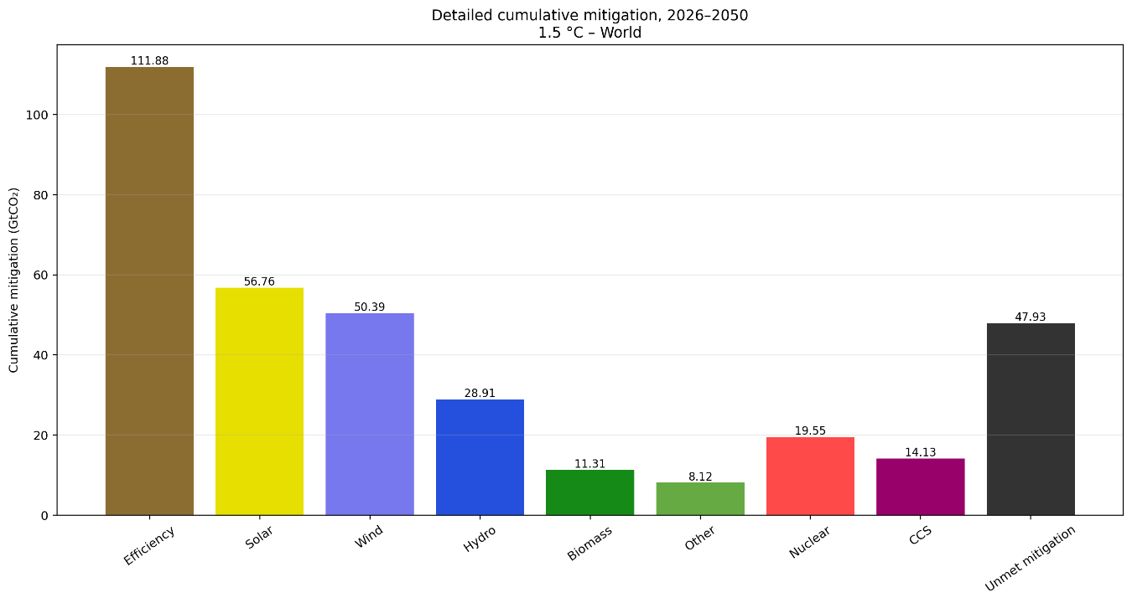
Supplementary Figure 10e. Detailed cumulative mitigation by technology for the 1.5 °C pathway, 2026–2050, based on the last ten years of technology deployment.
Supplementary Figure 10f. Detailed cumulative mitigation by technology for the 2 °C pathway, 2026–2050, based on the last ten years of technology deployment.
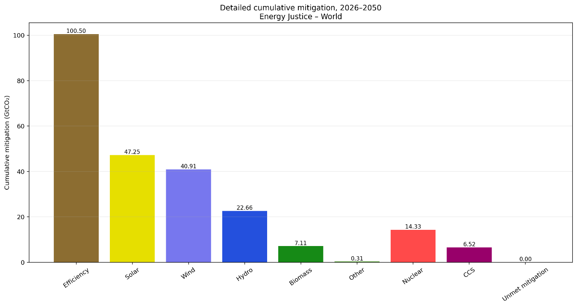
Supplementary Figure 10g. Detailed cumulative mitigation by technology for the Energy Justice pathway, 2026–2050, based on the last ten years of technology deployment.
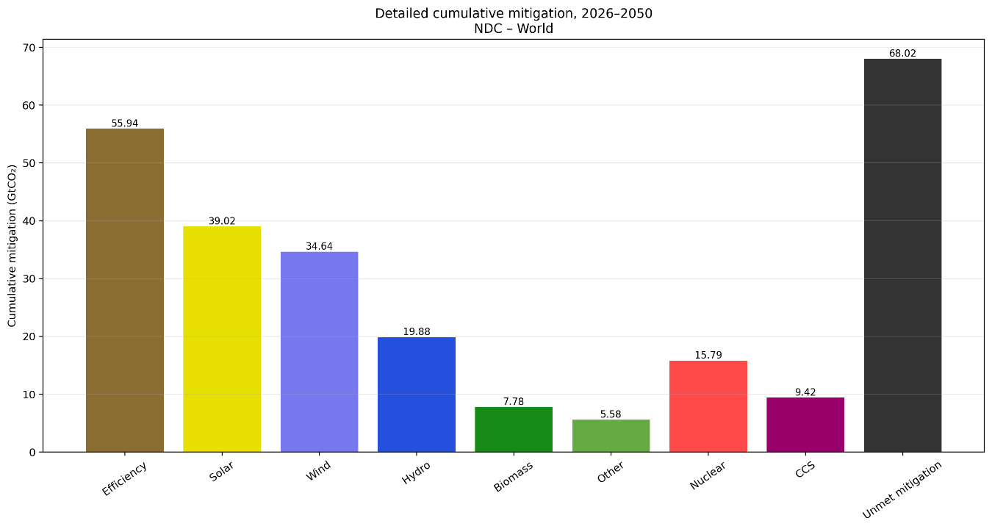
Supplementary Figure 10h. Detailed cumulative mitigation by technology for the NDC pathway, 2026–2050, based on the last ten years of technology deployment.

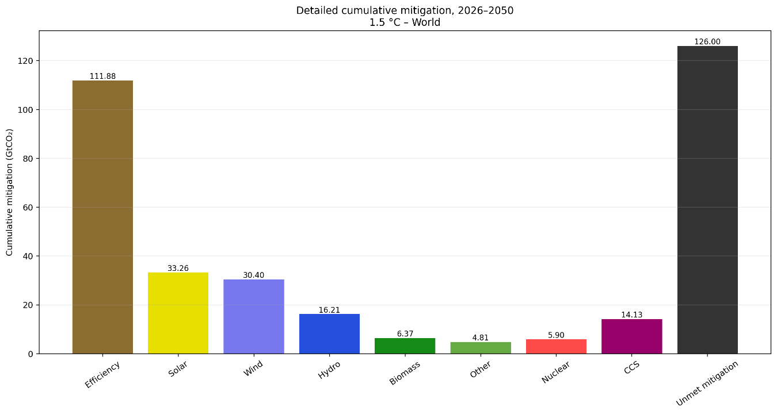
Supplementary Figure 10i. Detailed cumulative mitigation by technology for the 1.5 °C pathway, 2026–2050, based on the complete 2000–2025 technology-deployment trend.
Supplementary Figure 10j. Detailed cumulative mitigation by technology for the 2 °C pathway, 2026–2050, based on the complete 2000–2025 technology-deployment trend.
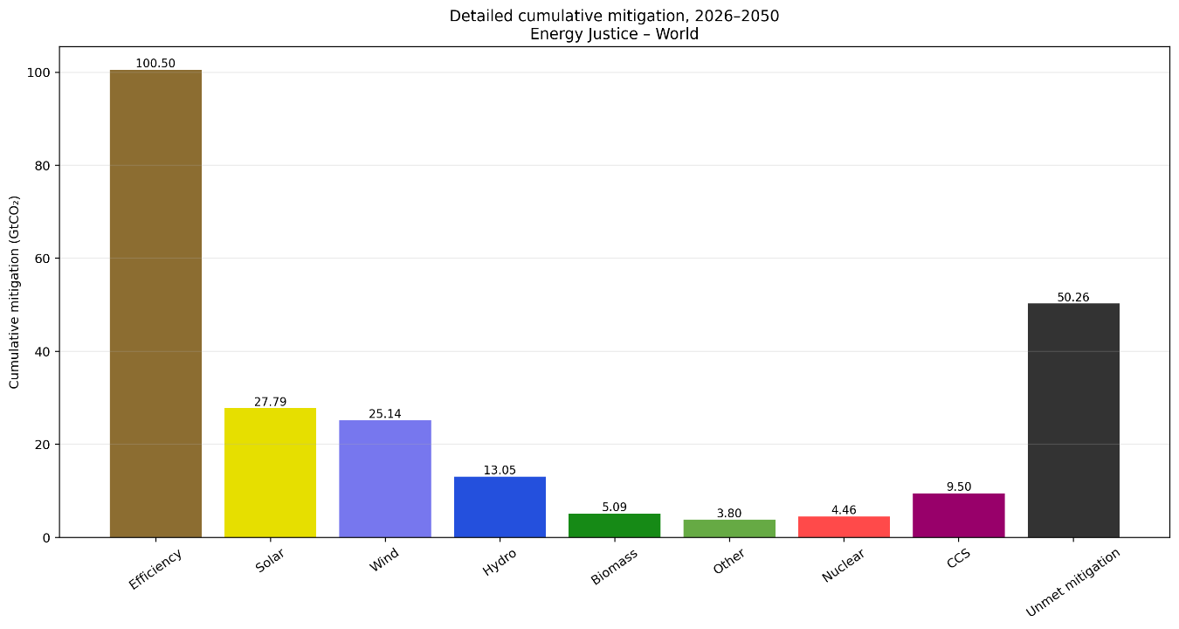
Supplementary Figure 10k. Detailed cumulative mitigation by technology for the Energy Justice pathway, 2026–2050, based on the complete 2000–2025 technology-deployment trend.
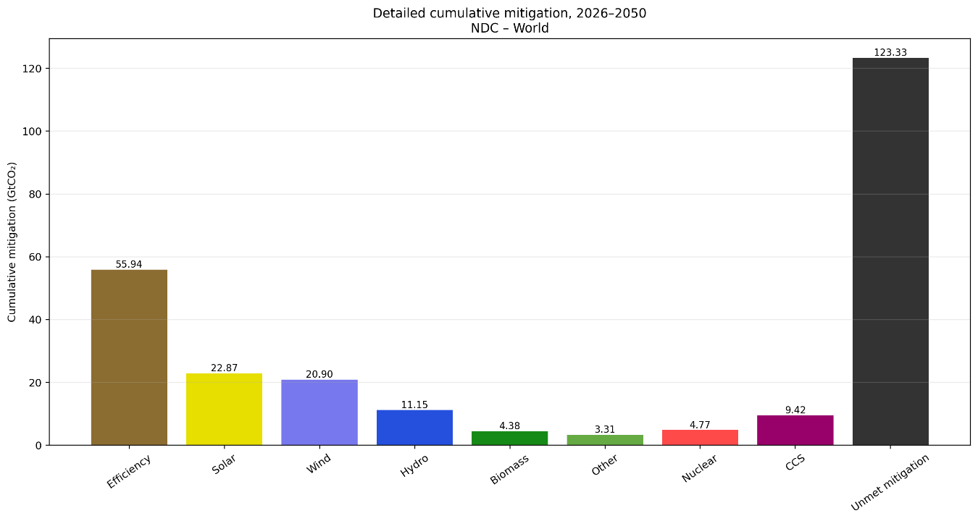
Supplementary Figure 10l. Detailed cumulative mitigation by technology for the NDC pathway, 2026–2050, based on the complete 2000–2025 technology-deployment trend.

Supplementary Table 5. Regional unmet mitigation by scenario under the 2000–2025 technology
deployment rate.
Rate | All years
Units | (GtCO₂) | (GtCO₂) | (GtCO₂) | (GtCO₂)
Scenarios | 1.5°C | 2°C | NDC | Energy Justice
Africa | 2.60 | 0 | 2.55 | 0.03
Central America | 0.93 | 0 | 0.90 | 0.17
East Asia | 38.77 | 0 | 66.10 | 38.41
Eurasia | 43.36 | 0 | 13.97 | 9.06
Europe | 6.56 | 0.03 | 5.21 | 0
Middle East | 9.72 | 1.43 | 12.16 | 8.85
North America | 20.47 | 0 | 16.53 | 9.57
Oceania | 0 | 0 | 0 | 0
South America | 4.44 | 0 | 2.53 | 0
South and Southeast Asia | 4.90 | 0.06 | 8.16 | 4.53
World | 131.76 | 1.49 | 128.12 | 70.63

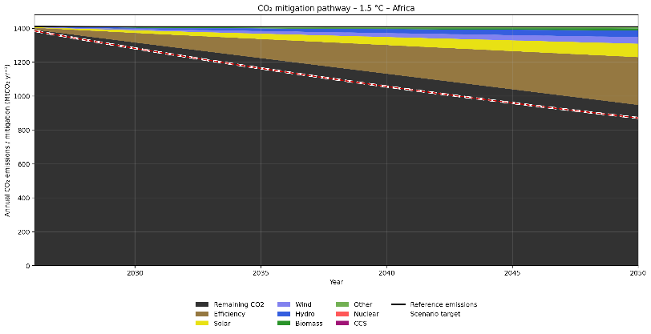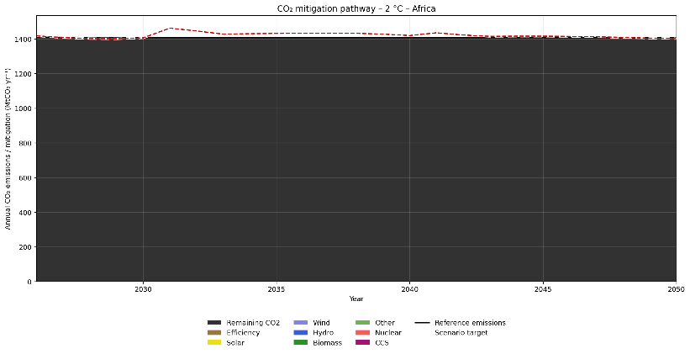
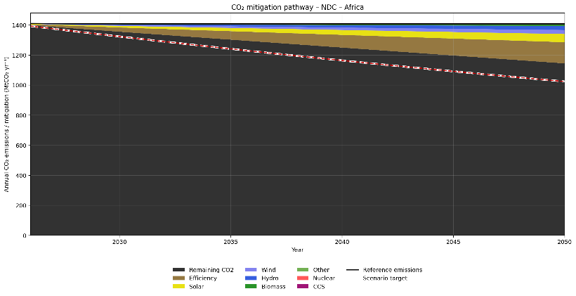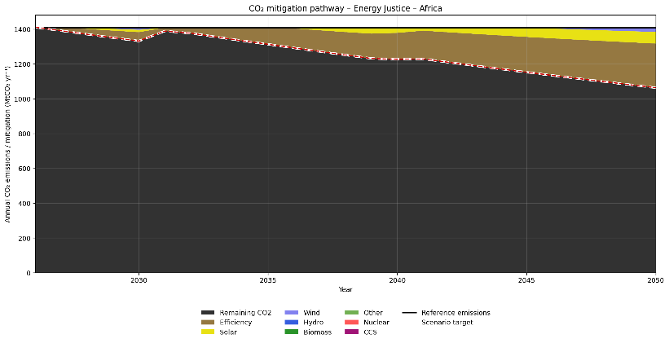
Supplementary Figure 11a. Annual CO₂ mitigation pathways by technology and scenarios for Africa with the latest 5 years rate.
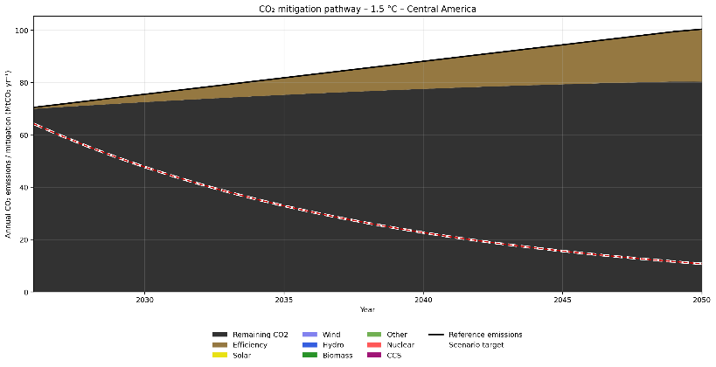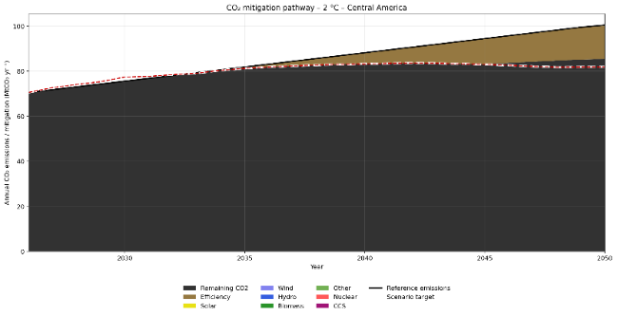
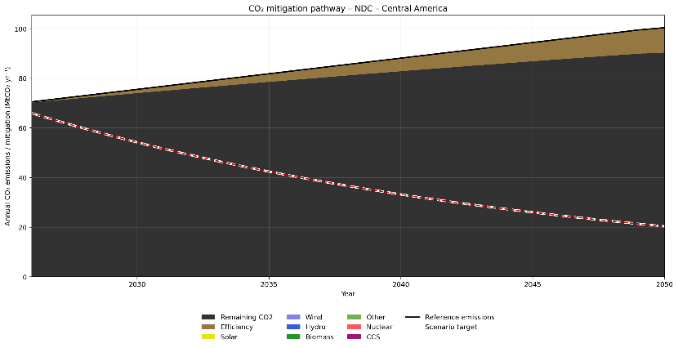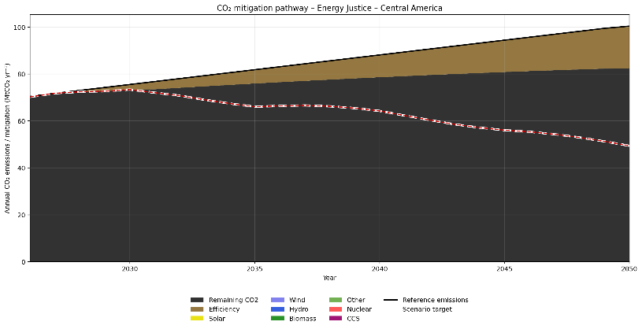
Supplementary Figure 11b. Annual CO₂ mitigation pathways by technology and scenarios for Central America with the latest 5 years rate.

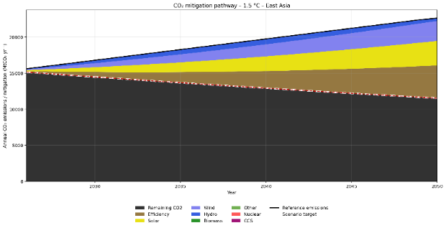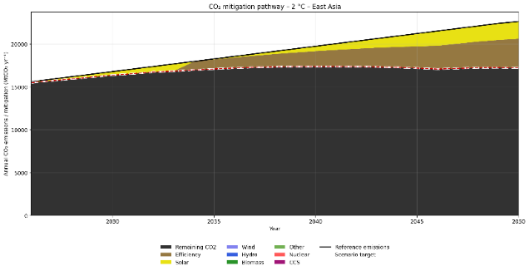
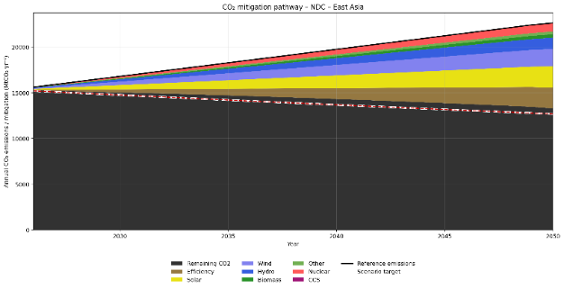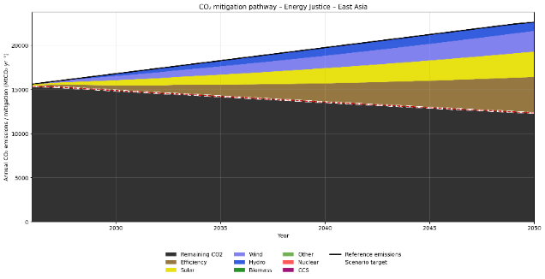
Supplementary Figure 11c. Annual CO₂ mitigation pathways by technology and scenarios for East Asia with the latest 5 years rate.

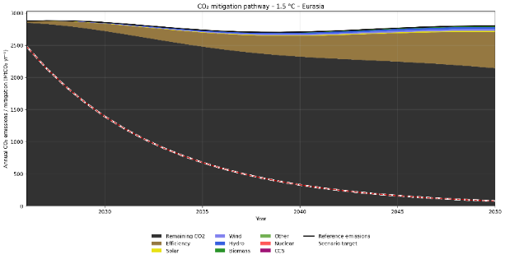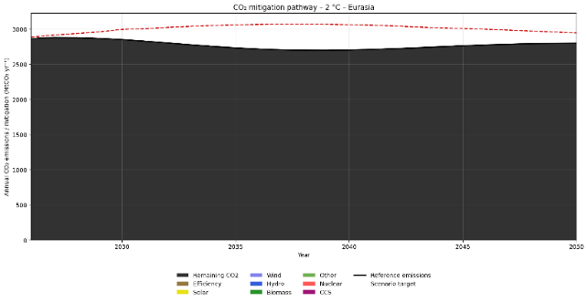
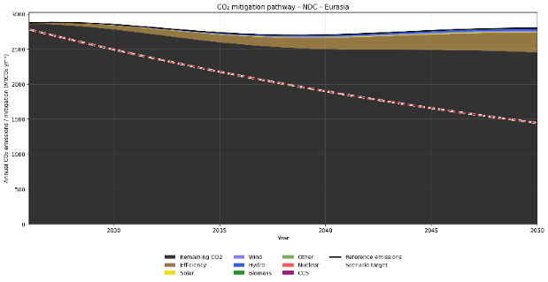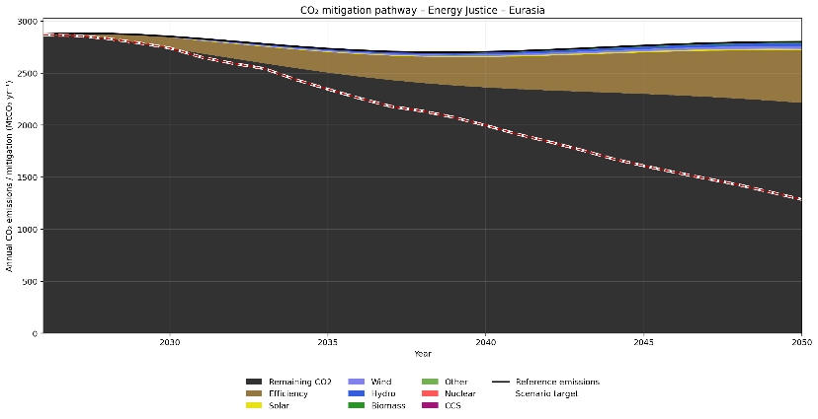
Supplementary Figure 11d. Annual CO₂ mitigation pathways by technology and scenarios for Eurasia with the latest 5 years rate.
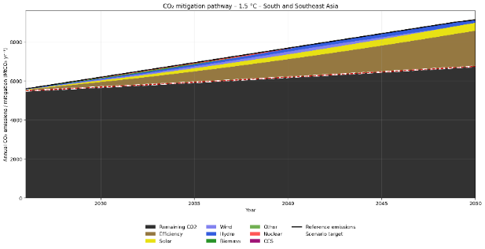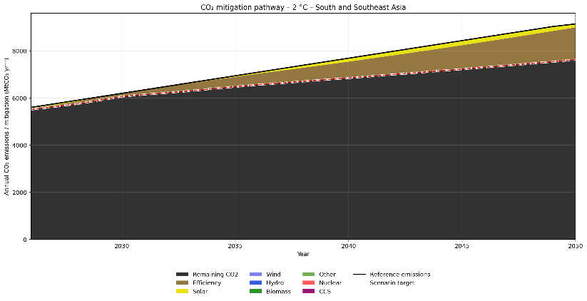
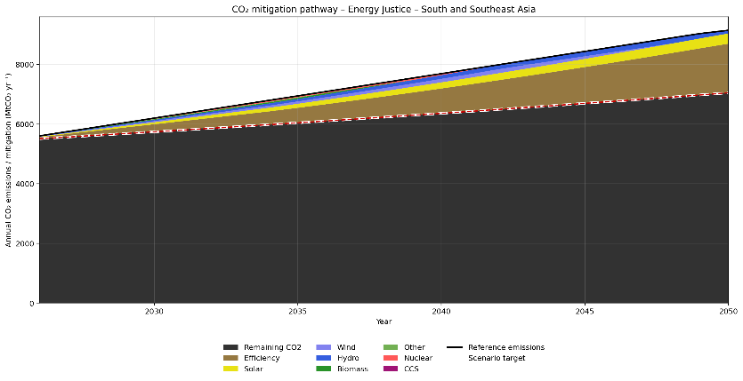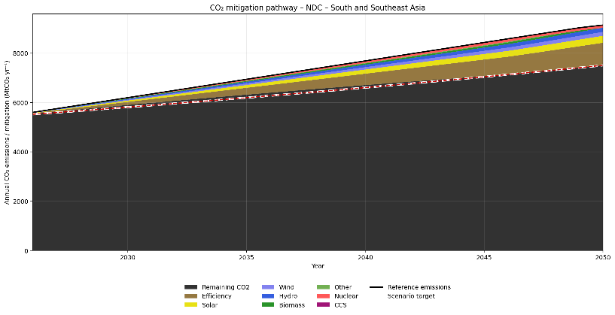
Supplementary Figure 11e. Annual CO₂ mitigation pathways by technology and scenarios for South and Southeast Asia with the latest 5 years rate.

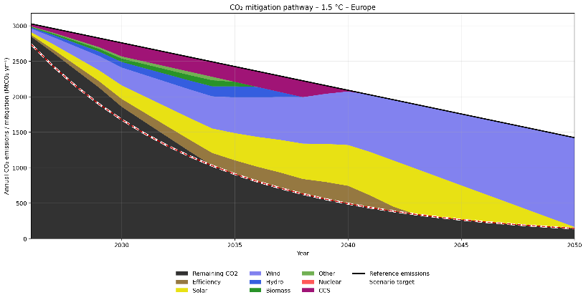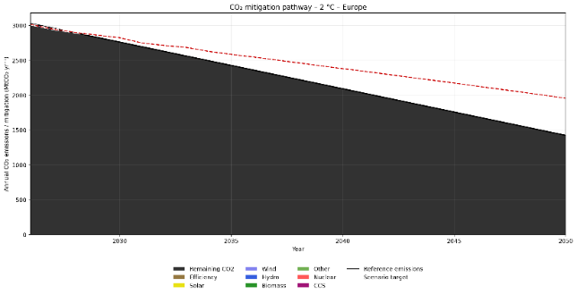
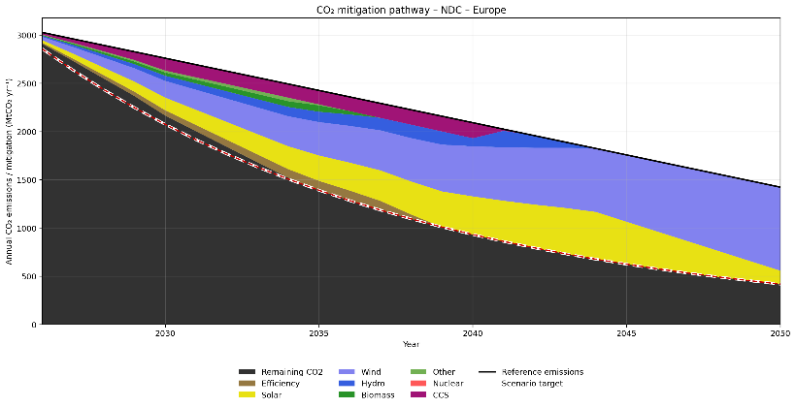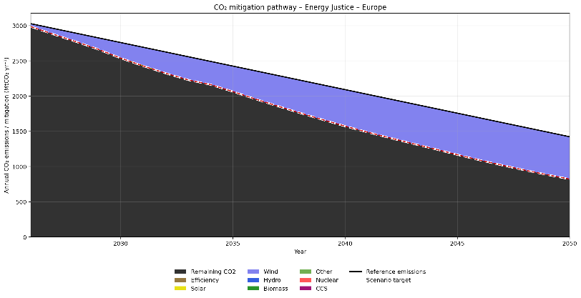
Supplementary Figure 11f. Annual CO₂ mitigation pathways by technology and scenarios for Europe with the latest 5 years rate.

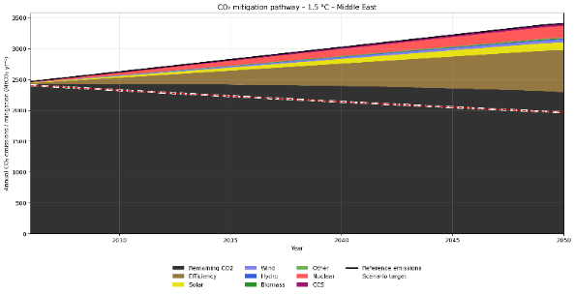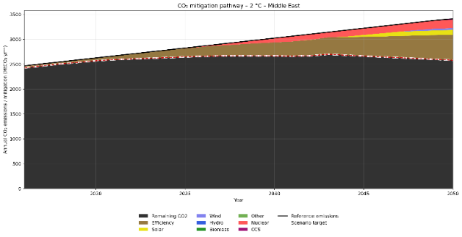
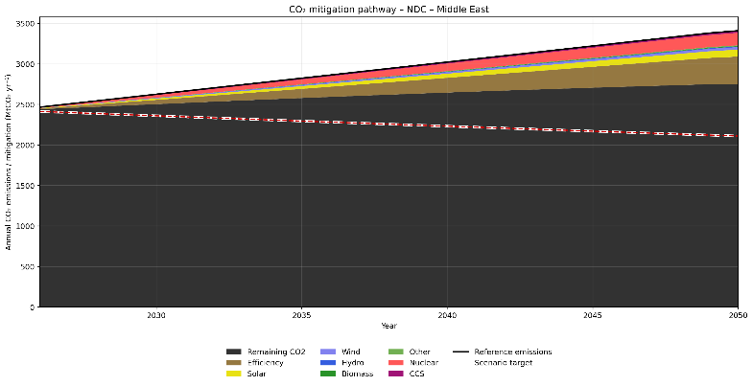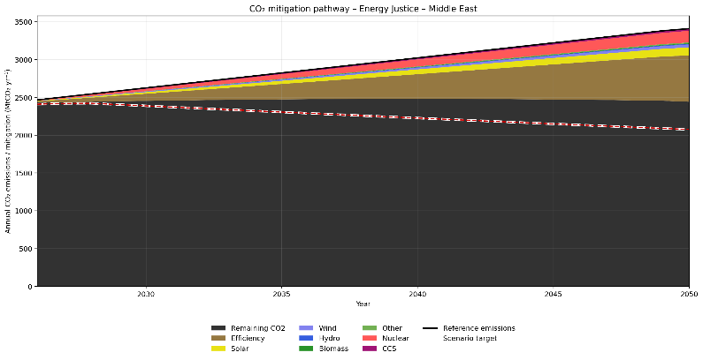
Supplementary Figure 11g. Annual CO₂ mitigation pathways by technology and scenarios for Middle East with the latest 5 years rate.

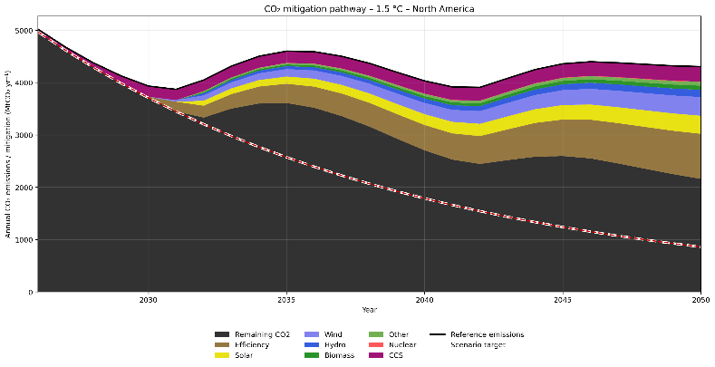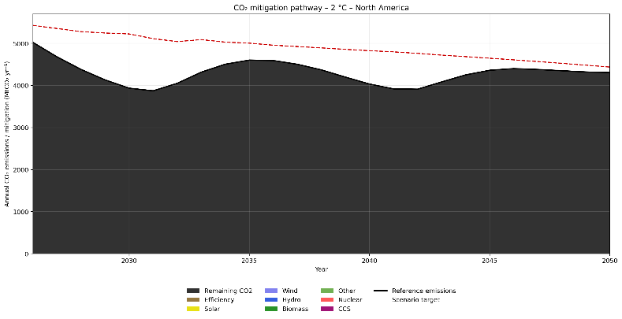
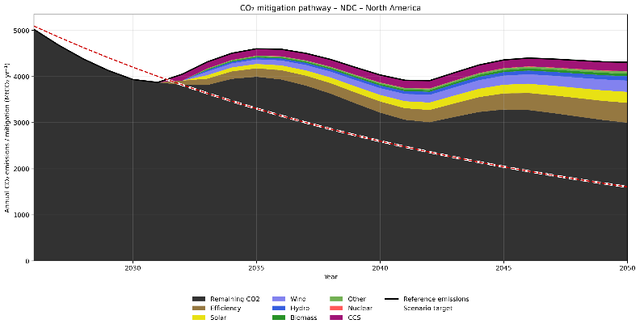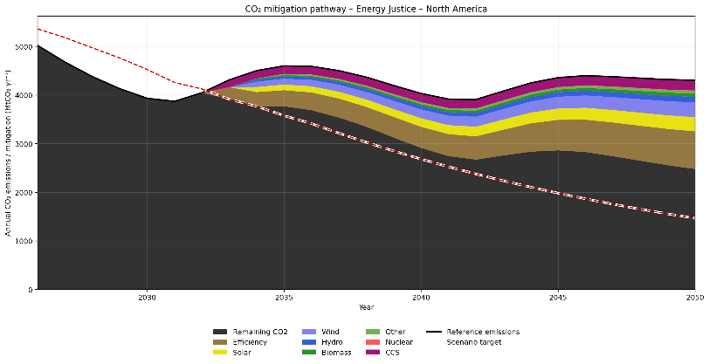
Supplementary Figure 11h. Annual CO₂ mitigation pathways by technology and scenarios for North America with the latest 5 years rate.

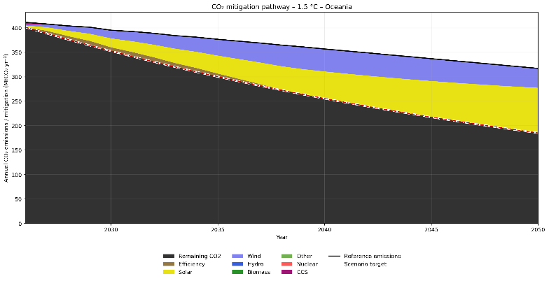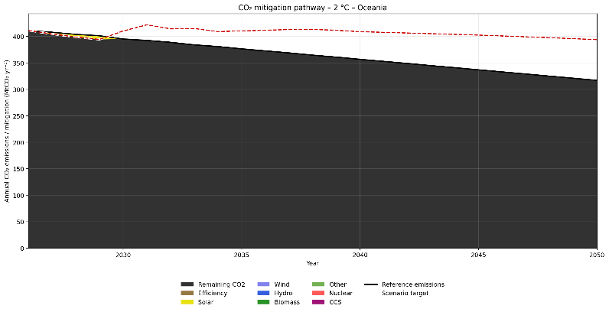
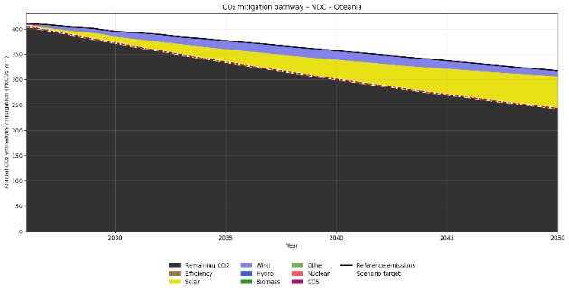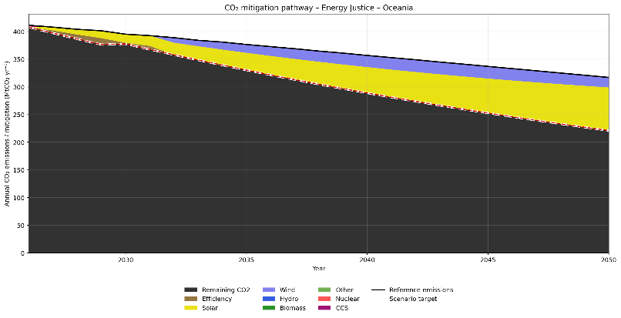
Supplementary Figure 11i. Annual CO₂ mitigation pathways by technology and scenarios for Oceania with the latest 5 years rate.
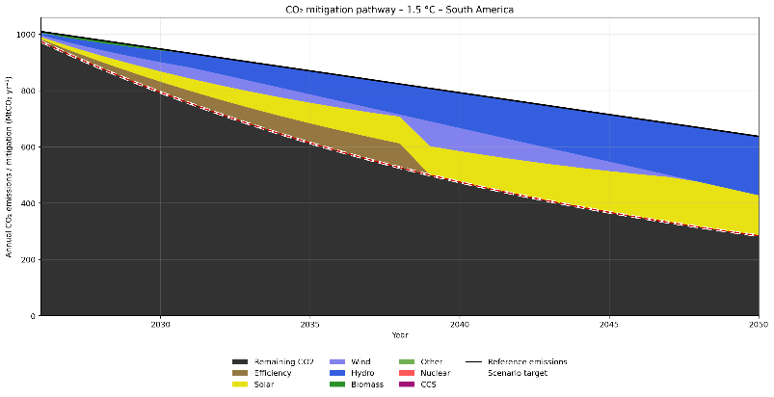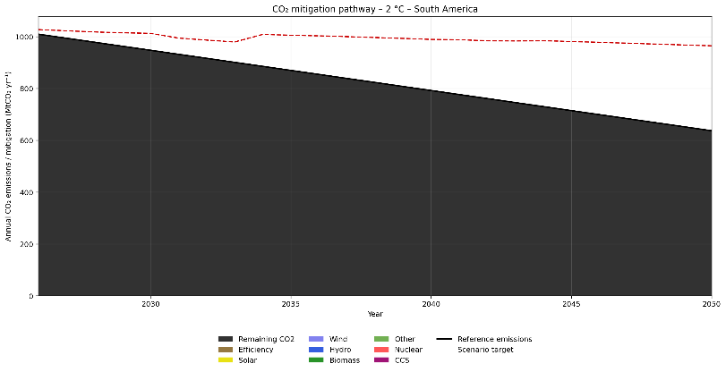
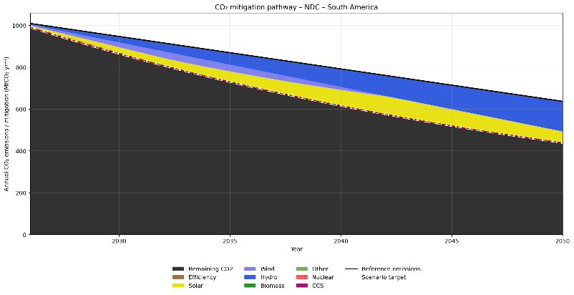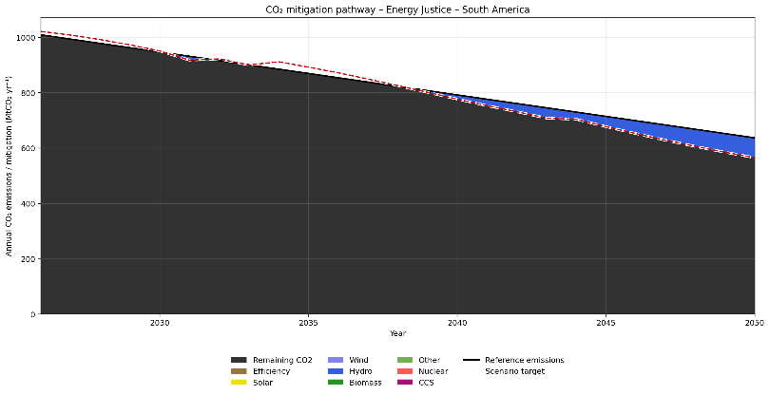
Supplementary Figure 11j. Annual CO₂ mitigation pathways by technology and scenarios for South America with the latest 5 years rate.

