Supplementary Information

Online Methods

Geologic composition
The geology of the Central Valley aquifer has been well-characterized from ~8,500 lithologic borehole logs, later kriged to become the basis of the Central Valley Hydrologic Model (CVHM) and CVHM-2 released by U.S. Geologic Survey ¹⁹. The aquifer is a heterogeneous alluvial aquifer system with confined, semi-confined, and unconfined layers and reaches around 2800 ft below the land surface.
The CVHM geotexture model has a grid size of 1-mi by 1-mi for the entire Central Valley and is vertically discretized into 10 layers of varying thickness spanning the 2800 ft of aquifer depth. The layers correspond to natural geologic layer divisions down depth, including the division between the Corcoran clay, a thick clay deposit, and other portions of the aquifer. Within the model cell, the borehole lithological data is classified in binary bins of fine-grained (clay, lime, loam, mud, or silt) or coarse-grained (sand, gravel, pebbles, and boulders) ^{23–26}, with the percentages between the two bins calculated in 50 ft vertical segments. Roughly 20,000 model cells are active within the Central Valley. Readers are pointed to Faunt (2009) ¹⁹ for more details on the original geotexture model. Within the neural network model, we used the coarse grain percentage from each model layer (1-10) as the prediction target. While our dataset contains this detailed layer-by-layer information, our broader goal is to predict the average coarse grain percentage across entire formations. This broader metric would enable geologists to estimate subsurface composition in regions where granular stratigraphic data is unavailable, making our model applicable to wider geographic areas with limited geological sampling.

Sentinel-1 InSAR processing
Sentinel-1 satellite data of tracks 42 and 144, covering March 1st 2015-August 31st 2020, and November 8th 2014-January 22nd 2019, respectively, were processed for vertical land motion. The two tracks collectively cover most of the central and southern portions of the Central Valley, including San Joaquin Valley and the Tulare Basin. Sentinel-1 provides wide-swath mode data over the study region with a regular interval of 12 days and a revisit time as short as 6 days using a Terrain Observation by Progressive Scan (TOPS) technique.
The JPL/Caltech ISCE software was used to generate the Sentienl-1 interferometry. It limited our interferometric pairs to the ones with a temporal baseline of no more than 24 days to mitigate temporal decorrelation. A Sentinel-1 stack processor was then used to co-register all SAR Single Look Complex (SLC) images to the reference geometry and employ the enhanced spectral diversity technique, estimating the azimuth misregistration between SLC images. Each interferogram was then corrected for topographic phase, unwrapped, and geocoded using the SRTM DEM model. After generating hundreds of unwrapped interferograms for each track, a variant of the small baseline subset InSAR timeseries inversion approach was utilized to solve for line-of-sight displacement time series and velocity. This approach also estimates the DEM error and uses spatiotemporal filtering to suppress high-frequency troposphere noise (Liu et al., 2019). The cumulative displacement at each image date was outputted to a GMT grid and resampled to a ground posting of 2 km $×$ 2 km.

Spatial Classification Based on Temporal Characteristics
Both InSAR and geotexure data were interpolated into the same spatial grid with 2 km $×$ 2 km grid cells, with the InSAR data interpolated to a discretization of every two weeks. The temporal characteristics of the InSAR signal for each spatial grid were then used to identify regions within the Central Valley with different temporal dynamics (Fig. S1). Consistent with the general theory of geological behavior, regions with coarser grain percentages (Fig. S1B) tended to exhibit the potential for reversible, elastic land compaction as higher frequency temporal variability (i.e., monthly to seasonal) without a long term trend signal, while regions with higher fine grain percentages (Fig. S1A) tended to exhibit more interannual and long term trend behavior temporally.
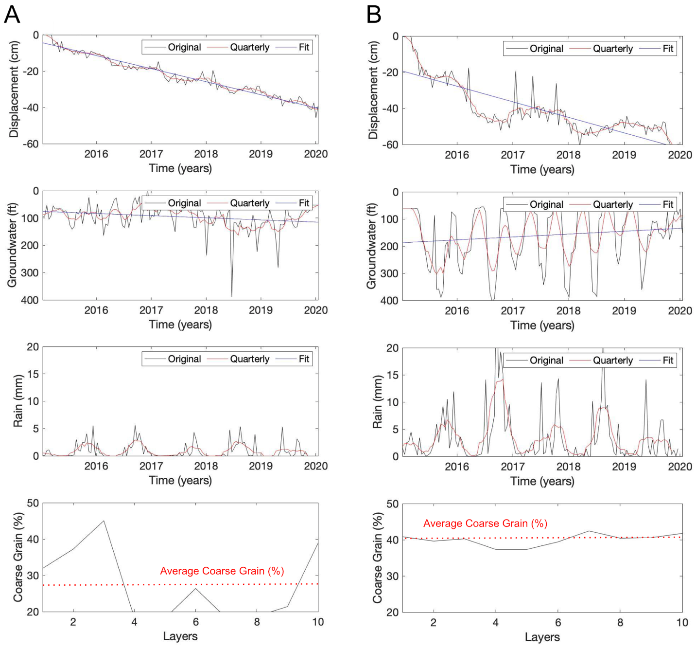

Fig. S1. Two representative regions of the Central Valley with significant subsidence with different characteristics. Groundwater data from the National Water Information System and precipitation from PRISM Climate Data support the surface movement trends. (A) Chowchilla with monotonically decreasing land displacements, less fluctuating groundwater depth, relatively low precipitation, and high fine-grain ratio across the middle CVHM model layers (Displacement = -22.47 ± 10.66, Groundwater (ft) = 95.53 ± 27.69, Rain (mm) = 0.84 ± 0.80, Coarse Grain (%) = 27.44 ± 10.13). (B) Helm with fluctuating land displacements, relatively large seasonal changes in groundwater depth, high precipitation, and a higher overall coarse-grain ratio across all CVHM model layers (Displacement = -40.95 ± 14.49, Groundwater (ft) =160.52 ± 65.82, Rain (mm) = 3.48 ± 3.15, Coarse Grain (%) = 40.01 ± 1.67).

Geologic Composition Estimation Model
We used a fully connected multi-layer feedforward neural network to model long-term ground subsidence patterns in California's Central Valley. Each input sample consisted of a time series of biweekly InSAR-derived subsidence measurements over a five-year period, yielding 132 data points per location. The input time series was flattened into a single vector and fed into the network, which was designed to learn nonlinear mappings from surface displacement patterns to underlying geological properties derived from the Central Valley Hydrologic Model (CVHM).
The network architecture began with an input layer of 132 units, corresponding to the number of biweekly measurements. This was followed by a dense layer with 256 units and a ReLU activation function, accompanied by batch normalization and a dropout rate of 0.3 to prevent overfitting. The second layer reduced the dimensionality to 128 units, again using ReLU activation and regularized with batch normalization and dropout. The third and fourth layers further reduced the feature space to 64 and 32 units, respectively, each with ReLU activations. The final output layer used a linear activation function to produce continuous-valued predictions of the target soil property.
Model training was performed using the Adam optimizer with a learning rate of 0.001 and mean squared error as the loss function. Early stopping was employed to prevent overfitting by monitoring validation loss. The model was trained for up to 200 epochs with a batch size of 64. Input features were normalized using Min-Max scaling to ensure stable convergence during training. The model’s predictions were benchmarked against reference values obtained from CVHM, enabling a quantitative assessment of its ability to recover subsurface geological composition from surface deformation data.

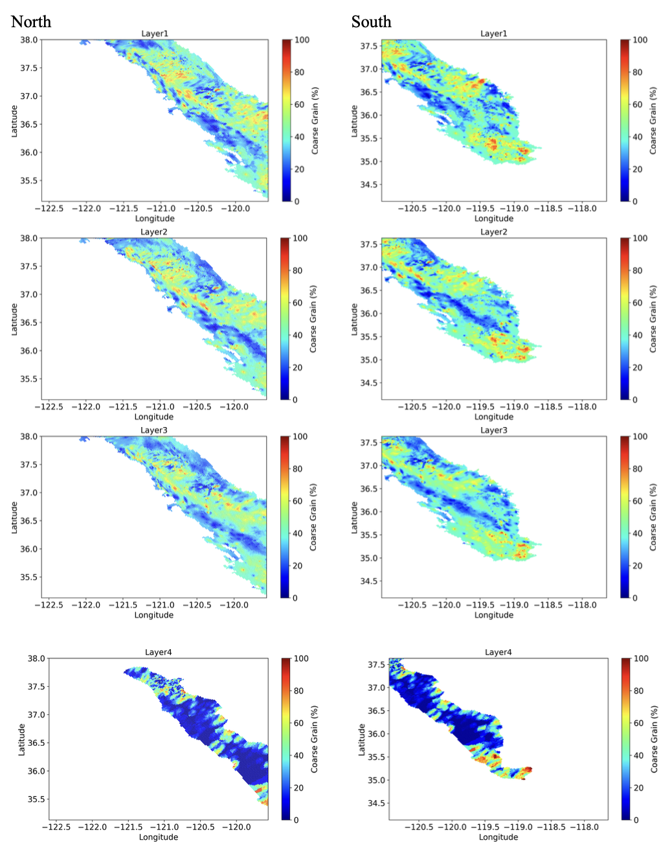
Fig. S2. Coarse Grain % from CVHM of each layer from 1 to 5 in northern and southern Central Valley regions. Note that by depth, some model cells from the original CVHM are not active regions of groundwater flow and the layers do not perfectly coincide in geometry. Compared to other layers (1-3), layer 4 has fine-grained clay regions (blue) that are in high contrast to other coarser-grained areas, which may be attributed to higher errors when the sampling distance increases.

