Supplementary Materials

All supplementary tables and figures below use the primary analytic cohort (adults ≥18 years, n = 50) unless otherwise noted, consistent with the main-text Results. The 7 pediatric patients excluded from the primary analysis are described separately in Table S6, and the full cohort (n = 57, including pediatric patients) is examined as a robustness check in Figure S2.

Supplementary Table S1. Complete Multi-Organ Manifestation List (Adults, N = 50)
Manifestation | n/N | % | Missing
Neuropathic pain | 35/46 | 76.1% | 4
Hypo-/hyperhidrosis | 31/44 | 70.5% | 6
Gastrointestinal symptoms | 21/43 | 48.8% | 7
Hearing loss | 16/44 | 36.4% | 6
Dizziness/vertigo | 21/45 | 46.7% | 5
Tinnitus | 21/44 | 47.7% | 6
Palpitations | 16/39 | 41.0% | 11
Orthostatic intolerance/hypotension | 17/43 | 39.5% | 7
Visual decline | 13/43 | 30.2% | 7
Headache | 15/41 | 36.6% | 9
Subjective memory decline | 26/45 | 57.8% | 5
Sleep disturbance | 16/42 | 38.1% | 8
Anxiety/depression (clinical impression) | 15/45 | 33.3% | 5
Cerebral infarction | 5/45 | 11.1% | 5
Cerebral hemorrhage | 0/42 | 0.0% | 8
Proteinuria | 23/46 | 50.0% | 4
Renal insufficiency | 16/45 | 35.6% | 5
Dialysis/renal transplantation | 4/45 | 8.9% | 5
Hypertension | 8/45 | 17.8% | 5
Hypertrophic cardiomyopathy | 21/45 | 46.7% | 5
Chronic kidney disease | 6/35 | 17.1% | 15
Angiokeratoma | 19/44 | 43.2% | 6
Corneal verticillata | 18/43 | 41.9% | 7
Retinal vessel tortuosity | 10/35 | 28.6% | 15
Diabetes mellitus | 0/36 | 0.0% | 14
Hyperlipidemia | 3/36 | 8.3% | 14
Full list of clinical manifestations recorded (Methods 2.2) in the primary adult cohort. Raw observed data; percentages use the available non-missing denominator; no imputation.

Supplementary Table S2. Full Symptom/Manifestation Comparison by Cognitive Status (Adults)
Manifestation | CI | Normal | P | q (FDR)
Neuropathic pain | 16/18 (88.9%) | 19/28 (67.9%) | 0.160 | 0.665
Hypo-/hyperhidrosis | 14/17 (82.4%) | 17/27 (63.0%) | 0.198 | 0.665
Gastrointestinal symptoms | 8/17 (47.1%) | 13/26 (50.0%) | 1.000 | 1.000
Hearing loss | 8/17 (47.1%) | 8/27 (29.6%) | 0.337 | 0.665
Dizziness/vertigo | 10/18 (55.6%) | 11/27 (40.7%) | 0.374 | 0.665
Orthostatic intolerance/hypotension | 7/17 (41.2%) | 10/26 (38.5%) | 1.000 | 1.000
Visual decline | 7/17 (41.2%) | 6/26 (23.1%) | 0.310 | 0.665
Headache | 5/15 (33.3%) | 10/26 (38.5%) | 1.000 | 1.000
Anxiety/depression (clinical impression) | 7/17 (41.2%) | 8/28 (28.6%) | 0.517 | 0.723
Cerebral hemorrhage | 0 cases observed | 0 cases observed | not tested | —
Proteinuria | 9/18 (50.0%) | 14/28 (50.0%) | 1.000 | 1.000
Dialysis/renal transplantation | 3/18 (16.7%) | 1/27 (3.7%) | 0.286 | 0.665
Chronic kidney disease | 4/13 (30.8%) | 2/22 (9.1%) | 0.166 | 0.665
Angiokeratoma | 9/18 (50.0%) | 10/26 (38.5%) | 0.542 | 0.723
Corneal verticillata | 10/18 (55.6%) | 8/25 (32.0%) | 0.210 | 0.665
Retinal vessel tortuosity | 5/14 (35.7%) | 5/21 (23.8%) | 0.474 | 0.723
Diabetes mellitus | 0 cases observed | 0 cases observed | not tested | —
Hyperlipidemia | 0/14 (0.0%) | 3/22 (13.6%) | 0.267 | 0.665
Comparison of cognitive impairment (CI) vs. normal cognition, adults only, for all manifestations not included Table 3. Fisher's exact test; q values are Benjamini-Hochberg FDR-corrected P values across these 16 testable comparisons (cerebral hemorrhage and diabetes mellitus had zero observed cases and were not tested). No comparison reached significance after FDR correction (all q > 0.6); these are exploratory and hypothesis-generating.

Supplementary Table S3. Regional ARWML Correlations with MMSE and MoCA Scores (Adults, MRI Subcohort)
Region | Instrument | n | r | P | q (FDR)
Frontal | MoCA | 28 | −0.48 | 0.011 | 0.012
Frontal | MMSE | 29 | −0.44 | 0.016 | 0.016
Parieto-occipital | MoCA | 28 | −0.59 | 0.001 | 0.002
Parieto-occipital | MMSE | 29 | −0.46 | 0.012 | 0.014
Temporal | MoCA | 28 | −0.56 | 0.002 | 0.003
Temporal | MMSE | 29 | −0.49 | 0.007 | 0.011
Basal ganglia | MoCA | 28 | −0.65 | <0.001 | 0.001
Basal ganglia | MMSE | 29 | −0.57 | 0.001 | 0.003
Infratentorial/cerebellar | MoCA | 28 | −0.61 | <0.001 | 0.002
Infratentorial/cerebellar | MMSE | 29 | −0.74 | <0.001 | <0.001
Tabular presentation of the data shown in Supplementary Figure S4. r = age-adjusted partial Pearson correlation coefficient (residual method); q = Benjamini-Hochberg FDR-corrected P value across these 10 region × instrument comparisons, treated as a family separate from Table 4. Bold indicates q < 0.05 (all 10 comparisons were significant). n = 28 (MoCA) or 29 (MMSE), reflecting the adult MRI subcohort (4 of the original 33 MRI cases were pediatric and are excluded here). Given the modest sample size underlying each regional estimate, these results are interpreted as hypothesis-generating (Methods 2.4; Discussion).

Supplementary Table S4. Age-Adjusted Partial Correlations Between Biomarkers and MMSE and MoCA Scores (Adults)
Variable | n | r | P | Adjusted P (q) | Age-adjusted β
MMSE (age-adjusted partial correlation)
α-Gal A activity | 42 | −0.05 | 0.764 | 0.829 | −0.13
Lyso-Gb3 | 40 | −0.16 | 0.336 | 0.829 | −0.01
MoCA (age-adjusted partial correlation)
α-Gal A activity | 41 | 0.03 | 0.829 | 0.829 | 0.12
Lyso-Gb3 | 39 | 0.10 | 0.558 | 0.829 | 0.01
r = age-adjusted partial Pearson correlation coefficient (residual method); β = coefficient on the biomarker from the OLS model cognition ~ biomarker + age. Adjusted P (q) is the Benjamini-Hochberg FDR-corrected P value across all 4 comparisons (2 biomarkers × 2 cognitive instruments) treated as a single family. No comparison reached significance. Raw observed data; n reflects available non-missing biomarker and cognitive data for each pairing, adults only; no imputation. Referenced in Results Section 3.5.

Supplementary Table S5. Exploratory Subgroup Analyses (Adults)
Outcome | Group 1 | Group 2 | P | q (FDR)
Genotype: Truncating vs. Non-truncating
CI prevalence | 9/18 (50.0%) | 8/28 (28.6%) | 0.212 | 0.318
MMSE (median) | 27.0 (n=18) | 29.0 (n=28) | 0.193 | 0.318
MoCA (median) | 24.0 (n=17) | 26.5 (n=26) | 0.081 | 0.194
Phenotype: Classic vs. Late-onset
CI prevalence | 12/30 (40.0%) | 7/20 (35.0%) | 0.774 | 0.928
MMSE (median) | 28.0 (n=30) | 28.5 (n=20) | 0.992 | 1.000
MoCA (median) | 26.5 (n=28) | 25.0 (n=19) | 0.102 | 0.205
Sex: Male vs. Female
CI prevalence | 12/31 (38.7%) | 7/19 (36.8%) | 1.000 | 1.000
MMSE (median) | 28.0 (n=31) | 27.0 (n=19) | 0.417 | 0.556
MoCA (median) | 27.0 (n=29) | 24.0 (n=18) | 0.043 | 0.139
Severe Clinical Event: Yes vs. No
CI prevalence | 13/23 (56.5%) | 5/22 (22.7%) | 0.033 | 0.139
MMSE (median) | 27.0 (n=23) | 29.0 (n=22) | 0.046 | 0.139
MoCA (median) | 24.5 (n=22) | 27.0 (n=21) | 0.012 | 0.139
CI prevalence compared using Fisher's exact test; MMSE/MoCA compared using the Mann-Whitney U test (medians shown). q values are Benjamini-Hochberg FDR-corrected P values across all 12 comparisons (4 factors × 3 outcomes) treated as a single family, adults only. Bold would indicate q < 0.05; no comparison met this threshold. Raw observed data; no imputation. Referenced in Results Section 3.7.

Supplementary Table S6. Pediatric Patients Excluded from Primary Analysis (n = 7, Descriptive Only)
Patient | Age | Sex | Education | Genotype | MMSE | MoCA | MSSI | MRI available | CI status
P52 | 7 | Male | Elementary | Non-truncating | 27 | 20 | 2 | No | Normal
P42 | 10 | Female | Elementary | Non-truncating | 30 | 30 | 3 | No | Normal
P17 | 11 | Female | Elementary | Truncating | 28 | 25 | 6 | Yes | Normal
P44 | 11 | Male | Elementary | Non-truncating | 25 | 24 | — | Yes | Normal
P10 | 14 | Male | Secondary | Non-truncating | 29 | 27 | 14 | Yes | Normal
P35 | 15 | Male | Elementary | Truncating | 29 | 23 | — | No | Normal
P8 | 9 | Male | Elementary | Unknown | 28 | 23 | — | No | Normal
None of the seven pediatric patients met the adult-based MMSE/MoCA threshold for cognitive impairment; these classifications are descriptive only and should not be interpreted as pediatric normative diagnoses.

Supplementary Figure S1. Missing Data Pattern (Adults)
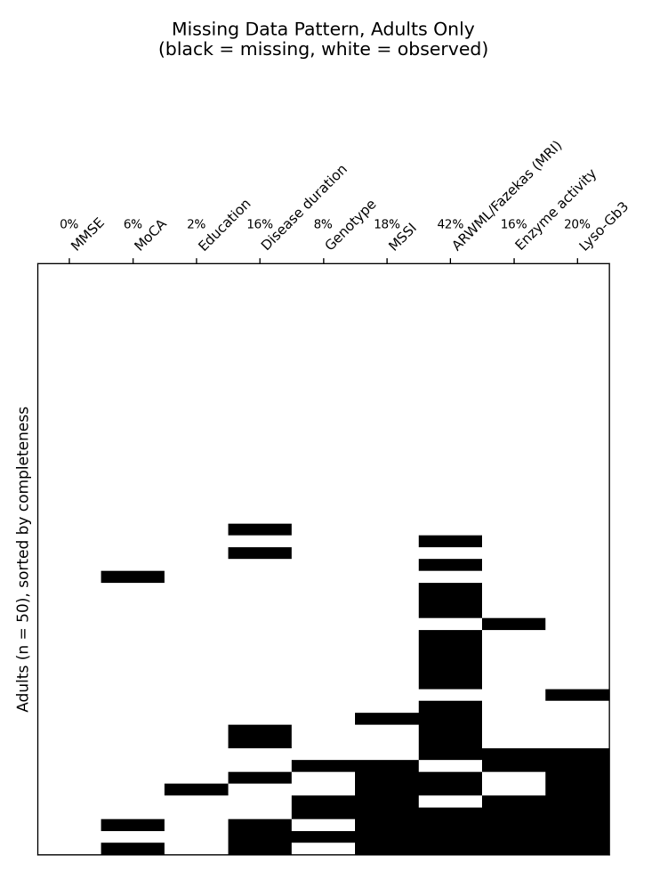
Missing data pattern across 9 key analytic variables in the primary adult cohort (n = 50). Black indicates missing; white indicates observed. Patients (rows) are sorted by completeness (fewest missing variables at top). Percentage missing for each variable is shown above its column. MoCA missingness reflects 1 patient with no MoCA administered plus 2 patients whose MoCA total was corrected from an erroneous 0 to missing.

Supplementary Figure S2. Robustness Check: Adults-Only Primary Analysis vs. Full Cohort
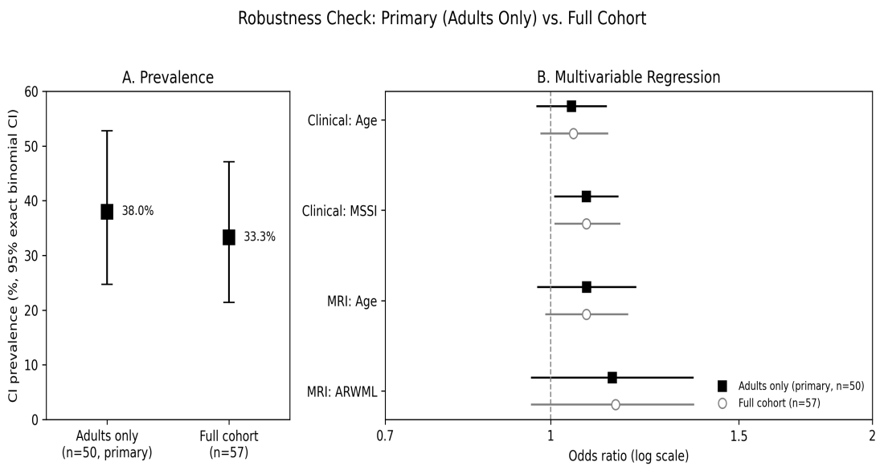
Robustness check comparing the adults-only primary analysis (n = 50) against the full cohort (n = 57, including the 7 pediatric patients). Panel A: cognitive impairment prevalence, with 95% exact binomial CI. Panel B: multivariable Firth logistic regression estimates (odds ratios with 95% Wald CI) for the clinical model (age, MSSI) and MRI model (age, ARWML), adults-only primary analysis (black squares) vs. full-cohort robustness check (gray circles). All 7 pediatric patients were cognitively normal; including them modestly lowered the point-estimate prevalence but did not materially change the pattern or significance of the multivariable associations. Referenced in Results Sections 3.1 and 3.7.

Supplementary Figure S3. Overlap of MMSE- and MoCA-Defined Cognitive Impairment (Adults)
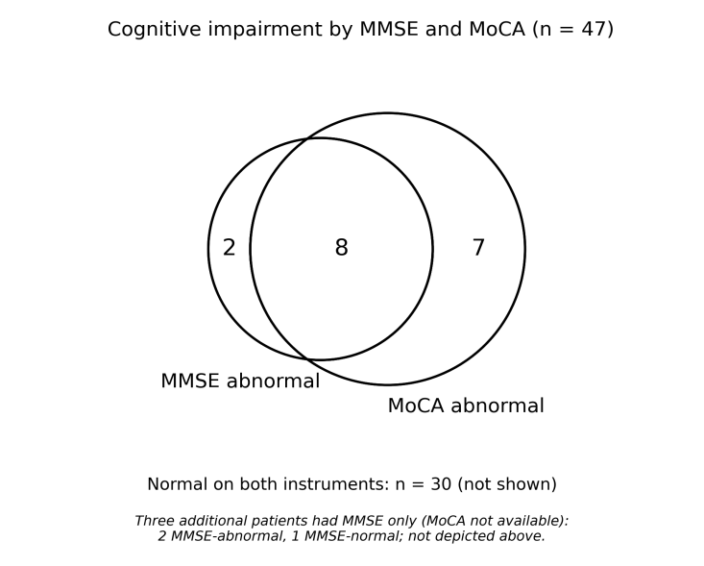
Overlap of MMSE- and MoCA-defined cognitive impairment among the 47 adults with both instruments available. An additional 3 adults had MMSE only (MoCA missing): 2 MMSE-abnormal, 1 MMSE-normal (not depicted). Referenced in Results Section 3.2.

Supplementary Figure S4. Regional ARWML Correlations with Global Cognition (Adults)
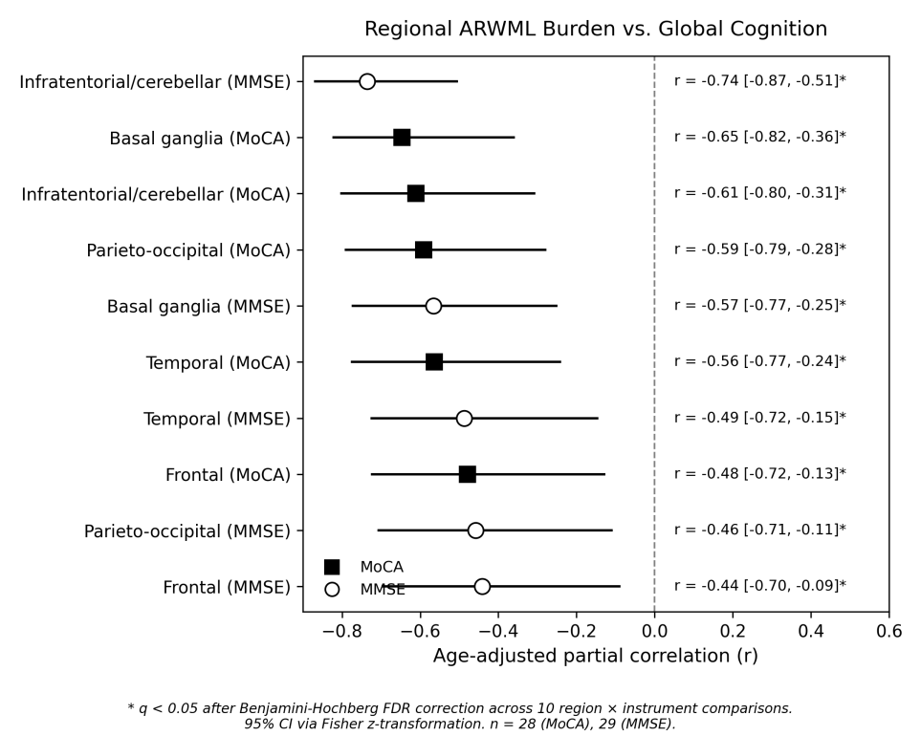
Forest plot of age-adjusted partial correlations between regional ARWML burden (5 bilateral regions) and global cognition (MoCA, MMSE), adult MRI subcohort. Squares = MoCA; circles = MMSE. Horizontal lines are 95% CI (Fisher z-transformation). Asterisks indicate q < 0.05 after FDR correction across 10 region × instrument comparisons; all 10 were significant. Tabulated in Supplementary Table S3. Referenced in Results Section 3.5.

