Supporting Information (SI)

A comprehensive study of the role of phosphorylation in the coordination and hydrolytic behaviour of the human Tau(28-34) protein fragment

Gomaa E. Amer,^{a, b, c} Katalin Várnagy ª

ª Department of Inorganic and Analytical Chemistry, Faculty of Science and Technology University of Debrecen, Egyetem tér 1, H-4032, Debrecen, Hungary
^{b} Doctoral School of Chemistry, University of Debrecen, Egyetem tér 1, H-4032, Debrecen, Hungary
^{c} Department of Chemistry, Faculty of Science, Damanhour University, Damanhour 22511, Egypt

Table S1: list of the abbreviations used for the ligands.
Peptide | Abbreviation | Reference
tau(28-34), Ac-GYTMHQD-NH₂ | L1 | this work
tau(28-30T(P)-34), Ac-GYT(P)MHQD-NH₂ | L1P | this work
tau(Y29A-34), Ac-ATMHQD-NH₂ | L2 | [32]
tau(371-376), Ac-IETHKL-NH₂ | L3 | [32]
tau(261-268), Ac-GSTENLKH-NH₂ | R1 | [31]
tau(261-262S(P)-268), Ac-GS(P)TENLKH-NH₂ | R1P | [31]

Table S2: pH-dependence ¹H-NMR data of native tau(28-34) protein fragment (L1 ligand)
pH | His-CH (*)  aromatic (s) | His-CH (Δ)  aromatic (s) | Tyr-CH (●)  aromatic (d) | Tyr-CH (Ṩ)  aromatic (d) | His-CH₂ (d) | Tyr-CH₂ (d) |  sp-CH₂  (d) |  hr-CH₃  (d)
2.91 | 8.62 | 7.29 | 7.11 | 6.83 | 3.21 | 3.03 | 2.87 | 1.12
4.86 | 8.61 | 7.29 | 7.11 | 6.83 | 3.21 | 3.01 | 2.69 | 1.12
6.55 | 8.41 | 7.21 | 7.11 | 6.83 | 3.17 | 3.01 | 2.66 | 1.12
8.08 | 7.75 | 6.97 | 7.10 | 6.83 | 3.08 | 3.01 | 2.66 | 1.12
8.45 | 7.69 | 6.94 | 7.10 | 6.83 | 3.08 | 3.00 | 2.66 | 1.12
11.56 | 7.67 | 6.95 (overlapped) |  | 6.68 | 3.08 | 2.94 | 2.66 | 1.13

Table S3: pH-dependence ¹H-NMR data (δ(ppm)) of phosphorylated tau(28-30T(P)-34) protein fragment (L1P ligand)
pH | His-CH (*)  aromatic  (s) | His-CH (Δ)  aromatic  (s) | Tyr-CH (●)  aromatic  (d) | Tyr-CH (Ṩ)  aromatic  (d) | His-CH₂ (d) | Tyr-CH₂ (d) |  sp-CH₂  (d) |  hr-CH₃  (d)
3.02 | 8.62 | 7.30 | 7.11 | 6.83 | 3.24 | 3.03 | 2.88 | 1.24
4.89 | 8.61 | 7.29 | 7.11 | 6.83 | 3.23 | 3.02 | 2.70 | 1.23
6.36 | 8.52 | 7.26 | 7.11 | 6.83 | 3.22 | 3.02 | 2.66 | 1.20
7.94 | 7.97 | 7.06 | 7.10 | 6.82 | 3.15 | 2.98 | 2.65 | 1.17
8.36 | 7.82 | 7.00 | 7.10 | 6.82 | 3.15 | 2.97 | 2.65 | 1.17
11.42 | 7.68 | 6.96 (overlapped) |  | 6.59 | 3.10 | 2.91 | 2.65 | 1.17

Table S4. CD parameters (λ_{max} [nm] and Δɛ [M⁻¹.cm⁻¹]) of Cu(II) complexes of L1, L1P, and some tau peptides for comparison (T=298 K, I = 0.2 M KCl).
Binding Sites | L1 | L1P | L2 [32] | L3 [32]
(N–,N–,N_{im}) | 623(−0.334)  525(+0.172)  324(+0.622)  296(+0.099)  256(+3.581) | 539(+0.662)  341(−0.389)  254(+6.474) | 617 (−0.541)  330 (+0.763)  296 (−0.312)  256 (+3.239) | 520 (+0.492)  310 (−0.426)  250 (+7.006
(N–,N–,N–,N_{im}) | 561(−0.705)  489(+0.182)  356(−0.074)  279(+3.681) | 644(+1.013)  494(−1.939)  361(−0.323)  314(+1.424)  286(−1.019)  247(+12.713) | 636 (+0.102)  560 (−0.629)  492 (+0.273)  305(+1.392)  277 (+2.483) | 645 (+1.203)  495 (−1.717)  355 (−0.977)  260 (+9.160

Table S5: Time-dependent CD spectral data of the Ni(II): tau(28-34) protein fragment Ac-GYTMHQD-NH₂ (1:1) ratio system as a function of pH at T = 25°C.
Time (t) | pH = 8.90 | pH = 10.05 | pH = 10.45 | pH = 11.03
t = 0 min. | 555(+0.480)  492(−1.079)  447(+0.319)  406(−0.426) | 555(+0.469)  493(−1.551)  444(+0.540)  402(−0.301) | 557(+0.439)  493(−1.672)  442(+0.621)  400(−0.227) | 561(+0.411)  493(−1.804)  441(+0.692)  393(−0.163)
t = 2 hr. | 554(+0.421)  491(−1.148)  444(+0.226)  405(−0.308) | 557(+0.381)  492(−1.432)  441(+0.380)  401(−0.165) | 558(+0.349)  492(−1.542)  439(+0.455)  397(−0.107) | 559(+0.318)  492(−1.653)  437(+0.520)  389(−0.074)
t = 24 hr. | ⎯  479(−1.766)  411(+0.723)  ⎯ | ⎯  480(−1.817)  412(+0.772)  ⎯ | ⎯  480(−1.851)  410(+0.790)  ⎯ | ⎯  481(−1.917)  411(+0.875)  ⎯

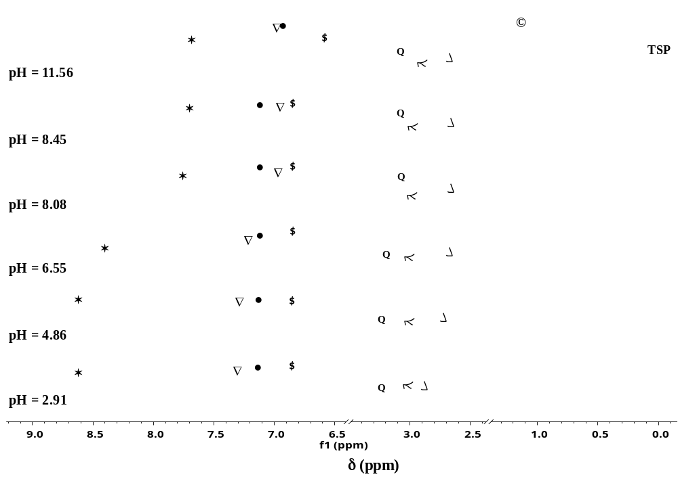
Figure S1: pH-dependence of the ¹H-NMR spectra registered for L1 ligand (* and Δ (s) are His-aromatic protons signals, ● and Ṩ (d) are Tyr-aromatic proton signals, Q (d) is His-CH₂ signal, h (d) is Tyr-CH₂ signal, x (d) is Asp-CH₂ signal, © (d) is Thr-CH₃ signal).

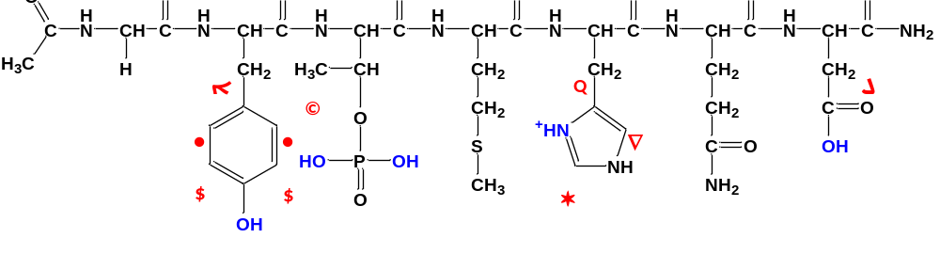
Figure S2: Chemical structure of the protonated phosphorylated tau(28-30T(P)-34) protein fragment (L1P) with assignments of the ¹H-NMR signals.

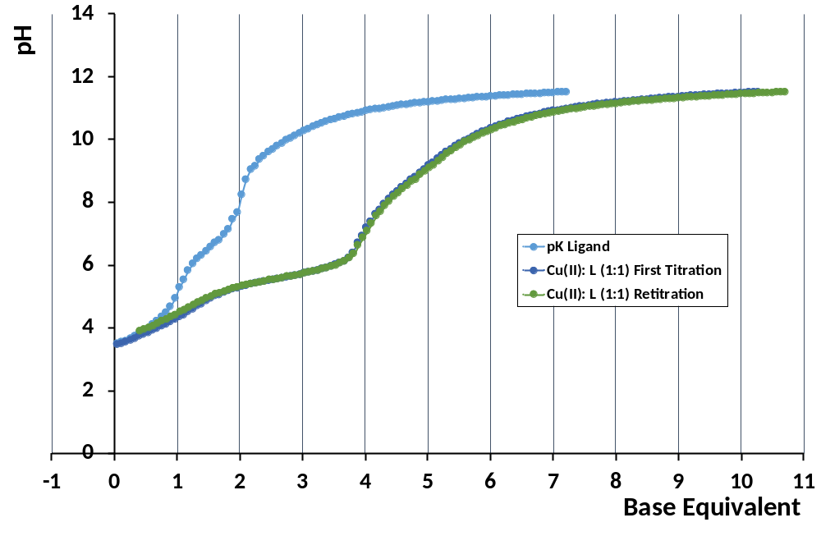
Figure S3: Titration curves of the equimolar Cu(II):L1 system (1:1) and its repeated series after reacidification indicated with a green color.

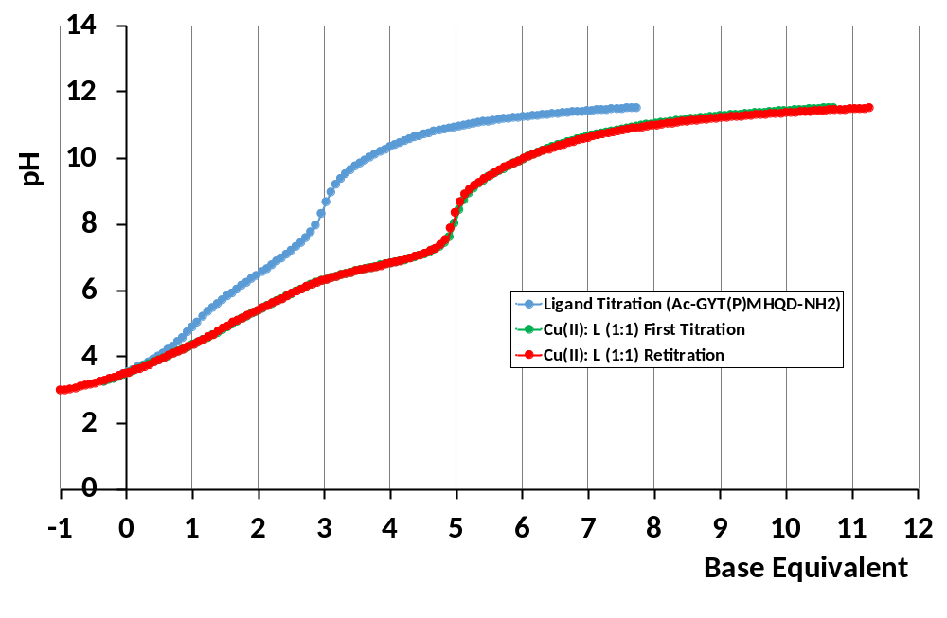
Figure S4: Titration curves of the equimolar Cu(II): L1P system (1:1) and its repeated series after re-acidification indicated with a red color.
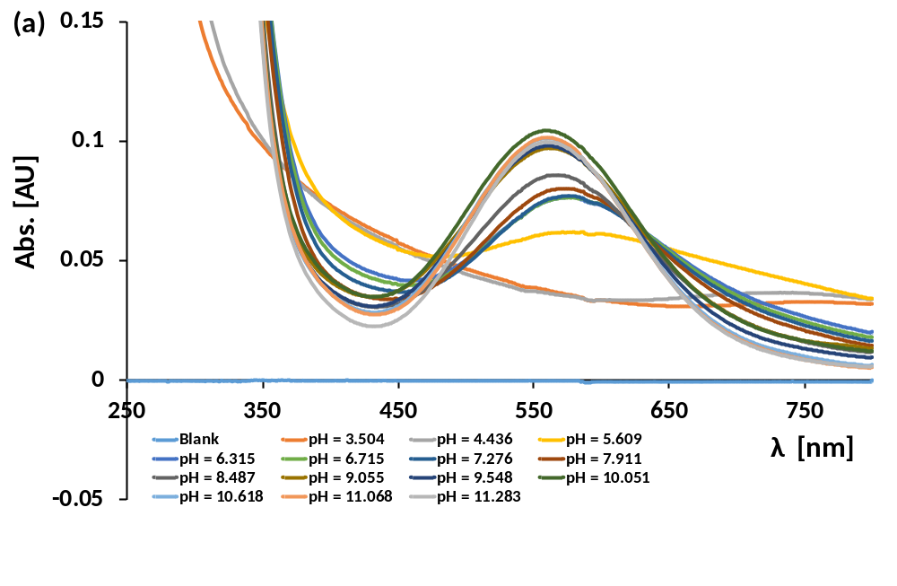
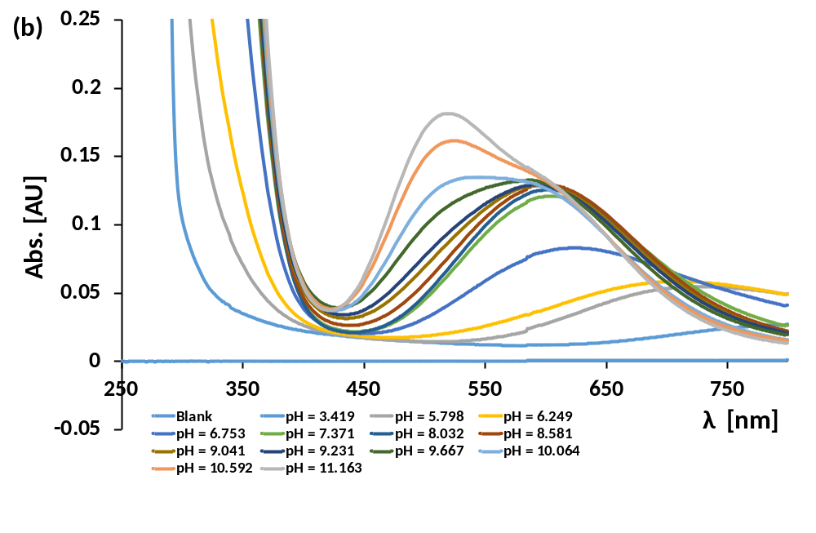
Figure S5: UV-Vis spectra of Cu(II) complexes of L1 (c(L) = c(M) = 1.09 mM) (a) and L1P (c(L) = c(M) = 1.33 mM) (b) at (1:1) ratio in function of pH.
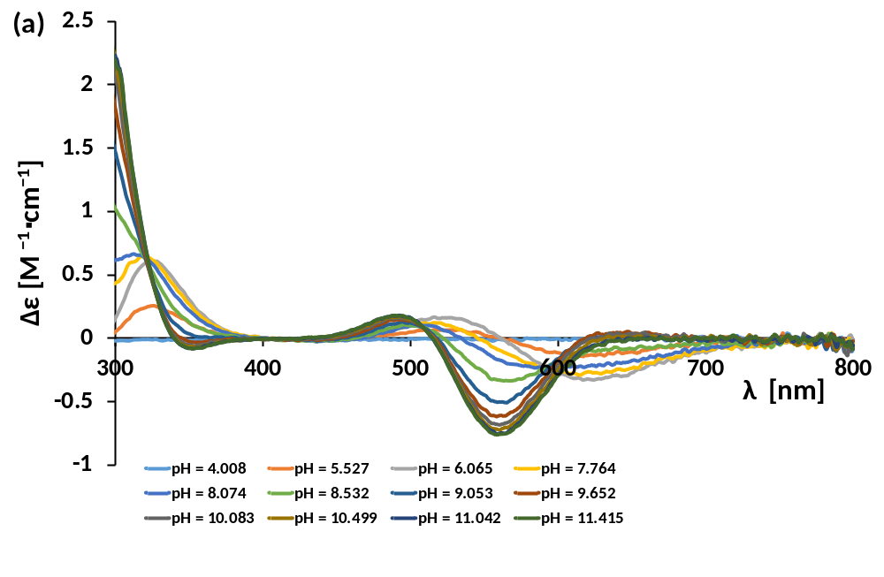
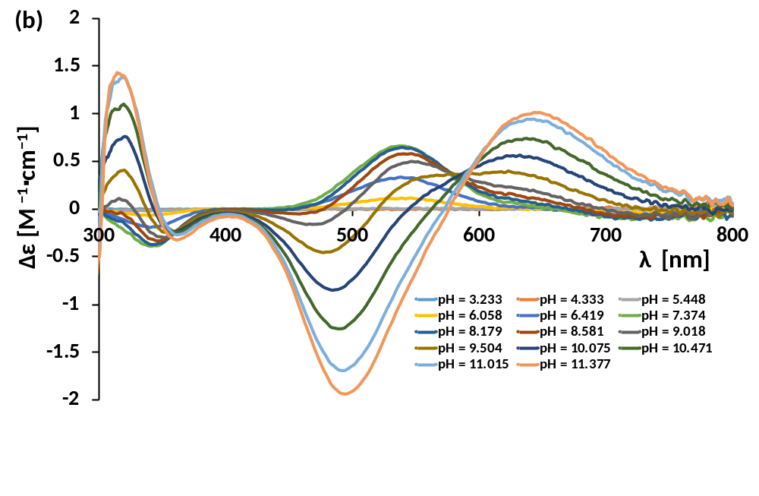
Figure S6: CD spectra of Cu(II) complexes of L1 (a) and L1P (b) at 1:1 ratio in function of pH.
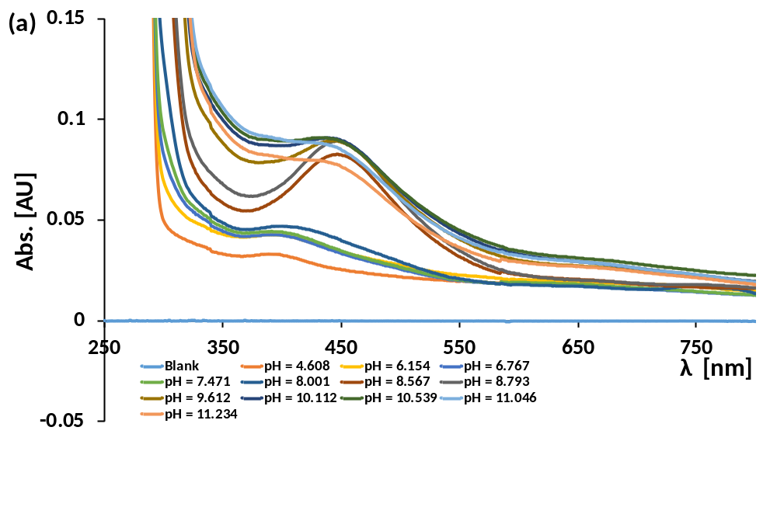
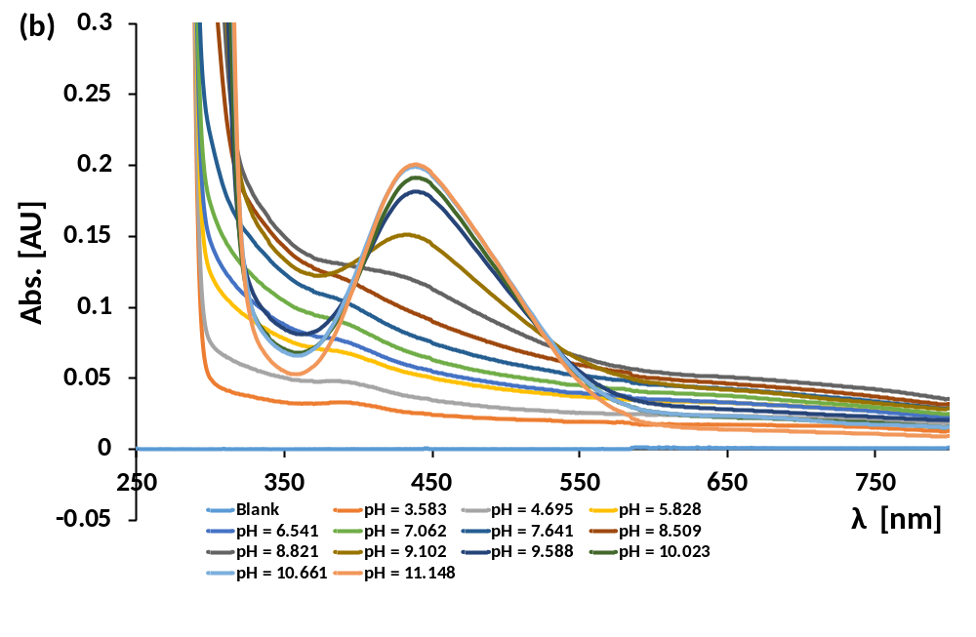
Figure S7: UV-Vis spectra of Ni(II) complexes of L1 (c(L) = c(M) = 1.07 mM) (a) and L1P (c(L) = c(M) = 1.28 mM) (b) at 1:1 ratio in function of pH.
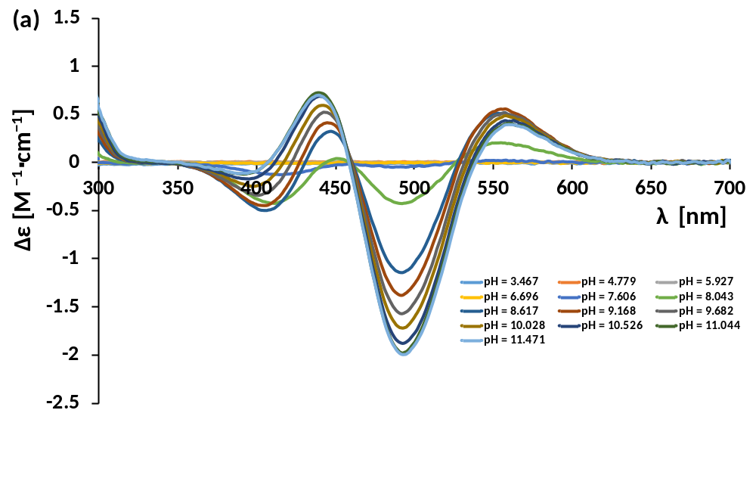
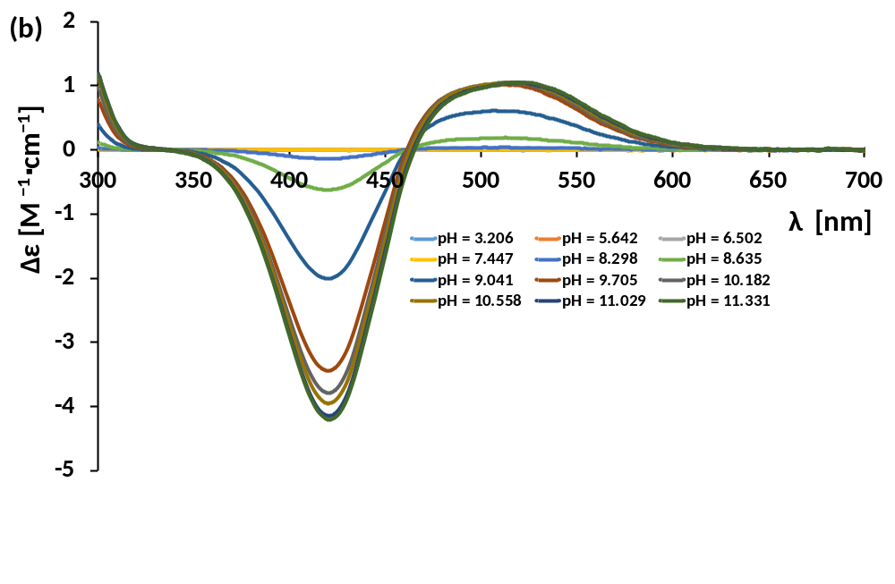
Figure S8: CD spectra of Ni(II) complexes of native L1 (a) and phosphorylated L1P (b) at 1:1 ratio in function of pH.
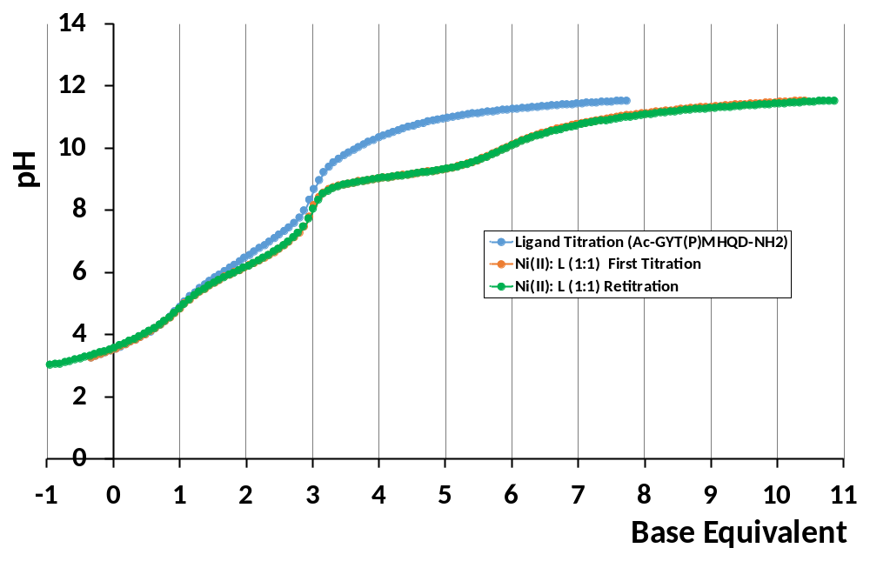
Figure S9: Titration curves of the equimolar Ni(II): L1P system (1:1) and its repeated series after reacidification indicated with a green color.

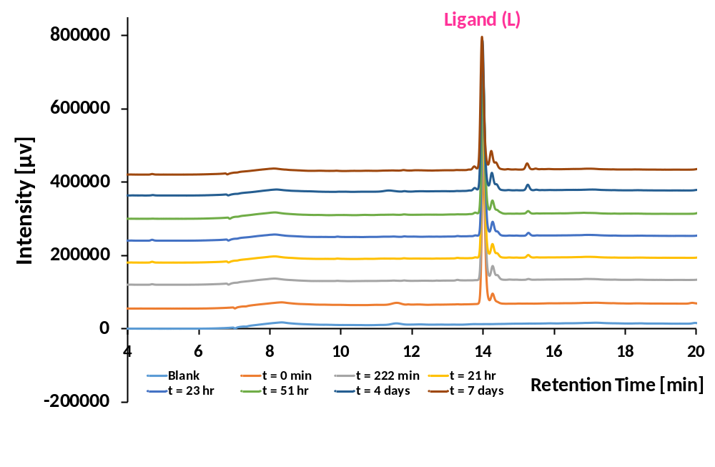
Figure S10. Time-dependent HPLC chromatograms for phosphorylated tau(28-30T(P)-34) protein fragment at pH = 11.0 and T = 25°C.
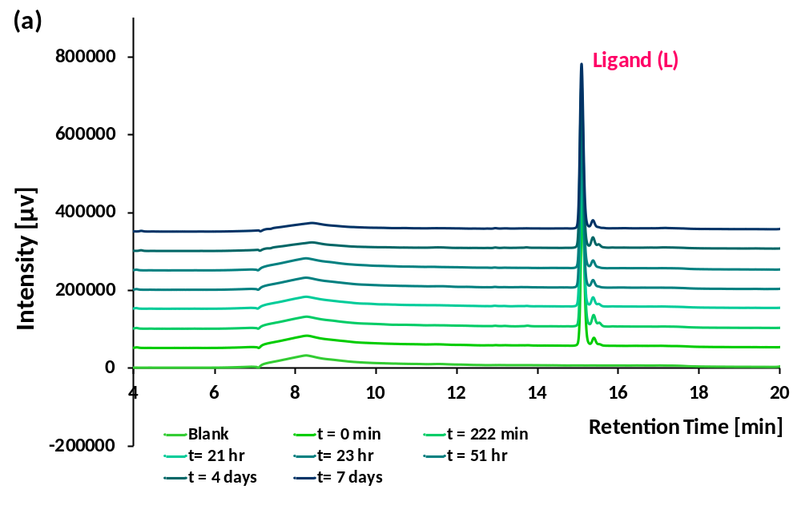
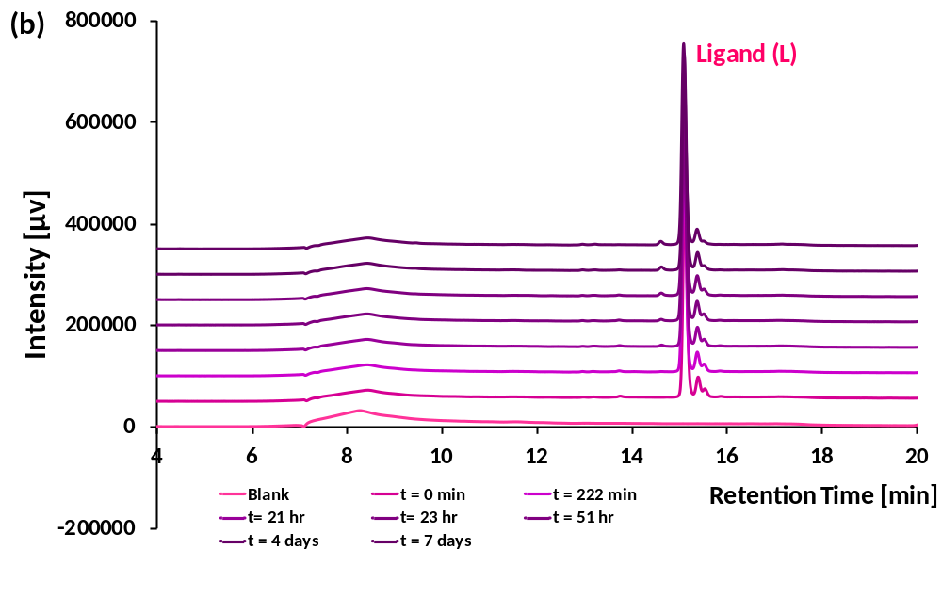
Figure S11. Time-dependent HPLC chromatograms for L1 ligand at pH = 8.0 (a) and pH = 11.0 (b) at T = 25°C.
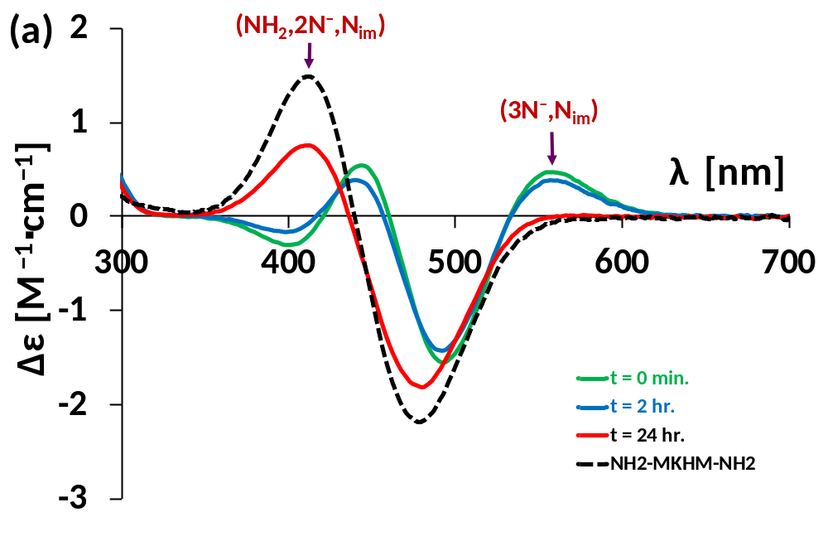
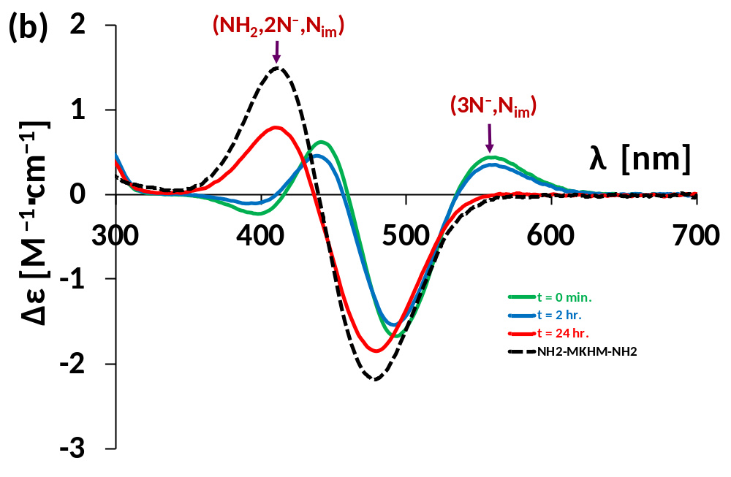
Figure S12: Time-dependent CD spectra for the Ni(II): L1 system at 1:1 ratio at two pH values: pH 10.0 (a), pH 10.5 (b) in function of time at T = 25°C. The CD spectrum of the (NH₂,N–,N–,N_{im}) coordinated Ni(II) complex of NH₂-MKHM-NH₂ peptide is also shown (dash black curve).

