Logic Model for the Research Experience for Medical Students (REMS) Elective Series
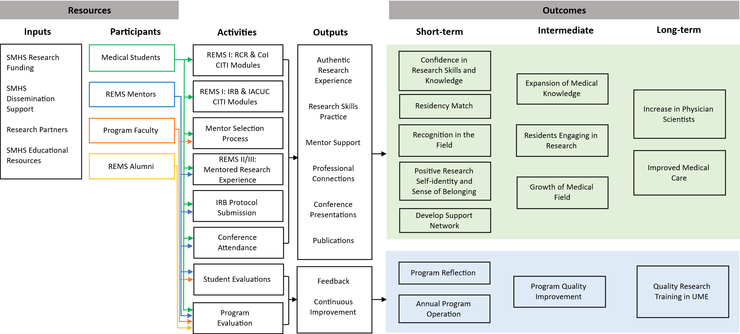
The logic model illustrates the conceptual and operational framework of the Research Experience for Medical Students (REMS) elective series, linking foundational resources to short-term, intermediate, and long-term outcomes.
Resources (Inputs and Participants): Program inputs comprise School of Medicine and Health Sciences (SMHS) research funding, dissemination support, research partners, and SMHS educational resources. Active participants engaged across programmatic activities include medical students, faculty research mentors, program leadership/faculty, and REMS alumni.
Activities and Outputs: Program activities are divided into instructional curricula and continuous quality improvement mechanisms:
- Curricular activities include foundational CITI training modules (Responsible Conduct of Research, Conflicts of Interest, Institutional Review Board, and Institutional Animal Care and Use Committee protocols), a structured mentor selection process, immersive mentored research electives (REMS II/III), formal IRB protocol submissions, and conference attendance. These activities generate direct scholarly outputs, including authentic research experiences, targeted research skills practice, mentor support, professional network expansion, conference presentations, and peer-reviewed publications.
- Programmatic activities include formal student evaluations and comprehensive program evaluations, which produce continuous feedback and systematic quality improvement.
Outcomes: Expected outcomes are categorized across participant-level benefits (green panel) and programmatic benefits (blue panel) through three sequential phases:
- Short-term outcomes: Participant-level gains encompass increased self-efficacy and confidence in research methodology, successful residency match placement, professional recognition, fostering a positive research self-identity and sense of belonging, and the establishment of peer and professional support networks. Programmatic gains include systematic program reflection and structured annual program operations.
- Intermediate outcomes: Participant-level effects include the expansion of clinical and biomedical knowledge, continued active engagement in research during residency training, and contributions toward the growth of medical scholarship. Programmatic effects center on sustained institutional program quality improvement.
- Long-term outcomes: The overarching long-term impacts aim to expand the physician-scientist workforce pipeline and advance clinical care quality, while establishing a sustainable standard of quality research training within undergraduate medical education (UME).

