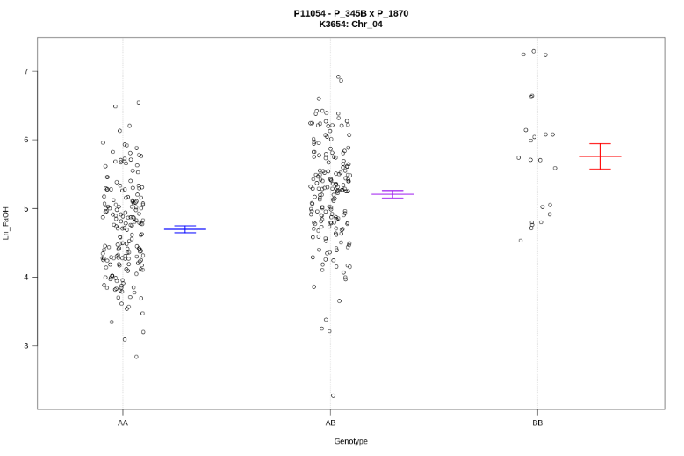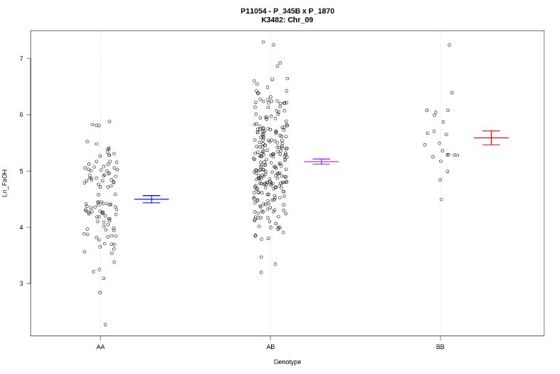
b
a
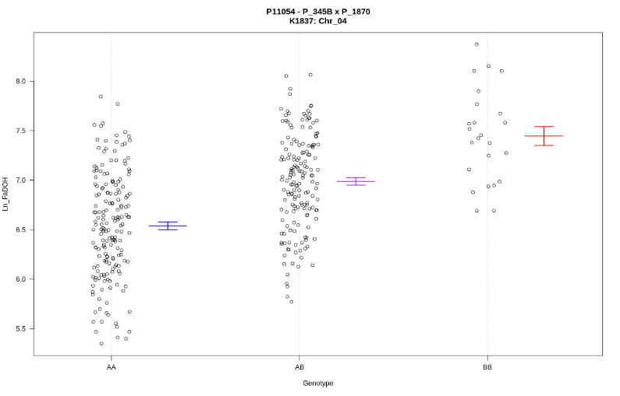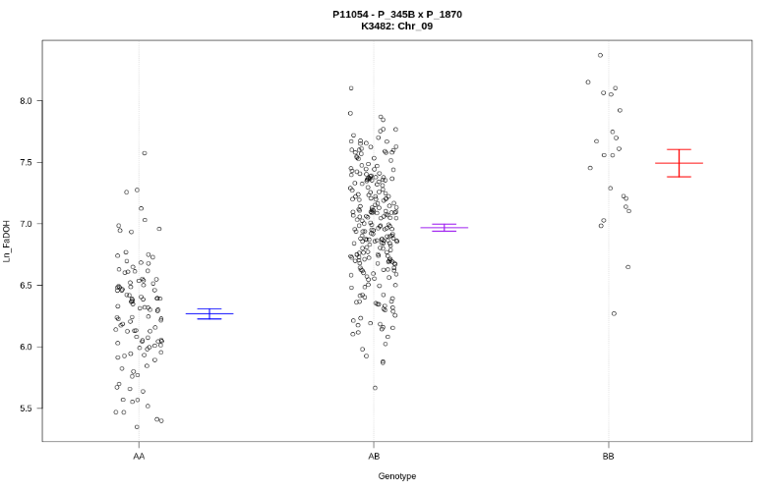
d
c

Figure S3 PA contents of marker genotypes. Phenotypic distribution is shown for peak markers of the following major QTLs: a FaOH_4.1 (K3654), b FaOH_9.1 (K3482), c FaDOH_4.1 (K1837), d FaDOH_9.1 (K3482).

