c
a

b
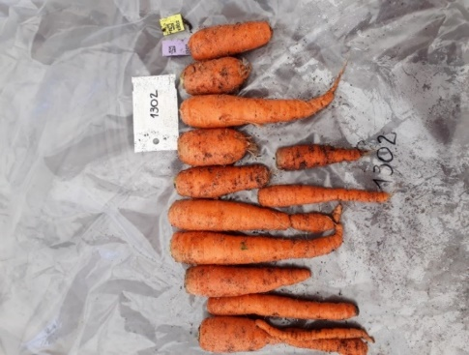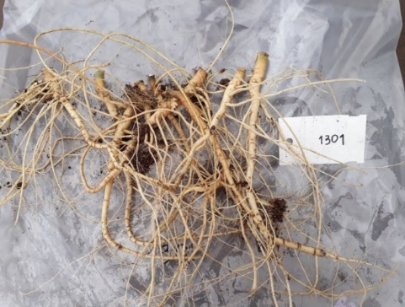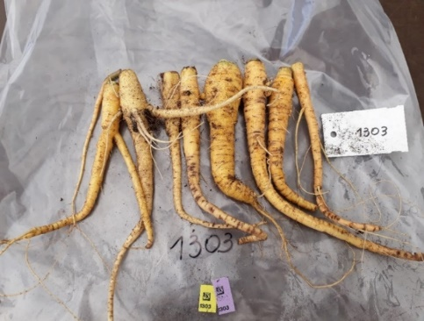

d FaOH
e FaDOH

Figure S1 Characteristic carrot root phenotypes of the cultivated inbred line ´345-B´ (a), of the inbred line derived from D. carota ssp. commutatus accession JKI 1870 ('1870') (b) and of the F₂ population ´CA´. FaOH and FaDOH levels of each six parental individuals of ´345-B´ and´1870´, and nine F₂ individuals of ´CA´ are shown in d and e, respectively. Due to morphological reasons, root tissue for PA analysis was sampled using the 'PPX' method. For details, see method section.

