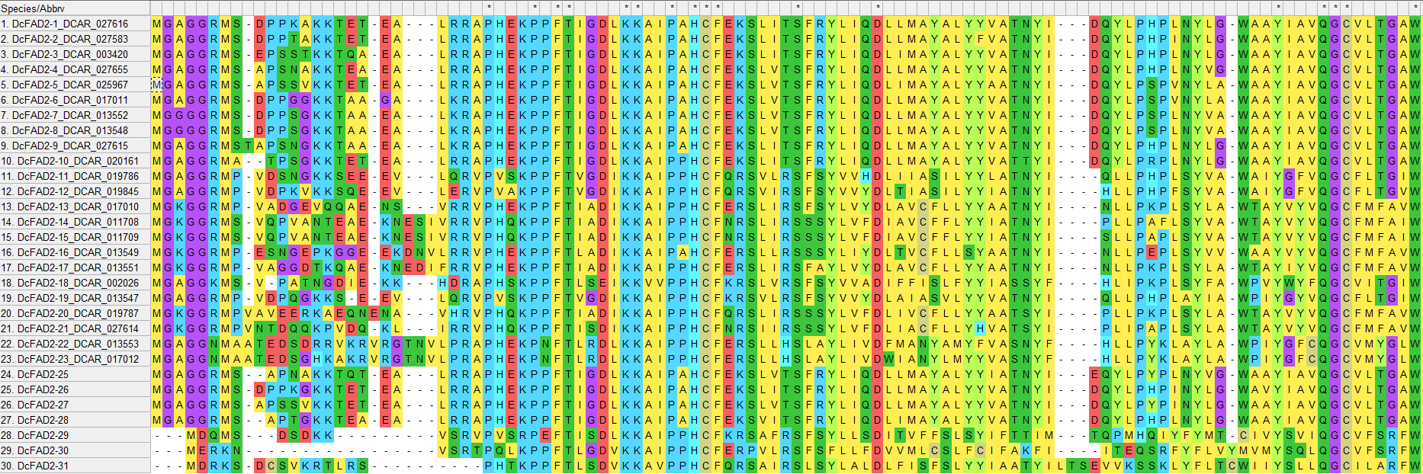
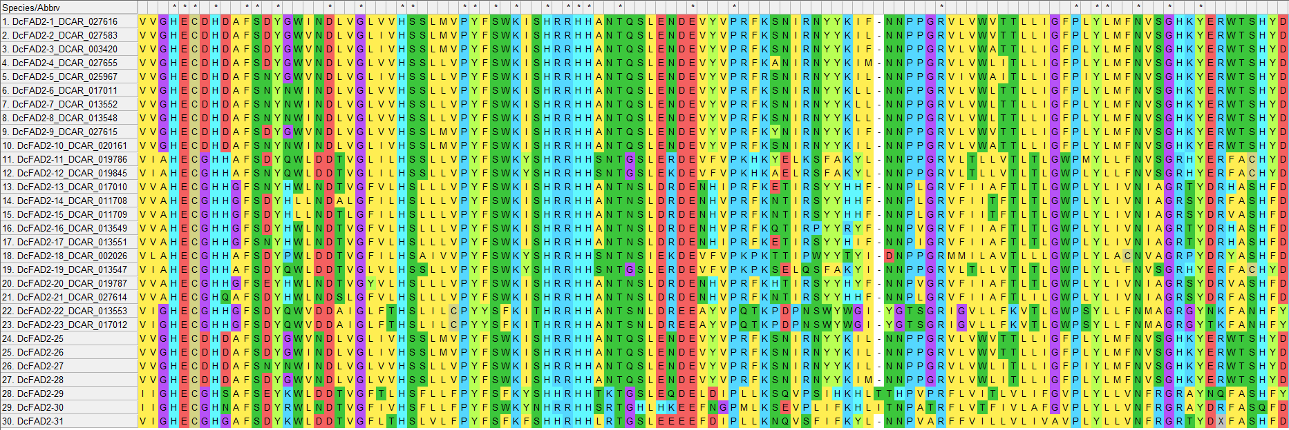
HXXHH
HXXXH

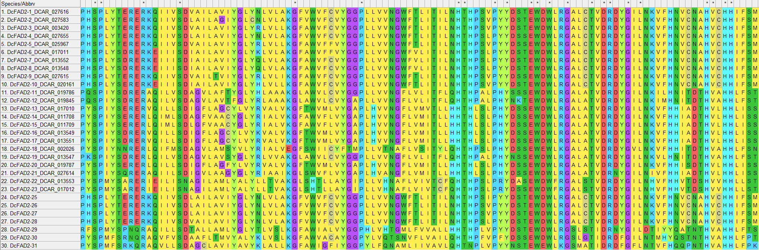
HXXHH
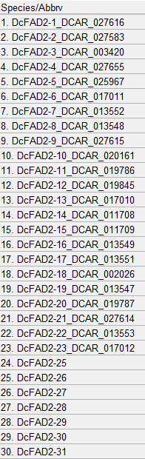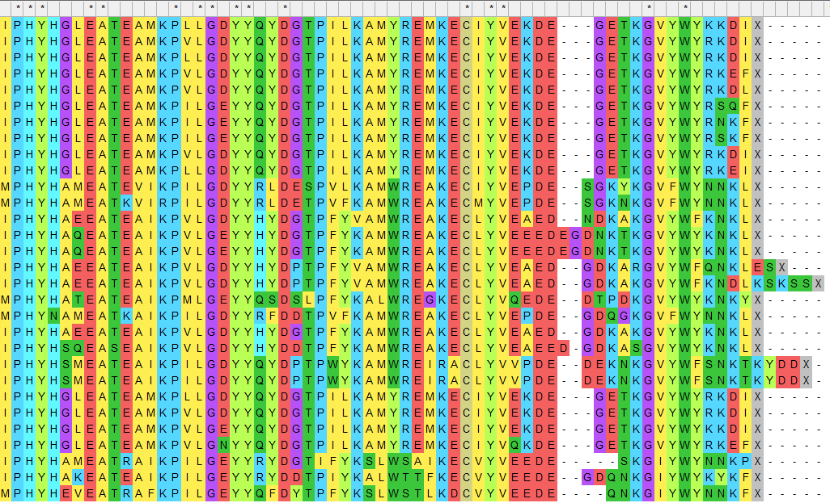
ER localization
Figure S4 Alignment (MEGA-X, Muscle) of the predicted protein sequences of 23 D. carota FAD2s [5] and seven newly identified carrot FAD2s (DcFAD2-25 to DcFAD2-31, this study). Three putative His boxes are underlined in blue. The position of the G/A residues putatively promoting acetylenase activity is marked by a black arrow. Residues indicating divergent FAD2 function (according [5]) are marked with red arrows. The putative ER localization motif at the C-terminus is underlined in black.

