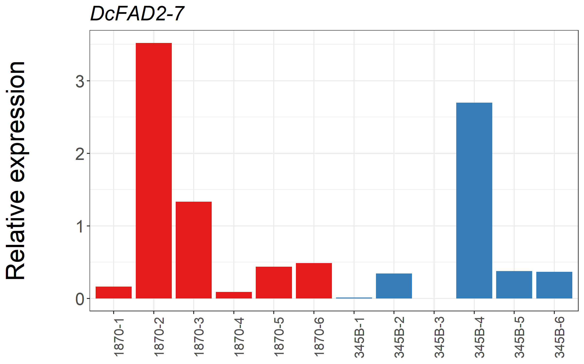
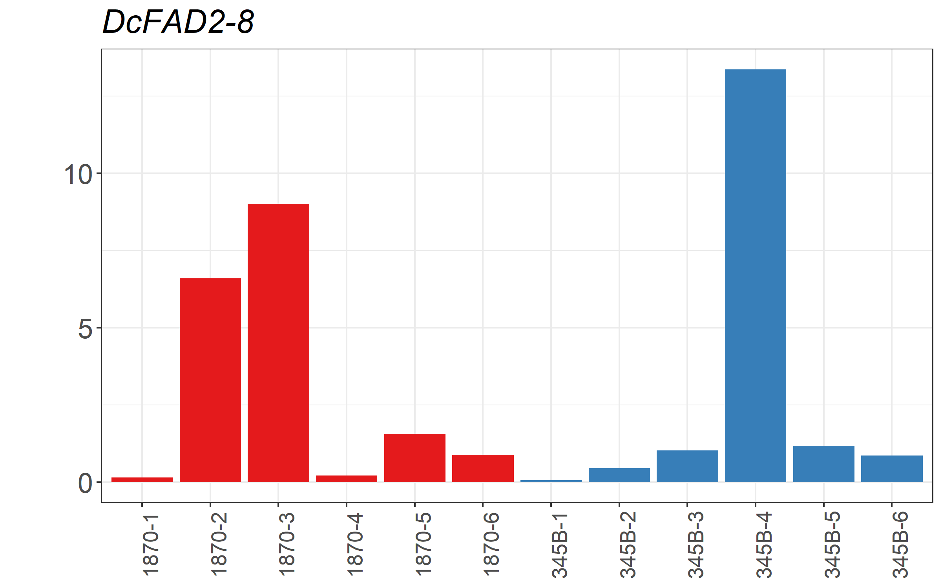
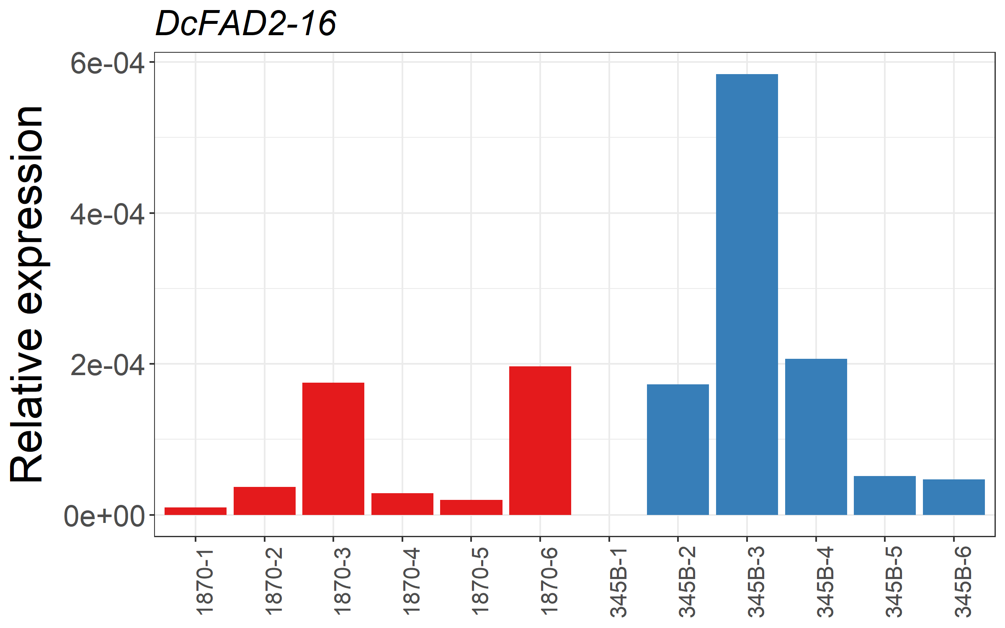
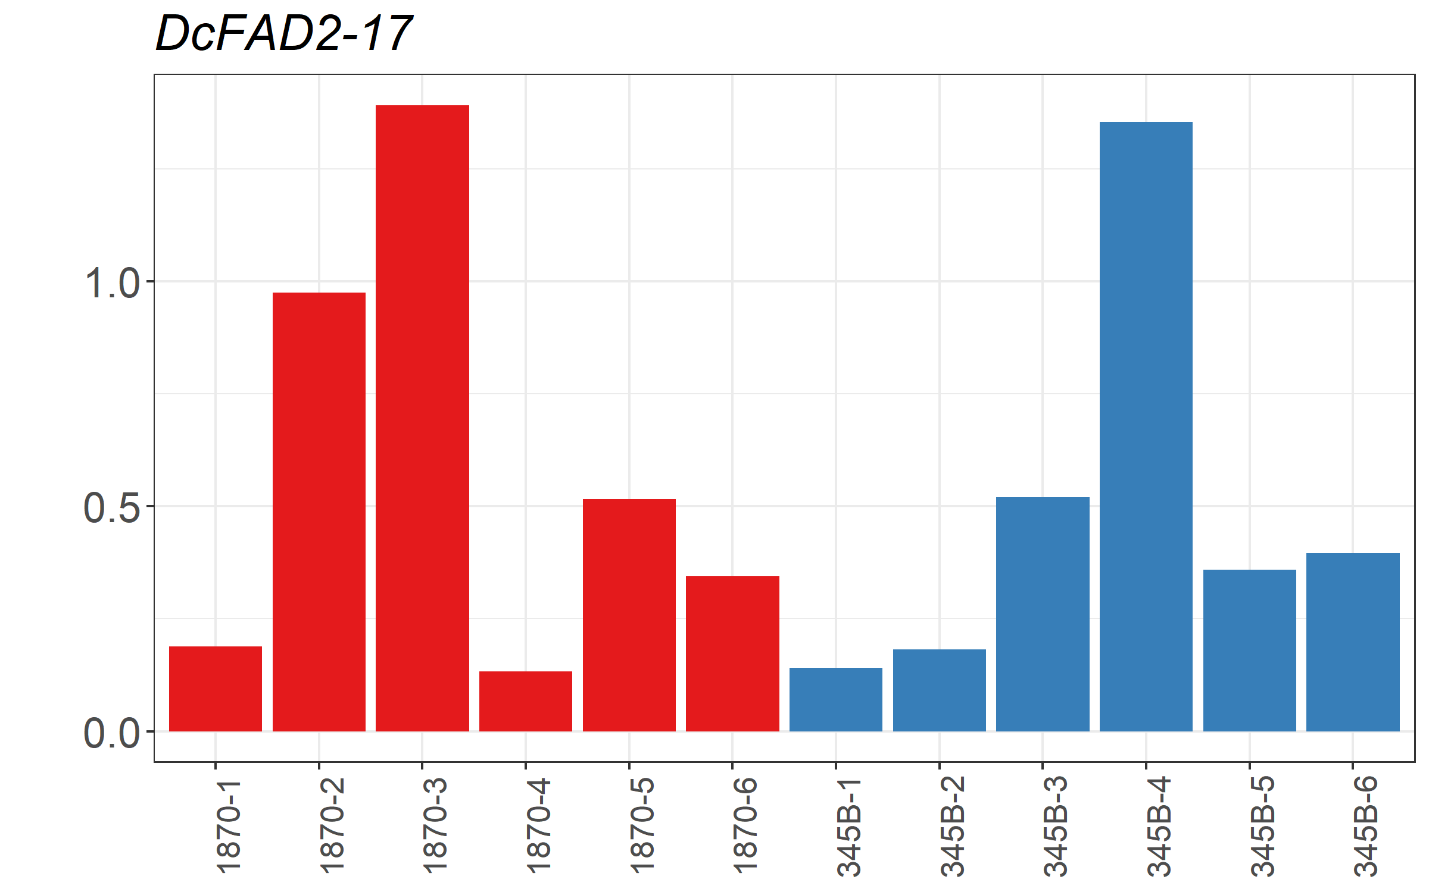
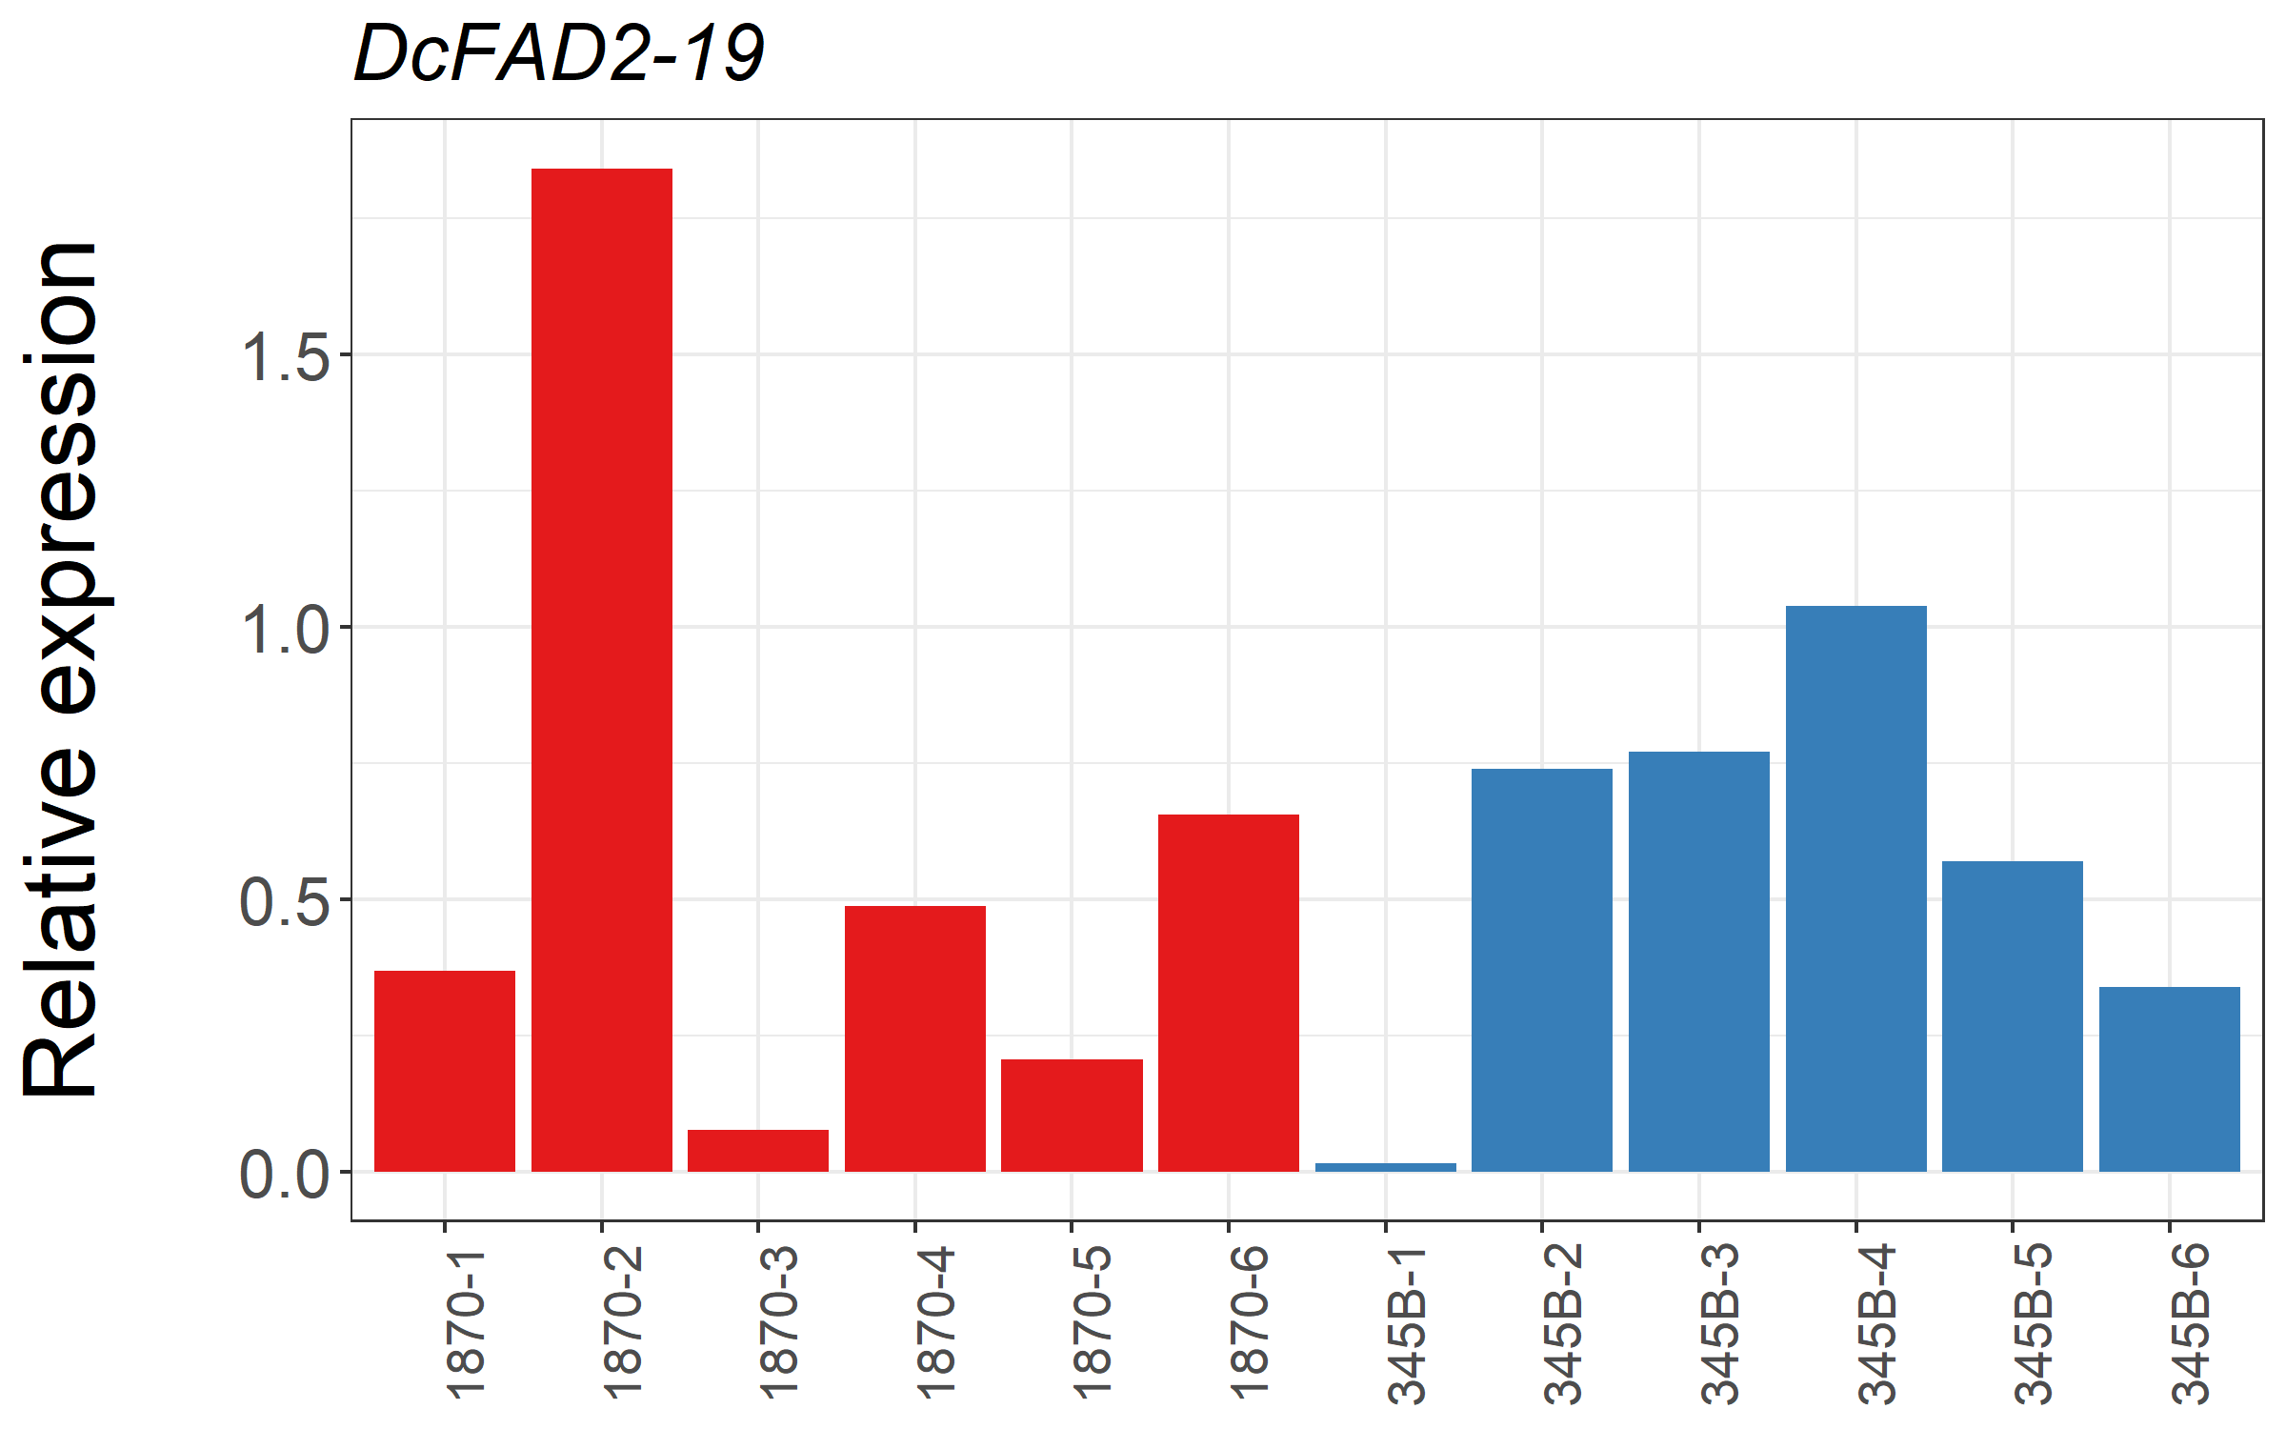
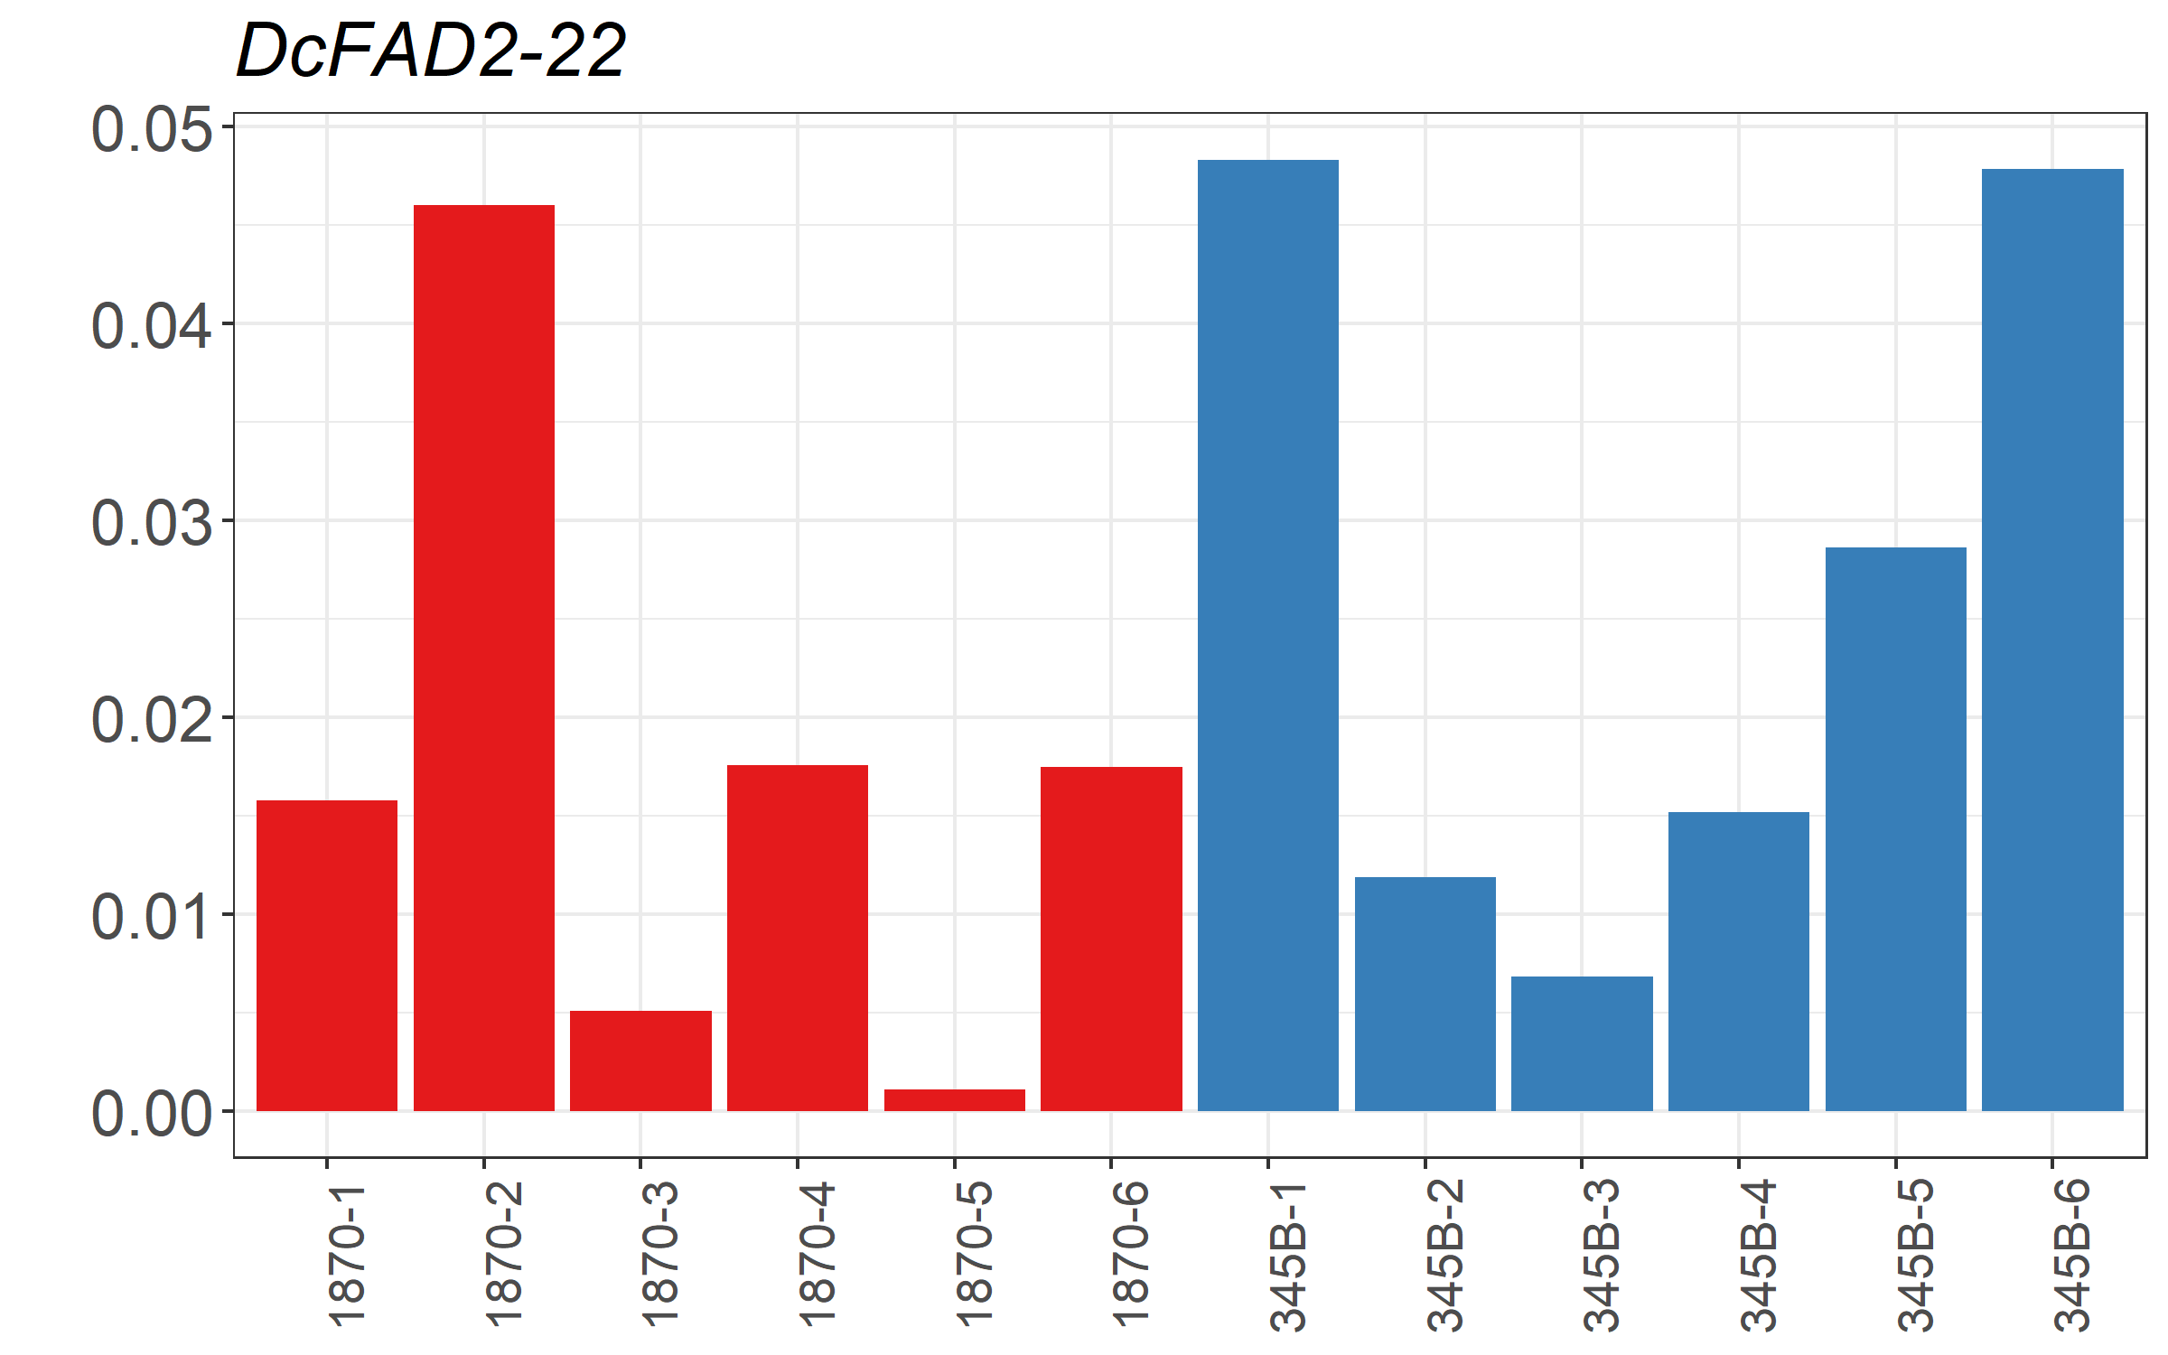
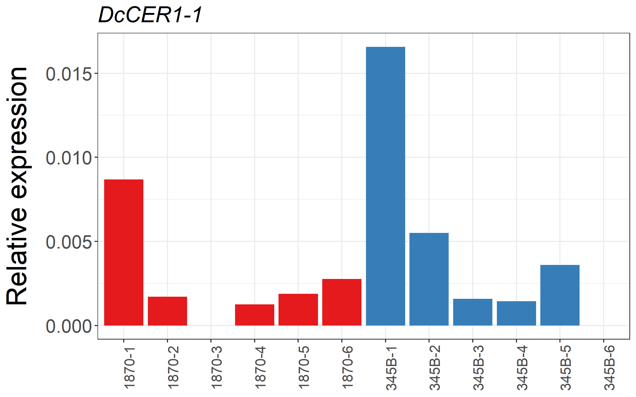
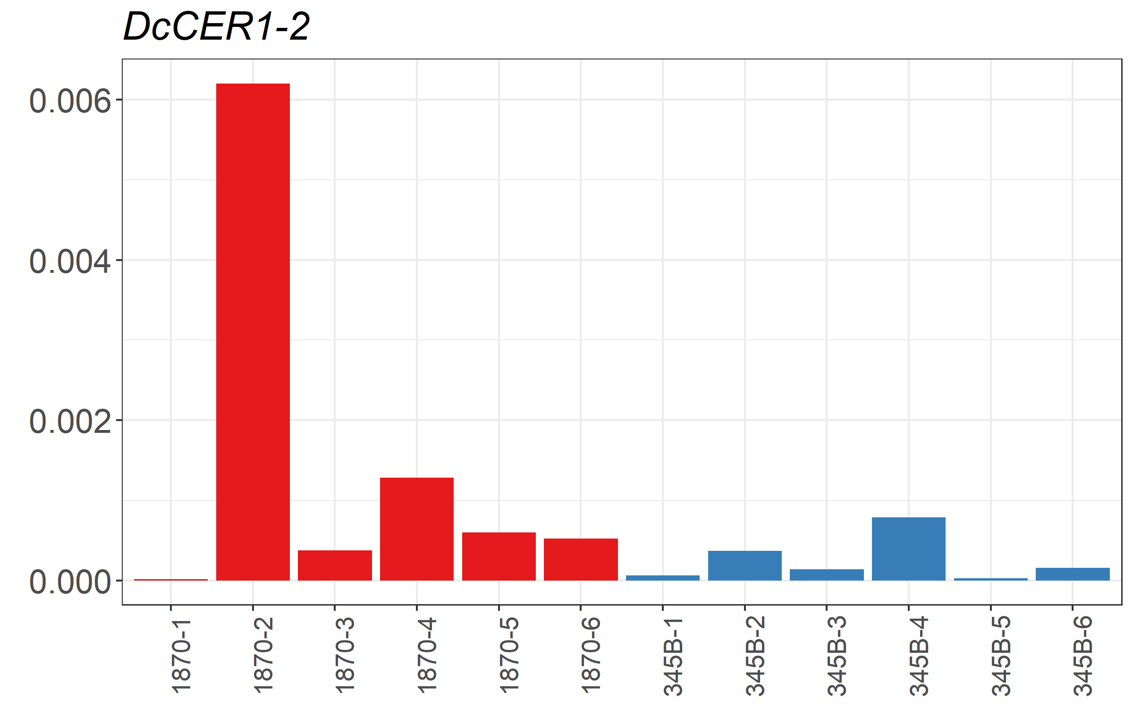
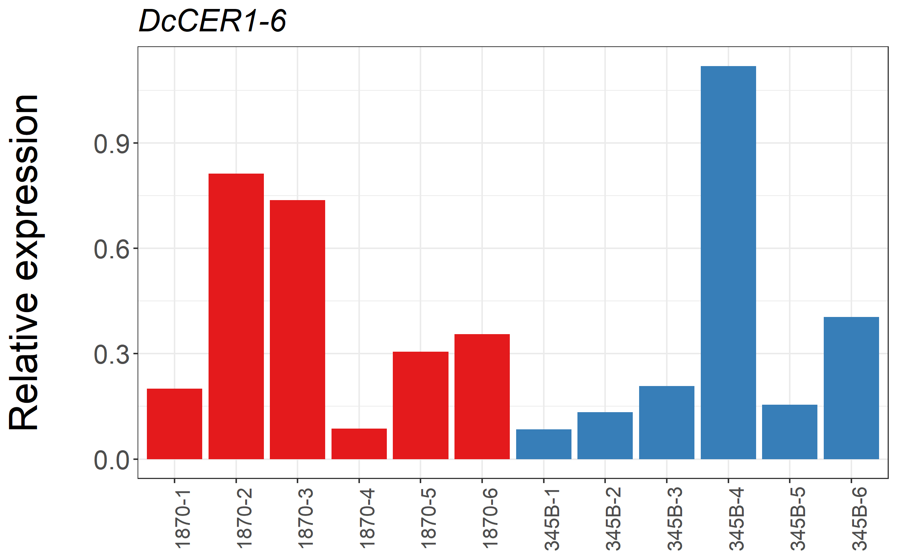

Figure S9 Expression profiles of six DcFAD2 genes and three DcCER1 genes located within 2-LOD QTL intervals on chromosomes 4 and 9, respectively. The levels of RNA transcripts for DcFAD2-7, DcFAD2-8, DcFAD2-16, DcFAD2-17, DcFAD2-19, DcFAD2-22, DcCER1-1, DcCER1-2 and DcCER1-6 were analysed in a mixed root sample (PPX method, see Mat. + Methods) from individual roots of six genotypes each of parental lines 1870 (red) and 345B (blue).

