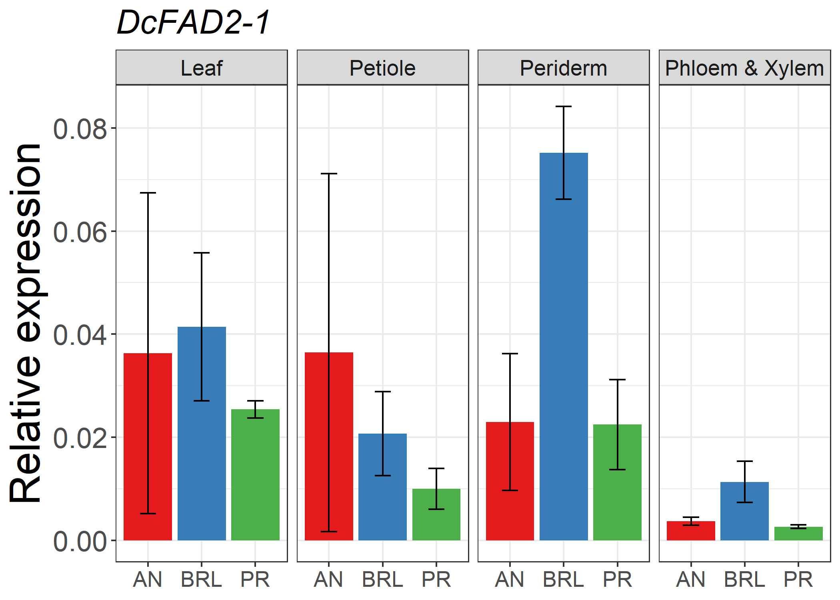
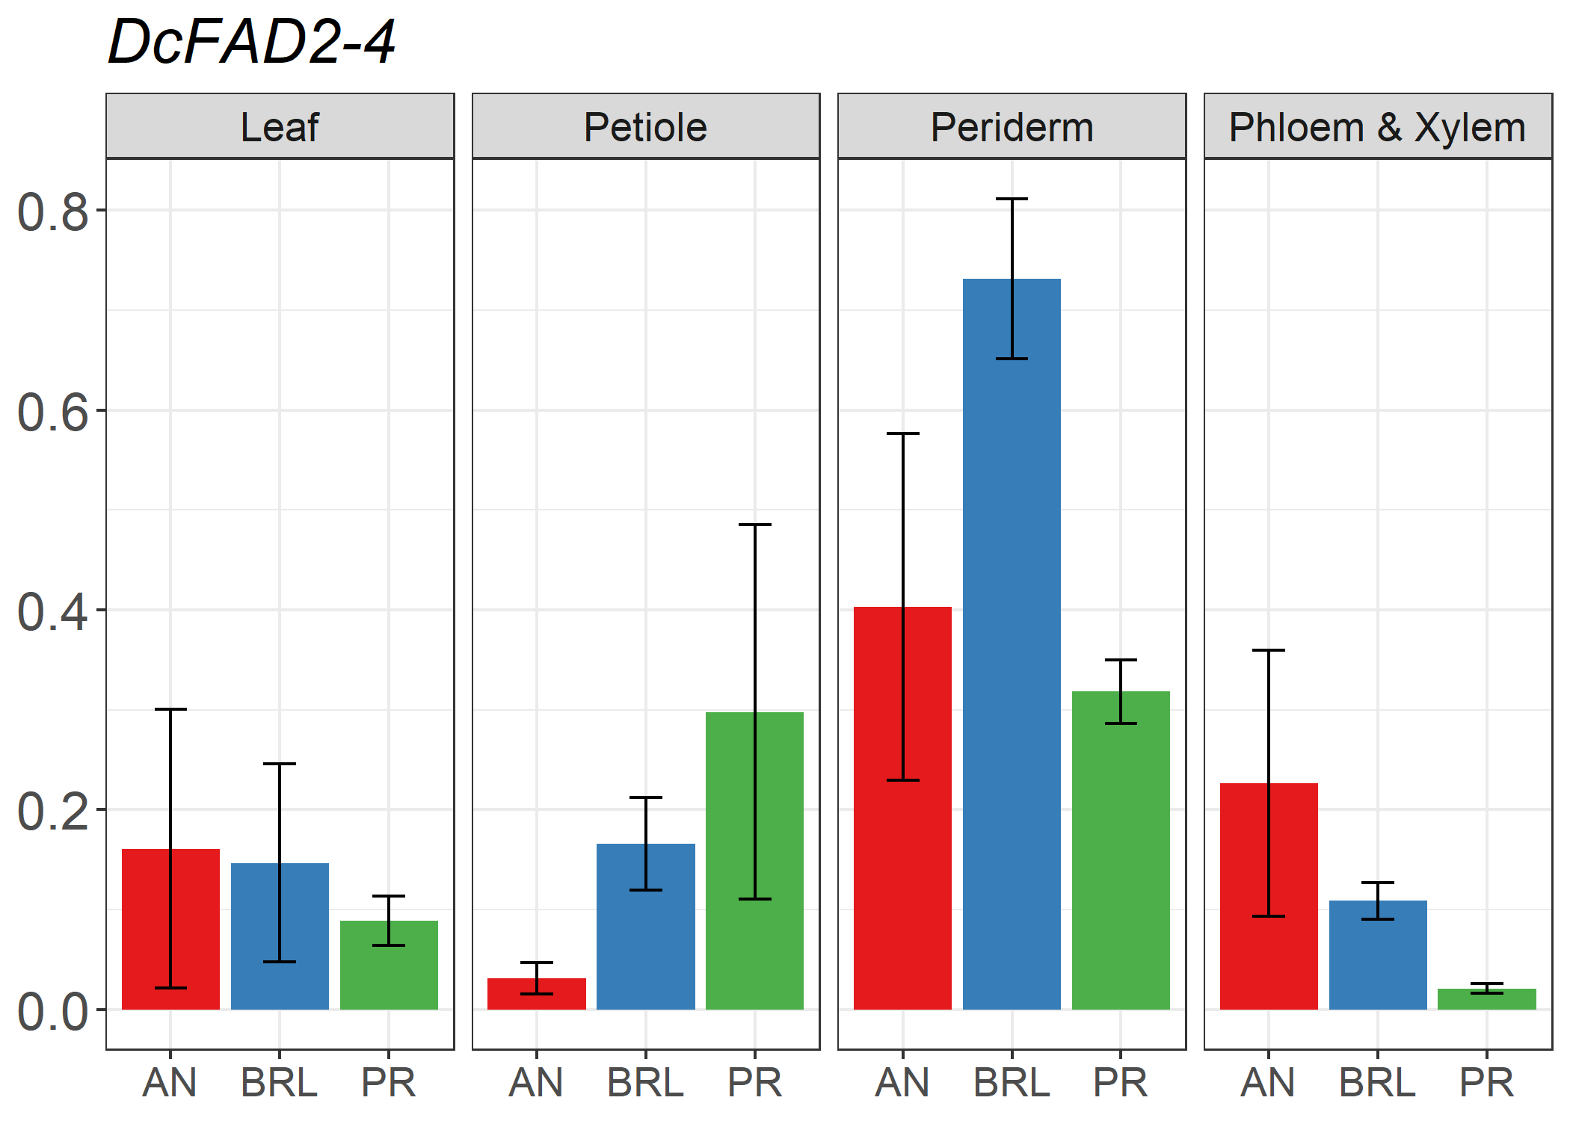
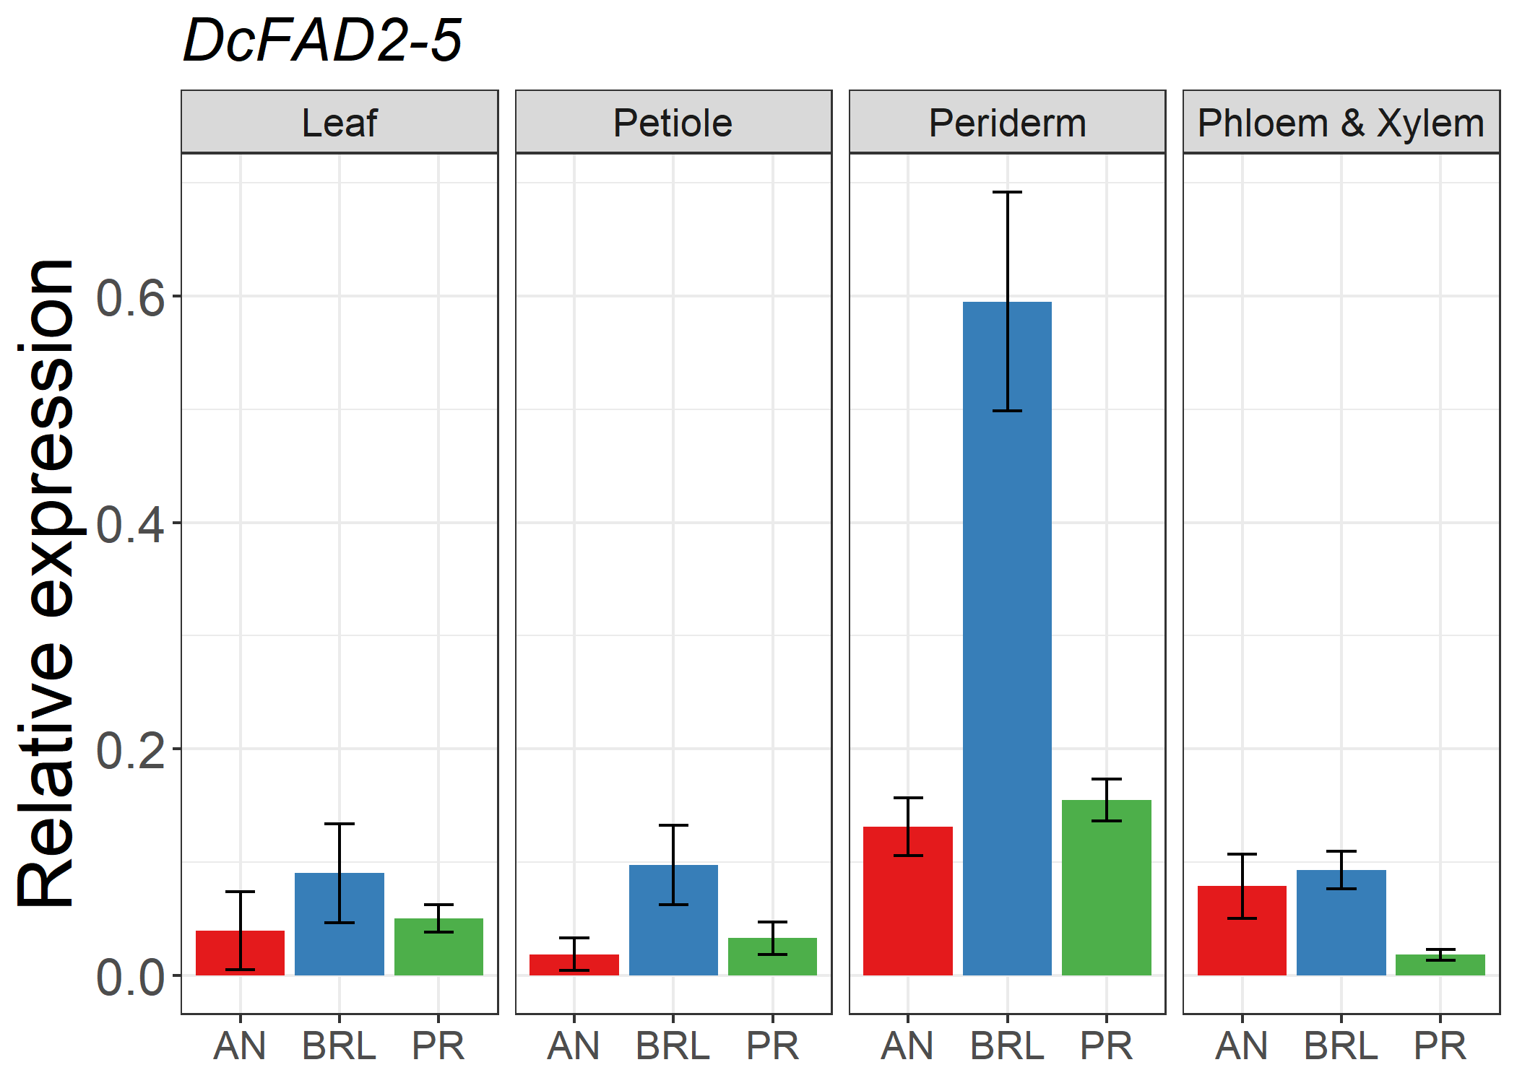
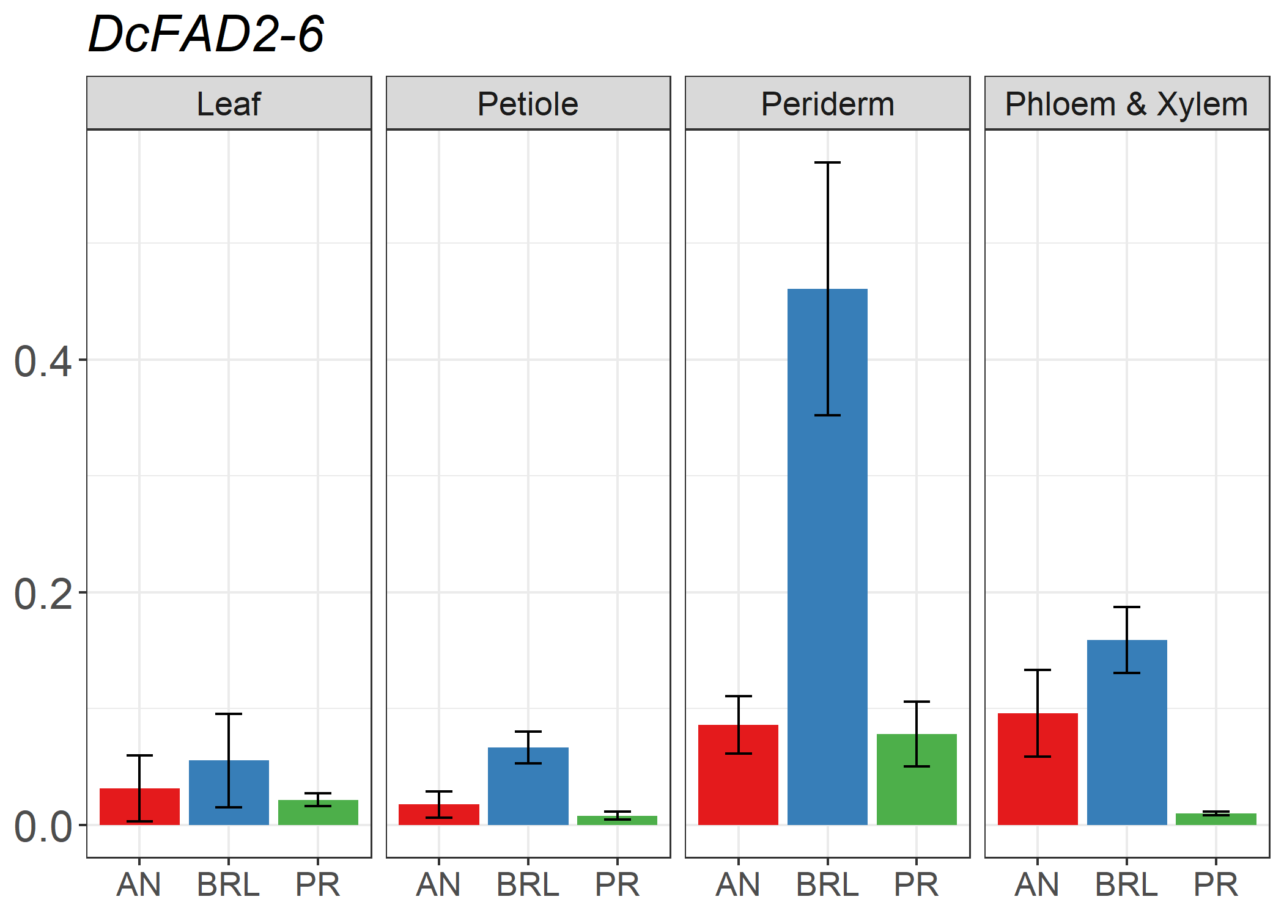
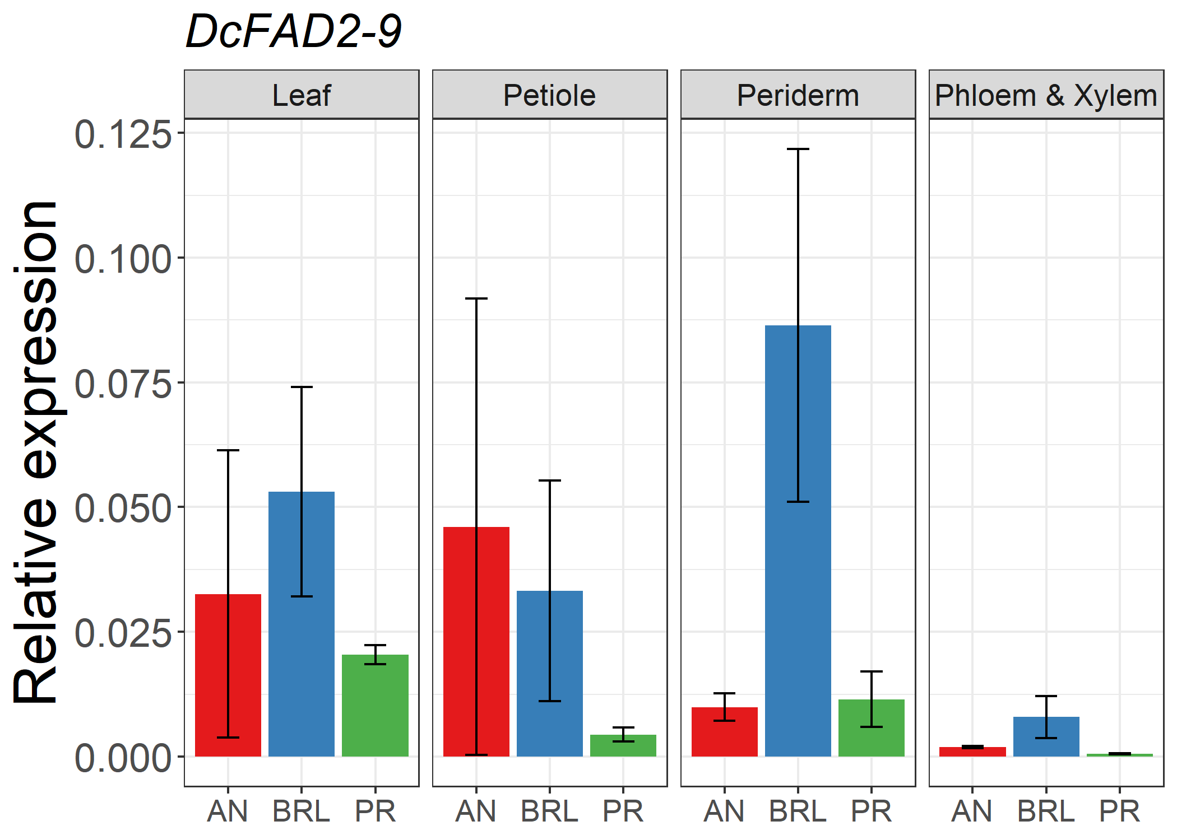
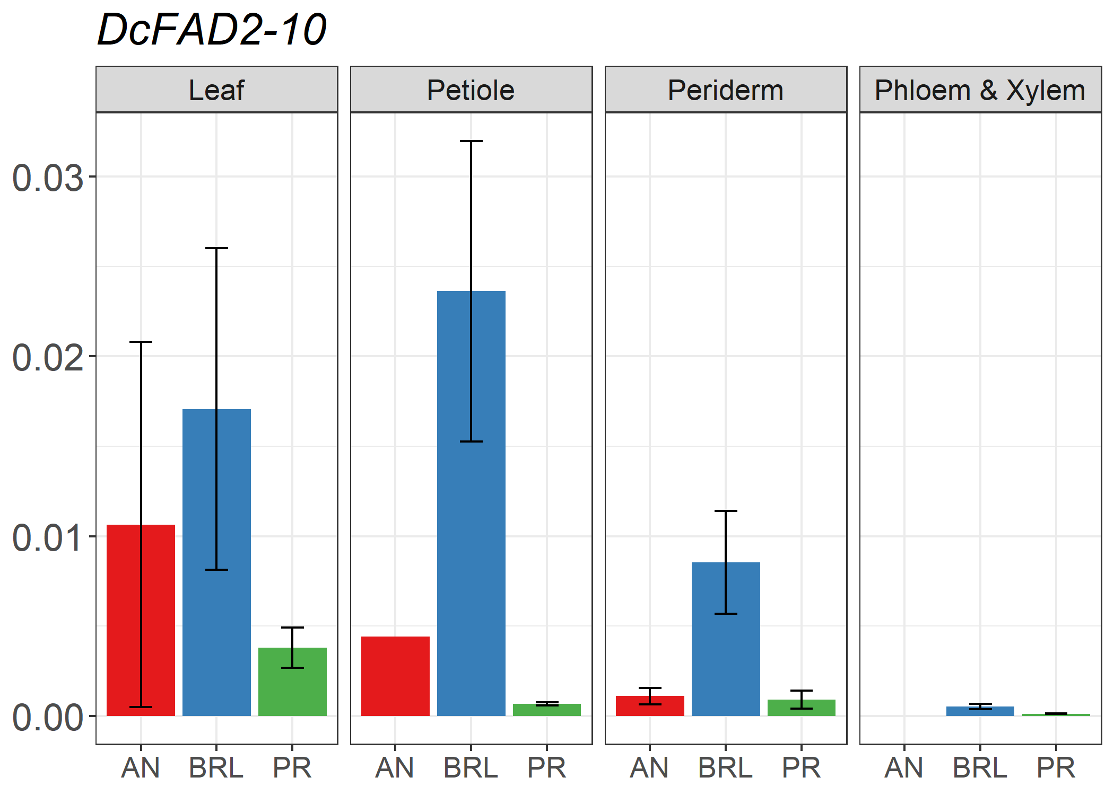
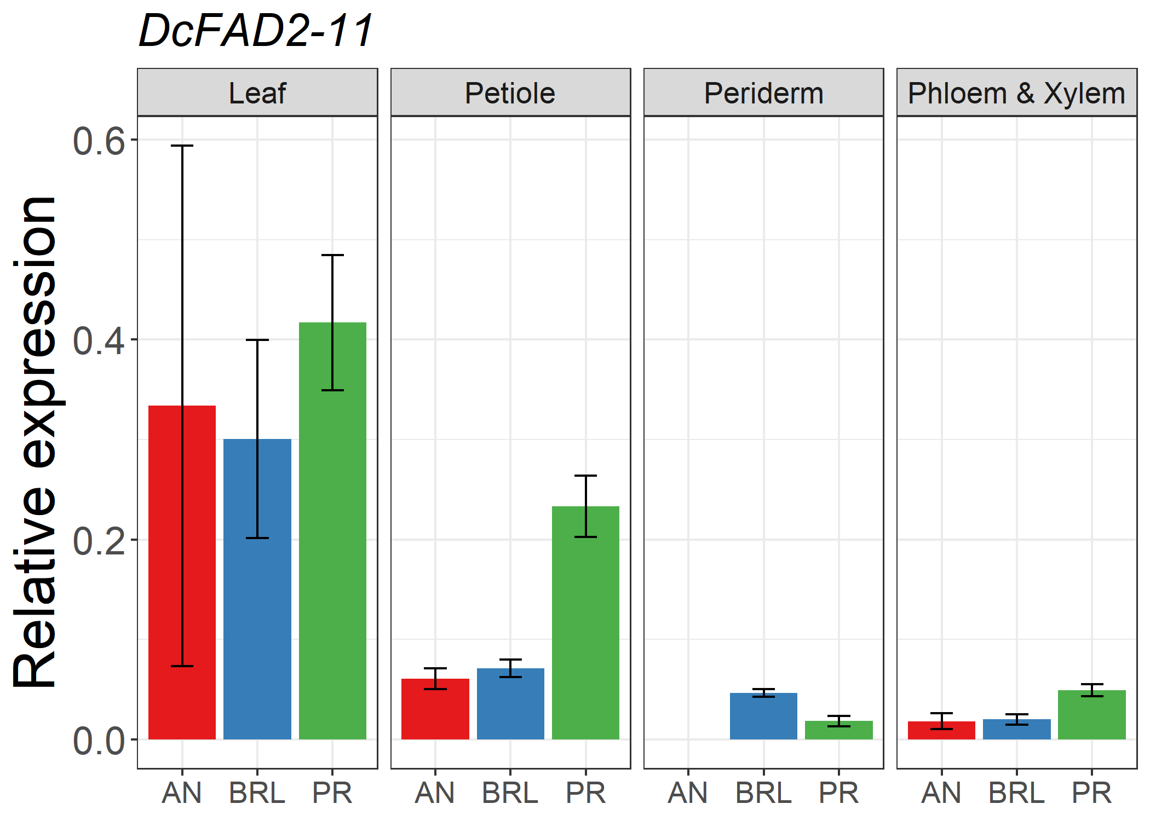
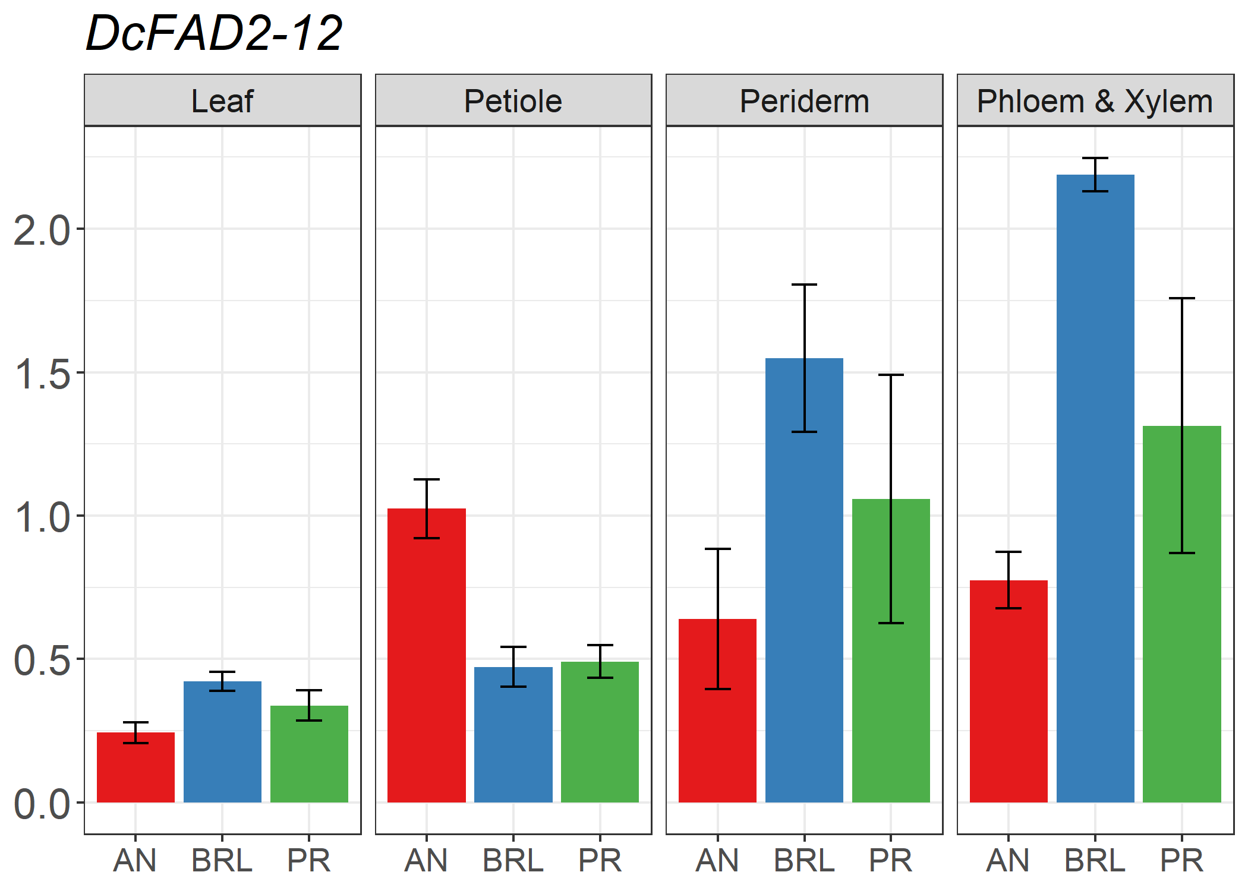
Figure S8 Tissue-specific expression profiles of additional FAD2 genes associated with minor QTLs (DcFAD2-1, DcFAD2-4, DcFAD2-9, DcFAD2-11) or not associated with QTLs (DcFAD2-5, DcFAD2-6, DcFAD2-10, DcFAD2-12). The levels of RNA transcripts were analysed in leaf, petiole, periderm, and a mixture of phloem and xylem of Anthonina (AN), Breeding line (BRL) and Presto (PR). Data represent means of three individuals of each cultivar with error bars indicating standard error.

