Supplementary Figure legends
Supplementary Figure 1.
A Elsevier Pathway Collection analysis of upregulated steroid metabolism-associated genes in PARP2 KO vs. CTL SZ95 sebocytes show the top 10 enriched GO terms at fold change cut-off 1.50. B Analysis of PARP2 expression in publicly available microarray datasets from acne patients (1-3). The GEO accession numbers of the datasets are highlighted on bar charts. Dots on each charts represent an individual involved in the studies. NL: non-lesional skin of acne patients; L: lesional, inflammatory skin of acne patients. Data is expressed as mean±SD of expression levels. C Analysis of PARP2 expression of publicly available microarray data (accession No: GSE120721) from whole skin, epidermis and dermis of healthy control (H), non-lesional (NL AD) and lesional AD (L AD) skin (n=6/5) (4). D Human Phenotype Ontology analysis of upregulated lipid metabolism-associated DEGs in PARP2 KO vs. CTL SZ95 sebocytes show the top 10 enriched GO terms at fold change cut-off 1.50.
Supplementary Figure 2.
A Pearson correlation analyses were performed from a publicly available RNAseq dataset (GEO accession No: GSE121212) between the expression of PARP2 and AKR1C2 and PARP2 and SREBF2 in healthy skin (H; n=37), non-lesional AD skin (NL AD; n=22), and lesional AD skin (L AD; n=20) (5). B Gene Ontology Biological Process analysis of downregulated DEGs in the skin of Parp2 KO AD vs. WT AD mice show the top 10 enriched terms at fold change cut-off 1.25.

Supplementary Figure legend References
1. Carlavan I, Bertino B, Rivier M, Martel P, Bourdes V, Motte M, et al. Atrophic scar formation in patients with acne involves long-acting immune responses with plasma cells and alteration of sebaceous glands. Br J Dermatol. 2018;179(4):906-17.
2. Kelhala HL, Palatsi R, Fyhrquist N, Lehtimaki S, Vayrynen JP, Kallioinen M, et al. IL-17/Th17 pathway is activated in acne lesions. PLoS One. 2014;9(8):e105238.
3. Trivedi NR, Gilliland KL, Zhao W, Liu W, Thiboutot DM. Gene array expression profiling in acne lesions reveals marked upregulation of genes involved in inflammation and matrix remodeling. J Invest Dermatol. 2006;126(5):1071-9.
4. Esaki H, Ewald DA, Ungar B, Rozenblit M, Zheng X, Xu H, et al. Identification of novel immune and barrier genes in atopic dermatitis by means of laser capture microdissection. J Allergy Clin Immunol. 2015;135(1):153-63.
5. Tsoi LC, Rodriguez E, Degenhardt F, Baurecht H, Wehkamp U, Volks N, et al. Atopic Dermatitis Is an IL-13-Dominant Disease with Greater Molecular Heterogeneity Compared to Psoriasis. J Invest Dermatol. 2019;139(7):1480-9.

Supplementary Figure 1.
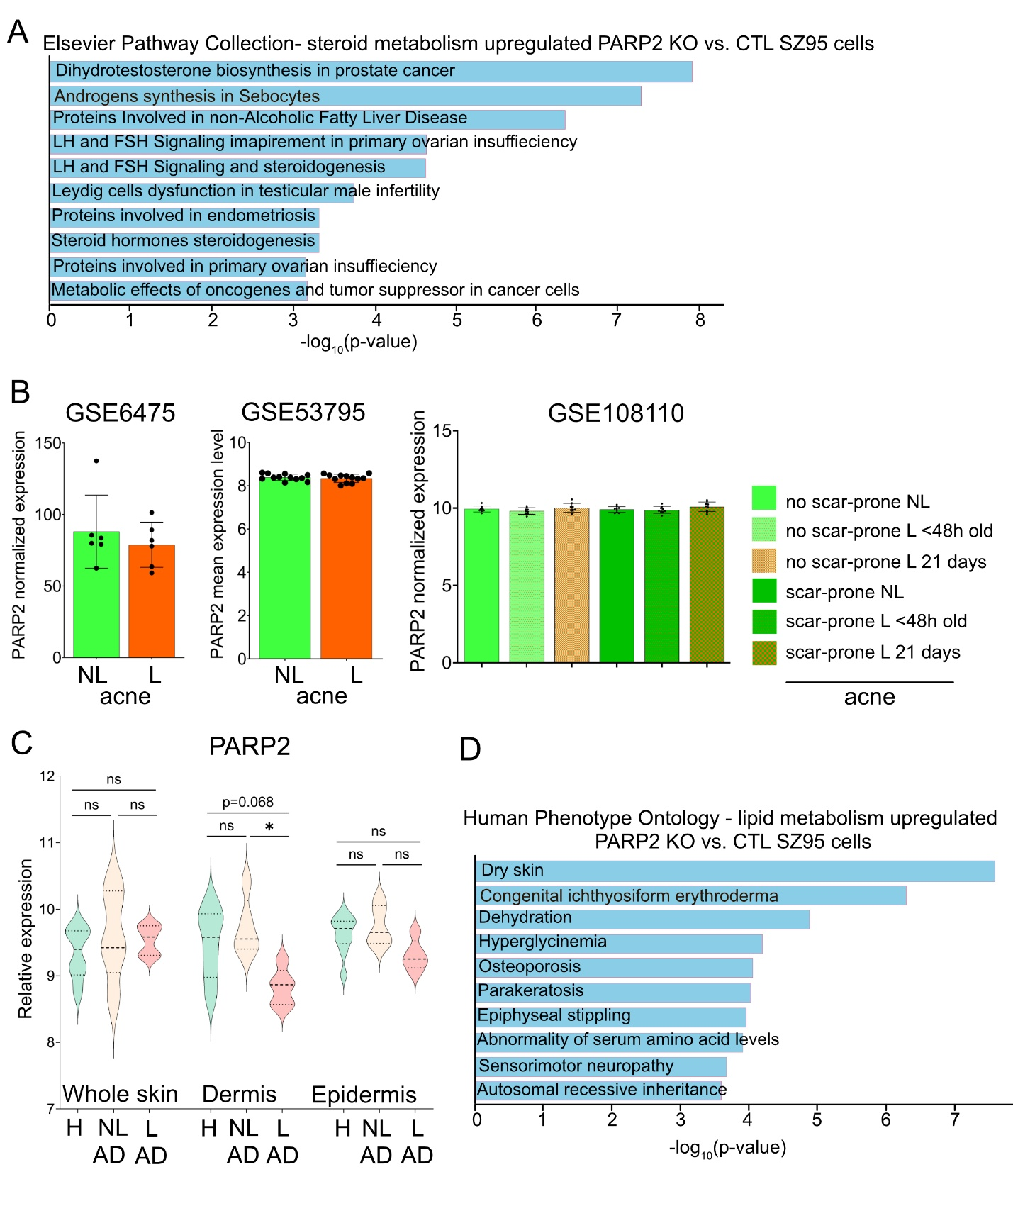

Supplementary Figure 2.
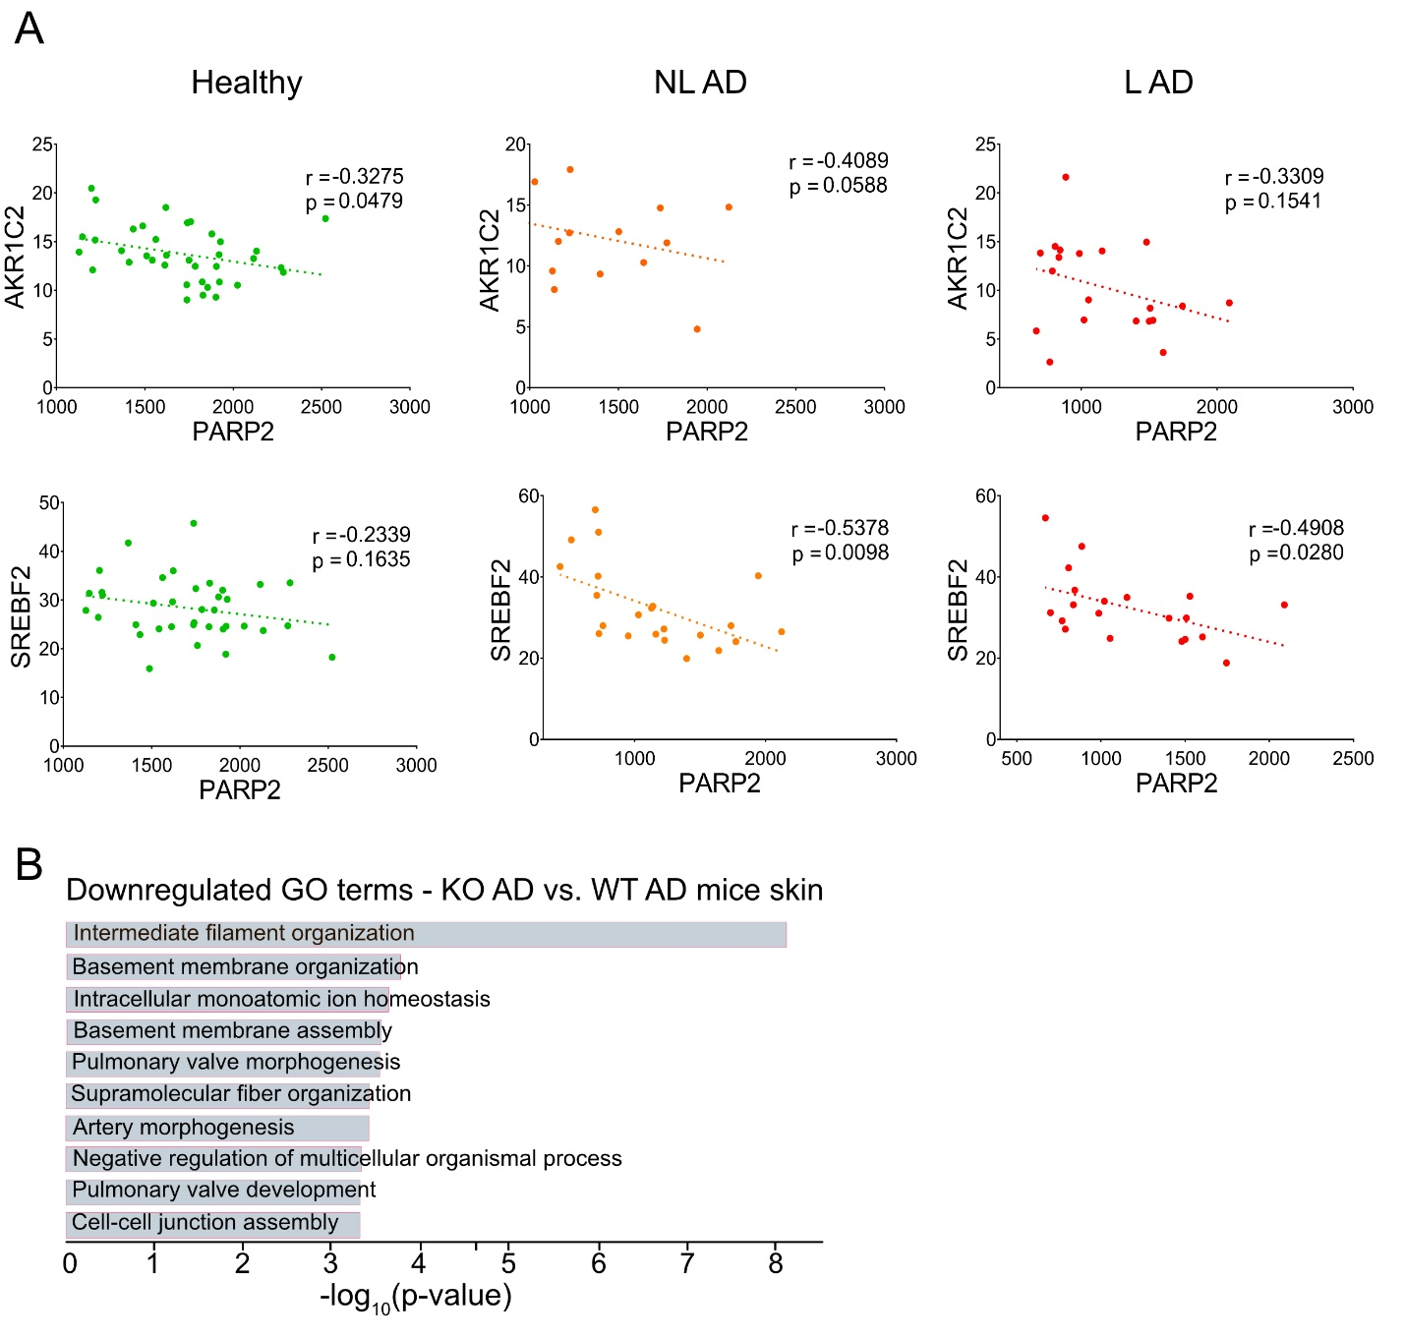

Supplementary Materials and Methods
Cell culture and treatment
Human immortalized SZ95 sebocytes (1) were maintained in Sebomed Basal Medium (Merck, Darmstadt, Germany) supplemented with 10% fetal bovine serum (Capricorn scientific GmbH, Ebsdorfergrund, Germany), 1 mM CaCl₂, 5 ng/ml human recombinant epidermal growth factor (Merck, Darmstadt, Germany), and cocktail of 50 IU/ml penicillin and 50 μg/ml streptomycin (Biosera, Cholet, France). Cells were cultured under standard laboratory conditions (37°C in a humidified atmosphere containing 5% (v/v) CO₂). Treatment conditions, when applicable, are specified in Figure legends.
CRISPR/Cas9 gene editing
Commercially available PARP2 CRISPR/Cas9 KO Plasmid (sc-402224), and Control (CTL) CRISPR/Cas9 plasmid (sc-418922; both from Santa Cruz Biotechnology, Inc.) were applied for transfection according to the CRISPR KO Transfection Protocol of Santa Cruz Biotechnology with minor modifications. SZ95 cells were seeded in 6-well plates at 2×10⁵ cells/well density 24h prior to transfection. As transfection reagent, 7 µl/well Lipofectamine 3000 (Invitrogen, ThermoFisher Scientific, L3000001) was dissolved in 125 µl/well Opti-MEM medium (Gibco, ThermoFisher Scientific, 31985062). Aqueous solutions of KO/Control plasmid containing 3 µg DNA was dissolved in 125 µl/well Opti-MEM medium and 6 µl/well P3000 transfection enhancer reagent (provided with Lipofectamine 3000 reagent) was added to the solution. After 5 min incubation at room temperature (RT), the plasmid DNA solution was added dropwise to the diluted transfection reagent. During the 20 min incubation time at RT, media on the cells was replaced by fresh, antibiotic-free media, subsequently, 250 µl/well transfection mix was added dropwise to wells. Cells were incubated for 48 h, then transfected cells were sorted based on detection of green fluorescent protein (GFP) signal with a FACS Aria II cell sorter (BD Biosciences) to yield single cell clones that were subsequently cultured in 96-well plates.
RNA isolation and RT-qPCR
PARP2 KO and CTL SZ95 human sebocytes were seeded in 6-well plates (TPP, 2×10⁵ cells/well). Cells were washed twice with phosphate-buffered saline (PBS) solution and then total RNA from cells was isolated using Quick-RNA Miniprep Kit (R1055, Zymo Research, CA, USA) according to the manufacturer’s instructions. Similarly, total RNA was isolated from mouse skin samples after homogenization in RNA Lysis Buffer provided in the kit using T25 ULTRA-TURRAX (IKA-Werke GmbH & Co. KG, Staufen, Germany). RNA concentration and purity was assessed using a NanoDrop ND-1000 spectrophotometer (Thermo Fisher Scientific; Waltham, MA, USA). Before RT-qPCR, 1 μg of DNase-treated RNA samples were reverse transcribed using High-Capacity cDNA Reverse Transcription Kit (4368813; Applied Biosystems, Foster City, CA, USA). The RT-qPCR reactions were performed using the TaqMan Gene Expression Master Mix protocol (Thermo Fisher Scientific, 4369016) in a Light-Cycler 480 Detection System (Roche Applied Science, Basel, Switzerland). As internal control, GAPDH (assay ID Mm99999915_g1) was used. The following TaqMan assays were used: IL4; assay ID Mm00445259_m1; IL13; assay ID Mm00434204_m1; TSLP; assay ID Mm01157588_m1.
Transcriptome analyses by RNA sequencing (RNAseq)
To obtain global transcriptome data high-throughput mRNA sequencing analysis was performed on Illumina sequencing platform. Total RNA sample quality was checked on Agilent BioAnalyzer using Eukaryotic Total RNA Nano Kit according to manufacturer’s protocol. Samples with RNA integrity number (RIN) value >7 were accepted for library preparation process. RNA-Seq libraries were prepared from total RNA using Ultra II RNA Sample Prep kit (New England BioLabs) according to the manufacturer’s protocol. Briefly, poly-A RNAs were captured by oligo-dT conjugated magnetic beads then the mRNAs were eluted and fragmented at 94-Celsius degree. First strand cDNA was generated by random priming reverse transcription and after second strand synthesis step double stranded cDNA was generated. After repairing ends, A-tailing and adapter ligation steps adapter ligated fragments were amplified in enrichment PCR and finally sequencing libraries were generated. Sequencing run were executed on Illumina NextSeq500 instrument using single-end 75 cycles sequencing. For RNAseq data analysis, raw sequencing data (fastq) was aligned to human reference genome version GRCh38 using HISAT2 algorithm and BAM files were generated. Downstream analysis was performed using StrandNGS software (www.strand-ngs.com). BAM files were imported into the software DESeq1 algorithm was used for normalization. To identify differentially expressed genes between conditions Moderated t-test with Benjamini-Hochberg FDR for multiple testing correction was used.
Lipidomic analyses
The solvents used for extraction and mass spectrometry (MS) analyses were of Optima liquid chromatographic (LC)/MS grade from Thermo Fisher Scientific (Bremen, Germany) and LC grade from Merck (Darmstadt, Germany). Lipid standards were purchased from Avanti Polar Lipids (Alabaster, AL, USA) and Cambridge Isotope Laboratories (Tewksbury, MA, USA). All other chemicals were from Merck (Darmstadt, Germany) and were of the best available grade. Approximately 13 million/clone PARP2 KO/CTL SZ95 cells were pelleted in 1.5 ml tubes (Eppendorf, Hamburg, Germany), and the pellets were subjected to a one-phase methanolic extraction (2) by adding 1300 μl methanol containing 50 μg phosphatidylcholine (PC)(di20:0) (as extraction standard) and 0.001% butylated hydroxytoluene (as an antioxidant). The mixtures were sonicated in a bath sonicator for 5 min, shaken for 5 min, centrifuged at 10000 × g, and the supernatants were transferred into a new Eppendorf tube and stored at −20°C until MS analysis. Electrospray ionization (ESI)-MS-based lipidomic analyses were performed on a high-sensitivity, high-resolution Orbitrap Fusion Lumos instrument (ThermoFisher Scientific) equipped with a TriVersa NanoMate robotic nanoflow ion source (TriVersa NanoMate, Advion BioSciences), using chips with spraying nozzles of 5.5 μm diameter. The instrument was fully calibrated before analysis. The ion source was controlled by Chipsoft v8.3.1 software. The ionization voltages were +1.3 and −1.9 kV in positive and negative modes, respectively, and the back-pressure was set to 1 psi in both modes. The temperature of the ion transfer capillary was 260 °C. Acquisitions were performed at mass resolution 240,000 at m/z=200, and signals were recorded in the centroid mode. For quantification, 2 μl extract was further diluted with 150 μl infusion solvent mixture (chloroform/methanol/isopropanol 1:2:1, by volume) containing an internal standard mix (Appendix Table). Next, the mixture was halved, and 5% dimethylformamide (additive for the negative ion mode) or 3 mM ammonium chloride (additive for the positive ion mode) was added to the split sample halves. 10 μl of the solution was infused, and data were acquired for 1 min. Phosphatidylcholine (diacyl, PC and alkyl-acyl, PC-O), lysophosphatidylcholine (LPC), sphingomyelin (SM), diacylglycerol (DG), triacylglycerol (TG), cholesteryl ester (CE), carnitine (Carn), and acylcarnitines (AcCar) were detected and quantified using the positive ion mode, whereas phosphatidylethanolamine (diacyl, PE and alkenyl-acyl, PE-P), phosphatidylinositol (PI), phosphatidylserine (PS), phosphatidic acid (PA), phosphatidylglycerol (PG), cardiolipin (CL), the corresponding lyso derivatives LPE, LPI, LPS, LPG and LCL as well as ceramide (Cer), hexosyl ceramide (HexCer), globotriaosylceramide (Gb3), and free fatty acids (FFA) were detected and quantified using the negative ion mode.
Lipids were identified by the LipidXplorer software (3) by matching the m/z values of their monoisotopic peaks to the corresponding elemental composition constraints. The mass tolerance was set to 2 ppm. Data files generated by LipidXplorer queries were further processed by custom Excel macros.
Lipid species were annotated with sum formulas according to the shorthand notation for lipid structures (4). Multivariate statistical analyses (PCA, hierarchical cluster analysis) were performed using MetaboAnalyst (5).
Appendix Table:
Lipid Class | Internal standard (IS) | Ion format | Conc of infusion (fmol/μL)
PC, PC-O, LPC | PC(D30-16:0/18:1) | [M+H]+ | 506
PE, PE-P, LPE | PE(D30-16:0/18:1) | [M−H]− | 178
PI, LPI | PI(D30-16:0/18:1) | [M−H]− | 77
PS, LPS | PS(D30-16:0/18:1) | [M−H]− | 135
PG, LPG | PG(D30-16:0/18:1) | [M−H]− | 17
PA | PA(D30-16:0/18:1) | [M−H]− | 6
CL, LCL | CL(tetra14:0) | [M−2H]²⁻ | 11
SM | SM(d18:1/17:0) | [M+H]+ | 37
Cer | Cer(d18:1/17:0) | [M+Cl]− | 12
HexCer | HexCer(d18:1/12:0) | [M+Cl]− | 21
Gb3 | LacCer(d18:1/17:0) | [M+Cl]− | 25
GM3 | GM3(d18:1/D3-18:0) | [M−H]− | 47
DG | DG(15:0/18:1-D7) | [M+NH4]+ | 38
TG | TG(15:0/18:1-D7/15:0) | [M+NH4]+ | 137
CE | CholE(14:0) | [M+NH4]+ | 153
FFA | FFA(19:0) | [M−H]− | 74
AcCar | AcCar(16:0D3) | [M+H]+ | 10
PC, phosphatidylcholine; PE, phosphatidylethanolamine; PI, phosphatidylinositol; PS, phosphatidylserine; PG, phosphatidylglycerol; PA, phosphatidic acid; CL, cardiolipin; LPC, LPE, LPI, LPS, and LPG, the corresponding lysolipids; SM, sphingomyelin; Cer, ceramide; HexCer, hexosylceramide; Gb3, globotriaosylceramide; GM3, GM3 ganglioside; DG, diacylglycerol; TG, triacylglycerol; CE, cholesteryl ester; FFA, free fatty acid; AcCar, acylcarnitine
Intracellular lipid detection
Intracellular lipid accumulation was quantified using AdipoRed Adipogenesis Assay Reagent (PT-7009, Lonza, Basel, Switzerland). PARP2 KO and CTL SZ95 human sebocytes were seeded on PerkinElmer 96-well black clear bottom plates (10⁴ cells/well) and maintained for 48h. Cells were washed with PBS and then incubated with 0.5 µl/well AdipoRed Reagent diluted in 200 µl of PBS at 37°C for 15 minutes. Lipid content was analyzed by high content screening (HCS) by Opera Phenix High Content Screening System (PerkinElmer, Waltham, MA, USA). A total of 60 fields with 5000–6000 cells were acquired per well and laser-based autofocus was performed for each imaging position. Images of DAPI and Alexa-647 channels were collected at the 2 µm position of the Z image plane relative to the bottom of the optical plate using a 40x water immersion objective (NA: 1.1). In order to visualize the lipid content of the cells excitation wavelength 640 nm was used to detect fluorescence, while emission was collected with a properly selected wavelength filter for Alexa647 with BP 650-760. The number and size of lipid droplets were determined by the Harmony 4.9 software (PerkinElmer). Elsewhere, PARP2 KO and CTL SZ95 cells (2x10⁴) were seeded in µ-Slide 8-well high IbiTreat ibidi chamber (80806, ibidi GmBH, Gräfelfing, Germany). After 24h, cells were treated with either DMSO as vehicle or 10μM Enzalutamide (S1250, Selleckchem, Houston, TX, USA) for 48 hours. Cells were washed once with PBS and incubated with 1,5μl/well AdipoRed Reagent in 300μl of PBS for 20 minutes. Confocal images were taken with a Leica TCS SP8 confocal microscope (Leica, Wetzlar, Germany) and LAS X 3.5.5.19976 software (Leica, Wetzlar, Germany). Processed images were analyzed using the CellProfiler software (6).
Protein extraction and Western blotting
PARP2 KO and CTL SZ95 sebocytes were seeded in 6-well plates (TPP, 2×10⁵ cells/well). After 48-h postculture, cells were washed with PBS solution and were then harvested in RIPA buffer (50 mM Tris, 150 mM NaCl, 1% Triton X-100, 0.5% sodium deoxycholate, 0.1% SDS, 1 mM EDTA, 1 mM Na₃VO₄, 1 mM NaF, 1 mM PMSF, 100× protease inhibitor cocktail, all from Merck) on ice. DNA-protein complexes in cell lysates were disrupted by sonication (Branson Sonifier, Emerson Electric, Pasig, Philippines) for 3×20 pulses, 15-s intervals. Protein isolates were separated from debris by centrifugation for 10 minutes at 10,000 x g, 4°C. Protein lysates were boiled with 2x Laemmli sample buffer supplemented with 5% 2-mercaptoethanol (both from Bio-Rad Laboratories, USA) for 15 minutes. Protein extracts (10-25 μg) were separated by SDS-PAGE and transferred onto nitrocellulose or PVDF membranes. Membranes were blocked with 5% BSA in TBS-Tween or 5% non-fat dairy milk in TBS-Tween for 1 hour at RT and incubated with primary antibodies overnight at 4 °C. Membranes were probed with a peroxidase-conjugated secondary antibody for 1 hour at RT. Signals were visualized by enhanced chemiluminescence reaction and captured by ChemiDocTM Touch Imaging System (Bio-Rad, Hercules, CA, USA). Bands were quantified by densitometry using Fiji ImageJ software. The following antibodies were used in immunoblots: anti-PARP2 (Cell Signaling Technology, 20009T, 1:1000), anti-LC3A/B (Cell Signaling Technology, 12741, 1:1000), anti-Mfn1 (Abnova, H00055669-A01, 1:1000), anti-Mfn2 (Sigma/Merck, WH0009927M3, 1:1000); anti-β-actin (Merck, A3854, 1:20000), anti-mouse IgG HRP-linked (Merck Millipore, A9044, 1:2000), anti-rabbit IgG HRP-linked (Cell Signaling Technology, 7074S, 1:2000).
Detection of cell death
PARP2 KO and CTL SZ95 human sebocytes were seeded in 6-well plates (TPP, 2×10⁵ cells/well). 48-h post-culture, apoptotic cells were detected using eBioscience Annexin V Apoptosis Detection Kit FITC with propidium iodide (PI) (88-8005-72/74, Invitrogen, Waltham, MA, USA) according to the manufacturer’s instructions as described in (7). Samples were diluted in PBS and subsequently analyzed by a NovoCyte Flow Cytometer (Agilent Technologies, San Diego, CA, USA).
Cellular morphology analysis
PARP2 KO and CTL SZ95 cells (5x10⁴) were seeded in µ-Slide 8-well high IbiTreat ibidi chamber (80806, ibidi GmBH, Gräfelfing, Germany), cultured for 48 hours and then were stained with CellMask™ DeepRed Plasma Membrane Stain (Thermo Fisher, C10046; 5 µg/ml) for 30 min at 37 °C. Cells were washed with PBS, and nuclei were stained with Hoechst dye (Invitrogen, 33342) diluted in PBS (2 µM) for 10 min at 37 °C, then cells were washed again in PBS. Confocal images were taken with Leica TCS SP8 confocal microscope and LAS X 3.5.5.19976 software (Leica, Wetzlar, Germany). Images were analyzed using the CellProfiler software (6).
Cell proliferation
Cells were cultured in T25 flasks (TPP) containing 4 ml of culture media. At designated time points, media was removed, cells were washed with PBS then were detached using 0.05% trypsin and 0.02% EDTA, 4Na (T3924, Sigma-Aldrich, Missouri, USA). Following trypsin neutralization with FBS-containing media cells were manually counted using a hemocytometer. The fold change in cell number was determined by dividing the final cell count by the initial number of plated cells.
Immunofluorescence
PARP2 KO and CTL SZ95 cells (5x10⁴) were seeded on glass coverslips into a 24-well plate (TPP). After 48-hour incubation, cells were fixed with 4% formaldehyde for 20 min at 37°C, rinsed three times with PBS, then permeabilized with 1% Triton X-100 in PBS for 10 min. Cells were incubated with primary antibodies (anti-LC3A/B, Cell signaling, D3U4C; anti-TOMM20, Merck (Sigma), ST1705) diluted in blocking buffer for overnight at 4 °C. Subsequently, cells were washed three times with 1× PBS, and were incubated with a secondary antibody (Alexa Fluor 488, TermoFisher, A-11008; Alexa Fluor 647, TermoFisher, A-21236) for 1 h at RT in the dark. The coverslips were mounted on glass slides using ProLong™ Gold Antifade Mountant with DNA Stain DAPI (Invitrogen, P36941). Confocal images were taken with Leica TCS SP8 confocal microscope and LAS X 3.5.5.19976 software (Leica, Wetzlar, Germany). Images were analyzed using CellProfiler software (6).
Analysis of cellular metabolism
PARP2 KO and CTL SZ95 sebocytes (2 × 10⁴ cells/well) were seeded onto XF96 cell culture microplates. After 24h, the culture medium was replaced with Seahorse XF DMEM medium supplemented with 2% FBS, 1 mM pyruvate, 2 mM glutamine and 10 mM glucose, and cells were incubated for 45 min in a CO₂‑free incubator. Mitochondrial functions were characterized by a Seahorse XF Cell Mito Stress Test Kit (103015-100, Agilent Technologies) and fuel dependency was determined using a Seahorse XF Mito Fuel Flex Test Kit (103260-100, Agilent Technologies) according to the manufacturer’s protocol using a Seahorse XF Pro Analyzer (Agilent Tecnologies). Final concentration of the used compounds: 1 μM oligomycin, 1.5 μM FCCP, 0.5 μM rotenone/antimycin, 3 μM BPTES, 4 μM Etomoxir and 2 μM UK5099. Oxygen consumption rate (OCR) values were normalized to total cellular protein content as determined using a BCA Protein Assay Kit (23227, ThermoFisher Scientific).
Transmission electron microscopy
For transmission electron microscopy (TEM), PARP2 KO and CTL SZ95 cells grown on Aclar film (Electron Microscopy Sciences) were chemically fixed in a mixture of 2.5% glutaraldehyde and 2% paraformaldehyde prepared in 0.1 M sodium cacodylate buffer, pH 7.4, for 2h at RT followed by overnight fixation at 4 °C. After three washes in cacodylate buffer, cells were post‑fixed in 1% osmium tetroxide (Electron Microscopy Sciences) for 1h at RT and washed again in buffer. Samples were then dehydrated through a graded ethanol series and propylene oxide and infiltrated with Durcupan ACM epoxy resin (Merck/Sigma) via propylene oxide/resin mixtures, followed by overnight infiltration in pure resin at RT. Excess resin was removed from the Aclar film surface, and the films were mounted and the resin polymerized at 56 °C for 48h. Resin blocks containing the cell monolayer were trimmed, and ultrathin sections (~50 nm) were cut using a Leica Ultracut UCT ultramicrotome, collected on Formvar‑coated nickel slot grids (Pelco, Ted Pella Inc.), and contrasted with uranyl acetate and Reynolds’ lead citrate. Sections were examined and imaged using a JEOL 1400 Flash transmission electron microscope.
Mice
Homozygous Parp2^{-/-} mice and their wild-type littermates (Parp2^{+/+}) on a C57BL/6J background from heterozygous crossings were used. Mice were bred at the animal facility of the University of Debrecen. No more than six mice were housed in each cage (standard block shape 365 × 207 × 140 mm, surface 530 cm2; 1284 L Eurostandard Type II. L from Techniplast) with Lignocel Select Fine (J. Rettenmaier und Söhne) as bedding. Mice had ad libitum access to water (sterilized tap water) and standard rodent diet (1320M, Animalab Hungary Kft, Vác, Hungary), and were kept under a 12/12 hr dark/light cycle. Only male mice were selected for the study at the age of 8-12 weeks, then mice were housed separately. Mice had paper tubes to enrich their environment. Cages were changed once a week, on the same day. The animal facility was overseen by a veterinarian. For the calcipotriol-induced atopic dermatitis (AD) model, hair was shaved off of the back of mice in 2 × 2 cm areas two days prior to start of treatment. Mice were randomized into different cohorts and topically treated daily once with either 40 µl ethanol (vehicle) or 40 µl ethanol containing 4 nmol of calcipotriol (MC903; Tocris Bioscience, Bristol, UK) for 6 consecutive days. On day 7, mice were sacrificed, and blood, skin and spleen samples were taken for further analyses. The study was approved by the Veterinary Centre of the University of Debrecen, Hungary (study registration No. 5/2023/DEMÁB).
Detection of androgen hormones
Dorsal skin samples were collected, briefly rinsed in ice‑cold PBS to remove residual blood, snap‑frozen in liquid nitrogen, and stored at -80 °C until extraction. For lipid extraction, frozen tissues were weighed and homogenized on ice in PBS using T25 ULTRA-TURRAX (IKA-Werke GmbH & Co. KG, Staufen, Germany). The samples were then transferred to glass extraction tubes, lipid‑soluble androgens were then extracted according to a modified Folch methanol-chloroform protocol. In brief, homogenates were mixed with methanol and chloroform (ratio 2:1 V/V), vortexed thoroughly, and incubated on ice for 10 min. Phase separation was induced by centrifugation at 3,000 g for 10 min at 4 °C. The lower organic phase was carefully collected into glass tubes, and extraction of the remaining aqueous phase was repeated once with fresh chloroform. Combined organic phases were evaporated to dryness at RT. Dried extracts were stored at -20 °C until further analysis. Before analyses, residues were reconstituted in the assay buffer supplied with the respective androgen ELISA kits (100 µl), vortexed vigorously, and briefly centrifuged to remove insoluble material. Supernatants were transferred to fresh tubes and, where necessary, further diluted in assay buffer to fall within the linear range of the standard curves.
Concentrations of androstenedione, testosterone, and 5α‑dihydrotestosterone (DHT) in skin extracts were determined using commercial competitive ELISA kits for mouse androstenedione (EIA05329m, Wuhan Enlibio Biotech Co., Ltd, Wuhan, China), testosterone (EIA06421m, Wuhan Enlibio Biotech Co., Ltd, Wuhan, China), and DHT (E‑EL‑0031, Wuhan Elabscience Biotechnology Co., Ltd, Wuhan, China), according to the manufacturers’ instructions. Absorbance was measured at 450 nm (with an appropriate reference wavelength, where applicable) using a microplate reader, and hormone concentrations were calculated from 4‑parameter logistic standard curves.
Hormone levels were normalized to the initial tissue wet weight and expressed as pg or ng androgen per mg tissue.
Supernatants of same set of clones of PARP2 KO and CTL SZ95 human sebocytes that were used for Western blots were collected and analyzed for human ASD, Free Testosterone, and DHT using commercially available ELISA kits (ASD: ASD31-K01, Eagle Biosciences, Amherst, NH, USA; Free Testosterone: TSF31-K01, Eagle Biosciences, Amherst, NH, USA; DHT: E-EL-0031, Wuhan Elabscience Biotechnology Co., Ltd, Wuhan, China) according to the manufacturer’s instructions.
Histology
Histology analyses were performed on 4 μm thick sections cut from formalin fixed, paraffin embedded mouse skin samples, similar, as in (8). Sections were stained with hematoxylin and eosin (H&E), and slides were digitalized with the PANNORAMIC confocal slide scanner (3DHISTECH Ltd, Budapest, Hungary). Images were taken of the scanned slides with the SlideViewer 2.8 for Windows 11 software of 3DHISTECH Ltd. Cross-sectional area of mice SGs in the vertical plane was measured using Fiji ImageJ software. SGs were outlined using polygonal ROIs, and area (μm2) was quantified following calibration to the image scale bar. All measurements were conducted under identical magnification settings.

Supplementary Materials and Methods References
1. Zouboulis CC, Seltmann H, Neitzel H, Orfanos CE. Establishment and characterization of an immortalized human sebaceous gland cell line (SZ95). J Invest Dermatol. 1999;113(6):1011-20.
2. Peter M, Glatz A, Gudmann P, Gombos I, Torok Z, Horvath I, et al. Metabolic crosstalk between membrane and storage lipids facilitates heat stress management in Schizosaccharomyces pombe. PLoS One. 2017;12(3):e0173739.
3. Herzog R, Schuhmann K, Schwudke D, Sampaio JL, Bornstein SR, Schroeder M, et al. LipidXplorer: a software for consensual cross-platform lipidomics. PLoS One. 2012;7(1):e29851.
4. Liebisch G, Vizcaino JA, Kofeler H, Trotzmuller M, Griffiths WJ, Schmitz G, et al. Shorthand notation for lipid structures derived from mass spectrometry. J Lipid Res. 2013;54(6):1523-30.
5. Xia J, Wishart DS. Web-based inference of biological patterns, functions and pathways from metabolomic data using MetaboAnalyst. Nat Protoc. 2011;6(6):743-60.
6. Lamprecht MR, Sabatini DM, Carpenter AE. CellProfiler: free, versatile software for automated biological image analysis. Biotechniques. 2007;42(1):71-5.
7. Molnar P, Demeny MA, Varkonyi B, Polgar Z, Por A, Kovacs I, et al. The clinically applied PARP inhibitor talazoparib ameliorates imiquimod-induced psoriasis in mice without reducing skin inflammation. Front Pharmacol. 2025;16:1519066.
8. Antal D, Por A, Kovacs I, Dull K, Poliska S, Ujlaki G, et al. PARP2 promotes inflammation in psoriasis by modulating estradiol biosynthesis in keratinocytes. J Mol Med (Berl). 2023;101(8):987-99.

