Supplementary material to the paper
‘Anticyclonic Eddies in the northeastern Japan/East Sea: simulation, observation and formation mechanisms’
Pavel A. Fayman, Sergey V. Prants and Alexander A. Didov

1. Trajectories of surface drifters in the study area
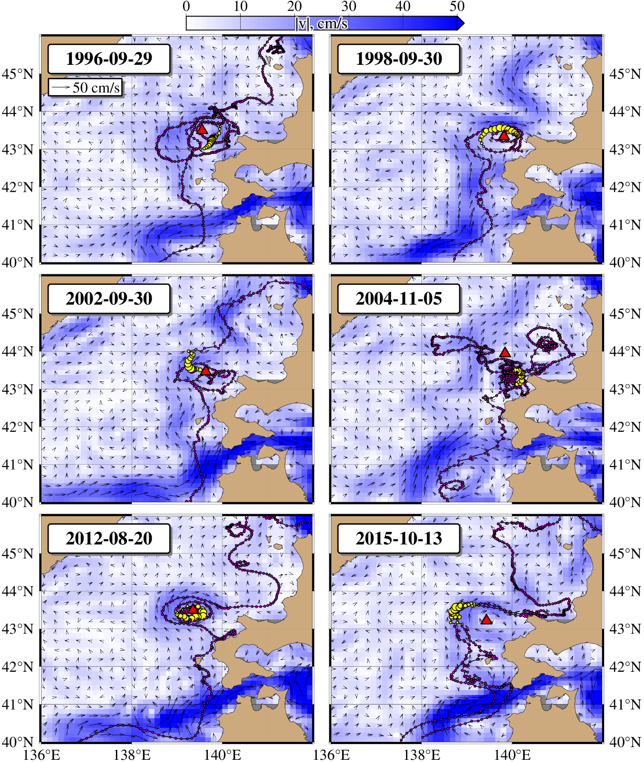
Fig. S1. Trajectories (pink) of several northward-moving drifters temporarily trapped by anticyclonic eddies in the study area, shown with the superimposed AVISO velocity field. Positions of the drifters in the AVISO velocity field for a few days before and after the indicated days (solid yellow circles). Red and green triangles denote the elliptic points (centers) of anticyclonic and cyclonic mesoscale eddies, respectively

2. Anticyclonic eddies in the study area presented in the diagnostic simulation

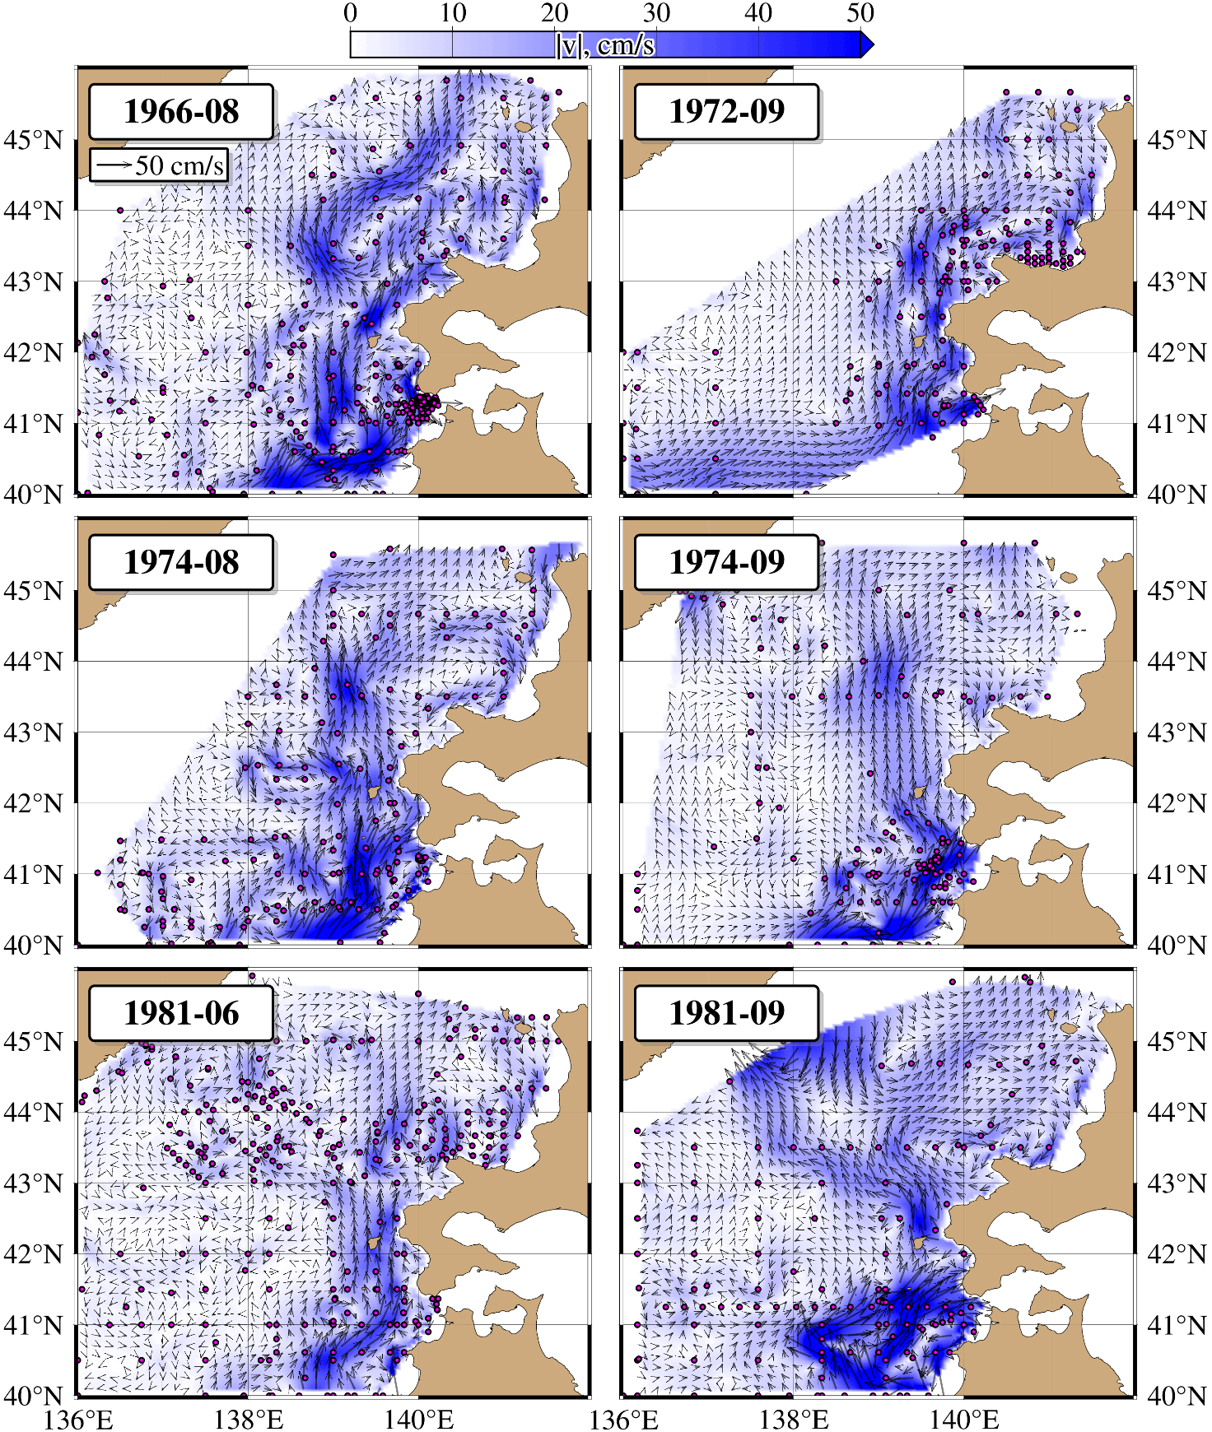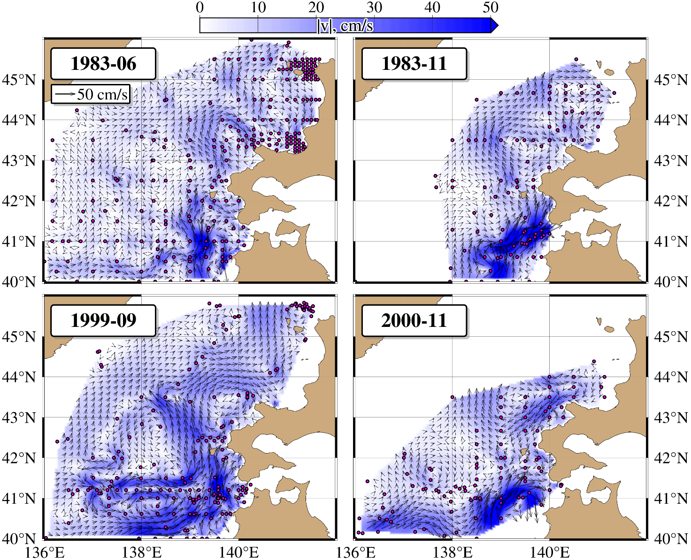
Fig. S2. Surface currents in various months and years obtained from the results of diagnostic calculations. Dots indicate CTD stations

3. Eddy vertical structure based on model results

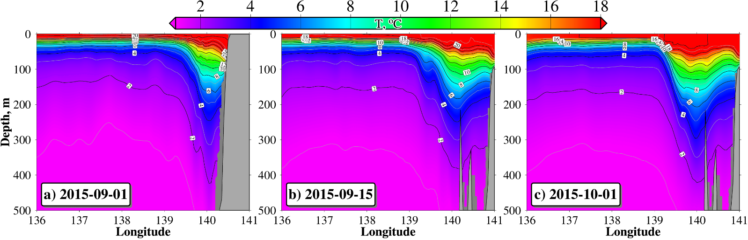
Fig. S3. Vertical sections of temperature based on model results through 43°N (a), 43.5°N (b, c)

4. Eddy vertical structure based on CTD-data

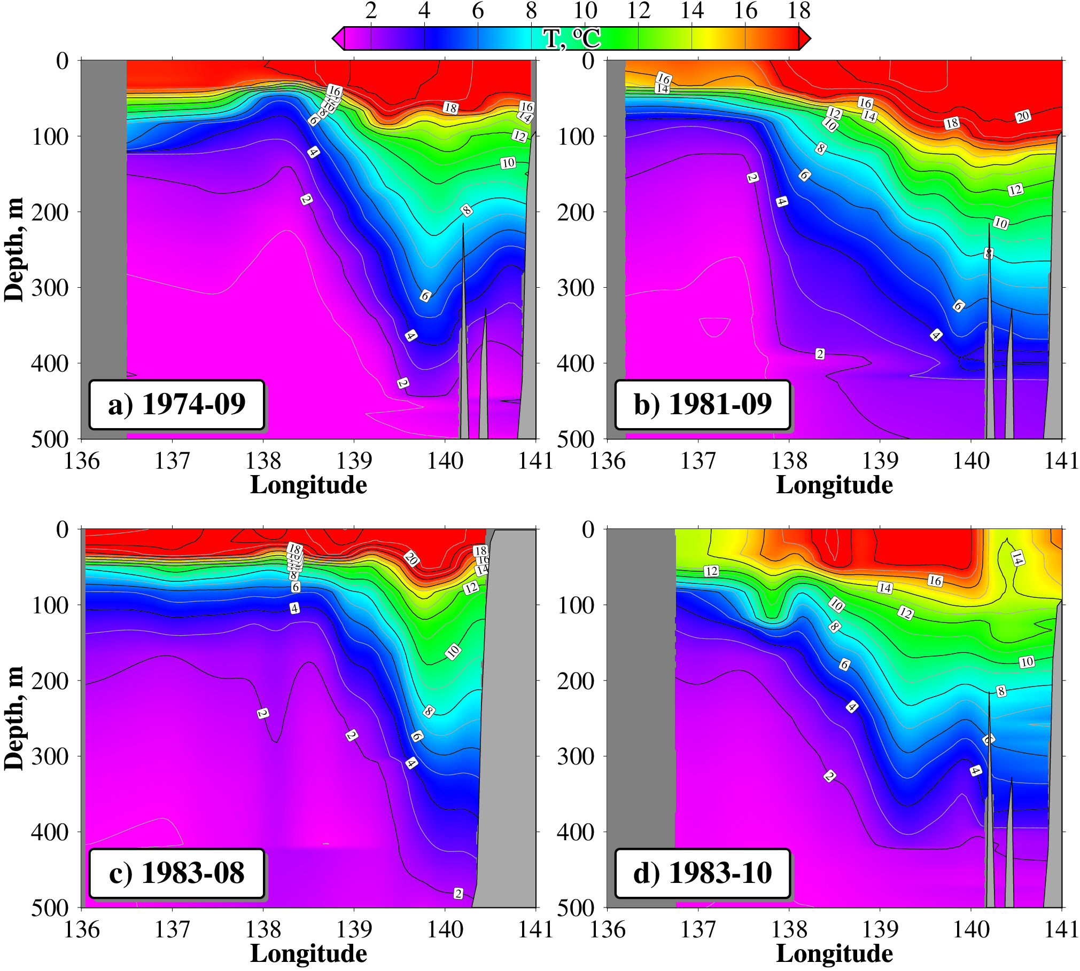
Fig. S4. Vertical sections of temperature based on СTD-data through 43.5°N in September and October (a, b, d) and through 43°N in August (c)

5. Locations of elementary volumes with negative values of Ertel’s potential vorticity

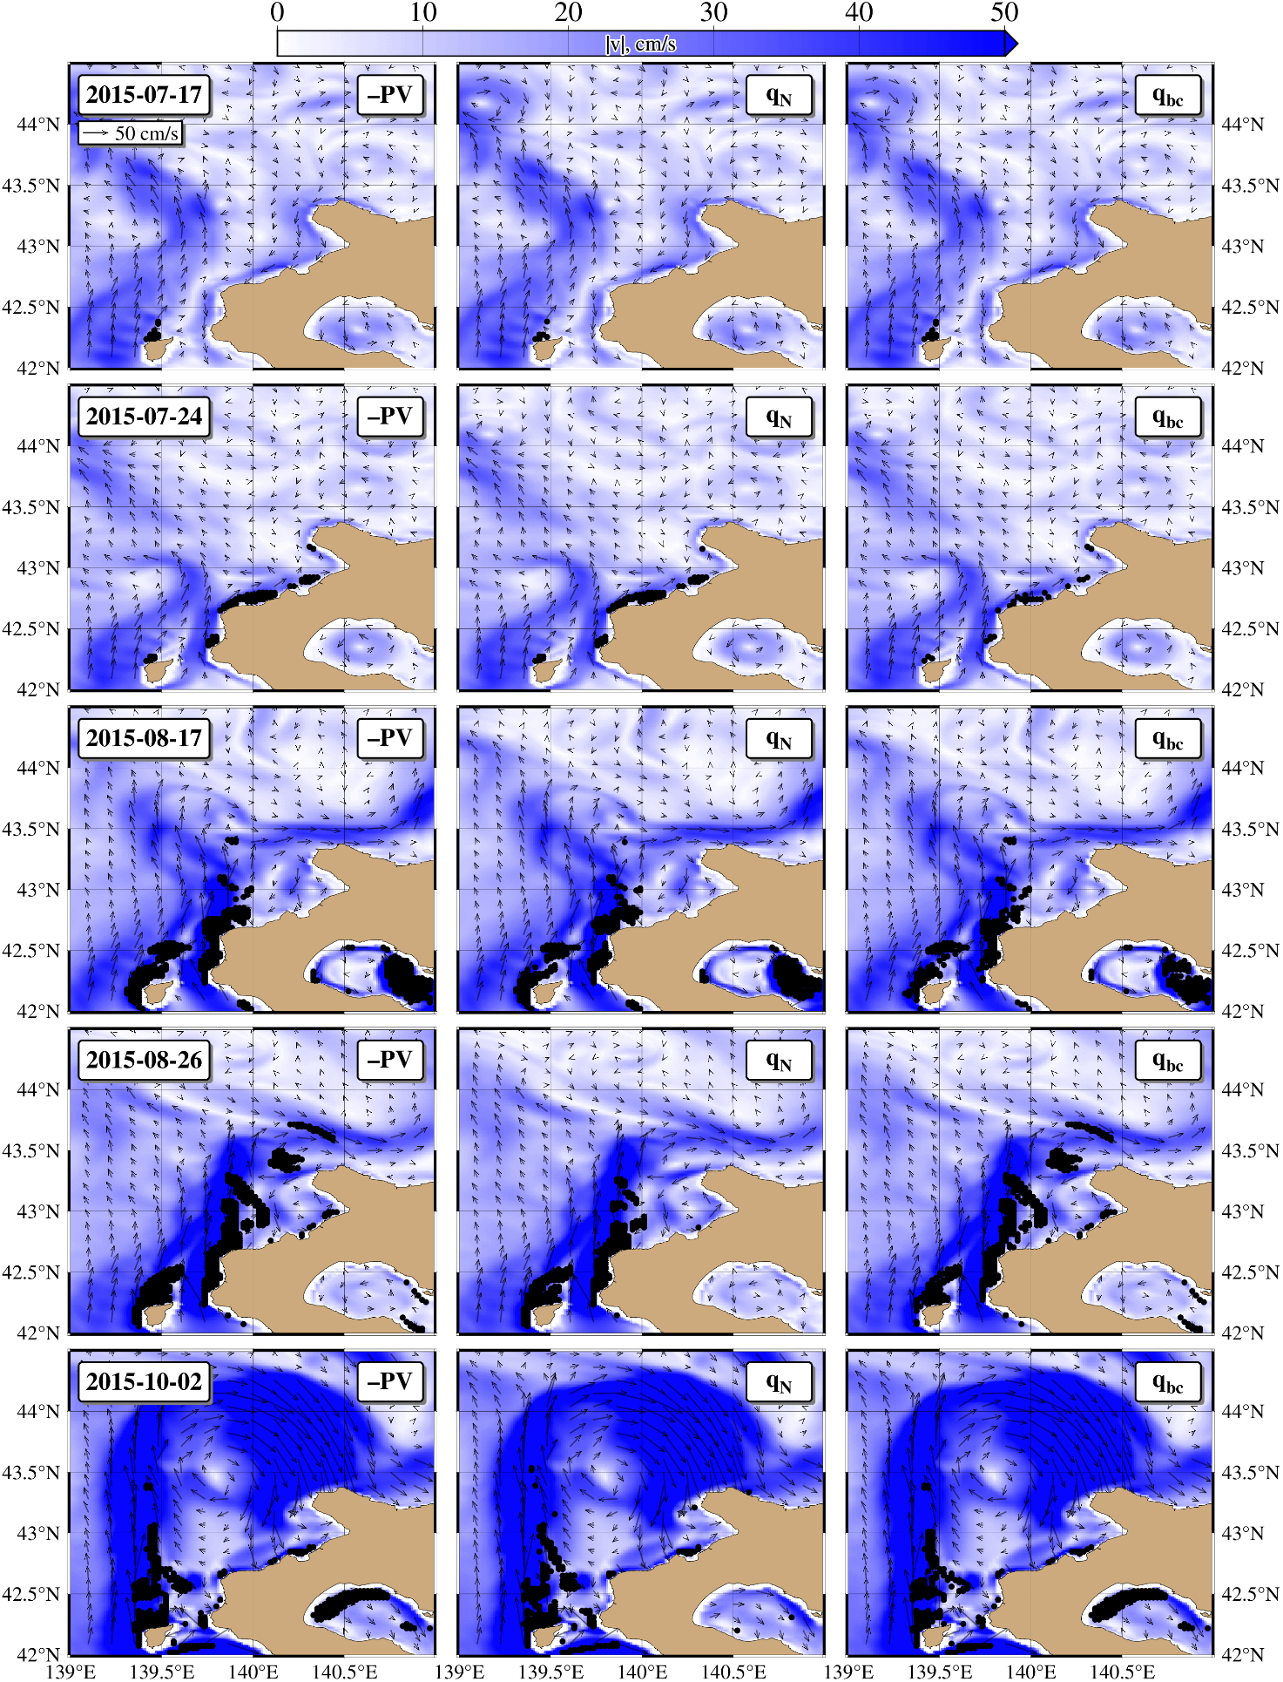
Fig. S5. Circulation in the subsurface layer (50-150 m depth) by dates. Black dots indicate elementary volumes where Ertel's potential vorticity is negative (left panel), conditions for the onset of inertial instability ($q_{N}$) are satisfied (central panel), and conditions for the onset of symmetric instability ($q_{bc}$) are satisfied (right panel)

6. A comparison of the diagnostic currents with the geostrophic currents derived from AVISO data

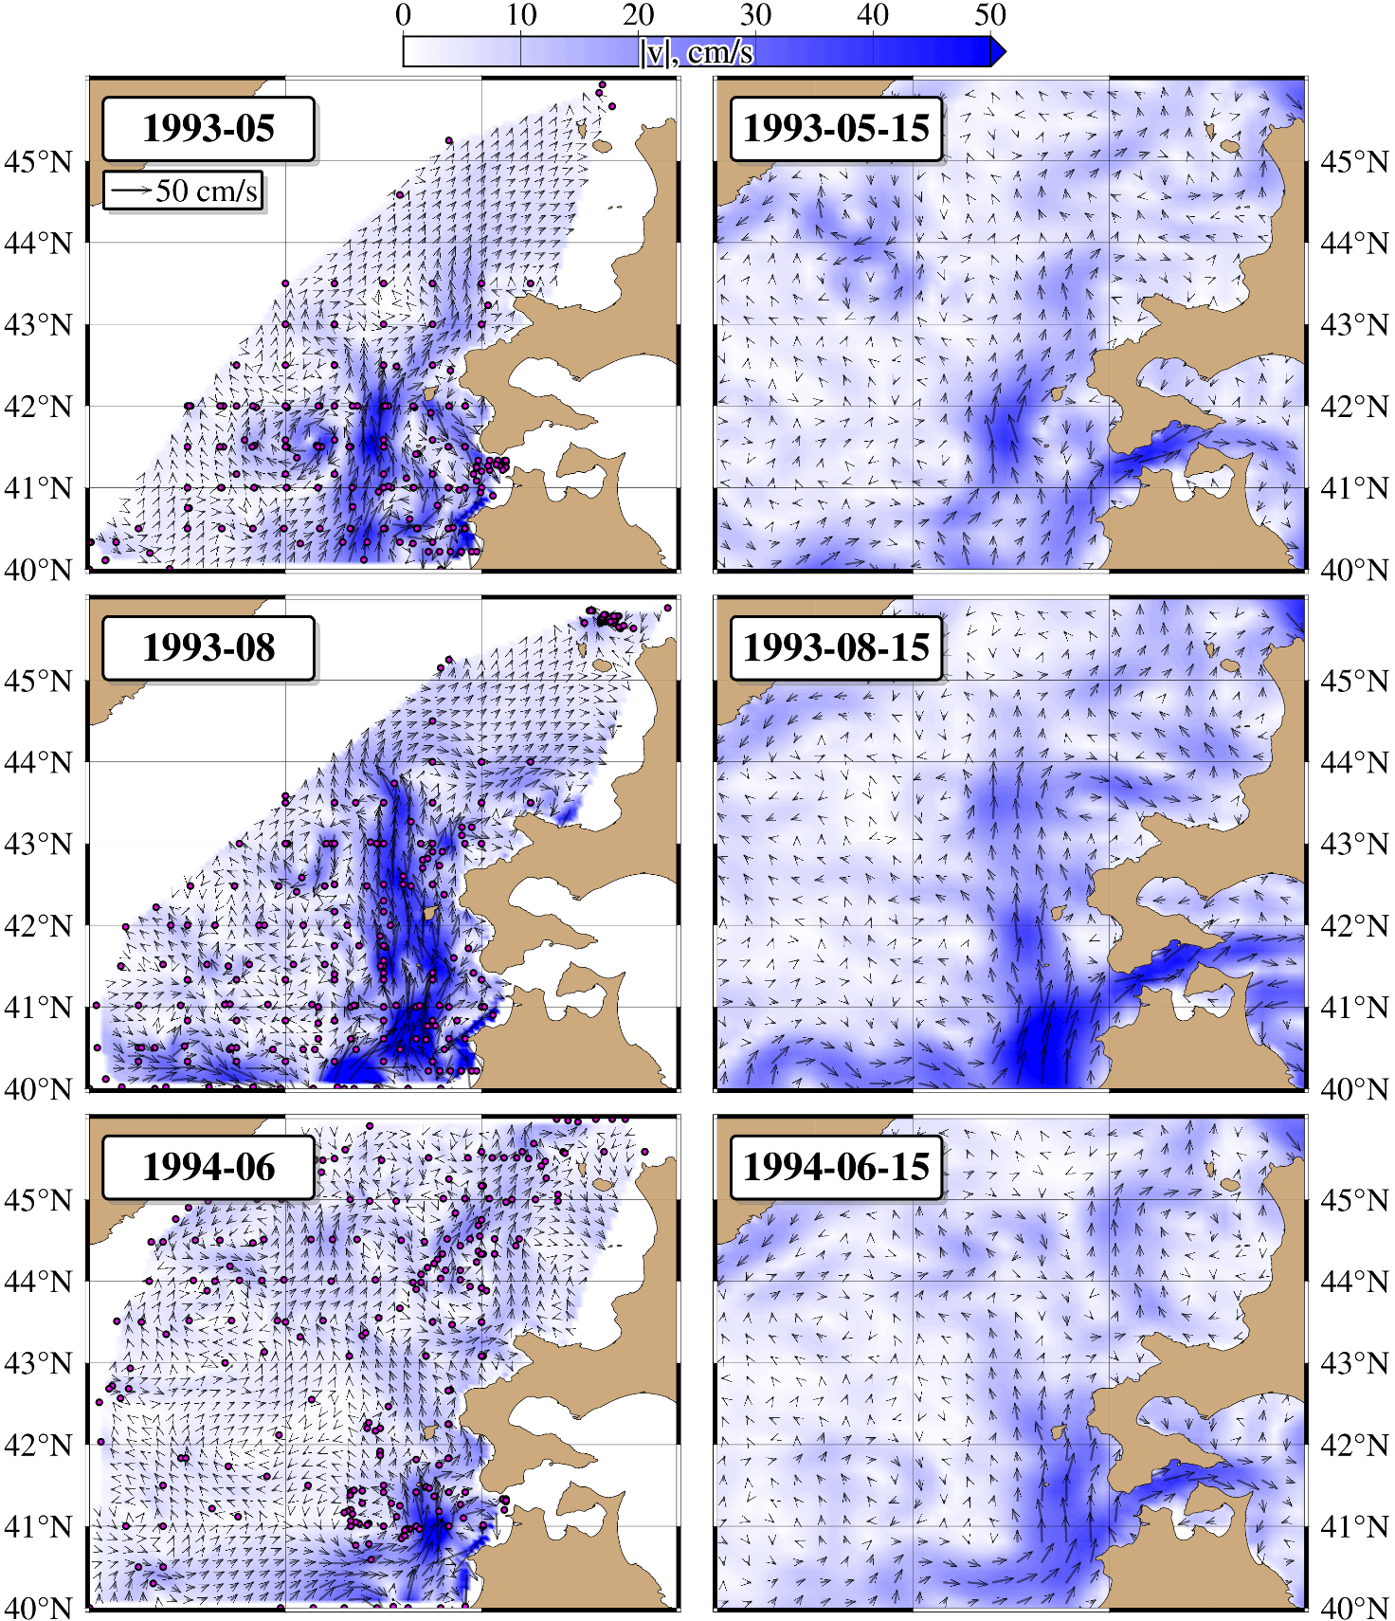

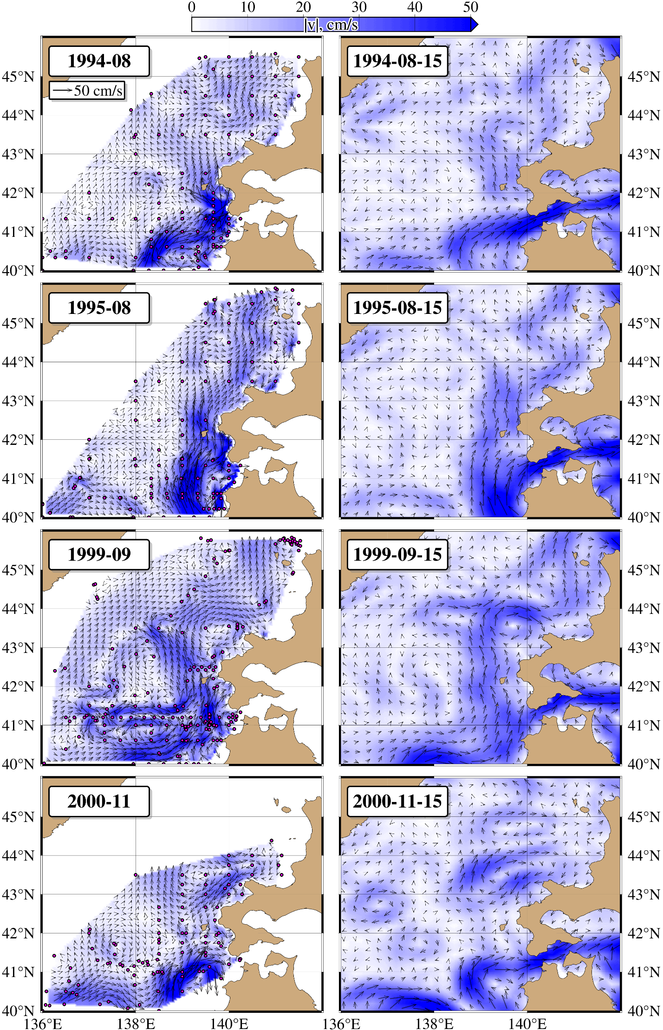
Fig. S6. Surface current patterns derived from diagnostic modeling based on CTD measurements (left column), and surface current patterns derived from geostrophic calculations based on satellite altimetry (right column).

