Supporting Information
Long-term fate of arsenic pollution in subtropical agricultural soils
Yamin Chen et al.

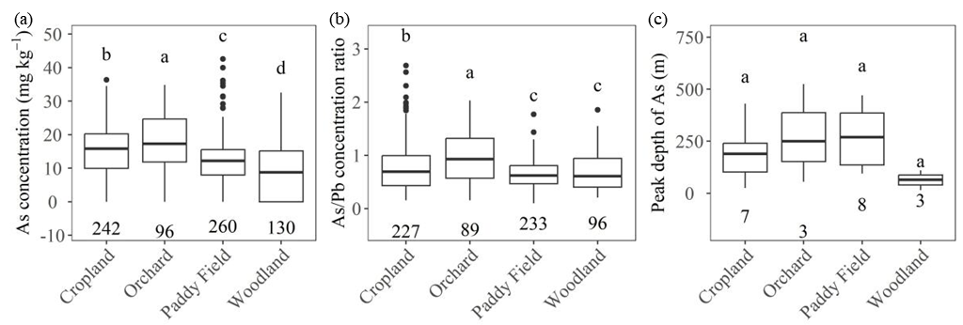
Figure S1. Variations in (a) As concentration, (b) As/Pb concentration ratio, and (c) peak depth of As concentration across different land use types. Values are presented as boxplots indicating the median, interquartile range (IQR), and outliers. Different lowercase letters above the boxes denote significant differences among groups at p<0.05 based on one-way ANOVA followed by LSD test. The numbers below each boxplot represent the sample size (n) for each group using data below 0-1950 cm

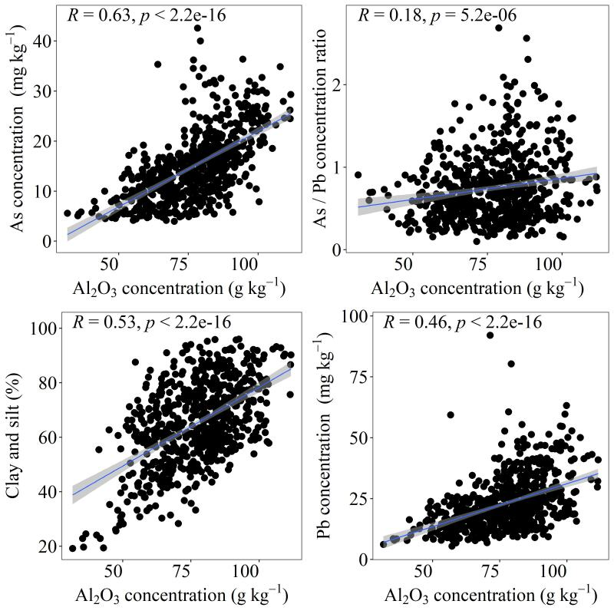
Figure S2. Pearson’s correlation between Al₂O₃ concentration and (a) As concentration, (b) As/Pb concentration ratio, (c) Clay and silt, and (d) Pb concentration. The solid black line is fitted with linear regression using data below 0-1950 cm.
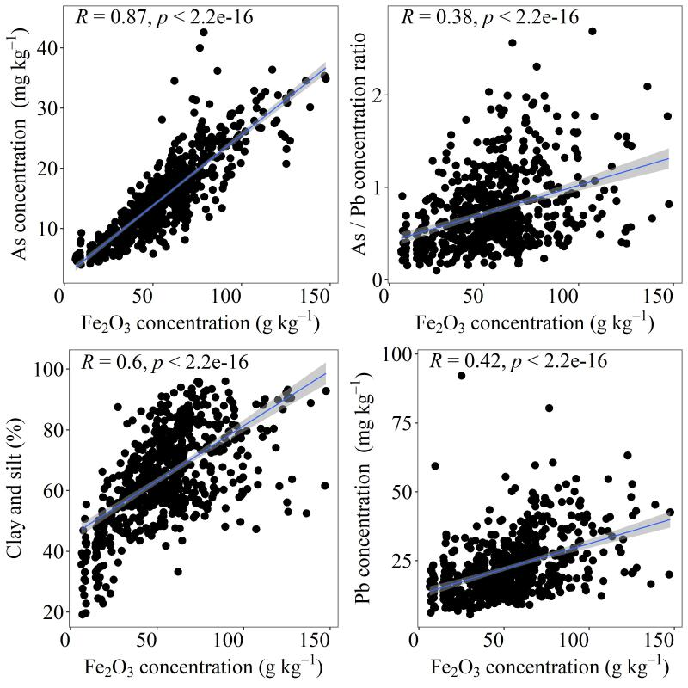
Figure S3. Pearson’s correlation between Fe concentration and (a) As concentration, (b) As/Pb concentration ratio, (c) Clay and silt, and (d) Pb concentration. The solid black line is fitted with linear regression using data below 0-1950 cm.

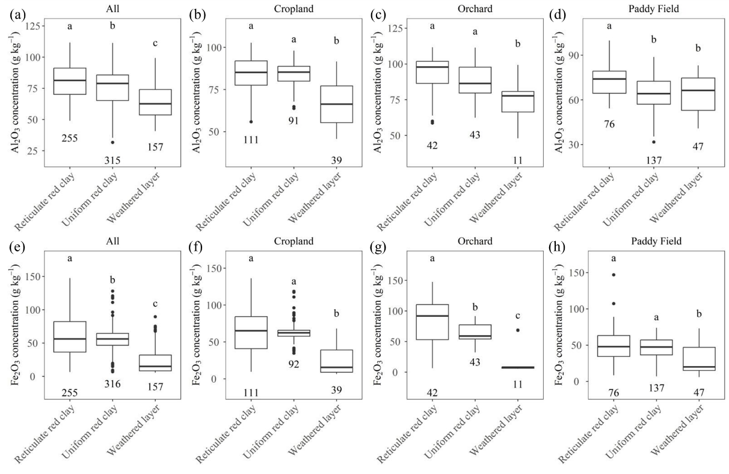
Figure S4. Variations in (a-d) Al₂O₃ concentration and (e-h) Fe₂O₃ concentration across different regolith architectures. Values are presented as boxplots indicating the median, interquartile range (IQR), and outliers. Different lowercase letters above the boxes denote significant differences among groups at p<0.05 based on one-way ANOVA followed by LSD test. The numbers below each boxplot represent the sample size (n) for each group using data below 0-1950 cm.

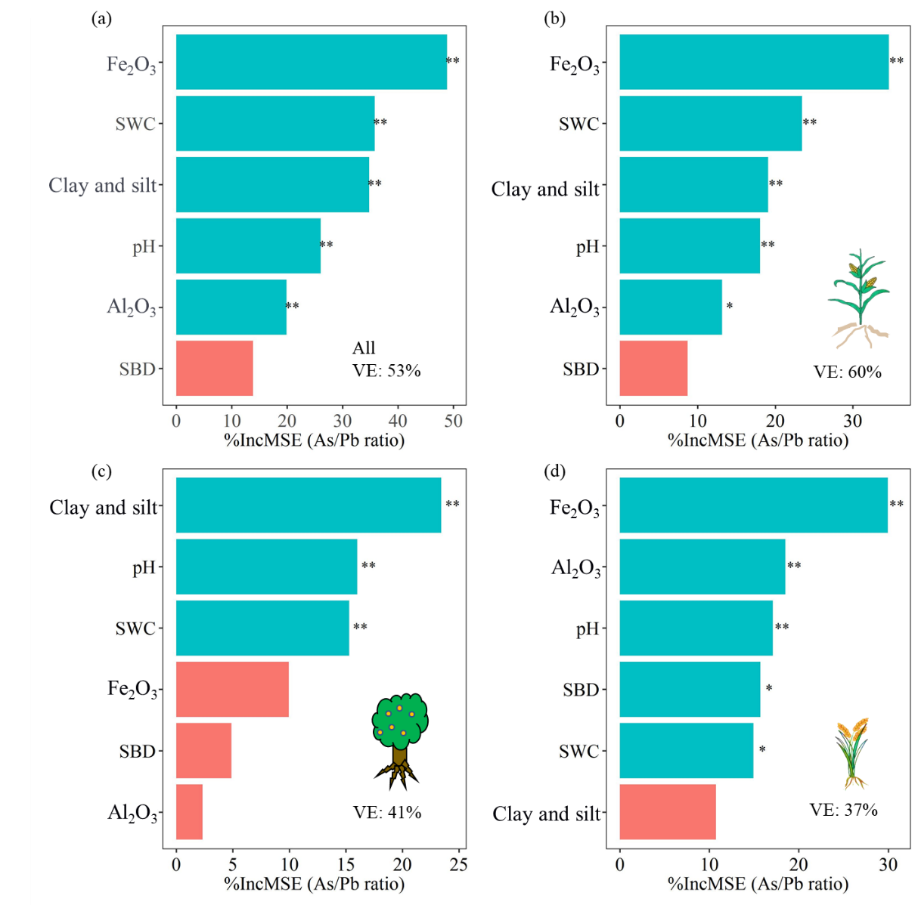
Figure S5. Relative importance of regolith properties (Al₂O₃, Fe₂O₃, Clay and silt, Sand, SWC, SBD, pH) to As/Pb concentration ratio in the full (a), cropland (b), orchard (c) and paddy-field (d) Random Forest models, respectively. *p < 0.05. SWC is soil water concentration, and SBD is soil bulk density. VE is % variance explained.
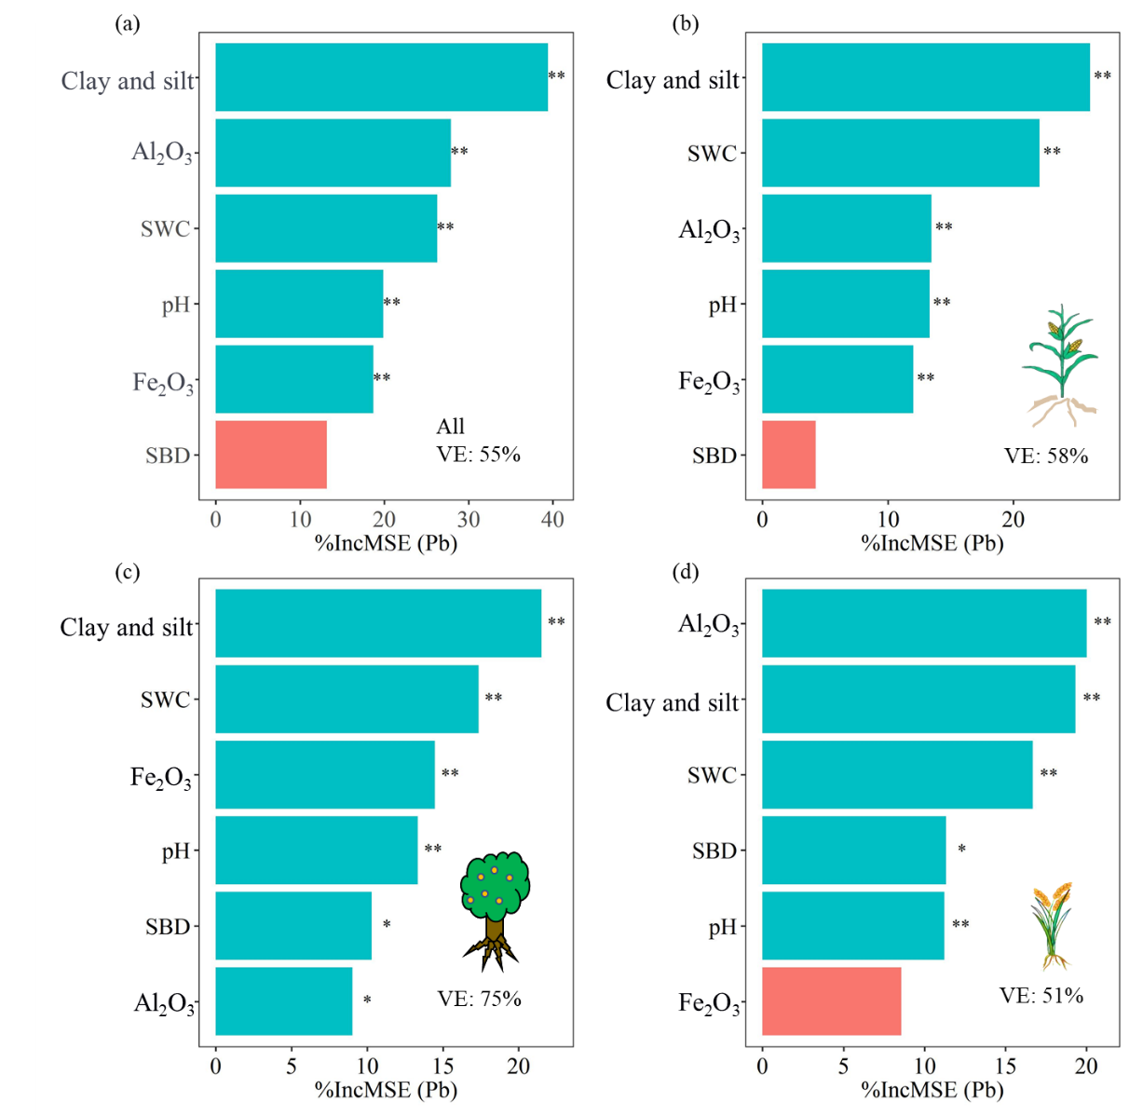
Figure S6. Relative importance of regolith properties (Al₂O₃, Fe₂O₃, Clay and silt, Sand, SWC, SBD, pH) to Pb concentration in the full (a), cropland (b), orchard (c) and paddy-field (d) Random Forest models, respectively. *p < 0.05. SWC is soil water concentration, and SBD is soil bulk density. VE is % variance explained.
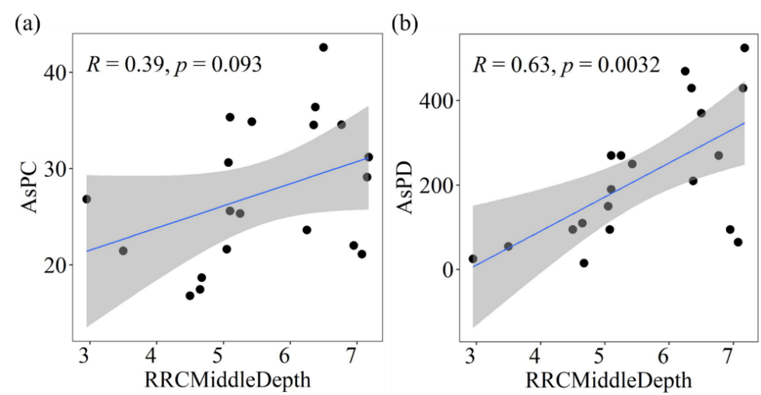
Figure S7. Correlation between the middle depth of reticulate red clay of (a) peak As concentration and (b) peak As depth.

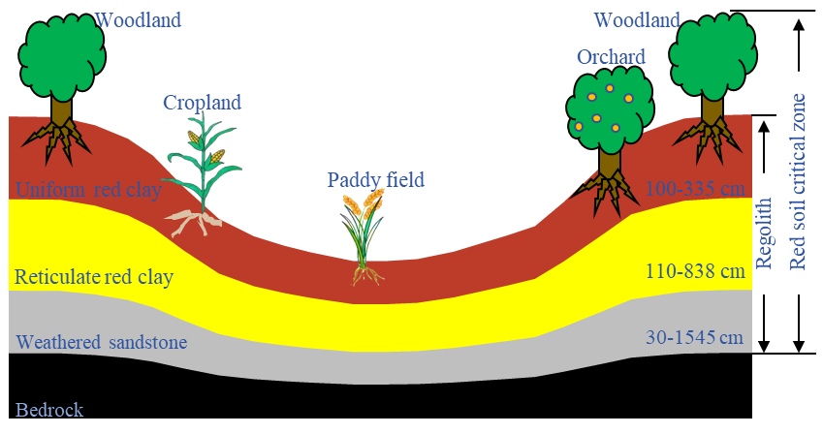
Figure S8. Illustration showing the geological stratigraphy and land-use pattern of the study area. Number ranges denote the thickness ranges for different layers.
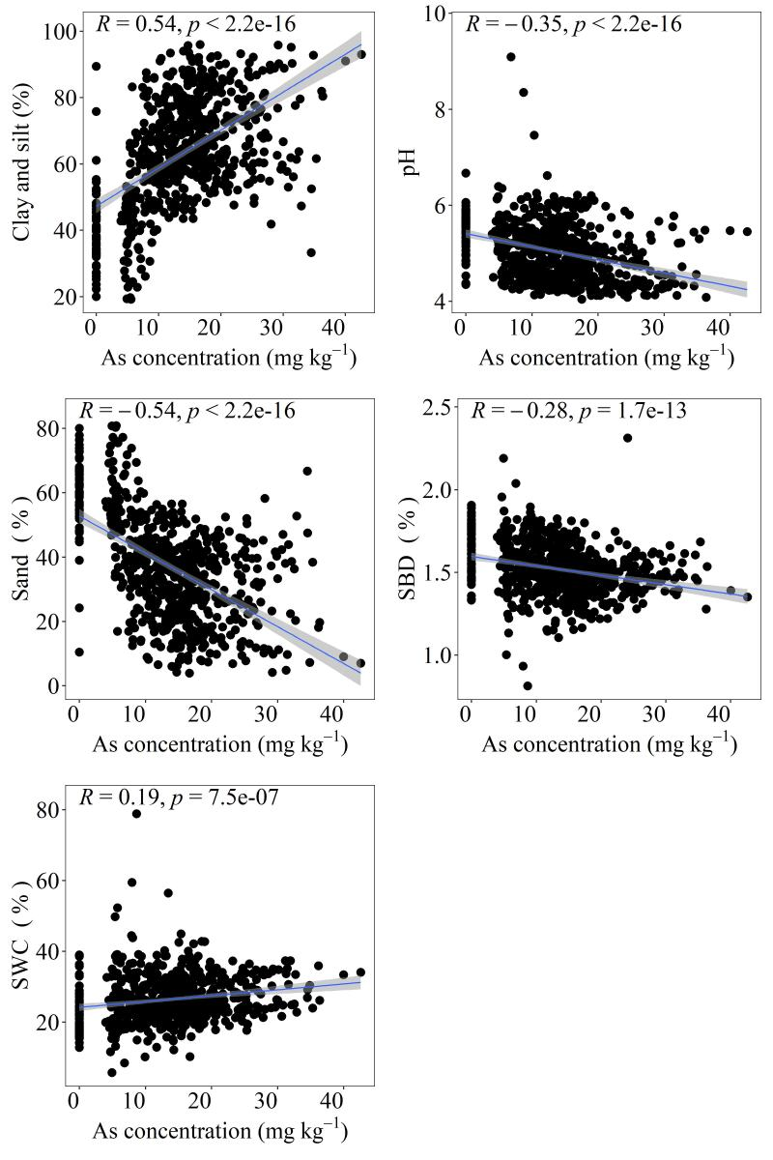
Figure S9. Pearson’s correlation between As concentration and (a) Clay and silt (%), (b) Sand (%), (c) Silt (%), (d) pH, (e) SBD (g cm⁻³) and (f) SWC (%). The solid black line is fitted with linear regression using data below 0-1950 cm.

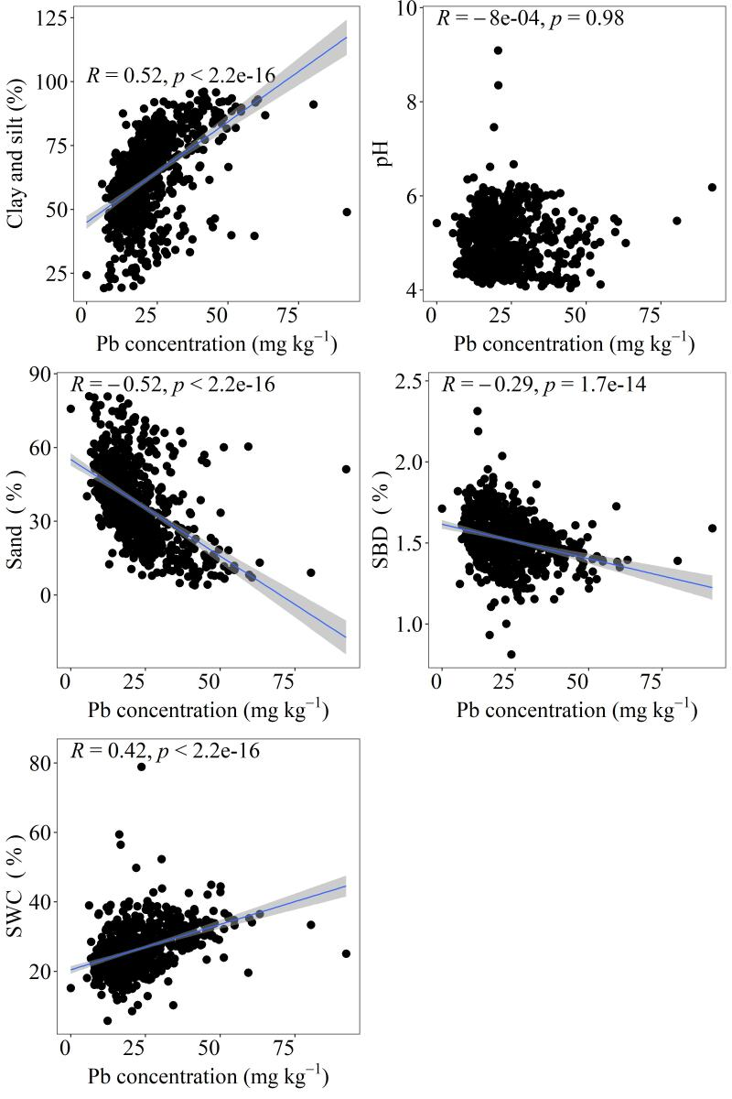
Figure S10. Pearson’s correlation between Pb concentration and (a) Clay and silt (%), (b) Sand (%), (c) Silt (%), (d) pH, (e) SBD (g cm⁻³) and (f) SWC (%). The solid black line is fitted with linear regression using data below 0-1950 cm.

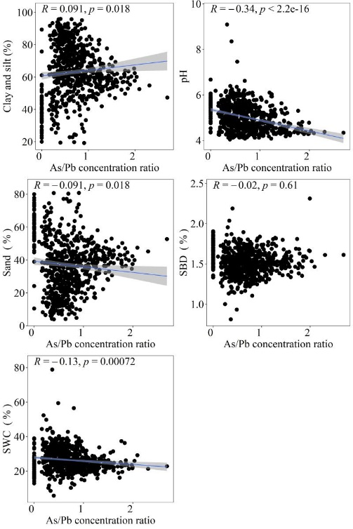
Figure S11. Pearson’s correlation between As/Pb concentration ratio and (a) Clay and silt (%), (b) Sand (%), (c) Silt (%), (d) pH, (e) SBD (g cm⁻³) and (f) SWC (%). The solid black line is fitted with linear regression using data below 0-1950 cm.

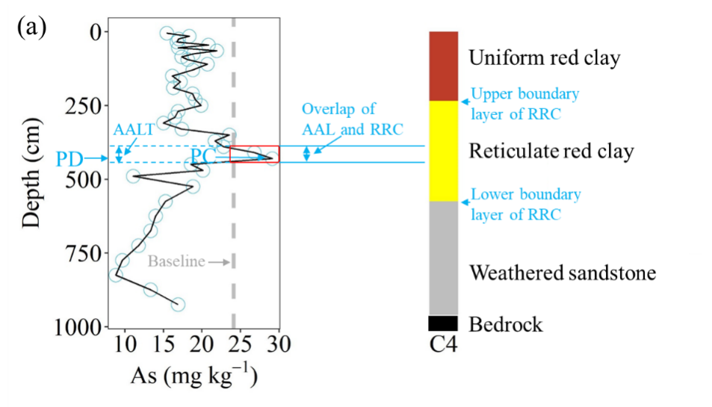
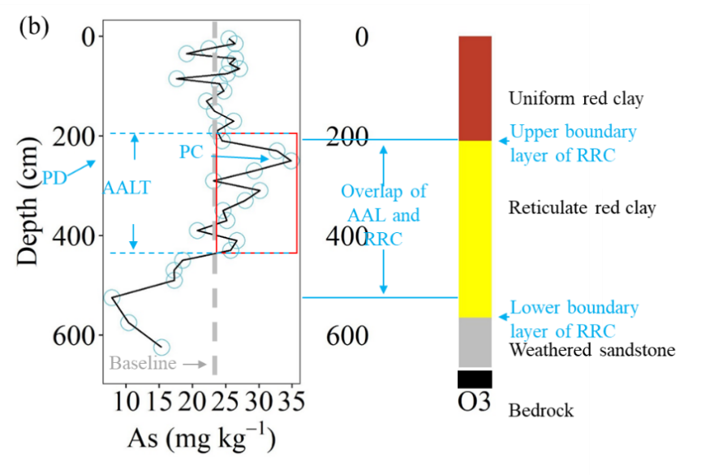
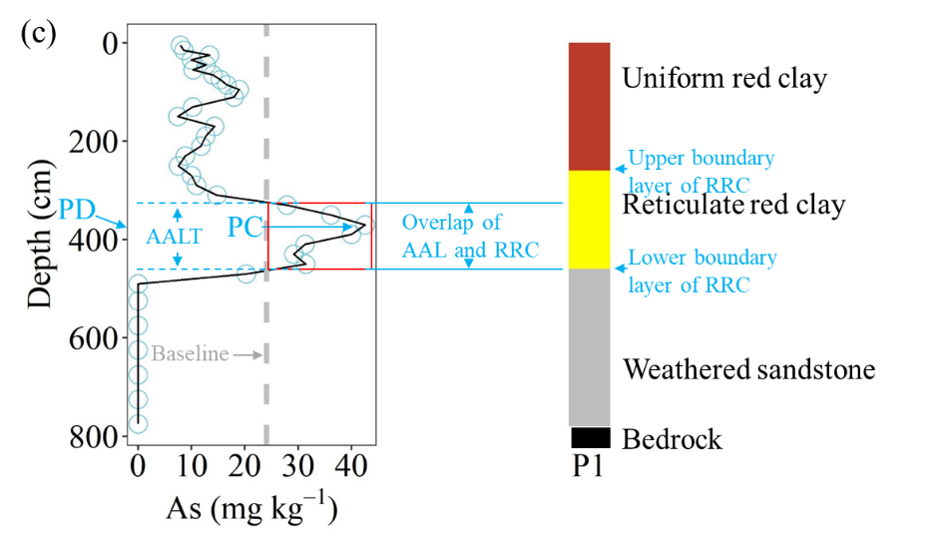
Figure S12. Illustration for the As accumulation layer (AAL) evaluation indices (peak concentration (PC), peak depth (PD) and the thickness of the AAL (AALT)) in the entire regolith profile. The As storage within the AAL and the mean As concentration within the AAL were calculated using the data within the AAL. The red box represents the AAL. Data of borehole (a) C4, (b) O3 and (c) P1 are used as examples.
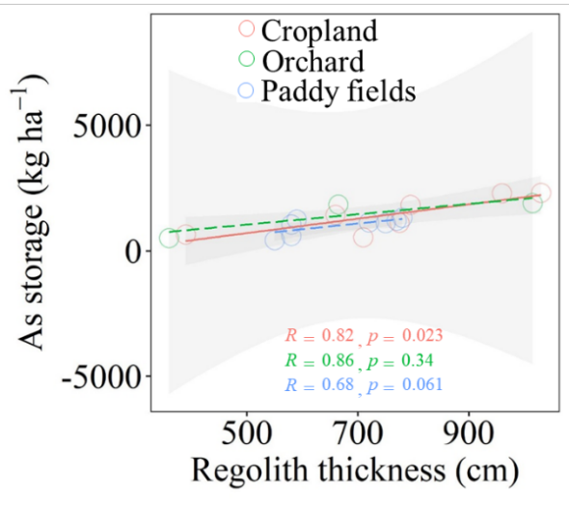
Figure S13. The relationship between regolith thickness and As storage across different land use types.

Table S1. Thickness of the reticulate red clay (RRC) layer and corresponding As storage and Pb storage
Land use | Type ID | Thickness of RRC layer (m) | As storage (kg ha⁻¹) | Pb storage (kg ha⁻¹) | Age Year for cultivated land (year)
Cropland | C1 | 2.3 | 1044.8 | 319.2 | 58
Cropland | C2 | 2.9 | 387.0 | 303.1 | 40
Cropland | C3 | 2.2 | 628.1 | 572.4 | 40
Cropland | C4 | 3.4 | 1923.9 | 1094.5 | 33
Cropland | C5 | 4.6 | 2756.8 | 1044.5 | 14
Cropland | C6 | 3.1 | 1293.3 | 726.5 | 58
Cropland | C7 | 8.4 | 3041.9 | 1889.7 | 27
Orchard | O1 | 4.5 | 985.3 | 1376.4 | 58
Orchard | O2 | 1.5 | 245.5 | 155.1 | 58
Orchard | O3 | 3.6 | 2608.9 | 1188.0 | 4
Paddy Field | P1 | 2.0 | 1192.0 | 779.7 | 63
Paddy Field | P2 | 1.9 | 737.5 | 525.7 | 63
Paddy Field | P3 | 1.5 | 872.7 | 413.1 | 63
Paddy Field | P4 | 1.1 | 524.3 | 208.9 | 48
Paddy Field | P5 | 1.2 | 277.8 | 106.0 | 63
Paddy Field | P6 | 4.9 | 1866.8 | 826.3 | 63
Paddy Field | P7 | 1.6 | 631.3 | 283.9 | 58
Paddy Field | P8 | 2.2 | 718.0 | 580.2 | 48
Note: C, O, and P refer to cropland, orchard, and paddy-field, respectively.

