Online Resource 9
Supplementary Table 1. ORR and DCR between the dacomitinib and afatinib subgroups in the 3+2 group
 | Dacomitinib  (n=42)(%) | Afatinib  (n=18)(%) |  | Total  (n=60)(%)
ORR
No | 32(76.20) | 17(94.40) | 49(81.70)
Yes | 10(23.80) | 1(5.60) | 11(18.30)
DCR
No | 8(19.00) | 4(22.20) | 12(20.00)
Yes | 34(81.00) | 14(77.80) | 48(80.00)

Online Resource 1
Exploratory analysis of the 3+2 treatment group KM plot of TTF by liver metastasis.
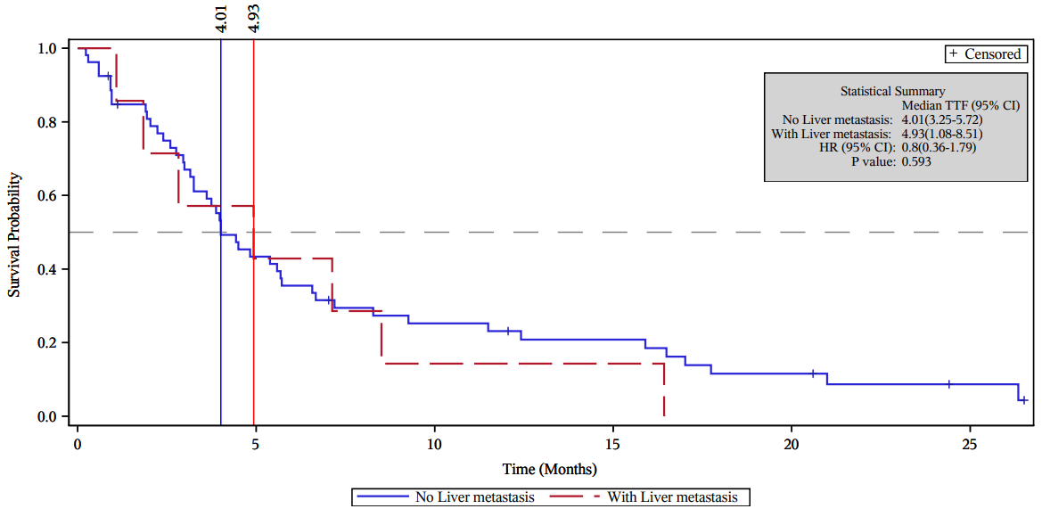

Online Resource 2
Exploratory analysis of the 3+2 treatment group KM plot of OS by liver metastasis.
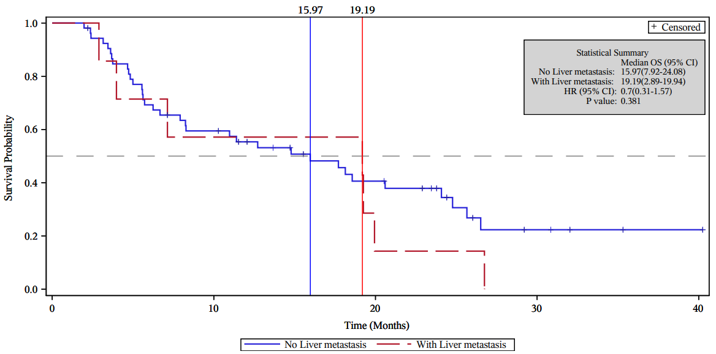

Online Resource 3
Exploratory analysis of the 3+2 treatment group KM plot of TTF by brain metastasis.
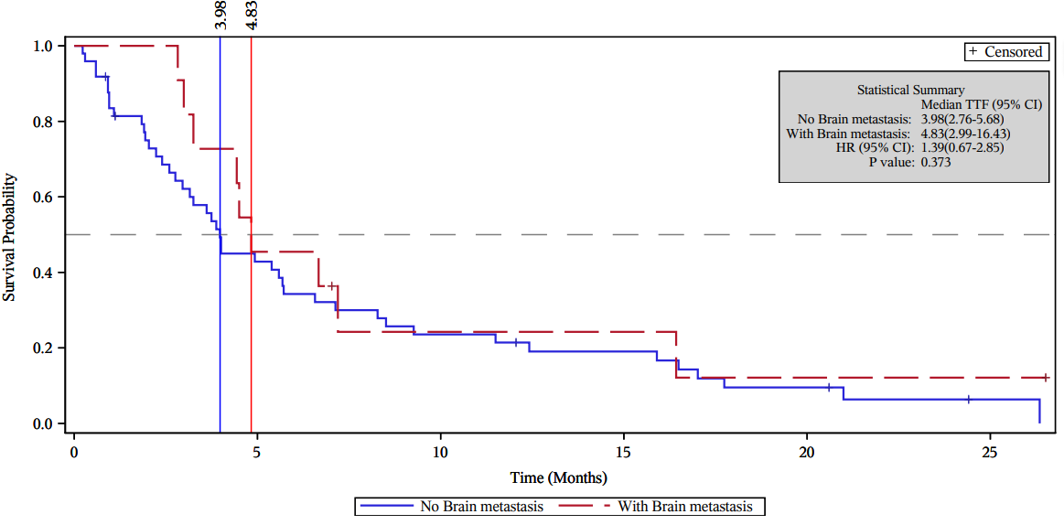

Online Resource 4
Exploratory analysis of the 3+2 treatment group KM plot of OS by brain metastasis.
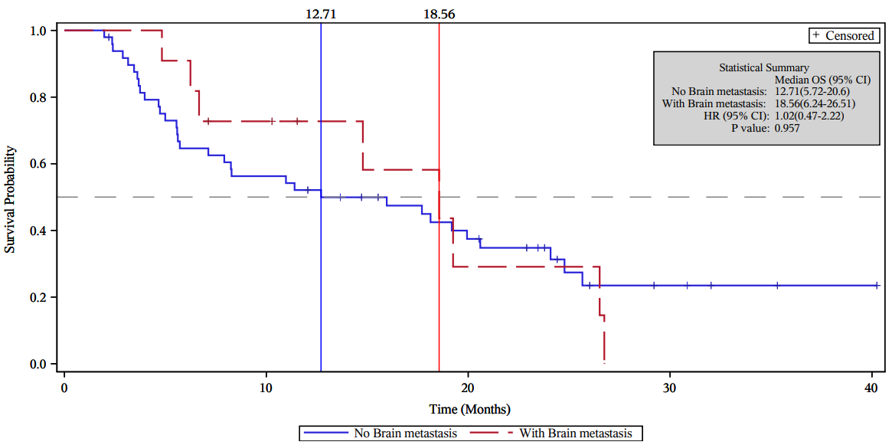

Online Resource 5
Exploratory analysis of the 3+2 treatment group KM plot of TTF by bone metastasis.
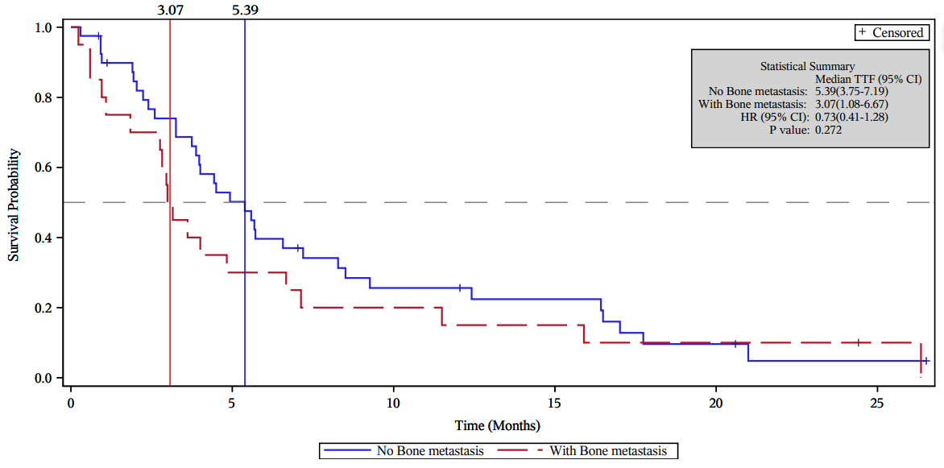

Online Resource 6
Exploratory analysis of the 3+2 treatment group KM plot of OS by bone metastasis.
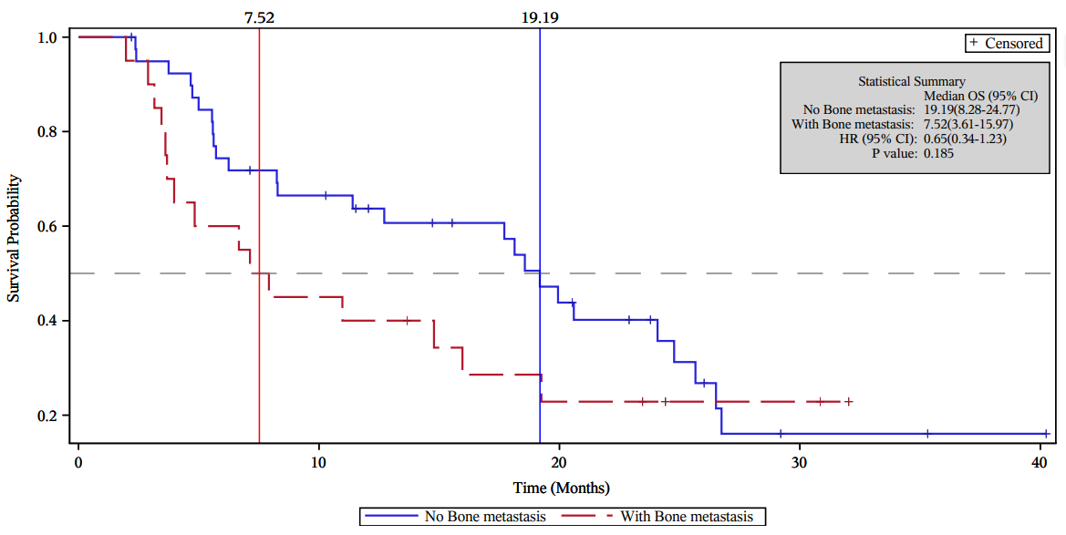

Online Resource 7
Exploratory analysis of the 3+2 treatment group KM plot of TTF by adrenal metastasis.
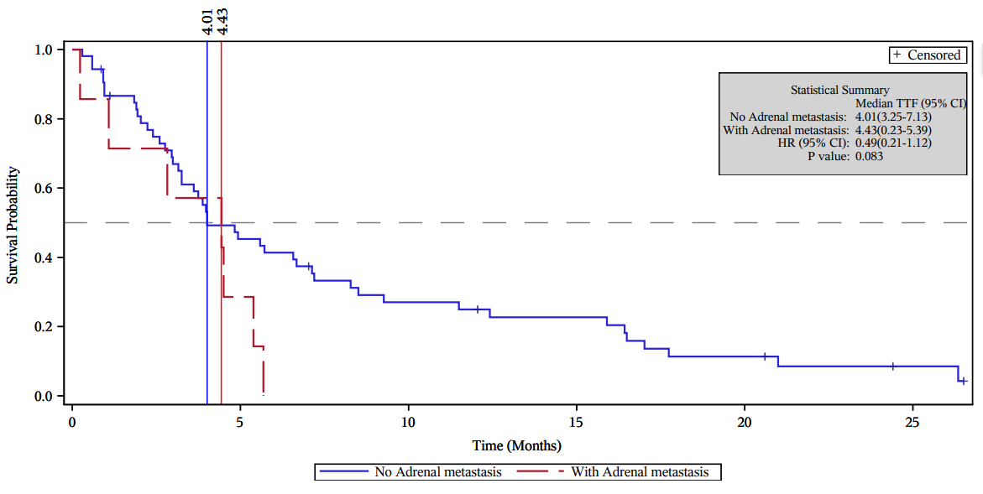

Online Resource 8
Exploratory analysis of the 3+2 treatment group KM plot of OS by adrenal metastasis.
