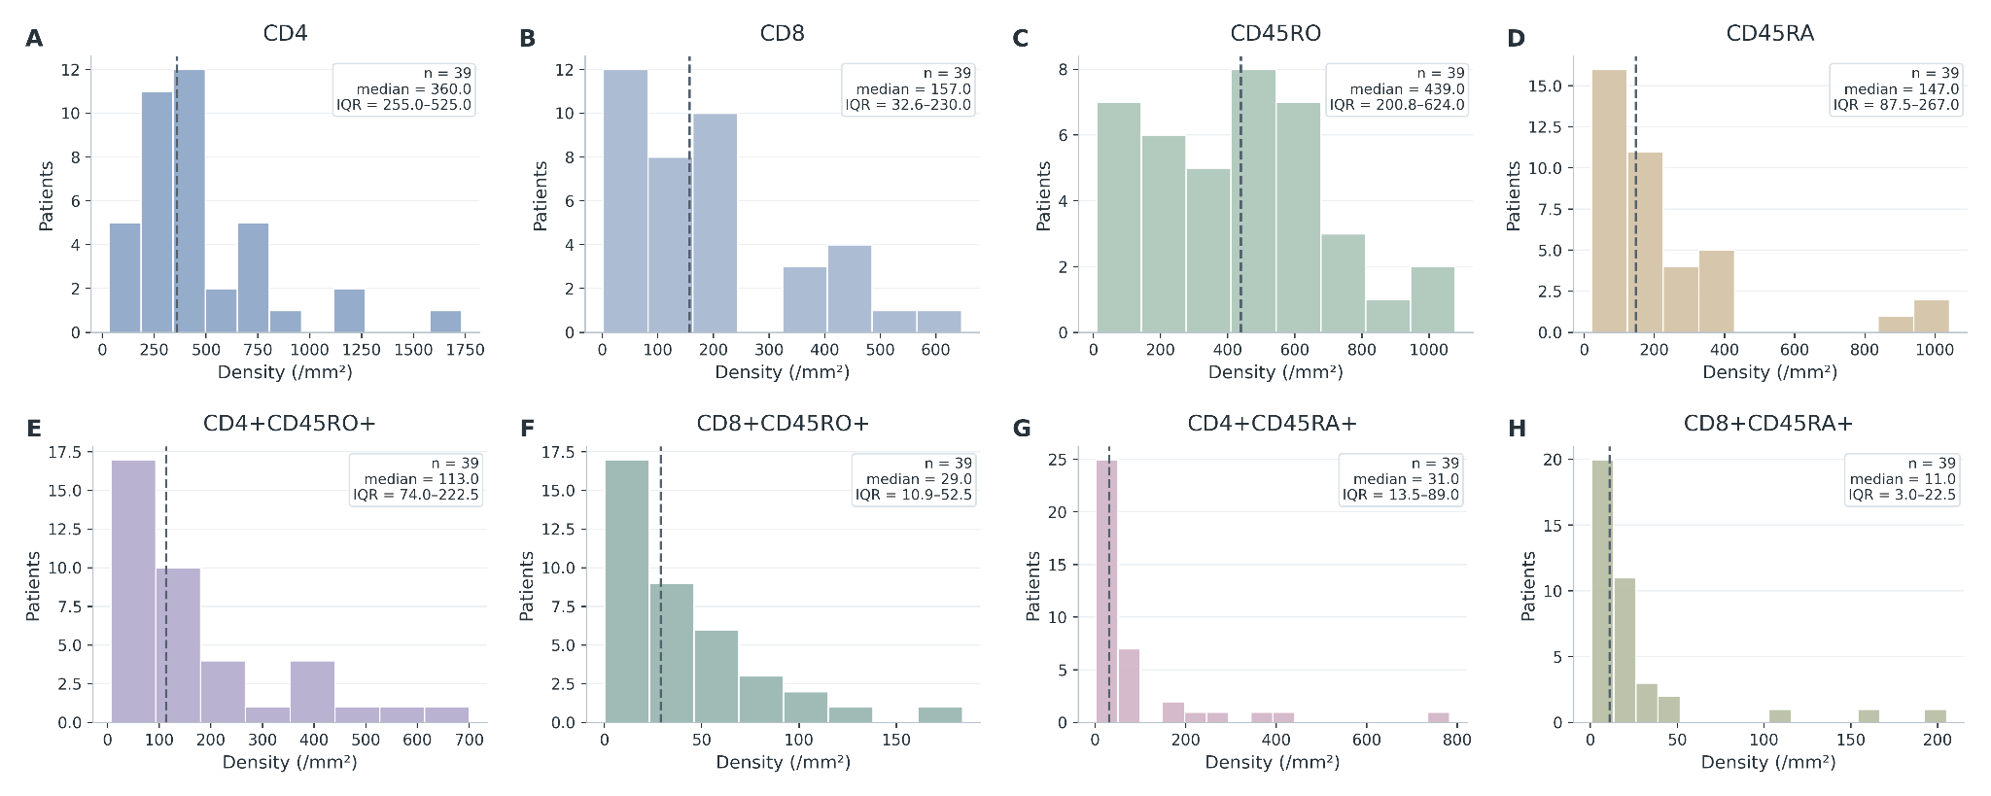
SFig 1. Distribution of patient-level immune-cell phenotype densities. Histograms show cohort-wide distributions of CD4+, CD8+, CD45RO+, CD45RA+ and lineage-restricted double-positive cell densities. Dashed lines indicate cohort medians; sample size, median and interquartile range are shown within each panel.

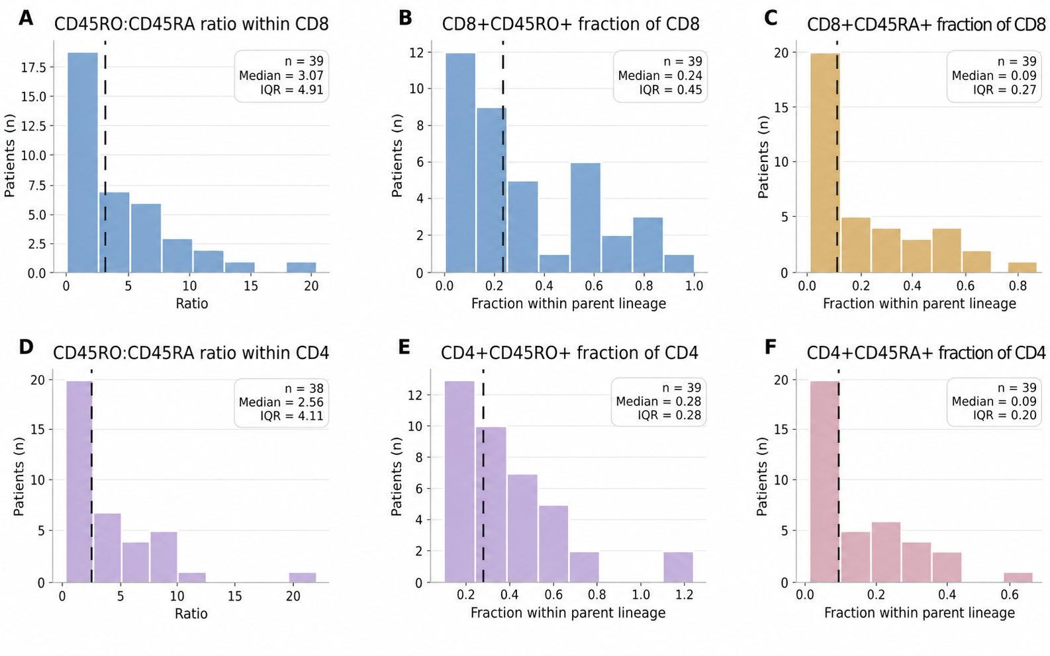
SFig 2. Distribution of lineage-specific CD45RO ratios and normalized T-cell fractions. Histograms show patient-level CD45RO ratios and CD45RO+ or CD45RA+ fractions within CD8+ and CD4+ parent lineages. Dashed lines indicate cohort medians; sample size, median and interquartile range are shown within each panel.

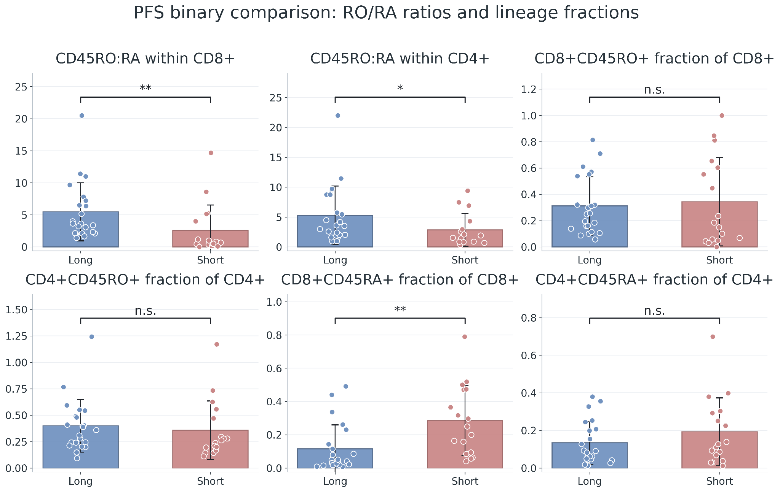
SFig 3. CD45RO ratios and lineage-normalized T-cell fractions according to PFS group. Patient-level CD45RO ratios and lineage-normalized CD45RO+ or CD45RA+ fractions were compared between long-PFS and short-PFS groups. CD45RO ratios were higher in long-PFS patients within both CD8+ and CD4+ lineages, while the CD8+CD45RA+ fraction within CD8+ cells was higher in short-PFS patients. Other lineage-normalized fractions did not differ significantly. Statistical significance is indicated above each comparison; n.s., not significant; *p<0.05; **p<0.01.

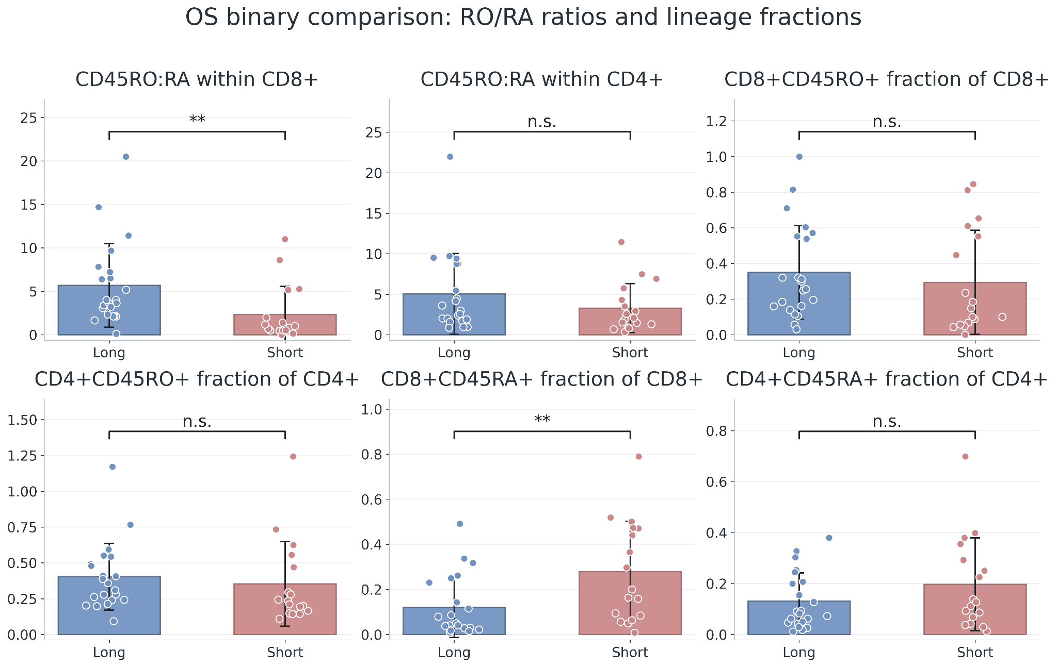

SFig 4. CD45RO ratios and lineage-normalized T-cell fractions according to OS group. Patient-level CD45RO ratios and lineage-normalized CD45RO+ or CD45RA+ fractions were compared between long-OS and short-OS groups. The CD45RO ratio within CD8+ cells was higher in long-OS patients, whereas the CD8+CD45RA+ fraction within CD8+ cells was higher in short-OS patients. The CD4-lineage ratio and the remaining lineage-normalized fractions did not differ significantly between groups. Statistical significance is indicated above each comparison; n.s., not significant; **p<0.01.

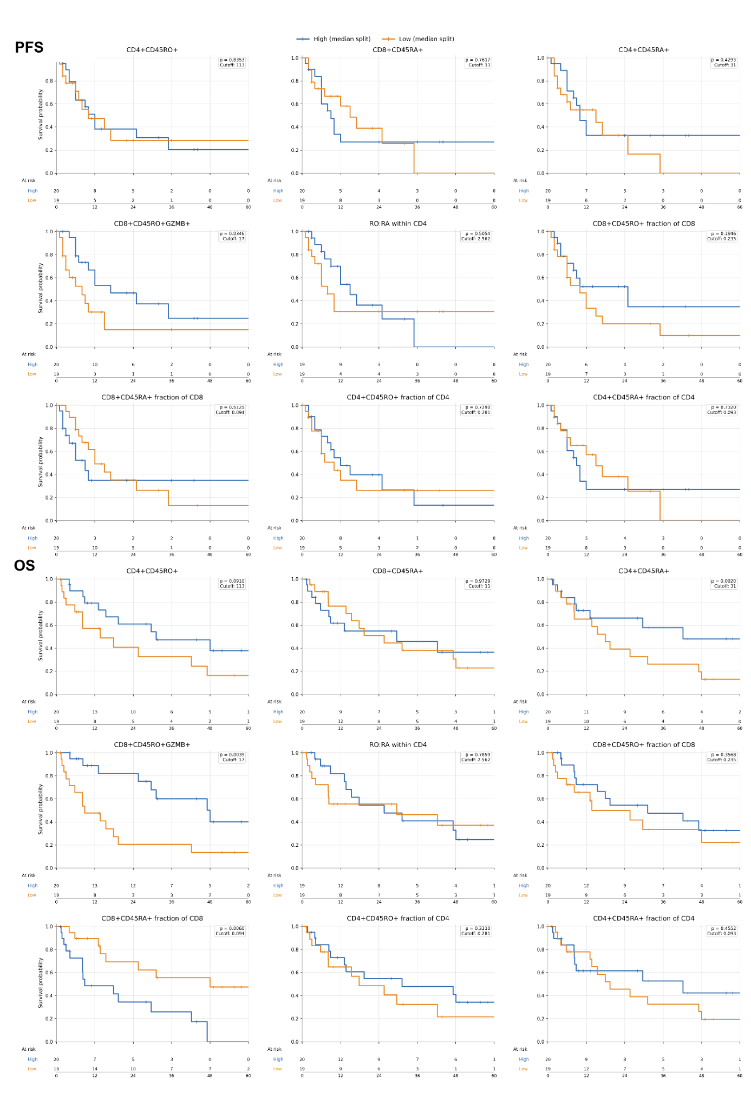
SFig 5. Additional Kaplan–Meier analyses of CD45RO- and CD45RA-related T-cell phenotypes. Progression-free survival (PFS; upper panel) and overall survival (OS; lower panel) were evaluated for lineage-restricted phenotype densities, CD45RO ratios and parent-lineage-normalized fractions. Patients were dichotomized into high and low groups using the cohort median for each variable, with the corresponding cutoff shown within each plot.
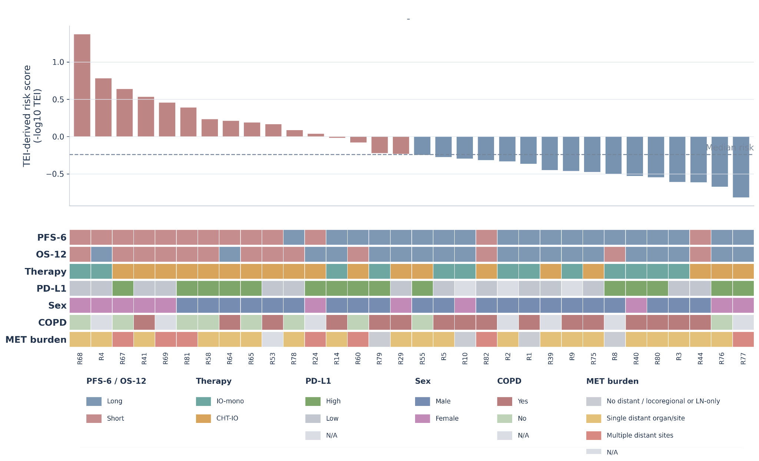
SFig 6. Patient-level distribution of the TEI-derived risk score and clinicopathological characteristics. Patients were ranked according to the TEI-derived risk score (−log10 TEI), with the dashed horizontal line indicating the cohort median. The annotation matrix below summarizes PFS6 and OS12 groups, treatment modality, PD-L1 status, sex, COPD status and metastatic burden for each patient

